LAB 2

1.DFS OUTPUT:
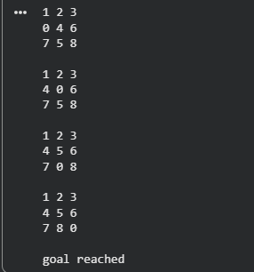
2.IDS OUTPUT
