**Hazardous Area Monitoring System For Industrial Plants**

**Introduction:**

**Overview:**

Internet of Things represents a general concept for the ability of network devices to sense and collect data from the world around us, and then share that data across the Internet where it can be processed and utilized for various practical purposes in the aspects of life. IOT based systems in industrial areas is still limited, but it has huge potential. In this project, we create an IOT based hazard monitoring system specifically suited to requirements of mining, refining and manufacturing industries. The system actively records, processes and analyzes the temperature of surroundings, which is a prime safety parameter in areas where melten metal is processed, manufacturing is done or welds are made. Also it keeps track of high levels of dangerous gases present in the environment. If a parameter is violated, the system sends an immediate notification to the list of users on their smartphones.

**Purpose:**

By this project everyone who are working in that area able to see the alerts at dangerous time.

**Literature Survey**:

**Existing problem**:

In the industrial areas, people working in the area suddenly if the temperature raises it is difficult to measure the temperature immediately and sometimes high level of dangerous gases released in the environment. It may harms the people in that area and people may die because of high level gases.

**Proposed solution**:

The project architecture is based multiple monitoring nodes and making use of arduino, which gathers and processes the data generated by different sensors like temperature sensors and gas detectors. A cloud platform is used to visualize and analyse the data thus generated and also thereby enabling us to perform real time tracking and possibly implement a warning system, send notifications through the cloud or an audible alarm.

**Theoretical Analysis**:

**Requirements:**

Arduino

ESP32

LM35

Gas sensor

OLED display

Buzzer

**Hardware/Software designing**:

The hardware part of the project involves the arduino.

The two sensors are connected to the arduino via the I2C interface. The sensor values are read by the arduino, processed, and then sent to the IBM Cloud services using the internet

module. The data send to mobile application which was develpoed using MIT app

Inventor. Here we use IOT device simulator for coding. Node-Red, etc. Software tools are

used.

**Experimental Investigations**:

There are several IoT authentication challenges and issues that need to be understood

before employing the right security solution that can dynamically vary with the situation

. Based on certain critical situations such as IOT area monitoring applications, frequent

authorization and authentication are necessary and could dynamically vary, potentially

resulting in changes to the authorization of IoT devices. To address these issues,

automated mutual authentication without user intervention is required in supporting

users from remembering passwords for a large number of devices.

**Result:**

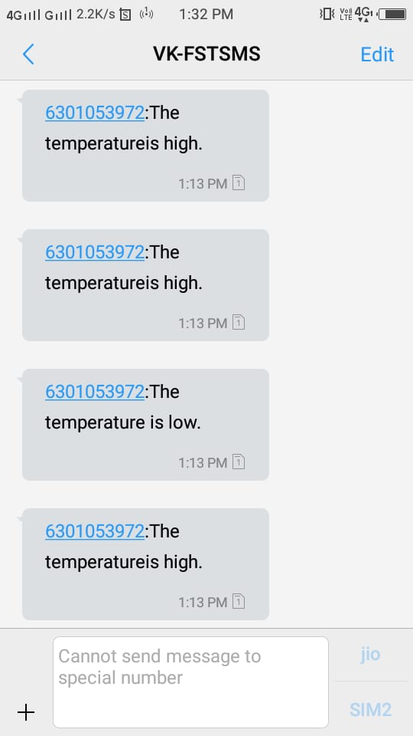.

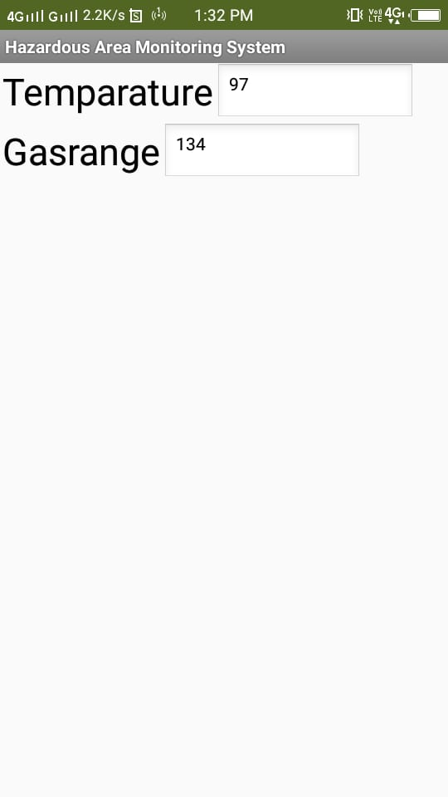

**Advantages & Disadvantages of IOT in industries**:

**Advantages**:

Better inventory management-find it fasts, from anywhere

Build a safer work environment

Secure your facilities

**Disadvantages**:

Compatibility: As of now, there is no standard for tagging and monitoring with sensors. A uniform concept like the USB or Bluetooth is required which should not be that difficult to do.

Safety: There is a chance that the software can be hacked and your personal information misused. The possibilities are endless. Your prescription being changed or your account details being hacked could put you at risk. Hence, all the safety risks become the consumer’s responsibility.

Complexity: There are several opportunities for failure with complex systems.

Privacy/Security: Privacy is a big issue with IOT. All the data must be encrypted so that data about your financial status.

**Conclusion:**

Thus, the proposed system could gather the temperature values and gas level in the environment in the industrial area. If there is any sudden changes in the environment, immediately it sends the notification and the details of the changes. It reduces the deaths.

**Future Scope**:

It increases more applications for more and different problems and it increases

opportunities and decreases the problems.