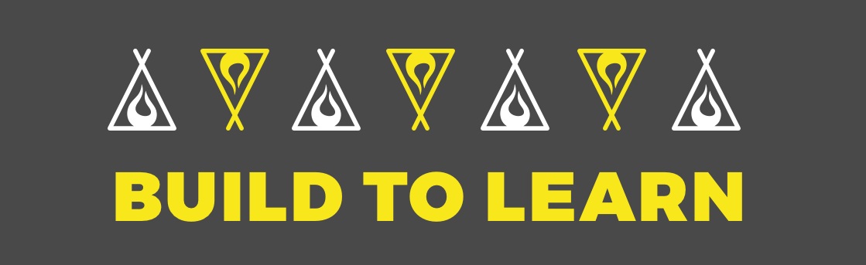
Hello, welcome to the team project you signed up for!

In this project you’re going to get the opportunity to experience working on a remote dev project!

It’s not going to be easy. ;p But isn’t that how we grow and improve the most, by overcoming challenges?!

OKAY, LET’S GET STARTED!

Soft-due date to finish: June 10th-20th.

Project Management: Whatever the team agrees on, but copying and pasting this Build.to.Learn Team Project Template is a great way to go. This doc is awesome because it allows the team to share ideas and add structure to the project. Here’s how a past team used this doc. Be the hero that sets this google doc up for your team! :)

How do we start? Say hi, ask where they are from. Use @username when speaking to people, as it’ll notify them of your message. Be friendly, and remember, everyone on the team signed up for the same thing as you. They are just as nervous and excited to get started!

Plan the first meeting within 5 days. Any later and I’ll label the team I-Fear-the-Ship-Is-Sinking because teams that don’t build momentum fast, fail.

Before you end the first meeting, plan the next meeting.

Resources: can be found here.

OPTIONAL READ
Points of note

You might be surprised by what you’re capable of.

You won’t have a Project Manager and you’re essentially on your own as a team! (Personally, I think this is a good thing as learning to adapt is probably the most important skill to develop as a developer).

Momentum will be your team’s best friend. Friendliness and high-energy are the lifeblood of team projects. If you bring the momentum early and sustain it, the project will be finished. If the team let’s that momentum go though, the opportunity will likely be lost.

Be ready to learn, be ready to adapt, be ready to build.

A major goal of the cohorts is to become one of the collaboration capitals of the web - a place where people who want to learn and build can find opportunities they couldn’t find alone. From making splash pages to chatbots to social networking sites (we’ve had teams build each), we are a place where anyone from anywhere can take on such challenges.

We’ve found that build.to.learn teams of 2 and 3 have the highest percentage of finishing and launching their project (with a slight edge to teams of 2).

We will be launching around 40 build.to.learn teams this cohort session (spread amongst the Otters, Gerenuks, Walruses, and Parrots). Only 15-30 will likely finish. Team dev projects are hard, and 90% of people come in having never worked in a dev team before.

Sometimes, owners of companies or people who hire reach out and ask me to recommend devs to hire. I have only ever recommended people who have finished team projects.

Here’s why → “Chingu is bringing together highly motivated people using modern communication tools. Chance and his team are exposing these Chingu cohort members to real time, distributed collaboration in a very real and practical way. The remote developers we’ve hired via Chingu already “get it”, they understand what it takes to be a successful remote developer.” (that’s from a CTO who has hired people from the cohorts).

I have a trello board called The Chingu-Guggenheim Sketch where I keep track of all the projects in the cohorts. At any given time there are 60-100 ongoing team projects, many of those build.to.learns but also larger projects and Moonshots. As much as I’d love to help facilitate every project, I sadly can’t. What I do, however, is check in once a week or two and label each project in the trello board (to know which projects are worth prioritizing and showcasing). The labels I use are: Progressing Well, Github Repo made, I-Fear-The-Ship-Is-Sinking, Momentum-less/dead, and LAUNCHED.

Once you finish your first build.to.learn project, the sky is the limit. You are a part of a network of hundreds of coders of all levels, who come from all kinds of different disciplines (and thus, have diverse skillsets), who come from all over the world (last time I counted it was somewhere around 90 different countries), and who are excited about building together. The potential for projects in this group is absolutely crazy.

