ASSIGNMENT-3

**The Scheme of library management System looks like**

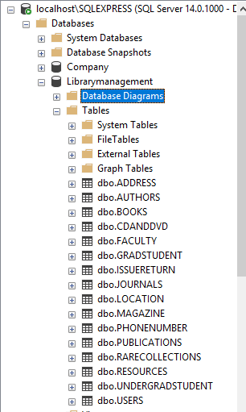

**The above are the tables created in my schema users is superclass and Grad,Undergrad and Faculty are subclasses. Resources is superclass and has subclasses Publications and CDSANDDVDS. Publications again have subclassesbooks, journals,magazine,rarecollections.**

**The undergrad,grad,and Faculty have field as Noofitemschecked in each of them instead in their superclass because there is a constraint for each of them separately for checked items.(grad 150, undergrad 5, Faculty 300 items).Assuming all publications have LCCN number which acts as a primary key for that table.**

**The following are the DDL statements used with constraints**

**The below created tables are self-sufficient to perform all relationships of library like borrow,issue,return,fine,search of books.**

CREATE DATABASE Librarymanagement;

-- Creating Company Schema

USE Librarymanagement;

-- Creating USERS table

DROP TABLE IF EXISTS USERS;

CREATE TABLE USERS (

Firstname varchar(15) not null,

Middlename varchar(1),

Lastname varchar(15) not null,

Email varchar(30) not null check ( Email like ('%@%.com')),

BorrowerType varchar(20) not null check ( BorrowerType in ('Gradstudent','Undergradstudent','Faculty')),

UTDID varchar(10),

NETID varchar(15) not null unique,

Gender char not null check (Gender in ('M' , 'F')),

Department char(10) not null,

CONSTRAINT pk_user primary key (UTDID))

-- Creating GRADSTUDENT and UNDERGRADSTUDENT and FACULTY

DROP TABLE IF EXISTS GRADSTUDENT;

CREATE TABLE GRADSTUDENT (

degreeplan varchar(15) not null,

Noofitemschecked varchar(3) Check (Noofitemschecked <= 150),

UTDID varchar(10) Unique,

CONSTRAINT fk_user_grad foreign key (UTDID) references USERS(UTDID)

)

DROP TABLE IF EXISTS UNDERGRADSTUDENT;

CREATE TABLE UNDERGRADSTUDENT (

class varchar(5) not null,

Noofitemschecked varchar(3) Check (Noofitemschecked <= 5),

UTDID varchar(10) Unique,

CONSTRAINT fk_user_ungrad foreign key (UTDID) references USERS(UTDID)

);

DROP TABLE IF EXISTS FACULTY;

CREATE TABLE FACULTY (

Position varchar(15) not null,

Noofitemschecked varchar(3) Check (Noofitemschecked <= 300),

UTDID varchar(10) Unique,

CONSTRAINT fk_user_faculty foreign key (UTDID) references USERS(UTDID));

-- Creating Address and Phone number tables

DROP TABLE IF EXISTS ADDRESS;

CREATE TABLE ADDRESS (

UTDID varchar(10) not null,

Home varchar(50) not null,

Localaddress varchar(50),

CONSTRAINT fk_user_add foreign key (UTDID) references USERS(UTDID)

)

DROP TABLE IF EXISTS PHONENUMBER;

CREATE TABLE PHONENUMBER (

UTDID varchar(10),

Mobile varchar(MAX) ,

Home varchar(MAX) ,

Office varchar(MAX) ,

CONSTRAINT chk1 check ( DATALENGTH([Mobile]) = 10),

CONSTRAINT chk2 check ( DATALENGTH([Home]) = 10),

CONSTRAINT chk3 check ( DATALENGTH([Office]) = 10),

CONSTRAINT fk_user1_pno foreign key (UTDID) references USERS(UTDID),

)

-- Creating Resources Table and Publications table

DROP TABLE IF EXISTS RESOURCES;

CREATE TABLE RESOURCES (

ResourceId varchar(15) primary key,

ItemType varchar(15) not null,

Description varchar(260),

Borrowtypeofresource varchar(20) Check (Borrowtypeofresource in ('Is borrowable','Cannot be borrowed')))

DROP TABLE IF EXISTS PUBLICATIONS;

CREATE TABLE PUBLICATIONS (

LCCN varchar(15) Unique not null,

Title varchar(50) not null,

TotalCopies varchar(15) not null,

Publisher varchar(30) not null,

Publicationdate Date check (Publicationdate >= '1500' AND Publicationdate <= '2019') not null,

Edition varchar(15),

NoofPages varchar(15),

ResourceId varchar(15) not null,

CONSTRAINT fk_resid_id foreign key (ResourceId) references RESOURCES(ResourceId)

)

--creating CDANDDVD

DROP TABLE IF EXISTS CDANDDVD;

CREATE TABLE CDANDDVD (

ISBN varchar(15) primary key,

ResourceId varchar(15) not null,

Name varchar(20),

CONSTRAINT fk_cdd_id foreign key (ResourceId) references RESOURCES(ResourceId)

)

--Creating AUTHORS

DROP TABLE IF EXISTS AUTHORS;

CREATE TABLE AUTHORS (

Resourceid varchar(15) not null ,

AuthorName varchar(20) primary key,

CONSTRAINT fk_auc_id foreign key (Resourceid) references Resources(Resourceid)

);

---Creating books,magazines,journals and rarecollections

DROP TABLE IF EXISTS BOOKS;

CREATE TABLE BOOKS (

ISBN varchar(13) primary key,

Typeofbook varchar(20) not null,

LCCN varchar(15) not null,

IsFiction varchar(3) not null,

DDSN varchar(15),

CONSTRAINT fk_lc_id foreign key (LCCN) references PUBLICATIONS (LCCN)

);

DROP TABLE IF EXISTS MAGAZINE;

CREATE TABLE MAGAZINE (

BIPAD varchar(13) primary key,

LCCN varchar(15) not null,

CONSTRAINT fk_mz_id foreign key (LCCN) references PUBLICATIONS (LCCN)

);

DROP TABLE IF EXISTS JOURNALS;

CREATE TABLE JOURNALS (

ISSN varchar(13) primary key,

LCCN varchar(15) not null,

CONSTRAINT fk_jz_id foreign key (LCCN) references PUBLICATIONS (LCCN)

);

DROP TABLE IF EXISTS RARECOLLECTIONS;

CREATE TABLE RARECOLLECTIONS (

Serialno varchar(13) primary key,

LCCN varchar(15) not null,

CONSTRAINT fk_rz_id foreign key (LCCN) references PUBLICATIONS (LCCN)

);

-- Create Location table

DROP TABLE IF EXISTS LOCATION;

CREATE TABLE LOCATION (

ResourceId varchar(15) unique,

floorno Int not null,

Rackno Int not null,

CONSTRAINT fk_loc2_id foreign key (ResourceId) references RESOURCES(ResourceId)

);

-- Create issue and return status in ISSUERETURN which has details of user and resource

DROP TABLE IF EXISTS ISSUERETURN;

CREATE TABLE ISSUERETURN (

Issueid varchar(15) primary key,

UTDid varchar(10) not null,

Resourceid varchar(15),

Issuedate Date,

Expectedreturndate Date,

Actualreturndate Date,

CONSTRAINT fk_brrs_id foreign key (Resourceid) references Resources(ResourceId),

CONSTRAINT fk_usid_id foreign key (UTDid) references USERS(UTDID)

);

**CREATING INDEXES**

1. CREATE INDEX booktitle ON PUBLICATIONS (Title);

I have created on booktitle since most of users search the books by title which requires fast access.

1. CREATE INDEX floor_id ON Location(floorno,Rackno);

I have created on floor_id since users search the location after knowing that it is available in library even this field requires fast access.

**Answering 7 questions**

1. What books do we have by Shamkant Navathe?

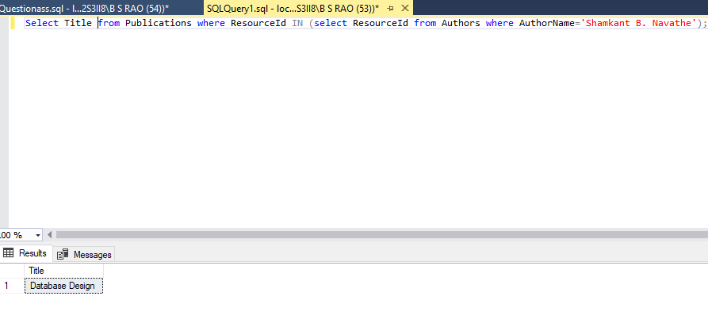

1. What books do we have on databases?

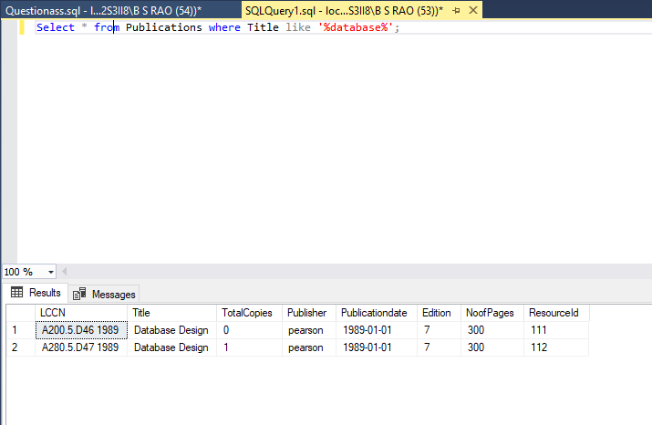

1. Which books are overdue, and who has them?

Books which are overdue

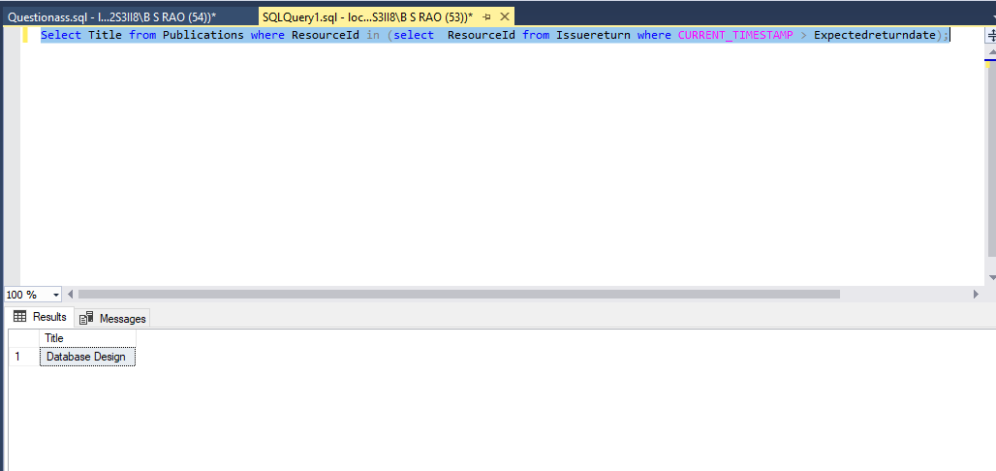

Person who has the book

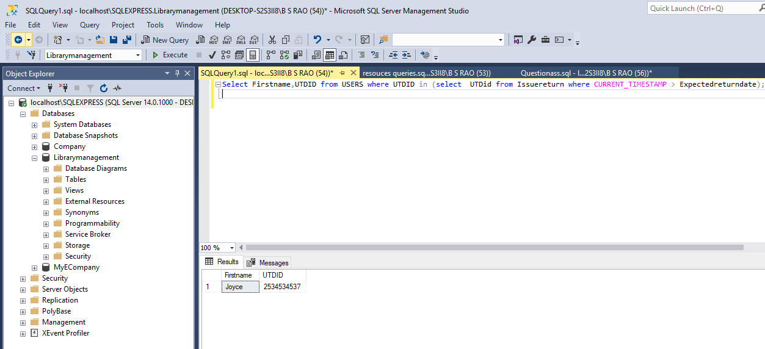

1. What is the fine, if any, on a book when it is returned?

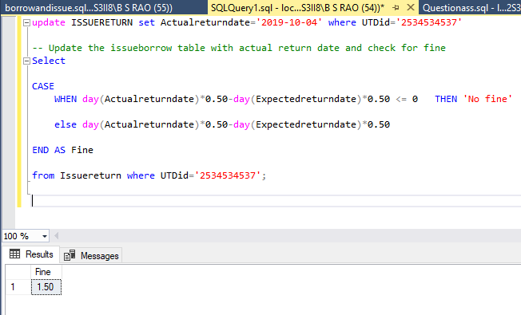

1. We have just acquired a book; put it into the system.

Finding out exact resource id for the book

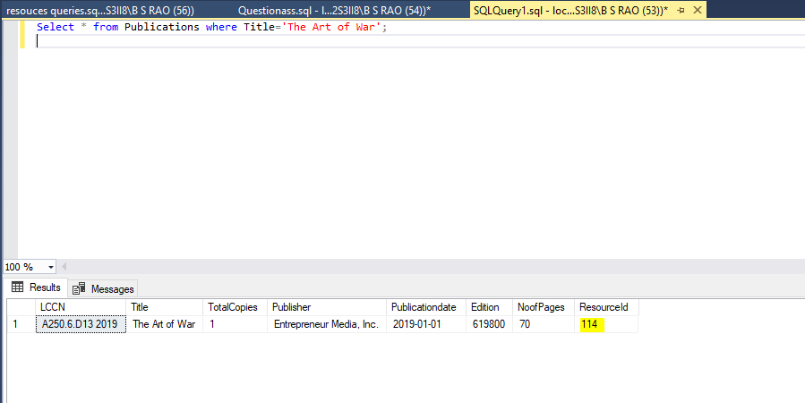

Inserting the resource taken and utdid expected return date in issuereturn table

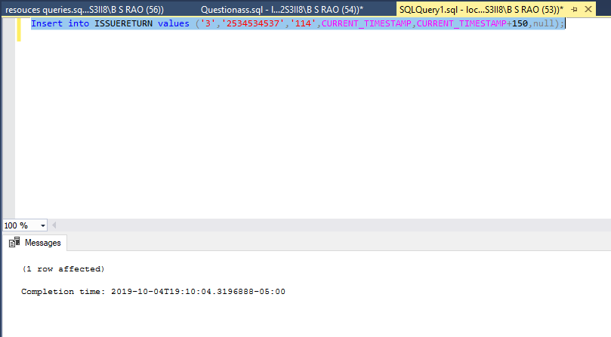

Now updating publications table and changing totalcopies to ‘0’ so that other users know that particular book was taken.

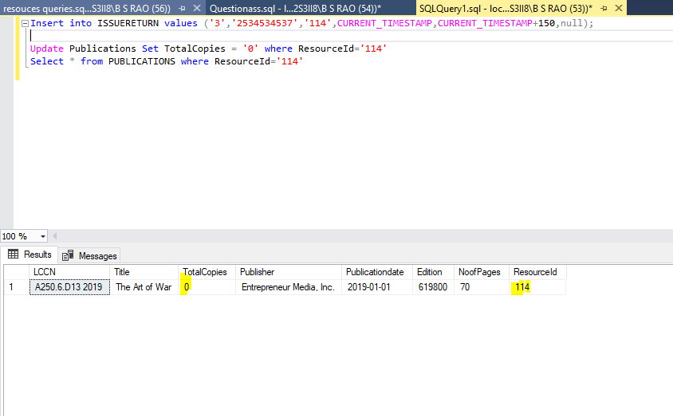

Updating the student profile with no of items checked incremented by one to maintain constraint for no of items checked.

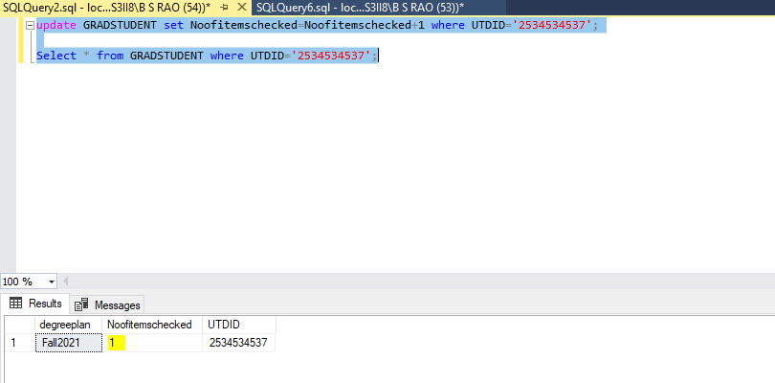

1. Find the e-book of the Big Nerd Ranch Guide to Android Programming.

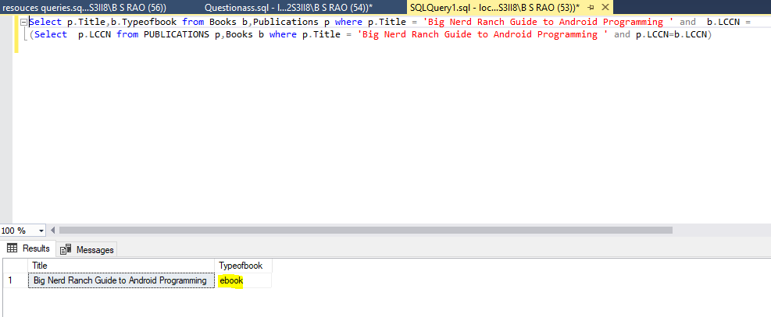

1. Where is *The Art of War* physically located within the library?

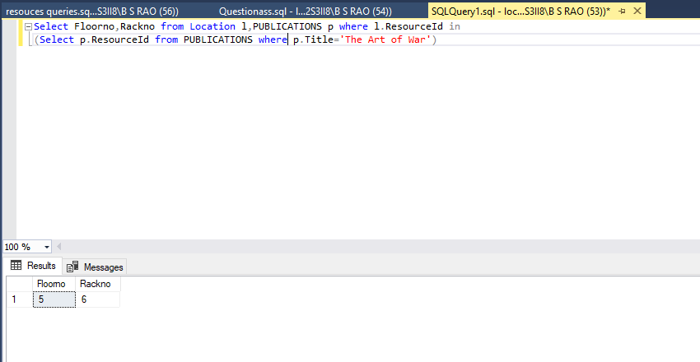

1. Are there any copies of *Zen and the Art of Motorcycle Maintenance* on the shelves?

