**Plots obtained**

**Polynomial degree**

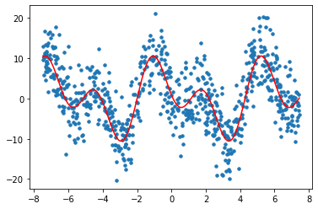

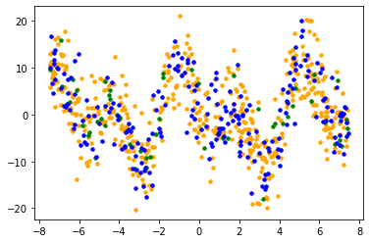

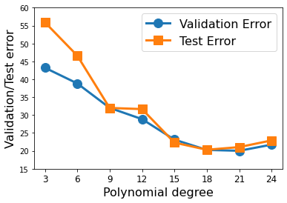

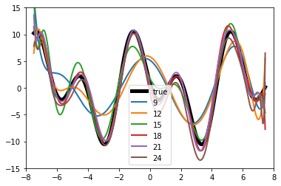

**validationErr**

Out[111]:

{3: 43.2261353235444,

6: 38.84038651639953,

9: 32.017855783911465,

12: 28.86603217046569,

15: 23.140328163045574,

18: 20.264071431987322,

21: 20.02528501991423,

24: 21.73788444006755}

testErr

Out[112]:

{3: 55.92270050247532,

6: 46.6084832717055,

9: 31.991853535683592,

12: 31.674451298674178,

15: 22.307542265844408,

18: 20.312082077554606,

21: 21.053427339649307,

24: 22.92316439910942}

From plot of vs. validation error below, which choice of do you expect will generalize best?

For this considering the validation an test errors I believe for degree ‘21 ‘where validation and testerrors almost coincide works best and is the best fit.

**Radial basis function**

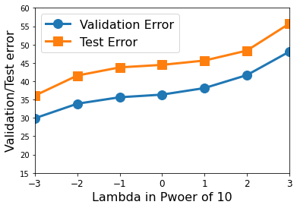

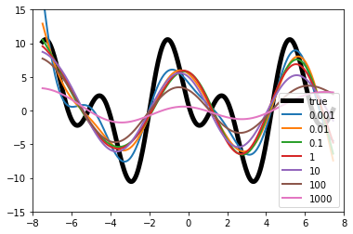

validationErr

Out[114]:

{-3: 29.908089944815366,

-2: 33.87125527283883,

-1: 35.628354726730926,

0: 36.3504379943167,

1: 38.13184009629207,

2: 41.66499975877452,

3: 48.04301525028529}

testErr

Out[115]:

{-3: 36.083101647026666,

-2: 41.54911050563332,

-1: 43.77388708564906,

0: 44.460799762861754,

1: 45.63404503207107,

2: 48.34668094953206,

3: 55.68174178686711}

**Observations**

Ideal Value of Lambda is 0.001, as from the error graph we see as lambda increases error also increases.

Ideal values are 0.001,0.01.

The smaller the lambda better the graph fit to true function and when we increase the lambda the graph becomes more linear.