


Date 28 May, 2013
BOOTSTRAPPING APPLICATION WITH AWS CLOUDFORMATION AND INTEGRATION WITH PUPPET

Summary
This documentation gives the description of how to bootstrap an application in amazon ec2 instance and also to setup whole environment/infrastructure in amazon cloud using the CloudFormation service. It covers the three different ways of bootstrapping an application in ec2 instance, like customization of an ami, customization of an instance at launch time using CloudInit and CloudFormation along with an example for each. It also explains different ways in which the environment is set up with CloudFormation namely using AWS Console, Command Line Interface and APIs. It also gives brief description of Amazon Simple Storage Service (S3).
Later, it also explains is of how to manage server configuration using Puppet and do server orchestration using MCollective. It also discusses how together with Amazon’s CloudFormation, Puppet and MCollective application can be deployed, configured and services be managed across all servers reducing downtime and automating the configuration management while also eliminating inconsistencies in configurations across servers thus enforcing compliance.

Version details

Version number | Changes made | Date | Reviewer name
1 | Initial Document | 09-04-2013

Table of Contents
Summary 1
Introduction 5
1. Customization of an AMI 6
1.1 Steps to customize an AMI: 7
1.1.1 Create an amazon EC2 instance from a set of available AMIs 7
1.1.2 Connecting to the terminal of EC2 instance 10
1.1.3 Installing the softwares required via commands. 13
1.1.4 Creating an AMI from the newly created instance 14
1.2 Implementation 16
2. Customization of an instance at Launch Time using CloudInit 17
2.1 Steps to create instance by passing User-data script at launch time 19
2.2 Implementation 20
3. AWS CloudFormation 21
3.1 Using AWS Management Console 23
3.1.1 Sign up for the service 23
3.1.2 Pick a template 24
3.1.3 Create the stack 24
3.2 Using AWS CloudFormation Command Line Interface (CLI) 26
3.2.1 Configuring the CloudFormation CLI Tools for Windows 27
3.2.2 cfn commands (cfn-cmd) 28
3.3 Using AWS CloudFormation API 28
3.3.1 Setting Up the AWS Toolkit for Eclipse 29
3.3.2 Deploying an AWS CloudFormation Template in Eclipse 32
3.4 Implementation 35
4. Puppet 36
4.1 What is Configuration Management? 36
4.2 How Puppet manages server configuration? 36
4.2.1 The Big Picture 36
4.2.2 Puppet Resource Types, RAL and Catalog generation 36
5. Managing servers in EC2 with Puppet. 42
5.1 Master-Agent setup in EC2. 42
5.2 Auto Signing certificates requests 47
5.3 External Node Classifier 48
5.3.1 Our puppet’s external node classifier. 48
5.3.2 How ENC works in our setup? 50
6. MCollective for pushing changes immediately and selectively. 51
6.1 Overall Setup 51
6.2 Configuring the systems 52
6.2.1 Setting Active-MQ broker. 52
6.2.2 Setting MCollective Agent 52
6.2.3 Setting up MCollective Servers 54
6.3 Doing a few things with MCollective. 56
6.4 Using Filters for parallel execution of tasks. 58
7. Integrating CloudFormation with Puppet and MCollective 59
7.1 Overall Idea 59
7.2 Puppet modules for application. 59
7.2.1 The tomcat6 module. 60
7.2.2 The tomcat7 modules 60
7.2.3 The vehiclerentalbusiness module 61
7.2.4 The vehiclerentalpresentation module. 64
7.2.5 The clients module 66
7.3 Amazon templates for creating the application stack. 68
References 70
Appendix 71

Introduction
This documentation gives the description of how to bootstrap an application in amazon ec2 instance and also to setup whole environment/infrastructure in amazon cloud using the amazon CloudFormation service. An AMI (Amazon Machine Image) that encapsulates the operating system to launch on an Amazon EC2 instance is mainly used to bootstrap an application in instance.
Bootstrapping can be done mainly in three ways namely, Customize an AMI, Launch an instance using cloud-init and CloudFormation. Customization of an AMI provide a way to create golden images containing a well-defined set of OS and application versions as well as files and other configurations that can be used over and over, so that each instance has the same software installed and is configured in the same way. Launching an instance using cloud-init can be done via userdata script. User Data means the data specified by the user when launching the instance. This data can be used to build more generic AMIs that can be modified by configuration supplied at launch time. AWS CloudFormation is a service that gives developers and businesses an easy way to create a collection of related AWS resources and provision them in an orderly and predictable fashion.
Later this document also discusses how servers and services on them along with application’s configurations can be managed using Puppet and MCollective. Puppet is a server configuration management tool from PuppetLabs. It has an open source and free version as well as enterprise version which are paid (free to manage up to 10 nodes). MCollective is an RPC framework created by R. I. Pienaar which now is an intellectual property of PuppetLabs. Several RPC modules have already been written and available from use from the repository of PuppetLabs.
Puppet encapsulates the complexities of package and service management across different flavors of Linux Operating System. It can also be used to manage Windows nodes but we have only tried managing *nix Operating Systems. It has its own language for identifying and defining managed resources.

Customization of an AMI
An AMI (Amazon Machine Image) encapsulates the operating system to launch on an Amazon EC2 instance. The AMI can also include any other software, configuration files or other file‐based artifacts, pre-installed on the instance. When the instance is launched all of the applications are already loaded and ready to run. The AMI is like a template of a computer's root volume. For example, an AMI might contain the software to act as a web server (Linux, Apache, and your web site) or it might contain the software to act as a Hadoop node (Linux, Hadoop, and a custom application).
Public AMIs can be launched by all AWS accounts. They are advertised and shared in the AWS AMI catalog. Amazon and the Amazon EC2 community provide a large selection of public AMIs. The AWS Management Console enables you to search for an AMI that meets specific criteria, and then launch instances from that AMI. You might find that public AMIs suit your needs. However, you might want to customize a public AMI and save that customized AMI for your own use later on. You can keep it private so that only you can use it, or you can share it with only specific AWS accounts that you specify. Another option is to make your customized AMI public so that the EC2 community can use it.
AMIs provide you with a way to create golden images containing a well- defined set of OS and application versions as well as files and other configurations that can be used over and over, so that each instance has the same software installed and is configured in the same way. In addition, all of the software is pre-installed and immediately ready as soon as the instance launches, making AMI-based deployments fast as shown in the fig1.

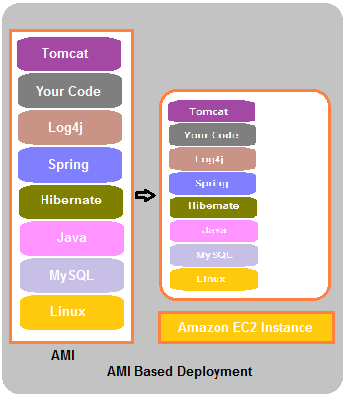
Figure1: AMI Based Deployment

Steps to customize an AMI:
- Create an amazon EC2 instance from a set of available AMIs.
- Connecting to the terminal of that instance
- Install the softwares required via commands
- Creating an AMI from the newly created instance

Create an amazon EC2 instance from a set of available AMIs
Sign in to the AWS Management Console, switch to the Amazon EC2 tab, and click the Launch Instance button
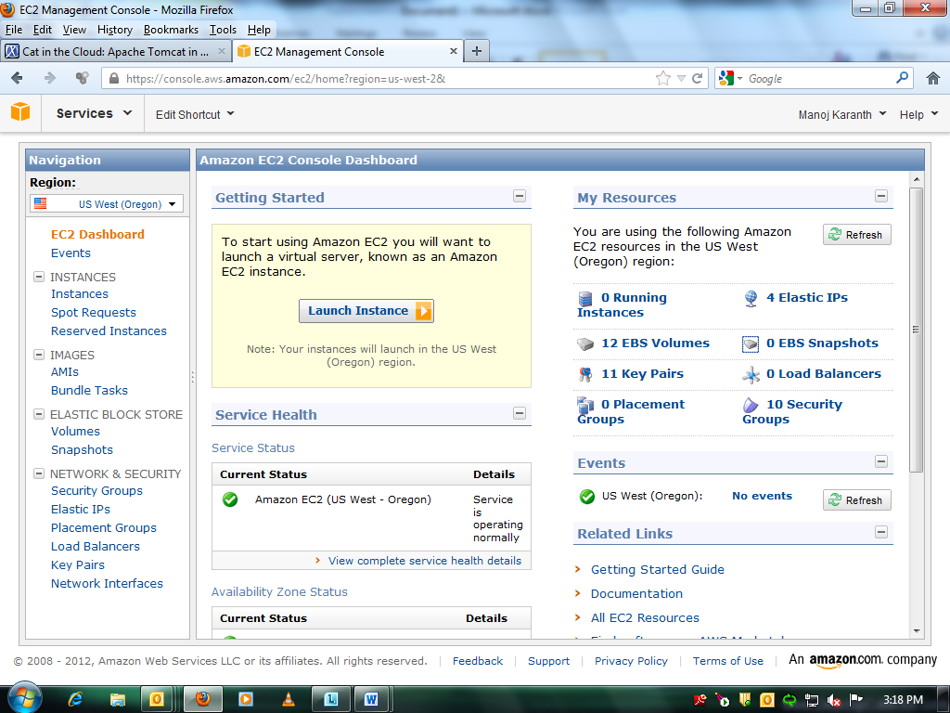
Select an AMI from set of available AMIs. E.g.: 32 bit Amazon Linux AMI of Linux type.
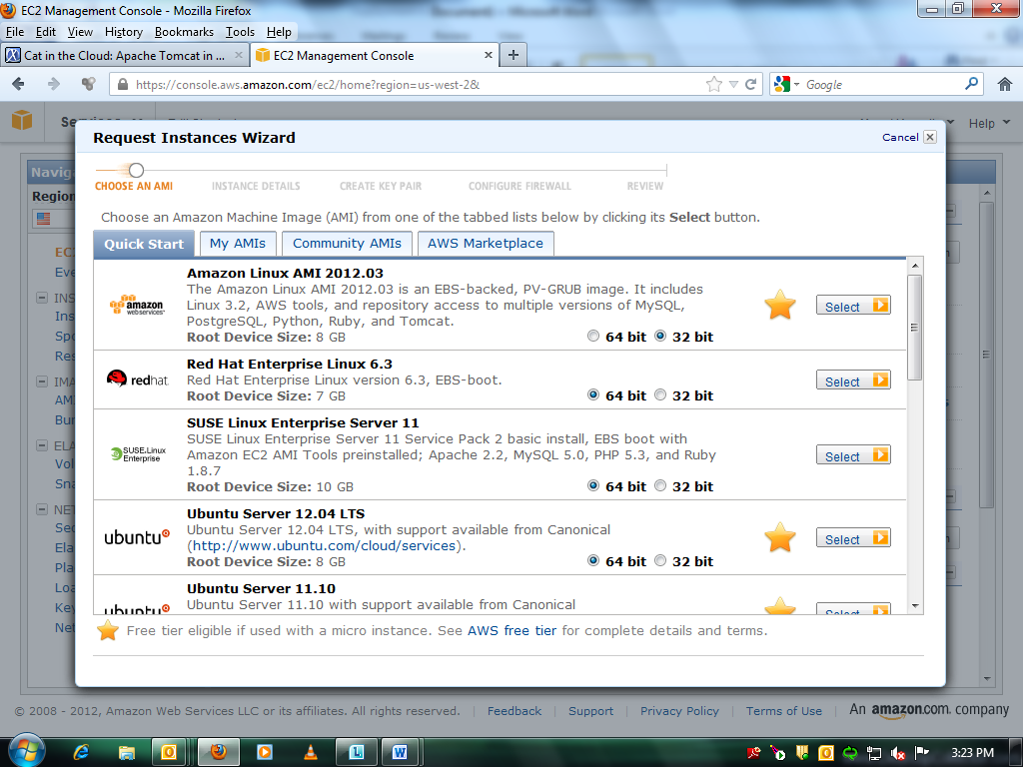
AWS provides the ability to make changes to the instance details. These details include information like number of instances, instance type and availability zone. Here you can specify the number of instances, instance type and availability zone. The default values are
Number of Instance: 1
Instance Type: t1.micro (free tier eligible)
Availability Zone: No Preference
Note: If you choose as No Preference then instance will be created in any of the sub regions available as availability zone
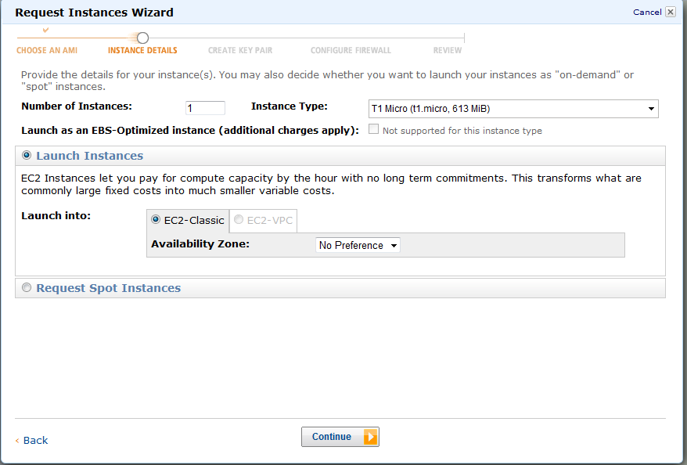

Type the name of the ec2 instance (e.g. MyInstance) into the Value field and click Continue
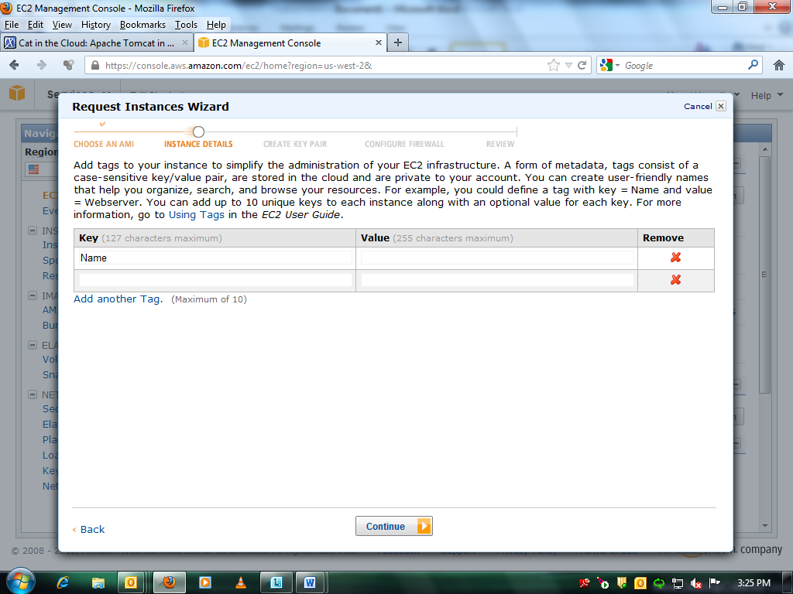
To connect to an instance, you will need a running instance and the private key file that corresponds to the key pair that was selected when the instance was launched.
AWS uses public–key cryptography to encrypt and decrypt login information. Public–key cryptography uses a public key to encrypt a piece of data, such as a password, then the recipient uses the private key to decrypt the data. The public and private keys are known as a key pair. AWS only stores the public key, and you store the private key. Anyone who possesses your private key can decrypt your login information, which is why it is important to store your private keys in a secure place.
In Amazon EC2, all key pairs, whether created or imported, are specific to the region that they are created in or imported to. Make sure your Amazon EC2 endpoint is correctly set before creating or importing the key pair.
On the Key Pair step, create a new key pair: enter a name and click Create & Download your Key Pair. If there are any key Pairs created priorly you can use that by selecting ‘Choose from your existing key Pairs’.

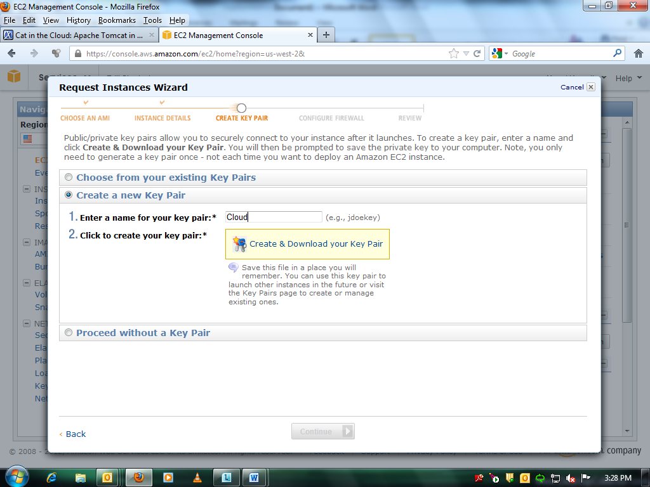

On the Configure Firewall screen, create a new Security Group which will be a rule for SSH access. As a minimum, you should add All ICMP (for ping to work), and a custom TCP rule for port 8080. Add a rule for HTTP if you want to access Tomcat on port 80 or run it behind an HTTP proxy. If there are any security groups created priorly you can use that by selecting ‘Choose one or more of your existing Security Groups.
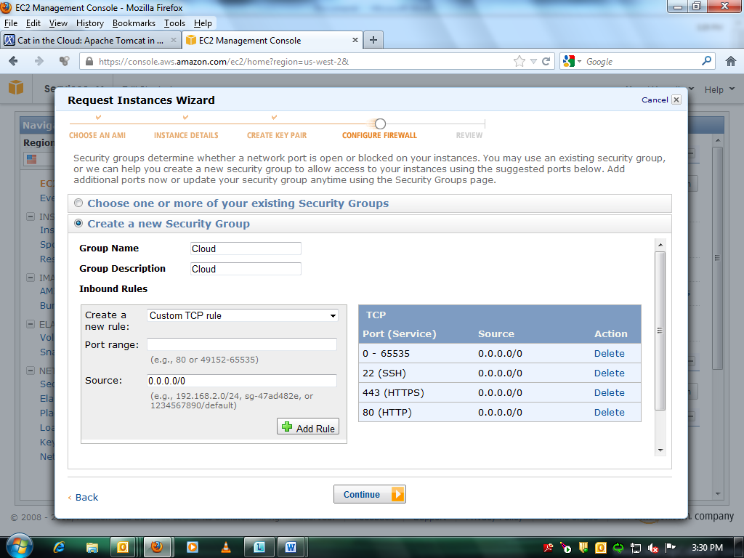

Review the instance settings and click Launch
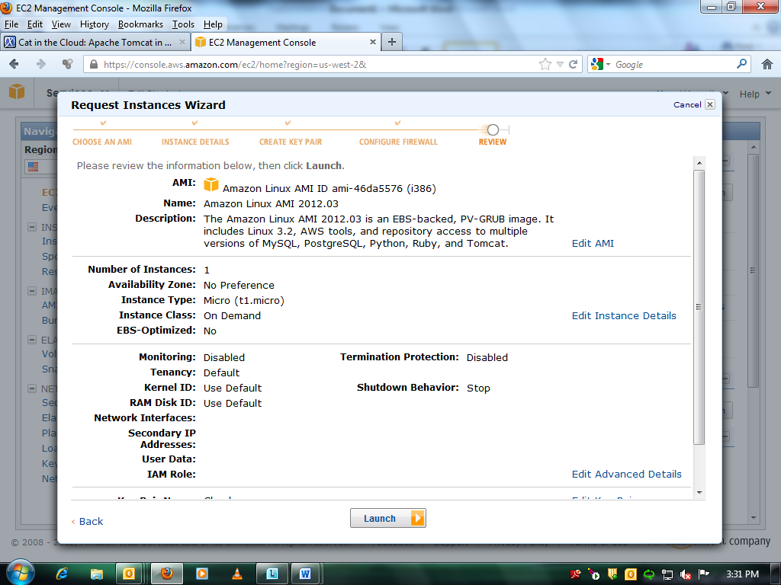
The instance will be running now. Allocate a new elastic IP and associate it with the instance.

Connecting to the terminal of EC2 instance
Right click on the instance and click on Connect. Connection can be done in two ways either using ‘putty’ or ‘java enabled browser’
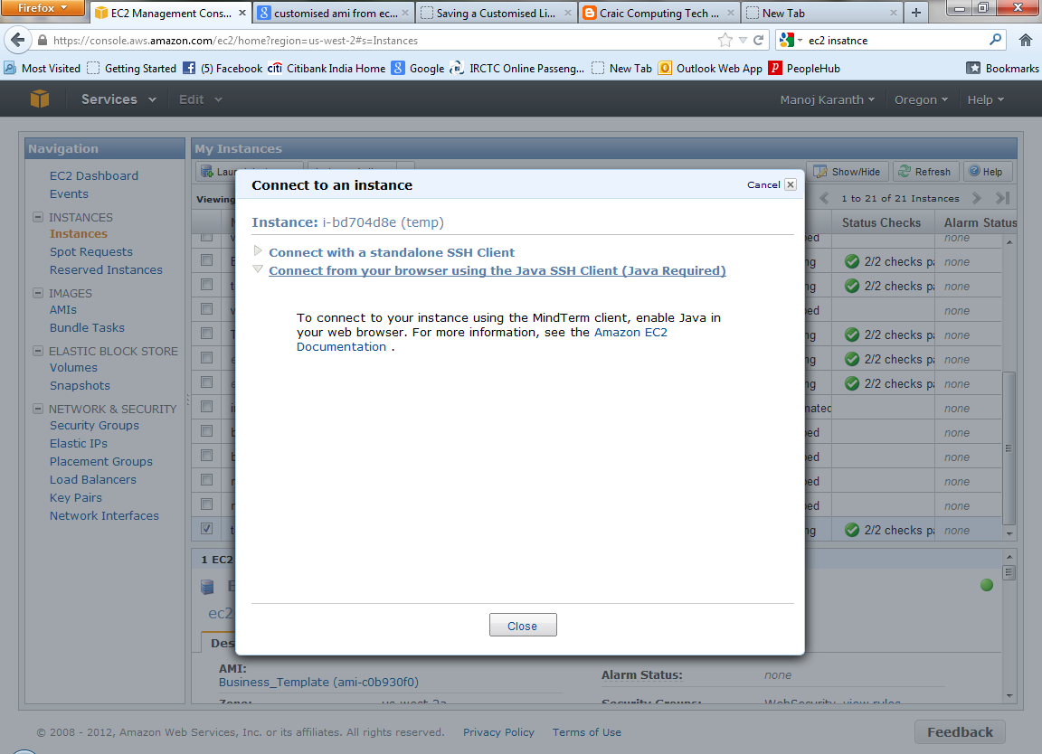

Using PUTTY
Go to the application PuTTY Key Generator. Click
ConversationsImport Key and browse for the pem file downloaded as keypair.
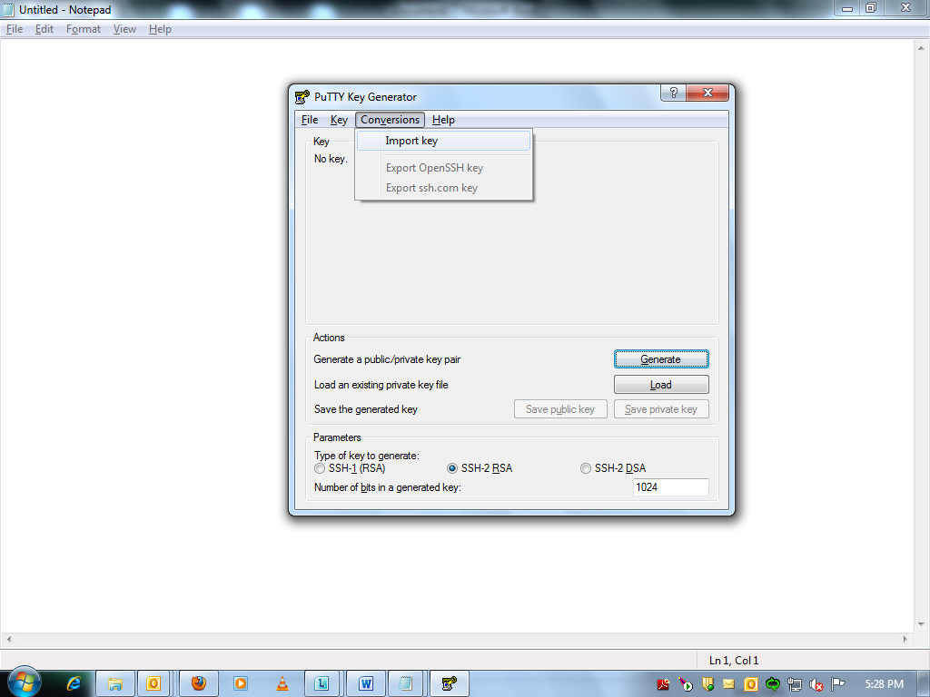

Click Save private key and click on yes in the puTTygen Warning dialog box.
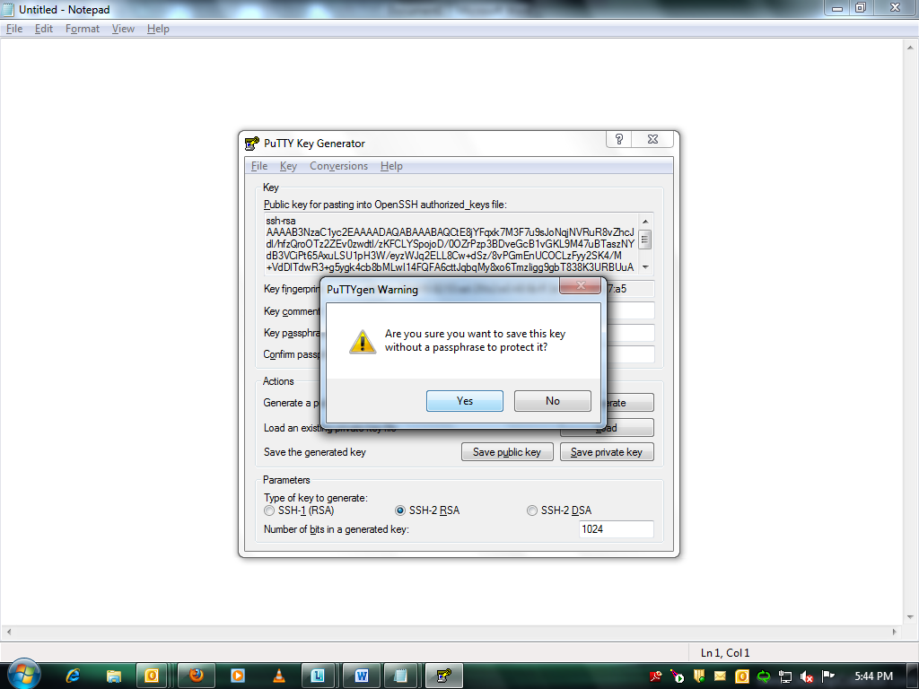
Go to PuTTY Configuration. Give the IP address of EC2 instance. Select SSH and opt for Auth and browse private key ppk file and click open
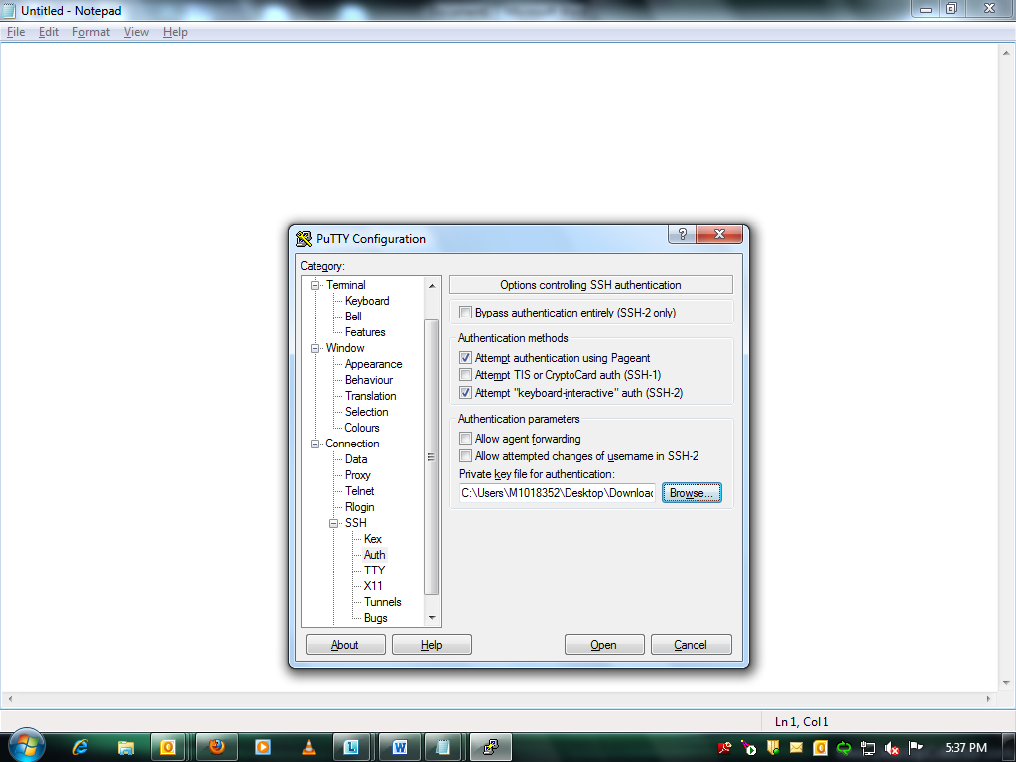
Click yes option for putty Security Alert as shown below and login as ec2-user
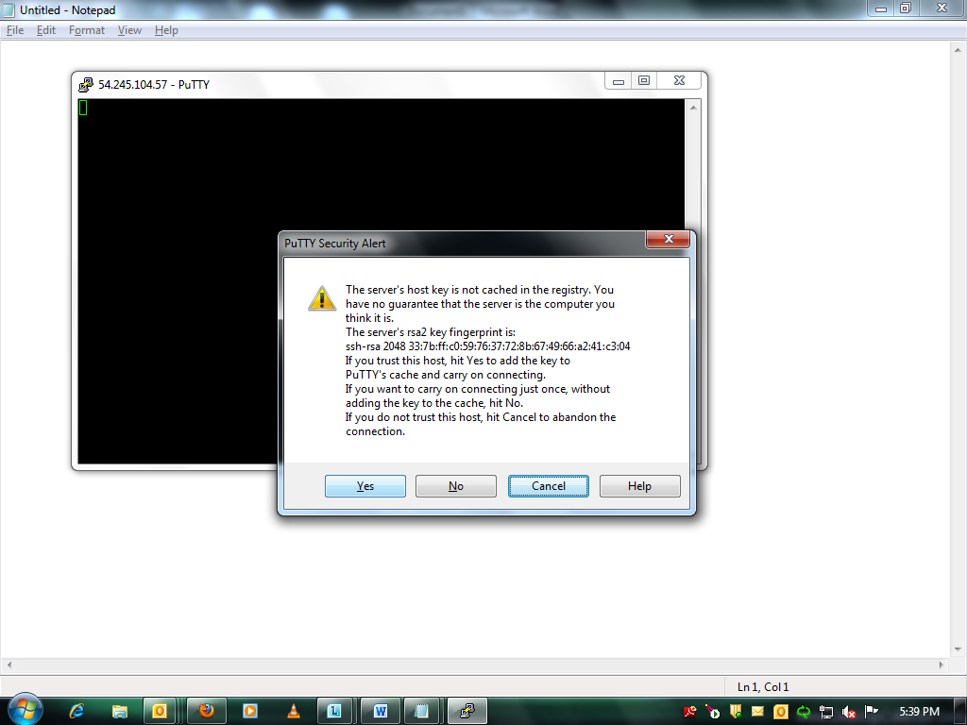

Using java SSH Client
Give the location of pem file and give username as ec2-user. Click Launch SSH Client.
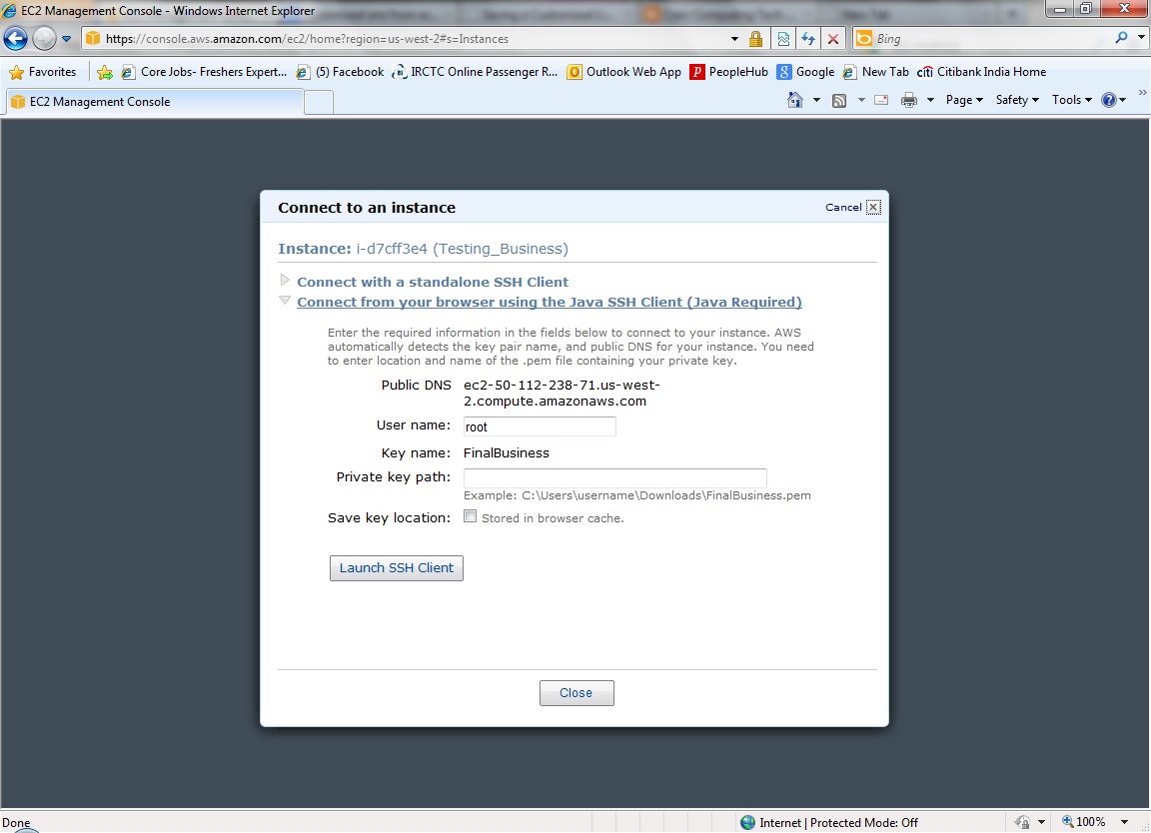

Installing the softwares required via commands.
Example:
The following set of commands illustrates the installation of tomcat6 server and MySQL server in an EC2 Instance.
Java setup
echo ${JAVA_HOME}
sudo yum install java-1.6.0-openjdk-devel ---- install full jdk
Install tomcat6
sudo yum install tomcat6
Edit tomcat-users.xml --
command : sudoedit /etc/tomcat6/tomcat-users.xml
add an entry as follows in tomcat-users.xml
<role rolename="manager"/>
<user username="admin" password="password" roles="manager"/>
Install tomcat manager
sudo yum install tomcat6-webapps tomcat6-docs-webapp tomcat6-admin-webapps
Mysql Setup
update all packages
sudo yum update
Install mysql
sudo yum install mysql
sudo yum install mysql-server
sudo /etc/init.d/mysqld start
mysqladmin -u root password 'welcome123' -- set usr and pswd
sudo chkconfig mysqld on ---- to rum mysql on startup

Creating an AMI from the newly created instance
Right click on the ec2 instance and click on Create Image(EBS AMI)
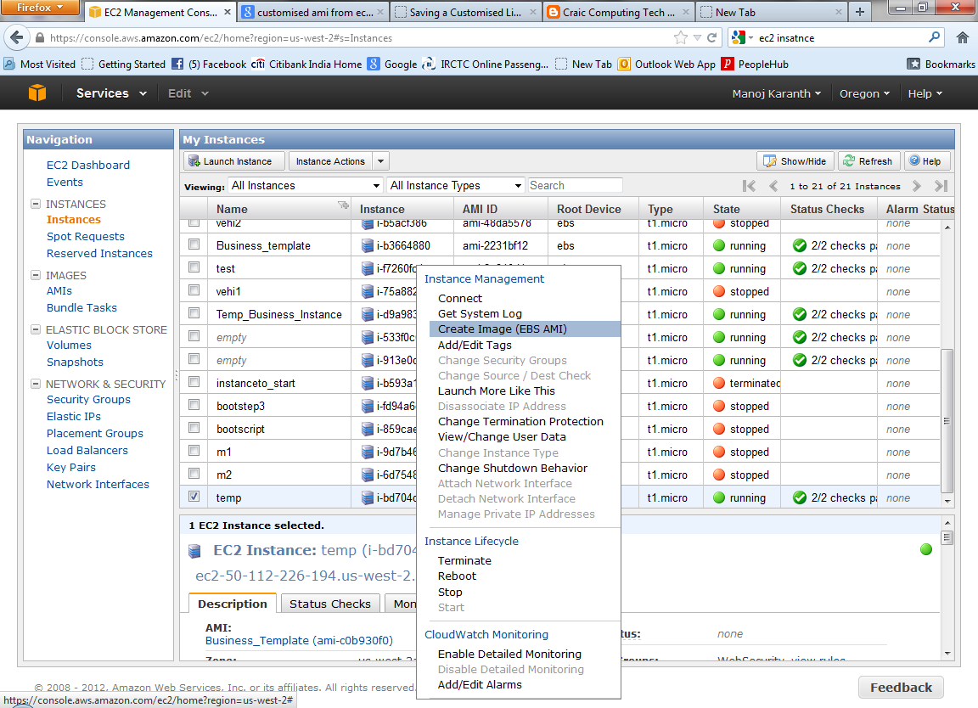
Enter name and description for the AMI and click Yes, Create
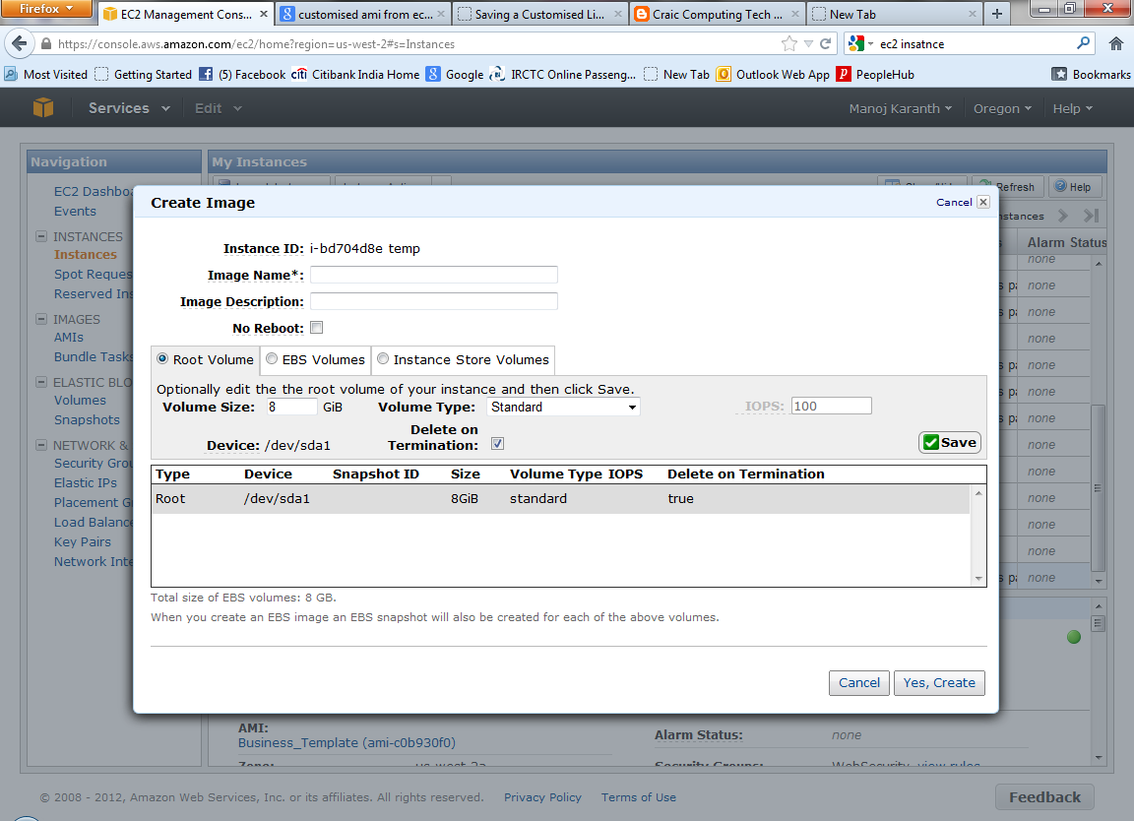
The customized AMI is created and can be chosen to create EC2 instance.

Implementation
We have used the Vehicle Rental Application (refer appendix for details) to deploy it in tomcat server using customized AMI as follows.
Step1: Created an EC2 instance using basic amazon Linux ami.
Step2: Installed the required softwares (tomcat6 server, MySQL server).
Step3: Created an AMI out of it.
Step4: Created new EC2 instance using the customized AMI and deployed the application (war file) by browsing from local system.

Customization of an instance at Launch Time using CloudInit
The challenge with AMI-based deployments is that each time you want to upgrade your softwares or apply security updates to the operating system that will then be applied predictably to all instances; you need to create a new AMI. This quickly leads to needing to define a strategy for managing and maintaining multiple versions of AMIs.To overcome the challenge with AMI based deployment, we can customize an instance at launch time.
CloudInit allows passing instance configuration actions to instances at launch time via the Amazon EC2 user-data fields, enabling remote configuration of Amazon EC2 instances. Both the Ubuntu Linux AMI and the Amazon Linux AMI contain a version of CloudInit enabling you to specify actions that should happen to your instance at boot time. You can pass desired actions through the user data fields when launching an instance. This means you can use a common AMI for many use case and configure them dynamically at startup. From an application bootstrapping perspective, using CloudInit to execute scripts at launch time enables you to download and install software without having to have the applications pre-­installed in the AMI.
User Data means the data specified by the user when launching the instance. This data can be used to build more generic AMIs that can be modified by configuration supplied at launch time. Cloud-init uses the Amazon EC2 UserData field to pass configuration information. If the UserData field starts with #! , the contents of the User Data are assumed to contain a script to execute on startup.
There are a couple of additional things to keep in mind if you chose to use CloudInit. The CloudInit script is passed via the Amazon EC2 user data field. This field has a size limit of 16K bytes. In addition, because CloudInit is script-based, it is non-declarative, making it challenging to audit exactly what is installed.
Note that user data is immutable. Once an instance is launched, you cannot modify it, so you should carefully chose what types of configuration information you want to pass in this way. Rather than pass configuration values directly, you may decide to pass the location of a SimpleDB domain or an Amazon S3 bucket via user data rather than the data itself, allowing you to make changes to the actual data in the data store without having to change the location of the configuration.
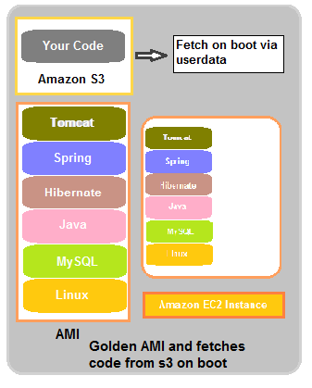
Figure2: Customization of an instance at Launch Time using CloudInit

Example:
The following bash shell script is used to pass as user data for getting a file from Amazon S3 and starting tomcat server in an EC2 instance.
#!/bin/sh
sudo su
cd /root
touch logfile.txt
echo "logfile created" >> logfile.txt
whoami >> /root/logfile.txt
echo "am a user of=$(whoami)" >> logfile.txt
echo "getting file from s3" >> logfile.txt
wget https://s3.amazonaws.com/warbucket444/01vehicleuser30oct.war
echo "copying files from s3 to instance" >> logfile.txt
cp /root/01vehicleuser30oct.war /var/lib/tomcat6/webapps
echo "file got copied" >> logfile.txt
echo "Initializing Environment" >> logfile.txt
CATALINA_HOME=/usr/share/tomcat6
export CATALINA_HOME
echo"Setting EVS Environment: CATALINA_HOME=${CATALINA_HOME}" >> logfile.txt
cd $CATALINA_HOME
echo "starting tomcat service" >> /root/logfile.txt
service tomcat6 start
echo "tomcat started" >> /root/logfile.txt

Steps to create instance by passing User-data script at launch time
- Open AWS Management Console, then open Amazon EC2 console.
- Click on Launch Instance, Click Continue.
- Request Instances Wizard opens, click on MyAMI’s to choose your AMI. Select your customized AMI. Click Continue
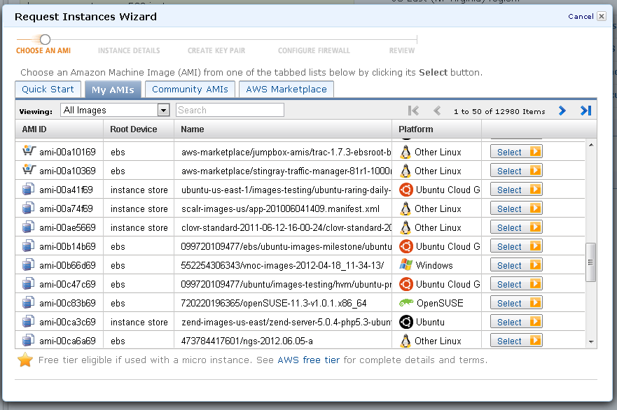
- Add your user data script in the User-data field. Click Continue and proceed with creating instances as specified in above document.
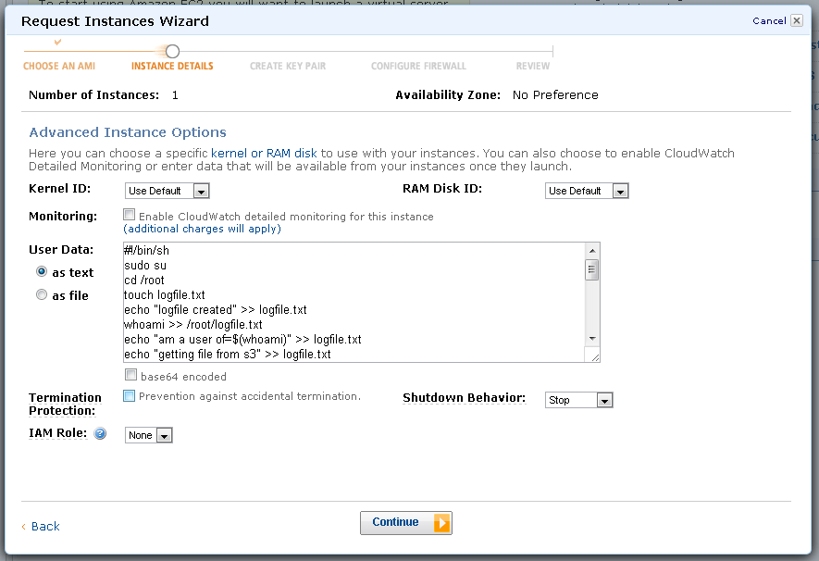
Now you will be able to access your application using url:http://instance-ip:8080/application

Implementation
We have used the Vehicle Rental Application (refer appendix for details) to deploy it in tomcat server using userdata script as follows.
Step1: Created EC2 instance by passing the userdata script.
Userdata includes the script to
- install the softwares (tomcat server, MySQL server )
- fetch application (war file) from remote location (Amazon S3).
- start the tomcat server

AWS CloudFormation
AWS CloudFormation gives you an easy way to create the set of resources such as Amazon EC2 instance, Amazon RDS database instances and Elastic Load Balancers needed to run your application. AWS CloudFormation introduces 2 concepts: Template, a JSON-format, text-based file that describes all the AWS resources you need to deploy to run your application and Stack, the set of AWS resources that are created and managed as a single unit when a template is instantiated by AWS CloudFormation.
A stack will either be created or updated in its entirety or rolled back if it cannot be fully instantiated or modified. During stack creation, for debugging purposes, the rollback operation can be disabled and manually initiated at a later time. You can create, delete and update the stack in a few simple steps as shown in the following block diagram.
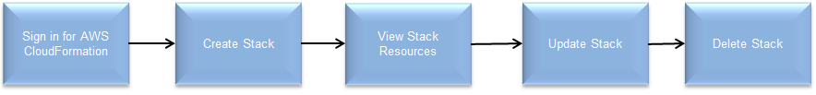

The template describes what resources you need and AWS CloudFormation takes care of how: provisioning the resources in an orderly and predictable fashion, handling and recovering from any failures or issues. You can use AWS CloudFormation’s sample templates or create your own templates to describe the AWS resources, and any associated dependencies or runtime parameters, required to run your application. You don’t need to figure out the order in which AWS services need to be provisioned or the subtleties of how to make those dependencies work. CloudFormation takes care of this for you. Once deployed, you can modify and update the AWS resources in a controlled and predictable way allowing you to version control your AWS infrastructure in the same way as you version control your software.
AWS CloudFormation allows you to define the set of packages, files and operating system services through metadata in a template. In addition, AWS CloudFormation provides helper functions to interpret the metadata and act on it, installing packages, creating files and starting or restarting services on the instance.
The AWS CloudFormation scripts build on the basic CloudInit functionality and enable you to create a common, simple CloudInit startup script that is data-­-driven through metadata. You Bootstrapping Applications via AWS CloudFormation 3 describing what needs to be installed on the host in metadata and AWS CloudFormation takes care of the how.
CloudFormation is available at no additional charge, and you pay only for the AWS resources needed to run your applications.
In the template, you can declare six main objects: the template's format version, its description, and the parameters, mappings, resources, and outputs .you need to create your stack. The format version, descriptions, parameters, mappings and outputs are optional. You only need to declare one resource.
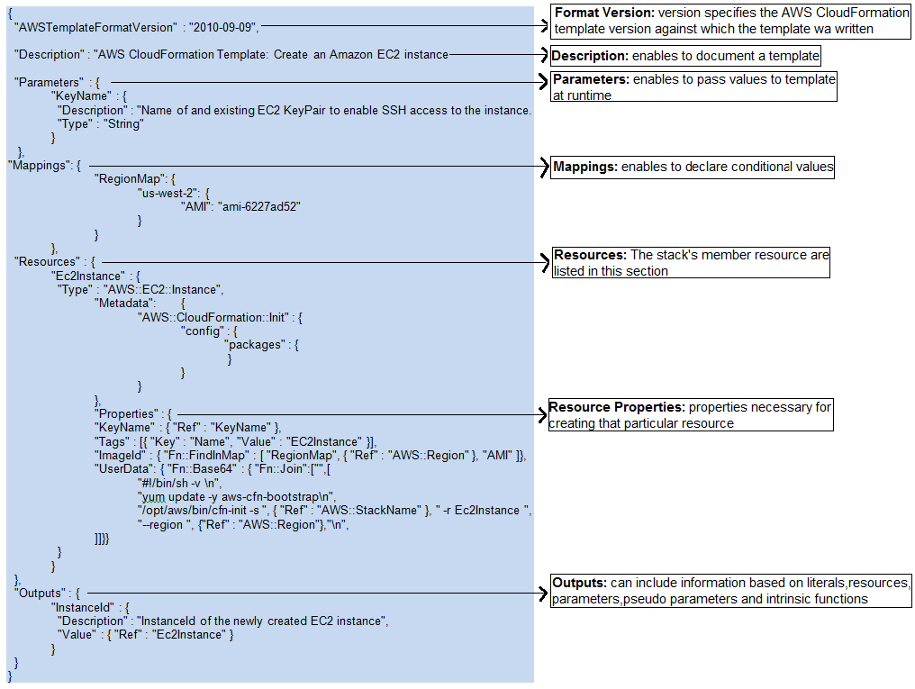

Figure4: Sample Template
The following figure shows the whole infrastructure set up once the creation of stack is completed.
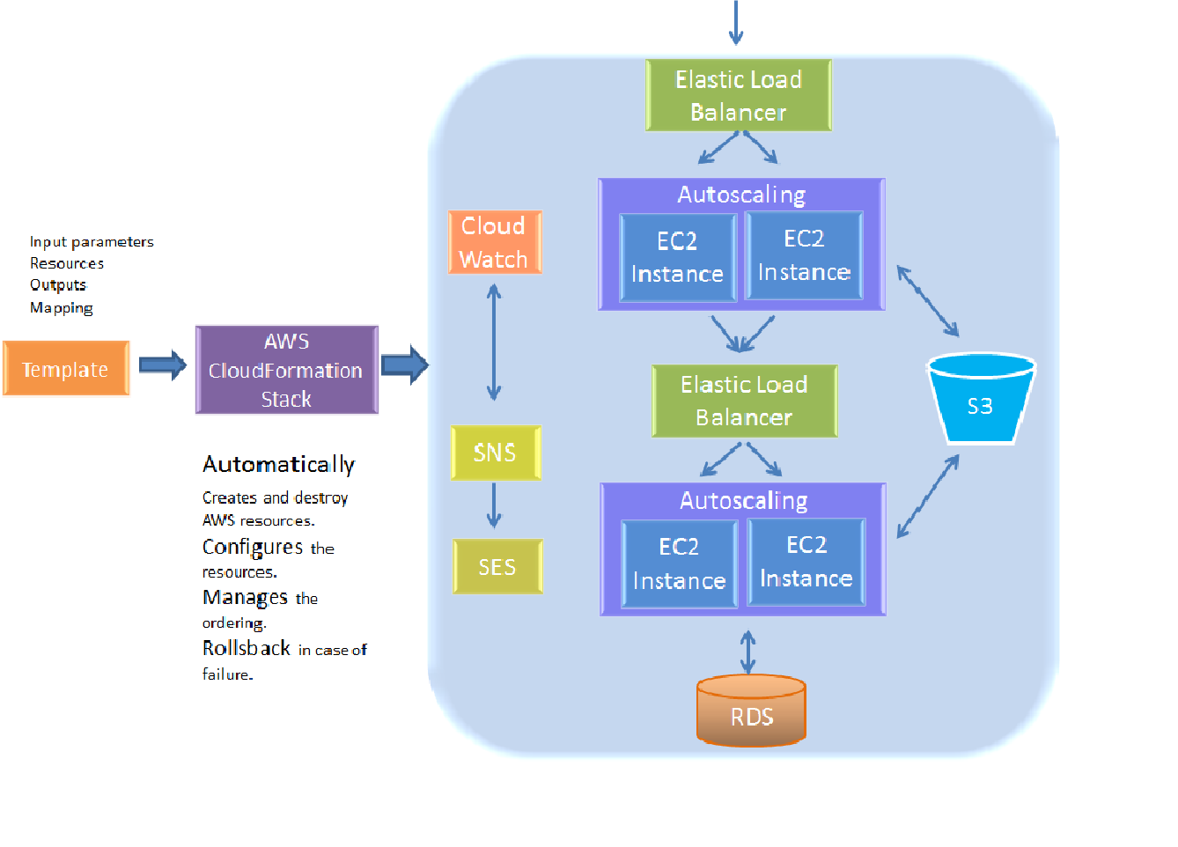
Figure 4: Environment setup using CloudFormation

You can deploy and update a template and its associated collection of resources (called a stack) via the AWS Management Console, CloudFormation command line tools or APIs.

Using AWS Management Console
- Sign up for the service
- Pick a template
- Create the stack

Sign up for the service
Signing up for AWS CloudFormation also automatically signs you up for other AWS products you need, such as Amazon Elastic Compute Cloud, Amazon Relational Database Service and Amazon Simple Notification Service.
To sign up for AWS CloudFormation
Go to http://aws.amazon.com/cloudformation, and then click Sign Up for AWS CloudFormation.
Follow the on-screen instructions.
If you don't already have an AWS account, you'll be prompted to create one when you sign up for AWS CloudFormation.
Part of the sign-up procedure involves receiving a phone call and entering a PIN using the phone keypad.

Pick a template
Next, you'll need a template that specifies the resources you want in your stack.
Make sure you have prepared any required items for the stack.
Before you create a stack from a template, you must ensure that all dependent resources that the template requires are available. A template can use or refer to both existing AWS resources and resources declared in the template itself. AWS CloudFormation takes care of checking references to resources in the template and also checks references to existing resources to ensure that they exist in the region where you are creating the stack. If your template refers to a dependent resource that does not exist, stack creation will fail.
Make sure you have a valid EC2 key pair, and make note of the Key Pair Name, before you create the stack.

Create the stack
To create the stack
- Sign in to the AWS Management Console and open the AWS CloudFormation console at https://console.aws.amazon.com/cloudformation/.
- Click Create New Stack.
- In the Stack Name box, type a stack name. For this example, use TestTemplate. The stack name must not contain spaces.
- Click Upload template file. Browse the template from your local machine and then click Continue:
You can also use sample templates available in http://aws.amazon.com/cloudformation/aws-cloudformation-templates/ . You can also provide url of template stored in remote location
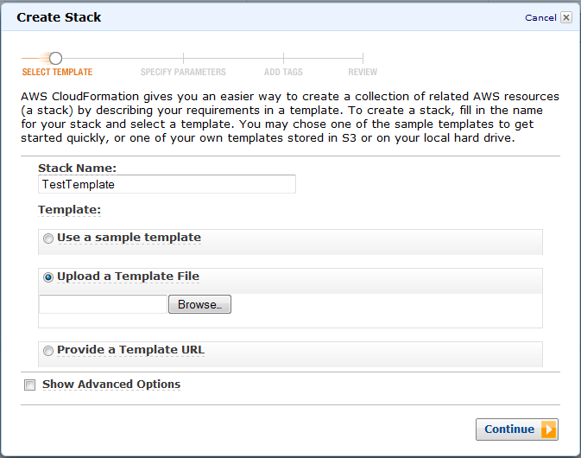

- In specify Parameters page
Specify the parameter if any as follows and click Continue
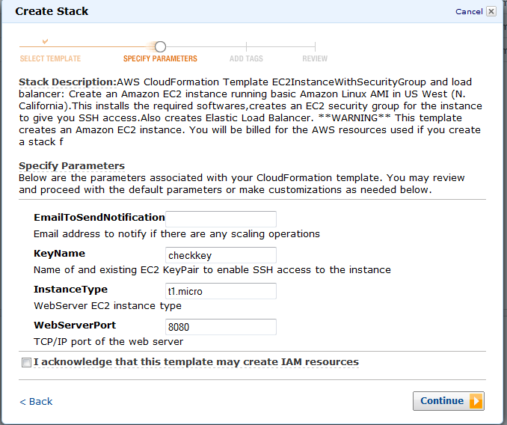
- Monitor the progress of stack creation
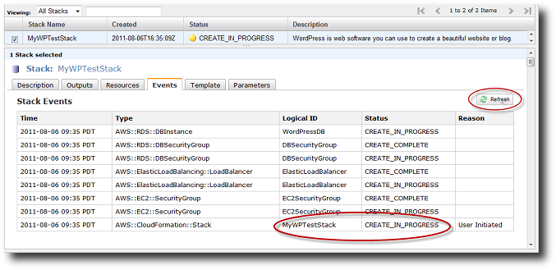

- When AWS CloudFormation has successfully created the stack, you will see the following event at the top of the Events tab:
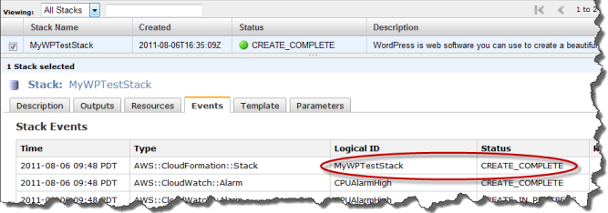
- To view the resources for a stack
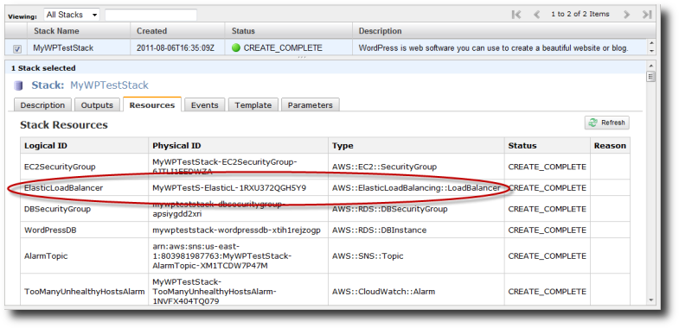

Using AWS CloudFormation Command Line Interface (CLI)
The AWS CloudFormation CLI provides you with a way to interact with your AWS CloudFormation stacks from your system's command-line interface. The following are the steps to configure CLI tools for Windows

Configuring the CloudFormation CLI Tools for Windows
Step1:
Prior to installing the AWS CloudFormation command line tools, you will need to install Java. To install Java go to http://www.java.com and follow the download and installation instructions. You will need Java 1.5 or later. Once you have Java installed, to figure out which version of Java you have go to a command prompt and type
java-version
Step2:
Download the AWS CloudFormation tools and save the AWSCloudFormation-cli.zip file on your local disk
http://aws.amazon.com/developertools/AWS-CloudFormation/2555753788650372
Step3:
Once it is downloaded, double click on the AWSCloudFormation-cli.zip file and it will open up to show you a folder named AWSCloudFormation-1.0.6
Step4:
Drag and drop that folder somewhere on your hard disk – let’s say your home directory C:\Users\Chris\AWSCloudFormaton-1.0.6
This is where AWS_CLOUDFORMATION_HOME will point to shortly.
Step5:
In a location of your choice, create a new file with your AWS credentials using notepad. The file has the following 2 line format:
AWSAccessKeyId=<Your access key Id>
AWSSecretKey=<Your secret key>
Step6:
In the Environmental Variables dialog box
For variable name type AWS_CLOUDFORMATION_HOME.
For variable value type in the location of the AWSCloudFormation-1.0.6 directory.
(C:\Program Files\Java\jdk1.6.0_25)
For variable name type AWS_CREDENTIAL_FILE
For Variable value type in the location of the credential file you created previously
Now scroll through you environment variables and find the one called "Path". Click on it and click "Edit"
(Note... this should be your account's Path variable NOT the system Path variable)
GO to the end of the current variable value and add the following:
;%AWS_CLOUDFORMATION_HOME%\bin
Note, if you don't have a Path variable, create a new one by clicking on "New..."
In the variable name type Path.
In the variable value type %AWS_CLOUDFORMATION_HOME%\bin
To check you variables are set as expected, at the command prompt type the command:
Set
This will list all your environment variables. You should see AWS_CLOUDFORMATION_HOME, AWS_CREDENTIAL_FILE, JAVA_HOME set up and you should see the AWS CloudFormation bin directory in you Path environment variable.
Step7:
Once this is done try typing
cfn-version
you should see
AWS CloudFormation CLI version 1.0.6 (API 2010-05-15)

cfn commands (cfn-cmd)

Command Name Description
------------ -----------
cfn-cancel-update-stack Cancel a stack update.
cfn-create-stack Create a new stack.
cfn-delete-stack Delete a stack.
cfn-describe-stack-events Describe events for one or more stacks.
cfn-describe-stack-resource Describe a particular resource of a stack.
cfn-describe-stack-resources Describe the resources for a stack.
cfn-describe-stacks Return information about one or more stacks.
cfn-get-template Get the template used to create a stack.
cfn-list-stack-resources Return information about a stack's resources.
cfn-list-stacks Return information about stacks.
cfn-update-stack Update a stack.
cfn-validate-template Validate a template and parameters
help
version Prints the version of the CLI tool and the API.
For help on a specific command, type '<command-name> --help'
Refer
http://docs.aws.amazon.com/AWSCloudFormation/latest/UserGuide/cfn-installing-cli.html to
Configure CloudFormation command line interface for Linux

Using AWS CloudFormation API
Amazon Web Services introduced a new CloudFormation editor that simplifies the authoring of CloudFormation templates. The editor is part of the AWS Toolkit for Visual Studio and the AWS Toolkit for Eclipse. AWS CloudFormation allows you to easily create and update a collection of AWS resources through templates. These templates are JSON formatted text files that define all of the AWS resources required by your application.
The CloudFormation template editor understands the template format and provides intelligent assistance as you're editing. You can use code completion with inline descriptions to quickly find and insert definition blocks for different AWS resources. Then you simply configure your specific details into the placeholders. The editor will also validate your template as you make changes to identify any problems in the file. Once you define your templates, you can use them to create and update your stack of AWS resources right from within Visual Studio and Eclipse, This documentation explains about AWS Toolkit for Eclipse.
The AWS Toolkit For Eclipse:
The AWS Toolkit for Eclipse is an open source plug-in for the Eclipse Java integrated development environment (IDE) that makes it easier for developers to develop, debug, and deploy Java applications that use Amazon Web Services. Some of the features of the AWS Toolkit for Eclipse that enhance the development experience are:
- AWS Explorer
- Amazon Elastic Compute Cloud (Amazon EC2)
- AWS DynamoDB
- AWS Elastic Beanstalk
- AWS SDK for Java integration
The AWS Toolkit for Eclipse now includes a built-in AWS CloudFormation template editor. Among the features supported:
- The ability to create and update stacks directly from the Eclipse IDE from the currently-edited template.
- A JSON validator to help ensure that your template complies with JSON formatting and content rules.

Setting Up the AWS Toolkit for Eclipse
This section describes you regarding the installation and configuration of AWS Toolkit for Eclipse.
Prerequisites:
The AWS Toolkit for Eclipse has the following prerequisites.
- Amazon Web Services account. To obtain an AWS account, go to the AWS home page and click the Sign Up Now button. This sign-up will enable you to use all the services offered by AWS.
- Supported operating system: Linux, Apple MacOS X, or Microsoft Windows.
- Java 1.5 or a later version.
- Eclipse IDE for Java Developers 3.6 or a later version. We recommend Eclipse IDE for Java EE Developers 3.7 ("Indigo").
Installation:
To install the AWS Toolkit for Eclipse from the AWS website using the Eclipse user interface
- Click Help, and then click Install New Software.
- In the Work with box, type http://aws.amazon.com/eclipse. Press Enter.
- In the list that appears, click AWS Toolkit for Eclipse.

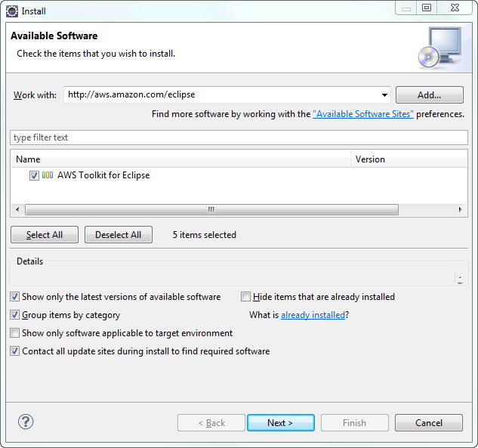
- Click Next, and the Eclipse wizard guides you through the remaining installation steps.
Credentials:
Configure Your Credentials
In order to access AWS through the AWS Toolkit for Eclipse, you must configure the AWS Toolkit with your AWS credentials. Your credentials are issued to you when you sign-up for AWS and are stored securely with your AWS account. In addition to enabling the AWS Toolkit to access your account, your credentials are used to sign programmatic web services requests to AWS. Signing web services requests ensures that only authorized programs can make such requests. Also, by associating credentials with each web services request, AWS is able to track service usage for billing purposes.
- Click the AWS icon from the toolbar, and then click Preferences. The Preferences (Filtered) dialog box appears.
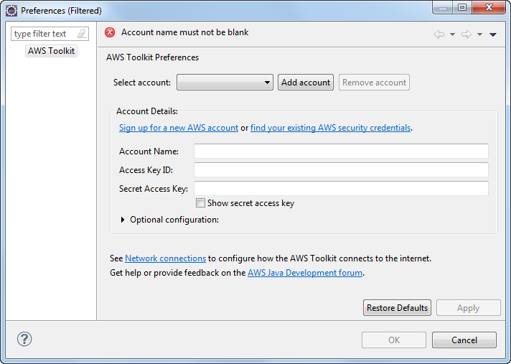
- Enter a unique Account Name, such as the email address associated with your AWS account, and then enter values for Access Key ID and Secret Access Key. If you don't yet have an AWS account, click Sign up for a new AWS account. If you have an account and just need to retrieve your credentials, click find your existing AWS security credentials.
- Click Apply, and then click OK.
The following is the list of actions supported by CloudFormation API
- CancelUpdateStack
- CreateStack
- DeleteStack
- DescribeStackEvents
- DescribeStackResource
- DescribeStackResources
- DescribeStacks
- EstimateTemplateCost
- GetTemplate
- ListStackResources
- ListStacks
- UpdateStack
- ValidateTemplate
Refer the below link for more details on APIs.
http://awsdocs.s3.amazonaws.com/AWSCloudFormation/2010-05-15/cfn-apiref-2010-05-15.pdf

Deploying an AWS CloudFormation Template in Eclipse
Note
At this time, only files that end in .template can be launched from the Eclipse IDE. If your file ends with another extension, such as .json, you will need to rename it first with a .template extension to use this feature.
To deploy an AWS CloudFormation template from Eclipse
- With your AWS CloudFormation .template file open in the AWS CloudFormation template editor (see Adding and Accessing Templates for more information), right-click on the open template and select Run on AWS, then Create Stack on the context menu.
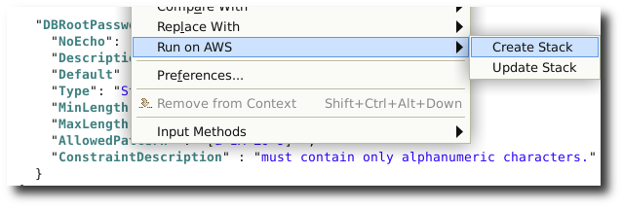
- In the Create New CloudFormation Stack dialog, enter your stack name in the Stack Name field. Your template file should be automatically chosen in the Template File field.
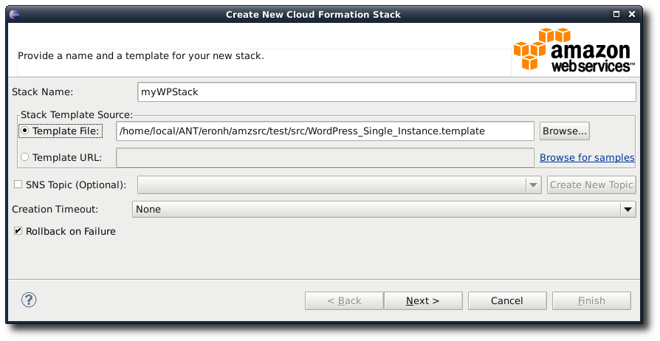

- Choose any (or none) of the following options:
  - SNS Topic – choose an existing SNS topic from the list to receive notifications about the stack's progress, or create a new one by typing an email address in the box and clicking Create New Topic.
  - Creation Timeout – choose how long AWS CloudFormation should allow for the stack to be created before it is declared failed (and rolled back, unless the Rollback on failure option is unchecked.
  - Rollback on failure – if you want the stack to rollback (delete itself) on failure, check this option. Leave it unchecked if you would like the stack to remain active, for debugging purposes, even if it has failed to complete launching.
- Click Next to continue with entering parameter values.
- If your stack has parameters, you will enter values for them next. For parameters with a predefined list of possible responses, you can choose a value from the list provided.
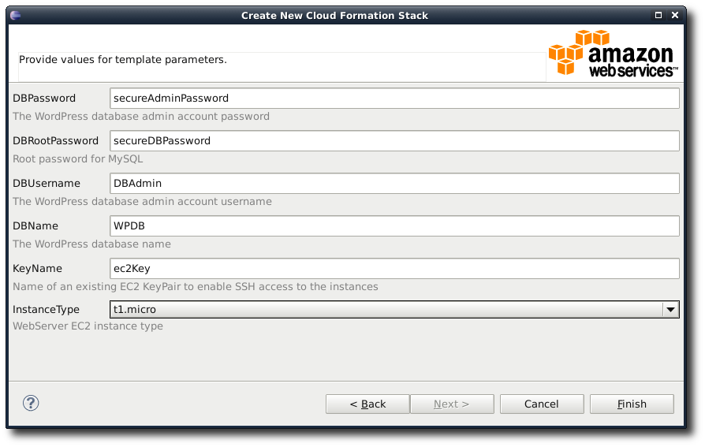
- Click Finish to begin launching your stack.
While your stack is being launched, you can view its status by double-clicking the stack name beneath the AWS CloudFormation node in the AWS Explorer view, or by right-clicking the stack name and selecting Open in Stack Editor on the context menu.
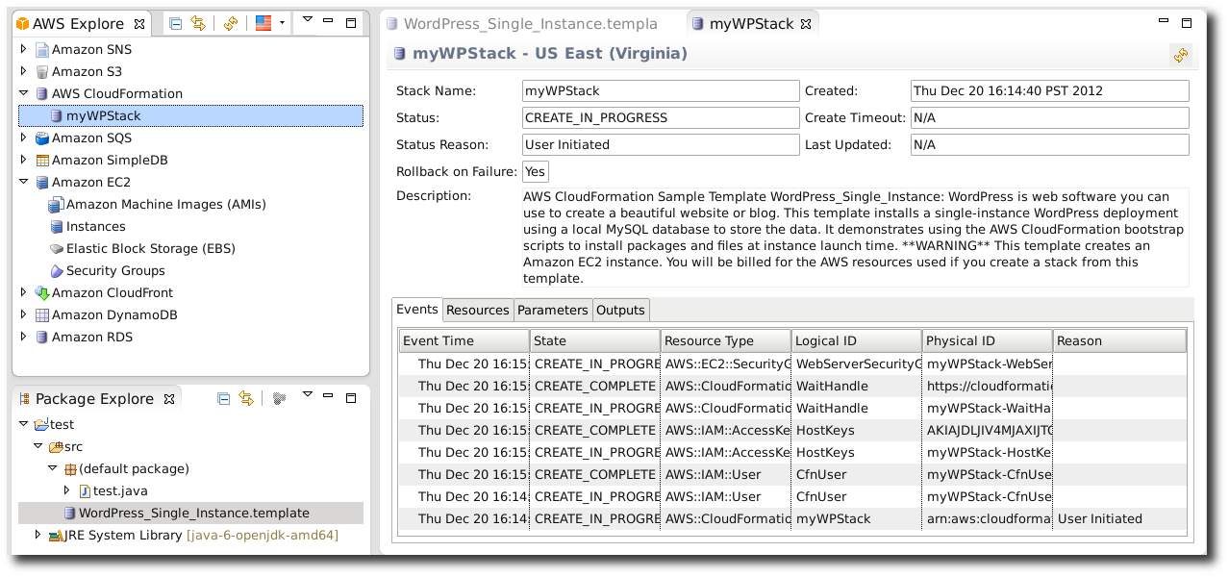
Note
If you cannot see the stack you launched in AWS Explorer, you may need to manually refresh the view by clicking the Refresh AWS Explorer icon at the top of the AWS Explorer view.
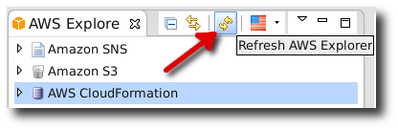
Refer the below link for details of updating, managing and validating template through aws Toolkit for Eclipse
http://docs.aws.amazon.com/AWSToolkitEclipse/latest/GettingStartedGuide/tke-cfn-editor.html

Implementation
Services integrated with CloudFormation for deployment of VehicleRental Application.
- EC2 INSTANCE
- LOAD BALANCER
- AUTO SCALING
- SNS TOPIC
- RDS
- CLOUD WATCH
- CLOUDFRONT
Step 1: Created the templates integrating all the services.
We used three templates namely Presentation.template, Business.template and Memcached.template for Presentation service, Business service and session management respectively. We have integrated Business.template and Memcahed.template inside the Presentation.template using the Template composition concept.
Step2: Created the stack with the Presentation.template using above mentioned methods. Presentation.template in turn called the other two templates and set up the whole environment for Vehicle Rental Application.
We had stored the templates and the application war files in the Amazon S3.
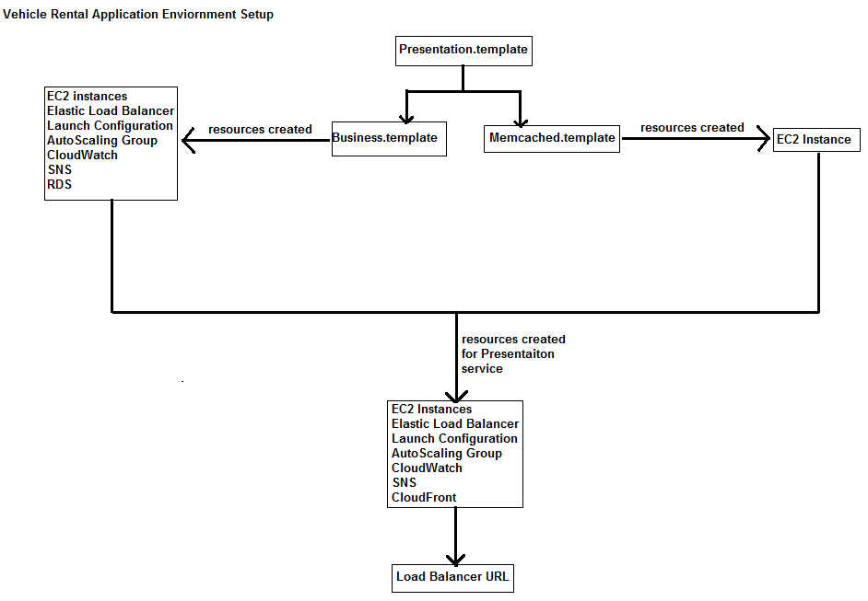

Puppet
Puppet in IT automation software that makes it easy for systems administrators to provision, configure, and manage infrastructure throughout its lifecycle. It helps minimize configuration drift, non-compliance and increases productivity and responsiveness. In short Puppet is configuration management software.

What is Configuration Management?
Configuration management is the process of standardizing resource configurations and enforcing their state across IT infrastructure in an automated yet agile manner. Configuration management is critical to the success of other IT processes, including provisioning, change management, release management, patch management, compliance and security.

How Puppet manages server configuration?

The Big Picture
Server configuration with Puppet follows client-server architecture. The nodes which are to be managed are called puppet agent and the node that manages all other nodes is called puppet master. The agent nodes are configured to be reachable to the master on port 8140 and vice-versa, and each agent node must be identifiable by unique host name. Communication between agent and master occurs over SSL, with certificate of each node being signed by the Certificate Authority – in this case CA being the Puppet server – OR the CA server generates signed certificates for each of the agent and the certificate is manually moved to respective machines. One of the most important requirements is that all the systems including the master must have synchronized clocks or else authentication via SSL would fail.
In master the configuration of a server is defined by various modules and/or manifests which result into a catalog after compilation on master. This catalog states the desired state of the machine and agent decides how to reach from the state it is in to the given state.
Puppet’s agent/master mode is pull-based. Usually, agents are configured to periodically fetch a catalog and apply it, and the master controls what goes into that catalog. Upon application of the catalog, the agent gets to the desired state. The following image (is a .gif image and opens in external program) describes how the pull model works and a system takes itself to a desired state.
Attachment 4.1

Puppet Resource Types, RAL and Catalog generation

Puppet Resource
Every system has configurations and let them be called a collection of molecules: In puppet they are called “resources” and each of them is of different types. There are many resource types that puppet defines and can manage, the most important of them being as follows (from cheat sheet) – in no particular order.
Attachment 4.2
- file: manages files and could also manage its content if they are text files..
- package: responsible for managing packages in *nix operating systems.
- service: manages service on a system, it state – running, stopped, enabled or disabled.
- notify: sends an arbitrary message to the agent run-time log.
- exec: executes an arbitrary command on the agent node.
- cron: manages cron job on agent
- user: manages user accounts; mostly used for system users.
- group: manages groups.
Example of resource in puppet’s language (Puppet’s DSL):
file{'mysql-connector':
path => '/var/lib/tomcat7/lib/mysql-connector-java-5.1.24.jar',
ensure => file,
source => 'puppet:///modules/vehiclerentalbusiness/context.xml',
}
Listing 4.1: Example of puppet’s resource.
In above example we have several attributes:
title: mysql-connector, is the title of the resource, by default in a file resource type, it is also the absolute path of the file, instead of specifying the file path in path, we could give it in the title itself.
path: this is the location where the file should be placed and also determines the name of file on agent, it not present defaults to the title of file resource.
ensure: this could be either file or directory, since here it should be a file and not a directory, we have mentioned file.
source: this is where from the file should be downloaded by nodes that are being managed by Puppet.
There are several other attributes besides what’s given in the example and details can be found at http://docs.puppetlabs.com/references/latest/type.html

The RAL
The various resource types are usually conceptually identical across operating systems, regardless of how the implementations differ. Puppet abstracts the description of a resource from its implementation. These two insights form Puppet’s resource abstraction layer (RAL). The RAL splits resources into types (high-level models) and providers (platform-specific implementations), and lets us describe resources in a way that can apply to any system.
Puppet uses the RAL to both read and modify the state of a resource on a system. Since it’s a declarative system, Puppet starts with an understanding of what state a resource should have. To sync the resource, it uses the RAL to query the current state, compares that against the desired state, then used the RAL again to make any necessary changes.

Puppet manifest and module
Manifests are written using Puppet’s declarative language; the file ends with an extension of "pp". These manifests get compiled to form a catalog which is used by agents to reach to a desired state using RAL.
Example of a Manifest: Suppose we need a jdbc properties file for database connection. We will put the content in a file db_conn.properties in directory /root/properties directory.
What we need?
- The directory /root/properties directory exists.
- The file is present in the directory.
- The content is specified.
file{'db_properties':
path => '/root/db_conn.properties',
ensure => file,
content => "username: db_manager
password: S#CR#TPASSW0RD
driver: com.mysql.jdbc.Driver
url: jdbc:mysql://114.125.35.67:3306
database: sakila
",
}
file{'properties_directory':
path => '/root/properties',
ensure => directory,
}
File['properties_directory'] -> File['db_properties']
Listing 4.2: Creating a manifest in puppet’s declarative DSL.
In the above listing, we have created a manifest file with two resources, one of them is a directory and other is a file within that directory. But what was also required that directory is created before the file is placed in the directory. Hence the last line
File['properties_directory'] -> File['db_properties']
It describes the flow, and ensures that resource titled properties_directory is created first before db_properties resource is created. This dependency can also be specified within resource, as before or requires, in that case we would have the following listing.
file{'db_properties':
path => '/root/db_conn.properties',
ensure => file,
content => "username: db_manager
password: S#CR#TPASSW0RD
driver: com.mysql.jdbc.Driver
url: jdbc:mysql://114.125.35.67:3306
database: sakila
",
requires => File['properties_directory’],
}
file{'properties_directory':
path => '/root/properties',
ensure => directory,
}
Listing 4.3: Using requires to order resource. Since db_properties has dependency on properties_directory hence requires goes in db_properties resourfce.
The same be done specifying before => File['db_properties'], in properties_directory resource. A puppet module is made of one or more manifests like above and has a defined directory structure as described at http://docs.puppetlabs.com/module_cheat_sheet.pdf (embedded below).
Attachment 4.3

Catalog generation.
The following figure describes how manifest is compiled and applied.

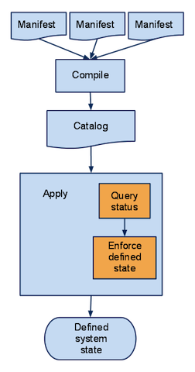
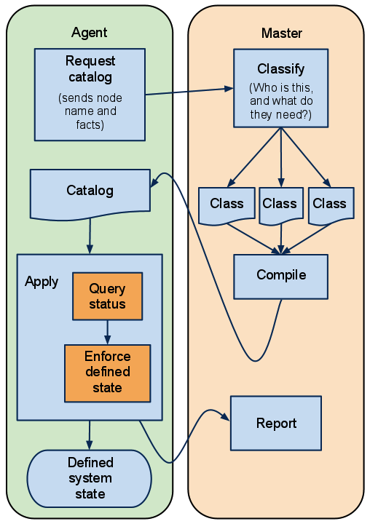
Fig 4.2: Puppet agent configuration in Server/Client model.
Fig 4.1: Compilation and application of manifest by puppet.
Agents don’t have to see any manifest files at all, and have no access to configuration information that isn’t in their own catalog.
Question: What are facts in Fig 4.2 ?
Answer: They are key pair values that describe several attributes of a system like RAM, Processor, security groups, uptime, etc and are generated by facter. The facts are generated by the facter program. Following is a fragment of the facts.

Managing servers in EC2 with Puppet.
Puppet can be used to manage servers on EC2 just as well as it can manage servers in private network. What is required that master and agent both are in EC2 so that the clocks are in sync, when the certificates are generated.
Using puppet as it is, we cannot start any instance and install puppet on it and then manage its configuration. However, with combination of other tools such as Amazon’s EC2 command line tool coupled with some scripts OR with puppet’s cloud formation plugin, we can start an instance and manage it. However when the need is to manage configuration of auto scaling applications where scaling is horizontal – the number of nodes increased or decreases automatically, we need few more things.
- Sign the incoming certificates automatically after verification – Having manual signing of certificates is not going to scale, since that requires constant monitoring of incoming certificate requests and verifying and signing them is going to be difficult.
- Classification of nodes based on roles they play – Since many nodes with similar host names are going to have different roles we need some other mechanism of node classification.

Master-Agent setup in EC2.
In this section we describe installing puppet master on an EC2 instance and managing an agent which would also be an EC2 instance. This discusses installing and configuring on machine with Amazon OS. The procedure could vary but not by lot and can be adapted to a different system easily.
- Start an EC2 instance from the web console and log into it using SSH (described in the document BootstrappingCloudFormation.docx)
- Install puppetlabs repository if it the OS is RHEL derivative – with Ubuntu and Amazon AMI puppet and related packages are already available (the repository is not available, just the packages)
For Enterprise Linux 5:
$ sudo rpm -ivh http://yum.puppetlabs.com/el/5/products/i386/puppetlabs-release-5-7.noarch.rpm
Listing 5.1

For Enterprise Linux 6:
$ sudo rpm -ivh http://yum.puppetlabs.com/el/6/products/i386/puppetlabs-release-6-7.noarch.rpm
Listing 5.2
Please refer to the website document at http://docs.puppetlabs.com/guides/puppetlabs_package_repositories.html for installing the repositories for other Operating Systems.
- Install puppet server
$ yum install puppet-server puppet
Listing 5.3 Installing puppet-server and puppet.
Note: Here we are installing puppet and puppet-server (the master) on the same server. Installing puppet is not required. This also installs other packages and one of them is facter which is used to report various facts about the system such as RAM, Uptime, EC2 security groups etc. Before starting the puppetmaster service, generate a certificate for the master. By default, the certificate name is the Fully Qualified Domain Name (FQDN) of the machine but that may not be sufficient as the host name is not essentially a name that is publicly reachable. We would need to edit /etc/hosts file of every machine – not too difficult but still adds a step.
We use the following to generate certificate for the master
puppet cert generate 'facter fqdn' --dns_alt_names='facter ec2_public_hostname'
Listing 5.4 Generating certificate for master
- Puppet would be installed and a directory /etc/puppet/ should exist now if installation is successful. Now modify puppet.conf
[main]
# The Puppet log directory.
# The default value is '$vardir/log'.
logdir = /var/log/puppet

# Where Puppet PID files are kept.
# The default value is '$vardir/run'.
rundir = /var/run/puppet

# Where SSL certificates are kept.
# The default value is '$confdir/ssl'.
ssldir = $vardir/ssl

[agent]
# The file in which puppetd stores a list of the classes
# associated with the retrieved configuratiion. Can be loaded in
# the separate ``puppet`` executable using the ``--loadclasses``
# option.
# The default value is '$confdir/classes.txt'.
classfile = $vardir/classes.txt
report=true
# Where puppetd caches the local configuration. An
# extension indicating the cache format is added automatically.
# The default value is '$confdir/localconfig'.
localconfig = $vardir/localconfig
server = ec2-54-214-124-125.us-west-2.compute.amazonaws.com
[master]
node_terminus=exec
external_nodes=/var/lib/enc/ec2_enc.rb
reports=http
Listing 5.5 puppet.conf example

Since we have installed puppet on our machine where puppet-master is installed we can choose to keep the block [agent] or remove it altogether, if we don’t want it to be managed via puppet.
Now we can start puppetmaster.
service puppetmaster start
Listing 5.6 Starting puppet master

In the above configuraton, under [master] block, there are node_terminus and external_nodes configuration. There are to describe the external node classifier, which we get onto later. If these are not present, then puppet looks for the file /etc/puppet/manifests/site.pp where the configurations are described for each node. Example of such a definition is below.
#/etc/puppet/site.pp
node default {
include clients
}

node 'ip-10-212-81-154.us-west-2.compute.internal'{
include tomcat7
include clients
}
Listing 5.7 Example of a site.pp configuration.

In the above listing, all the nodes are identified by their fully qualified domain name (fqdn) and the classes to be included within curly braces – can also mention arguments for parameterized classes. However such a setup is not feasible when the fqdn is assigned dynamically – hence an external program (called an External Node Classifier - ENC) is delegated the job to classify the nodes. In our case the node is classified by reading the fqdn of a node and querying AWS API for the security group associated with it. With each security group we have a different set of configuration which is applied. We discuss about ENC a little later in detail.
- Write a module for the agent – just for example we have a module tomcat7, which installs tomcat7 on the machine. All modules have a specific directory structure which is required to be followed (already discussed in section 4.2.2.3). The tomcat7 module goes below.
class tomcat7{
package{'tomcat7':
ensure => installed,
}
package{'tomcat7-admin-webapps':
ensure => installed,
}
package{'tomcat7-docs-webapp':
ensure => installed,
}
service{'tomcat7':
ensure => running,
enable => true,
}
Package['tomcat7'] -> Package['tomcat7-admin-webapps'] ->Package['tomcat7-docs-webapp'] -> Service['tomcat7']
Listing 5.8 Tomcat7 module.
Including tomcat7 would install package tomcat7 from repository and other associated packages and get it running.
- Prepare agents: We can launch instances and prepare our agents with configurations to talk to puppetmaster, by using console, login into each via ssh and then, prepare the puppet.conf file. But that would be time consuming. Hence we use already provided ec2 command line tools for this job. In Amazon AMI, the tools comes pre-installed, with others we need to download a zip file, unzip it and do some configuration - details available at http://aws.amazon.com/developertools/351 . Once configured, we can use commands from our machine to bring up an instance. Example below:
ec2-run-instances ami-6227ad52 -k Default_Key -n 1 --user-data-file puppet.sh -g tomcat7 -t t1.micro -z us-west-2a
Listing 5.9 Starting an instance from console.

Here, we have passed arguments.
-k The private key name to login in via ssl.
-n The number of instances to launch.
--user-data-file The user data file to be passed along with boot, can also be specified as –f.
-g The EC2 security group to be associated with the instance.
-t The instance type
-z The availability zone of the instance.
Content of user data file in our case is:
#!/bin/bash
yum update -y
yum install puppet -y
rpm -ivh http://yum.puppetlabs.com/el/6/products/i386/puppetlabs-release-6-7.noarch.rpm
(cat <<"END"
[main]
# The Puppet log directory.
# The default value is '$vardir/log'.
logdir = /var/log/puppet

# Where Puppet PID files are kept.
# The default value is '$vardir/run'.
rundir = /var/run/puppet

# Where SSL certificates are kept.
# The default value is '$confdir/ssl'.
ssldir = $vardir/ssl
factpath = $vardir/lib/facter
templatedir = $confdir/templates
runinterval = 300

[agent]
# The file in which puppetd stores a list of the classes
# associated with the retrieved configuratiion. Can be loaded in
# the separate ``puppet`` executable using the ``--loadclasses``
# option.
# The default value is '$confdir/classes.txt'.
classfile = $vardir/classes.txt
server = ec2-54-214-124-125.us-west-2.compute.amazonaws.com
# Where puppetd caches the local configuration. An
# extension indicating the cache format is added automatically.
# The default value is '$confdir/localconfig'.
localconfig = $vardir/localconfig
# Set the reporting on client to true
report = true
END
) > /etc/puppet/puppet.conf
service puppet start
Listing 5.10: puppet.sh file – file to be passed to ec2-run-instances command.

The above configures the agent to communicate to our master by creating a file puppet.conf in /etc/puppet/ directory. The configuration in [agent] block, server=ec2** specifies where to send the requests and receive configuration from.

Doing it via ec2-run-instances is not mandatory, what is required is that agent’s puppet.conf must have entries so that it can identify and talk to puppet master.
- We now have puppet managing the agent machine. Any change to the configuration as defined by Puppet’s language will be reflected in agent’s state when next request would arrive and the updated state would be communicated to agent.

Auto Signing certificates requests
Puppet can automatically sign incoming requests for certificate signing if host entries or patterns are present in /etc/puppet/autosign.conf file. The trick is to populate this file with host name entries, of valid hosts – in our case all the nodes that are reported by AWS using ec2-describe-instances are deemed as valid host entries. For this purpose we create a cron job that queries AWS every minute about the host names and makes entries to autosign.conf file. Doing a job every minute is the smallest interval of a repetitive task.
The cron job script is:

export EC2_HOME=/opt/aws/apitools/ec2
export JAVA_HOME=/usr/lib/jvm/jre
/opt/aws/apitools/ec2/bin/ec2-describe-instances -U https://ec2.us-west-2.amazonaws.com -O <OUR_ACCESS_KEY> -W <OUR_PRIVATE_KEY> | /bin/grep -o -P "ip-.*\.internal" > /etc/puppet/autosign.conf
Listing 5.11 Script that cron job would execute. File location: /root/autosign.sh

We make sure that this file is executable and then create cron job using crontab as below
crontab /root/cronjob.txt
Listing 5.12 creating cron job using crontab

File content of /root/autosign.txt
*/1 * * * * /root/autosign.sh
Listing 5.12 content of /root/autosign.txt
Auto signing of certificates can also be done by entering a pattern that resembles the fully qualified domain name, but that would lead to signing of certificates from unwanted hosts and is a potential security risk.

External Node Classifier
In the current setup, we are using an external node classifier to classify a node and provide the configuration based on security groups of a node. What benefit it provides is that, it reduces the effort in maintaining the long list of configuration’s that goes in site.pp file. With this we can forego site.pp file and rely on ENC to produce the state. Further, this is the only possible way of providing the configurations to a node for which the node name is not known (off-course its certificate must be signed before it’s configuration can be handed over, and we have already covered auto-signing certificates).
External node classifier in an executable program that has executable permission under the same user group as puppetmaster. It accepts one argument and returns a YAML document (string) with classes, parameters if any and environment. An complete document example is as below:
---
classes:
common:
puppet:
ntp:
ntpserver: 0.pool.ntp.org
aptsetup:
additional_apt_repos:
- deb localrepo.example.com/ubuntu lucid production
- deb localrepo.example.com/ubuntu lucid vendor
parameters:
ntp_servers:
- 0.pool.ntp.org
- ntp.example.com
mail_server: mail.example.com
iburst: true
environment: production
Listing 5.13: Example of YAML document that should be returned by an External Node Classifier
In the above document, the node for which classification is required is supposed to have puppet classes defined as: common, puppet, ntp – with arguments ntpserver, aptsetup with arguments, and some parameters. The environment required is production. Production is the default environment that is applied. Other environments available are dev and test.

Our puppet’s external node classifier.
In our setup, a ruby code serves as External Node Classifier. The code is taken from github .
#! /usr/bin/ruby
#
# ##
# # Classifies a puppet node based on its EC2 security group.
# # Requires the AWS gem.
# # Also requires a node_groups.yml file which specifies security groups
# # and the classes/params that should be applied, in the following
# # format (additionally keyed by security group name).
# # http://docs.puppetlabs.com/guides/external_nodes.html
# #
# # To use this script, add the following two lines to your puppet.conf:
# # node_terminus = exec
# # external_nodes = /path/to/ec2_enc.rb
# ##

require 'rubygems'
require 'aws-sdk'
require 'yaml'

ACCESS_KEY_ID='OUR_AWS_ACCESS_KEY'
SECRET_ACCESS_KEY='OUR_SECRET_KEY'
NODE_GROUPS_YAML='/var/lib/enc/node_groups.yml'
EC2_ENDPOINT = 'ec2.us-west-2.amazonaws.com'

def find_instance(host_name)
if (not host_name)
puts 'Usage: ec2_enc.rb <host_name>'
puts 'The parameter host_name must not be empty'
exit 1
end

node_groups = YAML::load( File.open( NODE_GROUPS_YAML ) )

ec2 = AWS::EC2.new(:access_key_id => ACCESS_KEY_ID,
:secret_access_key => SECRET_ACCESS_KEY,
:ec2_endpoint => EC2_ENDPOINT)

ec2.instances.filter('private-dns-name', host_name).each do |instance|
base = Hash.new
instance.security_groups.each do | group|
base = base.merge(node_groups.fetch(group.name, Hash.new))
end
# tags = Hash.new
# instance.tags.each do |key, value|
# tags['ec2_tag_'+key] = value
# end
#base['parameters'] = base.fetch('parameters', Hash.new).merge(tags) unless tags.empty?
return base.to_yaml
end
puts "Unknown host with name #{host_name}."
exit 1
end

puts find_instance(ARGV[0])
Listing 5.14: Ruby code for external node classifier.
Pre-requisites for the above code to execute properly.
- rubygems and its pre-requisites should be installed.
  - yum install make gcc ruby-devel
  - yum install rubygems
- ruby aws-sdk : gem install aws-sdk

The above code also uses another file namely node_groups.yml located in directory /var/lib/enc/. The content is a YAML document.
tomcat7:
classes:
tomcat7:
clients:
PuppetMaster:
classes:
clients:
Listing 5.15: A sample node_groups.yml file used by external node classifier code.

How ENC works in our setup?
The working is based on idea conveyed here, which is briefly explained below.
Every instance in EC2 is assigned a security group. When any node requests for configuration, the ruby code queries AWS about all the available nodes under the given access key and secret key. The returned result is a list of node entries containing Map of properties to value that describes an instance. For instance whose host name matches the argument, the security group is looked, and then a YAML document is prepared by looking the yml file. The yml file contains the classes applicable to nodes that has a given security group. For e.g. in above yml file, a node whose security groups happens to be tomcat7 will receive the configuration as specified by tomcat7 and clients classes. To use the enc, we must put the file in an accessible directory with read read permission for yml file and execute permission for ruby file.

MCollective for pushing changes immediately and selectively.
We have seen how the agent servers configure themselves and this is a pull based system. The agent asks at specified intervals – 300 seconds in our example, and master replies with catalog. What cannot happen in this setup is changing the system configuration at an arbitrary point in time, or stop/start a service, update a package, request puppet agent to run once, or execute some commands on some nodes filtering by some properties. All these are made possible by MCollective with the help of some mcollective plugins.
Marionette Collective AKA MCollective is a framework to build server orchestration or parallel job execution systems. It is primarily used as a means of programmatic execution of Systems Administration actions or clusters of servers. MCollective use modern tools like Publish Subscribe Middleware and modern philosophies like real time discovery of network resources using meta data and not hostnames, and thus delivers a very scalable and very fast parallel execution environment. It uses STOMP compliant middleware.
MCollective is not required to operate on puppet, but compliments puppet in configuration management and one of the most useful things we found was executing puppet agent just once across a selected group of servers, thus making configuration changes at will, without having to wait for time to pass across and let agent’s wait period get over to make configuration request to puppetmaster. We will see what the overall setup is, the configurations required and also what we can do and how we do them.

Overall Setup
Figure 6.1 One possible overall setup
Active-MQ Server
(STOMP Compliant Middleware)
Server-1
(MCollective Client)
Server-2
(Puppet Agent, MCollective Server)
Server-3
(Puppet Agent, MCollective Server)
Server-4
(Puppet Agent, MCollective Server)
Server - 0
(Puppet Master)
In the setup shown, we have.
- Server – 0: The usual puppet master.
- Server – 1 : Server-1, The MCollective Client, from where we can invoke commands of mcollective.
- Server – 2 to 4: The usual puppet agent servers, additionally mcollective server is installed and configured.
- Active-MQ Server: It is a STOMP compliant middleware server to which all servers running mcollective servers register themselves. It acts as broker between mcollective agent and servers.

Configuring the systems
MCollective and Puppet can run independent of each other, where MCollective is of used execution parallel jobs at any time we wish, unlike periodic syncing of configurations which is the default behavior in puppet systems. We show a simple system configured where, mcollective agent, Active-MQ broker and Puppet Master all are in the same machine. We have already discussed setting up Puppet Master.

Setting Active-MQ broker.
Active-MQ is the most widely used and STOMP compliant server, written in Java and configurable via an xml file. Active-MQ is available is a package in repository of Amazon and Ubuntu. For others, archive files are provided and what is only required is to unzip the archive and make activemq executable (Please refer http://activemq.apache.org/getting-started.html for getting started with ActiveMQ). We have only tried Single Broker configuration (https://raw.github.com/puppetlabs/marionette-collective/master/ext/activemq/examples/single-broker/activemq.xml), Multiple Broker configuration is also possible and is used when clustering is required.
Installing ActiveMQ from repository of Amazon installs it in directory /usr/share/activemq/, and the configuration file that is required to setup is /usr/share/activemq/config/activemq.xml. It is a Spring Configuration file, where we specify what ports to use, the usernames and their groups. For brevity we do not show it here, as it quite long. It can be viewed here.
The most important sections here is the <plugins> section, where are the communication, broker, authentication and authorization plugins go in. In the given configuration, we have two users, mcollective and admin with latter being in groups of mcollective, admins and everyone, while former being only assigned to mcollective and everyone group. What group of user is assigned to which parts of the application is configured in the authorizationPlugin section.
When Active-MQ is installed from repository, a service named activemq is created and can be used a regular linux service – start, stop and restart. Once Active-MQ is started, any server running mcollective can register itself for receiving broadcast requests.

Setting MCollective Agent
MCollective is not available in Amzon Machine Image’s repository. We need to install PuppetLabs repository as discussed in Section 4.1. There are three packages for each mcollective plugin (native os packages, named uniformly across each distro.)
The package names are the same across distributions, the package agent would have the following packages:
- mcollective-package-agent – install this on all managed server nodes
- mcollective-package-common – install this on both servers and clients
- mcollective-package-client – install this on our clients
We install following packages on our client (the puppetmaster).
- mcollective : is the main package – to install use "yum install mcollective"
- mcollective-client
- mcollective-common
- mcollective-facter-facts
- mcollective-filemgr-client
- mcollective-filemgr-common
- mcollective-iptables-client
- mcollective-iptables-common
- mcollective-logstash-audit
- mcollective-nettest-client
- mcollective-nettest-common
- mcollective-nrpe-client
- mcollective-nrpe-common
- mcollective-package-client
- mcollective-package-common
- mcollective-puppet-client
- mcollective-puppet-common
- mcollective-service-client
- mcollective-service-common
- mcollective-sysctl-data
The client configuration of mcollective is in /etc/mcollective/client.cfg, which in our case is as below
topicprefix = /topic/
main_collective = mcollective
collectives = mcollective
libdir = /usr/libexec/mcollective
logger_type = console
loglevel = info

# Plugins
securityprovider = psk
plugin.psk = abcdefgh

#connector plugin config
connector = activemq
plugin.activemq.pool.size = 1
plugin.activemq.pool.1.host = localhost
plugin.activemq.pool.1.port = 61613
plugin.activemq.pool.1.user = mcollective
plugin.activemq.pool.1.password = marionette
# Facts
factsource = yaml
plugin.yaml = /etc/mcollective/facts.yaml
Listing 6.1: client.cfg for configuring client in mcollective

Setting up MCollective Servers
To setup of mcollective servers, we first setup mcollective by installing just one package, mcollective.
yum install mcollective
Listing 6.2 Installing mcollective on machine
Package required on the mcollective servers are following:
- mcollective
- mcollective-common
- mcollective-facter-facts
- mcollective-filemgr-agent
- mcollective-filemgr-common
- mcollective-iptables-agent
- mcollective-iptables-common
- mcollective-logstash-audit
- mcollective-nettest-agent
- mcollective-nettest-common
- mcollective-nrpe-agent
- mcollective-nrpe-common
- mcollective-package-agent
- mcollective-package-common
- mcollective-puppet-agent
- mcollective-puppet-common
- mcollective-service-agent
- mcollective-service-common
- mcollective-sysctl-data
Not all the packages (mcollective plugins) are essential, but we installed all the mcollective related packages for servers. Each has its own purpose, for e.g filemgr is for creating, deleting a file, package is for package management, puppet is for managing puppet related resources, service is for managing services on servers and likewise.
Setting for mcollective server is stored in /etc/mcollective/server.cfg file, our settings are as below.
main_collective = mcollective
collectives = mcollective
libdir = /usr/libexec/mcollective
logfile = /var/log/mcollective.log
#logger_type=console
loglevel = info
daemonize = 1
#identity = fqdn
registerinterval = 300
max_log_size = 10240

# Plugins
securityprovider = psk

plugin.psk = abcdefgh
#connectore plugin config for activemq
connector = activemq
plugin.activemq.pool.size = 1
plugin.activemq.pool.1.host = ec2-54-214-124-125.us-west-2.compute.amazonaws.com
plugin.activemq.pool.1.port = 61613
plugin.activemq.pool.1.user = admin
plugin.activemq.pool.1.password = secret

# Facts
factsource = yaml
plugin.yaml = /etc/mcollective/facts.yaml
plugin.puppet.resource_allow_managed_resources = true
plugin.puppet.resource_type_blacklist = host, user, group
#plugin.puppet.resource_type_whitelist = all
plugin.puppet.command = puppet agent
plugin.puppet.splay = false
#plugin.puppet.splaylimit = 30
plugin.puppet.config = /etc/puppet/puppet.conf
Listing 6.3: server.cfg file for mcollective servers.
In the above configuration, the puppet plugin is also configured with whitelist and blacklist resources, so few puppet resources cannot be managed via mcollective’s parallel job execution. In our case, we have blacklisted host, user and group resource. In addition we have also specified the factsource, which is used to filter the servers based on facts.

Doing a few things with MCollective.
One mcollective is properly installed and configured on mcollective client and servers machines, a command namely mco become available for use. To do some task parallel across a number of machines, we use mco followed by task.
The general syntax for running orchestrations action is:
mco <PLUGIN> <FILTER> <ACTION> <ARGUMENT> <OPTIONS>
Listing 6.4: Genral syntax for mco command, for orchestration tasks.
FILTER can follow at the end of command. Below are some of the commands with some explanations.
To ping all the known servers to Active-MQ broker, we invoke
mco ping
Listing 6.5: pinging all the registered MCollective servers.

The result returned in our case is
info 2013/05/16 04:53:28: activemq.rb:96:in `on_connecting' TCP Connection attempt 0 to stomp://mcollective@localhost:61613
info 2013/05/16 04:53:28: activemq.rb:101:in `on_connected' Conncted to stomp://mcollective@localhost:61613
ip-10-252-57-190 time=705.60 ms
ip-10-254-81-211 time=606.80 ms
ip-10-245-25-190 time=456.15 ms

---- ping statistics ----
2 replies max: 705.60 min: 456.15 avg: 589.52
Listing 6.6: result of mco ping, we have total of 3 servers including active-mq server on which mcollective client and agent both is installed and configured, and two on which only mcollective server is configured.
Results may vary depending on network latencies and since IPs are dynamic, every time a new server is started/existing ones stopped and started the IP address will change.
Syntax for service related tasks.
mco service <servicename> <start|stop|status|restart>
Listing 6.7:syntax for service related task.
E.g Starting service tomcat7 on server.
mco service tomcat7 start
info 2013/05/16 05:14:47: activemq.rb:96:in `on_connecting' TCP Connection attempt 0 to stomp://mcollective@localhost:61613
info 2013/05/16 05:14:47: activemq.rb:101:in `on_connected' Conncted to stomp://mcollective@localhost:61613

* [ ============================================================> ] 1 / 1

ip-10-252-57-190: stopped

Summary of Service Status:

stopped = 1

Finished processing 1 / 1 hosts in 97.06 ms
info 2013/05/16 05:14:49: activemq.rb:106:in `on_disconnect' Disconnected from stomp://mcollective@localhost:61613
Listing 6.8: Starting tomcat7 service, along with output.
Running the above service, we only had one server.
Along the similar lines are tasks for other plugins.
Please http://docs.puppetlabs.com/mcollective/reference/basic/basic_cli_usage.html for more on basic command line usage of the commands.

Using Filters for parallel execution of tasks.
We can run tasks selectively across many machines, selecting them on basis of some facts, which are read from a file containing the information in a yaml format. As usual, the file must have read privilege to user running mcollective process. In our case we have a puppet configuration that dumps all facts in yaml format into /etc/mcollective/facts.yml file. So the file acts as fact source for mcollective. We will get onto that in Next Section
Notice the lines
# Facts
factsource = yaml
plugin.yaml = /etc/mcollective/facts.yaml

In server.cfg (Listing 6.3) file in directory /etc/mcollective/. It tells mcollective what is the source of facts, the facts source can also be a result of some process, for example the facter itself. To filter (select a set of servers with some property) we apply filter.
Example: If we want to stop services across all instances with security group named demoSecurityGroup, we execute the command
mco service tomcat7 stop –F ec2_security_groups=demoSecurityGroup
Listing 6.9: Stop service tomcat7 across all machines with security group demoSecurityGroup
It will stop service tomcat7 on all instances baring those with a different assigned security group. Similarly we can use other plugins and filter to keep the changes to few groups.

Integrating CloudFormation with Puppet and MCollective
With puppet we can manage configuration of a server that can communicate to the puppet master. However, in any application that has to scales, the instances need to increase or decrease depending the load or traffic, we cannot add or remove an instance using puppet or mcollective, neither can we setup the load balancers or RDS. For this purpose, we let amazon’s CloudFormation create the initial setup of application stack with configuration on each machine so that they are able to communicate with puppet master and let puppet take over the rest of application configuration. What advantage Puppet’s way of configuration is that changes happen to the configuration in Amazon’s template, then for changes to reflect in the servers, instances have to stop and restart, thus resulting in a downtime which is greater than that with Puppet. With Puppet we can have new zero downtime baring few cases. Also Puppet configurations can be version controlled.
Combined with MCollective, we have the ability to upgrade packages, do application patching, and propagate the changes across all the servers (can filter to narrow down the set of servers) just when we want. Here we explain how our Vehicle Rental Application is deployed and managed using a combination CloudFormation, Puppet and MCollective.

Overall Idea
The overall idea is to bring up the entire application stack using Amazon’s Cloud Formation Template, as we do it usually, except that now the template only has to configure instances to talk to Puppet Master (using master’s public DNS). Once instances come up, it becomes the task of puppet master to setup required applications and services – even setting up mcollective on each of them. Therafter, mcollective client can be used to control services, packages and puppet resource (if required) at will instead of at periodic intervals. However the most of the configuration task is still handled by puppet, mcollective only specifies when any change should happen (whenever we wish).

Puppet modules for application.
We have following puppet modules for application configuration and we assume that presentation will be deployed in instances with security group vehiclepresentation and business will be deployed in instances with security group vehiclebusiness. In case these change we will modify our node_groups.yml file which is used by External Node Classifier script.
The modules:
- tomcat6 : for installation of apache-tomcat6 and related packages.
- tomcat7: for installation of apache-tomcat7 and related packages.
- vehiclerentalbusiness: for configuration of business application.
- vehiclerentalpresentation: for configuration of presentation application.
- clients: for setting mcollective servers.
All of the modules have the directory structure as required by puppet, discussed in Section 4.2.2.3. Please note that we have done all these on Amazon Machine Image which has relevant packages available. The modules mentioned here are not generic and does not take care of variances in Operating System’s package names. There are conditional checks available in puppet language but for now we have not used them.

The tomcat6 module.
File: /etc/puppet/modules/tomcat6/init.pp
class tomcat6{
package{'tomcat6':
ensure => installed,
}
package{'tomcat6-admin-webapps':
ensure => installed,
}
package{'tomcat6-docs-webapp':
ensure => installed,
}
Package['tomcat6'] -> Package['tomcat6-admin-webapps'] -> Package['tomcat6-docs-webapp']
}
Listing 7.1: init.pp file for tomcat6 module.
This will ensure tomcat6 package and related is installed. The pre-requisite is Java Runtime Environment is installed and JAVA_HOME environment variable is correctly set. Fortunately, in Amazon’s AMI, this is already taken care.

The tomcat7 modules
File: /etc/puppet/modules/tomcat7/init.pp
class tomcat7{
package{'tomcat7':
ensure => installed,
}
package{'tomcat7-admin-webapps':
ensure => installed,
}
package{'tomcat7-docs-webapp':
ensure => installed,
}
Package['tomcat7'] -> Package['tomcat7-admin-webapps'] ->Package['tomcat7-docs-webapp']
}
Listing 7.2: init.pp file for tomcat7 module.

The vehiclerentalbusiness module
The vehiclerentalbusiness application, requires then url of database, which is the amazon’s RDS. Also, this required to setup a JNDI for which we require context.xml file, the mysql-jdbc-connector.jar file and dbcp.jar file (for connection pooling).
File: /etc/puppet/modules/vehiclerentalbusiness/manifests/init.pp
class vehiclerentalbusiness($username,
$password,
$endpoint,
$port='3306',
$database='UNSET',
$tomcatv="tomcat6"){

include "${tomcatv}"

service{"${tomcatv}":
ensure => running,
enable => true,
}
file{"tomcatContext":
path => "/usr/share/${tomcatv}/conf/context.xml",
ensure => file,
#source => "puppet:///modules/vehiclerentalbusiness/context.xml",
content => template("vehiclerentalbusiness/context.erb"),
notify => Service["${tomcatv}"],
}
file{"mysql-connector":
path => "/usr/share/${tomcatv}/lib/mysql-connector-java-5.1.24.jar",
ensure => file,
source => "puppet:///modules/vehiclerentalbusiness/mysql-connector-java-5.1.24.jar",
}
file{"dbcp-jar":
path => "/usr/share/${tomcatv}/lib/dbcp-6.0.36.jar",
ensure => file,
source => "puppet:///modules/vehiclerentalbusiness/dbcp-6.0.36.jar",
}
file{'application-war':
path => "/usr/share/${tomcatv}/webapps/VehicleBusiness.war",
ensure => file,
source => "puppet:///modules/vehiclerentalbusiness/VehicleBusiness.war",
}
file{"/usr/share/java/${tomcatv}/kryo-1.04.jar":
ensure => file,
source => "puppet:///modules/vehiclerentalpresentation/kryo-1.04.jar",
requires => Package["${tomcatv}"],
}

file{"/usr/share/java/${tomcatv}/kryo-serializers-0.9.jar":
ensure => file,
source => "puppet:///modules/vehiclerentalpresentation/kryo-serializers-0.9.jar",
requires => Package["${tomcatv}"],
}

file{"/usr/share/java/${tomcatv}/memcached-session-manager-1.6.0.jar":
ensure => file,
source => "puppet:///modules/vehiclerentalpresentation/memcached-session-manager-1.6.0.jar",
requires => Package["${tomcatv}"],
}

file{"/usr/share/java/${tomcatv}/memcached-session-manager-tc6-1.6.0.jar":
ensure => file,
source => "puppet:///modules/vehiclerentalpresentation/memcached-session-manager-tc6-1.6.0.jar",
requires => Package["${tomcatv}"],
}

file{"/usr/share/java/${tomcatv}/minlog-1.2.jar":
ensure => file,
source => "puppet:///modules/vehiclerentalpresentation/minlog-1.2.jar",
requires => Package["${tomcatv}"],
}

file{"/usr/share/java/${tomcatv}/msm-kryo-serializer-1.6.0.jar":
ensure => file,
source => "puppet:///modules/vehiclerentalpresentation/msm-kryo-serializer-1.6.0.jar",
requires => Package["${tomcatv}"],
}

file{"/usr/share/java/${tomcatv}/reflectasm-1.01.jar":
ensure => file,
source => "puppet:///modules/vehiclerentalpresentation/reflectasm-1.01.jar",
requires => Package["${tomcatv}"],
}

file{"/usr/share/java/${tomcatv}/spymemcached-2.7.3.jar":
ensure => file,
source => "puppet:///modules/vehiclerentalpresentation/spymemcached-2.7.3.jar",
requires => Package["${tomcatv}"],
}
Package["${tomcatv}"] -> File["mysql-connector"] -> File["dbcp-jar"] -> File["tomcatContext"] -> File["application-war"] -> Service["${tomcatv}"]
}
Listing 7.3: vehiclerentalbusiness modules’ init.pp file.
In this module we have used string interpolation to be able to install the application and get it running on either apache-tomcat6 or apache-tomcat7 depending on the need. We also need to put all the memcached related jar file in the files directory of vehiclrentlepresentation module.

Also the context.xml file that is required to create JNDI resource, is generated on the fly, depending on what arguments are passed to the parameterized class vehiclerentalbusiness.
File: /etc/puppet/vehiclerentalbusiness/templates/context.erb
<?xml version='1.0' encoding='utf-8'?>

<!-- The contents of this file will be loaded for each web application -->
<Context>

<!-- Default set of monitored resources -->
<WatchedResource>WEB-INF/web.xml</WatchedResource>

<Resource name="jdbc/VehicleRental"
auth="Container"
type="javax.sql.DataSource"
username="<%= @username %>"
password="<%= @password %>"
driverClassName="com.mysql.jdbc.Driver"
url="jdbc:mysql://<%= @endpoint %>:<%= @port %>/<%= @database %>"
maxActive="8"
maxIdle="4"/>
</Context>
Listing 7.4: context.erb file for generation of context.xml file on agent servers.

Further we put the required files in /etc/puppet/vehiclerentalbusiness/files/ directory.

The vehiclerentalpresentation module.
The vehiclerentalpresentation module needs endpoints of vehiclerentalbusiness application which in our case is the url of load balancer which forwards the request to any of the instances running application.
File: /etc/puppet/modules/vehiclerentalpresentation/manifests/init.pp
class vehiclerentalpresentation($endpoint, $port="80", $tomcatv="tomcat6"){
include "${tomcatv}"

service{"${tomcatv}":
ensure => running,
enable => true,
}
file{'application-war':
path => "/usr/share/${tomcatv}/webapps/VehiclePresentation.war",
ensure => file,
source => 'puppet:///modules/vehiclerentalpresentation/VehiclePresentation.war',
notify => Service["${tomcatv}"],
}
file{'presContext':
path => "/usr/share/${tomcatv}/conf/context.xml",
ensure => file,
#source => 'puppet:///modules/vehiclerentalpresentation/context.xml',
content => template("vehiclerentalpresentation/context.erb"),
notify => Service["${tomcatv}"],
}
Package["${tomcatv}"] -> File['presContext']-> File['application-war'] -> Service["${tomcav}"]
}
Listing 7.5: init.pp file for vehiclerentalpresentation module.

<?xml version='1.0' encoding='utf-8'?>

<Context>

<!-- Default set of monitored resources -->
<WatchedResource>WEB-INF/web.xml</WatchedResource>
<Environment name="location" value="https://s3-us-west-2.amazonaws.com/vehicle-rental/CSS/frame.css" type="java.lang.String"/>
<Environment name="datepickercsslocation" value="https://s3-us-west-2.amazonaws.com/vehicle-rental/CSS/jsDatePick_ltr.min.css" type="java.lang.String"/>
<Environment name="businessURL" value="http://<%= @endpoint %>:<%= @port %>/VehicleBusiness/vehiclerental" type="java.lang.String"/>
</Context>
Listing 7.6: context.erb file for generating Contex.xml file for presentation application.
Other than this we need node_groups.yml file modified to incorporate changes for the parameterized file.
vehiclebusiness:
classes:
vehiclerentalbusiness:
username: "vikesh"
password: "vikeshS3cr3t"
endpoint: "vehiclerentaldb.cjiscbeashpl.us-west-2.rds.amazonaws.com"
database: "vehicle_rental"
port: "3306"
tomcatv: "tomcat6"
clients:
vehiclepresentation:
classes:
vehiclerentalpresentation:
endpoint: "business-elb-329973699.us-west-2.elb.amazonaws.com"
port: "80"
clients:
Listing 7.7: node_groups.yml file to be used by external node classifier script.

The clients module
This module will install mcollective package and related plugins to be used by mcollective clients.
File: /etc/puppet/modules/clients/manifests/init.pp
class clients {
$mcollpackages=["mcollective", "mcollective-common", "mcollective-facter-facts", "mcollective-filemgr-agent", "mcollective-filemgr-common", "mcollective-iptables-agent", "mcollective-iptables-common", "mcollective-logstash-audit", "mcollective-nettest-agent", "mcollective-nettest-common", "mcollective-nrpe-agent", "mcollective-nrpe-common", "mcollective-package-agent", "mcollective-package-common", "mcollective-puppet-agent", "mcollective-puppet-common", "mcollective-service-agent", "mcollective-service-common", "mcollective-sysctl-data"]
file{"/etc/mcollective/facts.yaml":
owner => root,
group => root,
mode => 400,
loglevel => debug, # this is needed to avoid it being logged and reported on every run
# avoid including highly-dynamic facts as they will cause unnecessary template writes
content => inline_template("<%= scope.to_hash.reject { |k,v| k.to_s =~ /(uptime_seconds|timestamp|free)/ }.to_yaml %>"),
}
service{'mcollective':
ensure => running,
enable => true,
}

package ={$mcollpackages:
ensure => installed,
}
file{"/etc/mcollective/server.cfg",
ensure => file,
requires => Package[$mcollpackages],
}
Package[$mcollpackages] -> Service['mcollective'] -> File["/etc/mcollective/facts.yaml"]
}
Listing 7.8: init.pp file for clients module for installing mcollective and related packages. Also this ensures that facts.yaml file is generated which will be used for node filtering.
File: /etc/puppet/modules/clients/file/server.cfg
main_collective = mcollective
collectives = mcollective
libdir = /usr/libexec/mcollective
logfile = /var/log/mcollective.log
#logger_type=console
loglevel = info
daemonize = 1
#identity = fqdn
registerinterval = 300
max_log_size = 10240

# Plugins
securityprovider = psk
plugin.psk = abcdefgh

#connectore plugin config for activemq
connector = activemq
plugin.activemq.pool.size = 1
plugin.activemq.pool.1.host = ec2-54-214-54-5.us-west-2.compute.amazonaws.com
plugin.activemq.pool.1.port = 61613
plugin.activemq.pool.1.user = admin
plugin.activemq.pool.1.password = secret

# Facts
factsource = yaml
plugin.yaml = /etc/mcollective/facts.yaml

plugin.puppet.resource_allow_managed_resources = true
plugin.puppet.resource_type_blacklist = host, user, group
#plugin.puppet.resource_type_whitelist = all
plugin.puppet.command = puppet agent
plugin.puppet.splay = false
#plugin.puppet.splaylimit = 30
plugin.puppet.config = /etc/puppet/puppet.conf
Listing 7.9: server.cfg file. This is for configuring mcollective on puppet agents which in our case would be instances that keep on getting created for AutoScaling group.

Amazon templates for creating the application stack.
We have three templates for creating the stack. These files can be opened with any text editor and will open outside MS Word application.
Of these templates MemcachedInstall.template and BusinessWithPuppet.template should be uploaded to S3 and made public and there location should be put in VehicleRentalWithPuppet.template file. When Amazon executes the templates it creates an RDS, a load balancer for each presentation instances and business instance. It also create instance with memcached installed. The presentation and business instances with puppet installed and configured to talk to puppet master instance.
After cloudformation is complete, all the created instances will send their CSR (certificate signing requests); the puppet master signs them automatically (provided the instances the enc is able to list all the servers), the agents get the application configuration from puppet master and then starts serving whatever they are supposed to serve – which in our case is vehicle rental application’s UI and Services.
Next with MCollective’s configured into all instances, we can control the services, packages from one machine.
Before, the all the servers get their configurations, we must get our node_groups.yml file with proper parameters that includes all the balancer endpoints and RDS endpoints. This is the manual process, given how our ENC is supposed to work. We can also have ENC that get the data from some other service (web or database) and prints content to standard output stream from where puppetmaster reads configuration and produces the catalog. We can now use mco with all the plugins installed to do what MCollective is supposed to do – Parallel Job Execution.
For instance, if we need to upgrade a package say, openjdk-jre for newer bugfixes across only business application we can do so by executing following.
mco package update java-1.6.0-openjdk -F ec2_security_groups=vehiclebusiness
info 2013/05/16 11:17:35: activemq.rb:96:in `on_connecting' TCP Connection attempt 0 to stomp://mcollective@localhost:61613
info 2013/05/16 11:17:35: activemq.rb:101:in `on_connected' Conncted to stomp://mcollective@localhost:61613

* [ ============================================================> ] 4 / 4

Summary of Ensure:

1.6.0.0-61.1.11.11.53.amzn1 = 4
Listing 7.10 Upgrading packages on all instances with security group vehiclebusiness with result.

References
- Bootstrapping Applications via AWS CloudFormation
https://s3.amazonaws.com/cloudformation-examples/BoostrappingApplicationsWithAWSCloudFormation.pdf
- AWS CloudFormation
http://docs.aws.amazon.com/AWSCloudFormation/latest/UserGuide/GettingStarted.html
- AWS CloudFormation Command Line Interface(CLI)
http://docs.aws.amazon.com/AWSCloudFormation/latest/UserGuide/cfn-installing-cli.html
- Amazon S3
http://docs.aws.amazon.com/AmazonS3/latest/gsg/GetStartedWithS3.html
- PuppetCookbook with code snippets for various configurations
http://www.puppetcookbook.com/
- Learning Puppet Tutorials
http://docs.puppetlabs.com/learning/
- Puppet Documentation
http://docs.puppetlabs.com
- Installation of puppet labs repository on various distributions
http://docs.puppetlabs.com/guides/puppetlabs_package_repositories.html#for-red-hat-enterprise-linux-and-derivatives
- MCollective configuration and setup
http://docs.puppetlabs.com/mcollective/reference/basic/gettingstarted.html
- External Node Classifier in Puppet
http://docs.puppetlabs.com/guides/external_nodes.html
- Bootstrapping servers in EC2 with puppet, also has references to ENC code that we used after modification
http://www.niclas-meier.de/2013/02/bootstrapping-ec2-servers-with-puppet/
- Using EC2 security group for Classification by ENC http://engineering.gowalla.com/2011/10/21/puppet/
- Reference for command line EC2 tool. Includes commands for starting, stopping, terminating instances
http://docs.aws.amazon.com/AWSEC2/latest/CommandLineReference/command-reference.html :
- Creating a cron job
http://www.thesitewizard.com/general/set-cron-job.shtml
This document is the
Contact details:

Appendix
Amazon S3 (Simple Storage Service)
Amazon S3 (Simple Storage Service) is web service offered by Amazon Web Services. Amazon S3 provides storage through web services interfaces. You can use Amazon S3 to store and retrieve any amount of data at any time, from anywhere on the web. You can accomplish these tasks using the AWS Management Console. Amazon S3 is designed to meet the requirements for scalability, availability, speed, and low-cost.
Amazon S3 store data as objects within buckets. An object is comprised of a file and optionally any metadata that describes that file. Buckets are the containers for objects. You can have one or more buckets. For each bucket, you can control access to the bucket (who can create, delete, and list objects in the bucket), view access logs for the bucket and its objects, and choose the geographical region where Amazon S3 will store the bucket and its contents. You can create the folders within bucket to group your objects.
You can write, read and delete objects containing from 1 byte to 5 terabytes of data. Number of objects you can store is unlimited. Data stored in Amazon S3 is secure by default. Objects within the buckets are identified by unique, user-assigned key. Bucket names and keys are chosen so that objects are addressable using HTTP URLs.
To use Amazon S3, you need an AWS account. If you don’t have aws account, go to http://aws.amazon.com and sign up for Amazon Web service account.
Using AWS Management console one can create Amazon s3 bucket. Every object is stored in bucket. Before the data is stored in Amazon S3, bucket must be created.
Create Bucket:
Open AWS Management Console and open Amazon S3 console.
Click on create Bucket.
The Create a Bucket dialog box appears
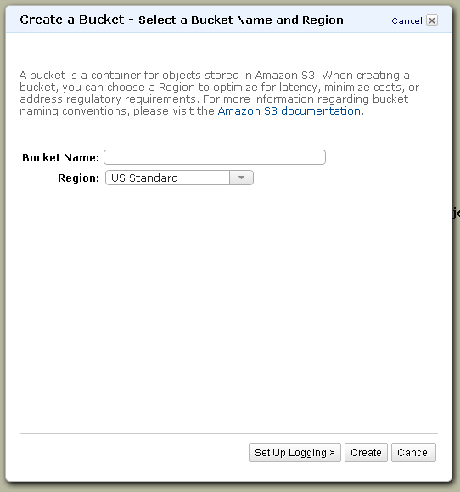
Enter the bucket name in Bucket Name field.
In the Region drop-down list box, select a region.
By default, Amazon S3 creates buckets in the US-Standard region.
Click Create.
When Amazon S3 successfully creates your bucket, the console displays your empty bucket in the Buckets panel.

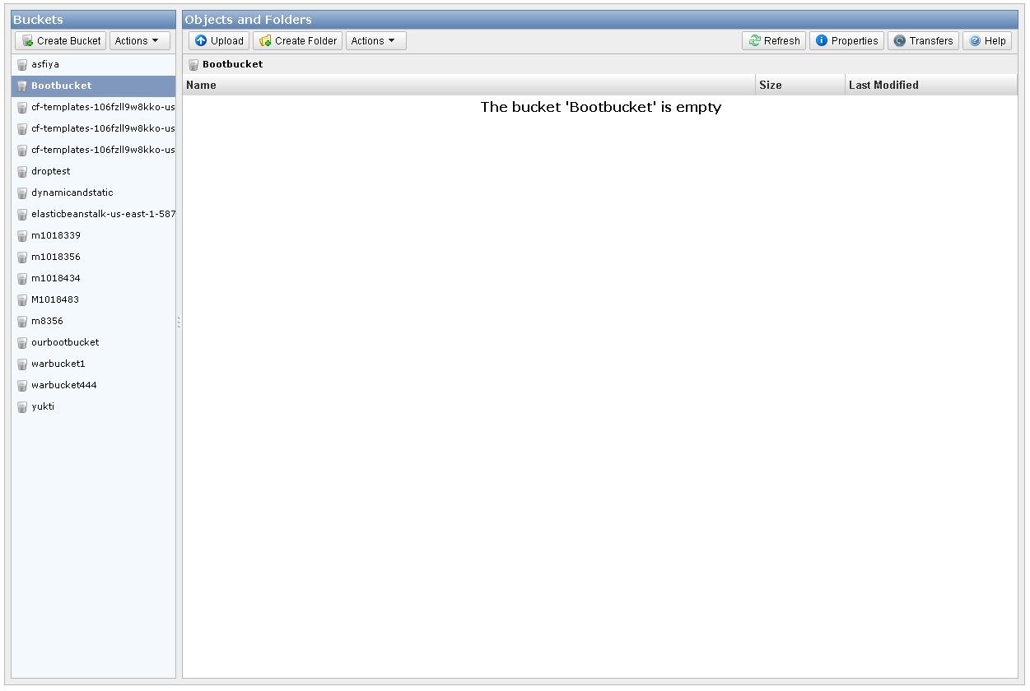
Upload an object
Click the bucket you want to upload object into and click on Upload in Objects and Folders panel.
The Upload - Select Files wizard opens
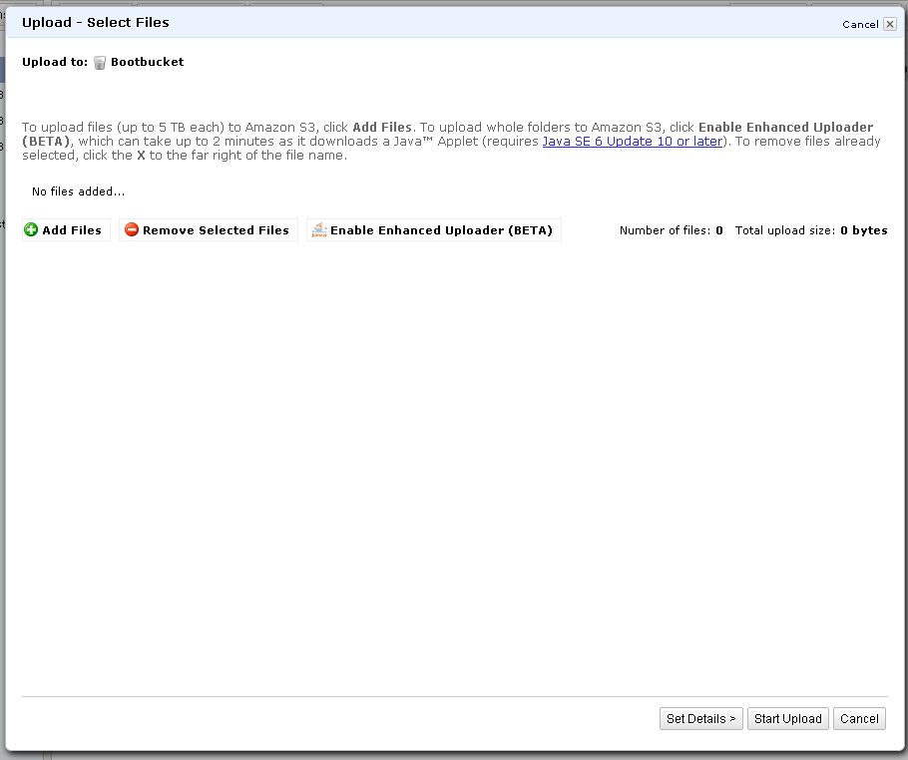
If you want to upload a folder you must click Enable Enhanced Uploader for the Java applet. After you download the Java applet, the Enable Enhanced Uploader link disappears from the wizard. You only need to do this once per console session and you can transfer entire folders
Click Add Files to select the file to upload from your computer. A file selection dialog box opens:
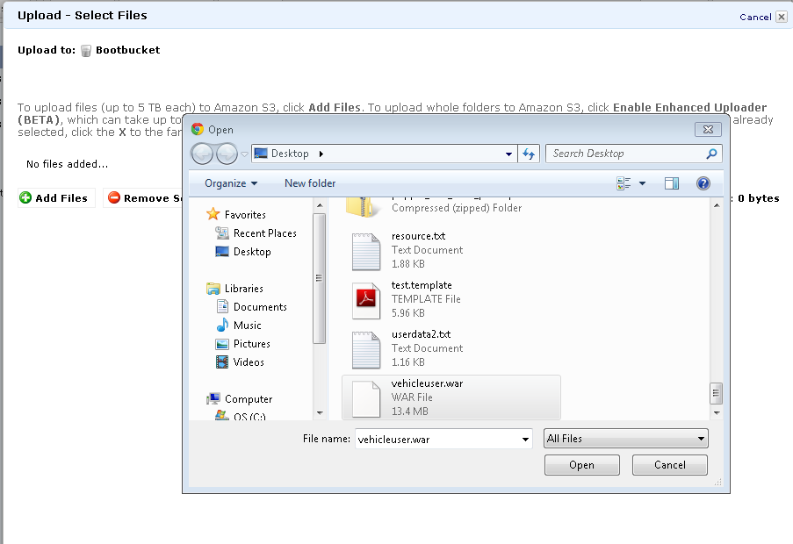
Select a file you want to upload and click Open. The Upload - Select Files wizard shows the files and folders you've selected to upload.
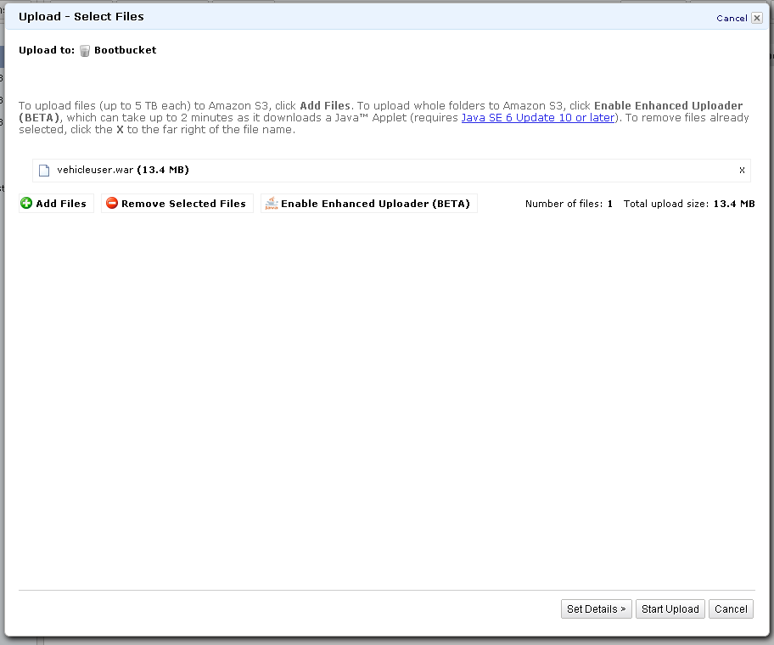
Click Start Upload. You can watch the progress of the upload using the Transfer panel. The Transfer panel appear on the bottom of the screen as soon as you begin the upload.
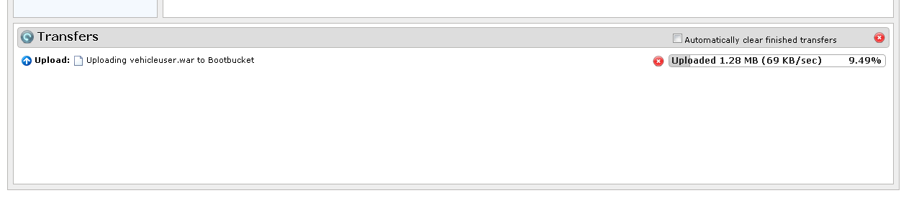
After the object uploads successfully to Amazon S3, it appears in the object listing.
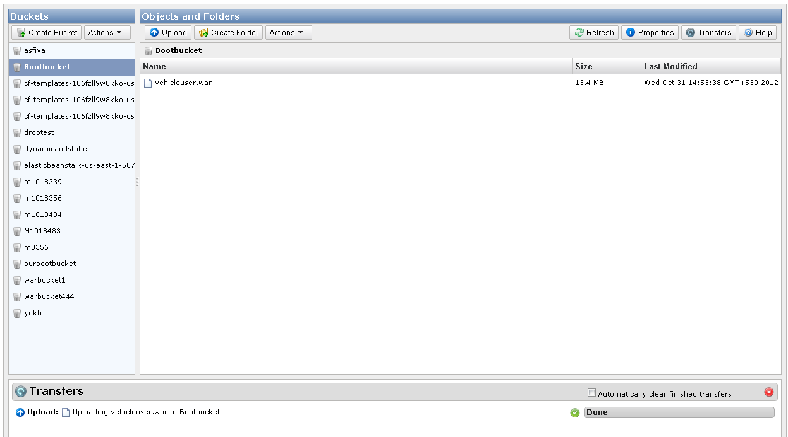
Make object public
Right-click on the object you want to delete. A dialog box shows the actions you can take on the selected object(s).
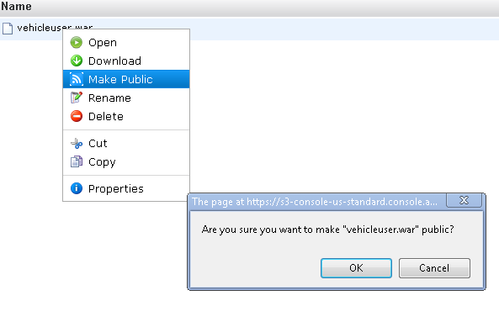
Click Make Public. Click OK.

Elastic IP address
Elastic IP addresses are static IP addresses. An Elastic IP address is associated with an aws account, not a particular instance and can be remapped to instances when desired.
Characteristic of Elastic IP are:
Association | Association of EIP with an instance will release its current public IP address.
Disassociation | Disassociation of an EIP from the instance, will automatically assign a new public IP address within a few minutes.
Reassociation | Associating an EIP that's already associated with another instance, the address is automatically associated with the new instance.
Instance Stop | Stopping the instance also disassociates the EIP from it.

Allocating an Elastic IP Address
The following are the steps to allocating new EIP address.
Open an Amazon EC2 console at https://console.aws.amazon.com/ec2/
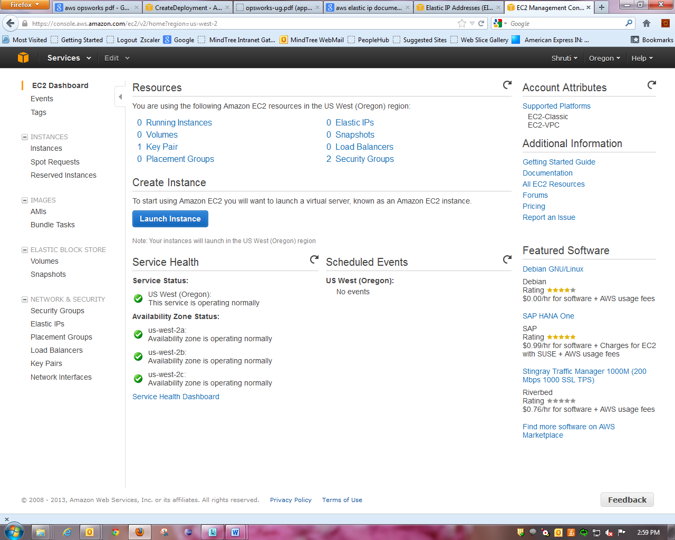

Click Elastic IPs in the navigation pane.
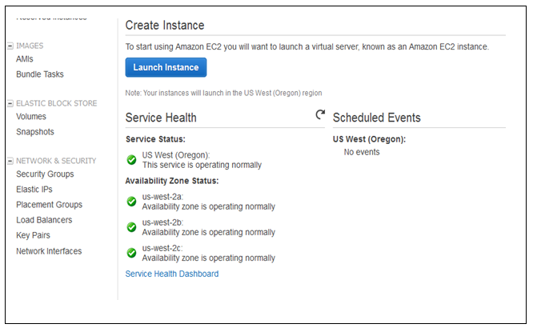
Click Allocate New Address.
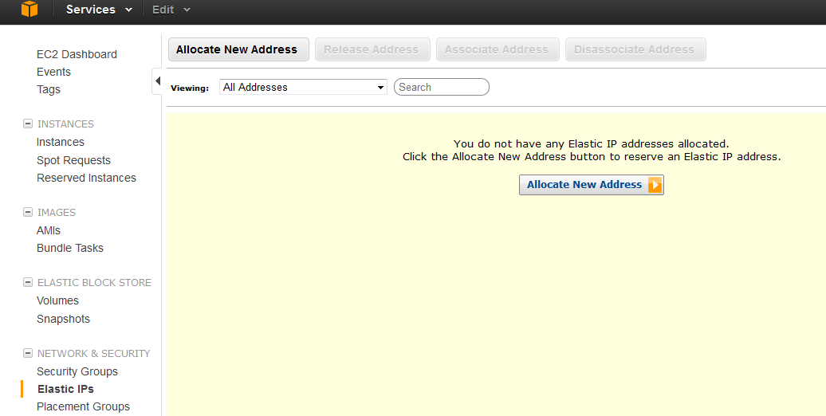
Select EC2 from the EIP list, and then click Yes, Allocate.
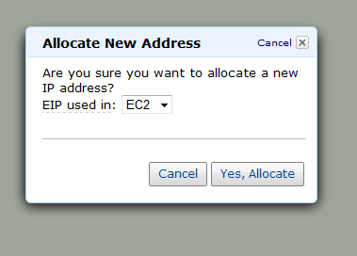

Describing Your Elastic IP Addresses
To view your Elastic IP addresses
Open the Amazon EC2 console at https://console.aws.amazon.com/ec2/.
Click Elastic IPs in the navigation pane.
The list of EIP will be displayed along the id of an associated instance if any.
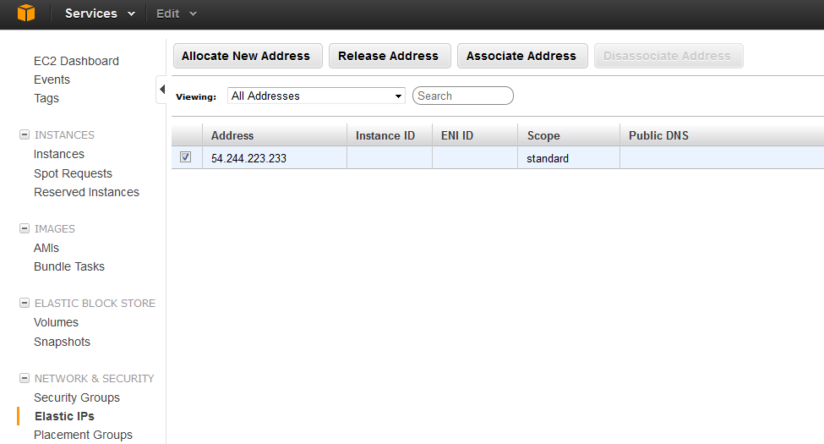
Associating an Elastic IP Address with a Running Instance
To associate an Elastic IP address with a running instance
Open the Amazon EC2 console at https://console.aws.amazon.com/ec2/.
Click Elastic IPs in the navigation pane.
Select an EIP and click Associate Address.

In the Associate Address dialog box, select the instance from the Instance list box and click Yes, Associate.
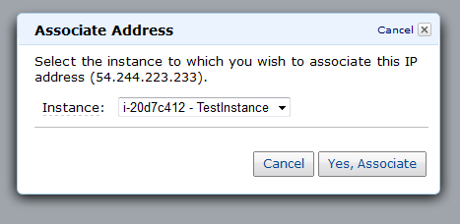

Releasing an Elastic IP Address
If you no longer need an EIP, it’s better to release it (the address must not be associated with an instance). You incur charges for any EIP that's allocated for use with EC2-Classic but not associated with an instance.
To release an Elastic IP address
Open the Amazon EC2 console at https://console.aws.amazon.com/ec2/.
Click Elastic IPs in the navigation pane.
Select the Elastic IP address, and then click the Release Address button and click yes, Release.
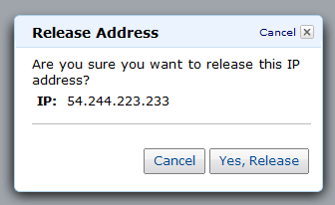

Elastic IP Address Limit
By default, all AWS accounts are limited to 5 EIPs, because public (IPv4) Internet addresses. If there a need to have to additional EIPs then you need to complete the Amazon EC2 Elastic IP Address Request Form found at http://aws.amazon.com/contact-us/eip_limit_request/

