INFORMATION FOR DEGREE COLLEGE WEBSITE

Dear sir/madam,
PLEASE FILL THE REQUIRED DETAILS FOR THE DESIGNING OF YOUR ORGNIZATION WEBSITE.
- Please fill all the details in capital letters.

- Enter the domain name in which you want for your college. (Ex:www.name.com)
- Please enter the full name of the college in capital letters.
- Fill the establishment year of the college.
- Fill the full address of the college along with email id.
- Fill the contact numbers of the college.
- Please insert the college logo image.
- Please mention the courses that are offered by the college and those details.
- Please mention some information about your college.
- Vision and Mission of your college.
- Enter the department, name and qualification of the faculty.
- Please give the details of the facilities providing along with the image.

Domain Name:
Ex: WWW.SRI SAI DEGREE COLLEGE.COM

College Name:
SRI SAI DEGREE COLLEGE
(Affiliated Dr.Br.Ambedkar University-Srikakulam)

Established Year:
2008

Address:
J.R.PURAM,
RANASTHALAM,
SRIKAKULAM DIST

Phone No:
9494447981

College Logo:


Courses Offered:
B.Sc | B.Com | B.A | Others
Ex: M.P.C  CBZ | Ex: GENERAL

About Us:
  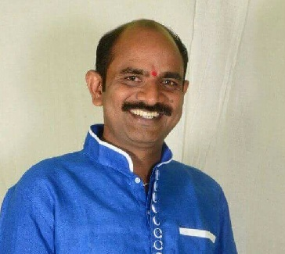
  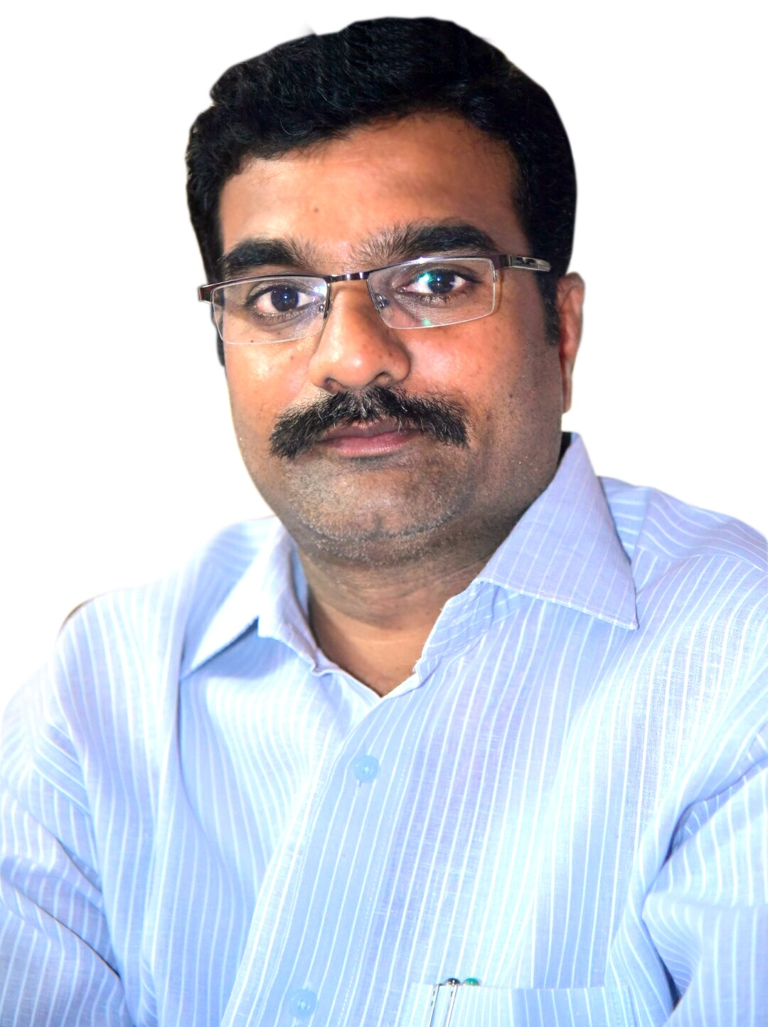
  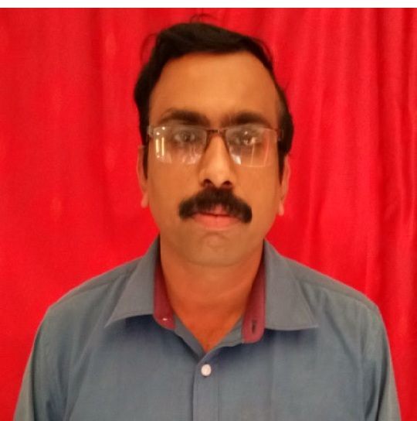
CHIRMEN | DIRECTOR | PRINCIPAL
Name K.APPALANAIDU | Name CH.DURGAPRASAD | Name S.SATEESH
Mobile No.9440436426 | Mobile No.9393929359 | Mobile No.9494447981
Email id: | Email id: | Email;  Sateeshsusarapu60@gmail.com

About Us:

Vision & Mission:

Faculty Details:
Department | Name | Qualification
Dept of Physics |  | M.Sc

Facilities:
- Image
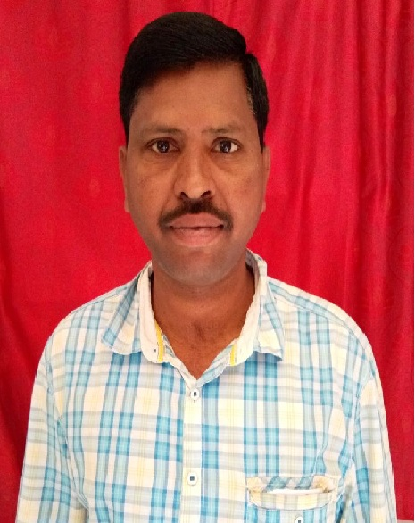 | L.JAYARAO  (LECTURER IN ECONOMIC)  M.A,B.Ed  THE HEAD DEPARTMENT OF COMMERCE  9491326298
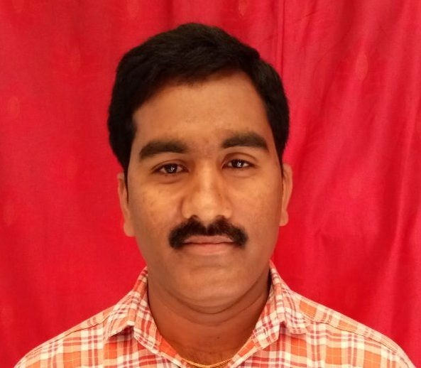 | K.SURYANARAYANA  (LECTRUER IN BOTANY)  M.Sc  HTE HEAD DEPARTMENT OF BOTANY  9849036647
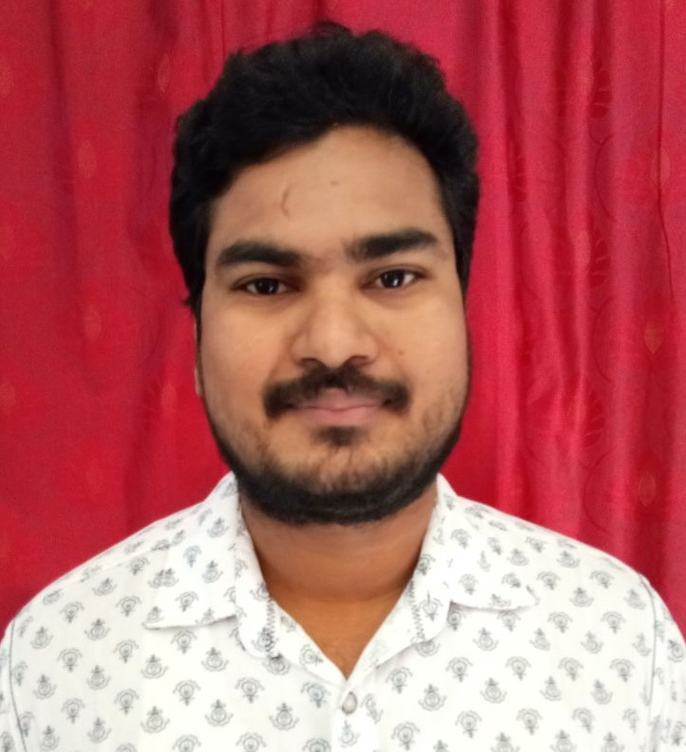 | I.UPENDRA  (LECTURER IN PHYSICS)  M.Sc, B.Ed  THE HEAD OF THE DEPARTMENT OF THE PHYSICS  9948532500
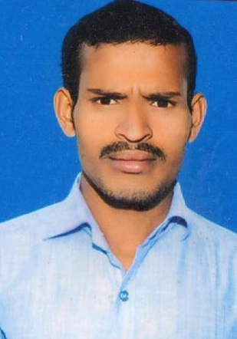 | K.ASIRINAIDU  (LECTURER IN TELUGU)  THE HEAD DEPARTMENT OF TELLUGU  9000073657
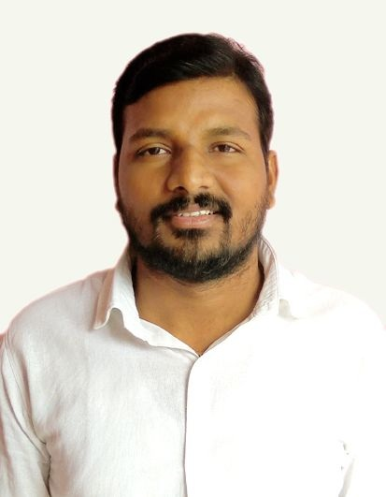 | N.K VEKATARAO  (LECTURER IN ZOOLOGY)  M.Sc, B.Ed  THE OF TE DEPARTMENT OF ZOOLOGY
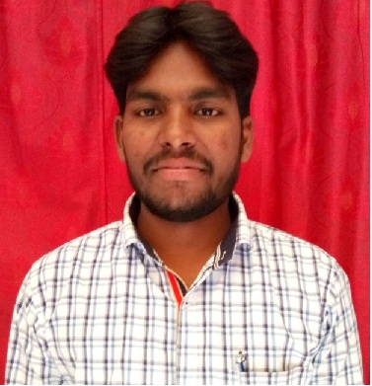 | L.CHENNARAO  M.COM.M.A,  (LECTURER IN COMMERCE)  9701463829
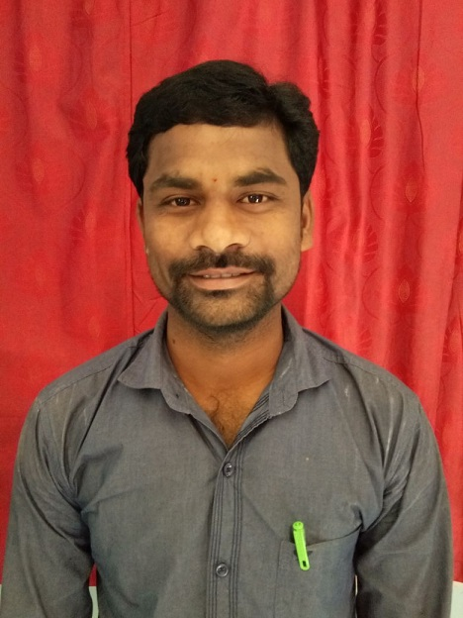 | B.RAMBABU  M.COM  (LECTURER IN COMMERCE)  9494340469
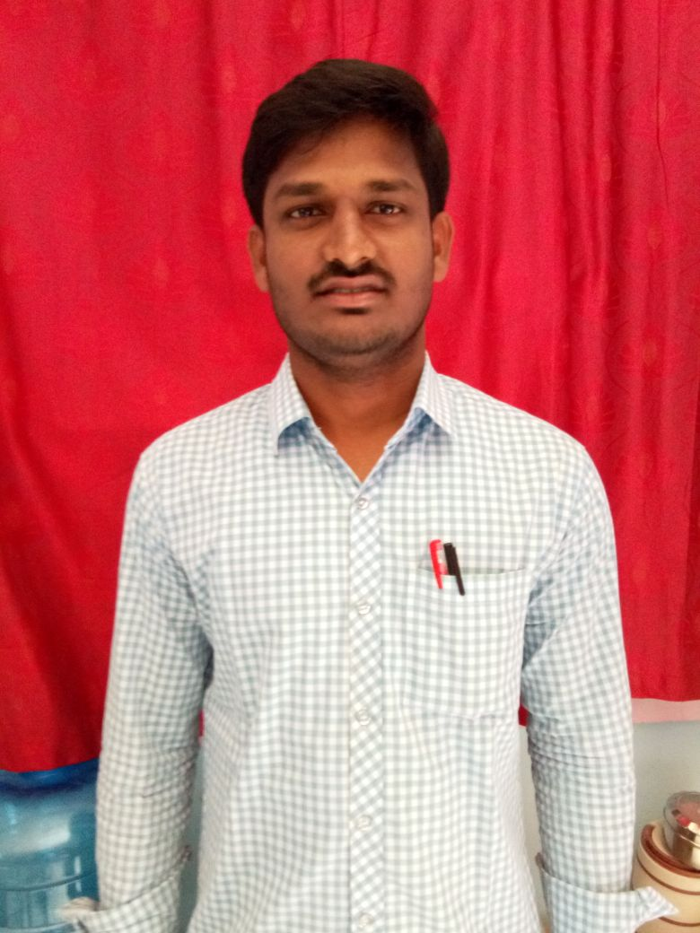 | K.KANAKARAO  M.SC  (LECTURER IN MATHS)  9398661663
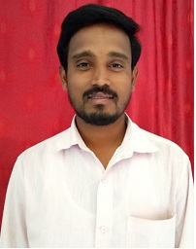 | K.RAMANA  M.SC (CHEMISTRY)  (LECTURER IN CHEMISTRY)  8008546089
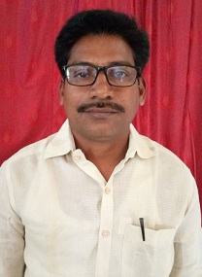 | V.SRINIVASARAO  M.A LIT  (LECTURER IN ENGLISH)  7978036838
M.V.RAMANA
B.SC
UDC
9491928349
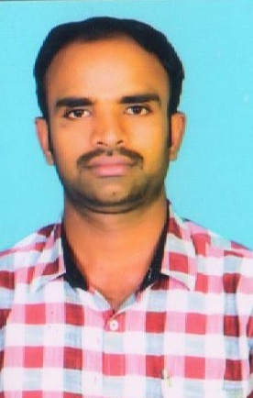 | M.RAMESH  B.SC  A.O  9000640632

- Lab name

News & Updates:
News & Updates

