Wireshark Lab: HTTP (Due 9/29 Friday)

Supplement to Computer Networking: A Top-Down Approach, 8th ed., J.F. Kurose and K.W. Ross

© 2005-2020, J.F Kurose and K.W. Ross, All Rights Reserved

Preparation:
- Install wireshark tool, https://www.wireshark.org/
- Optionally, install a different web browser just for the labs

1. The Basic HTTP GET/response interaction

Let’s begin our exploration of HTTP by downloading a very simple HTML file:
- Start up your web browser.
- Start up the Wireshark packet sniffer, as described in class (but don’t yet begin packet capture). Enter “http” (just the letters, not the quotation marks) in the display-filter-specification window, so that only captured HTTP messages will be displayed later in the packet-listing window. (We’re only interested in the HTTP protocol here, and don’t want to see the clutter of all captured packets).
- Wait a bit more than one minute (we’ll see why shortly), and then begin Wireshark packet capture.
- Enter the following to your browser
http://gaia.cs.umass.edu/wireshark-labs/HTTP-wireshark-file1.html
Your browser should display the very simple, one-line HTML file.
- Stop Wireshark packet capture.

Your Wireshark window should look similar to the window shown in Figure 1
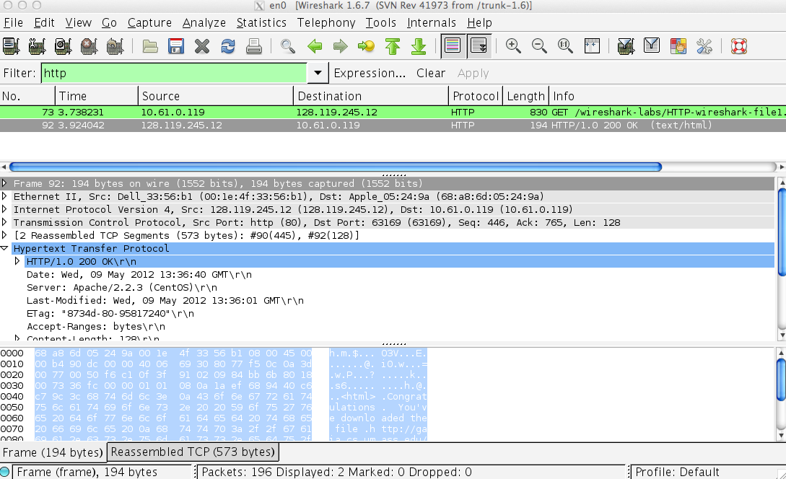

Figure 1: Wireshark Display after http://gaia.cs.umass.edu/wireshark-labs/ HTTP-wireshark-file1.html has been retrieved by your browser

The example in Figure 1 shows in the packet-listing window that two HTTP messages were captured: the GET message (from your browser to the gaia.cs.umass.edu web server) and the response message from the server to your browser. The packet-contents window shows details of the selected message (in this case the HTTP OK message, which is highlighted in the packet-listing window). Recall that since the HTTP message was carried inside a TCP segment, which was carried inside an IP datagram, which was carried within an Ethernet frame, Wireshark displays the Frame, Ethernet, IP, and TCP packet information as well.

By looking at the information in the HTTP GET and response messages, answer the following questions. When answering the following questions, you should attach screen snapshots that support your answers.
- Is your browser running HTTP version 1.0 or 1.1? What version of HTTP is the server running?

- What languages (if any) does your browser indicate that it can accept to the server?

- What is the IP address of your computer? Of the gaia.cs.umass.edu server?

- What is the status code returned from the server to your browser?

- When was the HTML file that you are retrieving last modified at the server?

- How many bytes of content are being returned to your browser?

2. The HTTP CONDITIONAL GET/response interaction

Most web browsers perform object caching and thus perform a conditional GET when retrieving an HTTP object. Before performing the steps below, make sure your browser’s cache is empty. (e.g., for Firefox, select Tools->Clear Recent History and check the Cache box, or for Internet Explorer, select Tools->Internet Options->Delete File; these actions will remove cached files from your browser’s cache.) Now do the following:
- Start up your web browser, and make sure your browser’s cache is cleared, as discussed above.
- Start up the Wireshark packet sniffer
- Enter the following URL into your browser
http://gaia.cs.umass.edu/wireshark-labs/HTTP-wireshark-file2.html
Your browser should display a very simple five-line HTML file.
- Quickly enter the same URL into your browser again (or simply select the refresh button on your browser)
- Stop Wireshark packet capture and enter “http” in the display-filter-specification window, so that only captured HTTP messages will be displayed later in the packet-listing window.

Answer the following questions:
- Inspect the contents of the first HTTP GET request from your browser to the server. Do you see an “IF-MODIFIED-SINCE” line in the HTTP GET?

- Inspect the contents of the server response. Did the server explicitly return the contents of the file? How can you tell?

- Now inspect the contents of the second HTTP GET request from your browser to the server. Do you see an “IF-MODIFIED-SINCE:” line in the HTTP GET? If so, what information follows the “IF-MODIFIED-SINCE:” header?

- What is the HTTP status code and phrase returned from the server in response to this second HTTP GET? Did the server explicitly return the contents of the file? Explain.

Submission:
- Answer all the questions with screenshots that support the answers.
- Submit the file on blackboard.

