Wireshark Lab: TCP
(Due 11/10)

Supplement to Computer Networking: A Top-Down Approach, 8th ed., J.F. Kurose and K.W. Ross

1. Capturing a bulk TCP transfer from your computer to a remote server

Before beginning our exploration of TCP, we’ll need to use Wireshark to obtain a packet trace of the TCP transfer of a file from your computer to a remote server. You’ll do so by accessing a Web page that will allow you to enter the name of a file stored on your computer (which contains the ASCII text of Alice in Wonderland), and then transfer the file to a Web server using the HTTP POST method.

Do the following:
- Start up your web browser. Go the http://gaia.cs.umass.edu/wireshark-labs/alice.txt and retrieve an ASCII copy of Alice in Wonderland. Store this file somewhere on your computer.
- Next go to http://gaia.cs.umass.edu/wireshark-labs/TCP-wireshark-file1.html.
- You should see a screen that looks like:

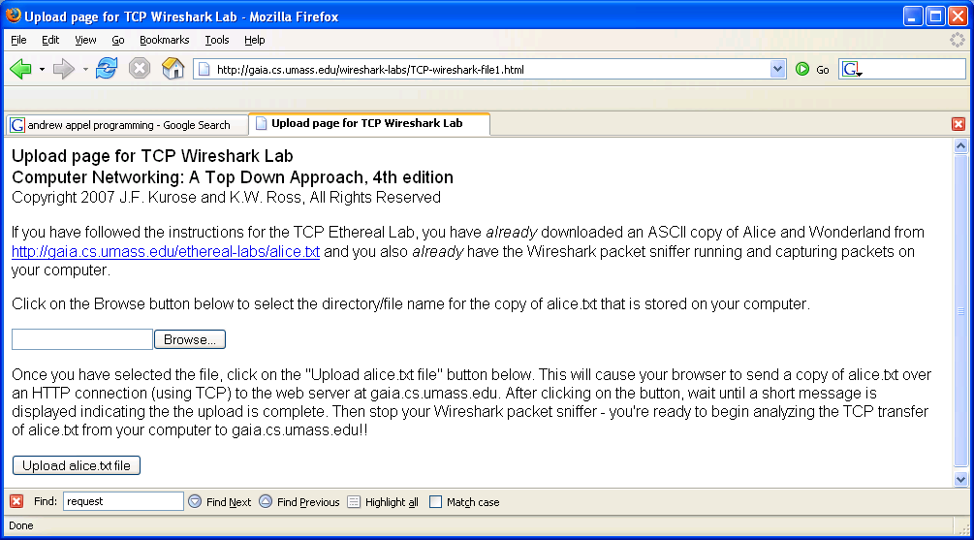

- Use the Browse button in this form to enter the name of the file (full path name) on your computer containing Alice in Wonderland (or do so manually). Don’t yet press the “Upload alice.txt file” button.
- Now start up Wireshark and begin packet capture (Capture->Start) and then press OK on the Wireshark Packet Capture Options screen (we’ll not need to select any options here).
- Returning to your browser, press the “Upload alice.txt file” button to upload the file to the gaia.cs.umass.edu server. Once the file has been uploaded, a short congratulations message will be displayed in your browser window.
- Stop Wireshark packet capture. Your Wireshark window should look similar to the window shown below.

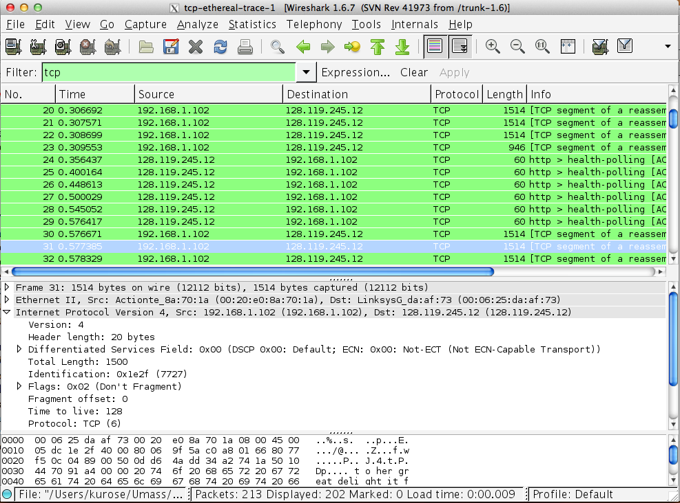

2. A first look at the captured trace

Before analyzing the behavior of the TCP connection in detail, let’s take a high level view of the trace.
- First, filter the packets displayed in the Wireshark window by entering “tcp” (lowercase, no quotes, and don’t forget to press return after entering!) into the display filter specification window towards the top of the Wireshark window. You may see other network traffic that have also been captured. Our target packets should have green background color.

What you should see is a series of TCP and HTTP messages between your computer and gaia.cs.umass.edu. You should see the initial three-way handshake containing a SYN message. You should see an HTTP POST message near the end of the trace.

3. TCP Basics

Answer the following questions for the TCP segments. Please attach screen snapshots or a packet print-out file. To print packets, select the packets (multiple packets) you need to answer the questions, use File->Print, choose Selected packet only, choose Packet summary line.

- What is the IP address and TCP port number used by your client computer (source) to transfer the file to gaia.cs.umass.edu?

- What is the sequence number of the TCP SYN segment that is used to initiate the TCP connection between the client computer and gaia.cs.umass.edu? What is it in the segment that identifies the segment as a SYN segment?

- What is the sequence number of the SYNACK segment sent by gaia.cs.umass.edu to the client computer in reply to the SYN? What is the value of the Acknowledgement field in the SYNACK segment? How did gaia.cs.umass.edu determine that value? What is it in the segment that identifies the segment as a SYNACK segment?

- What is the sequence number of the TCP segment containing the HTTP POST command?

- Identify the 3 TCP ACKs from the sever, and find their corresponding TCP data segments from the client. Explain how did you find these 3 TCP data segments. At what time was each TCP data segment sent by the client? When was each TCP ACK received? Given the difference, what are the RTT values for these 3 TCP segments?
Note: Wireshark has a nice feature that allows you to plot the RTT for each of the TCP segments sent. You can use it to compare with your own calculation. Select a TCP segment in the “listing of captured packets” window that is being sent from the client to the gaia.cs.umass.edu server. Then select: Statistics->TCP Stream Graph->Round Trip Time Graph.

- Among the 3 TCP ACKs you identified in the previous question, what are the minimum amount of available buffer space advertised at the received for the entire trace? Does the lack of receiver buffer space ever throttle the sender?

- What is the throughput (bytes transferred per unit time) for the TCP connection? Explain how you calculated this value.

4. TCP congestion control in action

Let’s now examine the amount of data sent per unit time from the client to the server. Rather than (tediously!) calculating this from the raw data in the Wireshark window, we’ll use one of Wireshark’s TCP graphing utilities - Time-Sequence-Graph(Stevens) - to plot out data.
- Select a TCP segment in the Wireshark’s “listing of captured-packets” window. Then select the menu : Statistics->TCP Stream Graph-> Time-Sequence-Graph(Stevens). You should see a plot that looks similar to the following plot.

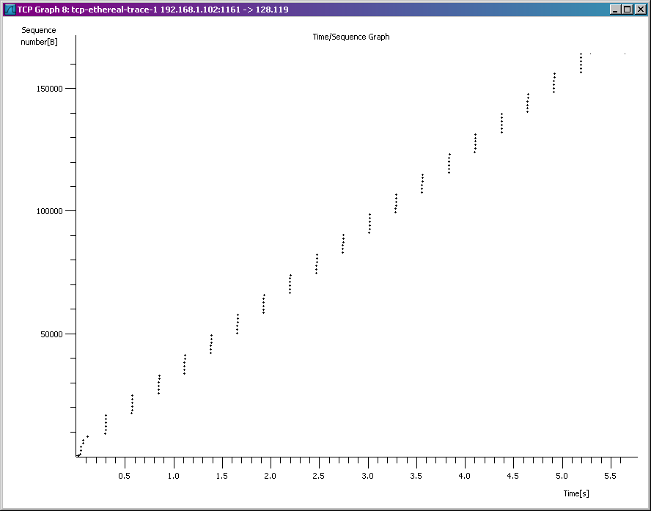

Here, each dot represents a TCP segment sent, plotting the sequence number of the segment versus the time at which it was sent. Note that a set of dots stacked above each other represents a series of packets that were sent back-to-back by the sender.

Answer the following questions for the TCP segments in your packet trace:

- Use the Time-Sequence-Graph(Stevens) plotting tool to view the sequence number versus time plot of segments being sent from the client to the gaia.cs.umass.edu server. Can you identify where is TCP’s slowstart phase and congestion avoidance phase? Can you identify any congestions?

