<dependency>
<groupId>org.springframework.boot</groupId>
<artifactId>spring-boot-starter-batch</artifactId>
</dependency>

batch dependency

Batch processing is a processing mode which involves execution of series of automated complex jobs without user interaction. A batch process handles bulk data and runs for a long time.

Time-based events such as periodic calculations.
- Periodic applications that are processed repetitively over large datasets.
- Applications that deals with processing and validation of the data available in a transactional manner.

What is Spring Batch
Spring batch is a lightweight framework which is used to develop Batch Applications that are used in Enterprise Applications.

In addition to bulk processing, this framework provides functions for −
- Including logging and tracing
- Transaction management
- Job processing statistics
- Job restart
- Skip and Resource management
You can also scale spring batch applications using its portioning technique

Features of Spring Batch
Flexibility − Spring Batch applications are flexible. You simply need to change an XML file to alter the order of processing in an application.

Maintainability − Spring Batch applications are easy to maintain. A Spring Batch job includes steps and each step can be decoupled, tested, and updated, without effecting the other steps.

Scalability − Using the portioning techniques, you can scale the Spring Batch applications. These techniques allow you to −
- Execute the steps of a job in parallel.
- Execute a single thread in parallel.

Reliability − In case of any failure, you can restart the job from exactly where it was stopped, by decoupling the steps.

Support for multiple file formats − Spring Batch provides support for a large set of readers and writers such as XML, Flat file, CSV, MYSQL, Hibernate, JDBC, Mongo, Neo4j, etc.

Multiple ways to launch a job − You can launch a Spring Batch job using web applications, Java programs, Command Line, etc.

In addition to these, Spring Batch applications support −
- Automatic retry after failure.
- Tracking status and statistics during the batch execution and after completing the batch processing.
- To run concurrent jobs.
- Services such as logging, resource management, skip, and restarting the processing.

architecture of Spring Batch

the architecture contains three main components namely, Application, Batch Core, and Batch Infrastructure.

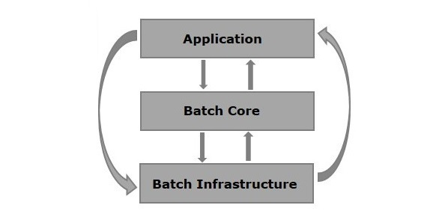

Application − This component contains all the jobs and the code we write using the Spring Batch framework.
Batch Core − This component contains all the API classes that are needed to control and launch a Batch Job.

Batch Infrastructure − This component contains the readers, writers, and services used by both application and Batch core components.

Components of Spring Batch
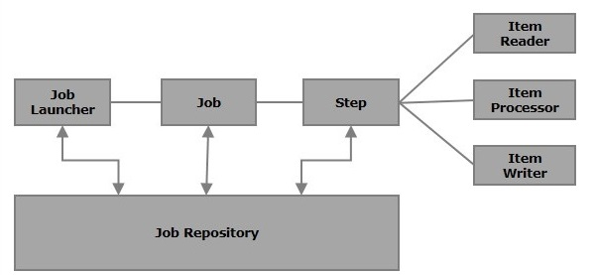

Job
In a Spring Batch application, a job is the batch process that is to be executed. It runs from start to finish without interruption

This job is further divided into steps (or a job contains steps (can multiple steps)).

We will configure a job in Spring Batch using an XML file or a Java class. Following is the XML configuration of a Job in Spring Batch.

<job id = "jobid">
<step id = "step1" next = "step2"/>
<step id = "step2" next = "step3"/>
<step id = "step3"/>
</job>

A Batch job is configured within the tags <job></job>. It has an attribute named id. Within these tags, we define the definition and ordering of the steps.

Restartable − In general, when a job is running and we try to start it again that is considered as restart and it will be started again. To avoid this, you need to set the restartable value to false as shown below.

<job id = "jobid" restartable = "false" >

</job>

Step
A step is an independent part of a job which contains the necessary information to define and execute the job (its part).

As specified in the diagram, each step is composed of an ItemReader, ItemProcessor (optional) and an ItemWriter. A job may contain one or more steps.

Readers, Writers, and Processors
An item reader reads data from particular source. Give to a Spring Batch application
item writer writes data from the Spring Batch application. give to a particular destination.

An Item processor is a class which contains the processing code which processes the data read into the spring batch.

If the application reads "n" records, then the code in the processor will be executed on each record.

Tasklet
A Tasklet is an interface that performs a single task within a step

When no reader and writer are given, a tasklet acts as a processor for SpringBatch.
It processes only a single task

For example, if we are writing a job with a simple step in it where we read data from MySQL database and process it and write it to a file (flat), then our step uses −

- A reader which reads from MySQL database.
- A writer which writes to a flat file.
- A custom processor which processes the data as per our wish.

<job id = "helloWorldJob">
<step id = "step1">
<tasklet>
<chunk reader = "mysqlReader" writer = "fileWriter"
processor = "CustomitemProcessor" ></chunk>
</tasklet>
</step>
</ job>

Spring Batch provides a long list of readers and writers. Using these predefined classes, we can define beans for them. We will discuss readers and writers in greater detail in the coming chapters.

JobRepository

A Job repository in Spring Batch provides Create, Retrieve, Update, and Delete (CRUD) operations for the JobLauncher, Job, and Step implementations. We will define a job repository in an XML file as shown below.
<job-repository id = "jobRepository"/>

In addition to id, there are some more options (optional) available. Following is the configuration of job repository with all the options and their default values.

<job-repository id = "jobRepository"
data-source = "dataSource"
transaction-manager = "transactionManager"
isolation-level-for-create = "SERIALIZABLE"
table-prefix = "BATCH_"
max-varchar-length = "1000"/>

In-Memory Repository − In case you don’t want to persist the domain objects of the Spring Batch in the database, you can configure the in-memory version of the jobRepository as shown below.

<bean id = "jobRepository"
class = "org.springframework.batch.core.repository.support.MapJobRepositoryFactoryBean ">
<property name = "transactionManager" ref = "transactionManager"/>
</bean>

JobLauncher

JobLauncher is an interface which launces the Spring Batch job with the given set of parameters. SampleJoblauncher is the class which implements the JobLauncher interface. Following is the configuration of the JobLauncher.

<bean id = "jobLauncher"
class = "org.springframework.batch.core.launch.support.SimpleJobLauncher">
<property name = "jobRepository" ref = "jobRepository" />
</bean>

JobInstance

A JobIinstance represents the logical run of a job; it is created when we run a job.

- Each job instance is differentiated by the name of the job and the parameters passed to it while running.

If a JobInstance execution fails, the same JobInstance can be executed again. Hence, each JobInstance can have multiple job executions.

JobExecution and StepExecution

JobExecution and StepExecution are the representation of the execution of a job/step.

They contain the run information of the job/step such as start time (of job/step), end time (of job/step).

Almost all the examples in this tutorial contain the following files −
- Configuration file (XML file)
- Tasklet/processor (Java class)
- Java class with setters and getters (Java class (bean))
- Mapper class (Java class)
- Launcher class (Java class)

Configuration File

The configuration file (XML) contains the following −
- The job and step definitions.
- Beans defining readers and writers.
- Definition of components like JobLauncher, JobRepository, Transaction Manager, and Data Source.

In our examples, for better understanding, we have divided this in to two files the job.xml file (defines job, step, reader and writer) and context.xml file (job launcher, job repository, transaction manager and data source).

Mapper Class
The Mapper class, depending upon the reader, implements interfaces such as row mapper, field set mapper, etc. It contains the code to get the data from the reader and to set it to a Java class with setter and getter methods (Java Bean).

Java Bean Class

A Java class with setters and getters (Java bean) represents data with multiple values. It acts as a helper class. We will pass the data from one component (reader, writer, processer) to other in the form of object of this class.

Tasklet/processor
The Tasklet/processor class contains the processing code of the Spring Batch application.
A processor is a class which accepts an object that contains the data read, processes it, and returns the processed data (in the form object).

Launcher class
This class (App.java) contains the code to launch the Spring Batch application.
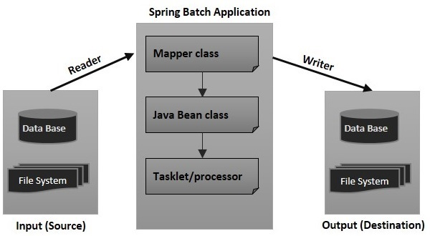

While writing a Spring Batch application,we will configure the

- job,
- step,
- JobLauncher,
- JobRepository,
- Transaction Manager,
- readers,
- writers

Job

This tag is used to define/configure the job of the SpringBatch. It contains a set of steps and it can be launched using the JobLauncher.
This tag has 2 attributes as listed below −

<job id = "jobid" restartable = "false" >
. . . . . . . .
. . . . . . . .
. . . . . . . . // Step definitions
</job>

Step

This tag is used to define/configure the steps of a SpringBatch job.
It has the following three attributes −

S.N | Attribute & Description
1 | Id  It is the Id of the job, it is mandatory to specify value to this attribute.
2 | next  It is the shortcut to specify the next step.
3 | parent  It is used to specify the name of the parent bean from which the configuration should inherit.

<job id = "jobid">
<step id = "step1" next = "step2"/>
<step id = "step2" next = "step3"/>
<step id = "step3"/>
</job>

Chunk
A chunk is a child element of the tasklet.
This tag is used to define/configure a chunk of a tasklet. It has the following four attributes −

S.N | Attribute & Description
1 | reader  It represents the name of the item reader bean. It accepts the value of the type org.springframework.batch.item.ItemReader.
2 | writer  It represents the name of the item reader bean. It accepts the value of the type org.springframework.batch.item.ItemWriter.
3 | processor  It represents the name of the item reader bean. It accepts the value of the type org.springframework.batch.item.ItemProcessor.
4 | commit-interval  It is used to specify the number of items to be processed before committing the transaction.

Following is the XML configuration of the chunk of a SpringBatch.
<batch:step id = "step1">
<batch:tasklet>
<batch:chunk reader = "xmlItemReader"
writer = "mysqlItemWriter" processor = "itemProcessor" commit-interval = "10">
</batch:chunk>
</batch:tasklet>
</batch:step>

JobRepository

The JobRepository Bean is used to configure the JobRepository using a relational database.

This bean is associated with the class of type org.springframework.batch.core.repository.JobRepository.

S.N | Attribute & Description
1 | dataSource  It is used to specify the bean name which defines the datasource.
2 | transactionManager  It is used specify the name of the bean which defines the transactionmanager.
3 | databaseType  It specifies the type of the relational database used in the job repository.

Following is the example configuration of the JobRepository.
<bean id = "jobRepository"
class = "org.springframework.batch.core.repository.support.JobRepositoryFactoryBean">
<property name = "dataSource" ref = "dataSource" />
<property name = "transactionManager" ref="transactionManager" />
<property name = "databaseType" value = "mysql" />
</bean>

JobLauncher

The JobLauncher bean is used to configure the JobLauncher. It is associated with the class org.springframework.batch.core.launch.support.SimpleJobLauncher (in our programs).

This bean has one property named jobrepository, and it is used to specify the name of the bean which defines the jobrepository.

Following is the example configuration of the jobLauncher.
<bean id = "jobLauncher"
class = "org.springframework.batch.core.launch.support.SimpleJobLauncher">
<property name = "jobRepository" ref = "jobRepository" />
</bean>

TransactionManager
The TransactionManager bean is used to configure the TransactionManager using a relational database. This bean is associated with the class of type org.springframework.transaction.platform.TransactionManager.
<bean id = "transactionManager"
class = "org.springframework.batch.support.transaction.ResourcelessTransactionManager" />

DataSource
The datasource bean is used to configure the Datasource. This bean is associated with the class of type org.springframework.jdbc.datasource.DriverManagerDataSource.
S.No | Attribute & Description
1 | driverClassName  This specifies the class name of the driver used to connect with the database.
2 | url  This specifies the URL of the database.
3 | username  This specifies the username to connect with the database.
4 | password  This specifies the password to connect with the database.
Following is the example configuration of the datasource.
<bean id = "dataSource"
class = "org.springframework.jdbc.datasource.DriverManagerDataSource">
<property name = "driverClassName" value = "com.mysql.jdbc.Driver" />
<property name = "url" value = "jdbc:mysql://localhost:3306/details" />
<property name = "username" value = "myuser" />
<property name = "password" value = "password" />
</bean>

An Item Reader reads data from particular source to the spring batch application from a,

Item Writer writes data from Spring Batch application to a particular destination.

An Item processor is a class which contains the processing code which processes the data read in to the spring batch. If the application reads n records the code in the processor will be executed on each record.

A chunk is a child element of the tasklet.

It is used to perform read, write, and processing operations.

We can configure reader, writer, and processors using this element, within a step as shown below.
<batch:job id = "helloWorldJob">
<batch:step id = "step1">
<batch:tasklet>
<batch:chunk reader = "cvsFileItemReader" writer = "xmlItemWriter"
processor = "itemProcessor" commit-interval = "10">
</batch:chunk>
</batch:tasklet>
</batch:step>
</batch:job>

To include a reader in your application, you need to define a bean for that reader, provide values to all the required properties within the bean, and pass the id of such bean as a value to the attribute of the chunk element reader (same for writer).

ItemReader

It is the entity of a step (of a batch process) which reads data. An ItemReader reads one item a time. Spring Batch provides an Interface ItemReader. All the readers implement this interface.

Following are some of the predefined ItemReader classes provided by Spring Batch to read from various sources

Reader | Purpose
FlatFIleItemReader | To read data from flat files.
StaxEventItemReader | To read data from XML files.
StoredProcedureItemReader | To read data from the stored procedures of a database.
JDBCPagingItemReader | To read data from relational databases database.
MongoItemReader | To read data from MongoDB.
Neo4jItemReader | To read data from Neo4jItemReader.

1. What is a Spring Batch Tasklet?
A Tasklet is an interface that performs a single task within a step

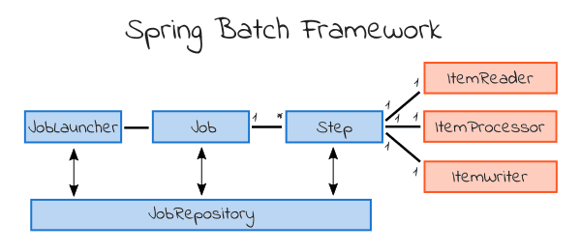

A batch process consists of a Job. This is an entity that encapsulates the entire batch process.

