GIT Features
- .git strorre al information
- Almost every oprtionis in local after all changes u can push remote
- Checksum is the string if u change anything the project it will change.
  - Eg : Used if hacker changed.

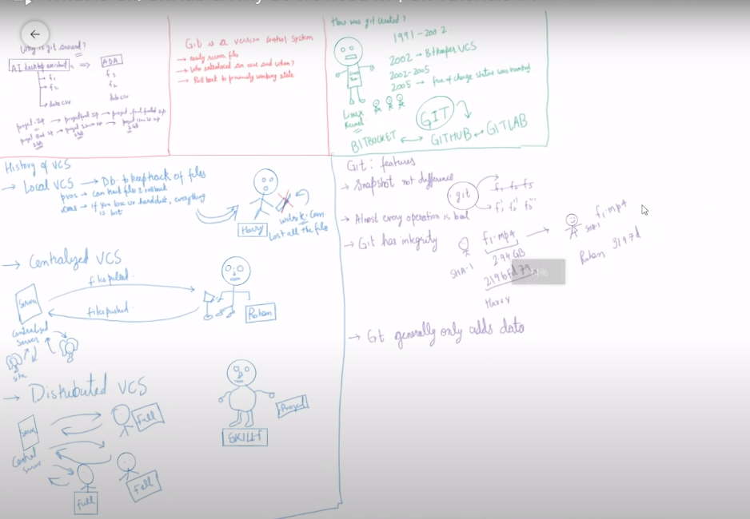

Git bash: is a terminal

U use git by 2 types
- Terminal
- GUI

Set for username and email

$ git config --global user.name "Sangam"
$ git config --global user.email "Sangam@gmail.com"

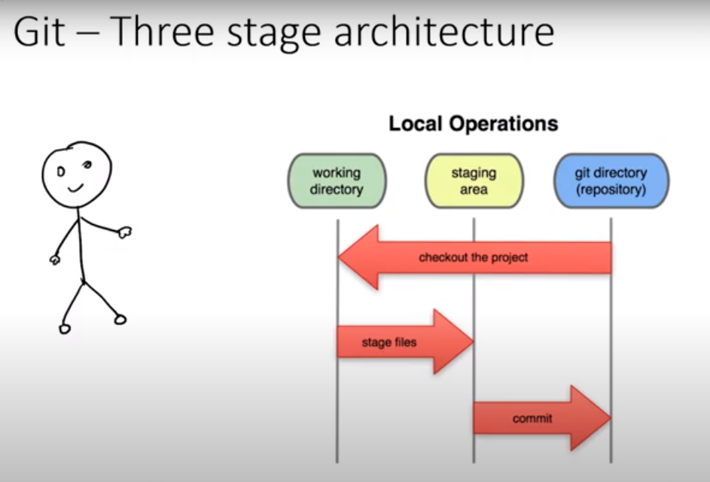

Current folder nor ts parent is git folder

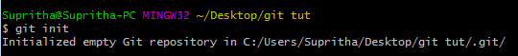

Telling that this folder is made has git

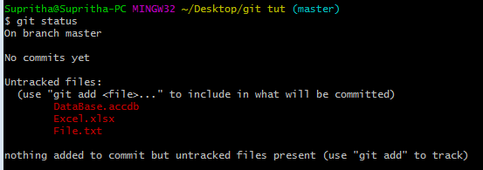

Telling that
- no commit
- 3 files are not traced

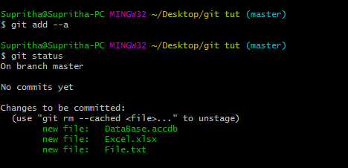

Git add : means add to stage area

Git status: red is turned to green telling that all 3 files are in the stage area

Changing in the file

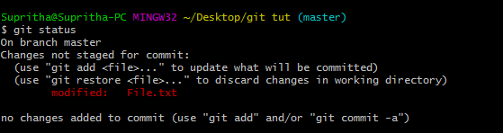

When u type command git status.
It is showing the 1 file change and But are not stagesd

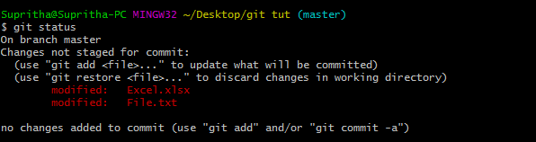

It is telling two file changes. But are not staged

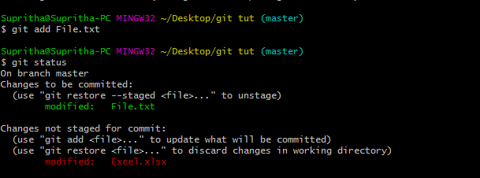

Only file.txt added to staged area. (so it showing the green)
Exccel is not added to staged area

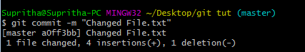

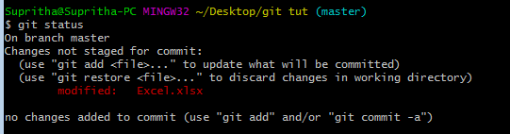

Git Log : u can see all the log

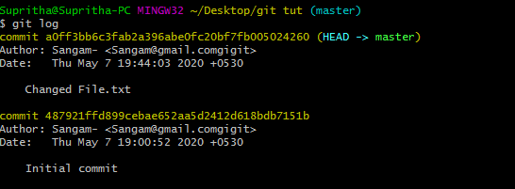



Is used to remove or delete .git .
Be very carful about it

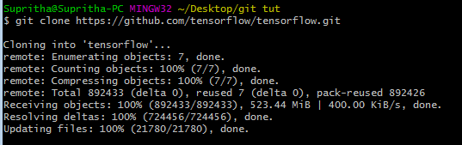

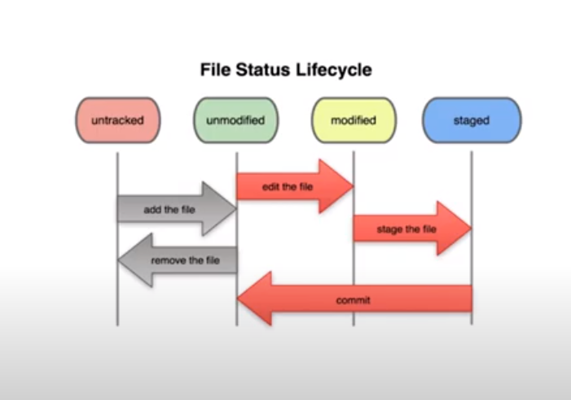.

Touch is used for reating the file

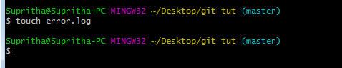

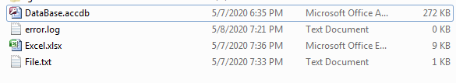

.gitignore

For ignoring the files
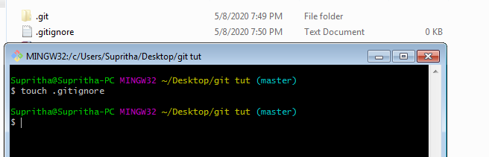

File the wanted to u igrnore

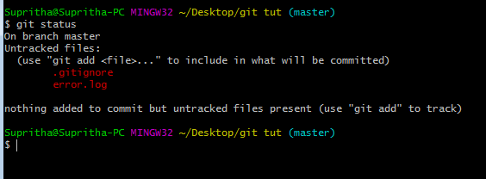

Has u see the two file
Error.log
.gtignore

- Ignore single file

Add it name in the .gitignore

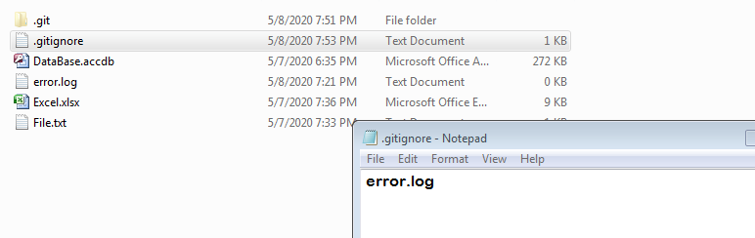

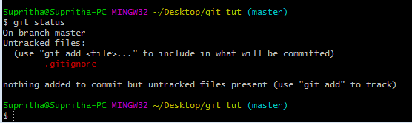

It is k to add the .gitignore

- Even if the change in the error.log it will not traced

- If u want add the mutlple file the then add extexion in the git

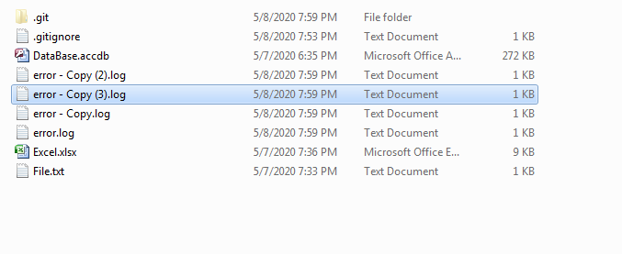

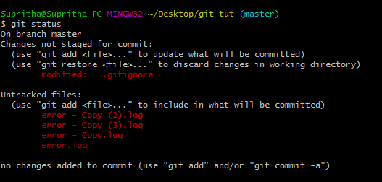

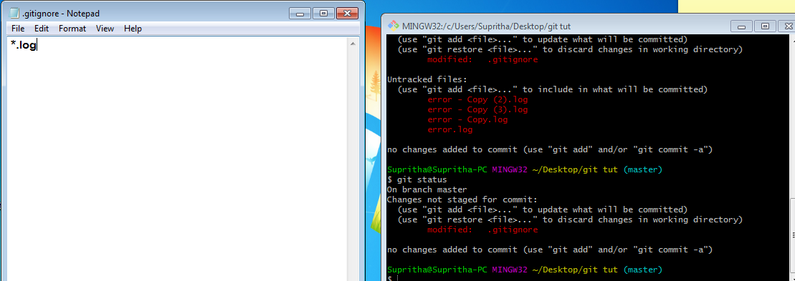

For the Directory

By default blank folder will be igronred

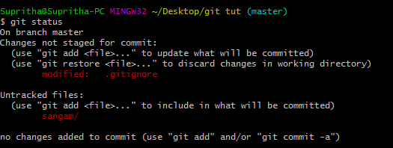

To ignore the directory

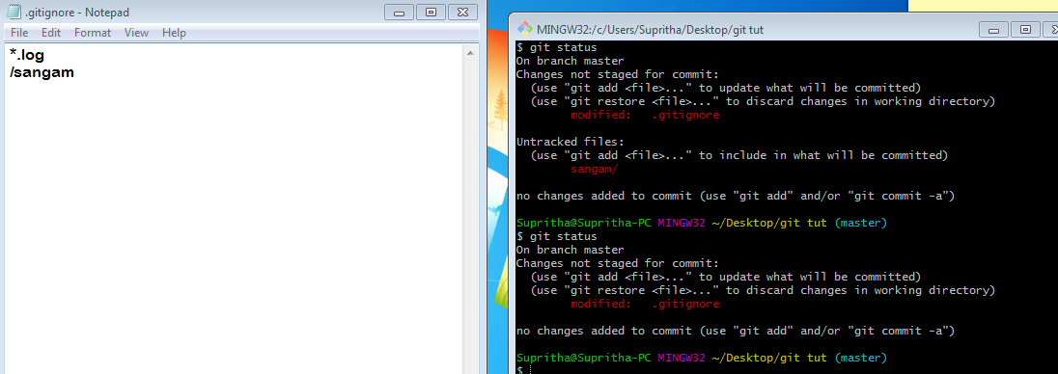

Create folder static

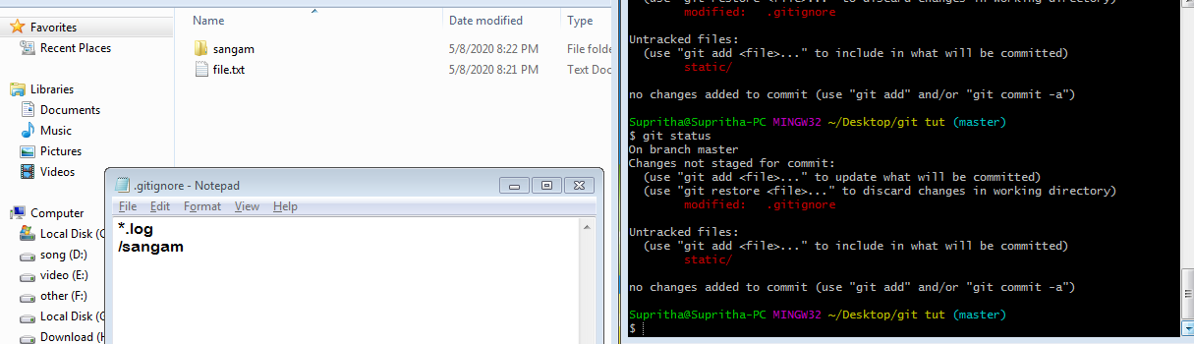

Although in static there is folder sangam but igronre has u metinoed in the .git ignore

U want to track the inside dir then

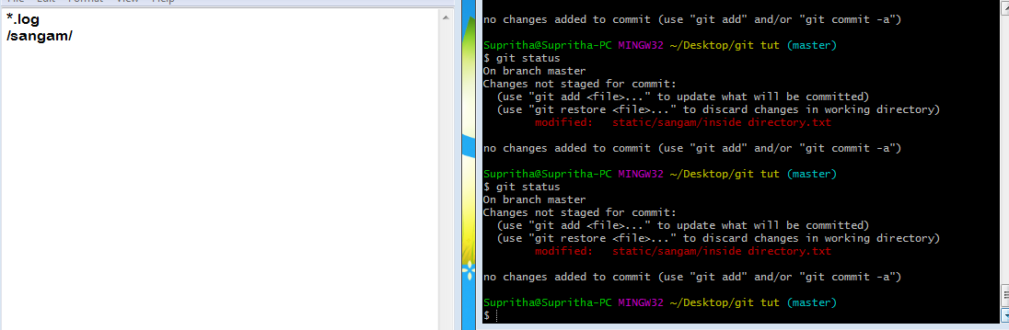

After adding the file to stag area then u change it it will show in both red and green

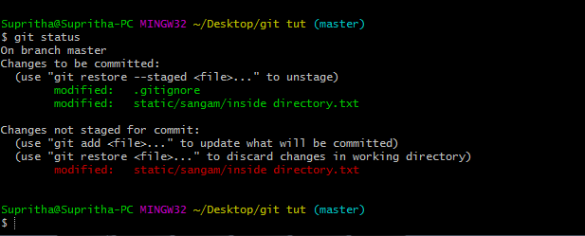

git diff:
compare the working directory to the staging area

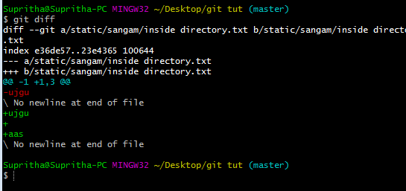
Red is removed line
Green is added line

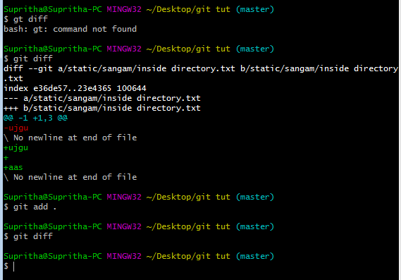

git diff --staged
Compare the prev commit to staging area
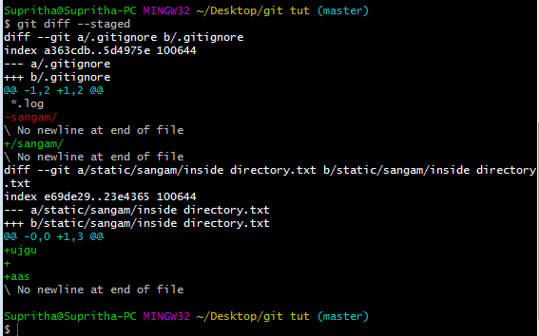

Git: Skipping The Staging Area

Used only when u don’t want add new file. Only commit the exiting file

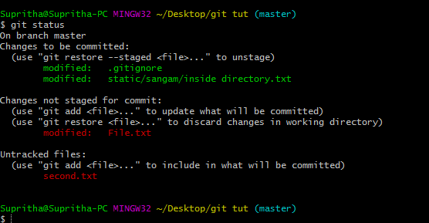

Has second.txt is not traked so it wll not aviable in the staged area. Will not commit
git commit –a –m” Dirwect commit”
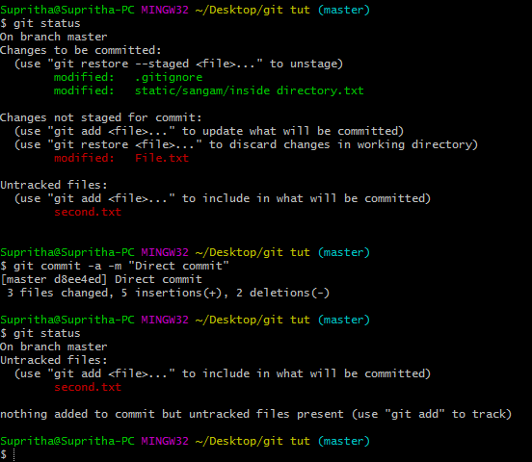

Moving and rename

Senior : when u change the name of the file
Second.txt to third.txt
git will assume that second is deleted and third is added

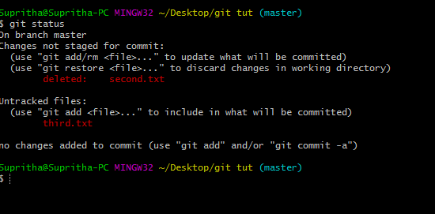

But u add in staging area it will come to know that the u have renamed it

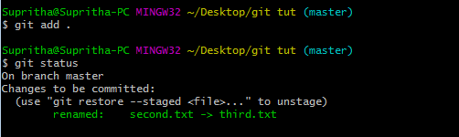

Commiting the rename of the file



git rm third.txt

it will remove file from the folder
and will staged that also
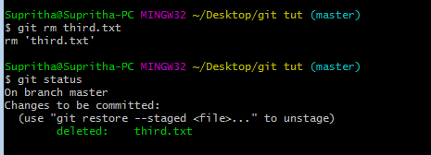

In case of manaualy delelte
U manlually delete the file
Add filme to staged area
(save of two steps)

U can rename the file
git mv first.txt rename.txt
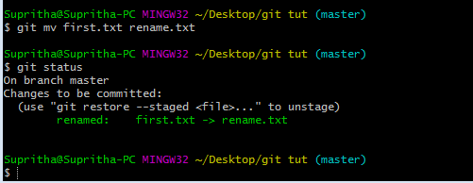

To remove from the track file

git rm –cached File.txt
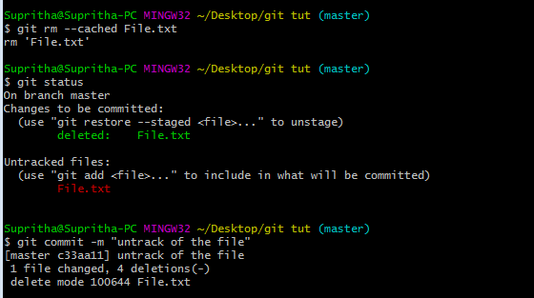

Now u can see file.txt tracked

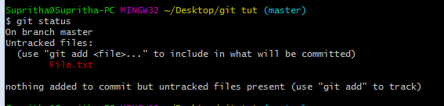

Git remote
Add of website to push and pull
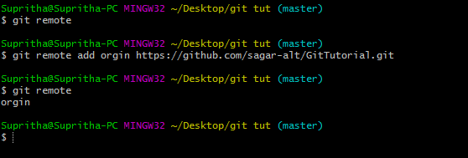

- git remote
has there is no website added

- git remote add orgin https://github.com/sagar-alt/GitTutorial.git
add of website

- git remote
now it will show has u added

git remote –v
will show where u push or pull
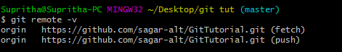

git push master origin

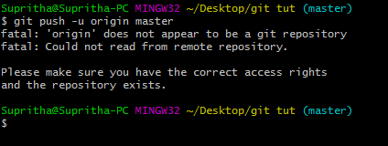

U cant push code. U need to add ssh key in git hub

- Create the SSH Key
$ ssh-keygen -t rsa -b 4096 -C your_email@example.com

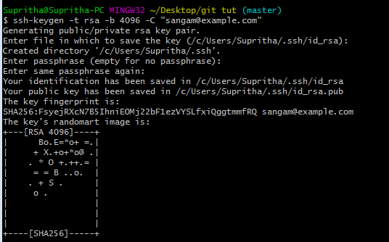
- Ensure the SSH key running



- Get SSh key add it

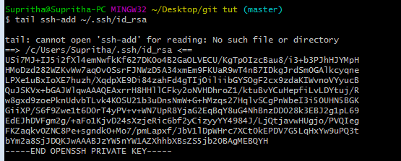

$ git push -u origin master

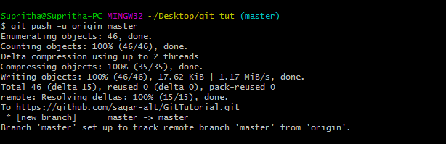

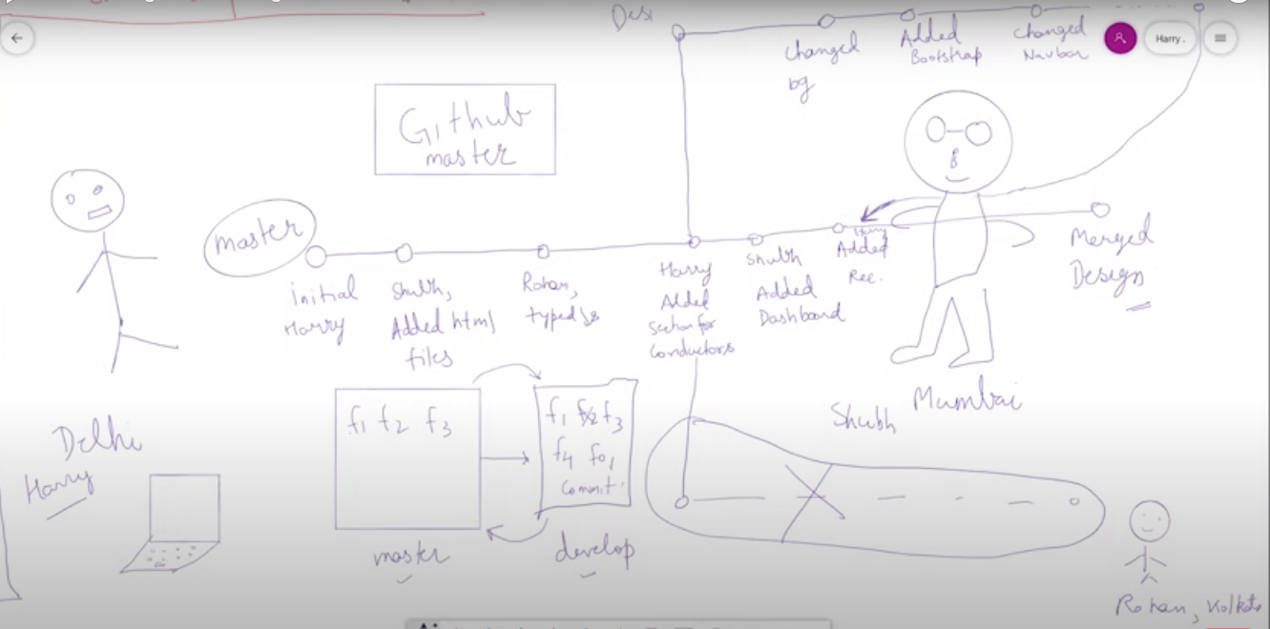

git checkout –b develop :
- It will create the new branch
- It will take u to new branch
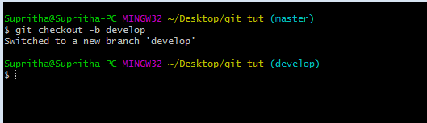

git branch:
- list all the branch



git checkout:
- will help to enter the branch
- make sure that before check out file’s are committed nor u will loose


Master

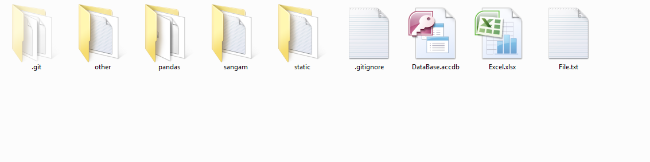

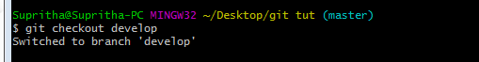

develop



Has u see in same folder two branch are created

Merge

