

KESHAV MEMORIAL INSTITUTE OF TECHNOLOGY
DEPARTMENT OF CSE(AI&ML)
PRAGYAAN 2.0
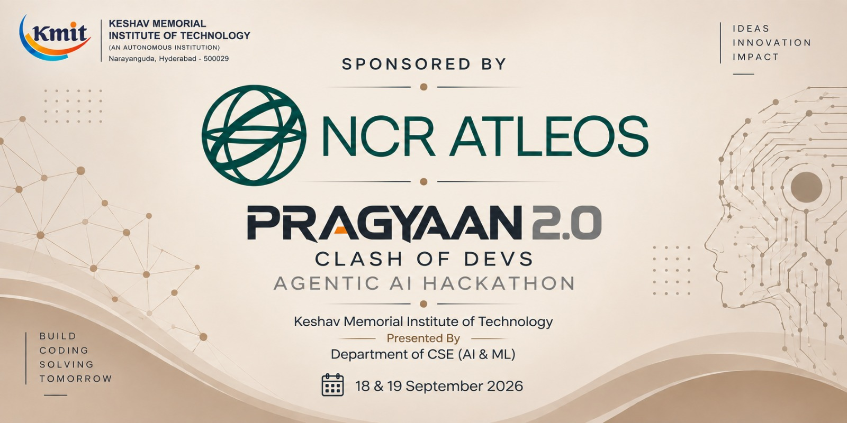

INSTRUCTIONS TO PARTICIPATING TEAMS

- Problem statements will be released by tomorrow, 18-Sep-2026 at 10:00am.
- A team can select a problem statement and start working on it as per the specifications.
- You are also given a template of .md file which you need to prepare for your problem statement.
- Around 6pm, on 18-Sep-2026, a google form is circulated to the team leaders in the whatsapp group. You are supposed to fill it and attach the .md file in it.
- The evaluators will go through the .md file and will get an initial understanding of your solution design.
- On 19-Sep-2026, you are supposed to come with your team by 9:00am. After registration and a short inaugural ceremony, the evaluators will start the Checkpoint Session. During this, you are asked to develop a solution for a new feature.
- You are supposed to complete it by lunch hour.
- You will break for lunch by 1:00pm.
- By 2:00pm, the evaluation process starts.
- Soon after the evaluation, the results will be consolidated, and the teams will proceed for a valedictory ceremony.
- The winners are announced and the prize distributed.
- The hackathon will be declared as completed.

*** We wish you all the very best***

