School Of Computing



**End semester Lab exam**

**Android Application Development**

**20CYS404**



**Amrita Vishwa Vidyapeetham Chennai – 601 103, Tamil Nadu, India.**

**Done by:**

**Srish N**

**CH.EN.U4CYS21081**

**Question:**

1. Create a Course Registration Form, Name, Course and Fees.

2. If OK button is pressed then the data should be saved in SQL lite and the "Record Added" toast should display.

3. If view is clicked all the previous data should be displayed inside a TABLE Format.

4. Perform EDIT, Delete, Back operations.

Storage should be done in SQLite and Firebase

Code:

MainActivity.java

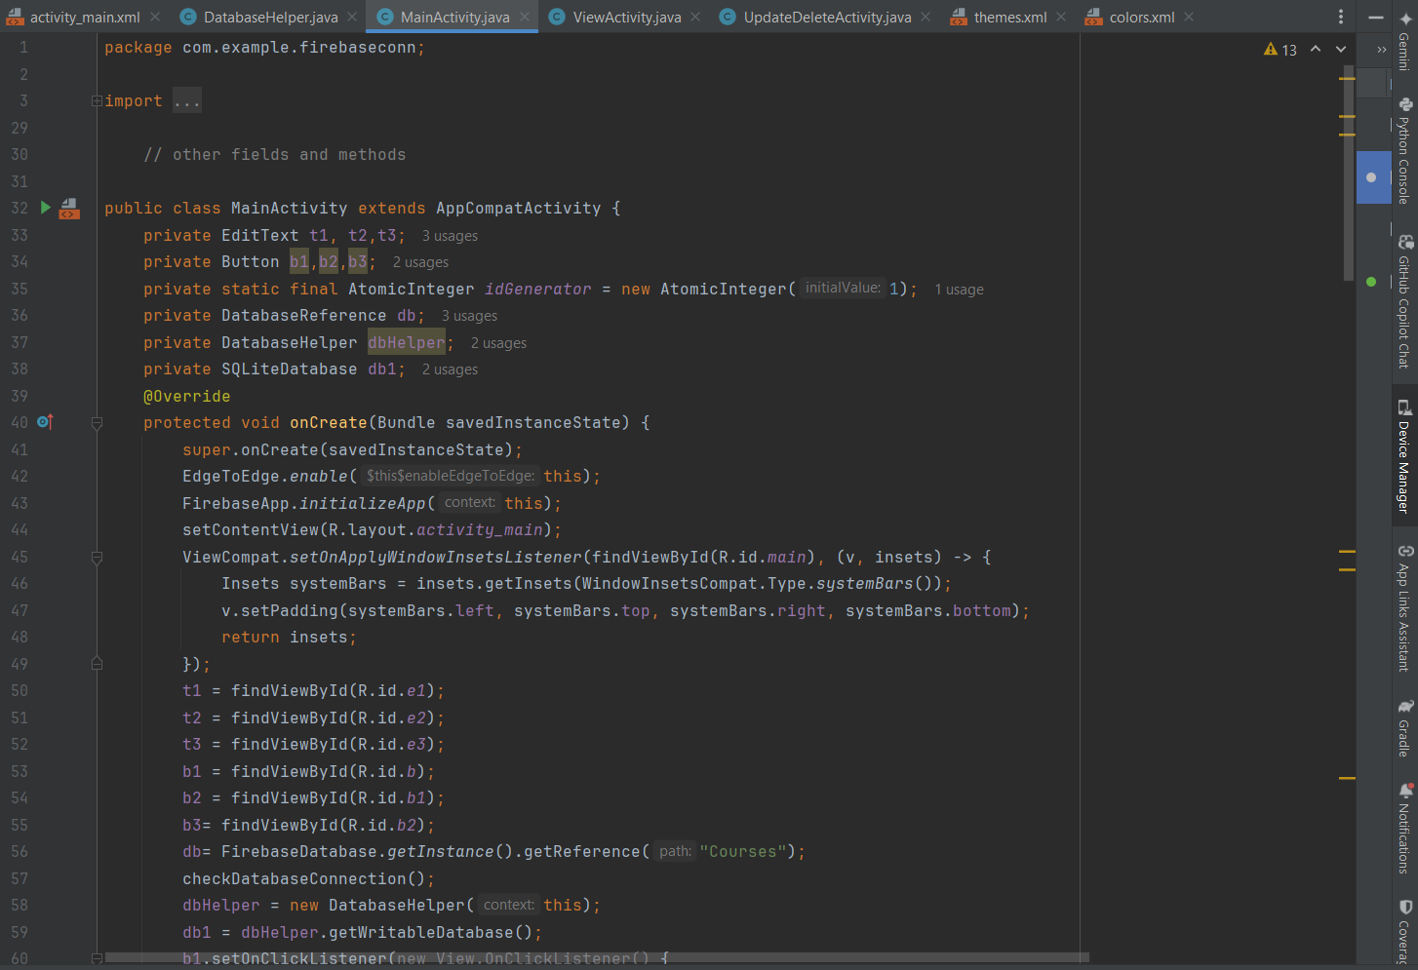

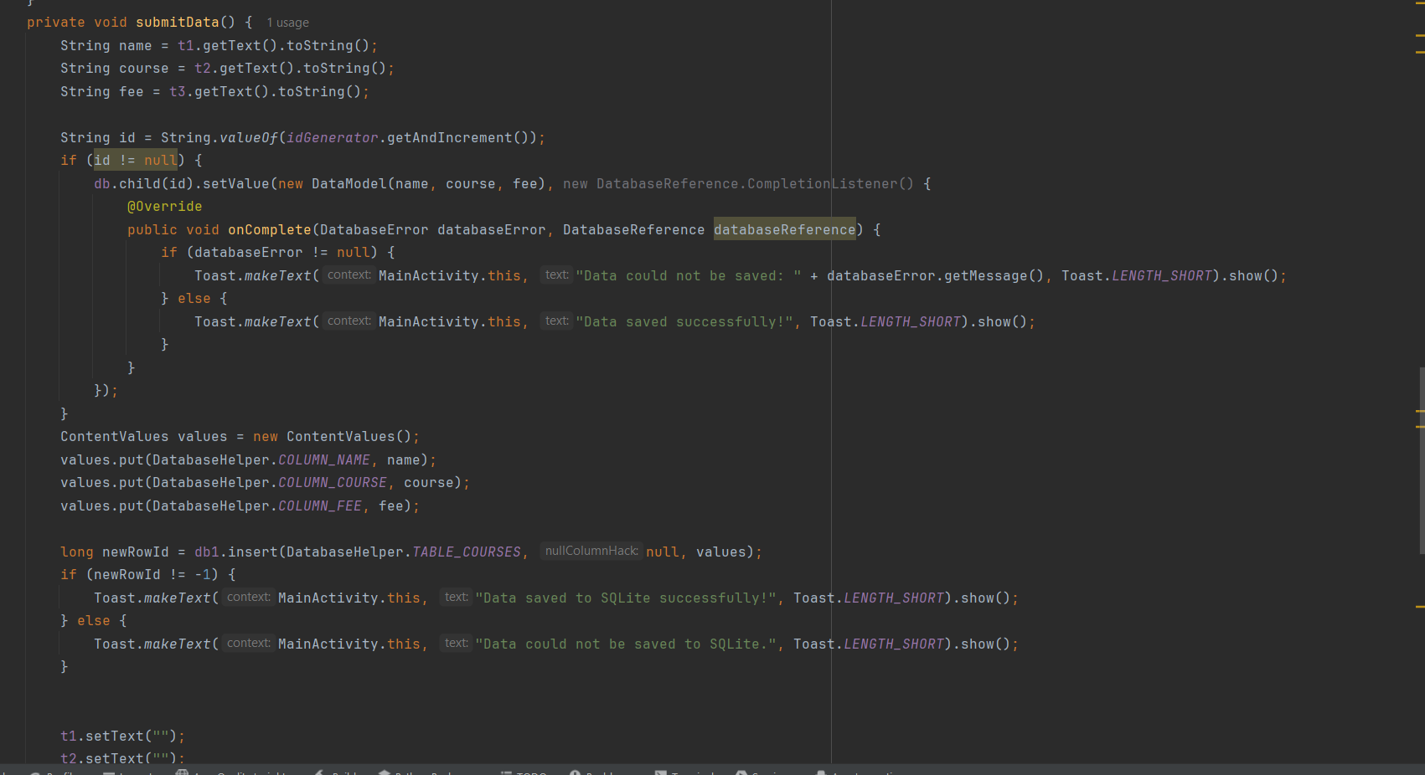

**View Activitu.java**

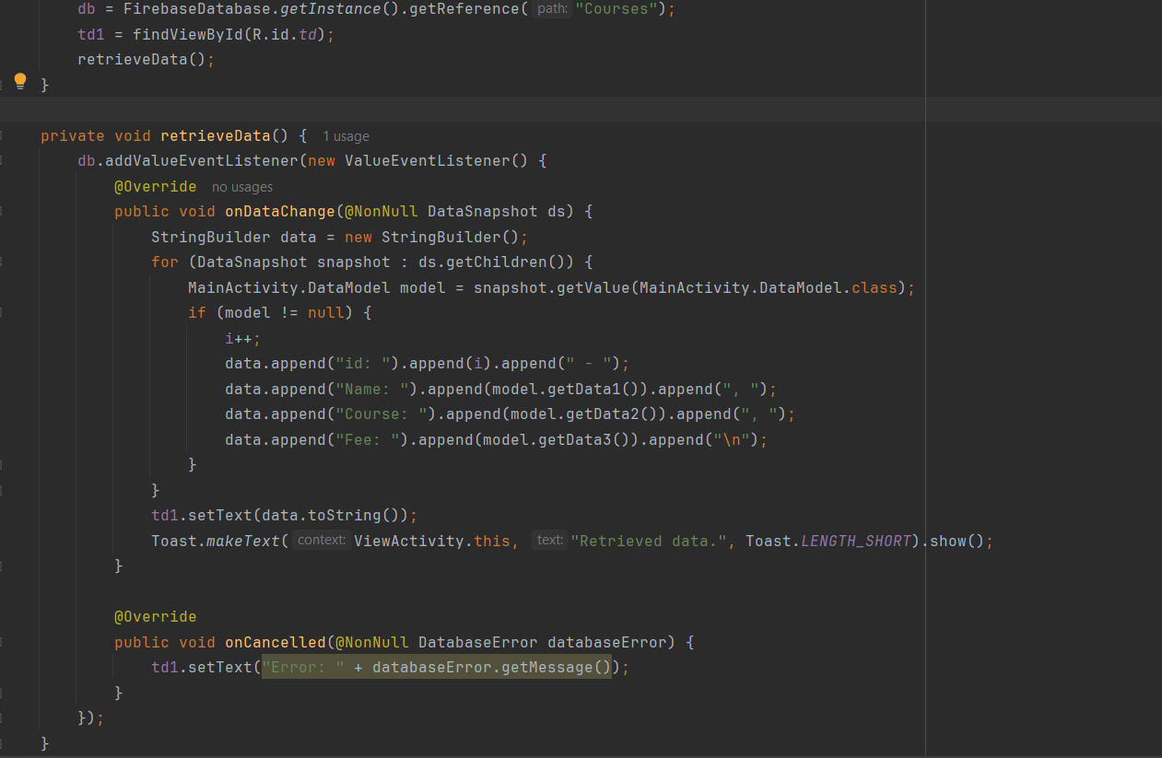

Updatedeleteactivity.java

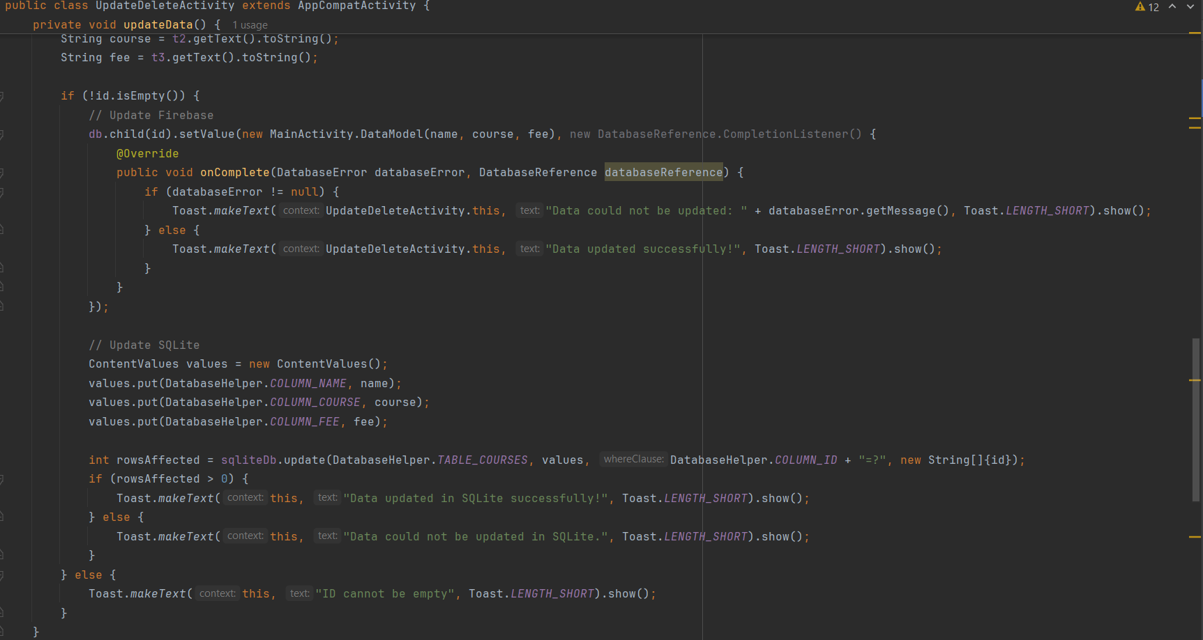

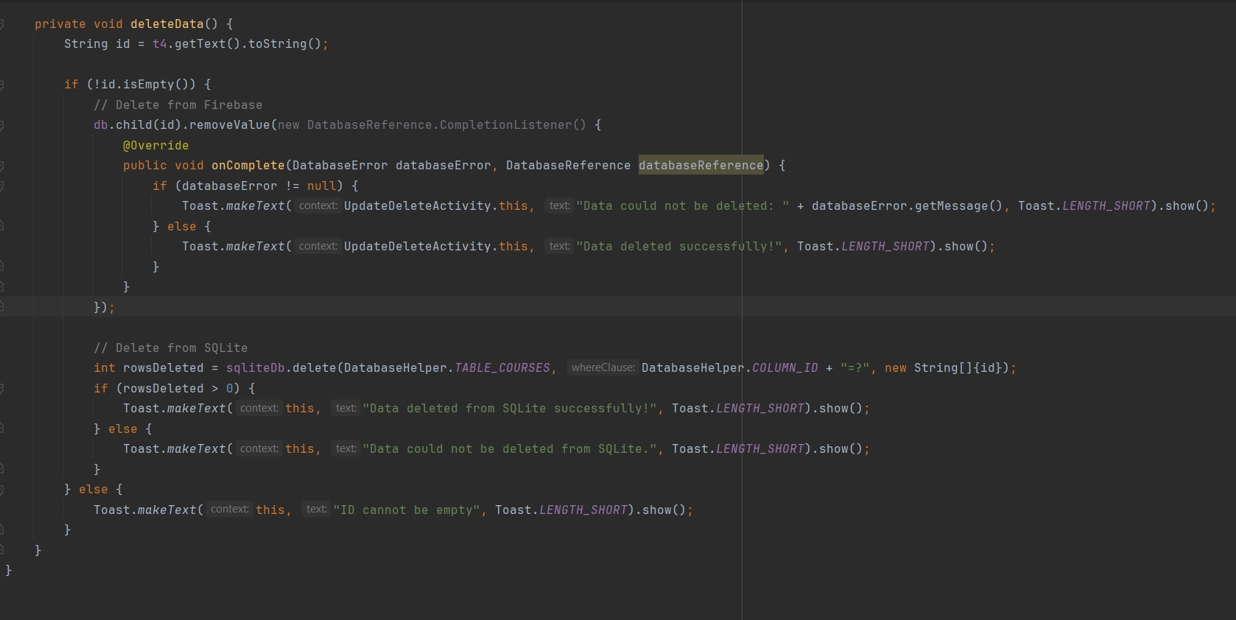

Database helper.java

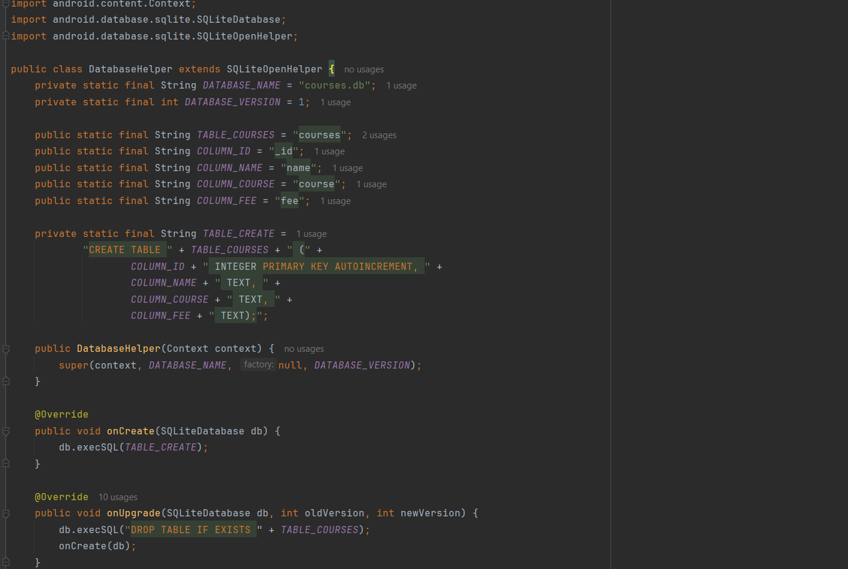

Activity main.xml

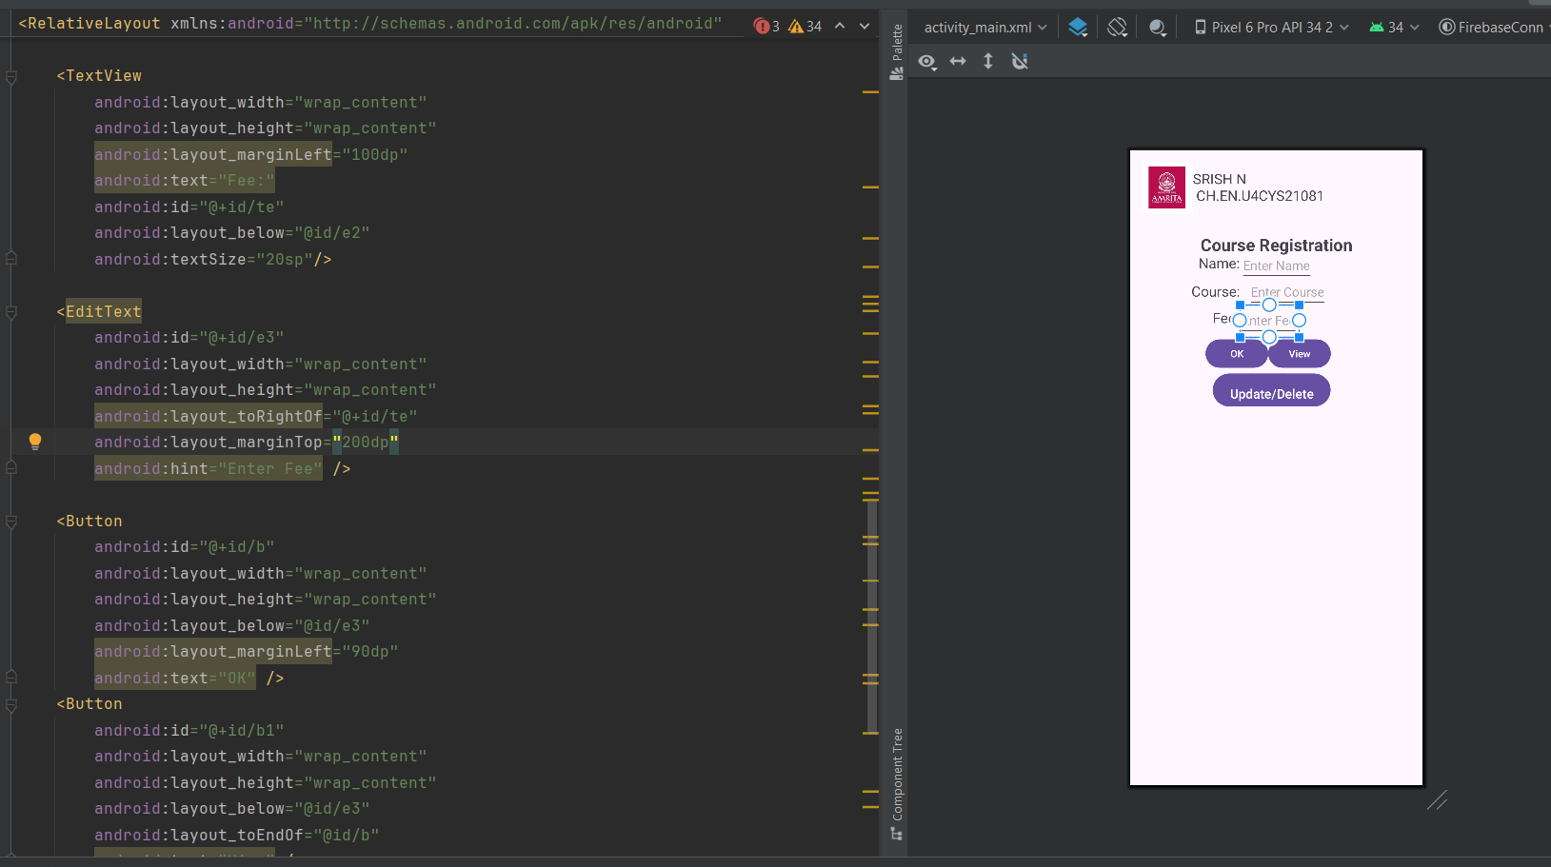

Activity_update_delete.xml

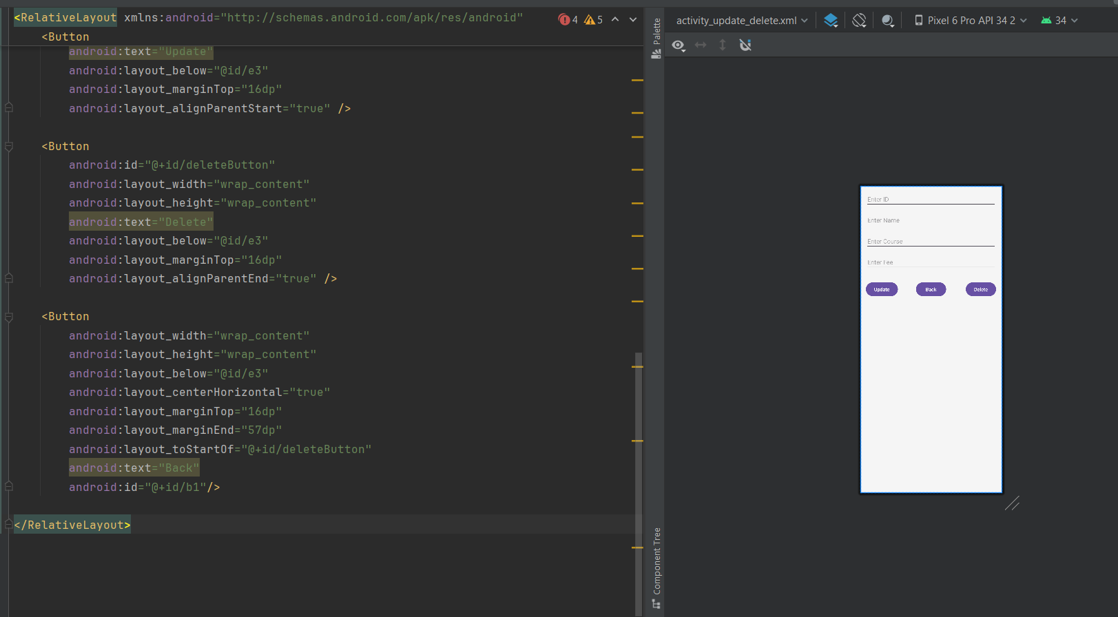

View_activity.xml

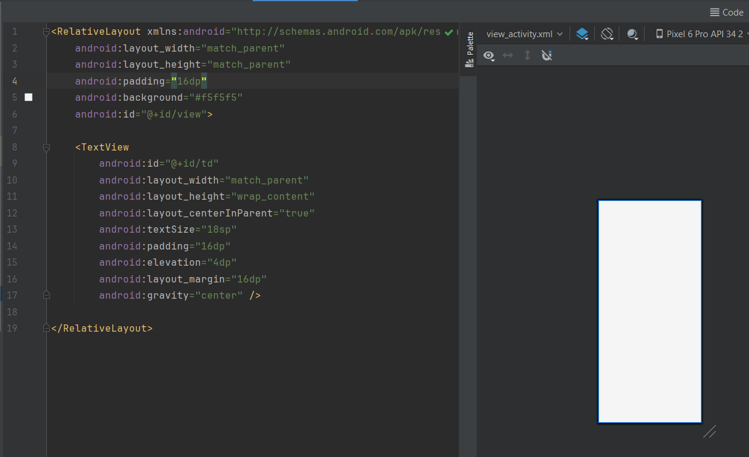

Outputs:

