1)

a)

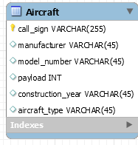

b)

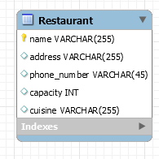

c)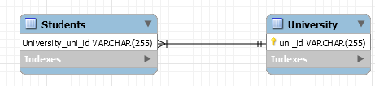

d)

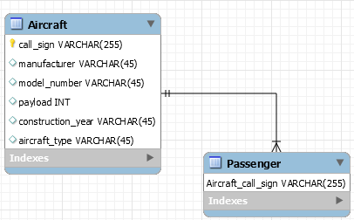

**Data in DB**

1a)aircraft Table

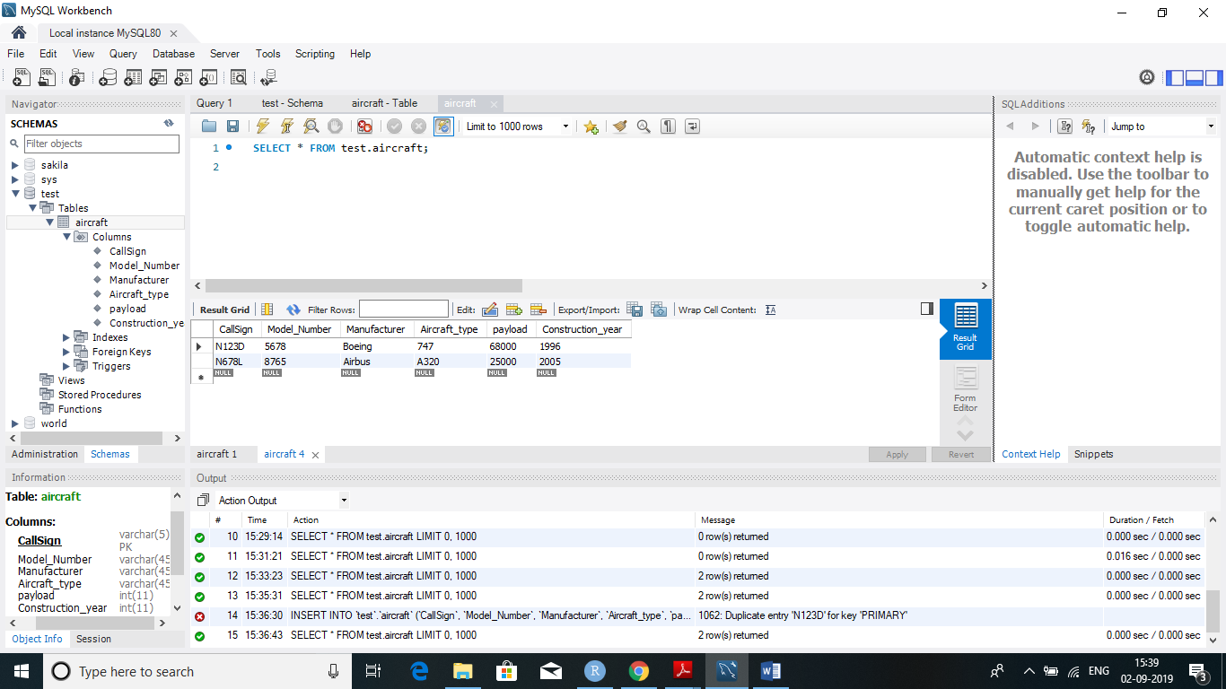

1 b)restaurants Table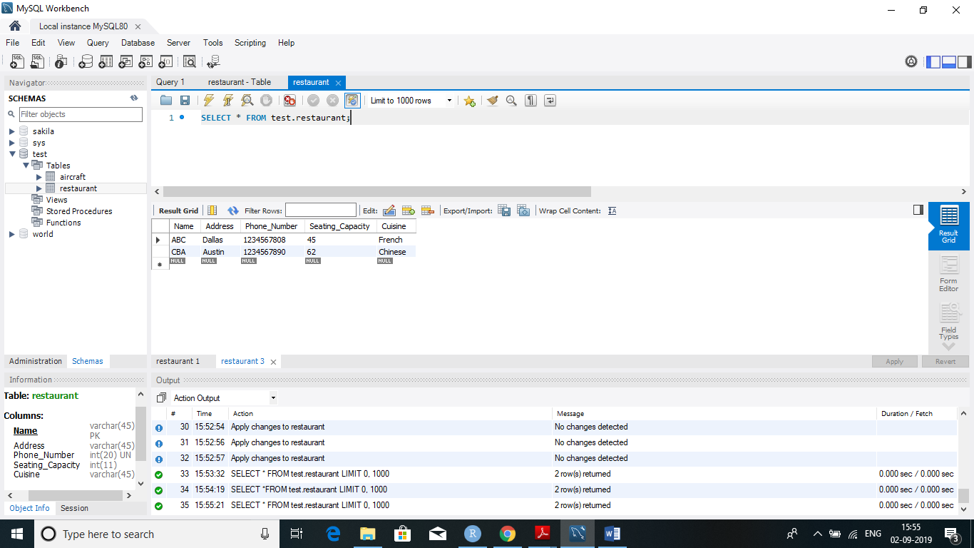

1 c)Student- University

1 c) University Table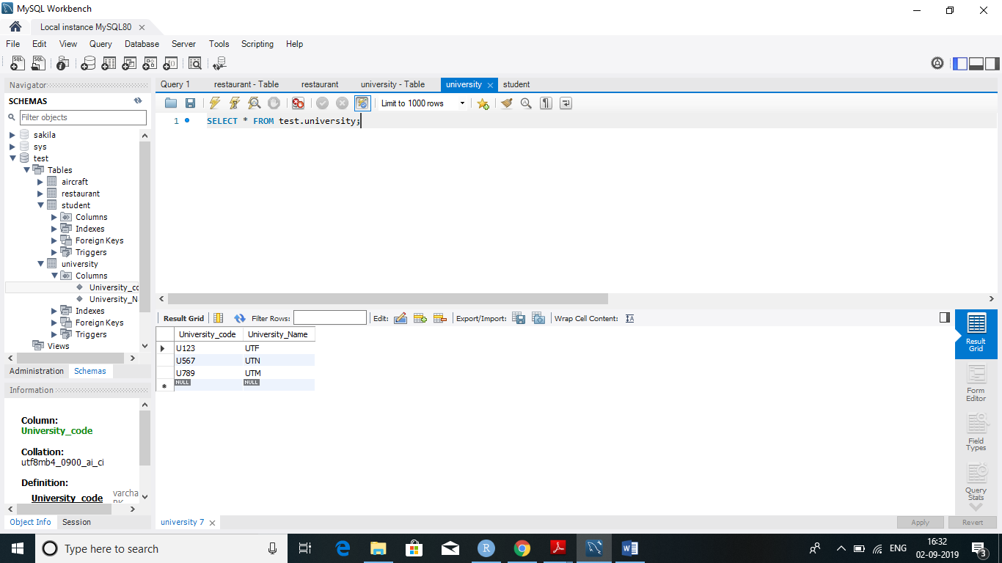

1 c) Student table with University code as foreign key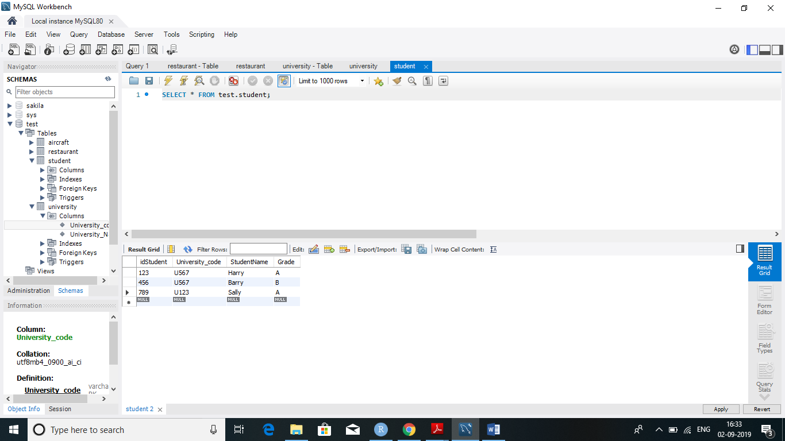

1 d) Passenger – Flight relationship

i) Flight table

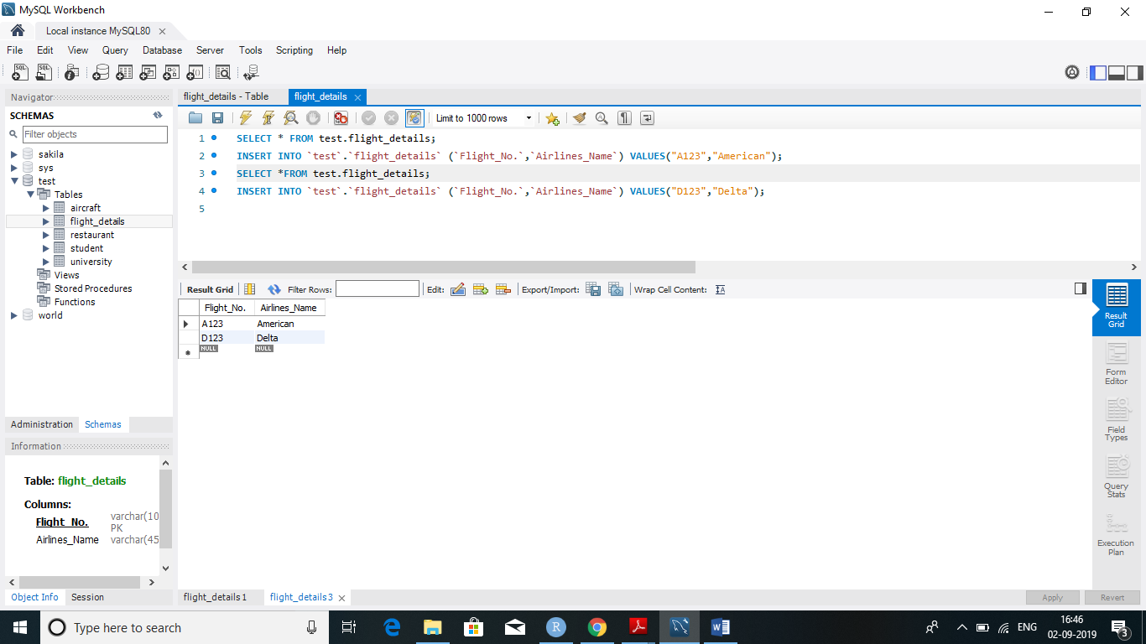

ii)Passenger table with Flight_No as foreign key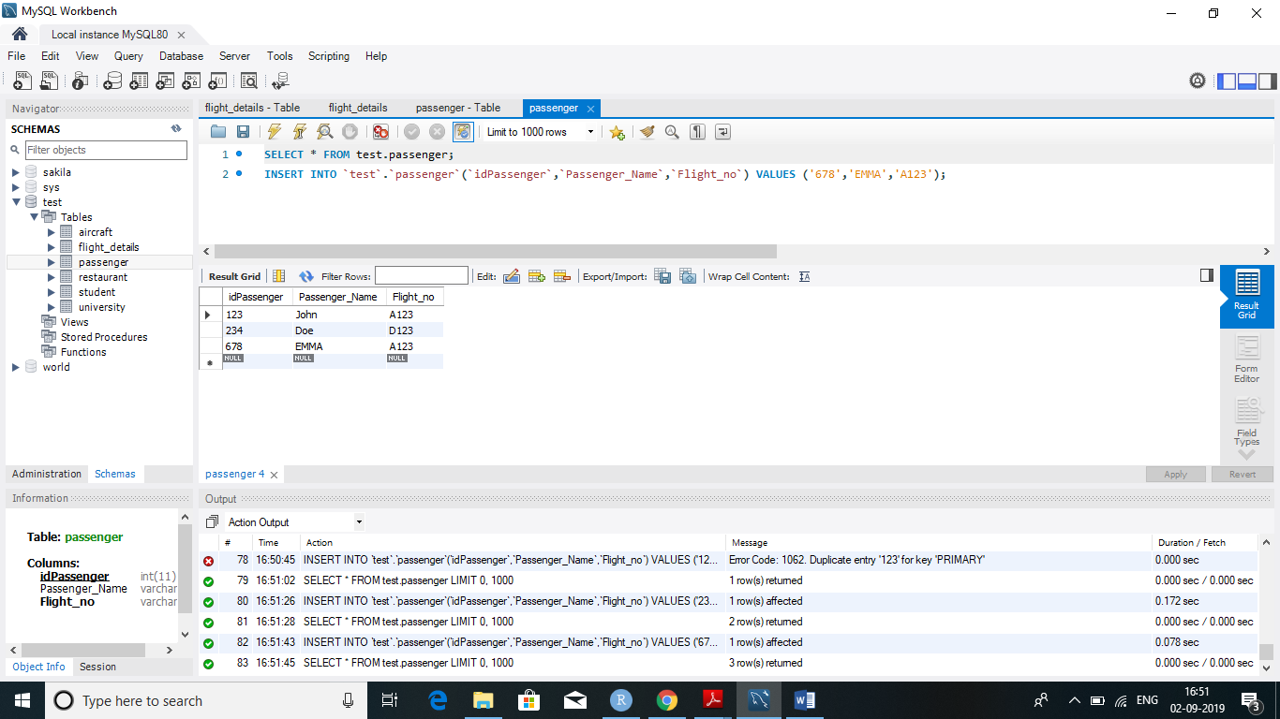

***CW1: Data Modeling and Normalization***

**Question 2**

2. Kick and Swing Inc. is a wholesaler of sporting goods equipment for retailers in a local metropolitan area. The company buys sporting goods equipment direct from manufacturers and then resells them to individual retail stores in the regional area. The raw data in attached spreadsheet illustrates some of the information required for the company’s purchase order system. As you can see, this information is characteristic of accounting purchase order systems but is not well organized. In fact, because of the repeating groups in the right-most columns, it cannot even be stored in a database.

Complete each of the following tasks (1 point each), using [K-Sdata.xlsx](https://elearning.utdallas.edu/bbcswebdav/pid-2602163-dt-content-rid-68015577_1/xid-68015577_1)

1. Reorganize the data in first normal form. Why is your data in first normal form?
2. Reorganize the data from part 1 into second normal form. Why is your data in second normal form?
3. Reorganize the data from part 2 into third normal form. Why is your data in third normal form?

**Raw Data**

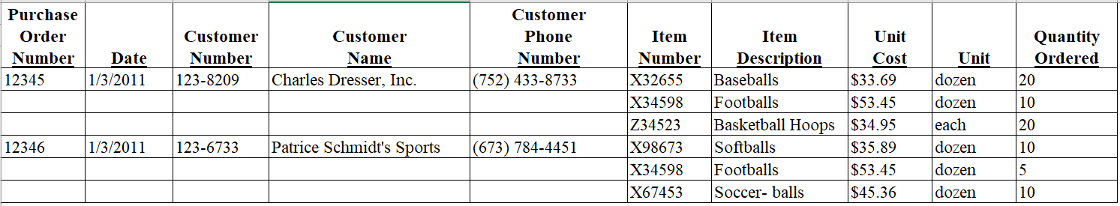

**1NF**

|  |
| --- |
| Each table cell should contain a single value. |
| Each record needs to be unique. |

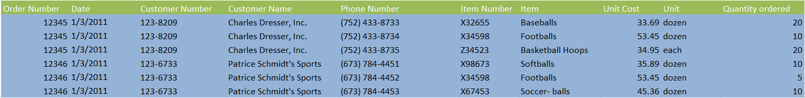

**2NF**

|  |
| --- |
| There are no repeating groups |
| All data values are atomic |
| Each field has a unique name |
| It has a Primary Key |



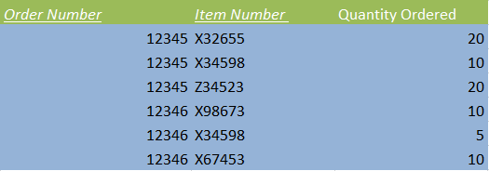

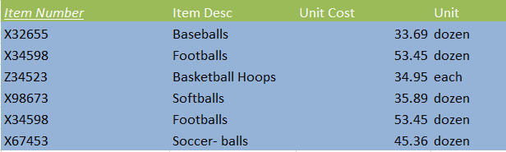

**3NF**

There must be no transitive dependency

