CW-3

**Question1**

Question: Show me an alphabetical list of all the staff members and their salaries if they make between $40,000 and $50,000 a year

Translation: Display all staff members whose salary lies between 40000$ and 50000$ in the alphabetical order.

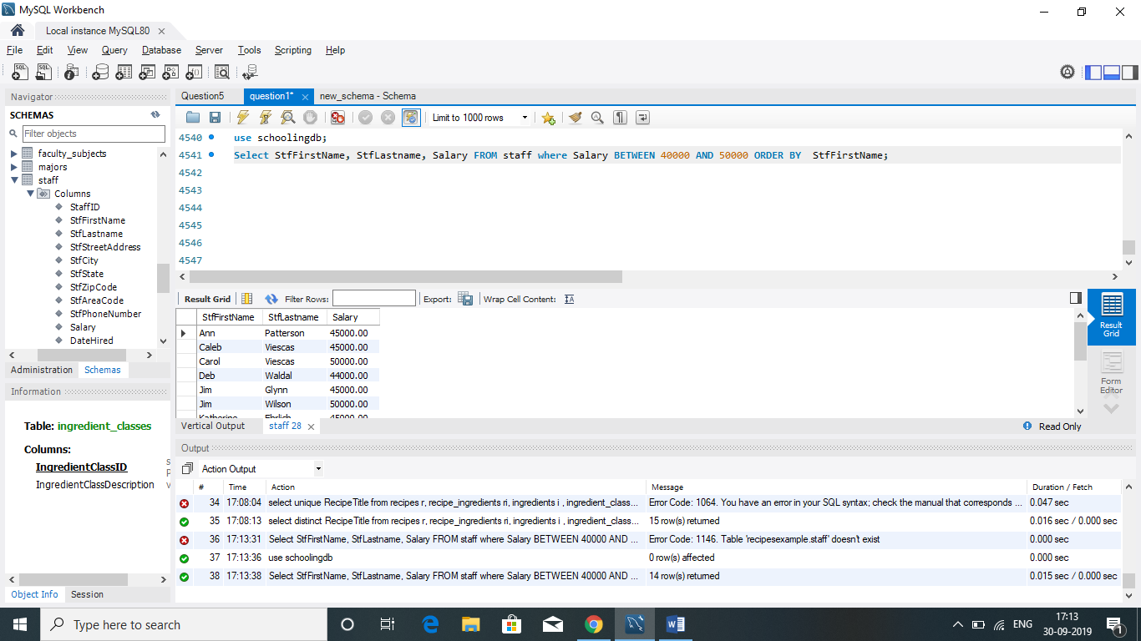

**Question 2**

**Question:** Show me a list of students whose last name is ‘Kennedy’ or who live in Seattle

**Translation**: Display/Select all students whose last name is Kennedy or students who live in the city of Seattle

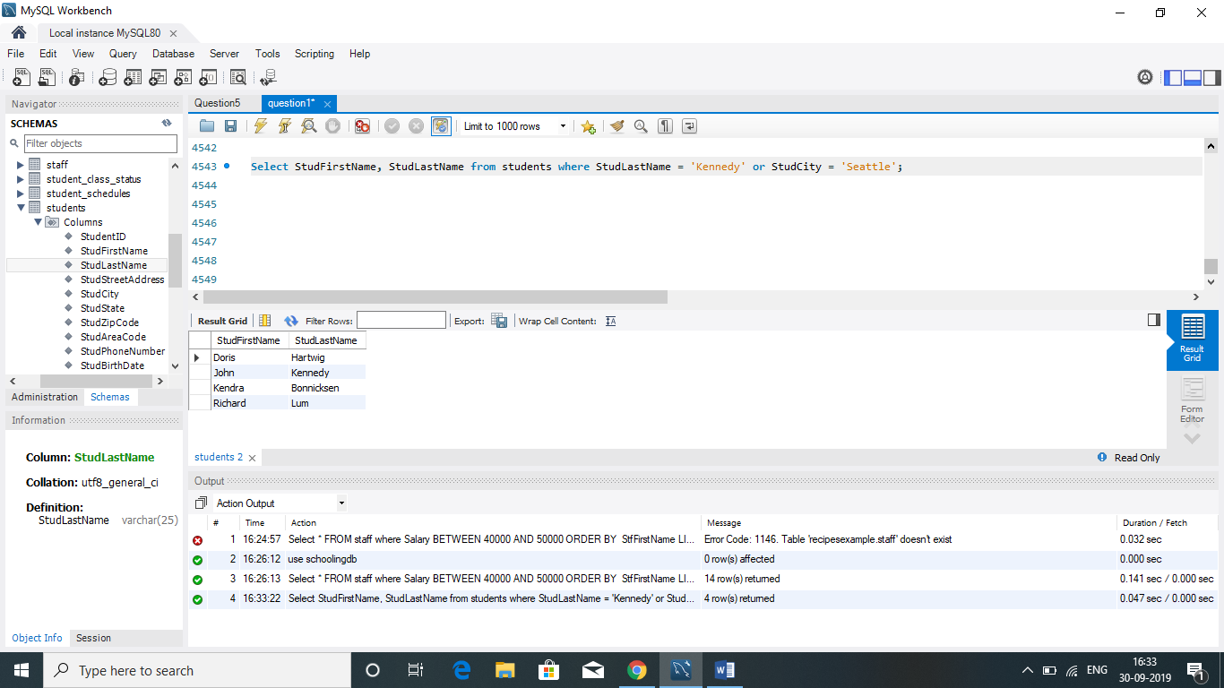

Question 5

**Question:** List the recipes that have no notes

**Translation**: Select all recipes where notes is null

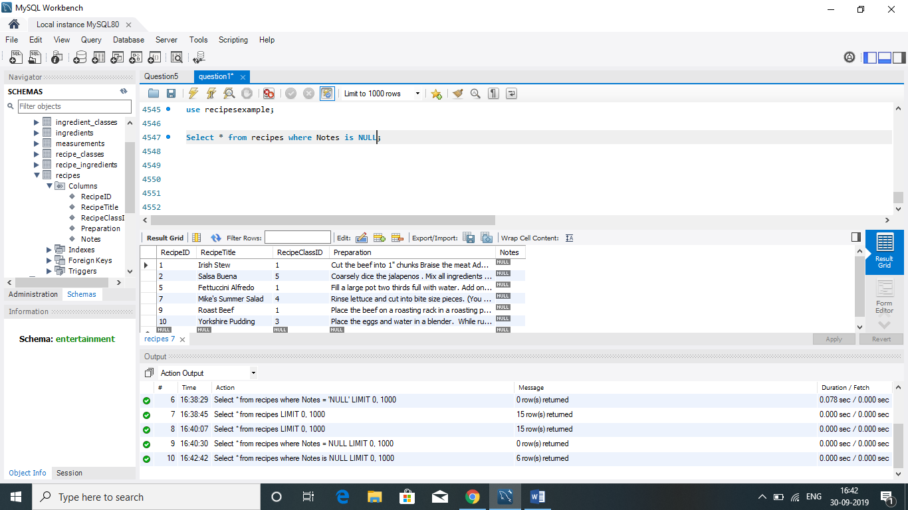

Question 6

**Question**: Show the ingredients that are meats (ingredient class is 2) but that aren’t chicken

**Translation**: Display all ingredients that have ingredientclass value 2 but are not chicken.

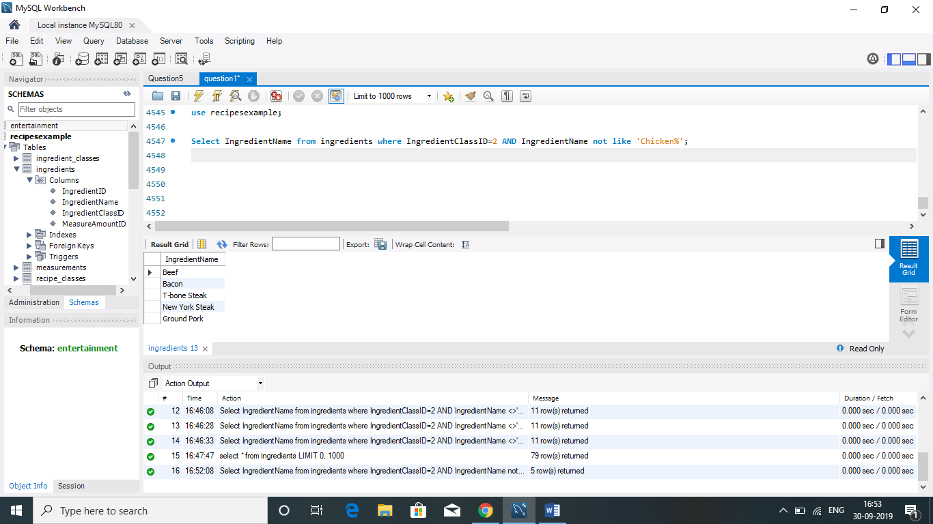

Question 10

**Question**: Provide a list of teams along with the names of the team captains

**Translation**: display all the team names and the corresponding captains of the team.

