1. How many classes are held in room 3346?

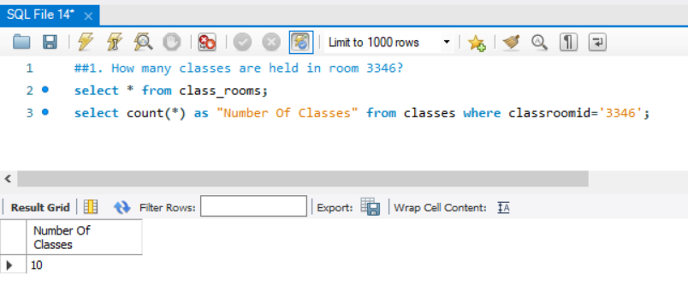

1. Calculate the current average raw score and handicap for each bowler.

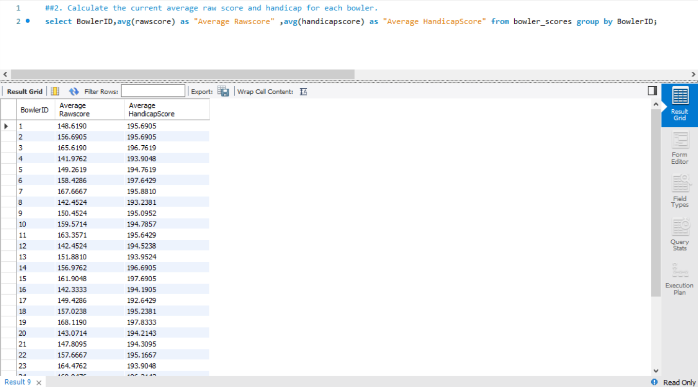

1. List all meat ingredients and the count of recipes that include each one.

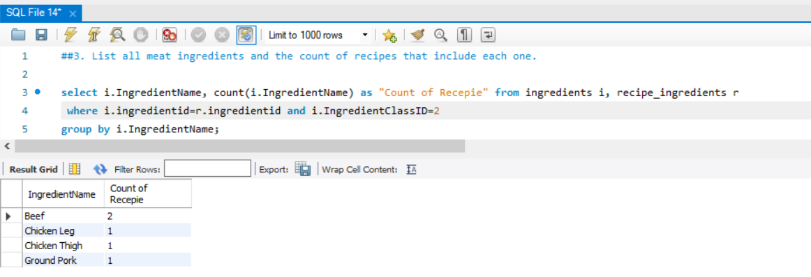

1. Show me the subject categories that have fewer than three full professors teaching that subject.

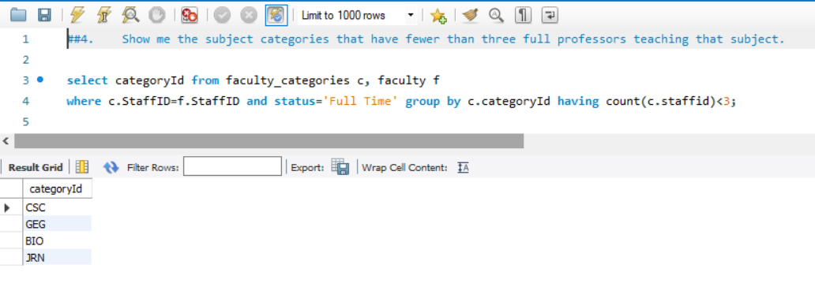

1. For what class of recipe do I have two or more recipes?

