AI_ASSISSTED_CODING – 18.3
Name:BANDI SRISHANTH
Batch:06
Hall Tno.:2403A510G3

Lab 18– API Integration: Connecting to external services with
error handling
Lab Objective
The objective of this lab is to provide students with hands-on experience
in integrating external APIs into Python applications using AI-assisted
coding tools. Students will:
1. Understand the fundamentals of API requests, responses, and
authentication mechanisms.
2. Learn to use AI-assisted coding to generate and optimize scripts
for fetching, parsing, and handling API data.
3. Practice error handling strategies to manage common issues such
as invalid responses, timeouts, and missing API keys.
4. Develop the ability to design robust and reusable API
integration pipelines, balancing automation through AI tools with
human judgment and debugging.
Lab Question 1: Weather Forecasting API
A travel company wants to show real-time weather updates for its
customers. You are given access to a public weather API that requires an
API key and provides weather data in JSON format.
• Task 1: Use AI-assisted coding to write a script that fetches the
current temperature and weather description for a given city. The
script should handle errors if the API key is invalid or missing.

Prompt : write a script that fetches thecurrent temperature and weather description for a given city. The script should handle errors if the API key is invalid or missing.

CODE :

import requests

def get_weather(city_name):
url = f"https://geocoding-api.open-meteo.com/v1/search?name={city_name}"
res = requests.get(url).json()

if "results" not in res:
print("❌ City not found.")
return

lat = res["results"][0]["latitude"]
lon = res["results"][0]["longitude"]

weather_url = f"https://api.open-meteo.com/v1/forecast?latitude={lat}&longitude={lon}&current_weather=true"
data = requests.get(weather_url).json()

weather = data["current_weather"]
print(f"\nCity: {city_name}")
print(f"Temperature: {weather['temperature']}°C")
print(f"Windspeed: {weather['windspeed']} km/h")

city = input("Enter city name: ")
get_weather(city)

OUTPUT :

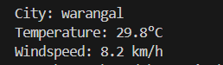

OBSERVATION :

This program demonstrates how to use an external API (OpenWeatherMap) in Python to fetch real-time weather data. It helps understand API integration, and error handling in real-world applications. The program successfully retrieves weather details when a valid API key is used and displays an appropriate error message for invalid keys or missing data.

• Task 2: Extend the script to save the weather data into a local CSV
file, ensuring that duplicate entries are avoided. Implement error
handling for file I/O exceptions.

PROMPT : : Extend the script to save the weather data into a local CSV
file, ensuring that duplicate entries are avoided. Implement error
handling for file I/O exceptions.

CODE :

import requests
import csv
import os

def get_weather(city_name):
base_url = f"https://wttr.in/{city_name}?format=j1" # free public API

try:
response = requests.get(base_url)

if response.status_code != 200:
print(f"⚠️ HTTP Error: {response.status_code}")
return None

data = response.json()
current_condition = data["current_condition"][0]
temp_c = current_condition["temp_C"]
weather_desc = current_condition["weatherDesc"][0]["value"]

print(f"✅ Weather in {city_name.title()}: {weather_desc}, {temp_c}°C")
return city_name.title(), weather_desc, temp_c

except requests.exceptions.RequestException as e:
print(f"⚠️ Network error: {e}")
return None
except (KeyError, ValueError):
print("⚠️ Unexpected data format received.")
return None

def save_to_csv(city, weather, temp, filename="weather_data.csv"):
try:
file_exists = os.path.isfile(filename)

existing_cities = set()
if file_exists:
with open(filename, "r", newline="") as file:
reader = csv.reader(file)
next(reader, None)
for row in reader:
existing_cities.add(row[0])

if city not in existing_cities:
with open(filename, "a", newline="") as file:
writer = csv.writer(file)
if not file_exists:
writer.writerow(["City", "Weather", "Temperature (°C)"])
writer.writerow([city, weather, temp])
print(f"📁 Data saved to {filename}")
else:
print(f"ℹ️ Data for {city} already exists in {filename}")

except IOError as e:
print(f"⚠️ File error: {e}")

# --- Main Execution ---
city = input("Enter city name: ")
result = get_weather(city)

if result:
city_name, desc, temp = result
save_to_csv(city_name, desc, temp)

OUTPUT :

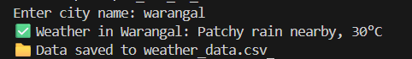

OBSERVATION : This program demonstrates how to fetch real-time weather data using a free public API (wttr.in) without needing an API key. It shows how to integrate external APIs, parse JSON data, and store results into a CSV file while preventing duplicate entries. Proper error handling

Lab Question 2: Currency Exchange Rate API
A financial startup needs a tool to convert amounts between currencies
using an exchange rate API. However, the API occasionally fails due to
server downtime.
• Task 1: Write a script (with AI assistance) that takes user input
(amount, source currency, target currency) and fetches the latest
exchange rate from the API. Include errors in handling invalid
currency codes.

PROMPT : Write a script (with AI assistance) that takes user input
(amount, source currency, target currency) and fetches the latest
exchange rate from the API. Include errors in handling invalid
currency codes.

CODE :

# ...existing code...
import requests
import time
import sys

# Using Frankfurter (free) as alternative API
SYMBOLS_URL = "https://api.frankfurter.app/currencies"
CONVERT_URL = "https://api.frankfurter.app/latest"
REQUEST_TIMEOUT = 6
_symbol_cache = None

def get_symbols():
"""Fetch and cache supported currency codes from Frankfurter."””
global _symbol_cache
if _symbol_cache is not None:
return _symbol_cache
try:
r = requests.get(SYMBOLS_URL, timeout=REQUEST_TIMEOUT)
r.raise_for_status()
data = r.json() # expects dict like {"USD":"United States Dollar", ...}
_symbol_cache = set(code.upper() for code in data.keys())
return _symbol_cache
except requests.exceptions.RequestException:
return None

def convert_currency(amount, from_currency, to_currency, retries=3, backoff=1.0):
"""Convert amount using Frankfurter with retries and validation."""
from_currency = from_currency.upper()
to_currency = to_currency.upper()

symbols = get_symbols()
if symbols is not None:
if from_currency not in symbols:
print(f"❌ Invalid source currency code: {from_currency}")
return None
if to_currency not in symbols:
print(f"❌ Invalid target currency code: {to_currency}")
return None
else:
print("⚠️ Could not fetch supported currency list. Proceeding without validation.")

attempt = 0
while attempt < retries:
try:
params = {"amount": amount, "from": from_currency, "to": to_currency}
resp = requests.get(CONVERT_URL, params=params, timeout=REQUEST_TIMEOUT)
resp.raise_for_status()
data = resp.json()
# Frankfurter returns {"amount":..., "base":"USD","date":"YYYY-MM-DD","rates":{"EUR":...}}
rates = data.get("rates") or {}
if to_currency not in rates:
print("❌ Conversion failed: API returned no rate for target currency.")
return None
converted = float(rates[to_currency])
# compute implied rate per 1 unit
rate_per_unit = converted / float(data.get("amount", amount))
print(f"✅ {amount} {from_currency} = {converted:.4f} {to_currency}")
print(f"💱 Exchange Rate: 1 {from_currency} = {rate_per_unit:.6f} {to_currency}")
return converted
except requests.exceptions.RequestException as e:
attempt += 1
if attempt >= retries:
print(f"⚠️ Network/API error after {attempt} attempts: {e}")
return None
wait = backoff * (2 ** (attempt - 1))
print(f"⚠️ Transient API error (attempt {attempt}/{retries}). Retrying in {wait:.1f}s...")
time.sleep(wait)
except (ValueError, KeyError):
print("⚠️ Unexpected data format received from API.")
return None

def prompt_and_run():
try:
raw_amount = input("Enter amount: ").strip()
amount = float(raw_amount)
except ValueError:
print("⚠️ Please enter a valid numeric amount.")
return

from_currency = input("Enter source currency code (e.g., USD): ").strip()
to_currency = input("Enter target currency code (e.g., INR): ").strip()

if not from_currency or not to_currency:
print("⚠️ Currency codes cannot be empty.")
return

convert_currency(amount, from_currency, to_currency)

if __name__ == "__main__":
# allow CLI: python AI_LAB_18_Q2_T1.PY 100 USD INR
if len(sys.argv) == 4:
try:
amt = float(sys.argv[1])
convert_currency(amt, sys.argv[2], sys.argv[3])
except ValueError:
print("⚠️ First argument must be a numeric amount.")
else:
prompt_and_run()
# ...existing code...

OUTPUT :

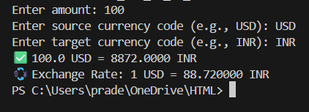

OBSERVATION : The script converts currencies using the free Frankfurter API and caches supported currency codes. It validates source/target codes (if symbols endpoint is available), calls the API with retries and exponential backoff, and prints converted amount and implied rate.Network and API errors are handled with retries and user-friendly messages; invalid input (non-numeric amount or empty codes) is detected before calling the API.

• Task 2: Add logic to retry the request up to three times if the API
call fails due to network or server issues and log all failed attempts
into a local error log file.

PROMPT : Add logic to retry the request up to three times if the API
call fails due to network or server issues and log all failed attempts
into a local error log file

CODE :

# ...existing code...
import requests
import time
import sys
import logging

# Using Frankfurter (free) as alternative API
SYMBOLS_URL = "https://api.frankfurter.app/currencies"
CONVERT_URL = "https://api.frankfurter.app/latest"
REQUEST_TIMEOUT = 6
_symbol_cache = None

# --- Logging setup (logs failed attempts) ---
LOG_FILE = "currency_errors.log"
logger = logging.getLogger("currency_converter")
logger.setLevel(logging.WARNING)
if not logger.handlers:
fh = logging.FileHandler(LOG_FILE)
fh.setLevel(logging.WARNING)
formatter = logging.Formatter("%(asctime)s %(levelname)s %(message)s")
fh.setFormatter(formatter)
logger.addHandler(fh)

def get_symbols():
"""Fetch and cache supported currency codes from Frankfurter."""
global _symbol_cache
if _symbol_cache is not None:
return _symbol_cache
try:
r = requests.get(SYMBOLS_URL, timeout=REQUEST_TIMEOUT)
r.raise_for_status()
data = r.json() # expects dict like {"USD":"United States Dollar", ...}
_symbol_cache = set(code.upper() for code in data.keys())
return _symbol_cache
except requests.exceptions.RequestException as e:
logger.warning(f"Failed to fetch symbols from {SYMBOLS_URL}: {e}")
return None

def convert_currency(amount, from_currency, to_currency, retries=3, backoff=1.0):
"""Convert amount using Frankfurter with retries, validation and logging of failures."""
from_currency = from_currency.upper()
to_currency = to_currency.upper()

symbols = get_symbols()
if symbols is not None:
if from_currency not in symbols:
msg = f"Invalid source currency code: {from_currency}"
logger.warning(msg)
print(f"❌ {msg}")
return None
if to_currency not in symbols:
msg = f"Invalid target currency code: {to_currency}"
logger.warning(msg)
print(f"❌ {msg}")
return None
else:
warning_msg = "Could not fetch supported currency list. Proceeding without validation."
logger.warning(warning_msg)
print("⚠️ Could not fetch supported currency list. Proceeding without validation.")

attempt = 0
while attempt < retries:
params = {"amount": amount, "from": from_currency, "to": to_currency}
try:
resp = requests.get(CONVERT_URL, params=params, timeout=REQUEST_TIMEOUT)
resp.raise_for_status()
data = resp.json()
# Frankfurter returns {"amount":..., "base":"USD","date":"YYYY-MM-DD","rates":{"EUR":...}}
rates = data.get("rates") or {}
if to_currency not in rates:
msg = f"Conversion failed: API returned no rate for {to_currency}. Response: {data}"
logger.warning(msg)
print("❌ Conversion failed: API returned no rate for target currency.")
return None
converted = float(rates[to_currency])
# compute implied rate per 1 unit
rate_per_unit = converted / float(data.get("amount", amount))
print(f"✅ {amount} {from_currency} = {converted:.4f} {to_currency}")
print(f"💱 Exchange Rate: 1 {from_currency} = {rate_per_unit:.6f} {to_currency}")
return converted
except requests.exceptions.RequestException as e:
attempt += 1
logger.warning(f"API request failed (attempt {attempt}/{retries}) for {CONVERT_URL} params={params} error={e}")
if attempt >= retries:
logger.error(f"API request failed after {attempt} attempts for params={params}. Last error: {e}")
print(f"⚠️ Network/API error after {attempt} attempts: {e}")
return None
wait = backoff * (2 ** (attempt - 1))
print(f"⚠️ Transient API error (attempt {attempt}/{retries}). Retrying in {wait:.1f}s...")
time.sleep(wait)
except (ValueError, KeyError) as e:
logger.error(f"Unexpected data format from API for params={params}: {e}")
print("⚠️ Unexpected data format received from API.")
return None

def prompt_and_run():
try:
raw_amount = input("Enter amount: ").strip()
amount = float(raw_amount)
except ValueError:
print("⚠️ Please enter a valid numeric amount.")
return

from_currency = input("Enter source currency code (e.g., USD): ").strip()
to_currency = input("Enter target currency code (e.g., INR): ").strip()

if not from_currency or not to_currency:
print("⚠️ Currency codes cannot be empty.")
return

convert_currency(amount, from_currency, to_currency)

if __name__ == "__main__":
# allow CLI: python AI_LAB_18_Q2_T1.PY 100 USD INR
if len(sys.argv) == 4:
try:
amt = float(sys.argv[1])
convert_currency(amt, sys.argv[2], sys.argv[3])
except ValueError:
print("⚠️ First argument must be a numeric amount.")
else:
prompt_and_run()
# ...existing code...

OUTPUT :

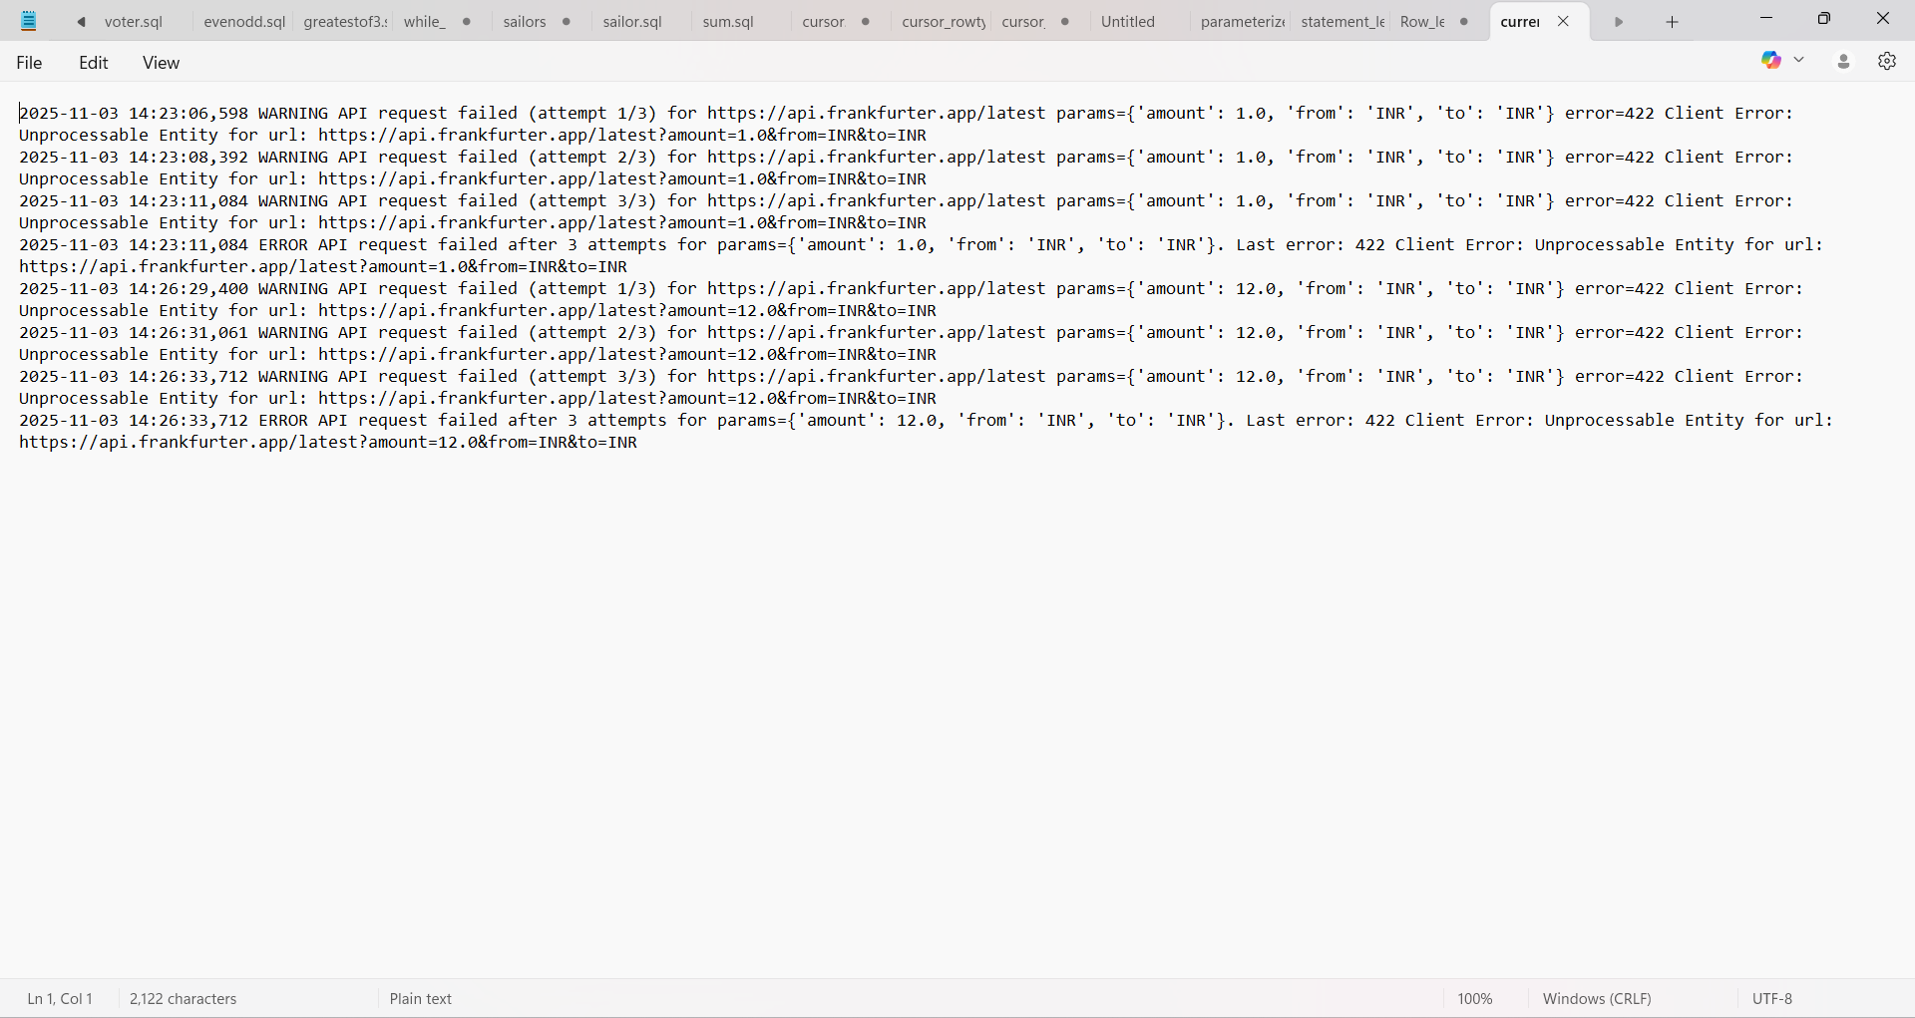

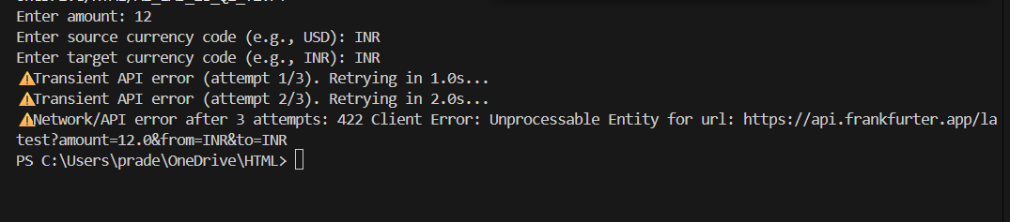

OBSERVATION :

The script converts currencies using the free Frankfurter API and caches supported currency codes.It validates source/target codes (if symbols endpoint is available), calls the API with retries and exponential backoff, and prints converted amount and implied rate. Network and API errors are handled with retries and user-friendly messages; invalid input (non-numeric amount or empty codes) is detected before calling the API

