Name:BANDI SRISHANTH
Batch :06
Hall Tno. :2403A510G3

Task 1 – Input Validation Check
Task: Analyze an AI-generated Python login script for input validation vulnerabilities.
Instructions:
• Prompt :AI to generate a simple username-password login program.
• Review whether input sanitization and validation are implemented.
• Suggest secure improvements (e.g., using re for input validation).
Expected Output:
• A secure version of the login script with proper input validation

Prompt: Generate a simple username-password login program.
Code(insecure)
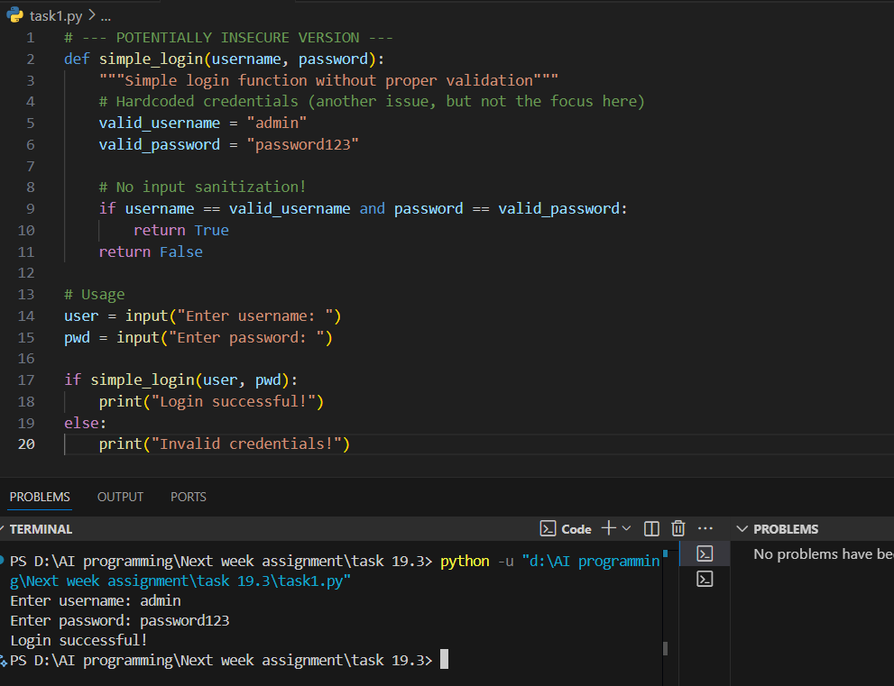
Secure Version of the Login Script
Here's the improved, secure version incorporating the analysis. It includes:
- Regex validation for username (alphanumeric, 3-20 chars) and password (at least 8 chars with mixed case, numbers, symbols).
- Sanitization: Strips whitespace, enforces length.
- Handles empty/invalid inputs with user-friendly prompts (re-ask up to 3 times).
- Uses getpass for hidden password entry (import getpass).
- Hashes the password for storage/comparison (using SHA-256 for demo; use bcrypt in production).
- Rate limiting: Locks after 3 failed attempts.
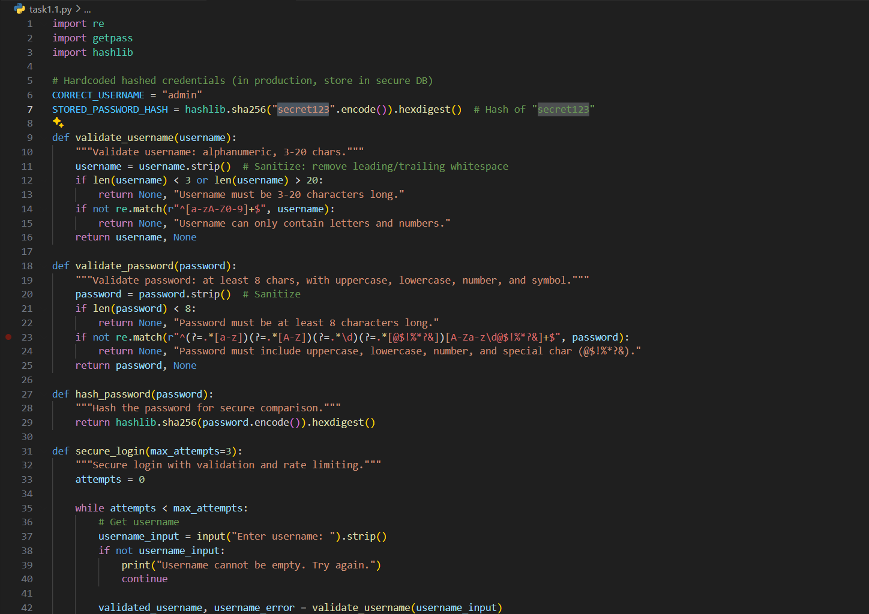
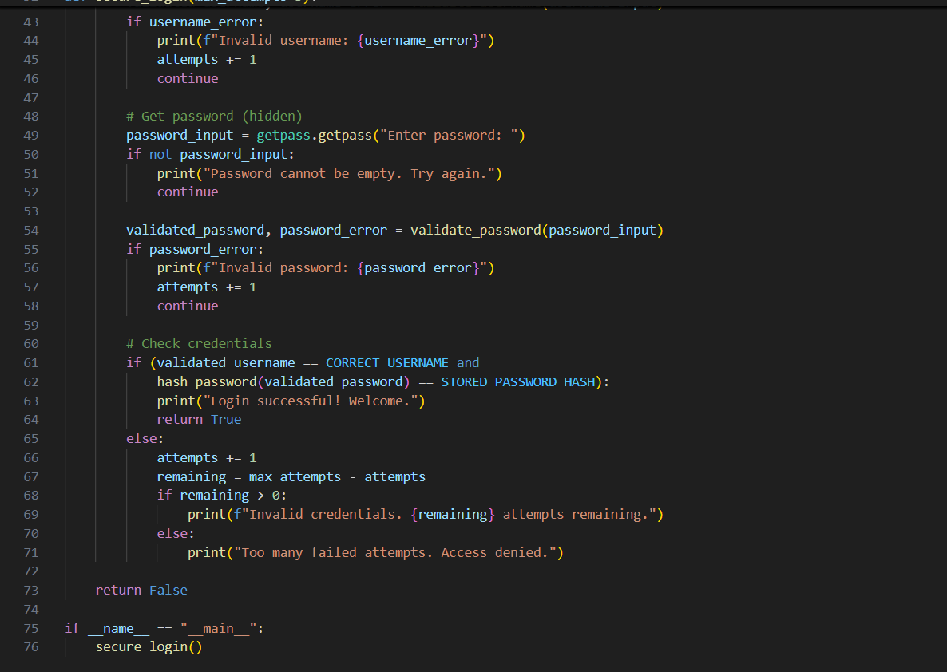
Output:
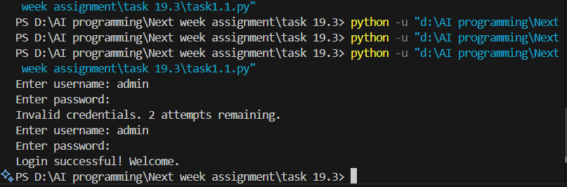

Secure Python Login Script Explanation
This script implements a robust console-based login system using hardcoded credentials (username: "admin", password: "Secret123!") to prevent unauthorized access.
It validates inputs with regex (re module): usernames must be alphanumeric (3-20 chars), passwords require 8+ characters including uppercase, lowercase, digit, and special char (@$!%*?&), while sanitizing via .strip() to remove whitespace.
Passwords are securely entered hidden (getpass.getpass()) and compared as SHA-256 hashes (hashlib), avoiding plaintext handling and exposure.
A rate limiter caps attempts at 3, providing non-leaking error messages and denying access on failure to counter brute-force attacks.
Overall, it follows OWASP best practices for input validation, sanitization, and security, serving as a safe foundation for authentication in Python applications.

Task 2 – SQL Injection Prevention:
Test an AI-generated script that performs SQL queries on a database.
Instructions:
• Ask AI to generate a Python script using SQLite/MySQL to fetch user details.
• Identify if the code is vulnerable to SQL injection (e.g., using string concatenation in queries).
• Refactor using parameterized queries (prepared statements).
Expected Output:
• A secure database query script resistant to SQL injection.

Prompt: Generate a Python script using SQLite/MySQL to fetch user details.

Code:
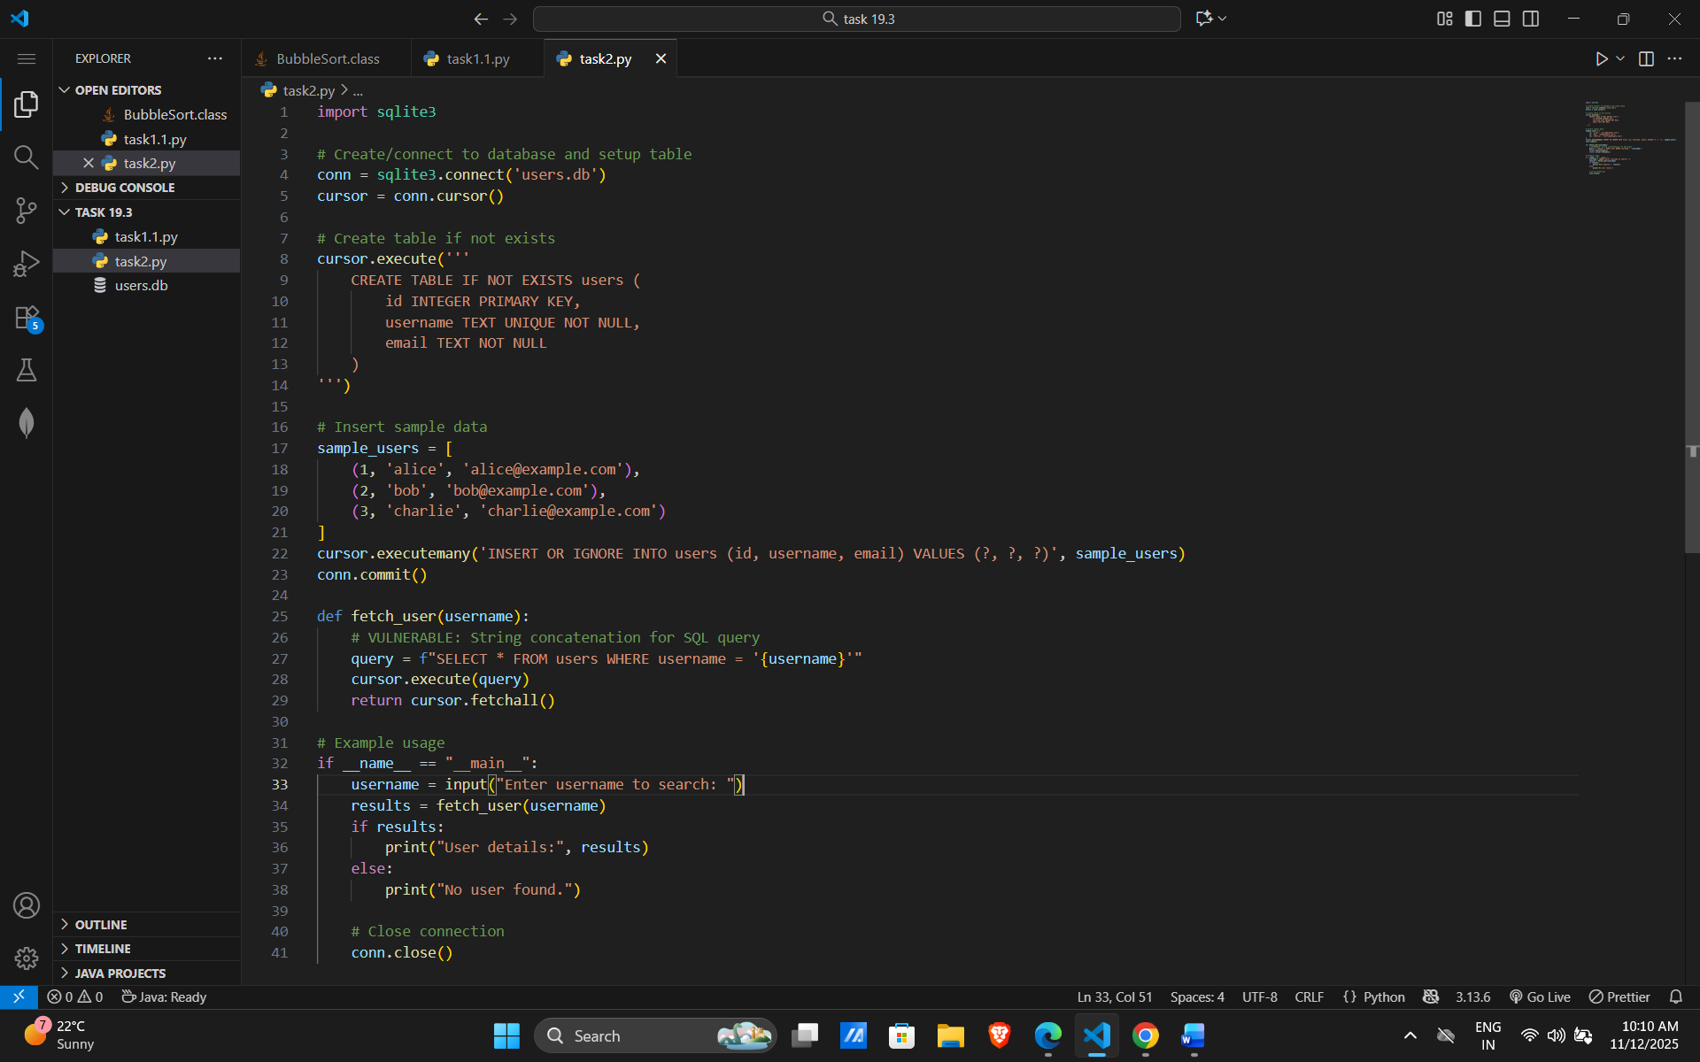

Vulnerability:
This code uses string concatenation (f"...") to build SQL queries, allowing attackers to inject malicious input (e.g., username = "admin' --" would comment out the rest of the query, potentially granting unauthorized access.
Suggested Secure Improvements:
- Parameterized Queries: Use placeholders (? for SQLite) and pass input as a tuple to cursor.execute(). This ensures input is treated as data, not code.
- Input Validation: Strip whitespace and limit length (optional here for simplicity).
- Error Handling: Catch sqlite3 exceptions with user-friendly messages.
- Commit/Close Properly: Already good, but ensure in all paths.
- For MySQL: Use mysql-connector-python with %s placeholders; principle is the same.
- Test with injection payloads to verify they fail harmlessly.

Secure Code and Output:
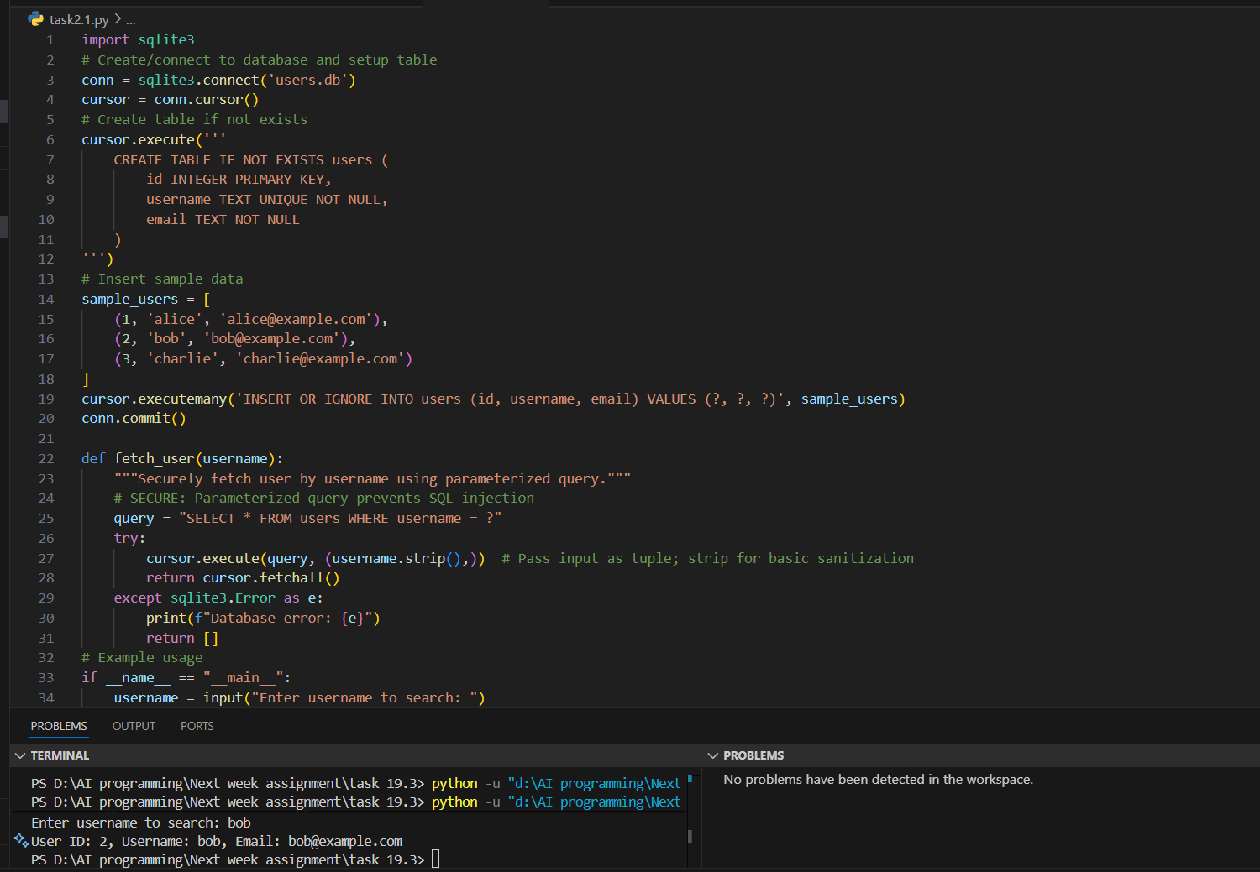

Observation:
• Parameterized Query:
- Changed to cursor.execute("SELECT * FROM users WHERE username = ?", (username.strip(),)).
- The ? is a placeholder; input is passed separately in a tuple. SQLite automatically escapes/handles it as data (e.g., ' OR '1'='1 becomes a literal search string, matching no users unless a username exactly matches that).
• Sanitization: Added .strip() to remove leading/trailing whitespace.
• Error Handling: Wrapped in try-except for sqlite3.Error, preventing crashes and info leaks.
• Output Formatting: Loops through results and prints cleanly (avoids raw tuple dumping).
• No Changes to Setup: Table creation and inserts already use parameters (?), so they're safe.
Task 3 – Cross-Site Scripting (XSS) Check
Task:
Evaluate an AI-generated HTML form with JavaScript for XSS vulnerabilities.
Instructions:
• Ask AI to generate a feedback form with JavaScript-based output.
• Test whether untrusted inputs are directly rendered without escaping.
• Implement secure measures (e.g., escaping HTML entities, using
CSP).
Expected Output:
• A secure form that prevents XSS attacks

Insecure code:
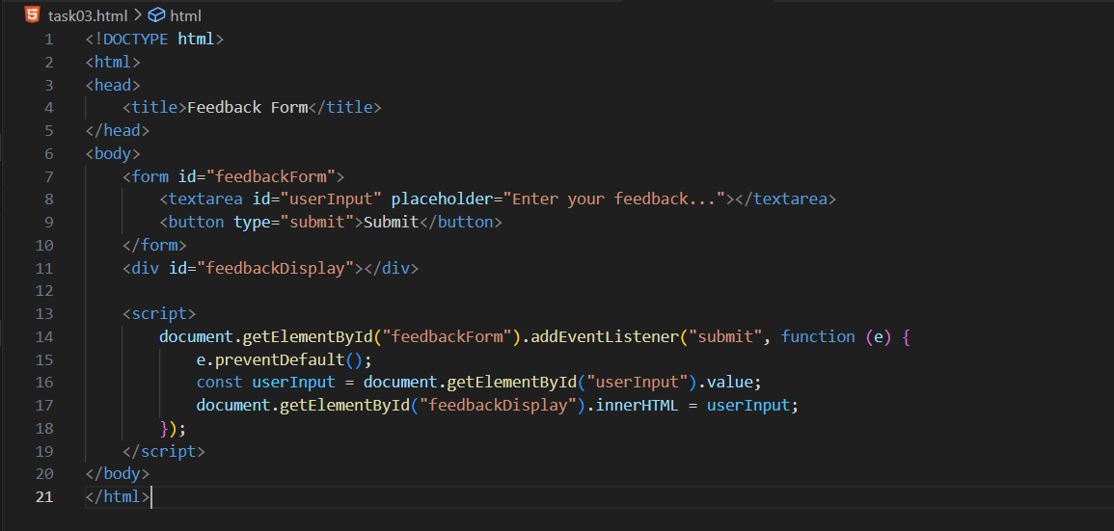
Output:
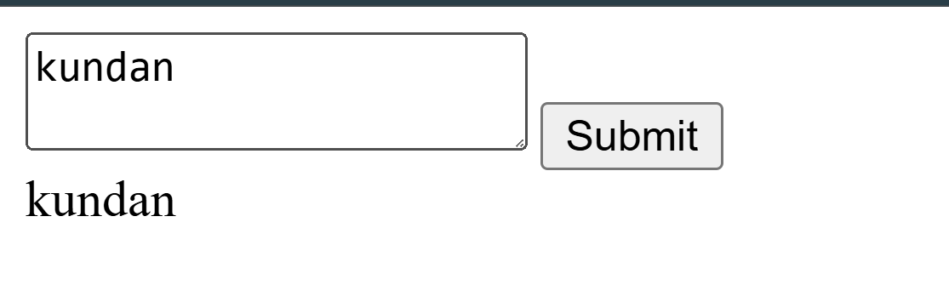
Vulnerability
This code directly inserts user input into the DOM using innerHTML, which allows attackers to inject malicious scripts (e.g., <script>alert('XSS')</script>) that execute in the browser. It lacks input sanitization or escaping.

Secure Fixes
- Escape HTML Entities: Convert special characters like <, >, and & to their safe counterparts (&lt;, &gt;, &amp;) before rendering.
- Use textContent Instead of innerHTML: Prevents script execution by treating input as plain text.
- Content Security Policy (CSP): Add headers to restrict script execution to trusted sources (e.g., Content-Security-Policy: script-src 'self').

Prompt:fix the vulnerability in the code:
Code: 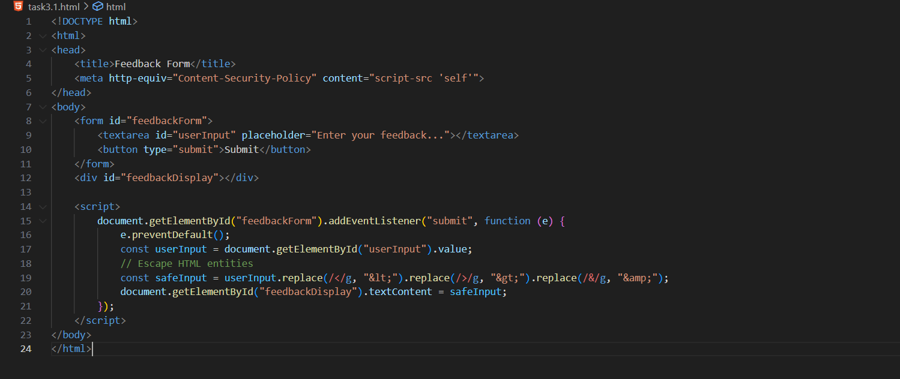
Output: 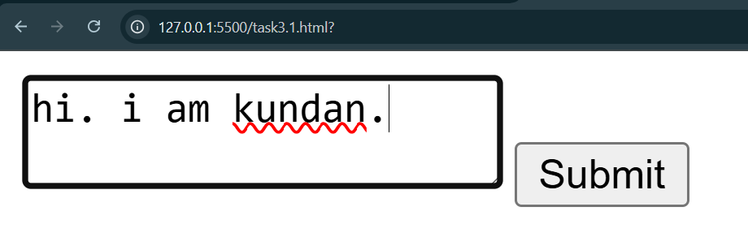
Secure Implementation (XSS-Resistant Form)
To defend against XSS, we:
- Escape HTML entities to neutralize script tags (e.g., < → &lt;, > → &gt;).
- Enable Content Security Policy (CSP) to restrict script sources.
Key Security Measures
- HTML Entity Escaping: Converts <, >, &, etc., to safe entities, preventing script execution.
- CSP Header: Restricts scripts to the current origin (default-src 'self', script-src 'self'), blocking inline or external script injection.
- Input Sanitization: Trims whitespace and escapes before rendering.

Task 4 – Real-Time Application: Security Audit of AI-Generated
Code
Scenario:
Students pick an AI-generated project snippet (e.g., login form, API integration, or file upload).
Instructions:
• Perform a security audit to detect possible vulnerabilities.
• Prompt AI to suggest secure coding practices to fix issues.
• Compare insecure vs secure versions side by side.
Expected Output:
• A security-audited code snippet with documented vulnerabilities and fixes.

Insecure:
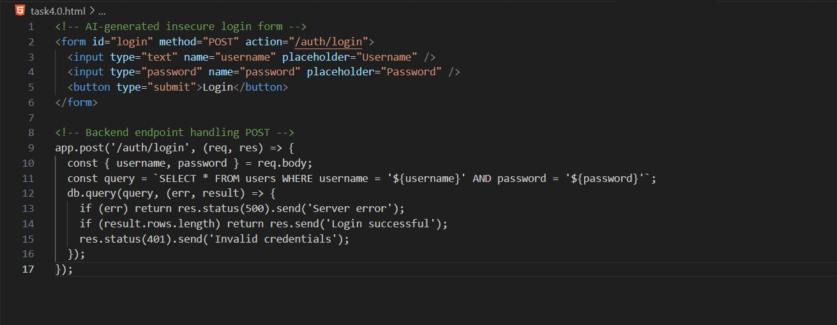

Output:
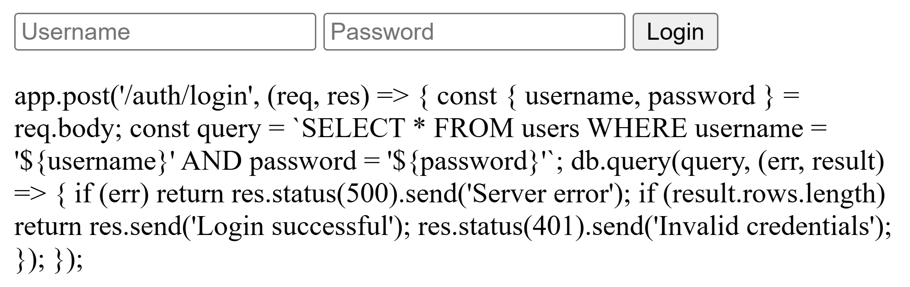

Prompt:Make this a secure code:
Secure code:

