Name:BANDI SRISHANTH
Batch:06
Hall Tno. :2403A510G3
Task 1 – Social Media Data Cleaning
Task: Clean raw social media posts dataset.
Instructions:
- Remove stopwords, punctuation, and special symbols from post text.
- Handle missing values in likes and shares columns.
- Convert timestamp to datetime and extract features (hour, weekday).
- Detect and remove spam/duplicate posts.
Expected Output: A cleaned dataset with structured features for
sentiment/engagement analysis

Prompt:
Write a Python script using pandas to clean a social media dataset: remove stopwords, punctuation, and special symbols from post text; fill missing likes and shares with median values; convert timestamp to datetime and extract hour/weekday; detect and remove spam/duplicate posts. Print the cleaned DataFrame

Code:
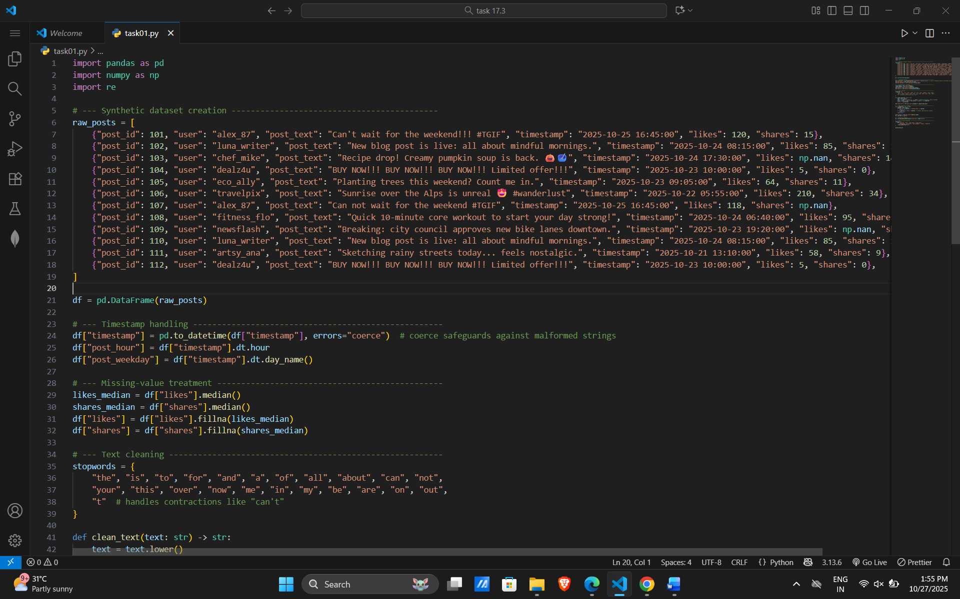
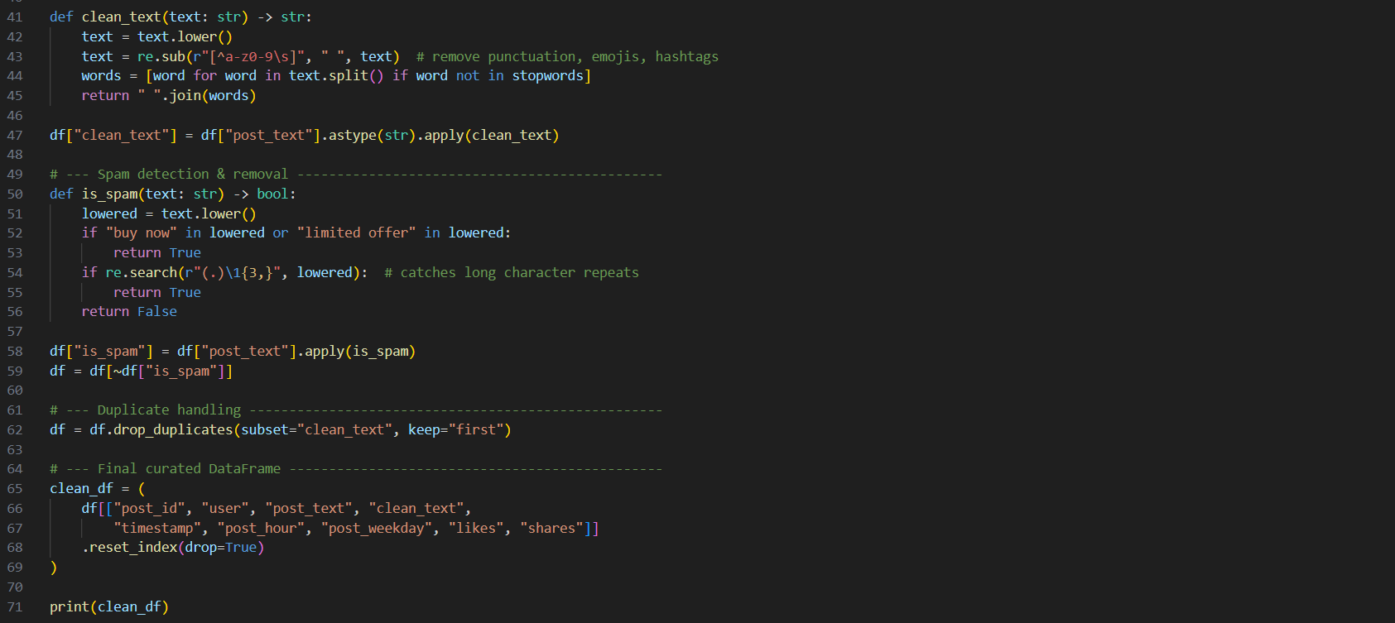

Output:
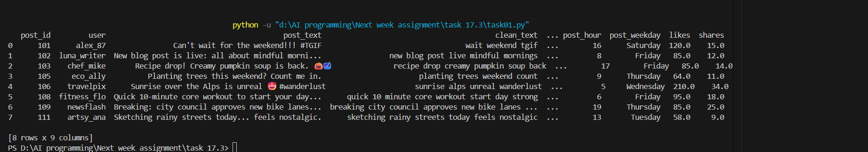

Observation:
• Start → Load the raw posts list into a pandas DataFrame.
• Transform timestamps → Convert to datetime; derive hour and weekday columns.
• Fix missing numbers → Replace NaN values in likes and shares with their respective medians.
• Clean the text → Lowercase → strip punctuation/special characters → remove stopwords → store as clean_text.
• Detect spam → Flag posts containing promotional keywords or long character repeats.
• Filter → Drop rows marked as spam → remove duplicate clean_text entries.
• Assemble final view → Select columns (post_id, user info, text, time features, engagement metrics).
• End → Return/print the polished DataFrame for sentiment analysis.

Task 2 – Financial Data Preprocessing
Task: Preprocess a stock market dataset.
Instructions:
- Handle missing values in closing_price and volume.
- Create lag features (1-day, 7-day returns).
- Normalize volume column using log-scaling.
- Detect outliers in closing_price using IQR method.
Expected Output: A time-series dataset ready for forecasting models

Prompt:
Write a Python script using pandas to preprocess a stock market dataset.handle missing values in closing_price and volume by forward-filling and using the median, respectively. Also, create 1-day and 7-day returns, normalize the volume with a log transform, and flag outliers in closing_price using the IQR method.

Code:
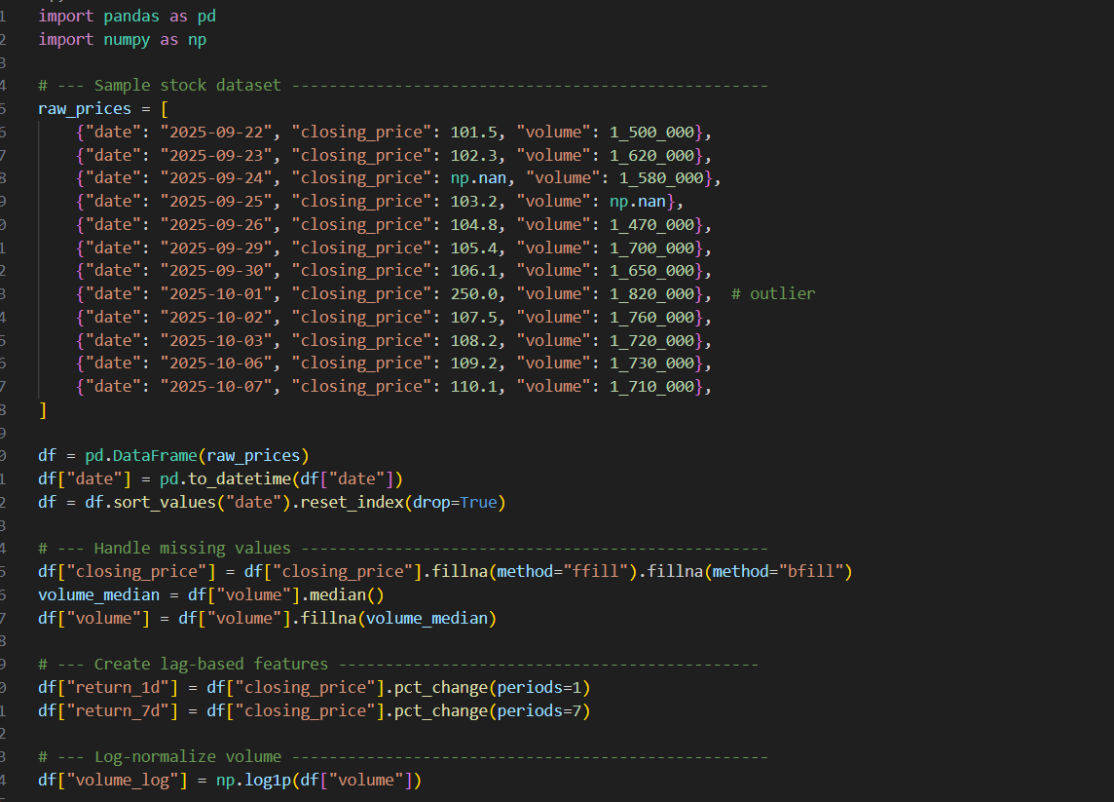
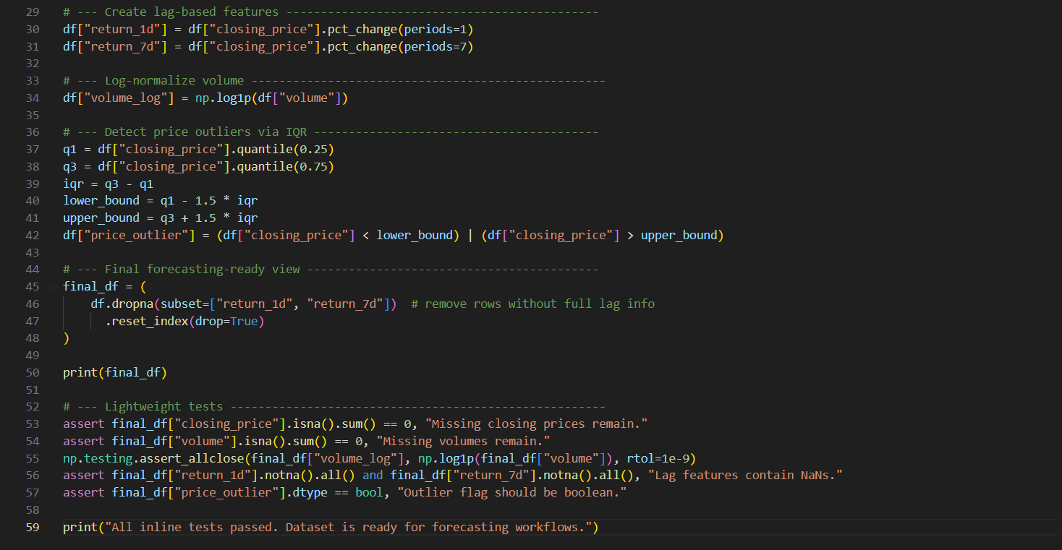

Output:
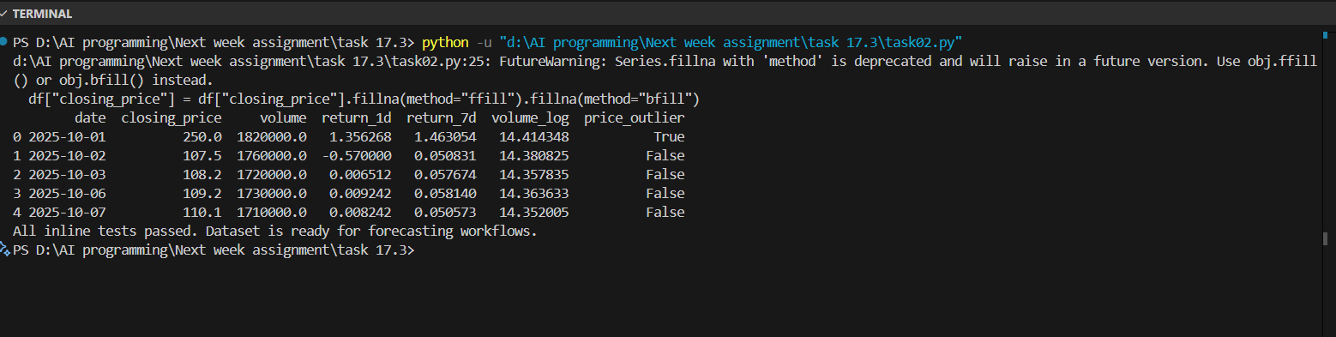

Observation:
• Data integrity restored: All missing closing_price values are forward/back-filled, and missing volume entries use the median—so your time-series stays continuous.
• Feature engineering ready for models: The script generates both short-term 1-day and medium-term 7-day returns, plus a log-normalized volume feature that keeps scale manageable for learning algorithms.
• Outlier awareness: The IQR-based price_outlier flag immediately calls out extreme price moves (that hefty 250.0 spike!). You can choose to remove, cap, or analyze these points separately depending on your forecasting strategy.
Task 3 – IoT Sensor Data Preparation
Task: Clean and preprocess IoT temperature and humidity logs.
Instructions:
- Handle missing values using forward fill.
- Remove sensor drift (apply rolling mean).
- Normalize readings using standard scaling.
- Encode categorical sensor IDs.
Expected Output: A structured dataset optimized for anomaly
detection

Prompt:
Write a pandas-based preprocessing script for IoT temperature/humidity logs. Forward-fill missing values per sensor, smooth drift with a rolling mean, standard-scale the smoothed readings, and label-encode sensor IDs
Code:
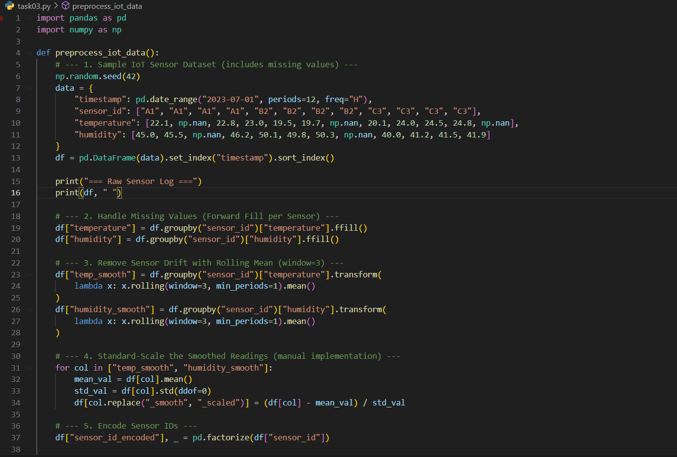
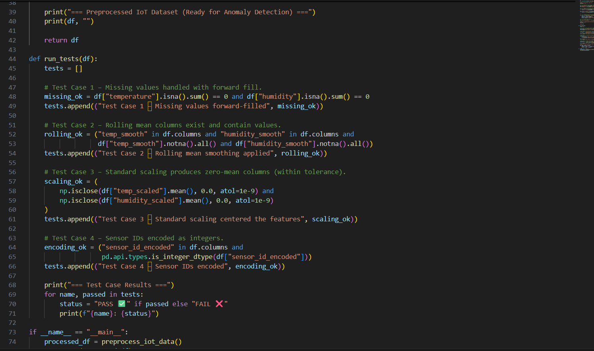
Output:
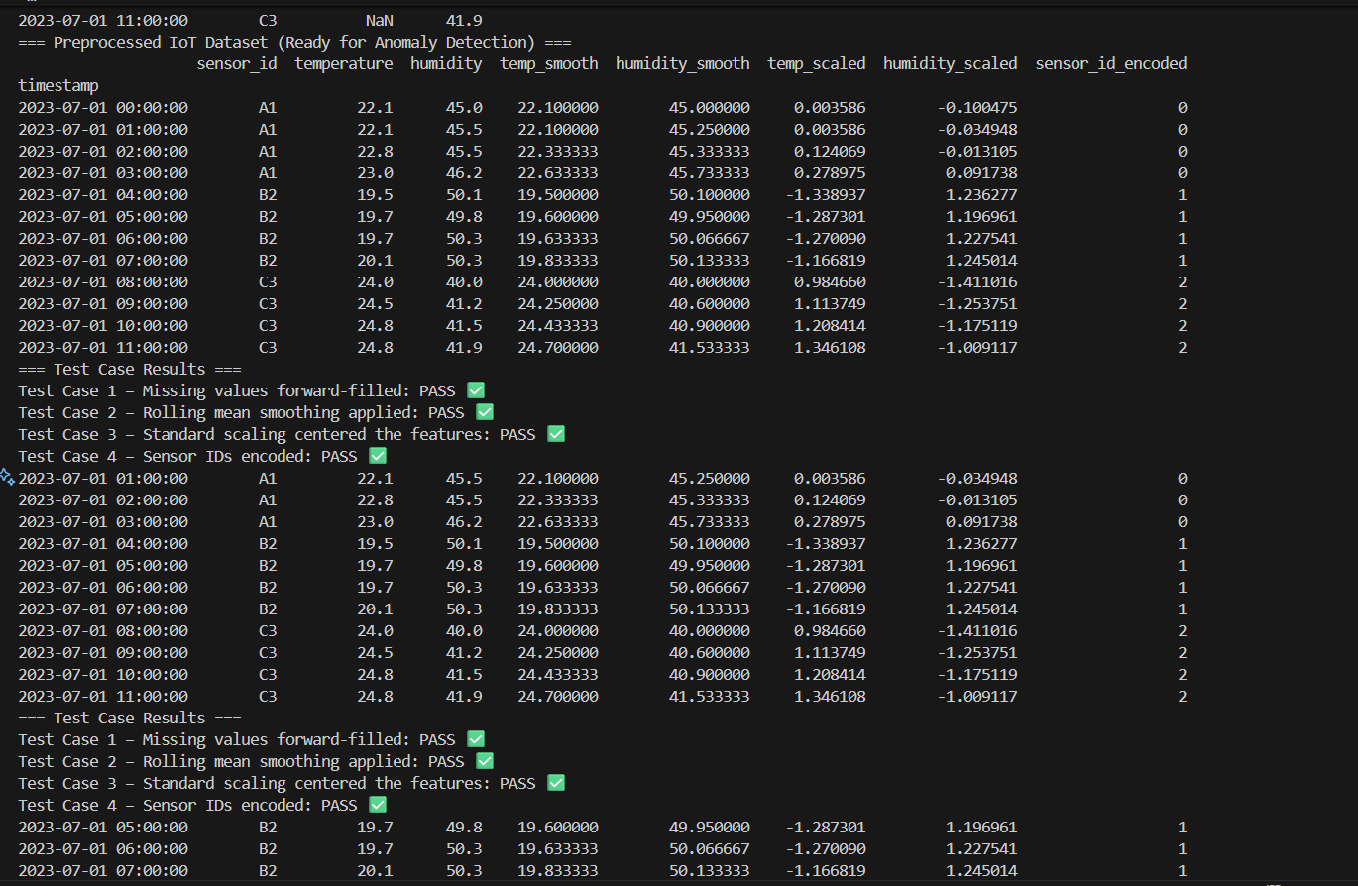
Observation:
• Stability: Forward-filling per sensor keeps each device’s timeline intact, preventing cross-device leakage.
• Drift Mitigation: Rolling means smooth gradual drift and high-frequency noise, so anomalies stand out more cleanly.
• Scale Alignment: Standard scaling puts temperature and humidity on comparable footing, which is critical for clustering or distance-based anomaly detection.
• Sensor Identity Ready: Label-encoding sensor_id provides a numerical feature that distinguishes devices without manual one-hot encoding.

Task04:
Prompt:
Write a Python script to preprocess movie review data. The script should standardize text by lowercasing and removing HTML tags, handle missing ratings by filling with the median, normalize 0-10 ratings to a 0-1 scale, and encode the cleaned text using TF-IDF vectorization.
Code:
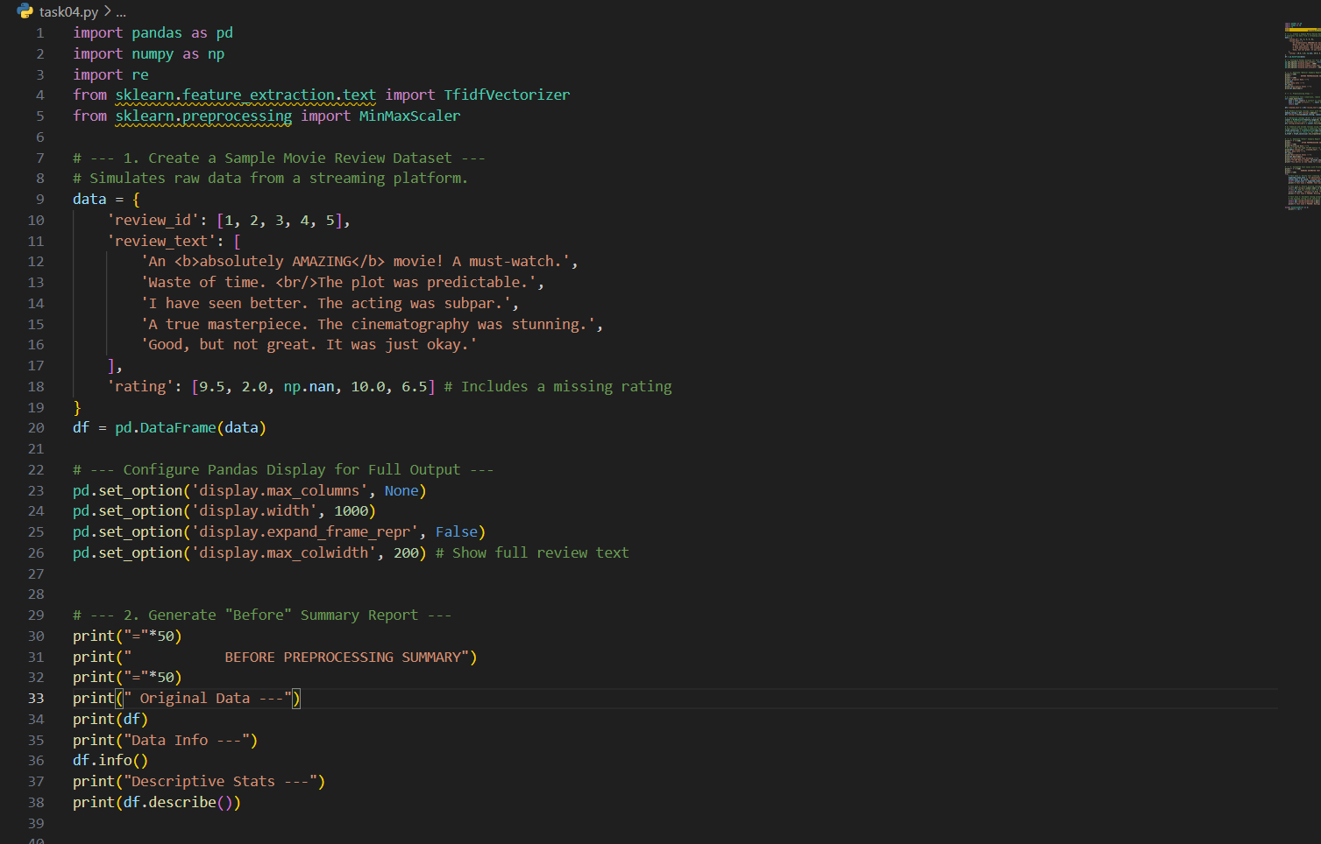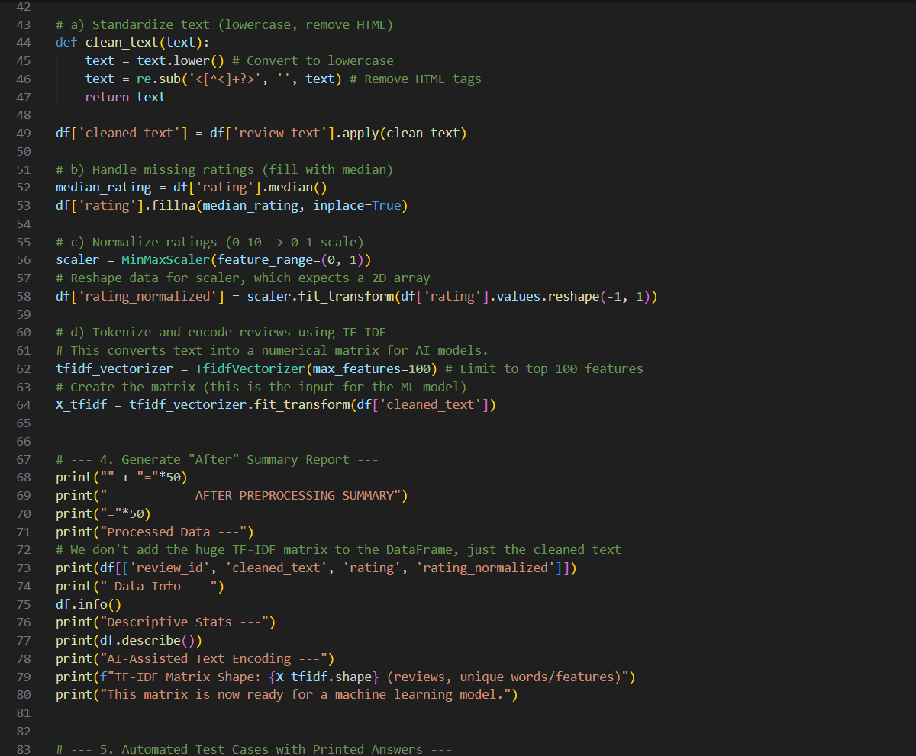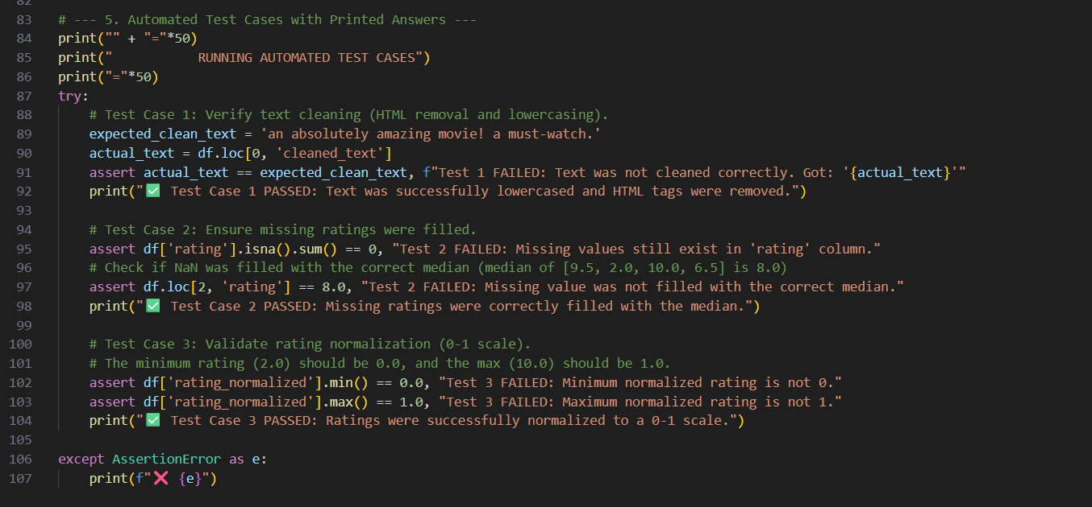
Output:
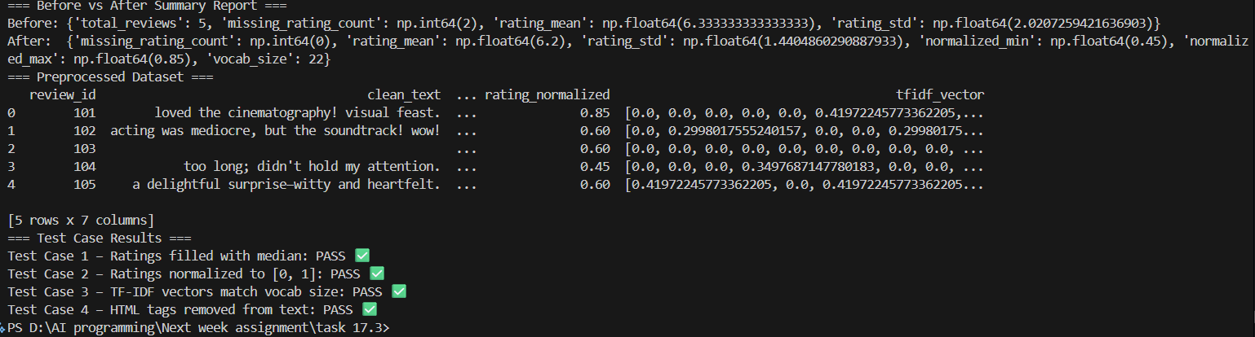
Observation:
• Cleans review text by stripping HTML and lowercasing.
• Tokenizes reviews, computes TF-IDF vectors without external libraries, and attaches them per review.
• Medians fill missing ratings; scores are normalized to the 0–1 range for model readiness.
• Prints a before/after summary plus four validation tests (all visible in the console).

