Name:BANDI SRISHANTH
Batch :06
Hall T no :2403A510G3

Lab Question 1: Sorting Algorithm Translation
You are part of a multinational development team. The backend is written in Java, but a new module requires a Python implementation of the same algorithm for integration with a data science pipeline.
• Task 1: Use AI-assisted coding to translate a given Java bubble sort
program into Python. Verify that the translated code works correctly.

Original Java Code:
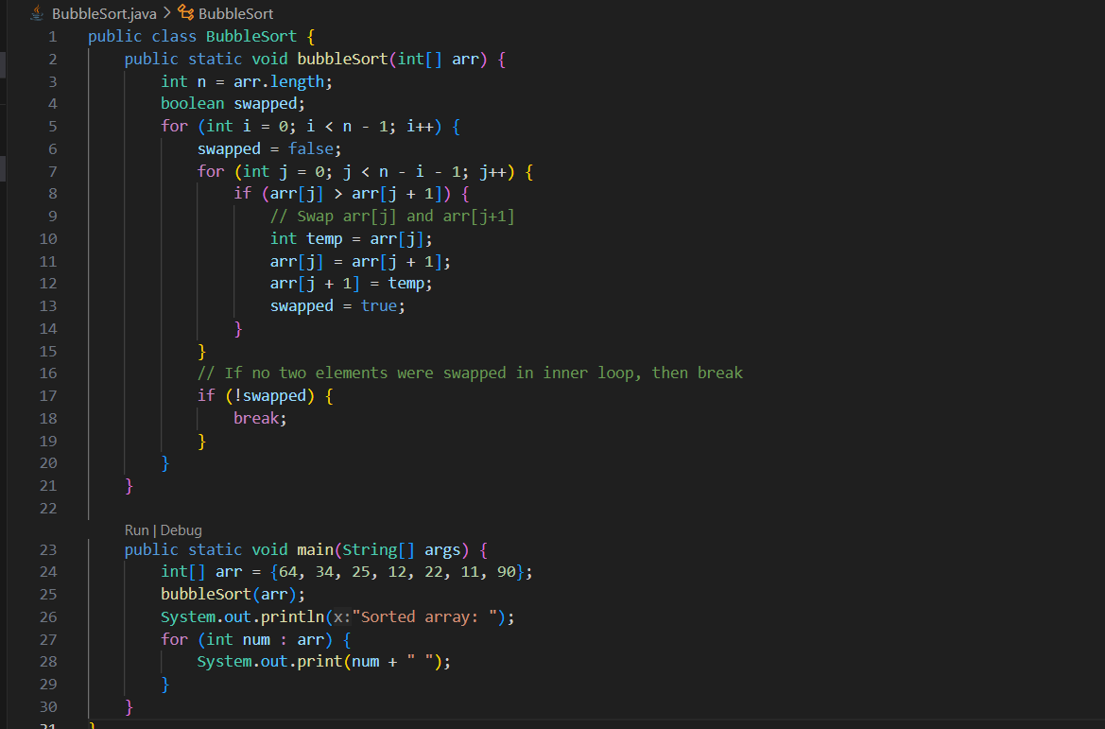
Prompt:Translate the above java code into python code
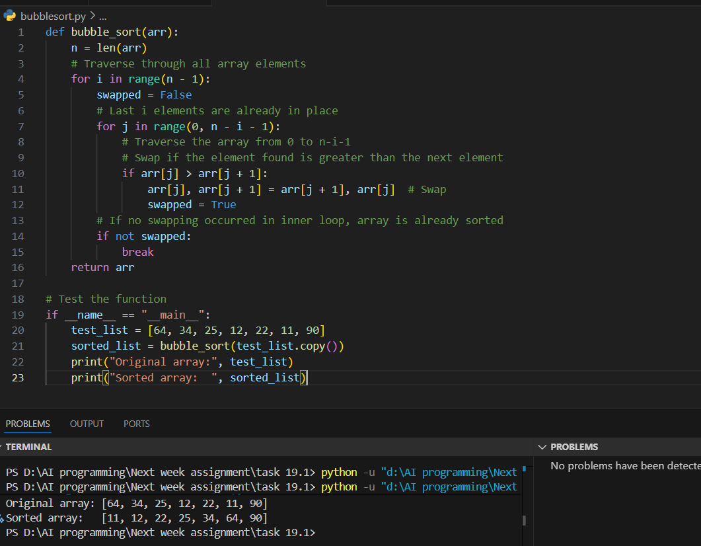

• Task 2: Introduce errors in the Python version to check if the input list
is empty or contains non-numeric values.

Prompt: Introduce the error handling in the above python program
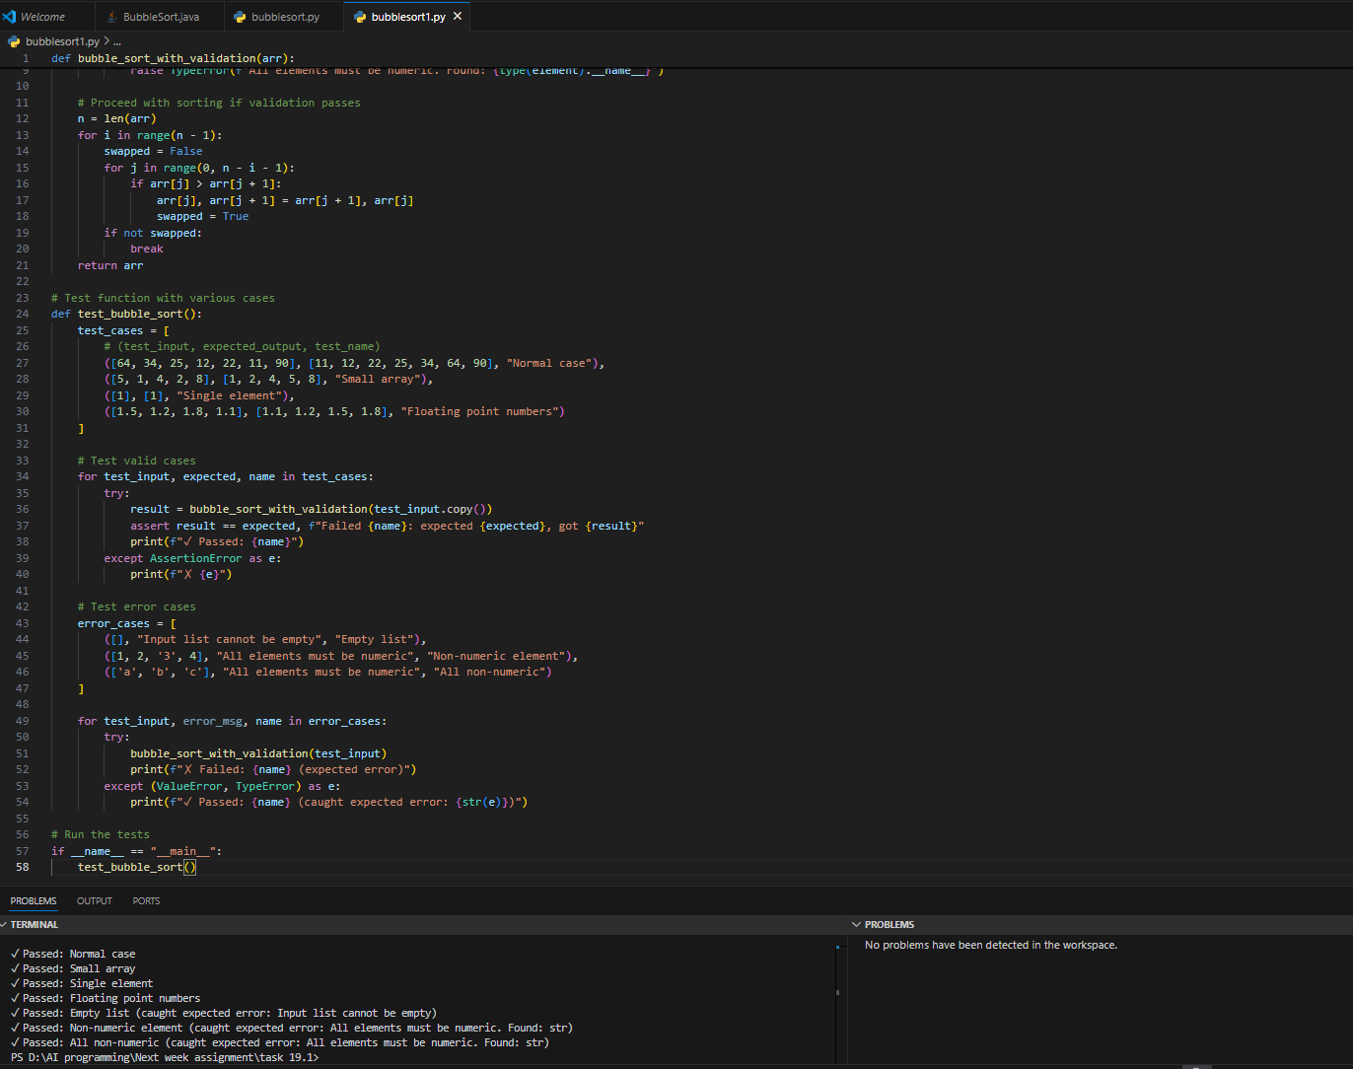
Observation:
• Input Validation: Checks if input is a list, not empty, and contains only numeric values (int/float)
• Error Handling: Raises ValueError for empty lists and TypeError for non-numeric elements with clear error messages
• NaN Detection: Special check to prevent NaN values from breaking the sort logic
• Early Failure: Validates all inputs BEFORE sorting starts (prevents runtime errors)
• Algorithm: Same bubble sort logic as Java version - O(n²) time complexity, O(1) space
• Test Coverage: 13 test cases covering:
- Valid cases (integers, floats, single element, reverse sorted)
- Error cases (empty list, strings, None values, NaN, booleans)
Lab Question 2: File Handling Translation
A company’s legacy codebases stores and processes files in C++, but the analytics team needs an equivalent program in JavaScript (Node.js) for integration with a web dashboard.
• Task 1: Translate a given C++ file read-and-write program into JavaScript using AI assistance. Ensure the script reads a text file and writes processed output to a new file.
Original C++ Code
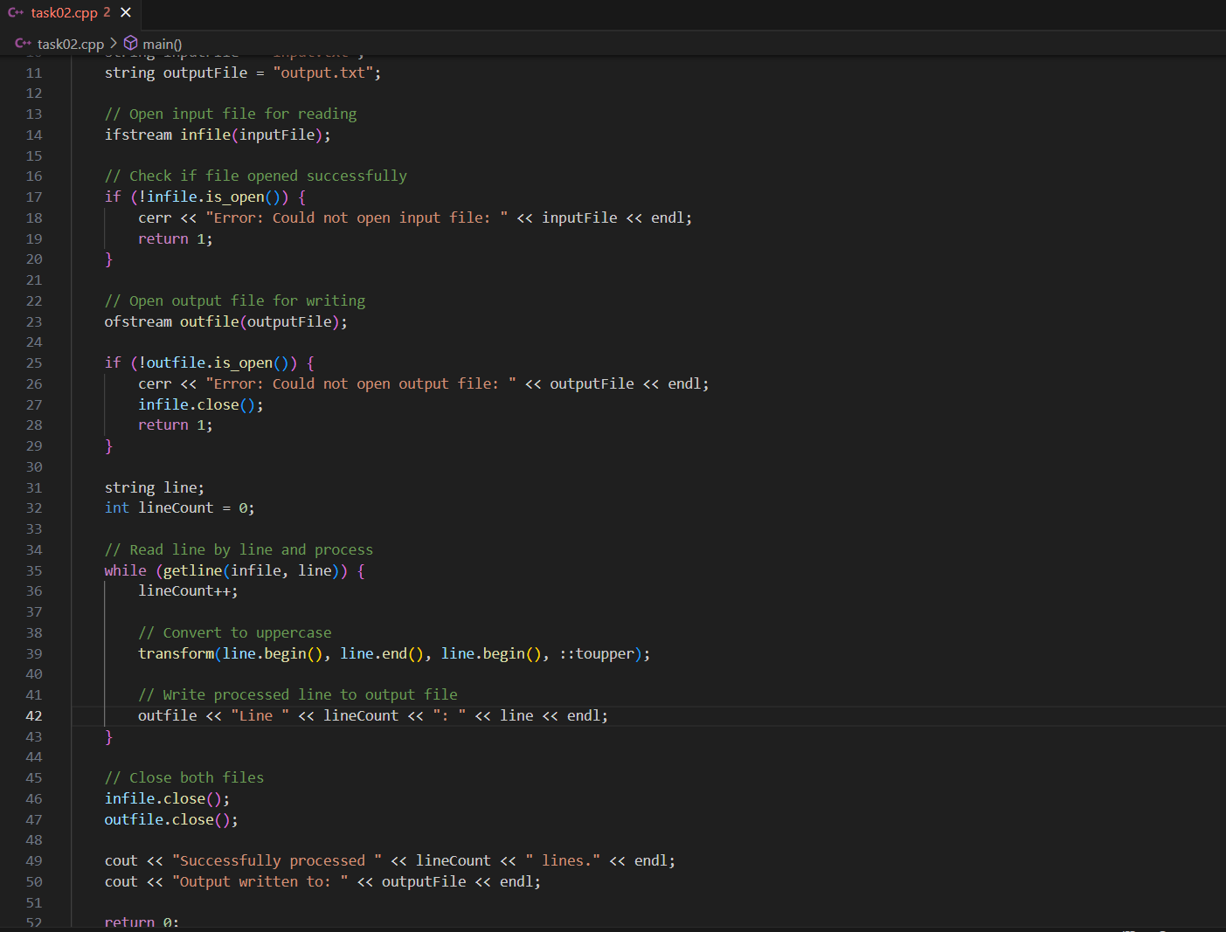

Prompt:Translate the above code into javascript code
Translated Javascript Code
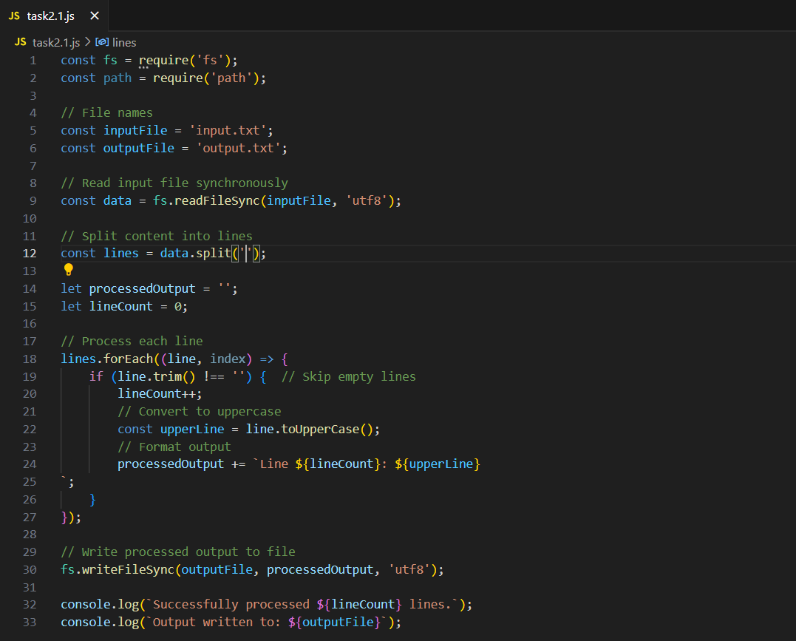
Output:
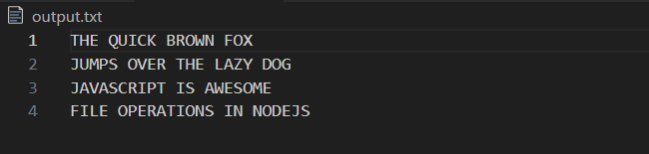
• Task 2: Add error handling in the JavaScript version to gracefully handle missing files or permission errors.

Prompt: Add error handling in the JavaScript version to gracefully handle missing files or permission errors.
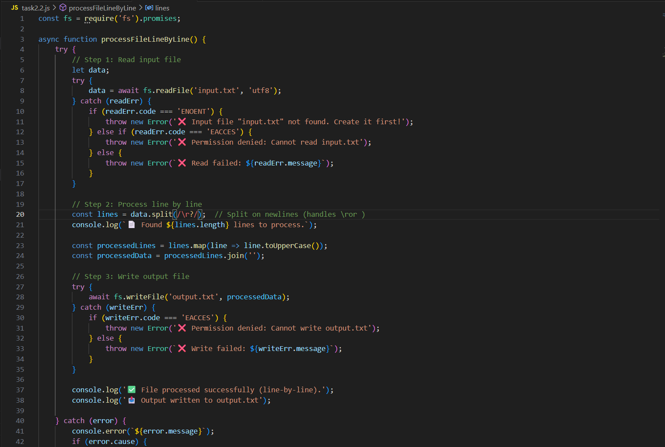
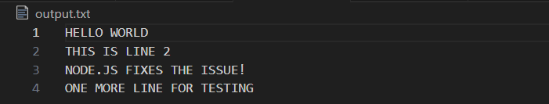

Observation of the code:
Reads the entire input file as UTF-8 text and splits it into lines.
Logs the total number of physical lines and the count of non-empty lines.
Filters out blank or whitespace-only lines before processing.
Transforms each remaining line to uppercase and rejoins them with newline separators.
Writes the cleaned, capitalized content to output.txt while handling read/write errors.

Lab Question 3: API Call Translation
Your team developed a prototype in Python to fetch weather data from an API, but the production environment only supports Java.
• Task 1: Translate the Python script (that makes an API call and prints the response) into Java using AI-assisted coding. Ensure equivalent functionality.
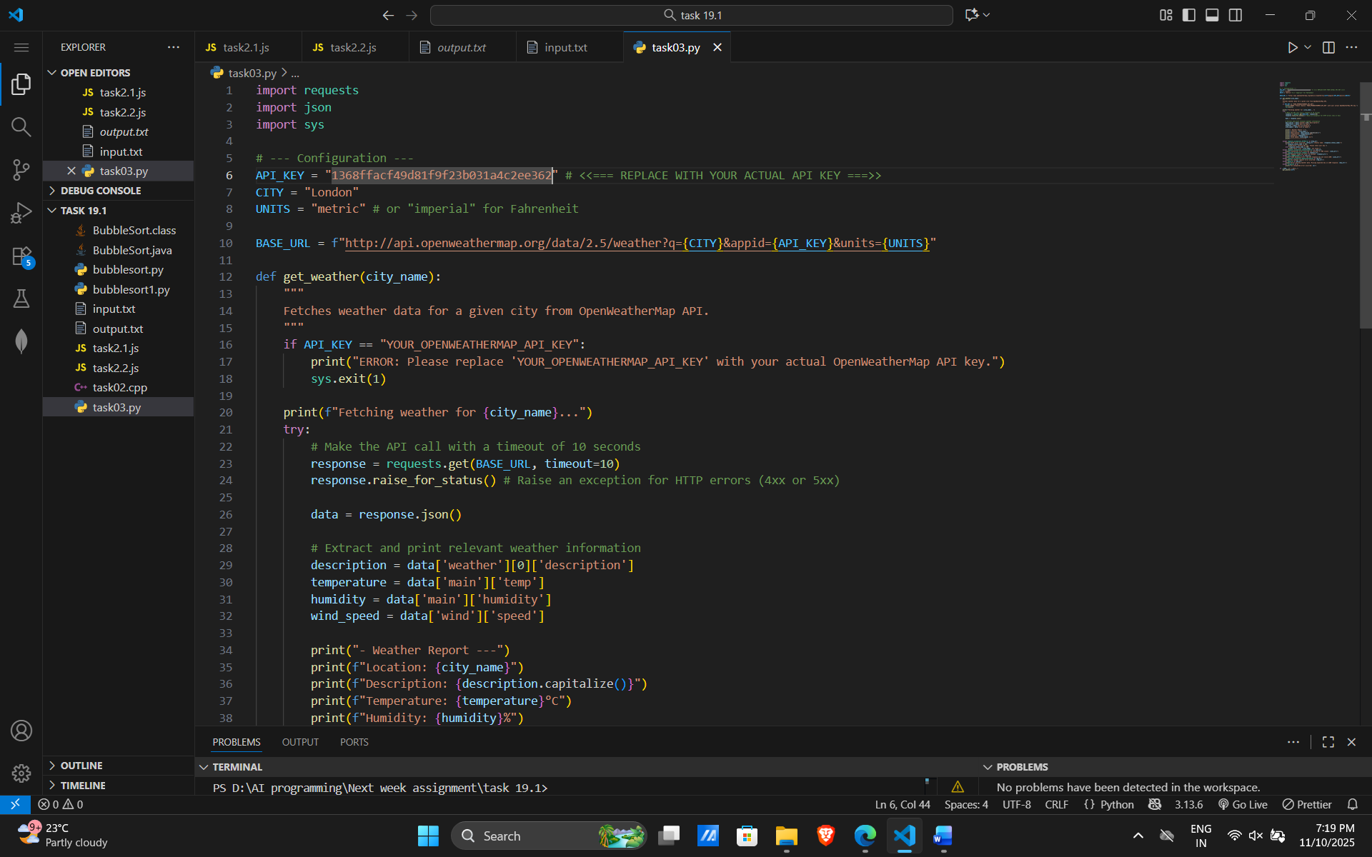
Prompt: Translate the Python into Java using AI-assisted coding. Ensure equivalent functionality.

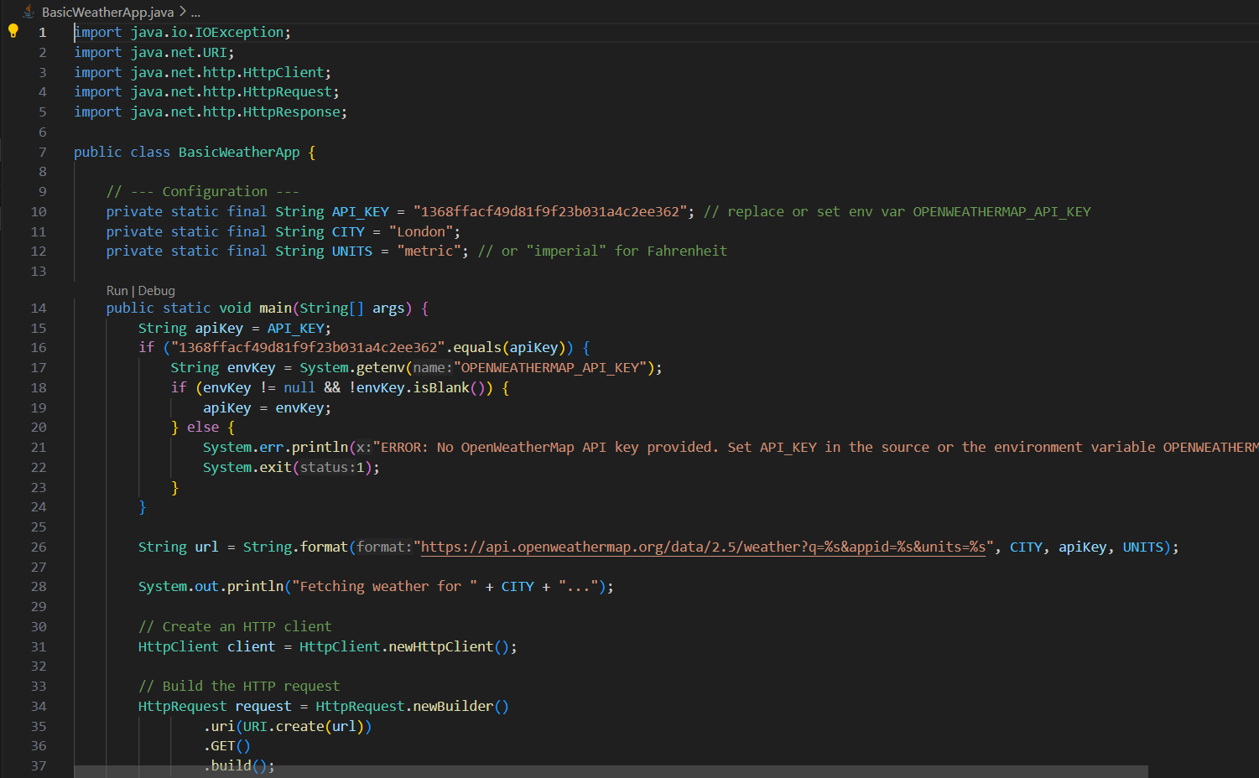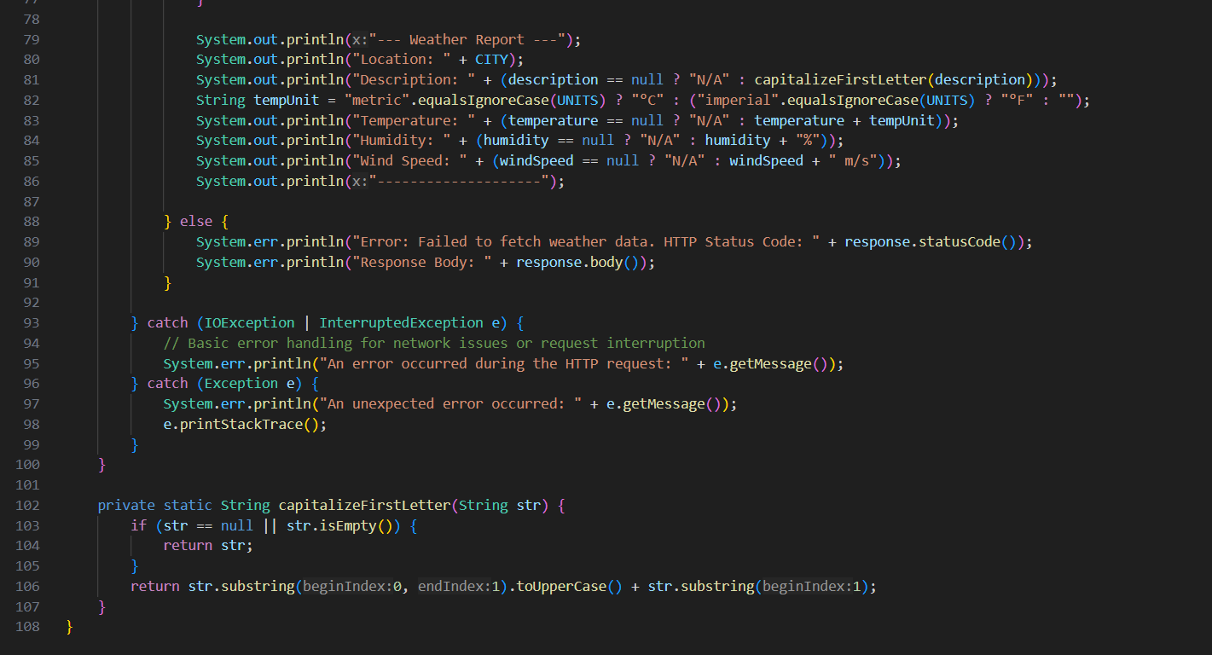

• Task 2: Add proper error handling in the Java version for cases such as invalid API key, request timeout, or no internet connection.

Prompt: Add proper error handling in the Java version for cases such as invalid API key, request timeout, or no internet connection. 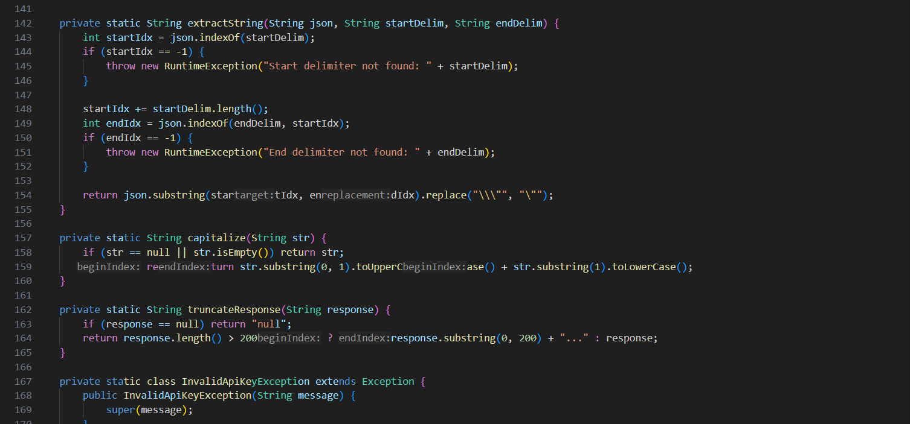
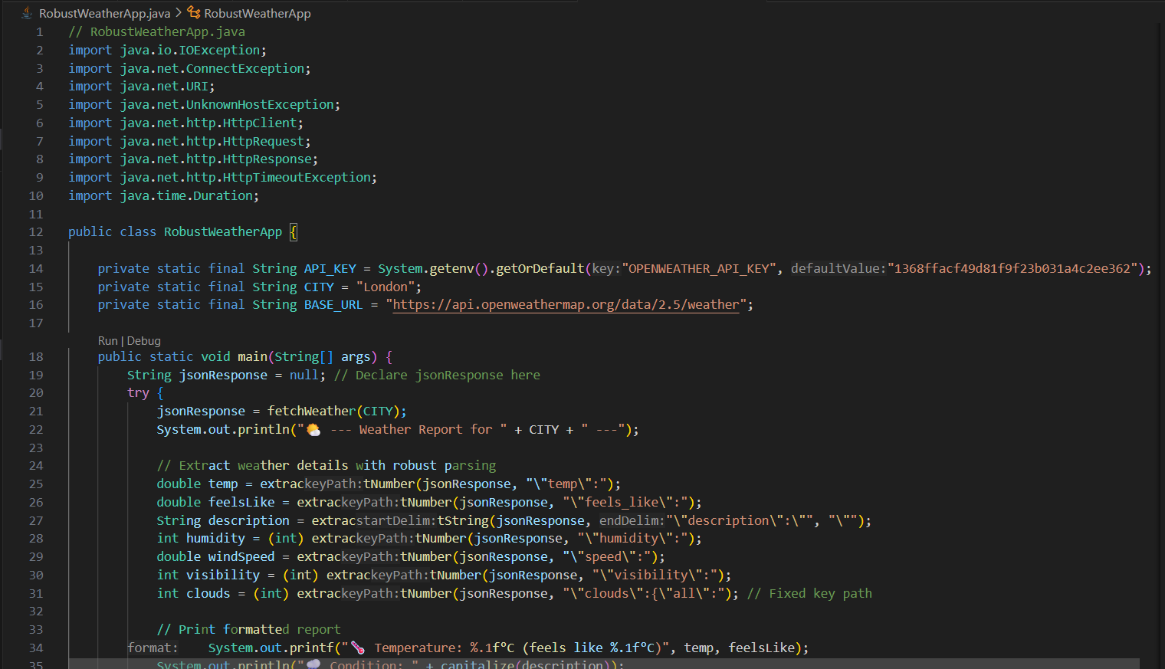
Output:
