**IOT_PHASE - 4**

**PROJECT TITLE :** SmartPublicRestroom

**Phase 4 :** Development part-2

Presented by

* SNEHA K
* JENIFER TABITHA S
* GAYATHRI P
* JASMIN MARY J

**INRODUCTION:**

In an era characterized by technological advancements, the concept of a "Smart Public Toilet" represents a significant leap forward in enhancing public infrastructure. This project harnesses the power of Internet of Things (IOT) sensors to transform conventional public restrooms into intelligent and efficient facilities. By integrating a range of sensors, this smart toilet aims to optimize resource utilization, improve hygiene, and enhance the overall user experience.

**Project Design:**

**NEAR BY TOILET APP:**

**Create a platform that displays real-time restroom availability and cleanliness data:**

**Find a toilet:**

The "Find a Toilet" is designed to help users locate nearby public restrooms efficiently. Its key features include:

1. GPS Integration: The app uses GPS to pinpoint the user's location.

2. Map Interface: It displays a map with restroom icons, highlighting nearby facilities.

3. Search Filters: Users can filter by cleanliness, accessibility, or ratings.

4. User Reviews: Allows users to leave reviews and ratings for restrooms.

5. Directions: Provides step-by-step directions to the chosen restroom.

6. Crowd sourcing: Users can add new restroom locations to the database.

7. Emergency Features: Some apps offer emergency options for urgent needs.

8. Offline Access: Some apps allow users to download maps for offline use.

9. Public Awareness: Promotes awareness of public restroom availability.

10. Community-Building: Connects users through a shared need for clean, accessible restrooms.

These design are invaluable for travelers, parents, and anyone in need of a public restroom, improving convenience and sanitation.

**Design:**

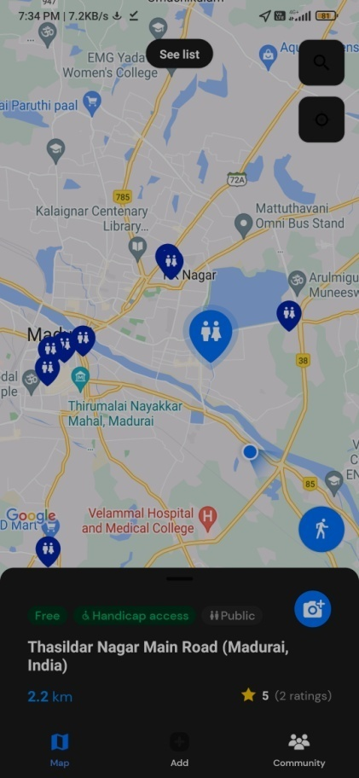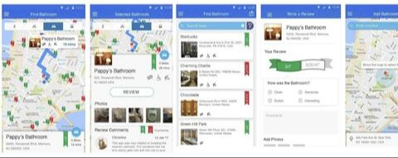

**Cleanliness:**

The "Find a Clean Public Toilet" is designed to help users locate nearby public restrooms and assess their cleanliness. It uses a mobile interface for easy access.

1. Frontend: Developed using Android Studio and Java, it provides a user-friendly interface.

2. Backend: Utilizes a cloud-based server, built with Node.js and MongoDB, to store restroom data.

3. Google Maps API: Displays toilet locations on a map.

4. User Authentication Package: Ensures secure user accounts.

5. Location Services: Tracks user's GPS coordinates.

6. Review and Rating System: Allows users to rate and review restrooms.

7. Notification Package: Sends alerts for nearby facilities.

8. Data Analytics Tools: Analyzes user reviews and usage patterns.

9. Database Management: Stores toilet data, user reviews, and ratings.

10. Search and Filter Functions: Helps users find specific toilet features (e.g., cleanliness, accessibility).

The app's software design and packages work together to provide a practical solution for finding clean public toilets with user-generated feedback for a better restroom experience.

**Design:**

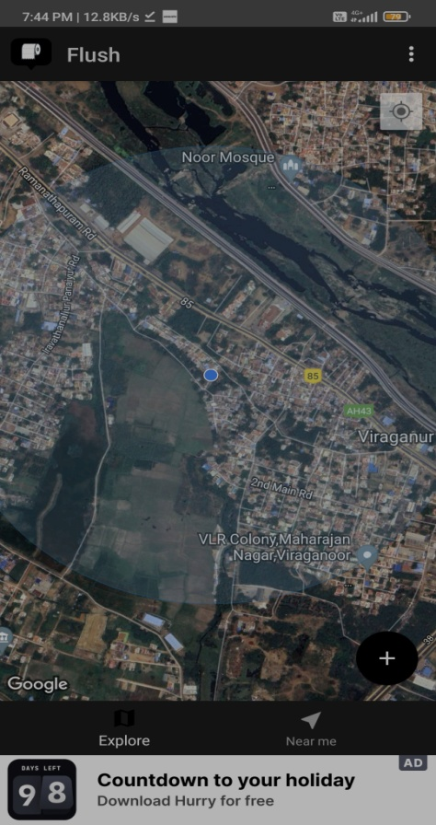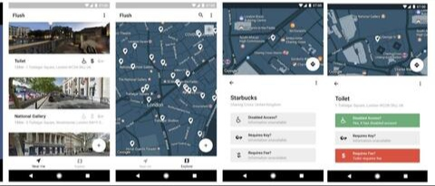

**Wokwi Simulation:**

The project can be simulated by using wokwi simulation software.

//Code for the device to detect the status of the Waste bins

#include <WiFi.h>//library for wifi

#include <PubSubClient.h>//library for MQtt

#define SOUND_SPEED 0.034//define sound speed in cm/uS

#define LED 15

const int trigPin = 13;

const int echoPin = 12;

void callback(char* subscribetopic, byte* payload, unsigned int payloadLength);

//-------credentials of IBM Accounts------

#define ORG "rr1qlb"//IBM ORGANITION ID

#define DEVICE_TYPE "sensor_devices"//Device type mentioned in ibm watson IOT Platform

#define DEVICE_ID "swmsfmc_D1"//Device ID mentioned in ibm watson IOT Platform

#define TOKEN "swmsfmc_D1" //Token

String data3;

float distance;

long duration;

//-------- Customise the above values --------

char server[] = ORG ".messaging.internetofthings.ibmcloud.com";// Server Name

char publishTopic[] = "iot-2/evt/data/fmt/json";// topic name and type of event perform and format in which data to be send

char subscribetopic[] = "iot-2/cmd/command/fmt/String";// cmd REPRESENT command type AND COMMAND IS TEST OF FORMAT STRING

char authMethod[] = "use-token-auth";// authentication method

char token[] = TOKEN;

char clientId[] = "d:" ORG ":" DEVICE_TYPE ":" DEVICE_ID;//client id

//-----------------------------------------

WiFiClient wifiClient; // creating the instance for wificlient

PubSubClient client(server, 1883, callback ,wifiClient); //calling the predefined client id by passing parameter like server id,portand wificredential

void setup()// configureing the ESP32

{

Serial.begin(115200); // Starts the serial communication

pinMode(trigPin, OUTPUT); // Sets the trigPin as an Output

pinMode(echoPin, INPUT); // Sets the echoPin as an Input

pinMode(LED,OUTPUT);

delay(10);

Serial.println();

}

void loop()// Recursive Function

{

digitalWrite(trigPin, LOW);

delayMicroseconds(2);

// Sets the trigPin on HIGH state for 10 micro seconds

digitalWrite(trigPin, HIGH);

delayMicroseconds(10);

digitalWrite(trigPin, LOW);

// Reads the echoPin, returns the sound wave travel time in microseconds

duration = pulseIn(echoPin, HIGH);

// Calculate the distance

distance = duration * SOUND_SPEED/2;

if (distance<100)

{

digitalWrite(LED, HIGH);

Serial.print("Alert! Bin is filled.");

Serial.println();

delay(1000);

}

else

{

digitalWrite(LED, LOW);

Serial.print("Bin is not filled.");

Serial.println();

}

if(distance<100)

{

PublishData(distance);

}

delay(1000);

if (!client.loop()) {

mqttconnect();

}

}

/.....................................retrieving to Cloud.............................../

void PublishData(float distance) {

mqttconnect();//function call for connecting to ibm

/*

creating the String in in form JSon to update the data to ibm cloud

*/

String payload = "{\"Alert\":";

payload += distance;

payload += "}";

Serial.print("Sending payload: ");

Serial.println(payload);

if (client.publish(publishTopic, (char*) payload.c_str())) {

Serial.println("Publish ok");// if it sucessfully upload data on the cloud then it will print publish ok in Serial monitor or else it will print publish failed

} else {

Serial.println("Publish failed");

}

}

void mqttconnect() {

if (!client.connected()) {

Serial.print("Reconnecting client to ");

Serial.println(server);

while (!!!client.connect(clientId, authMethod, token)) {

Serial.print(".");

delay(500);

}

initManagedDevice();

Serial.println();

}

}

void wificonnect() //function defination for wificonnect

{

Serial.println();

Serial.print("Connecting to ");

WiFi.begin("Wokwi-GUEST", "", 6);//passing the wifi credentials to establish the connection

while (WiFi.status() != WL_CONNECTED) {

delay(500);

Serial.print(".");

}

Serial.println("");

Serial.println("WiFi connected");

Serial.println("IP address: ");

Serial.println(WiFi.localIP());

}

void initManagedDevice() {

if (client.subscribe(subscribetopic)) {

Serial.println((subscribetopic));

Serial.println("subscribe to cmd OK");

} else {

Serial.println("subscribe to cmd FAILED");

}

}

void callback(char* subscribetopic, byte* payload, unsigned int payloadLength)

{

Serial.print("callback invoked for topic: ");

Serial.println(subscribetopic);

for (int i = 0; i < payloadLength; i++) {

//Serial.print((char)payload[i]);

data3 += (char)payload[i];

}

Serial.println("data: "+ data3);

if(data3=="lighton")

{

Serial.println(data3);

digitalWrite(LED,HIGH);

}

else

{

Serial.println(data3);

digitalWrite(LED,LOW);

}

data3="";

}

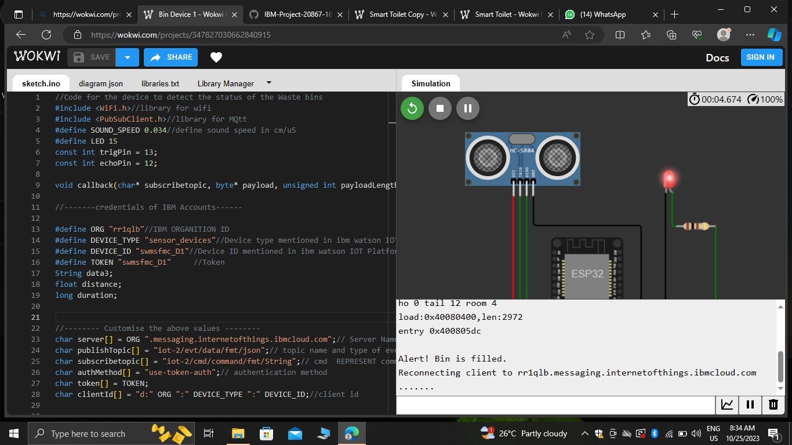

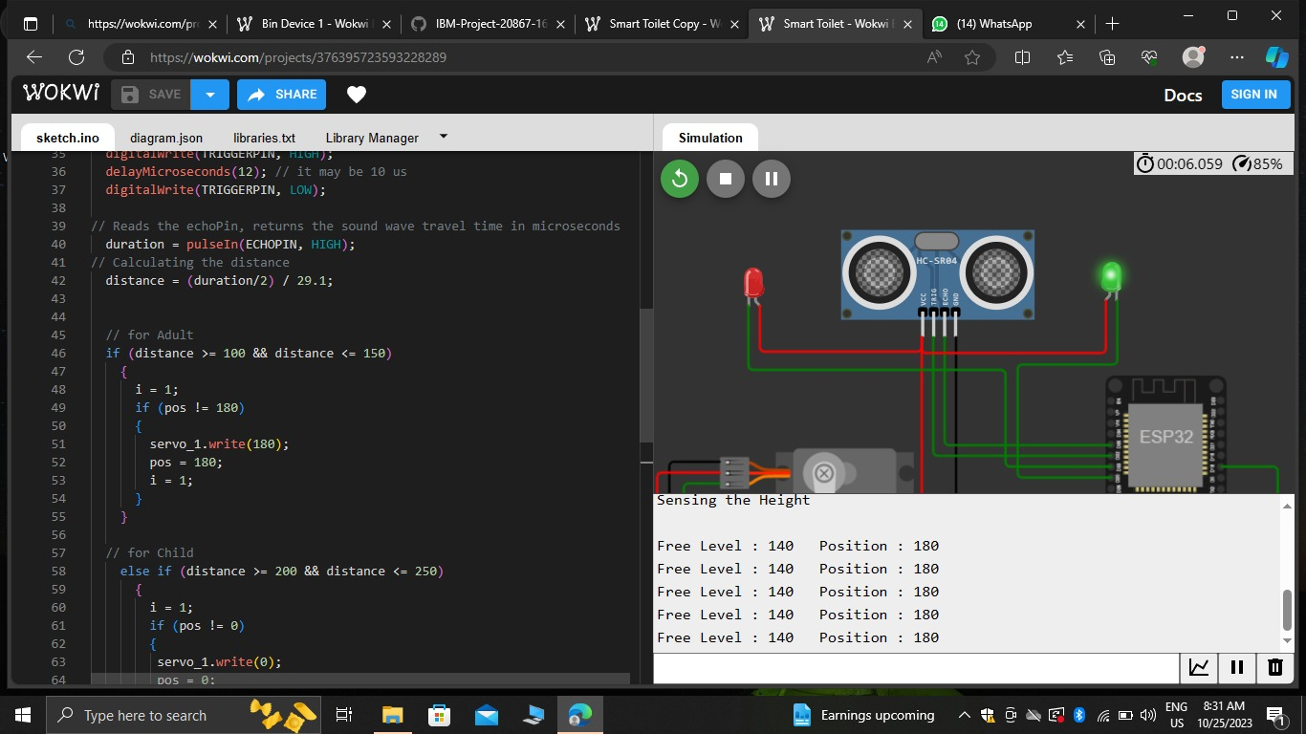

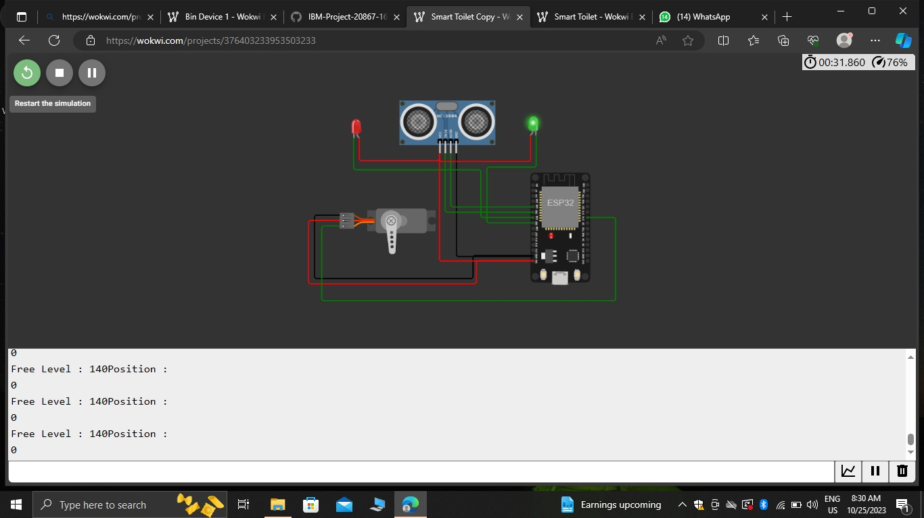

**CONCLUSION:**

Finally our conclusion is that, IOT-enabled smart public restroom project has demonstrated significant advantages in terms of efficiency, cleanliness, and user satisfaction. The real-time monitoring of restroom conditions, including occupancy and supply levels, ensures optimal resource allocation. User-friendly mobile apps enhance the overall experience by providing essential information. Cost savings through predictive maintenance and resource optimization make this system economically viable. Furthermore, the data collected can be used for data-driven decision-making and future improvements. Overall, our smart restroom solution offers a tangible and beneficial upgrade to public facilities.

NOTE: File naming Convention: IOT_Phase4