1. firstly, in a large kadai heat 2 tbsp oil and splutter 1 tsp mustard, 1 tsp urad dal, 1 tsp chana dal, 2 tbsp peanuts, 2 dried red chilli and pinch hing.  
   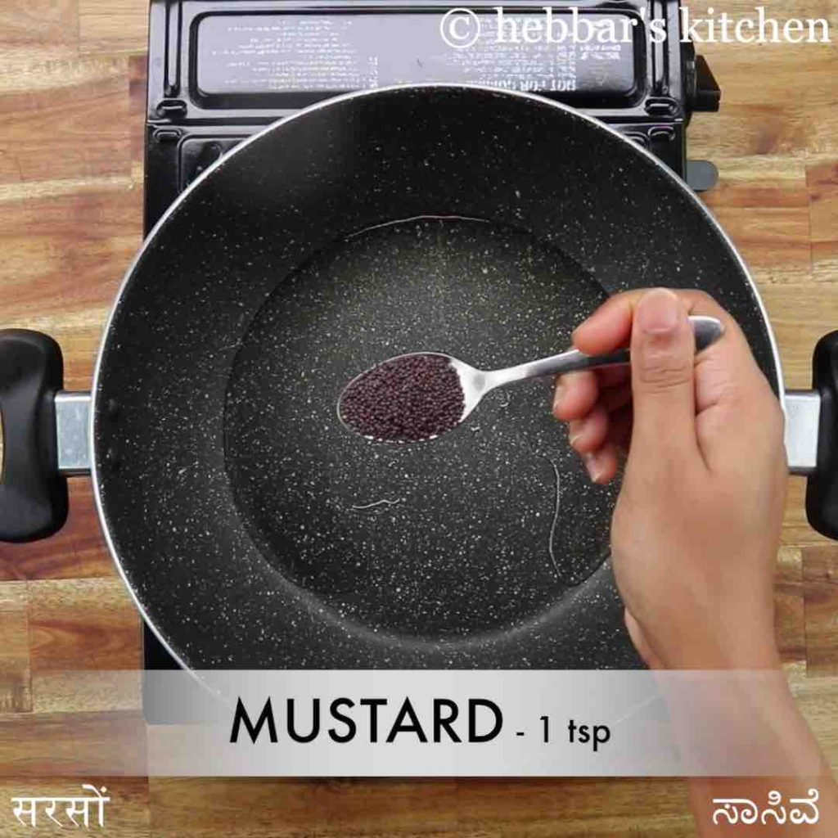
2. also add few curry leaves and 2 chilli saute slightly.  
   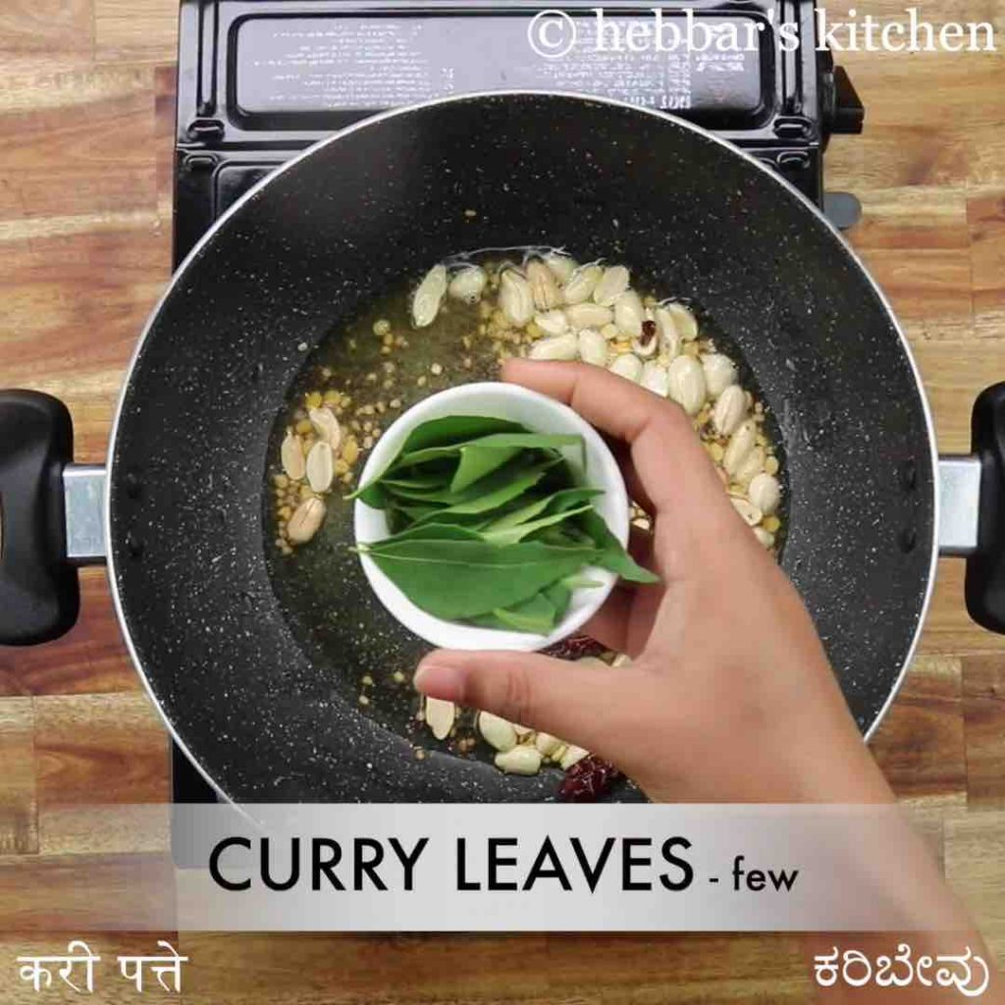
3. now add 1½ cup tamarind extract, ½ tsp turmeric, 1 tsp salt and 1 tsp jaggery.  
   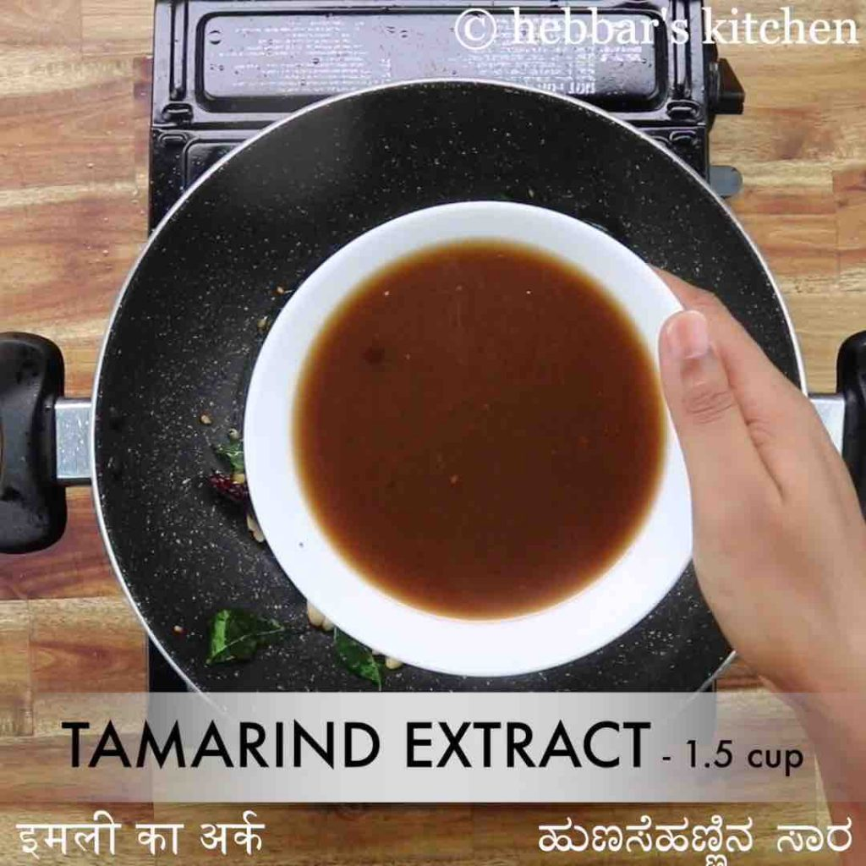
4. mix well, cover and boil for 10 minutes stirring in between.  
   
5. cook until the oil separates from tamarind extract.  
   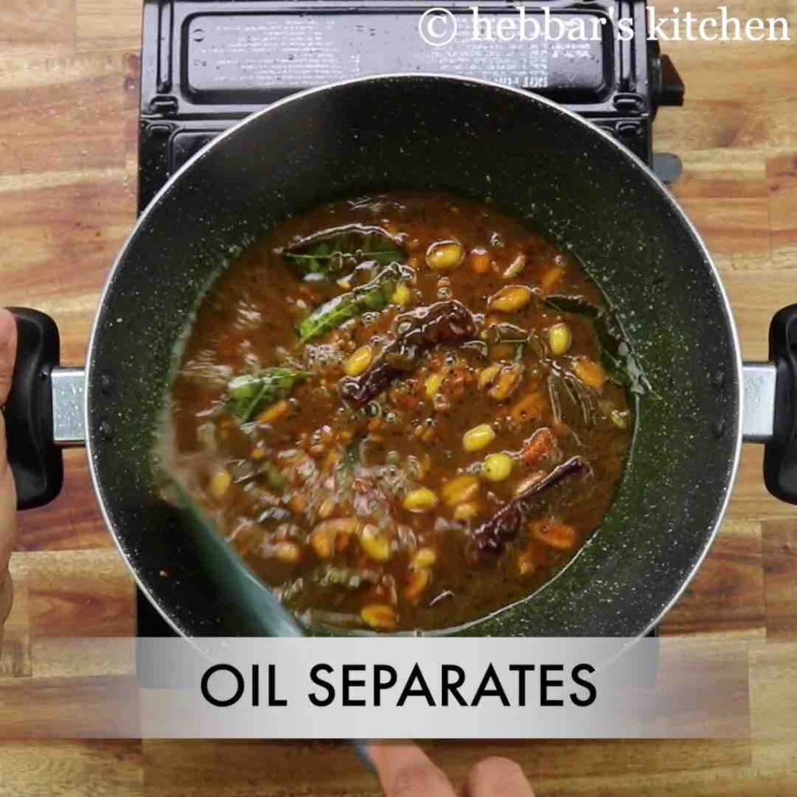
6. further in a pan dry roast 1 tsp mustard, 1 tsp urad dal, ½ tsp cumin, 1 tsp chana dal, 1 tsp coriander seeds, ¼ tsp methi, 1 tbsp sesame and 3 dried red chilli.  
   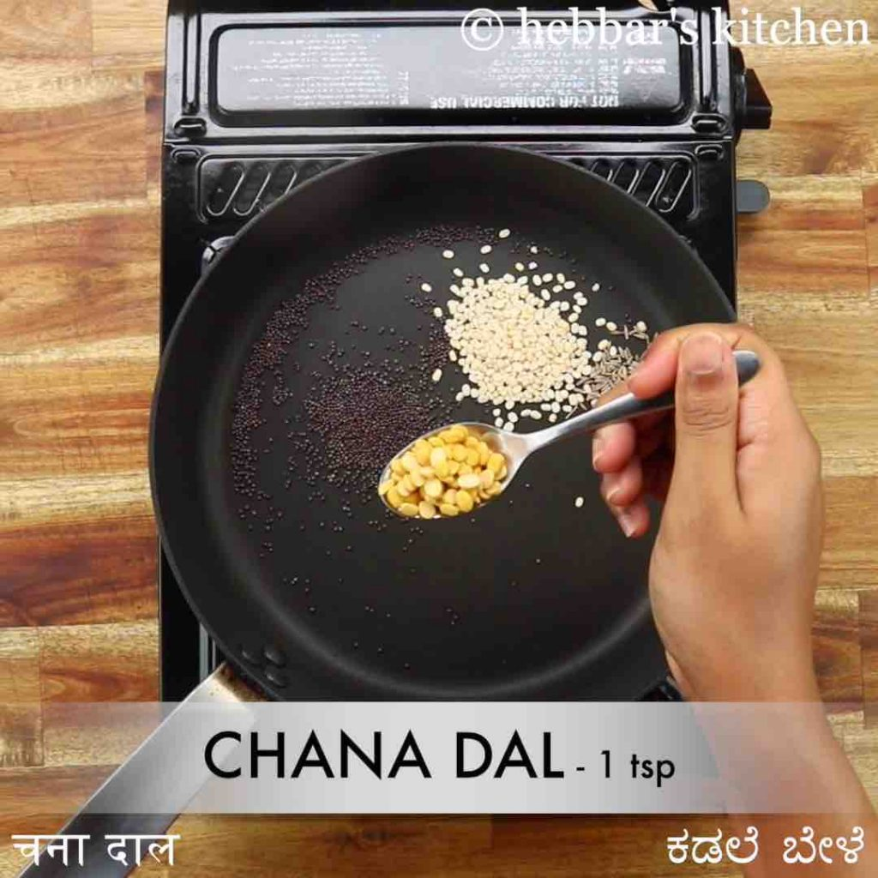
7. roast until the spices turn aromatic.  
   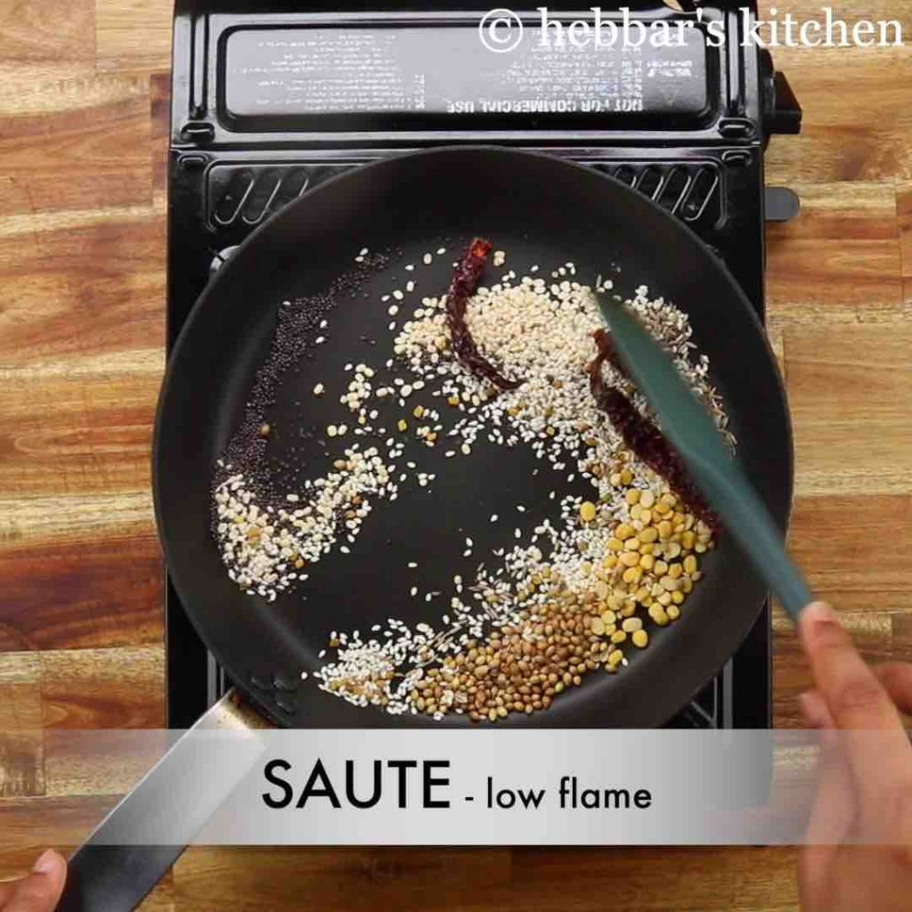
8. cool completely and blend to a fine powder.  
   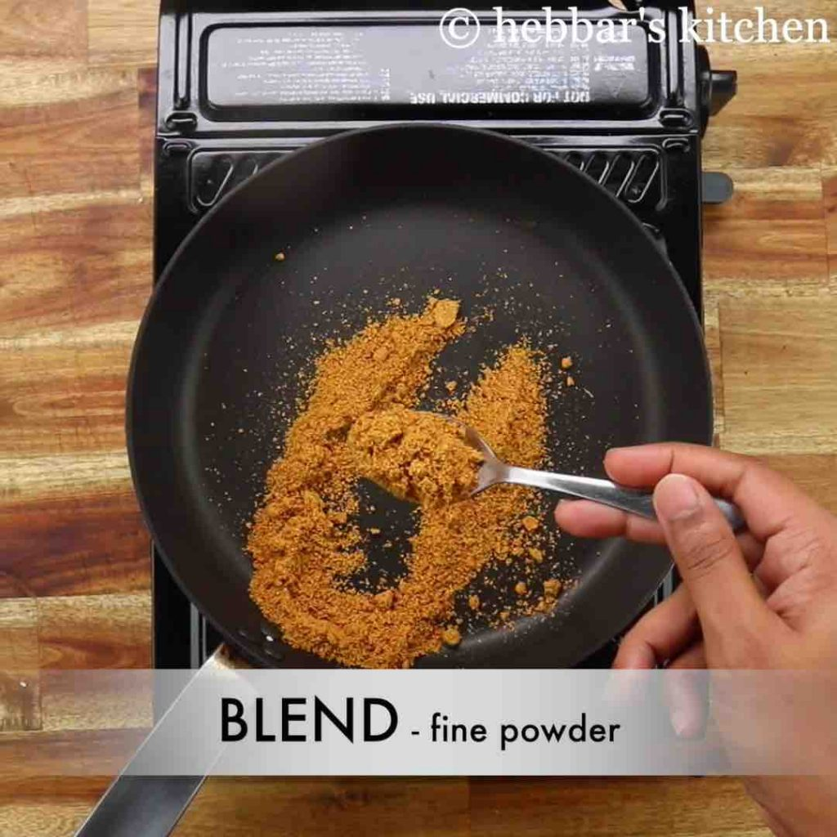
9. transfer the pulihora masala powder to the cooked tamarind extract and mix well.  
   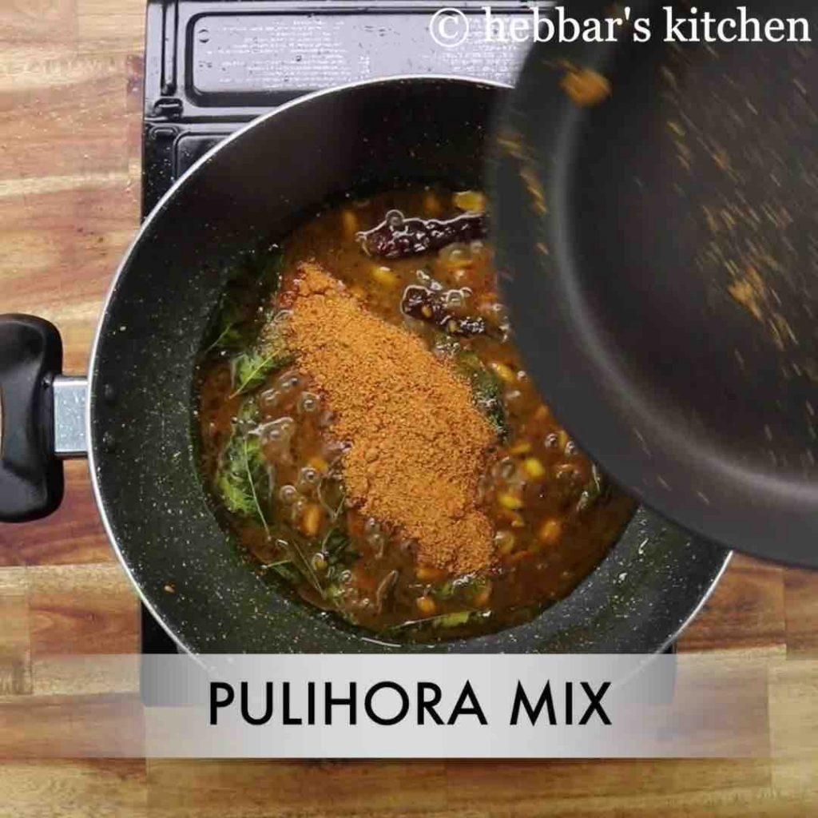
10. mix until the paste turns aromatic.  
    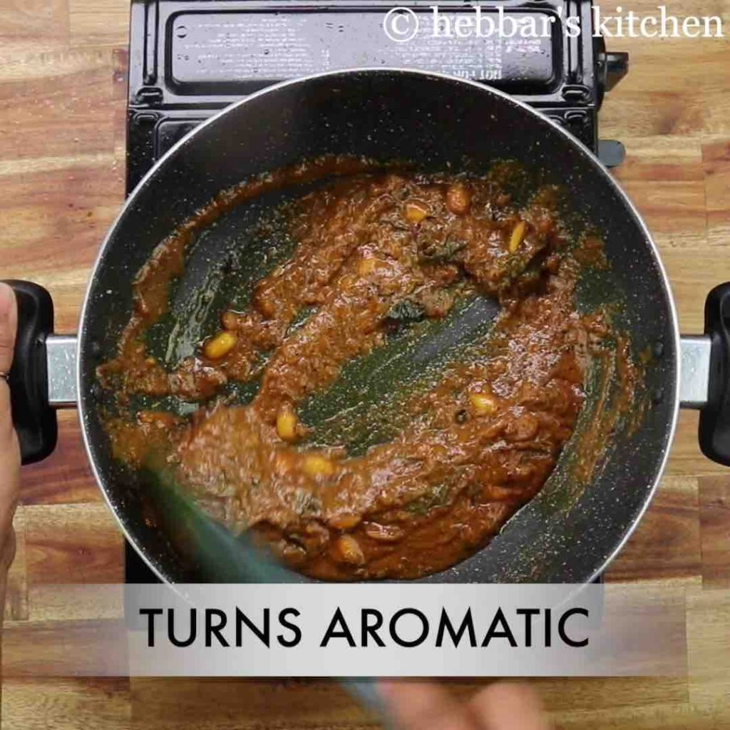
11. now add 4 cup cooked rice and ½ tsp salt.  
    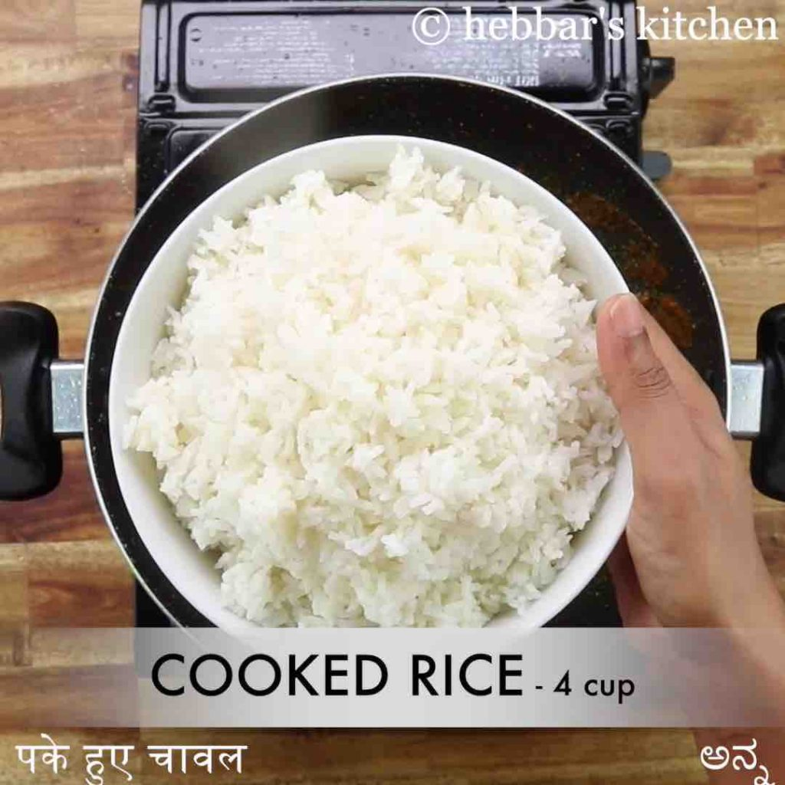
12. mix gently making sure the pulihora paste is well combined with the rice.  
    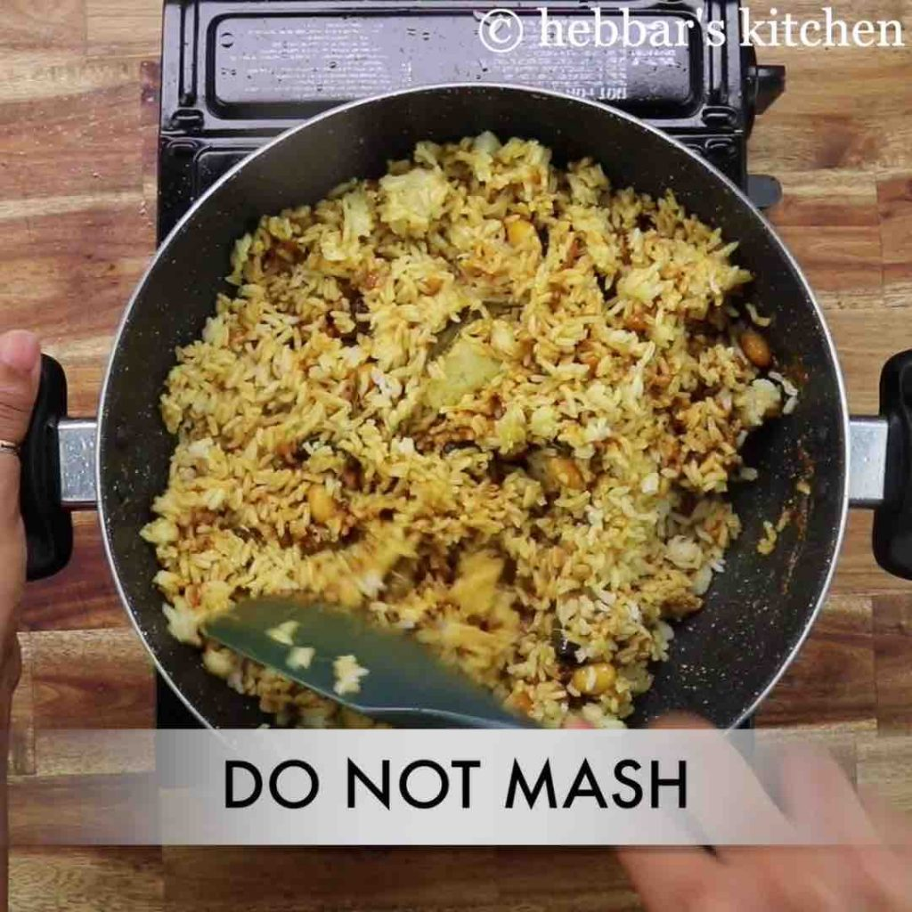
13. finally, enjoy **andhra style pulihora** with curd or papad.  
    