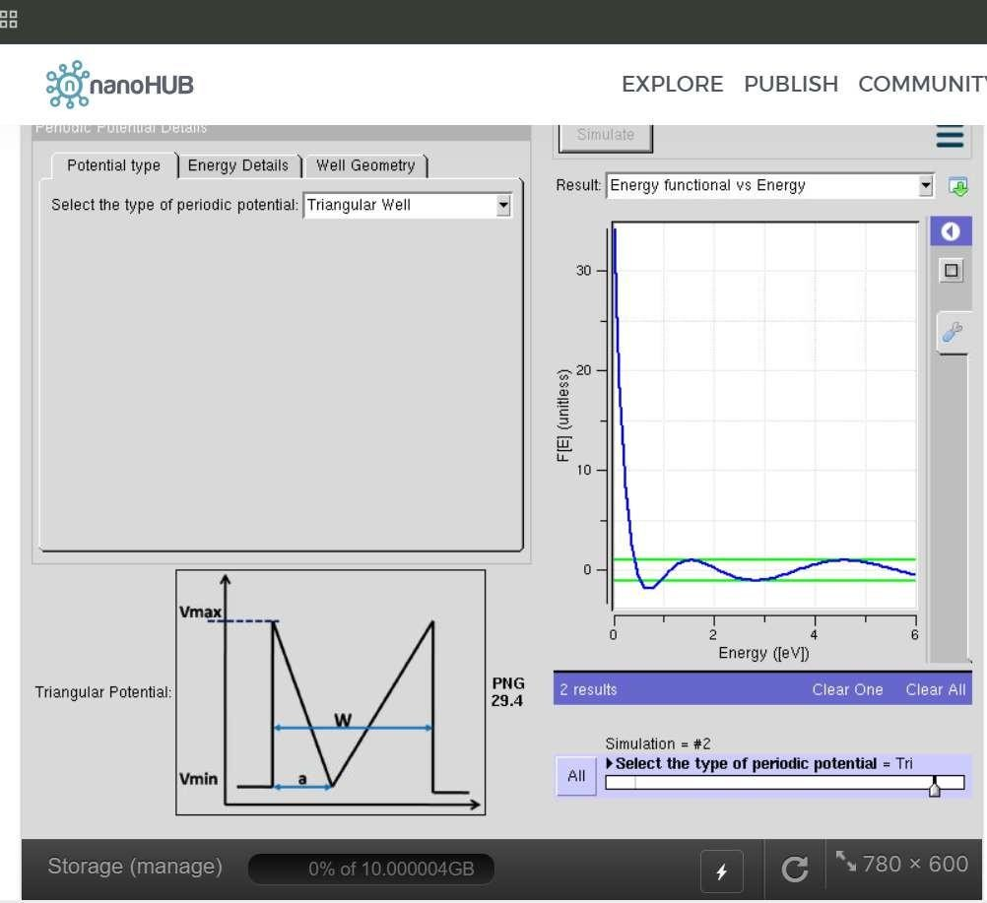
ECA3102
Nanoelectronics
Exp3: Kronig Penney Model
Aim: To simulate the Kronig–Penney model and study the formation of allowed energy bands and forbidden band gaps in a periodic crystal potential.
Case Study 1: Simulate the output for Triangular well
Aim: To simulate the electronic energy states of a triangular quantum well and analyze the effect of the triangular potential profile on quantum confinement. The study aims to understand the distribution of discrete energy levels and their significance in nanoscale semiconductor devices.
Outcome Justification: The simulation verifies that a triangular potential well produces quantized electron energy levels due to quantum confinement. Such potential profiles are widely used to study carrier behavior in MOSFET inversion layers, HEMTs, quantum well devices, and other nanoelectronic and optoelectronic application

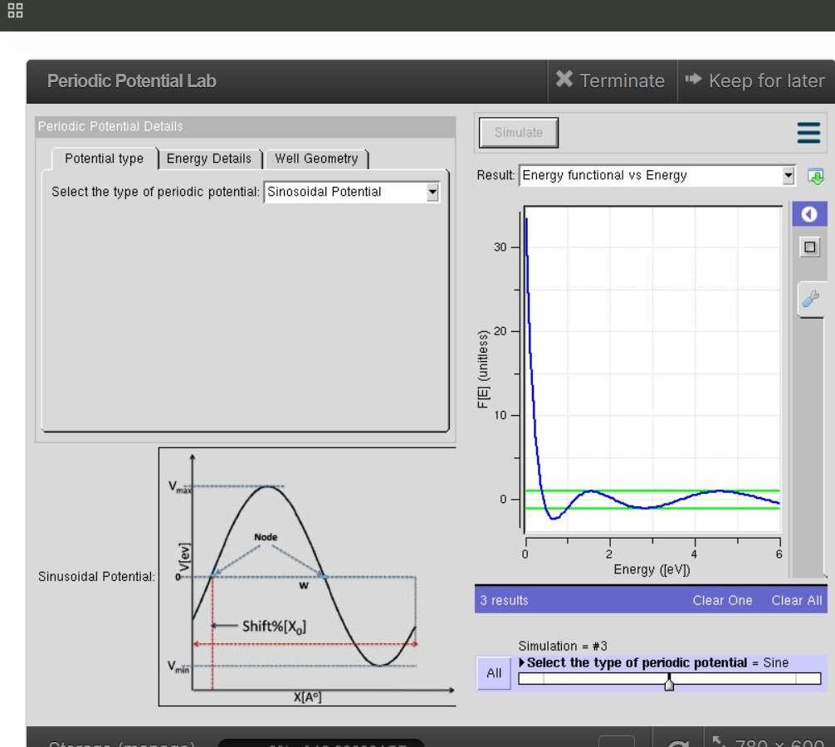
Outcome Justification: The simulation of the Sinusoidal Potential demonstrates the behavior of electrons in a periodic potential field, similar to that found in a crystal lattice. The Energy Functional vs. Energy graph shows oscillatory variations, indicating the presence of allowed energy states separated by regions corresponding to forbidden energy gaps (band gaps).
Case Study 2: Simulate the output for Sinusoidal Potential
Aim: To simulate the electronic energy states in a sinusoidal potential and analyze how a periodic sinusoidal potential influences the formation of energy bands and electron behavior. The study aims to understand the effect of periodic potentials on the electronic properties of semiconductor nanostructures.

