INTRODUCTION TO JAVASCRIPT

- Prompt for amount, interest rate and no. of years and calculate simple interest.
Code : https://github.com/srishh/Repo/blob/master/ques1.html
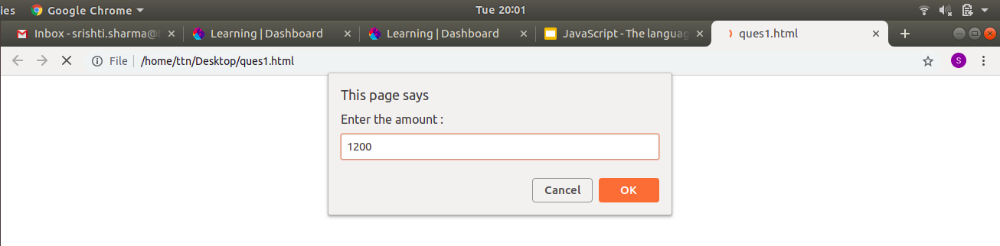
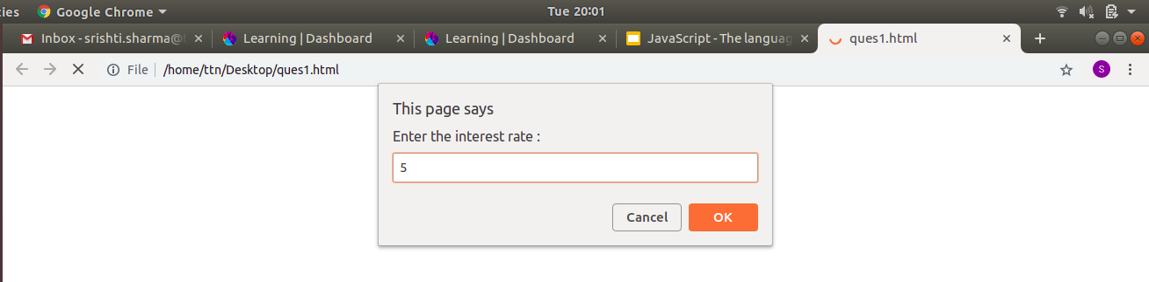
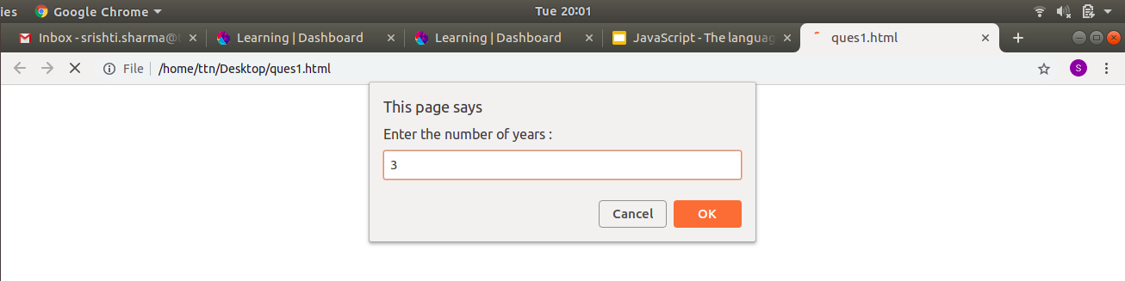
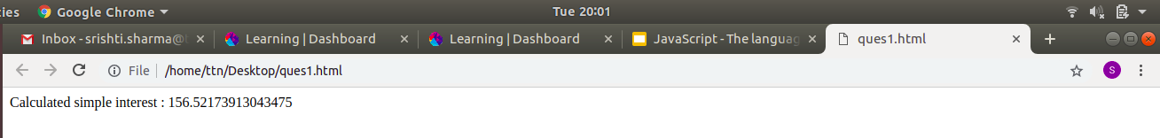

2. Check if string is palindrome.
Code : https://github.com/srishh/Repo/blob/master/ques2.html
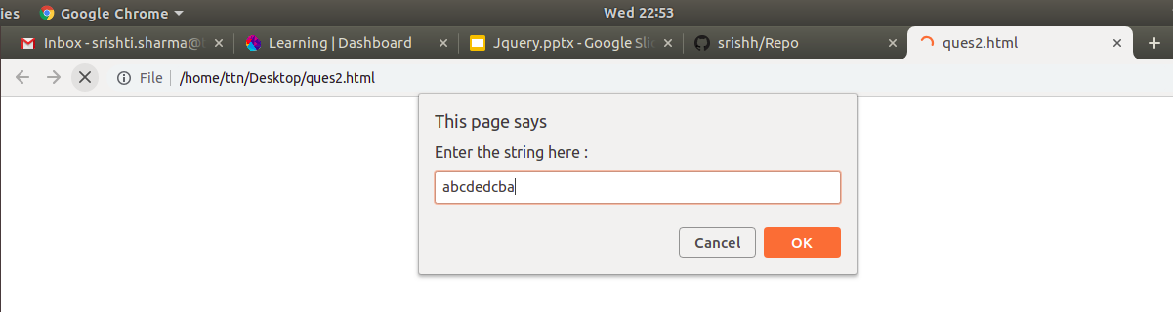
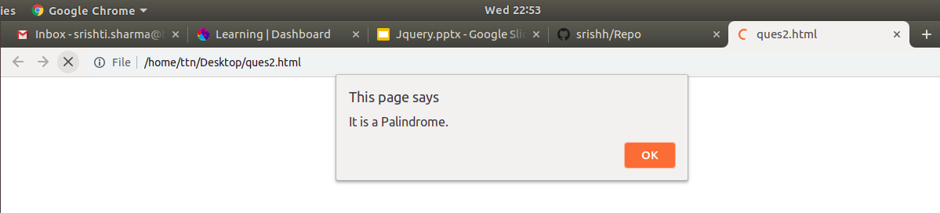
3. Area of circle
Code : https://github.com/srishh/Repo/blob/master/ques3.html
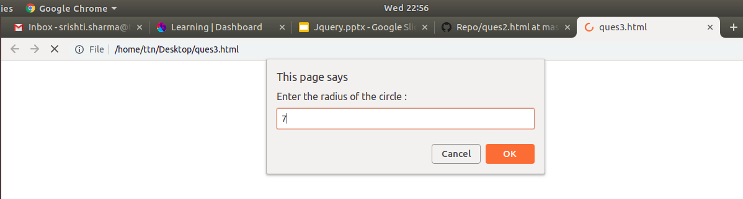
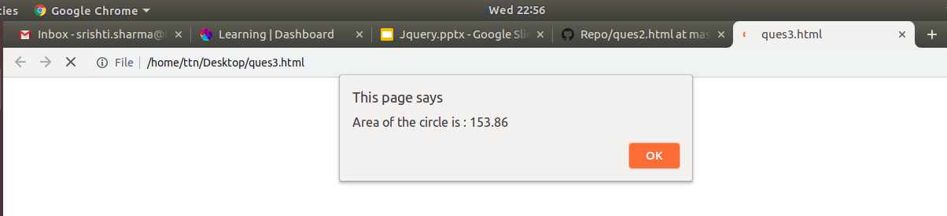
4. Copy informaton of one object to another and log it to console.
Code : https://github.com/srishh/Repo/blob/master/ques4.html
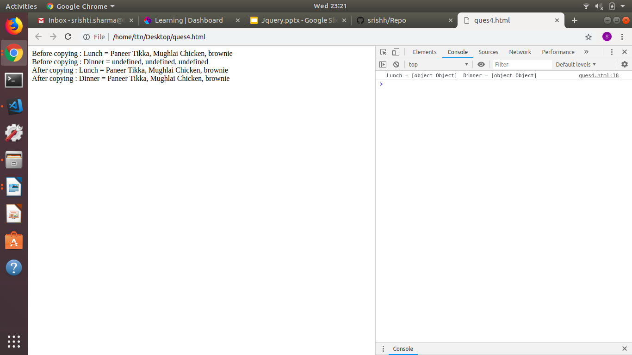
5. Create a list of objects of Employee with info as follows:
- Name, age, salary, DOB
- filter all employees with salary greater than 5000
- group employee on the basis of their age
- fetch employees with salary less than 1000 and age greater than 20. Then give them an incement 5 times their salary.
Code : https://github.com/srishh/Repo/blob/master/ques5.html
