INTRODUCTION TO JQUERY

1. Console "Hello Word" in document.ready function.

https://github.com/srishh/Repo/blob/master/jq1.html

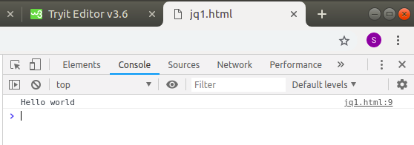

2. Select a ID name "#test" and add class "load" when DOM is loaded.

https://github.com/srishh/Repo/blob/master/jq2.html

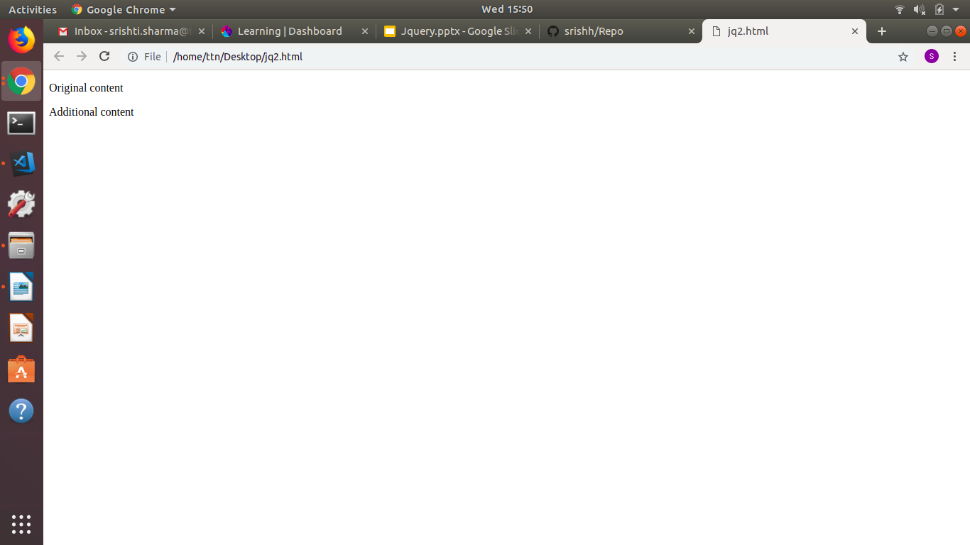
3. Change the color of element which class name end with "-new"
https://github.com/srishh/Repo/blob/master/jq3.html
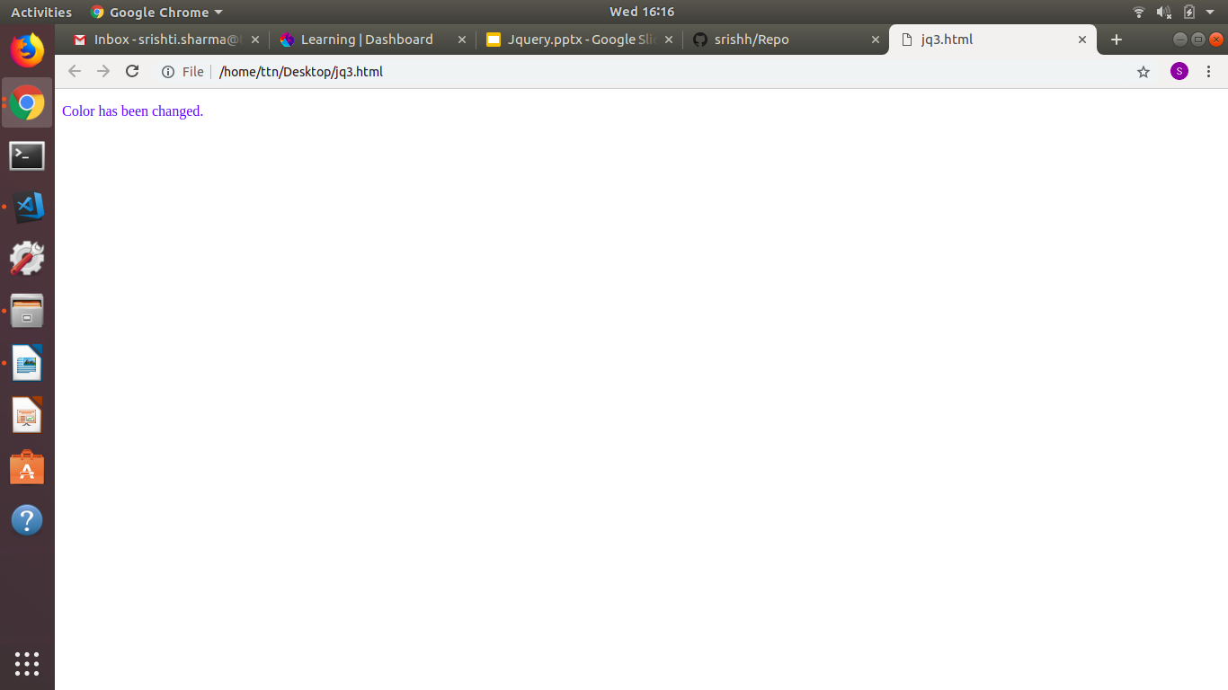
4. Disable submit button using jquery attr method.
https://github.com/srishh/Repo/blob/master/jq4.html
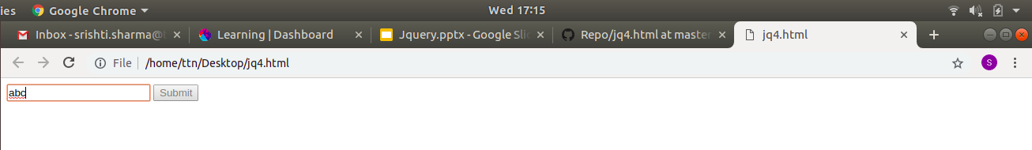
5. Change the font size of ".target" which has parent element with id name "#main".
https://github.com/srishh/Repo/blob/master/jq5.html
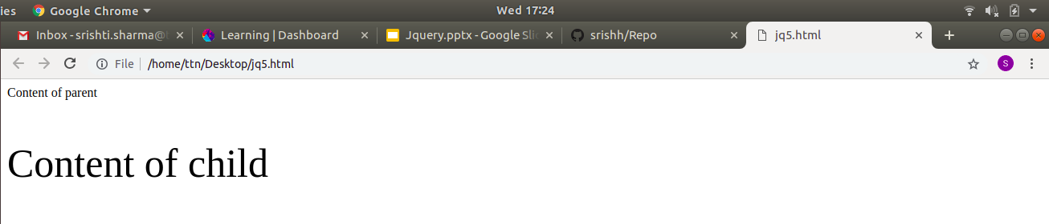
6. After page load change the HTML of div element with "p" element.
https://github.com/srishh/Repo/blob/master/jq6.html
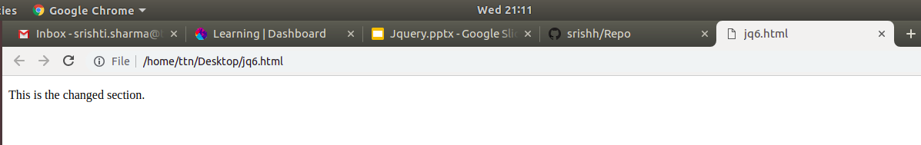
7. Bind a click function to an "click" element and append next "click" next to it.
https://github.com/srishh/Repo/blob/master/jq7.html
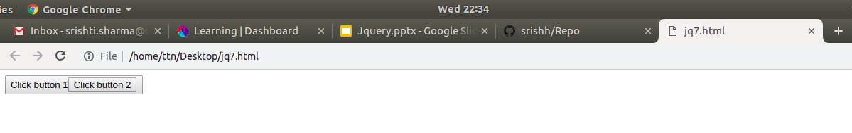
8. Click event not working on element which added dynamicly or via script, make it work using .on method
https://github.com/srishh/Repo/blob/master/jq8.html
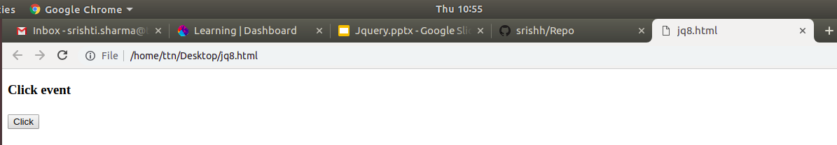
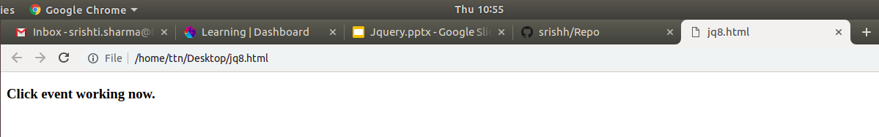

9. Get dropdown selected value on onchanage event and append in div container.
https://github.com/srishh/Repo/blob/master/jq9.html
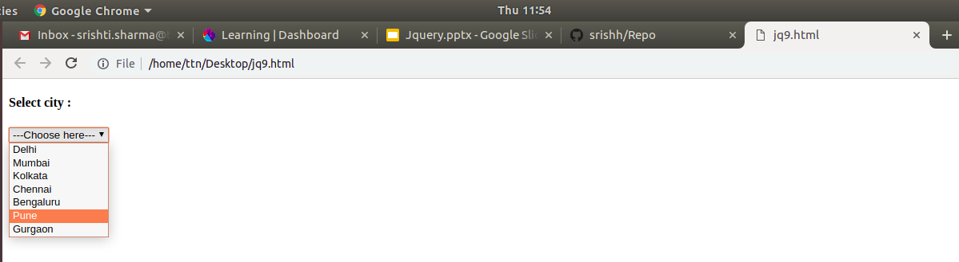
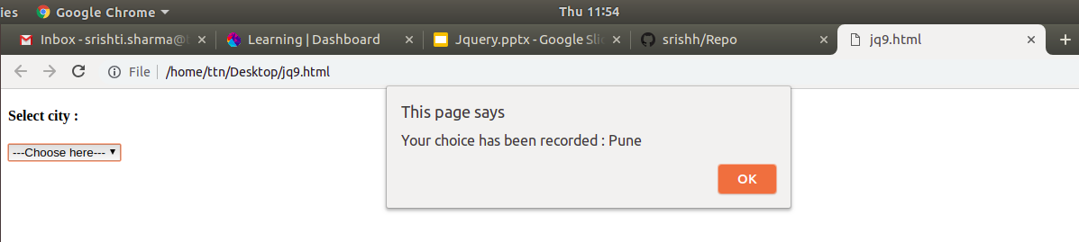
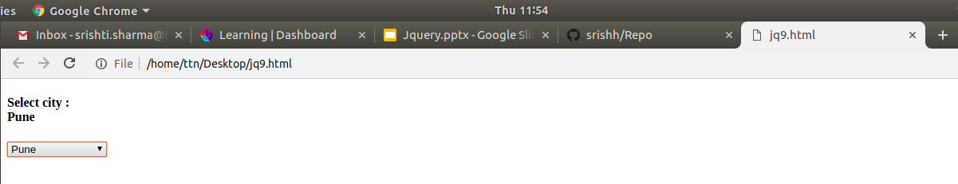
10. Create a dropdown menu using hover method in jquery.
https://github.com/srishh/Repo/blob/master/jq10.html
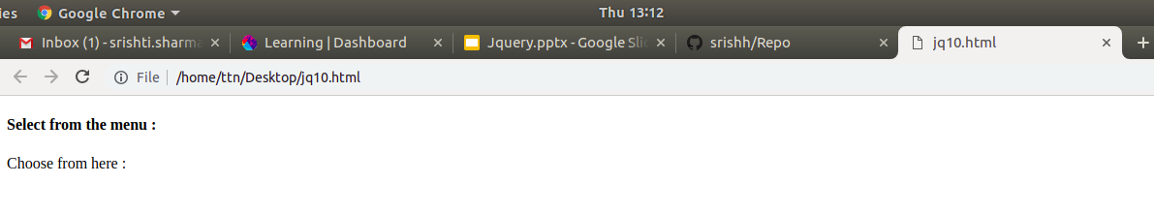
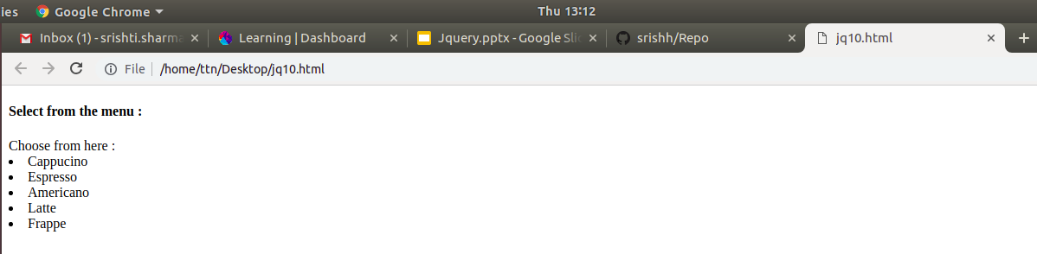

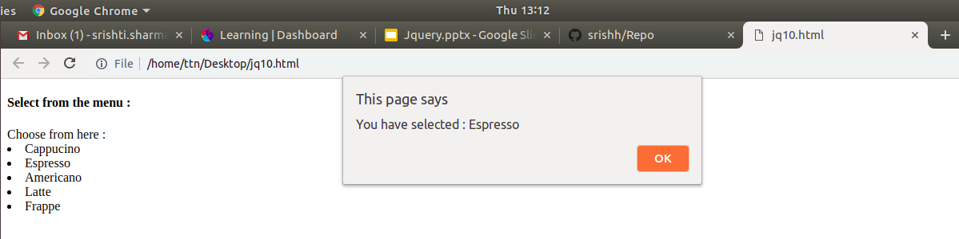
11. On clicking on "google" tag. It is taking us to google home page. Stop it from happening.
https://github.com/srishh/Repo/blob/master/jq11.html
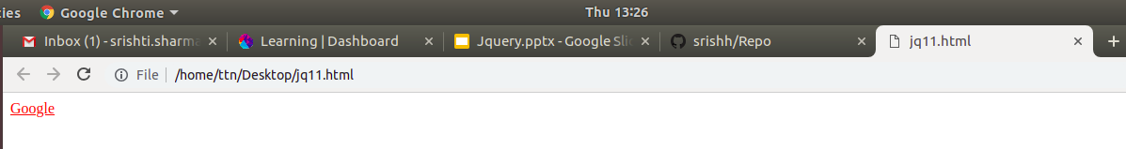
12. We have bind a click funtion to parent div but we want stop it from performing when user clicks on its child li.
https://github.com/srishh/Repo/blob/master/jq12.html
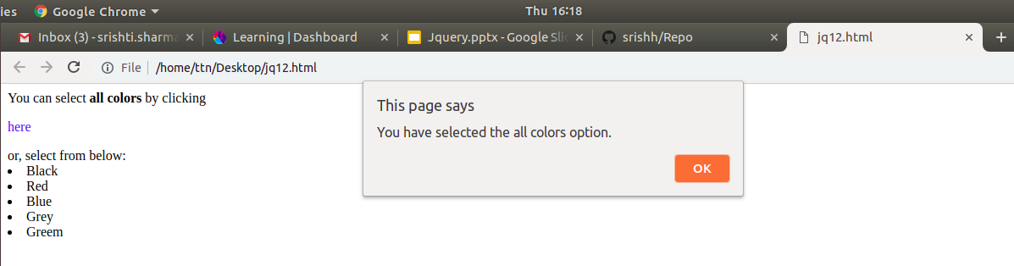
13. Get the max height of elements using jquery each method.
https://github.com/srishh/Repo/blob/master/jq13.html
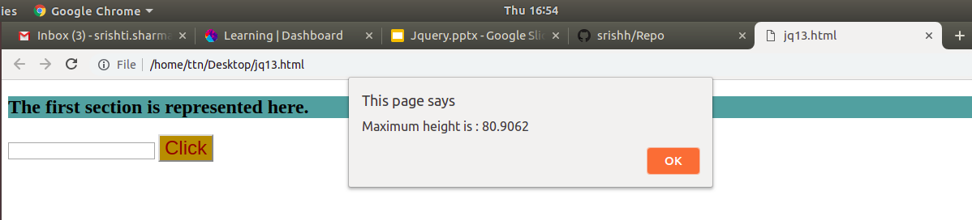

14. Chagne color of every cell which has number larger than 10.
https://github.com/srishh/Repo/blob/master/jq14.html
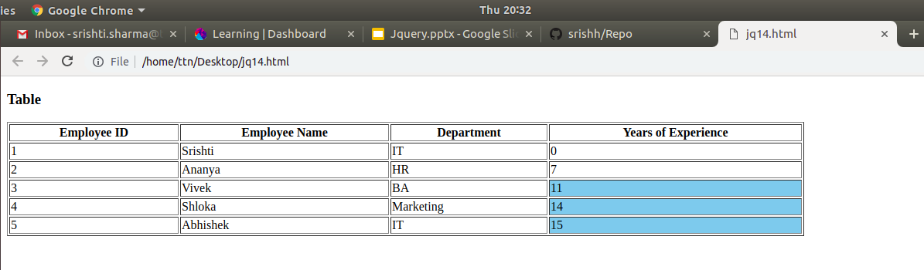
15. Retrive the data from server using ajax get call.
https://github.com/srishh/Repo/blob/master/jq15.html
