INTRODUCTION TO HTML/CSS

- How are inline and block elements different from each another?

An inline element does not cause a line break (start on a new line) and does not take up the full width of a page, only the space bounded by its opening and closing tag. It is usually used within other HTML elements.
Examples include : <span>, <a>

A block element always starts on a new line and takes up the full width of a page, from left to right. A block element can take up one line or multiple lines and has a line break before and after the element.
Examples include : <div>, <li>

- Explain the difference between visibility:hidden and display:none.

visibility:hidden - Here, the tag is not visible, but space is allocated for it on the page. The tag is rendered, it just isn't seen on the page. It removes the element from the normal flow of the page, allowing other elements to fill in.

display:none – Using this means that the tag in question will not appear on the page at all although you can still interact with it through the dom. There will be no space allocated for it between the other tags. It leaves the element in the normal flow of the page such that is still occupies space.

3. Explain the clear and float properties.

The float CSS property places an element on the left or right side of its container, allowing text and inline elements to wrap around it. The element is removed from the normal flow of the page, though still remaining a part of the flow.
The float property is specified as a single keyword, chosen from the list of values below.
left : The element must float on the left side of its containing block.
right : The element must float on the right side of its containing block.

The clear CSS property sets whether an element must be moved below, (cleared) floating elements that precede it. The clear property applies to floating and non-floating elements.
The clear property is specified as a single keyword, chosen from the list of values below.
left : The elements on the left are cleared from the float preceding them.
right : The elements on the right are cleared from the float preceding them.
both : The elements on both left and right are cleared from the preceding float property.

4. Explain difference between absolute, relative, fixed and static.

Absolute - The element is positioned absolutely to its first positioned parent. The positioning is done relative to the first relatively (or absolutely) positioned parent element. In the case when there is no positioned parent element, it will be positioned related directly to the HTML element (the page itself).
Relative - The element is positioned relative to its normal position. When the position is set relative to an element, without adding any other positioning attributes (top, bottom, right, left) nothing will happen. When an additional position is added, such as left: 20px, the element will move 20px to the right from its normal position. Here, the element becomes relative to itself. When the element moves, no other element on the layout will be affected.

5. Write the HTML code to create a table in which there are 4 columns( ID , Employee Name, Designation, Department) and at least 6 rows. Also do some styling to it.
Code : https://github.com/srishh/Repo/blob/master/question5.html
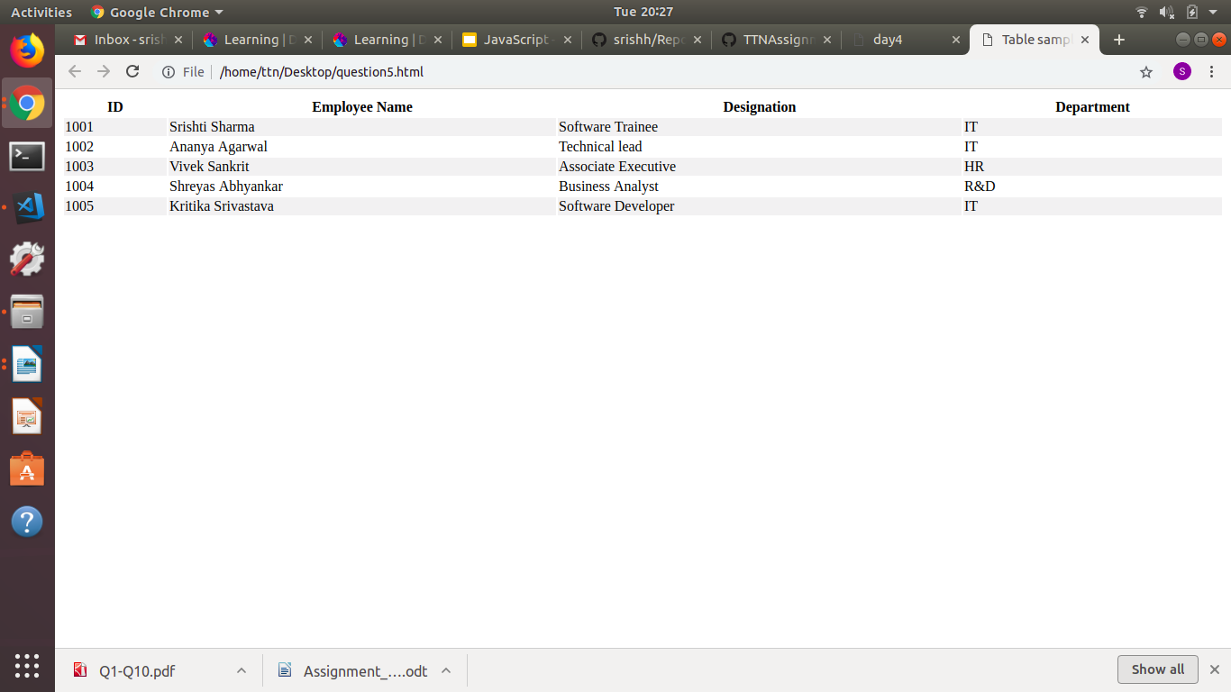

6. Why do we use meta tags?
The tag provides metadata about the HTML document. Metadata will not be displayed on the page, but will be machine parsable. Tag is typically used to specify page description, keywords, author of the document, last modified and other meta data The metadata can be used by the browsers, like how to display content or reload page. For example :
<head>
<meta charset = “UTF-8”>
<meta name = “Keywords” content = “HTML, CSS, XML, Javascript”>
</head>
7. Explain box-model.
• All HTML elements can be considered as boxes. In CSS, this term is used when talking about design and layout.
• It is essentially a box that wraps around every HTML element.
• It consists of : margins, borders, padding and the content.
Code (for a sample box-model) : https://github.com/srishh/Repo/blob/master/question7.html
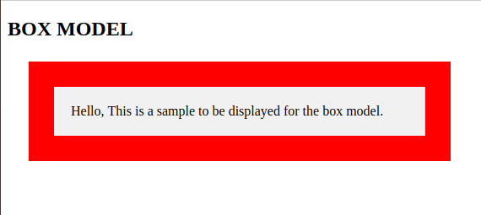

8. What are the different types of CSS Selectors?
• CSS selectors are used to select the content you want to style. They are part of CSS rule set.
• There are several types of selectors in CSS :

The element selector : The element selector selects elements based on the element name.

The id selector : The id selector uses the id attribute of an HTML element to select a specific element. The id of an element should be unique within a page, so the id selector is used to select one unique element. To select an element with a specific id, write a hash (#) character, followed by the id of the element.
3. The class selector : The class selector selects elements with a specific class attribute. To select elements with a specific class, write a period (.) character, followed by the name of the class.
4. Grouping selectors : If you have elements with the same style definitions, it will be better to group the selectors, to minimize the code.To group selectors, separate each selector with a comma.

9. Define Doctype.
• The declaration must be the very first thing in your HTML document, before the tag.
• The declaration is not an HTML tag; it is an instruction to the web browser about what version of HTML the page is written in.
• In HTML 4.01, the declaration refers to a DTD, because HTML 4.01 was based on SGML. The DTD specifies the rules for the markup language, so that the browsers render the content correctly.
• HTML5 is not based on SGML, and therefore does not require a reference to a DTD.

10. Explain 5 HTML5 semantic tags.
- <section> (Section) : A section is thematic grouping of content, typically with a heading.
- <article> (Article) : This element specifies independent, self-contained content. An article should make sense on its own, and it should be possible to read it independently from the rest of the web site.
- <header> (Article) : It should be used as a container for introductory content at the top generally.
- <footer> (Footer) : It should contain information about it’s containing element. A footer typically contains the author of the document, copyright information, links to terms of use, etc.
- <nav> (Navigation) : This tag defines a set of navigation links.

11. Please create the following web page using html5 tags and required css.
Code :
HTML file : https://github.com/srishh/Repo/blob/master/question11.html
CSS file : https://github.com/srishh/Repo/blob/master/style11.css

12. Please create the following form using required html5 form tags.
Code :
HTML file : https://github.com/srishh/Repo/blob/master/question12.html
CSS file : https://github.com/srishh/Repo/blob/master/style12.css

