INTRODUCTION TO NOSQL DATABASE ( MONGODB )

1. Create a Database named 'MYWall'

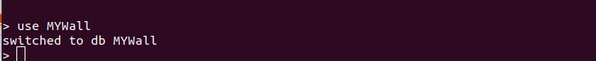

2. Create two collections named 'user and ''post'

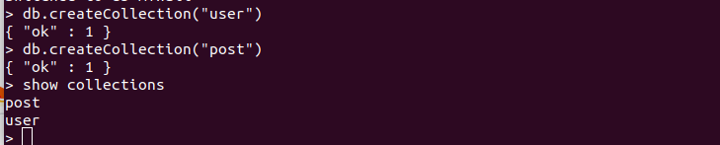
3. Insert some post related information like post_id, title, description , posted_by, comments, created_at etc…
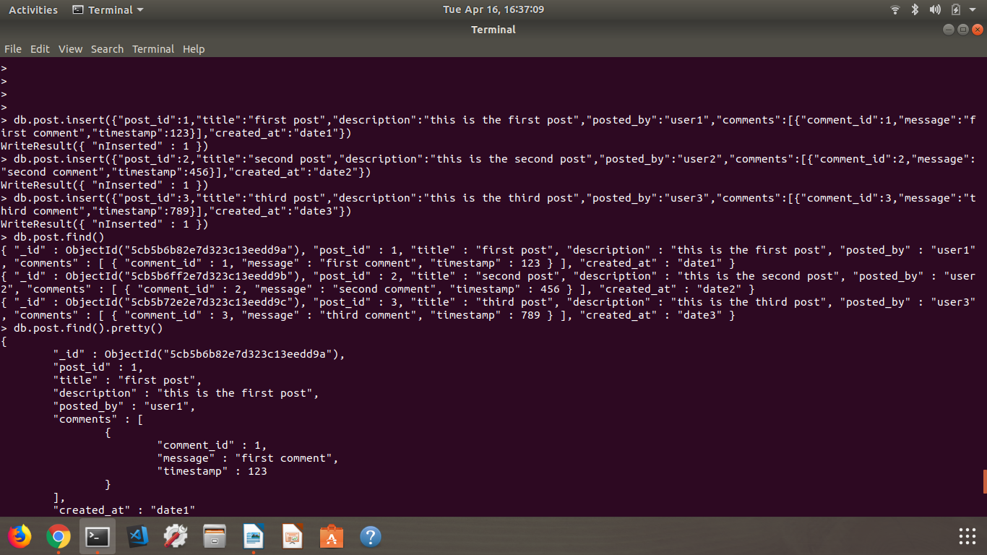
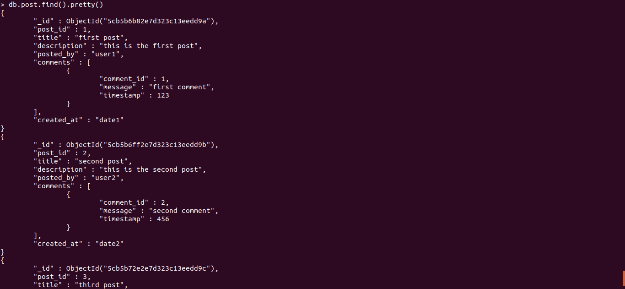
4. Comments should be an array of objects which has comment_id, message, timestamp
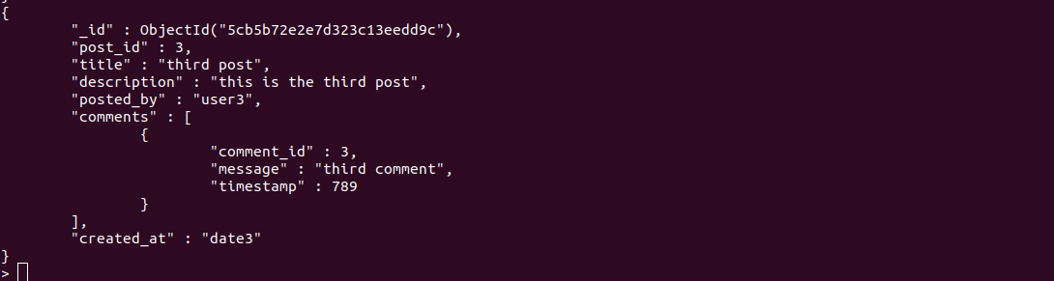
5. Write query to add a new comment for a post
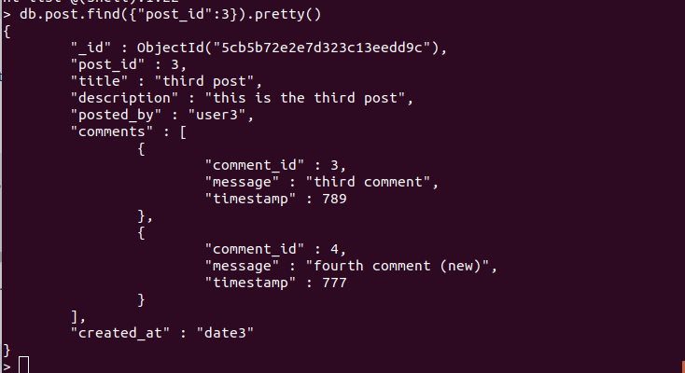
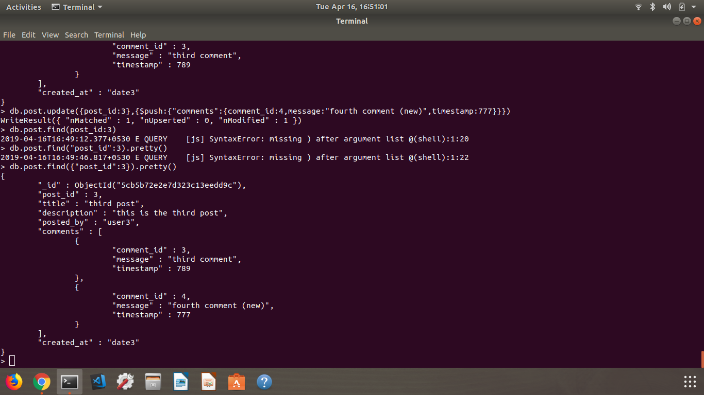
6. Write query to update description of a post
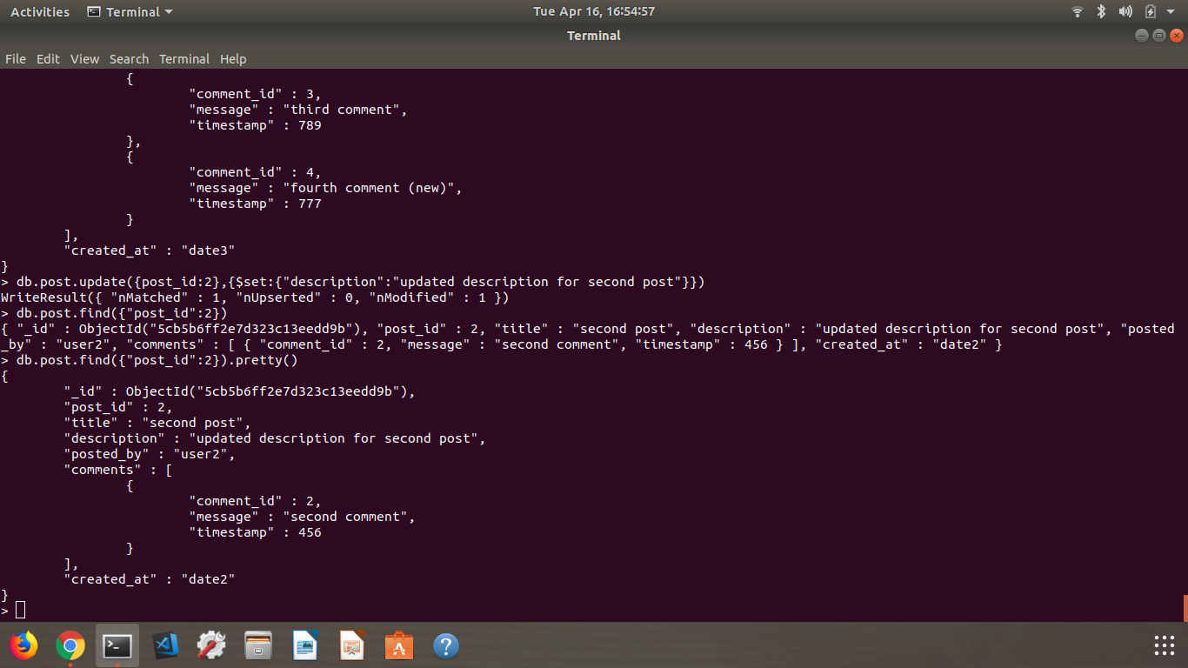
7. Write query to update comment message
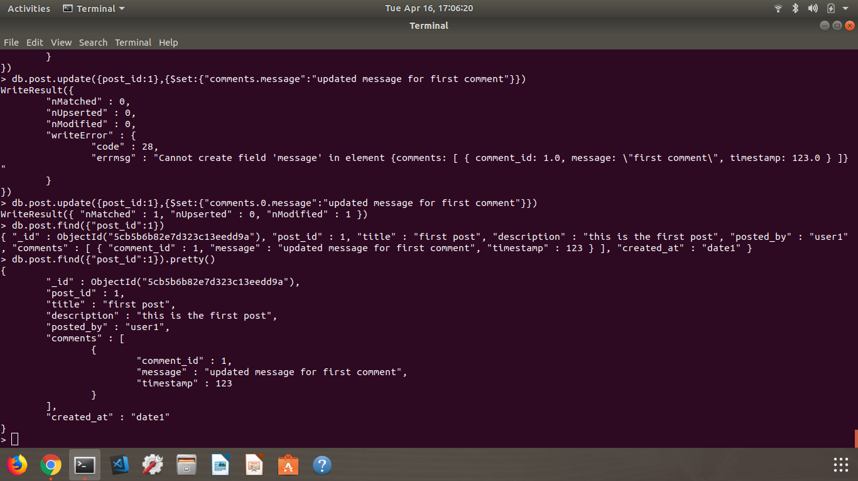
8. Write a query to remove a comment
