INTRODUCTION TO NODE + NPM

1. Installing node latest version and npm

Required commands :
- sudo apt update
- sudo apt install nodejs npm
- sudo apt install npm

2. Read file asynchronously and synchronously

Code :
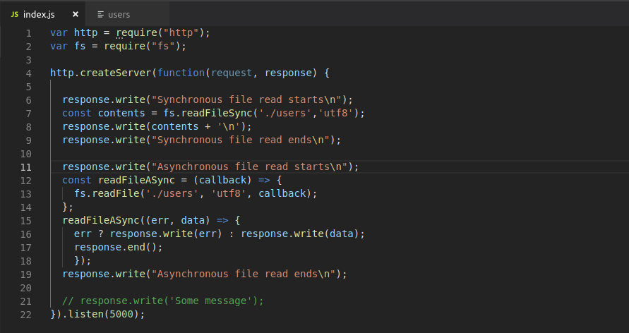
Output :
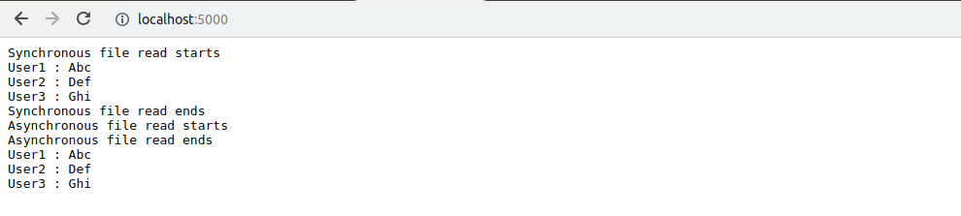

3. Install dependencies and dev dependencies

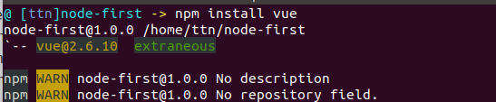
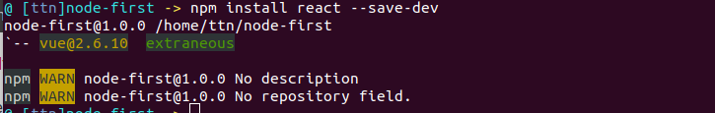

4. Customizing in package.json

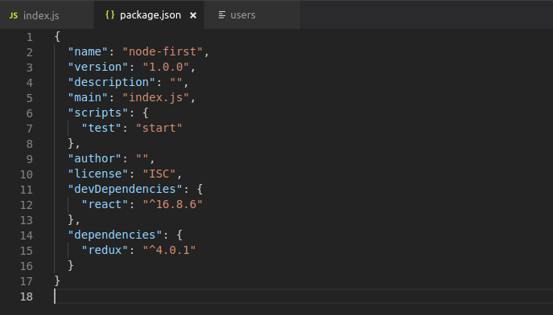

5. Creating module and import & export

index.js
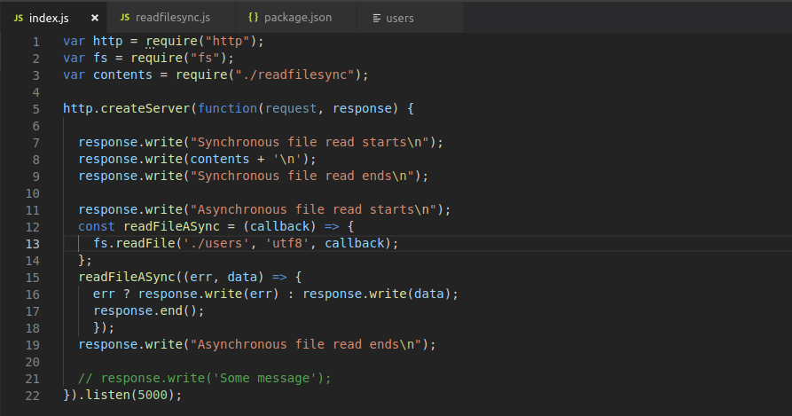
Exported module : readfilesync.js
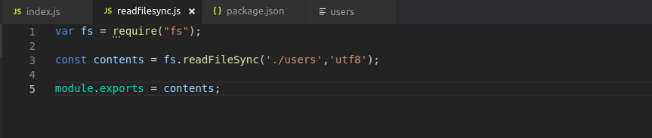
Output
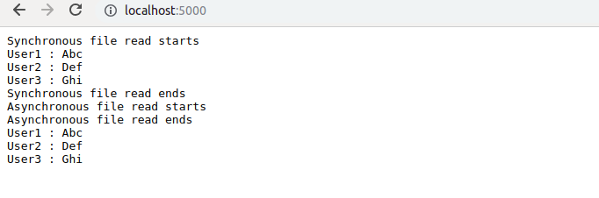

6. Creating a http server

Code
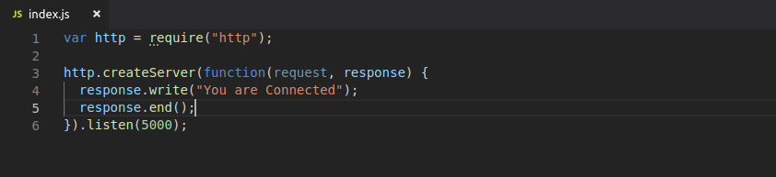
Output (Browser)
