**Amrita Vishwa Vidyapeetham**

**Amrita School of Engineering**

**Department of Computer Science and Engineering**

**15CSE385 – Compiler Design Lab- Periodical – 1**

SET 1

The format of the ISSN is an eight-digit code, divided by a hyphen into two four-digit numbers. As an integer number, it can be represented by the first seven digits. The last code digit, which may be 0-9 or an X, is a check digit. Formally, the general form of the ISSN code (also named "ISSN structure" or "ISSN syntax") can be expressed as follows:

NNNN-NNNC

where N is in the set {*0,1,2,...,9*}, a digit character, and C is in {*0,1,2,...,9,X*};

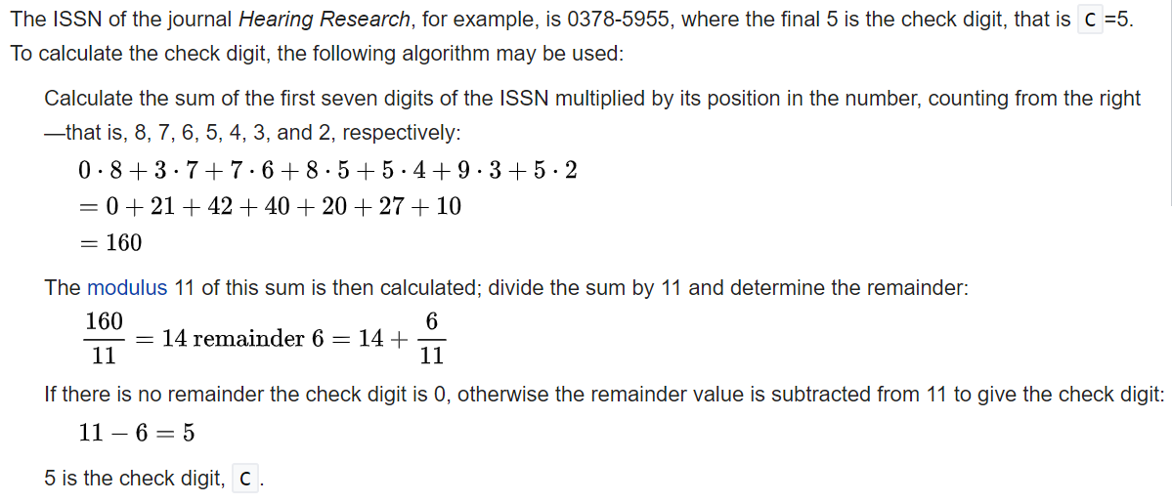

Construct a lexer grammar to check the ISSN syntax and write the java class to find the check digit.

**Considering the following grammar:**

E → id = n | { L } L → E ; L | ε

**Implement a recursive-descent parser for the given grammar. Sample Input:**

{ x = 3 ; { y = 4 ; } ; }

**Amrita Vishwa Vidyapeetham**

**Amrita School of Engineering**

**Department of Computer Science and Engineering**

**15CSE385 – Compiler Design Lab- Periodical – 1**

SET 2

In Roman numerals, there are seven characters that are repeated and combined in various ways to represent numbers.

* I = 1
* V = 5
* X = 10
* L = 50
* C = 100
* D = 500
* M = 1000

MDCCCLXXXVIII is equivalent to 1888.

Construct a lexer grammar to check the Roman numerals and write the java class to find the decimal equivalent.

**************************************************************************

**Consider the following grammar**

**Implement a recursive-descent parser for the given grammar.**

S → E + S | E

E → num | (S)

Input : (1+2+(3+4))+5)