MS D365 CRM

MS D365 CE NOTES

## Contents

Contents 1

1. Apps - 4

2. Solutions - 5

Solution Types - 5

Solution Publisher - 5

Exporting a solution - 6

Importing a solution - 6

Package Type - 8

3. Entities - 8

Entity Types - 8

New custom entity - 8

Ownership types - 10

4. Fields - 10

Field Requirements - 10

Data types available for fields - 10

Auditing - 11

Field Level Security - 11

Field Type options - 11

5. Forms - 13

Form Types - 13

Reference Panel - 18

Iframe - 19

Timer - 19

Subgrids - 20

6. Views - 21

Personal Views: 21

System Views: 22

Public Views: 24

7. Charts - 25

Column: 25

Bar: 26

Area: 26

Line: 26

Pie: 26

Funnel: 27

8. Dashboards - 27

Dashboards Types: 27

9. Business Rules - 29

Business Rules Scope: 30

10. Relationships - 31

One to Many: 31

Many to many: 33

Mappings: 35

11. Keys - 36

12. Hierarchy Settings - 37

Self-Referential Relationship: 37

13. Option sets - 38

14. Client Extensions - 39

15. Web Resources - 39

16. Processes - 39

17. Plug-in Assemblies - 40

18. Sdk Message Processing Steps - 40

19. Service Endpoints - 40

20. Dashboards - 40

21. Dialog Boxes - 40

22. Reports - 40

23. Connection Roles - 40

24. Article Templates - 41

25. Contract Templates - 41

26. Email Templates - 41

27. Mail Merge Templates - 41

28. Security Roles - 41

29. Field Security Profiles - 41

30. Routing Rule Sets - 42

31. Record Creation and Update Rules - 42

32. SLAs - 42

33. Model-driven Apps - 42

34. Custom Controls - 42

35. Virtual Entity Data Providers: 42

36. Virtual Entity Data Sources - 42

37. Mobile Offline Profiles - 43

38. Workflows - 43

Workflow Scope - 43

39. MISCELLANEOUS - 44

## Apps -

Custom business apps are comprised of components such as entities, dashboards, forms, views, charts, and business processes. The app designer helps you bring together all these components quickly.

**Sitemap:** The sitemap determines how users will navigate your app. Components that you select in the site map are also added as entities in the app designer.

**1**

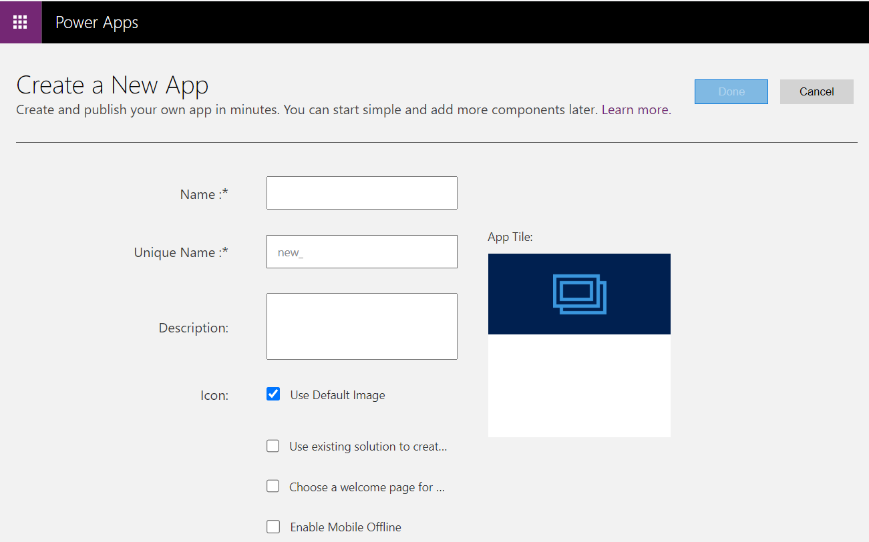

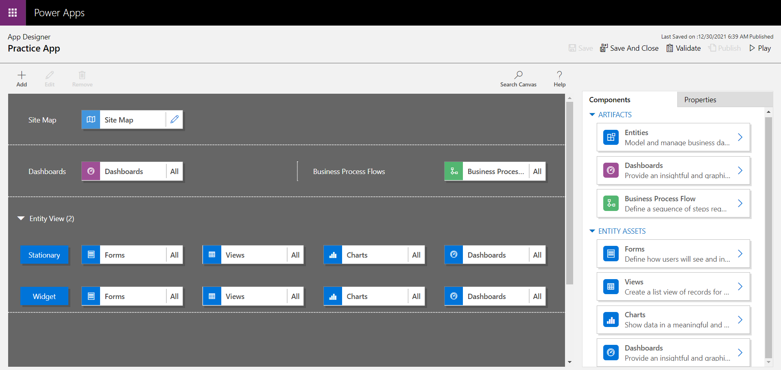

## Solutions -

Solutions are how customizers and developer’s author, package, and maintain units of software that extend Dynamics 365 for Customer Engagement. Solutions are leveraged to transport apps and components from one organization to another or to apply a set of customizations to existing apps.

### Solution Types -

1. **System solution:** The system solution represents the solution components defined within Dynamics 365. Without any managed solutions or customizations, it defines the default application behaviour. Many of the components in the system solution are customizable and can be used in managed solutions or unmanaged customizations.
2. **Managed Solution:** A managed solution is a completed solution that is intended to be distributed and installed.
3. **Unmanaged Solution:** An unmanaged solution is one that is still under development or isn't intended to be distributed. When the unmanaged solution is complete and you want to distribute it, export it and package it as a managed solution.

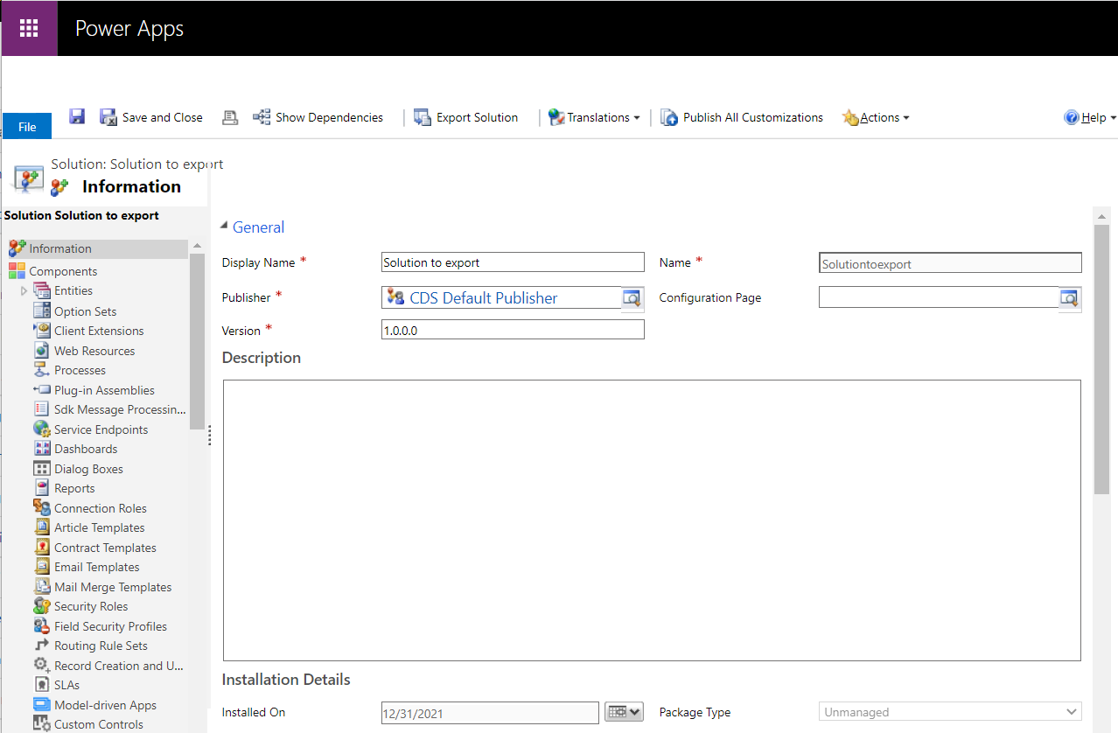

### Solution Publisher -

The solution publisher indicates who developed the app. The default solution has a publisher named “Default Publisher for <your organization name>”. The publisher record contains a **Prefix** value. The default value of this prefix is “new”.

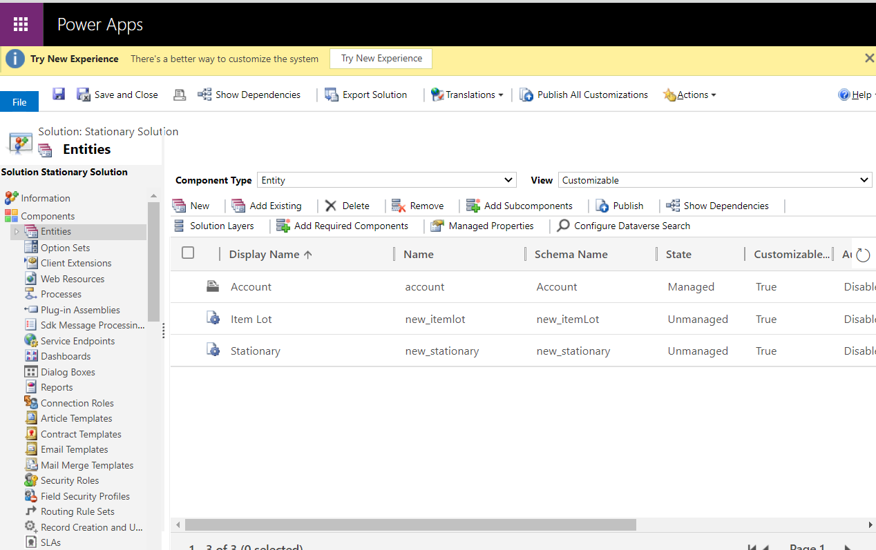

### Exporting a solution -

This will allow you to transport your configuration changes from one environment to another or to store your configuration into your source control system. You can only export an unmanaged solution.

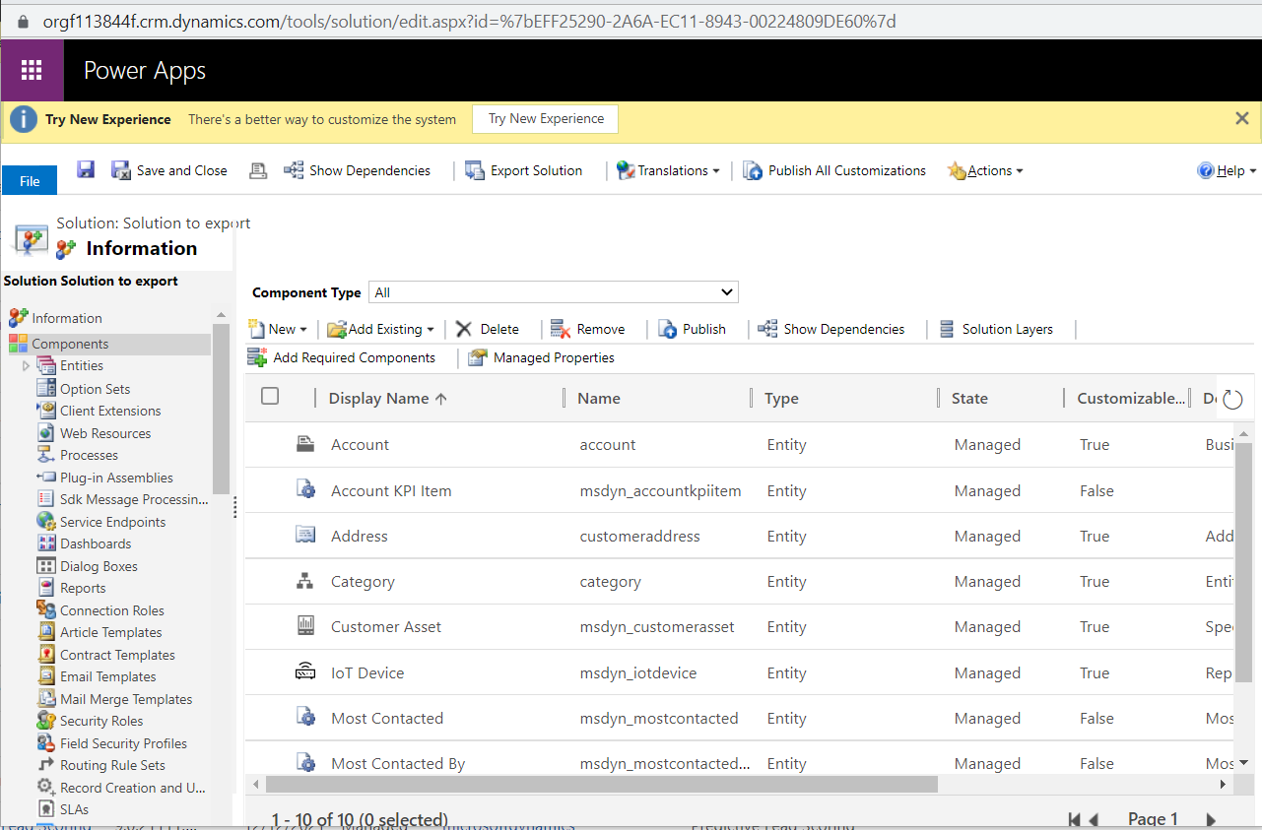

### Importing a solution -

You can import solutions manually. Only import solutions that you've obtained from a trusted source. Customizations might include code that can send data to external sources.

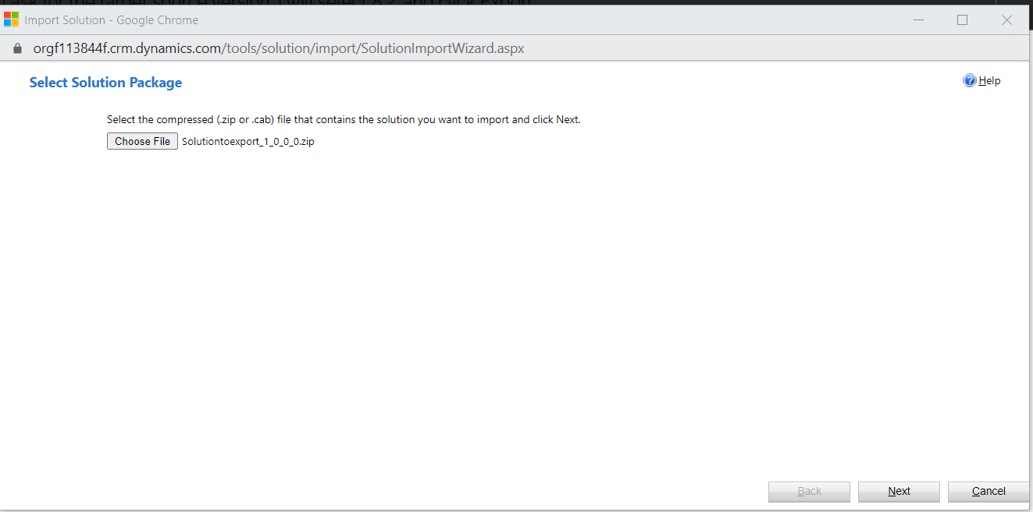

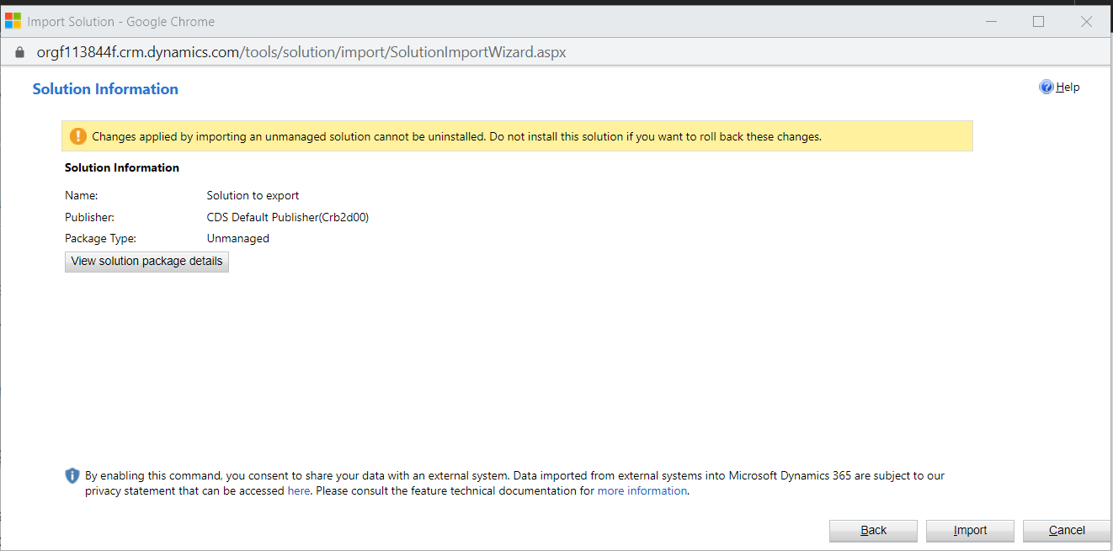 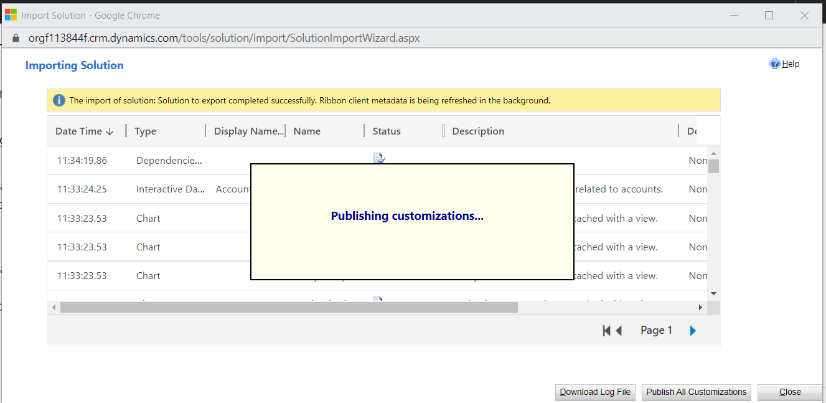

### Package Type -

Unmanaged solutions are intended to be used to transport configuration from one development environment to another or to check into your source control system.

Managed solutions are intended to be used to transport configuration to all other environments including test and production environments.

## Entities -

Metadata means data about data. The metadata is a collection of entities. Entities describe the kinds of data which is stored in the database. Each entity corresponds to a database table and each field (also known as attribute) within an entity represents a column in that table.

### Entity Types -

1. **System entities:** They are to handle all internal processes, such as workflows and asynchronous jobs. You cannot delete or customize system entities.
2. **Business entities:** These are part of the Dynamics 365 default installation and they appear in the customization user interface. For ex: An account, contact, and letter.
3. **Custom entities:** These are created by the user to address specific business needs of the organization.

### New custom entity -

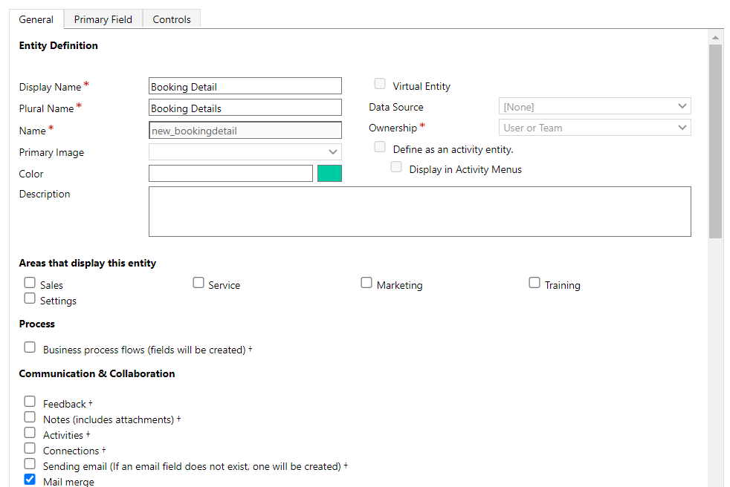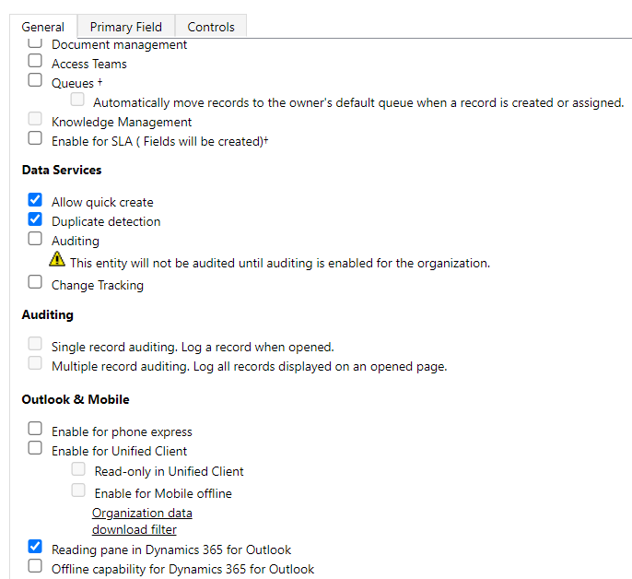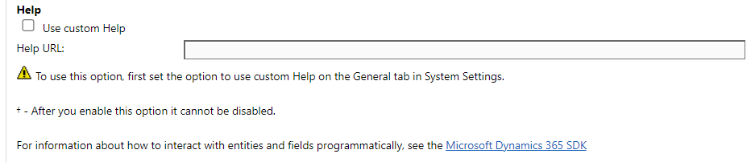

### Ownership types -

* **Organization owned:** There are organization-owned system entities. These include Article, Article Template, Competitor, Currency, and Web Resource.
* **User or team owned:** These records are owned by a user or team; they’re connected to a business unit and specific security roles for the business unit. Therefore, these entities participate in role-based security.

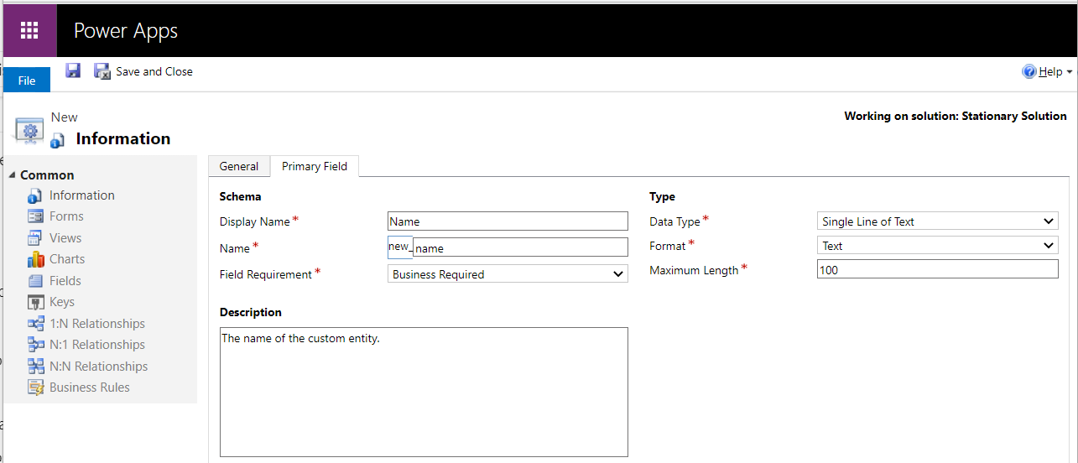

**3**

## Fields -

It defines the individual data items that can be used to store data in an entity. After creating the fields include them on the forms and views for the entity so that they are available from the relevant app user interface.

### Field Requirements -

1. **Optional:** The record can be saved even if there is no data in this field.
2. **Business Recommended:** The record can be saved even if there is no data in this field. However, a blue asterisk appears next to the field to indicate it is important.
3. **Business Required:** The record can’t be saved if there is no data in this field.

### Data types available for fields -

* Single line of text
* Currency
* Option Set
* Multiple Lines of text
* Multi Select Option Set
* Date and Time
* Two Options
* Lookup
* Image
* Customer
* Whole Number
* File
* Floating Point Number
* Decimal Number

### Auditing -

The Dynamics 365 Customer Engagement (on-premises) auditing feature logs changes that are made to customer records and user access so you can review the activity later.

### Field Level Security -

Record-level permissions are granted at the entity level, but you may have certain fields associated with an entity that contain data that is more sensitive than the other fields. For these situations, you use field-level security to control access to specific fields.

**IME mode:** Describes the input method editor mode.

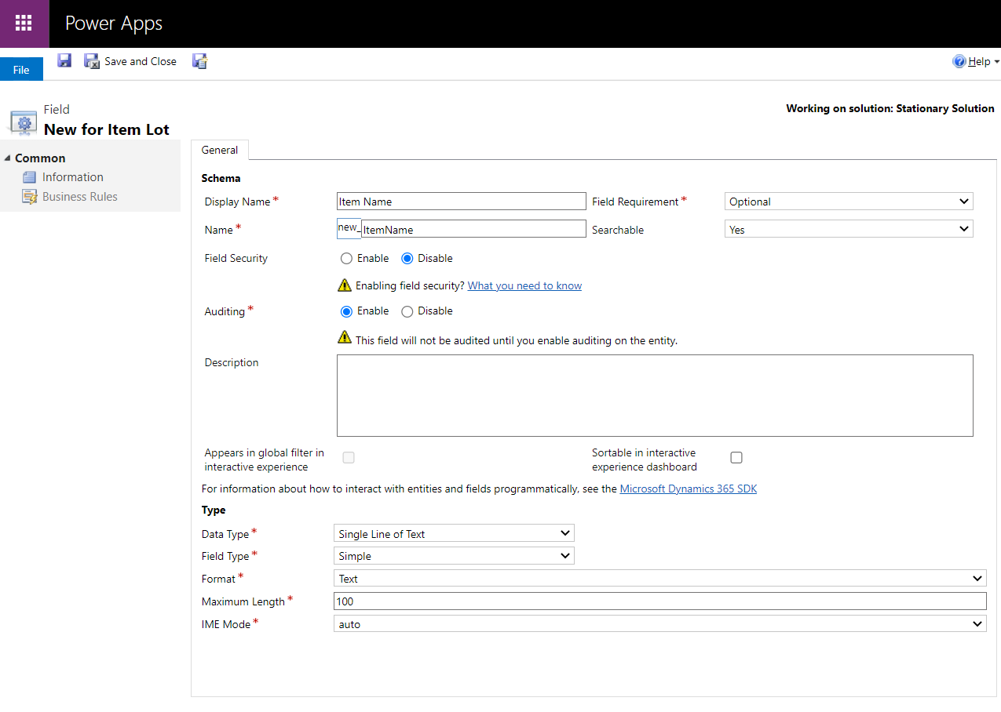

### Field Type options -

1. **Simple-** Contains data that is not based on a formula.
2. **Calculated**- Contains calculations that use fields from the current entity or related parent entities. These attributes are calculated in real-time when they are retrieved. Calculated attributes can be composed using different data types. Calculated attribute values are available in the retrieve plug-in pipeline.

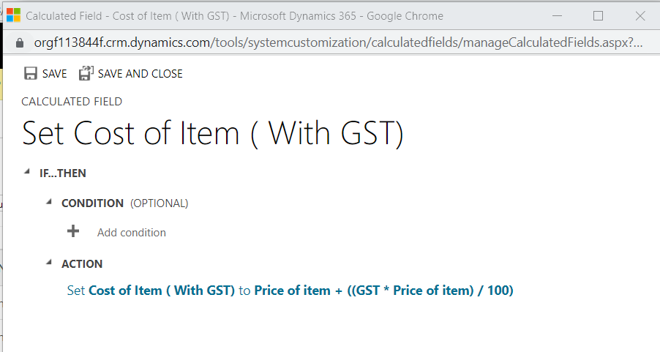

1. **Rollup-** Contains an aggregate value computed from the records related to a record, or a value computed over a hierarchy. They can be used for filtering or sorting. Rollup attribute values are calculated asynchronously by scheduled system jobs. Administrators set when a job is run or pause the job. By default, each attribute is updated hourly.

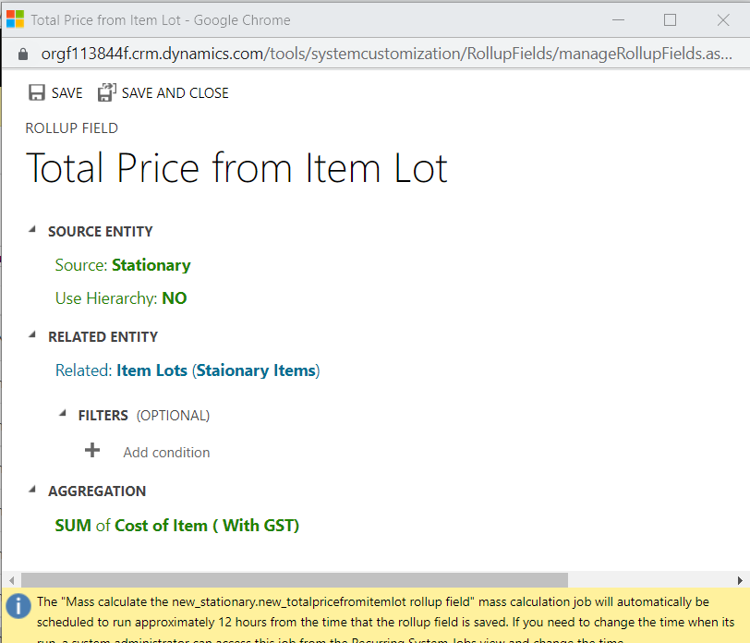

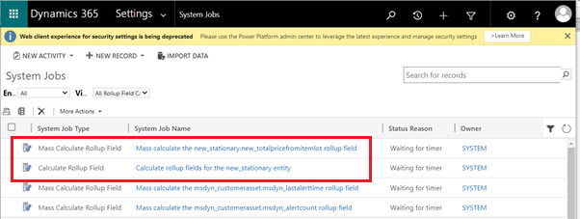

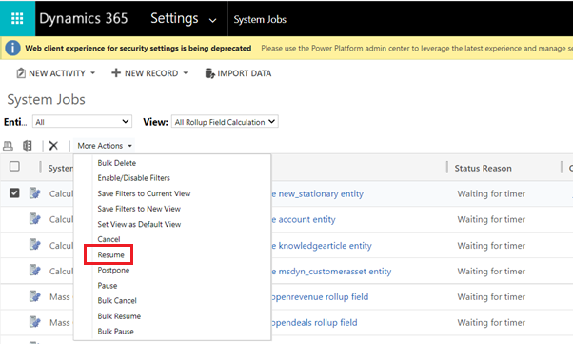

## Forms -

They provide the user interface that people use to interact with the data they need to do their work. These are designed to allow the users to find or enter the information they need efficiently.

### Form Types -

1. Main Form
2. Quick View Form
3. Quick Create Form
4. Card Form

#### Main Form:

It provides the main user interface for interacting with entity data.The main design objectives for main forms are that you design them once and deploy them everywhere. Each main form is composed of one or more tabs. Each tab can have one or more sections.

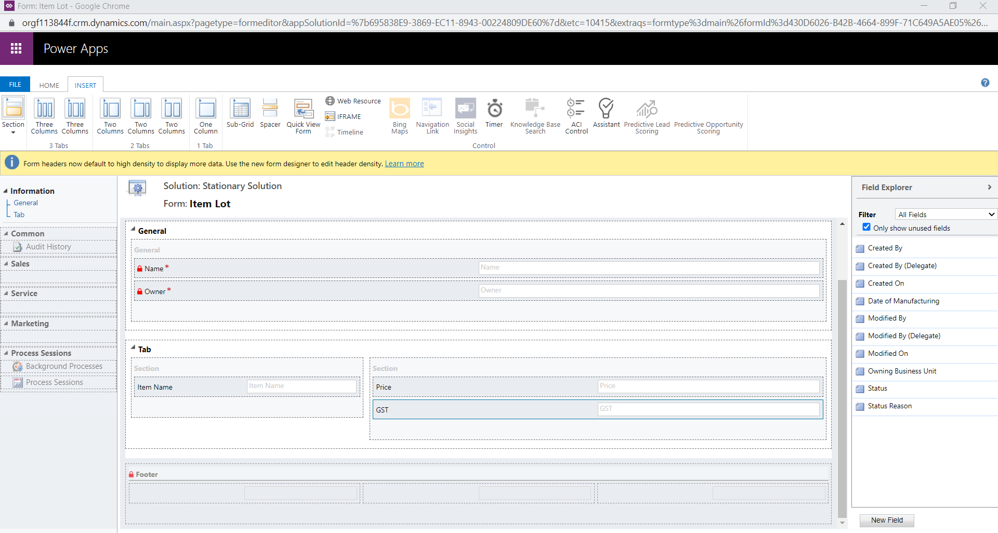

#### Quick Create Form:

It provides a basic form optimized for creating new records. These quick create forms can be used only when people add a new record for a sub-grid that displays that specific custom activity entity.

Quick create forms cannot be assigned to security roles and they do not provide the capability for the user to switch forms. The entity must have the **Allow Quick Create** option enabled for the quick create form to be displayed.

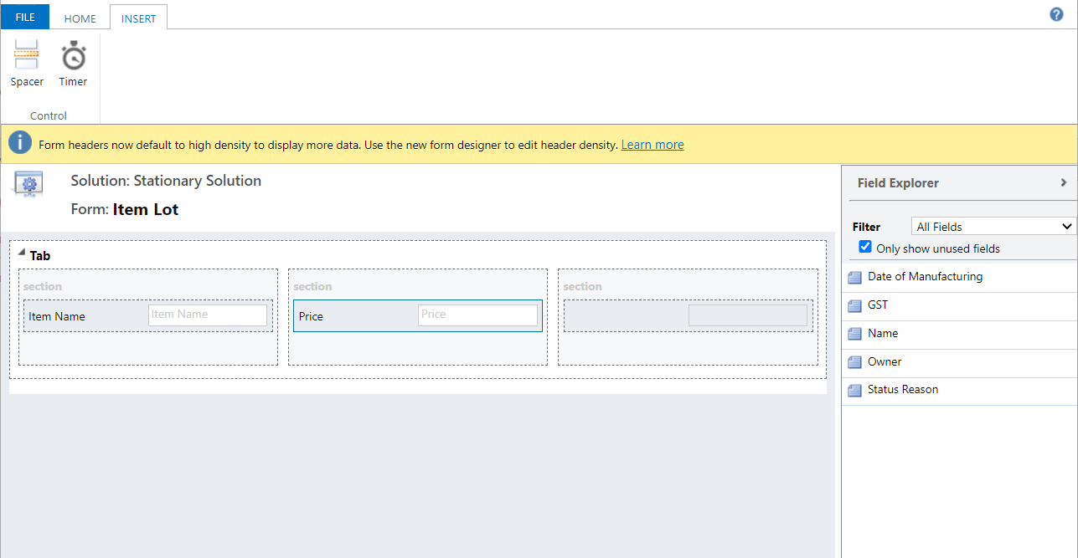

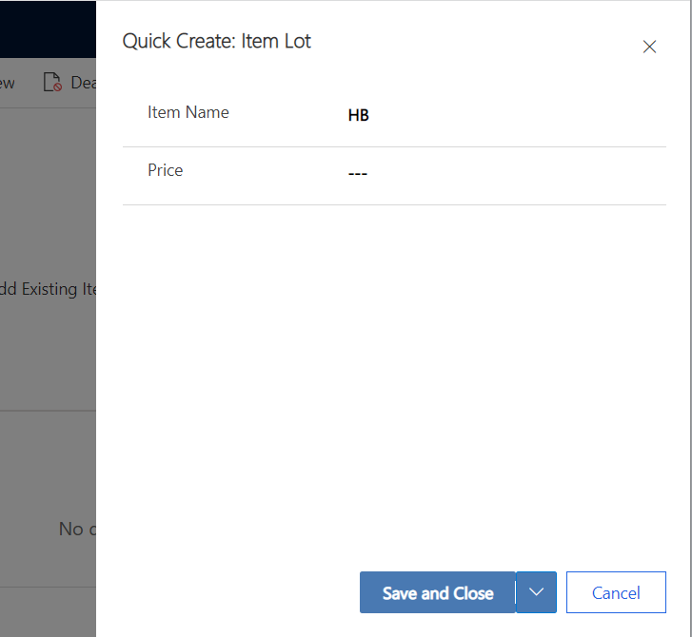

#### Quick view form:

It provides a template to view information about a related entity record within a form for another entity record.

These forms appear within the main form to display additional data for a record.  Only one single column tab is available. You can add only additional single column sections, fields, sub grids, and spacers.

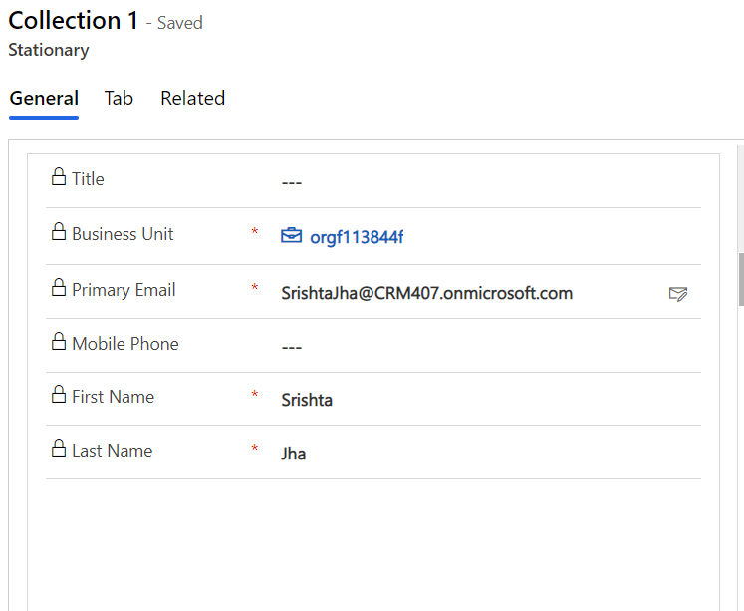

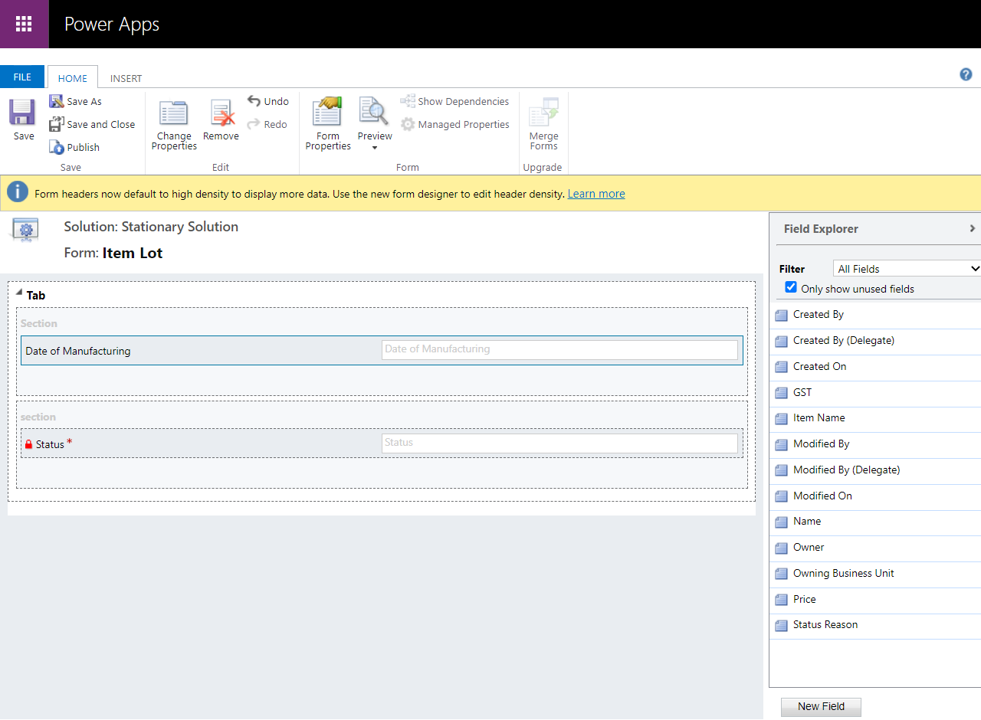

#### Card form:

Used in views for Unified Interface apps. Card forms are designed to present information in a compact format that is suitable for mobile devices.

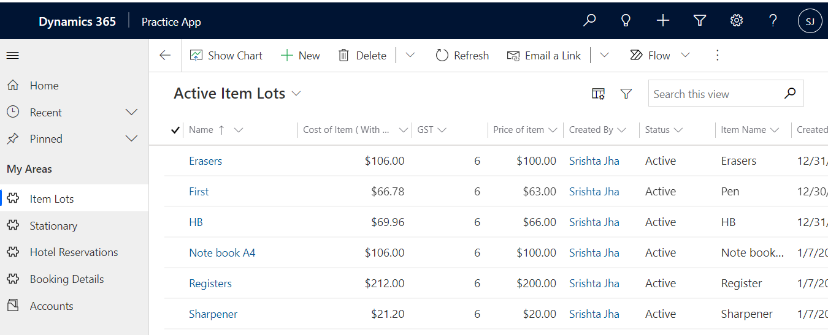

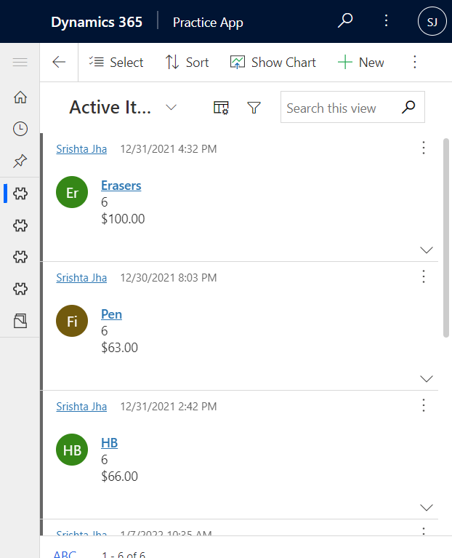

Although card forms can be created and edited in the same way as other form types, card forms are added to apps differently. Instead of adding a form as an app component, custom card forms are added to views by using the **Read Only Grid** control.

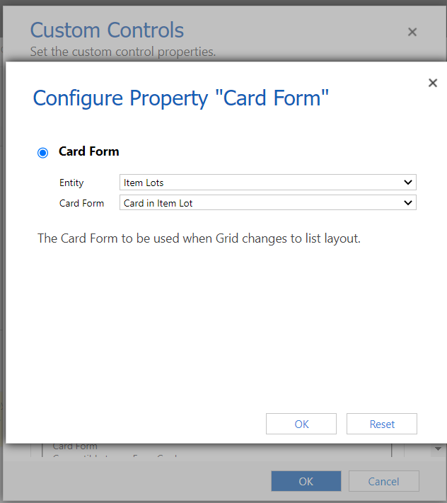 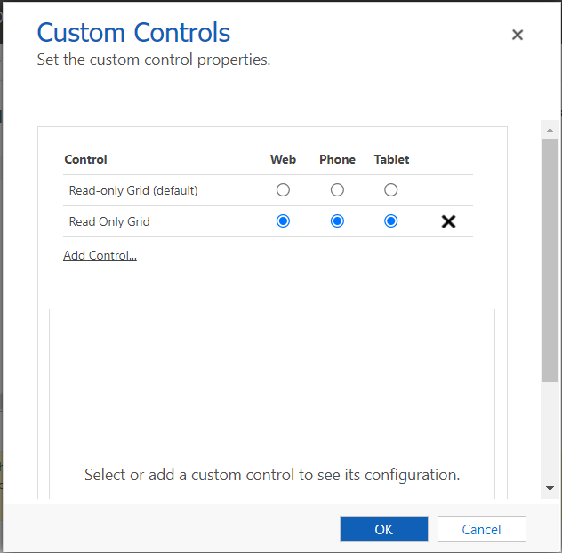

Only limited (11) fields are allowed in card form.

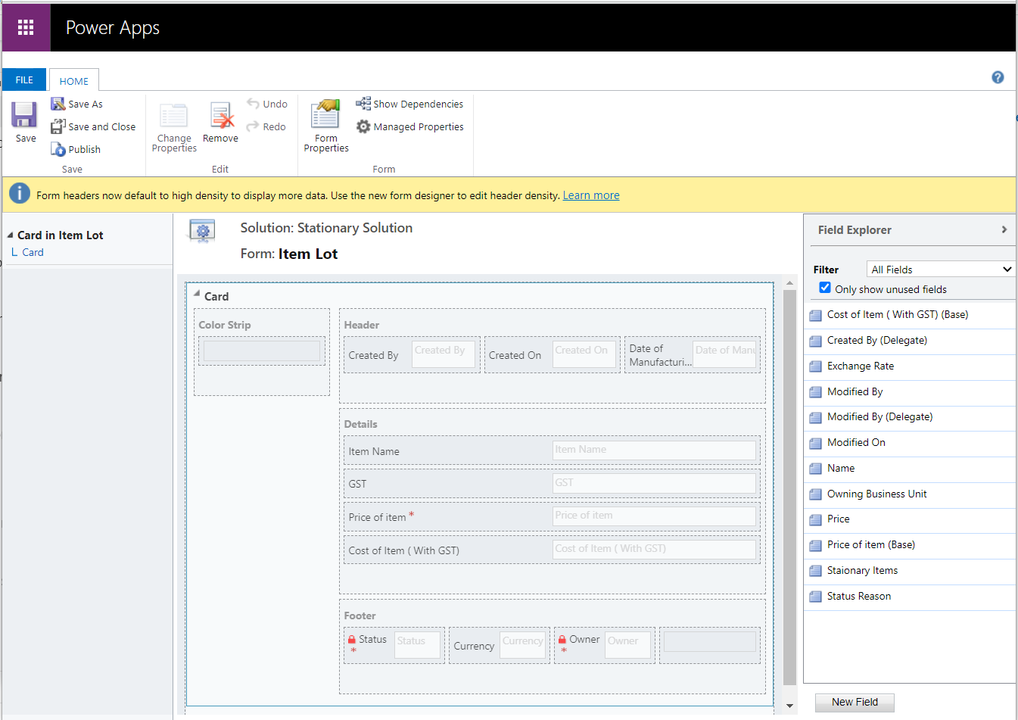

### Reference Panel -

A reference panel is a single column section. You can insert sub-grids, quick view control, or a knowledge base search control inside a reference panel section. Each control that you added in the reference panel appears as a vertical tab within the panel at runtime.

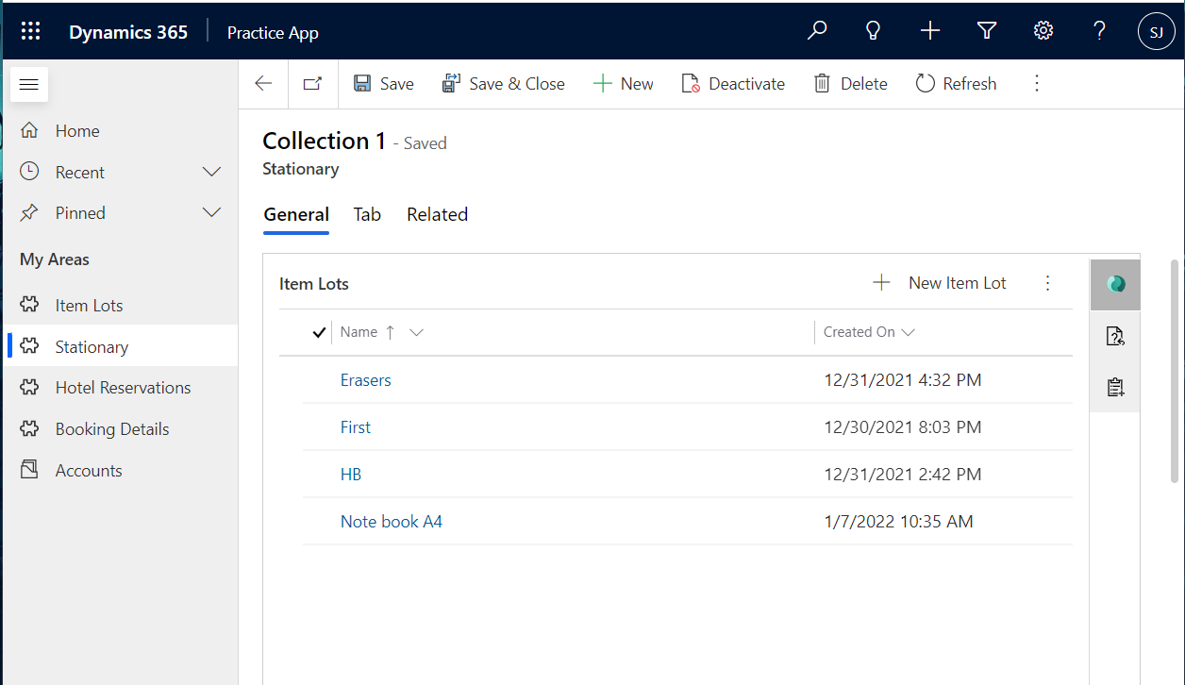

### Iframe -

You can add iFrames to a form to integrate content from another website within a form.

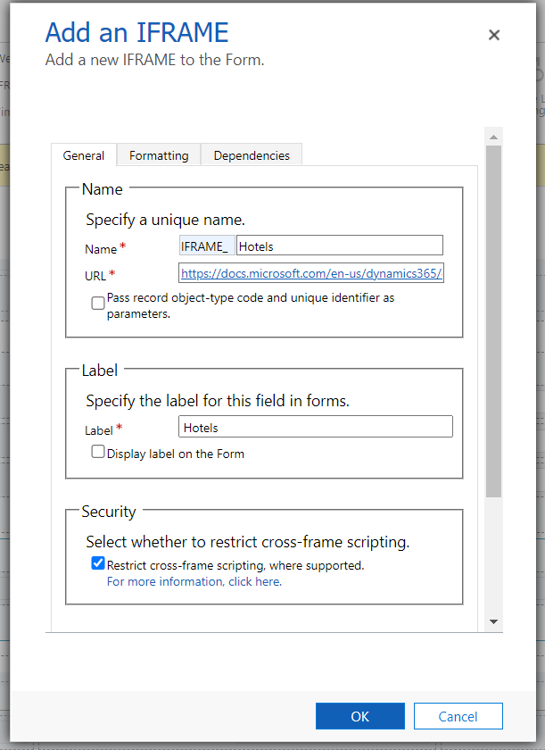 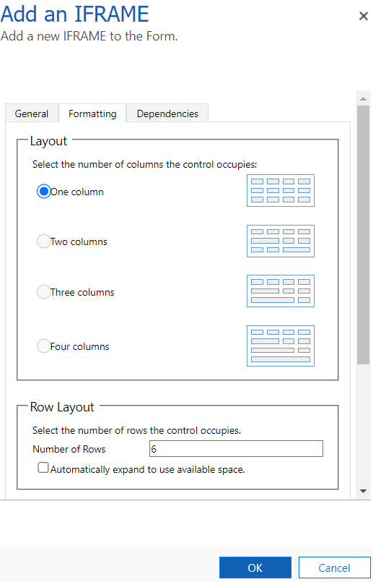

### Timer -

A timer control shows people how much time is available to complete an action in the resolution of an active record or how much time has passed since the time to complete the action has passed.

Timer control **Data Source** properties use fields for the entity.

* The **Failure Time Field** uses a date-time field to set the time. **Required**. Choose one of the date-time fields for the entity to represent when a milestone should be successfully completed.
* The three condition fields use one of the **Option Set**, **Two Options**, **Status**, or **Status Reason** fields for the entity.
* The Success Condition is **required**. Select a field for the entity to evaluate the success of the milestone, and then choose which option indicates success.
* The Warning and Cancel Condition are used to evaluate whether the milestone of event is at risk or should be cancelled.

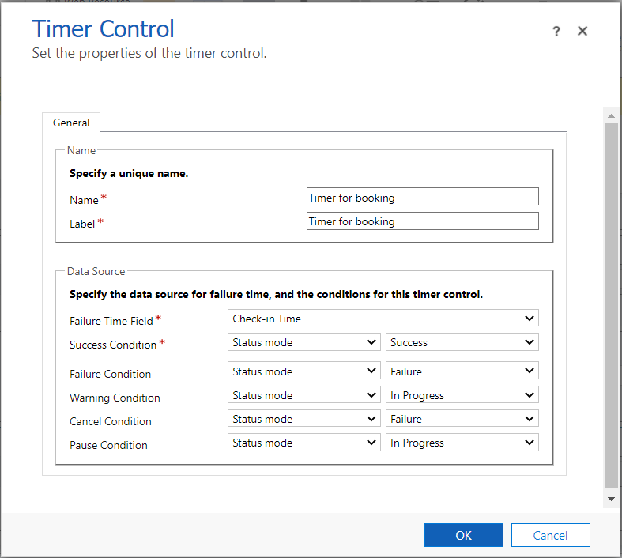

### Subgrids -

You can configure a sub-grid on a form to display a list of records or a chart.  Select **Show Chart Only** on the **Display** tab to show a chart instead of a list. Record types:

* **Only Related Records**: Sub-grid will display only records related to the current record.
* **All Record Types**: Sub-grid will display records filtered only by the default view or, if the view selector is enabled, any views the user chooses.

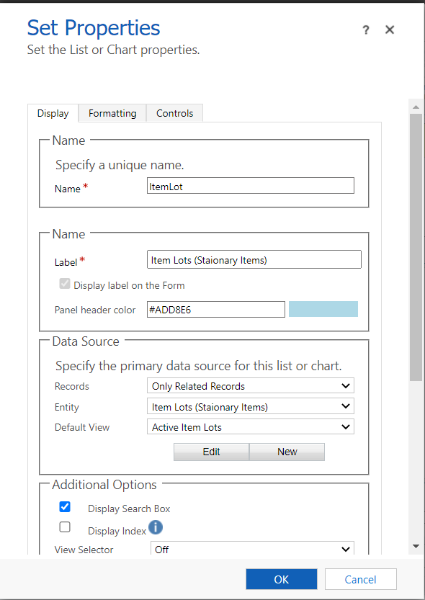 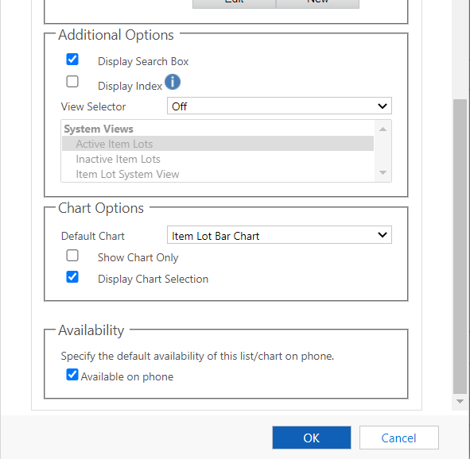

## Views -

It defines how a list of records for a specific entity is displayed in the application. Dynamics 365 view is a grid filled with filtered records. It is a type of saved query.

**Types:**

1. Personal Views
2. System Views
3. Public Views

### Personal Views:

Personal views are owned by individuals and, because of their default User level access, they are visible only to that person or anyone else they choose to share their personal views with.

You can create personal views by saving a query that you define by using Advanced Find or by using the **Save Filters as New Views** and **Save Filters to Current View** options in the list of views.

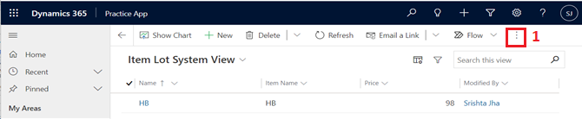

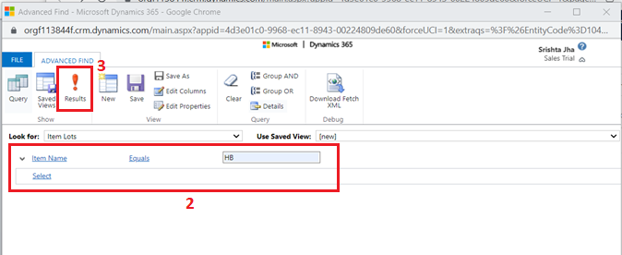

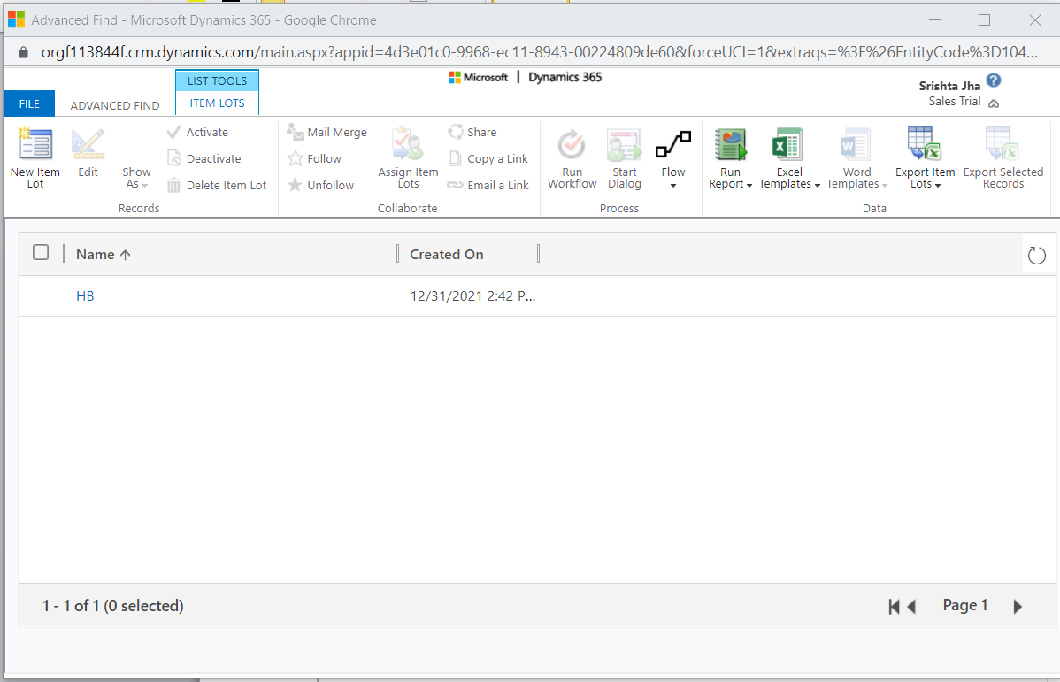

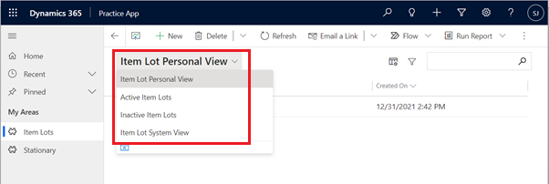

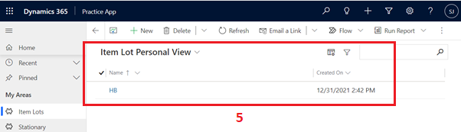

### System Views:

System views are special views the application depends on, which exist for system entities or are automatically created when you create custom entities. These views have specific purposes and some additional capabilities.

System views are owned by the organization so that everyone can see them. System Views include **Quick Find, Advanced Find, Associated, and Lookup.**

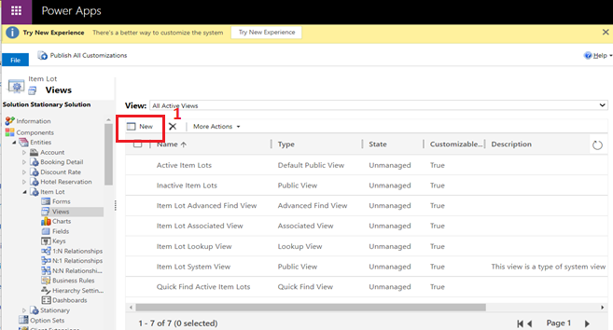

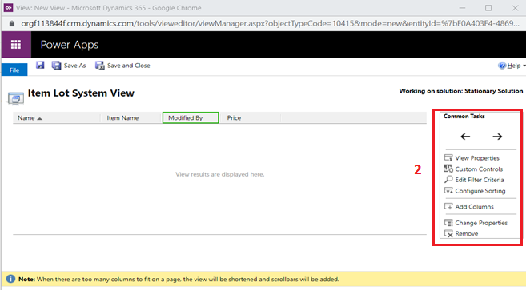

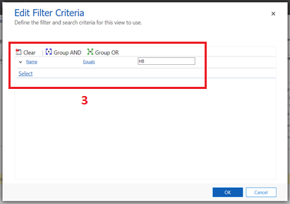 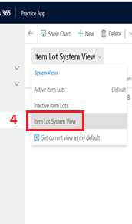

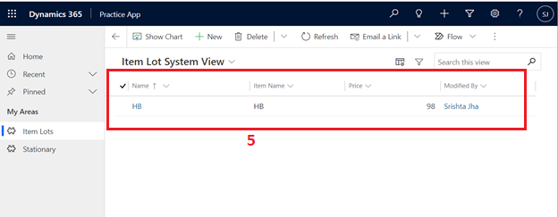

### Public Views:

Public views are general purpose views that you can customize as you see fit. These views are available in the view selector and you can use them in sub-grids in a form or as a list in a dashboard. Some public views exist by default for system entities and for any custom entity.

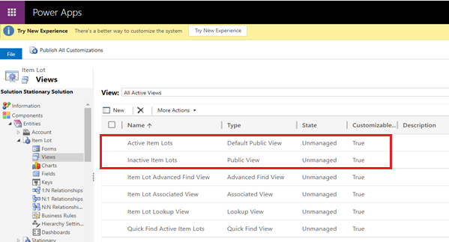

## Charts -

Present large quantities of data in your organization in a more insightful and graphical way by creating useful charts.

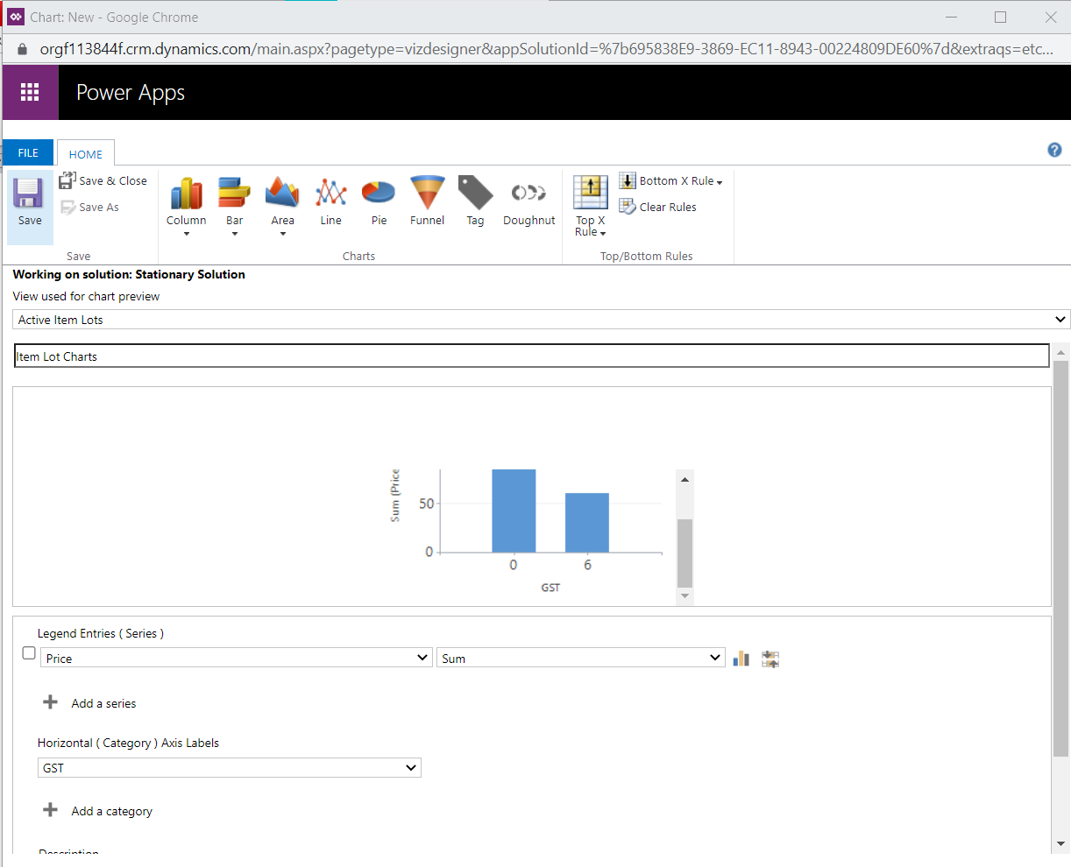

### Column:

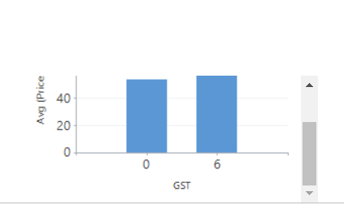

### Bar:

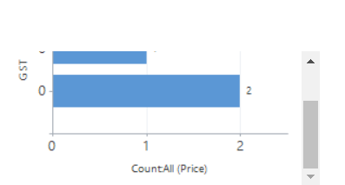

### Area:

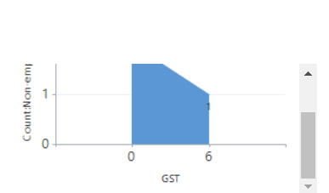

### Line:

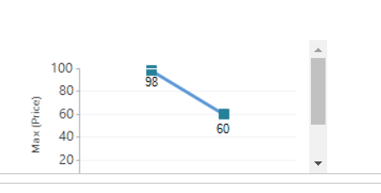

### Pie:

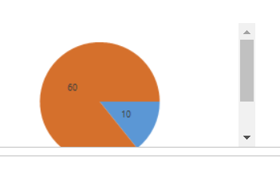

### Funnel:

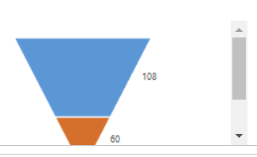

**Specify what to display in chart:**

* For non-numeric fields, you can select only **Count: All** or **Count: Non-empty**. For numeric fields, you can select one of the following aggregation options: **Count: All**, **Count: Non-empty**, **Avg**, **Max**, **Min**, or **Sum**.
* NULL values are not considered for computing minimum, maximum, and average of data. However, zeros (0) are considered.
* To stack items in a chart, select the chart type, and then select **Stacked** or **100% Stacked**. You can stack items only in a bar, column, or an area chart.
* To display only top items on the chart, select the **Top/Bottom Rules** icon > **Top X Rule** icon, > **Top 3** or **Top 5**, or **Custom** to specify a different number.

## Dashboards -

It gives you easy-to-read charts and graphs that help you see how you and your team are doing with key metrics (also known as key performance indicators, or KPIs).

### Dashboards Types:

1. User dashboards
2. System dashboards

An admin or customizer creates or customizes system dashboards that, when published, are visible to everyone in the organization. A user can choose to set their user dashboard as their default dashboard and override the system dashboard.

**Various options available while creating dashboards:**

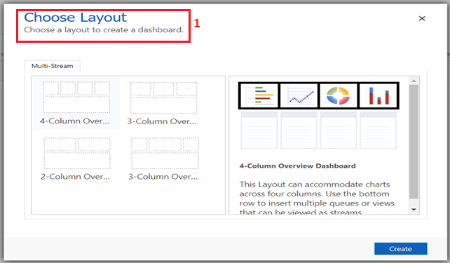

* **List:** Display a view on a tile of the dashboard.
* **Web resource:** Web resources are virtual files stored in the system. Each web resource has a unique name that can be used in a URL to retrieve the file.
* **Iframe:** Used to display the contents from another website

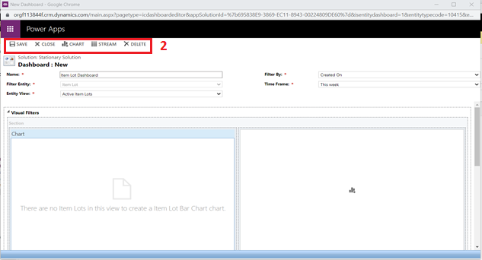

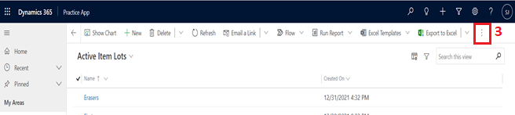

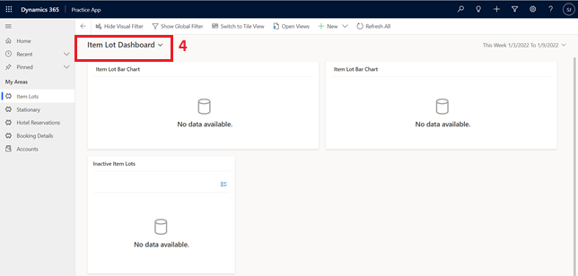

## Business Rules -

Business rules provide a simple interface to implement and maintain fast-changing and commonly used rules. They can be applied to Main and Quick Create forms.

By combining conditions and actions, you can do any of the following with business rules:

* Set field values
* Clear field values
* Set field requirement levels
* Show or hide fields
* Enable or disable fields
* Validate data and show error messages
* Create business recommendations based on business intelligence.

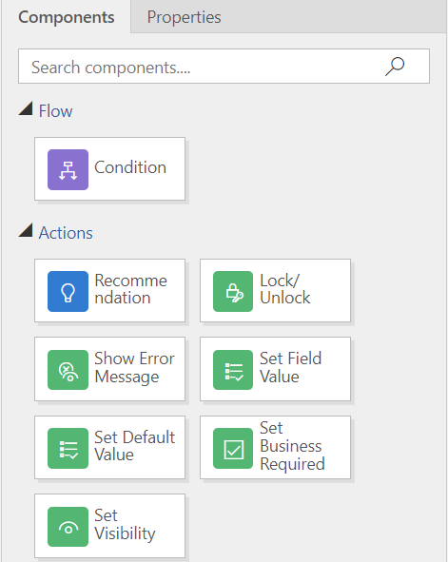

### Business Rules Scope:

|  |  |
| --- | --- |
| **If you select this item...** | **The scope is set to...** |
| Entity | All forms and server |
| All Forms | All forms |
| Specific form (Account form, for example) | Just that form |

**Example:**

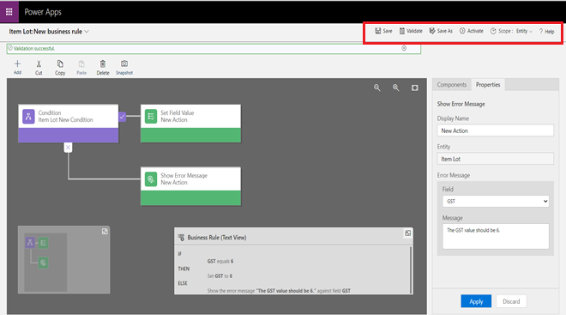

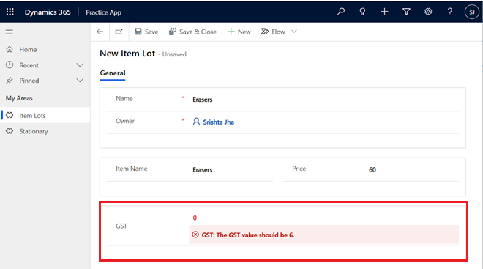

## Relationships -

Entity relationships define how records can be related to each other in the database.

**Types:**

1. One to many (1:N) and Many to one (N:1)
2. Many to many (N:N)

### One to Many:

An entity relationship where one entity record for the **Primary Entity** can be associated to many other **Related Entity** (also called Child entity) records because of a lookup field on the related entity.

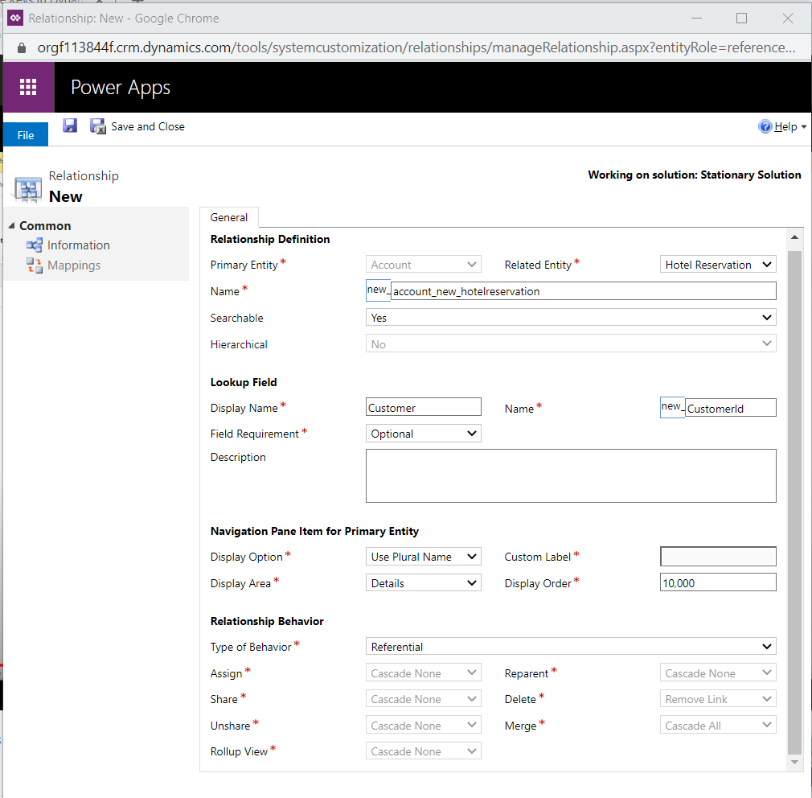

**Hierarchical:** Hierarchical data structures are supported by self-referential one-to-many (1:N) relationships of the related records. Presently, you can query the related data as a hierarchy, in one step. You’ll be able to query records using the **Under** and **Not Under** logic. The **Under** and **Not Under** hierarchical operators are exposed in Advanced Find and the workflow editor.

#### Relationship behaviour:

1. **Parental**: In a parental relationship between two entities, any action taken on a record of the parent entity is also taken on any child entity records that are related to the primary (or parent) entity record.
2. **Referential:** In a referential relationship between two entities, you can navigate to any related records, but actions taken on one will not affect the other.
3. **Referential, Restrict Delete**: In a referential, restrict delete relationship between two entities, you can navigate to any related records. Actions taken on the parent record will not be applied to the child record, but the parent record cannot be deleted while the child record exists.
4. **Configurable Cascading**: In a configurable cascading relationship between two entities, you select the behaviour associated with each of a set of possible actions.

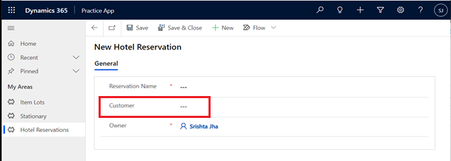

### Many to many:

1:N entity relationships establish a hierarchy between records. With N:N (many-to-many) relationships there is no explicit hierarchy. Records created using N:N relationships can be considered peers and the relationship is reciprocal.

With N:N relationships a special entity is created called a Relationship (or Intersect) entity. This entity has a relationship with each of the related entities and only stores the necessary values to define the relationship. You can’t add custom fields to a relationship entity.

**Types:**

1. **Native**: Entity created to store records will be hidden.
2. **Manual**: Extra entity required to store details. Entity will have 1:N relationship with other two entities.

#### Native:

N:N between Account and Hotel Reservation.

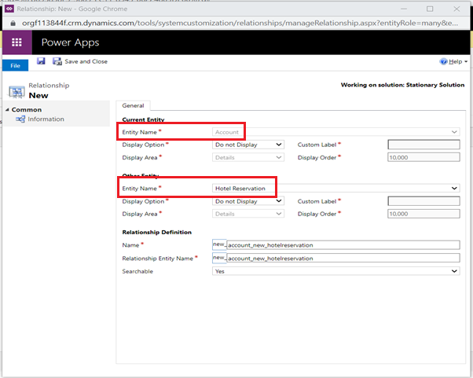

#### Manual:

**Steps:**

1. 1:N between Discount Rate and Item Lot
2. 1:N between Discount Rate and Stationery
3. This will create N:N between Item Lot and Stationery

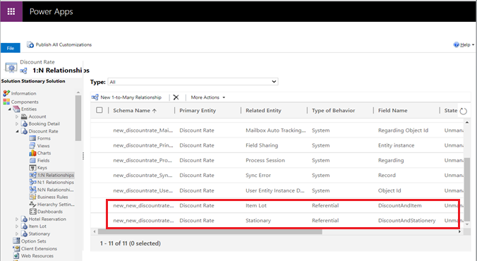

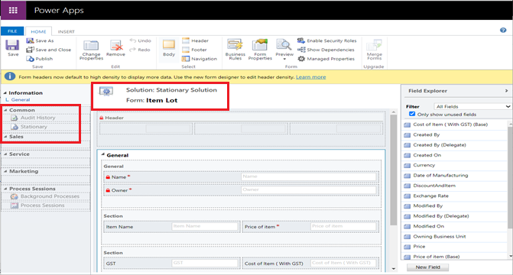

### Mappings:

You can map attributes between entities that have an entity relationship. The default values set when you create a new record from a list aren’t actually defined within the entity relationships, but they are exposed in the relationship user interface. Mappable entity relationships provide access to allow mapping entity fields.

Mapping can save a lot of time when you are entering data (in order to avoid duplicates), and help reduce errors.

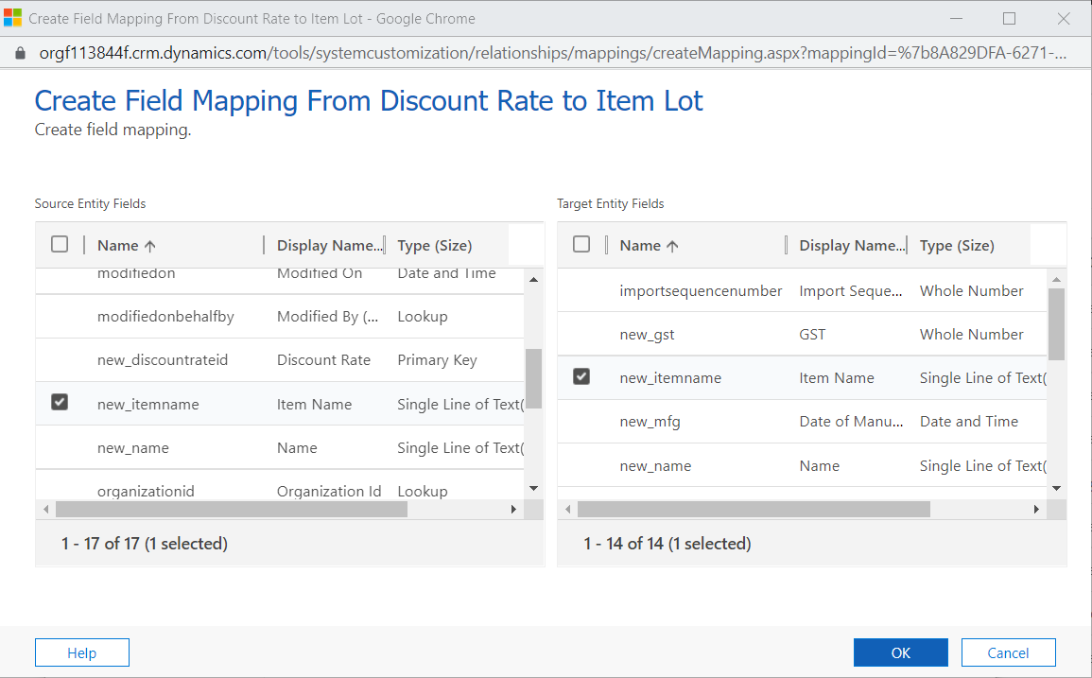

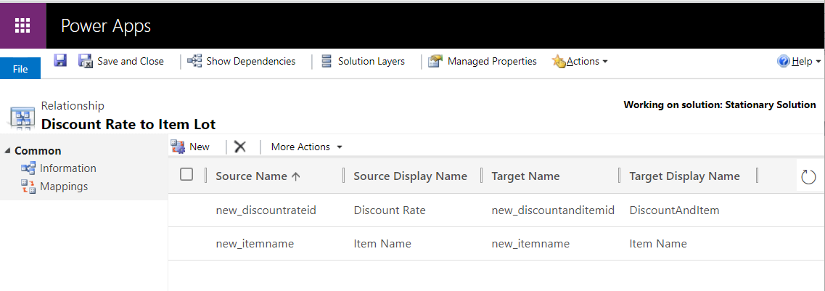

## Keys -

* All Dynamics 365 Customer Engagement (on-premises) records have unique identifiers defined as GUIDs. These are the primary key for each entity.
* Keys allow you to have a local reference to link to the Customer Engagement record. However, sometimes you can't modify the external database.
* With alternate keys you can now define an attribute in a Customer Engagement entity to correspond to a unique identifier (or unique combination of columns) used by the external data store. This alternate key can be used to uniquely identify a record in Customer Engagement in place of the primary key.
* You must be able to define which attributes represent a unique identity for your records.

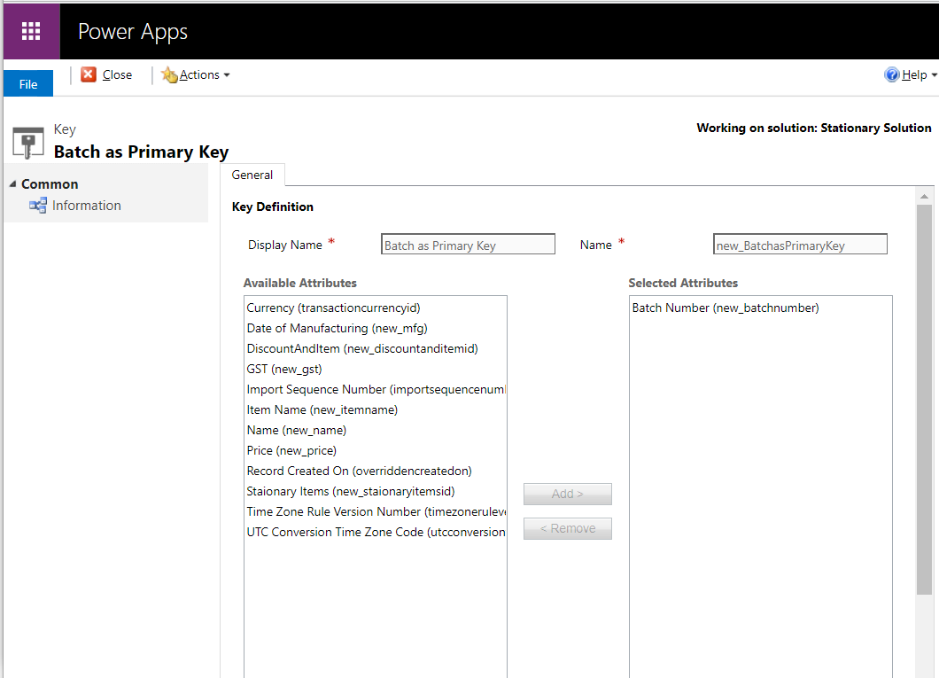

## Hierarchy Settings -

The entities that can’t be enables for a hierarchy don’t have this component i.e. Hierarchy Settings.

Only one (1: N) self-referential relationship per entity can be set as hierarchical. In this relationship the primary entity and the related entity must be of the same type, such as account_parent_account or new_new_widget_new_widget.

### Self-Referential Relationship:

* A self-referencing relationship is where the referencing and referenced entity is the same. For example, the account entity has a self-referencing one-to-many relationship that allows for a lookup labeled **Parent Account**.
* If the entity relationship behavior is defined as **Parental** it is not possible for a record to reference itself because this would create a circular reference when cascading behaviors are applied.

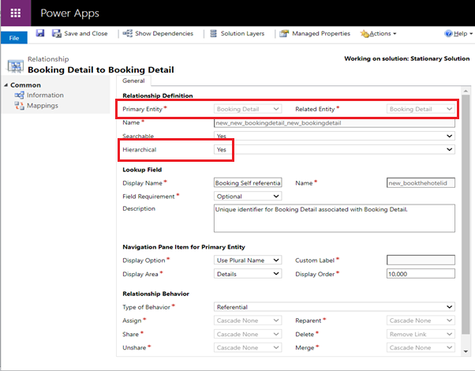

## Option sets -

* It defines a set of options (picklist). When an option set is displayed in a form it uses a drop-down list control. When displayed in Advanced Find it uses a picklist control.
* You can define an option set to use a set of options defined within itself (locally) or it can use a set of options defined elsewhere (globally) which can be used by other option set fields.
* Global option sets are useful when you have a standard set of categories that can apply to more than one entity.

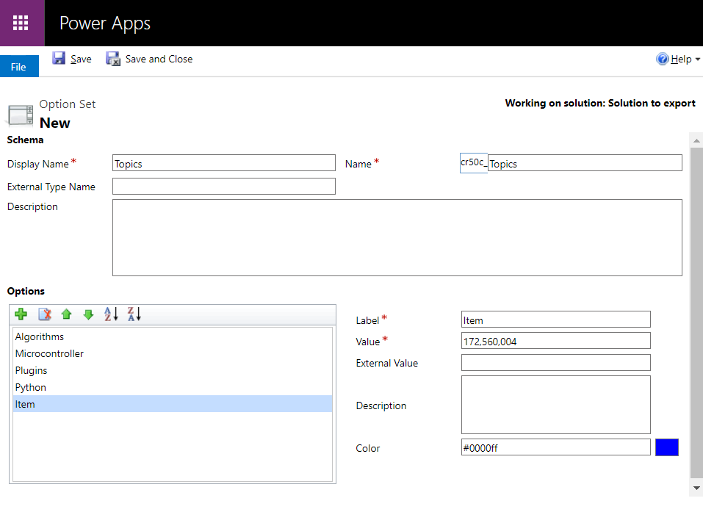

## Client Extensions -

* This section contains information about changes developers and customizers can make to extend Dynamics 365 by using **JavaScript and web resources.** These clients are designed to allow you to add extensions that can be applied for all clients rather than each one separately.
* Client extensions can provide a very rich and responsive experience for users because the code runs on their device. However, critical business logic should not be applied only by client-side scripts. They can’t apply business logic for data entering the system by other means, such as integrations with other systems, custom clients, or data import.

## Web Resources -

* Web resources are virtual files stored in the system. Each web resource has a unique name that can be used in a URL to retrieve the file. File can be such as **html files, JavaScript, and CSS** and several image formats.
* You can use web resources in form customizations, the SiteMap or the application ribbon because they can be referenced by using URL syntax.
* Because web resources are stored as records in the database, they can be managed programmatically by using the standard techniques to create, retrieve, and update records. Text-based web resources (JScript, CSS, XML, XSL, RESX, and HTML) can be edited and saved in the application.

## Processes -

Processes enable you to model real-life business processes, for example best practices or standard practices. There are four categories of processes:

1. **Workflow**: Use this process to model and automate real world business processes. These processes can be configured to run in the background or in real time and can optionally require user input. They can start automatically based on specified conditions or can be started manually by a user.
2. **Action**: Use this process to create a new operation that is not available in a standard Dynamics 365 installation or to combine multiple disparate operations into a single operation.
3. **Business process flow**: Use this process to create a visualization of the business process flow. Users are guided through various stages of the sales or customer service processes. At each stage, you complete specific steps and then move to the next stage.
4. **Dialog**: Use this process to create an interactive step-by-step data entry form that requires user input to start and run to completion. When you start the dialog process, a wizard-like interface is presented so you can make appropriate selections or enter data as you progress through each page of the wizard.

## Plug-in Assemblies -

A plug-in is custom business logic (code) that you can integrate with Dynamics 365 Customer Engagement (on-premises) to modify or augment the standard behavior of the platform. Assembly that contains one or more plug-in types. You will use the Plug-in Registration tool (PRT) to register assemblies containing custom workflow activities.

## Sdk Message Processing Steps -

Stage in the execution pipeline that a plug-in is to execute.

## Service Endpoints -

 A service endpoint **offers a native way to send messages to external systems via an Azure Service Bus, Service Hub, or Rest API.**

## Dashboards -

It gives you easy-to-read charts and graphs that help you see how you and your team are doing with key metrics (also known as key performance indicators, or KPIs). Types: user and system dashboards. An admin or customizer creates or customizes system dashboards that, when published, are visible to everyone in the organization. A user can choose to set their user dashboard as their default dashboard and override the system dashboard.

## Dialog Boxes -

Dialogs contain pages, and each page can contain multiple sets of prompts and responses. You can also specify a dialog as a child dialog, and then invoke that dialog from within a parent dialog. Dialogs are the synchronous or interactive processes in Dynamics 365 for Customer Engagement that collect and process information by using step-by-step scripts to direct users through a process.

## Reports -

Analyze data in Dynamics 365 Customer Engagement (on-premises) by using reports. Dynamics 365 includes default reports for many common business needs. However, most organizations customize the default reports and add custom reports for specific needs.

## Connection Roles -

In Dynamics 365 Customer Engagement (on-premises), you can create and view the relationships between records for many entities using **Connect**. Connections enable you to easily associate users, contacts, quotes, sales orders, and many other entity records with each other.

## Article Templates -

* Knowledge article templates help knowledge authors simplify the process of creating knowledge articles. Templates also help knowledge managers and authors maintain consistency in branding, language, and structure.
* When an author chooses a template to create an article, certain fields in the template are pre-populated with values, allowing the author to focus on the main content of the article.

## Contract Templates -

* A contract is an agreement to provide support during specified coverage dates or for a specified number of cases or length of time.
* The contract entity is used to track customer service agreements. You can create contracts for existing customers that specify the type of service and terms that apply to each customer.
* New contracts are created based on the contract template. You can create contracts only for existing accounts and contacts.

## Email Templates -

* Save time when creating multiple email messages by making email templates. Email templates contain prefilled data that you specify, so you don't have to re-enter the same information for each article.
* An email template is attached to an email activity after the activity is created. You can also create global templates that are available for any record type or personal templates available only to you or organizational templates available to anyone in your organization.

## Mail Merge Templates -

You can use mail merge templates with Office Word to create customer-ready letters, faxes, e-mail messages, and quotes. Word templates are created and edited in Word, but can be uploaded to customer engagement apps to use with mail merge and share with other users. Only Word .xml documents can be used as templates.

## Security Roles -

* A security role defines how different users, such as salespeople, access different types of records. To control access to data, you can modify existing security roles, create new security roles, or change which security roles are assigned to each user.
* Each user can have multiple security roles. Security role privileges are cumulative: having more than one security role gives a user every privilege available in every role.
* Each security role consists of record-level privileges and task-based privileges.

## Field Security Profiles -

Record-level permissions are granted at the entity level, but you may have certain fields associated with an entity that contain data that is more sensitive than the other fields. For these situations, you use field-level security to control access to specific fields. The scope of field-level security is organization-wide.

## Routing Rule Sets -

* Routing rules define how conversations are routed to different queues. Each routing rule has a condition and a destination queue. If the rule condition is evaluated as **True**, then the conversation is routed to the destination queue. If a rule condition is evaluated as **False**, further rules are evaluated.
* Routing rule conditions could be based on channel context, pre-chat context, and contact, account, or case context.

## Record Creation and Update Rules -

A record creation and update rule consists of rule items that define the conditions for creating or updating records, and also defines what actions or steps to take on the newly-created records. The rule also contains channel properties that are used to define conditions for rules, and also for setting properties of the record you’re creating or updating.

## SLAs -

* Service-level agreements (SLAs) enable businesses to track support policies and ensure customers are being supported per the support policy to which they are entitled.
* Businesses use SLAs to govern support products that customers either receive as part of their purchase or add on to their purchase.
* SLAs include policy details such as how quickly a customer is entitled to receive support, how many support requests a customer can make, and how long after purchases a customer can be supported as part of the agreement.

## Model-driven Apps -

Model-driven app design is an approach that focuses on adding components such as [forms](https://docs.microsoft.com/en-us/powerapps/maker/model-driven-apps/model-driven-app-glossary#form), [views](https://docs.microsoft.com/en-us/powerapps/maker/model-driven-apps/model-driven-app-glossary#view), and [charts](https://docs.microsoft.com/en-us/powerapps/maker/model-driven-apps/model-driven-app-glossary#chart) and [dashboards](https://docs.microsoft.com/en-us/powerapps/maker/model-driven-apps/model-driven-app-glossary#dashboard) to [tables](https://docs.microsoft.com/en-us/powerapps/maker/model-driven-apps/model-driven-app-glossary#table) using an app designer tool. Additionally, [relationships](https://docs.microsoft.com/en-us/powerapps/maker/model-driven-apps/model-driven-app-glossary#relationship) connect tables together in a way that permits navigation between them and ensures that data is not repeated unnecessarily. Using the app designer with little or no code, you can build apps that are simple or very complex.

## Custom Controls -

Custom controls let you transform fields that traditionally contain text into visualizations. Custom controls can appear as visualizations on forms, dashboards, views, and homepage grids. You can set one type of custom control to appear in the web browser client while having a different custom control appear in your Dynamics 365 for Customer Engagement phone or tablet mobile apps.

## Virtual Entity Data Providers:

* Using the Dynamics 365 for Customer Engagement (on-premises) Data SDK, .NET Developers have the option of creating custom virtual entity data providers to help integrate external data source types that are not supported by an existing data provider.
* Each data provider is composed of a reusable set of Dynamics 365 for Customer Engagement (on-premises) plug-ins that implements the supported CRUD operations.

## Virtual Entity Data Sources -

A virtual entity is a custom entity in Dynamics 365 Customer Engagement (on-premises) that has fields containing data from an external data source. Virtual entities appear in your app to users as regular entity records, but contain data that is sourced from an external database, such as an Azure SQL Database.

## Mobile Offline Profiles -

* Set up mobile offline synchronization to allow users to work in offline mode on their mobile device. Mobile offline allows users to use the Dynamics 365 for phones and tablets app in offline mode and interact with their data without internet connection.
* The mobile app provides a rich offline experience that helps users stay productive. You can use basic commands such as create, read, update, and delete when you're offline.
* Once you're back online, the changes that you made on the mobile app are automatically synchronized with Microsoft Data verse.
* The offline experience uses Azure services to periodically synchronize tables with the mobile app so that synchronized rows are available when a user's mobile devices are disconnected from the internet.

## Workflows -

### Workflow Scope -

1. **User -** Choosing this scope means the workflow will run only on the records owned by the same user as the workflow user.
2. **Business Unit -** This means the workflow will run on all records owned by the users of the same business unit as the workflow user.
3. **Parent: Child Business Unit -** With this, the workflow will run on the records owned by the users of the same business unit as the workflow user as well as any child business units.
4. **Organization -** The workflow will run on records owned by any user in CRM. Since it will trigger for all records, organization scope is the most used scope option.

## MISCELLANEOUS -