PROJECT REPORT: SCHEME SENTINEL
Smart Fraud Detection in Government schemes

1. Introduction
Government welfare programs like PM-KISAN, MGNREGA, and PDS are designed to funnel critical subsidies to deserving citizens. However, as these systems digitize, they become targets for organized digital fraud syndicates. A critical challenge is that as the frauds usually understand the pattern of fraud detection they will easily overcome it soo we will follow dynamic pattern system. SchemeSentinel is built on this principle, moving beyond static checks to an evolving, data-driven defense mechanism that ensures every rupee reaches its verified beneficiary.

2. Problem Statement
The core problem is the massive financial leakage in welfare distribution caused by coordinated fraud rings. These groups exploit metadata loopholes—using a single mobile device to manage dozens of accounts or linking multiple "beneficiaries" to one shared bank account. In current infrastructures, there is no real-time way to track these patterns across different schemes. Furthermore, because as the frauds usually understand the pattern of fraud detection they will easily overcome it soo we will follow dynamic pattern system that identifies anomalies in behavior, hardware fingerprints, and geospatial footprints.

3. Existing System
Current verification systems rely heavily on manual KYC and isolated database checks. These systems lack cross-scheme visibility and hardware fingerprinting. Their primary limitation is their predictable, rule-based nature. As the frauds usually understand the pattern of fraud detection they will easily overcome it soo we will follow dynamic pattern system to replace these static barriers with evolving safeguards that track relational data rather than isolated entries.

4. Objectives
- Eliminate data silos between different government departments through a unified monitoring interface.
- Provide investigators with visual evidence of organized fraud syndicates and hidden networks.
- Implement a security layer where, as the frauds usually understand the pattern of fraud detection they will easily overcome it soo we will follow dynamic pattern system to stay ahead.
5. System Design & Prototype Architecture
SchemeSentinel is a full-stack dashboard integrating real-time analysis with graph-theoretical visualization. As the frauds usually understand the pattern of fraud detection they will easily overcome it soo we will follow dynamic pattern system.

5.1 Dashboard & Risk Overview
Real-time monitoring of regional shifts in fraudulent activity.
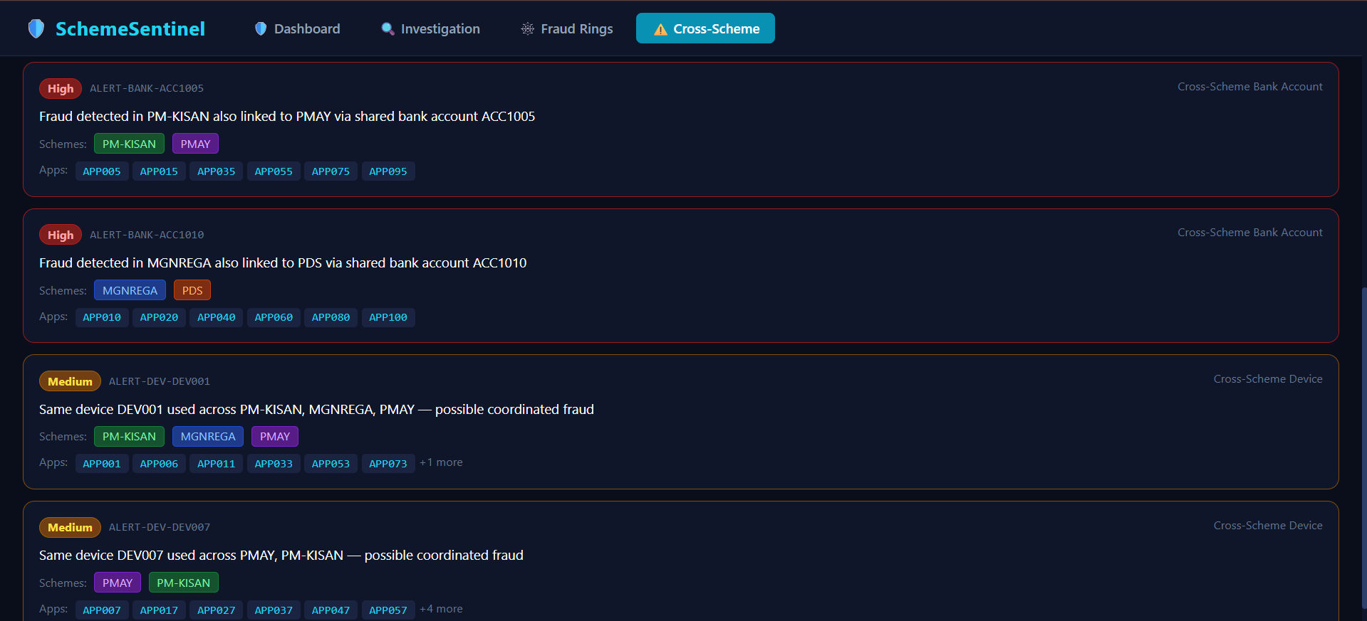

5.2 Granular Investigation
Retrieval of digital profiles using Applicant IDs to verify IP addresses and locations.
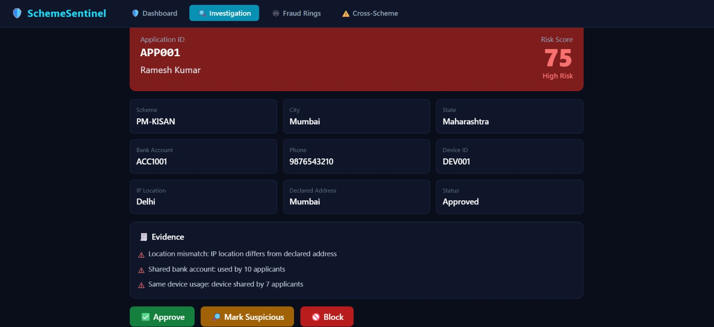

6. The Core Engine: Graph Neural Networks (GNN)

A Graph Neural Network (GNN) is a type of Deep Learning designed to work directly on graph structures. Unlike traditional machine learning which treats every person's data as a single row in a table, GNNs understand that data is interconnected. Since as the frauds usually understand the pattern of fraud detection they will easily overcome it soo we will follow dynamic pattern system using GNNs to analyze the 'relationships' between data points rather than the data points themselves.

6.1 How GNN Detects Complex Fraud

GNNs operate on the principle of 'Guilt by Association.' In our system, we represent the data as follows:
- Nodes: These represent Applicants, Bank Accounts, Device IDs, and IP Locations.
- Edges: These represent the connections between nodes (e.g., an Applicant 'owns' a Bank Account or 'uses' a Device ID).
- Message Passing: This is the brain of the GNN. It allows nodes to share information with their neighbors. If a bank account is flagged as fraudulent, the risk 'flows' through the edges to all applicants connected to it, even if those applicants haven't committed a crime yet.
- Pattern Recognition: GNNs can identify 'Fraud Ring' shapes (like star or mesh networks) that indicate coordinated attacks by professional syndicates.
By analyzing these multi-hop relationships, we ensure that as the frauds usually understand the pattern of fraud detection they will easily overcome it soo we will follow dynamic pattern system that sees through artificial layers of anonymity.

6.2 Relationship Mapping in Action

Visualizing how shared metadata connects multiple 'independent' accounts into a single Fraud Ring.

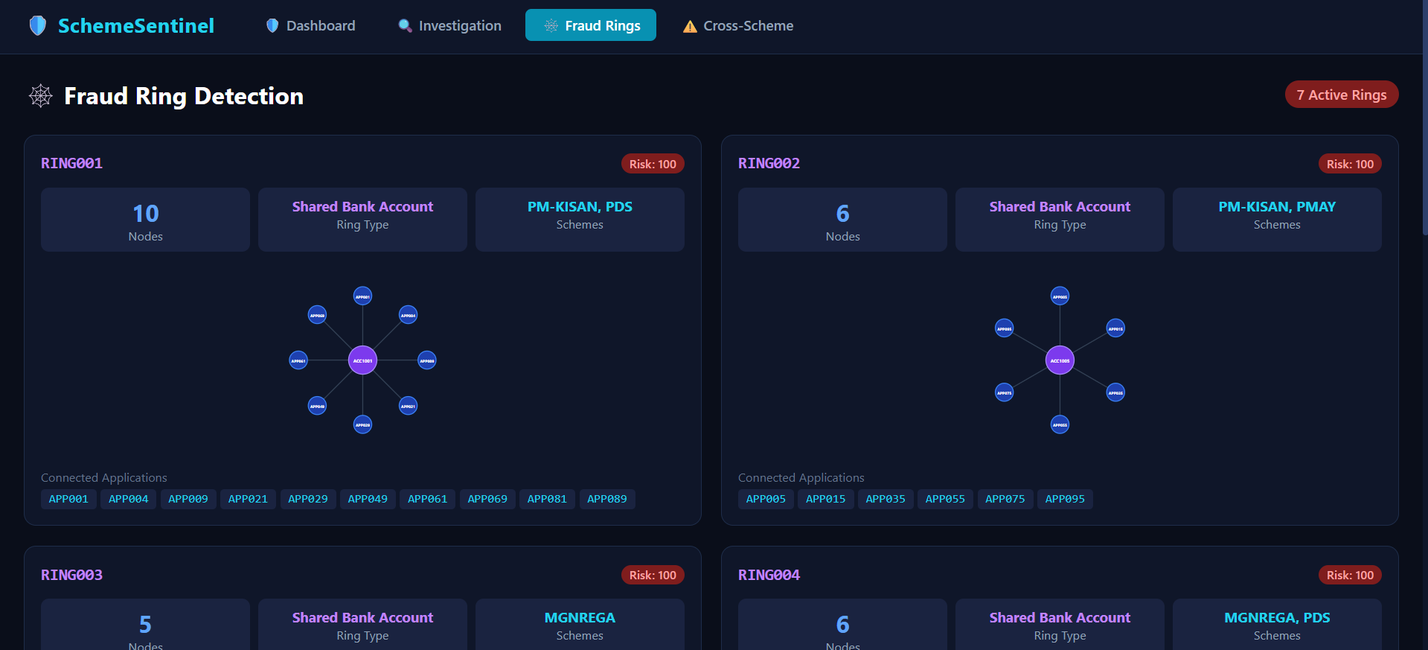

6.3 Cross-Scheme Synchronization

Detecting if a node flagged by GNN in one scheme appears in another.

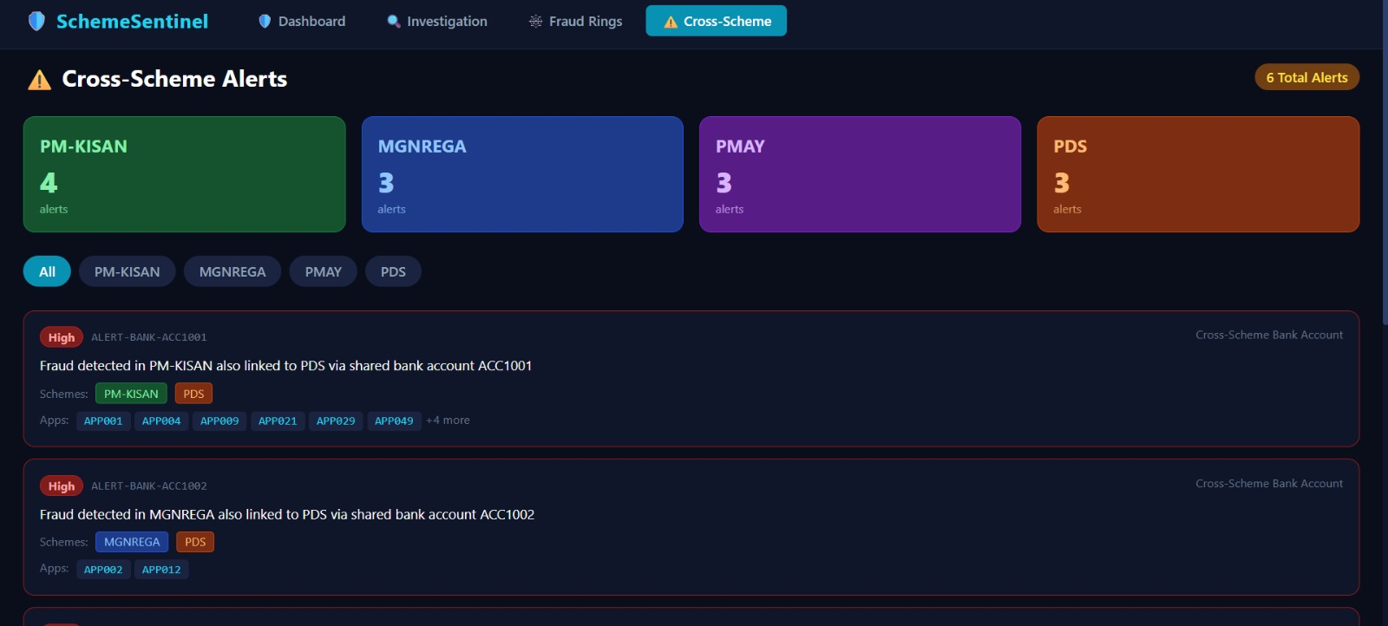

7. Conclusion
SchemeSentinel successfully moves from static database checks to dynamic graph-based prevention. Recognizing that as the frauds usually understand the pattern of fraud detection they will easily overcome it soo we will follow dynamic pattern system, we have built a prototype that is adaptive and accurate.

8. Future Work
We plan to enhance our GNN models with temporal analysis (tracking how connections change over time) because as the frauds usually understand the pattern of fraud detection they will easily overcome it soo we will follow dynamic pattern system that remains robust against evolving threats.

