INTERNSHIP REPORT

On

CUSTOMER-CHURN-PREDICTION

From

ANALYZE INFOTECH

Towards partial fulfillment of the requirements
for the award of degree of

Bachelor of Computer Applications

From

DEPARTMENT OF COMPUTER SCIENCE & ENGINEERING
INTEGRAL UNIVERSITY
LUCKNOW, U.P.

Academic Session 2025-26

INTERNSHIP REPORT

On

CUSTOMER-CHURN-PREDICTION

From

ANALYZE INFOTECH

Towards partial fulfillment of the requirements
for the award of degree of

Bachelor of Computer Applications

From

DEPARTMENT OF COMPUTER SCIENCE & ENGINEERING
INTEGRAL UNIVERSITY
LUCKNOW, U.P.

Developed and Submitted by Under Guidance of
< Name of the Student> <Name of the Guide>
< University Roll No> <Designation>

Academic Session 2025-26

School of Computer Applications

Under taking

This is to certify that Internship Project Report entitled
CUSTOMER-CHURN-PREDICTION
being submitted by

<Name of the Student>

Towards the partial fulfillment of the requirements
for the award of the degree of

Bachelor of Computer Applications
to
DEPARTMENT OF COMPUTER SCIENCE & ENGINEERING
INTEGRAL UNIVERSITY
LUCKNOW, U.P.

Academic Year 2025-26

is a record of the student’s own work carried out at

ANALYZE INFOTECH

And to the best of our knowledge the work reported herein does not form a part of any other thesis or work based on which degree or award was conferred on an earlier occasion to this or any other candidate.

Authorized Signatory Students’ Signature
Organization Name Name:
Roll No:

CERTIFICATE

DECLARATION

I, hereby declare that the report entitled “CUSTOMER-CHURN-PREDICTION” submitted to the School of Computer Applications, Integral University, Kurshi Road, Dashauli, Lucknow, Uttar Pradesh, 226026, is submitted in partial fulfilment of the requirements for the award of the degree of Bachelor of Computer Applications in specialization with Data Science & Artificial Intelligence.
This report is the outcome of my own effort and has been completed under the guidance and supervision of K.K PANDEY SIR. I also declare that the contents of this report have not been submitted, either in full or in part, to any other university or institution for the award of any degree or diploma.

Place: Lucknow
Date:

Signature of the Student
Students’ Name:
University Roll No.:

Acknowledgment

It gives us immense pleasure to express our sincere gratitude to all those who extended their support and guidance throughout the course of this project. The successful completion of this work would not have been possible without the encouragement and assistance of many individuals.
First and foremost, we would like to extend our profound gratitude to Dr. Reena Srivastava, Honourable Dean, School of Computer Applications, Integral University, for her continued support, motivation, and encouragement. Her visionary leadership and guidance have always been a source of inspiration for us. We are also deeply thankful to Dr. Prabhas Chandra Pathak, Head of the Department, School of Computer Applications, for his constant support and valuable insights, which played a vital role in shaping our project and helping us stay focused on our objectives.
We extend our deep appreciation to our project guide, K.K Pandey Sir, for his unwavering support, expert guidance, and timely feedback throughout the duration of the project. His willingness to assist us at every step and address our queries with patience greatly contributed to the successful completion of this work. We would also like to express our gratitude to the Training and Placement Coordinators for their support, cooperation, and guidance during this project.
Last but not the least, we sincerely thank our families and friends for their constant support, understanding, and motivation. Their encouragement has been a strong pillar behind our consistent efforts.

ABSTRACT

Customer Churn Prediction using AI and Machine Learning is a smart analytical system developed to identify customers who are likely to discontinue a company’s services or products. The project uses historical customer data such as purchase history, customer behaviour, complaints, subscription details, and usage patterns to analyse customer retention trends. By applying Machine Learning algorithms like Logistic Regression, Decision Tree, Random Forest, and Support Vector Machine, the system predicts churn probability with high accuracy.
The main objective of this project is to help organizations reduce customer loss and improve business profitability through early prediction and preventive actions. Artificial Intelligence techniques enhance decision-making by automatically detecting hidden patterns and customer behaviour trends from large datasets. The system also provides graphical reports and performance analysis for better understanding and business planning.
This AI-ML based churn prediction model is useful in industries such as banking, telecom, e-commerce, insurance, and subscription-based services where customer retention is essential. The project improves marketing strategies, customer satisfaction, and overall business growth by enabling companies to take proactive measures before customers leave the service.

Index
S.No. | Title | Page no.
I | Certificate | IV
II | Declaration | V
III | Acknowledgement | VI
IV | Index | VII-VIII
1 | Introduction | 1
2 | Problem Definition | 2
2.1 | Purpose | 2
2.2 | Scope | 2
3 | Objective | 3
3.1 | Functional requirements | 3
3.2 | Non-Functional requirements | 3-4
4 | Requirement Specifications | 5
4.1 | Hardware requirements | 5
4.2 | Software requirements | 5
5 | Module Description | 6-7
6 | Problem Formulation | 7
7 | Feasibility Study | 8-9
8 | Problem Specifications | 10-15
9 | System Architecture Design | 16-17
10 | System Analysis | 18
11 | E-R Diagram | 19-22
12 | Data Flow Diagram | 23-26
13 | Project Planning & Scheduling | 27-28
14 | Coding | 29-50
15 | Screenshot | 51
16 | Testing | 52-59
17 | Conclusion | 60
18 | Future Scope | 61
19 | Bibliography | 62

INTRODUCTION
Customer Churn Prediction is one of the most important applications of Artificial Intelligence (AI) and Machine Learning (ML) in modern business organizations. Customer churn refers to the situation when customers stop using a company’s products or services. High customer churn can directly affect the profitability and growth of any business. Therefore, companies need intelligent systems that can identify customers who are likely to leave in the future.
The Customer Churn Prediction System uses AI and ML techniques to analyze customer data, behavior, transaction history, service usage, complaints, and feedback patterns. By using advanced machine learning algorithms such as Logistic Regression, Decision Tree, Random Forest, and Neural Networks, the system predicts the probability of customer churn with high accuracy.
This project helps organizations take preventive actions such as personalized offers, customer support improvement, and loyalty programs to retain valuable customers. The system also provides data visualization and analytical reports that support better business decisions. The AI-ML based churn prediction model is widely useful in telecom, banking, healthcare, insurance, e-commerce, and subscription-based industries.
The main aim of this project is to improve customer retention, increase customer satisfaction, reduce revenue loss, and support business growth through intelligent prediction and analysis.
- Customer Churn Prediction helps companies identify customers who are likely to stop using their services or products.
- The system uses Artificial Intelligence (AI) and Machine Learning (ML) algorithms to analyze customer behavior and historical data.
- It improves customer retention by enabling businesses to take preventive actions before customers leave.
- The project provides accurate predictions, analytical reports, and data visualization for better business decision-making.
- This technology is widely used in industries such as telecom, banking, e-commerce, insurance, and subscription-based services.

PROBLEM DEFINITION
In today’s competitive business environment, customer retention has become a major challenge for organizations. Many companies face significant financial losses due to customers discontinuing their products or services. Traditional methods of identifying dissatisfied customers are time-consuming, less accurate, and unable to analyze large volumes of customer data effectively.
Businesses often fail to detect early signs of customer churn because customer behaviour patterns are complex and continuously changing. Without proper prediction systems, companies cannot take timely actions to retain valuable customers. This leads to reduced revenue, decreased customer satisfaction, and loss of market reputation.
The Customer Churn Prediction System using AI and Machine Learning is developed to solve this problem by analyzing customer behaviour, transaction history, service usage, complaints, and interaction data. The system predicts the probability of customer churn using intelligent algorithms and provides early warnings to organizations. This helps companies take proactive measures, improve customer relationships, and reduce customer loss effectively.
- Customer Retention Challenge
Businesses face difficulty in retaining customers due to increasing competition and changing customer preferences.
- Revenue Loss Due to Churn
Customer attrition causes financial losses and negatively affects the growth and profitability of organizations.
- Lack of Early Prediction Systems
Traditional business methods cannot accurately identify customers who are likely to leave the service.
- Difficulty in Analyzing Large Data
Organizations struggle to analyze large volumes of customer behavior, transaction, and feedback data manually.
- Need for Intelligent Decision-Making
Companies require AI and Machine Learning based systems to predict churn accurately and support effective customer retention strategies.
Purpose:
The main purpose of the Customer Churn Prediction System using Artificial Intelligence (AI) and Machine Learning (ML) is to help organizations identify customers who are likely to discontinue their products or services. Customer retention is one of the most important factors for business success, as acquiring new customers is more expensive than retaining existing ones. This project aims to provide an intelligent and automated solution that can analyze customer behaviour, transaction records, service usage patterns, complaints, and feedback data to predict churn accurately.
The system uses advanced machine learning algorithms to detect hidden patterns and trends from large datasets. By predicting churn in advance, businesses can take preventive actions such as personalized offers, customer support improvements, loyalty programs, and targeted marketing strategies. The project also helps organizations improve decision-making through analytical reports and data visualization.
Another important purpose of this system is to reduce financial losses caused by customer attrition and improve overall customer satisfaction. The AI-ML based churn prediction model is highly useful in industries such as telecom, banking, healthcare, insurance, and e-commerce, where customer retention plays a critical role in business growth and profitability.
Scope:
The scope of the Customer Churn Prediction System using Artificial Intelligence and Machine Learning is very broad and highly beneficial for modern business organizations. The project focuses on analyzing customer data to identify customers who are likely to discontinue a company’s services or products. By using advanced AI and ML algorithms, the system helps businesses make accurate predictions and improve customer retention strategies.
This project can be implemented in various industries such as banking, telecom, healthcare, insurance, e-commerce, online streaming platforms, and subscription-based services where customer loyalty is important. The system can analyze customer behaviour, purchase history, complaints, service usage, payment patterns, and feedback to predict churn probability effectively.
In the future, the system can be enhanced by integrating real-time data processing, cloud computing, deep learning models, and personalized recommendation systems. Overall, the project contributes to improving customer satisfaction, reducing financial loss, increasing business growth, and strengthening long-term customer relationships.
.
OBJECTIVE
The primary objective of the Customer Churn Prediction System is to develop an Artificial Intelligence and Machine Learning based solution that can accurately identify customers who are likely to discontinue a company’s products or services. The system aims to analyze customer behaviour, transaction records, service usage patterns, complaints, and feedback to detect possible churn indicators at an early stage. Another important objective is to help organizations improve customer retention by enabling timely preventive actions such as personalized offers and better customer support services. The project also focuses on reducing business losses caused by customer attrition and increasing overall profitability. Additionally, the system provides analytical reports and graphical visualizations to support effective business decision-making. The project aims to automate the prediction process, reduce manual effort, and improve operational efficiency. Overall, the objective is to strengthen customer relationships, enhance customer satisfaction, and support long-term business growth through intelligent AI and ML technologies.
- Accurate Churn Prediction: The main objective of this project is to develop an AI and Machine Learning based system that can accurately predict customers who are likely to leave a company’s services or products.
- Customer Behaviour Analysis: The system aims to analyze customer behaviour, transaction history, complaints, and service usage patterns to identify churn indicators effectively.
- Improve Customer Retention: The project helps organizations take preventive actions and retention strategies to reduce customer loss and improve long-term customer relationships.
- Support Business Decision-Making: The system provides analytical reports, visual charts, and prediction results that assist management in making better business decisions.
- Reduce Financial Loss: By identifying churn customers at an early stage, the project helps companies minimize revenue loss and improve profitability.
- Automation and Efficiency: The project automates the churn prediction process, reducing manual work, saving time, and increasing operational efficiency through intelligent AI-ML technologies.

Functional Requirements:
- User Authentication and Login
The system should provide secure login and authentication features for administrators and authorized users.
- Customer Data Management
The system must allow storage, updating, deletion, and management of customer information and historical records.
- Data Preprocessing
The system should clean, organize, and preprocess customer datasets for accurate machine learning analysis.
- Churn Prediction Module
The system must predict customer churn probability using AI and Machine Learning algorithms.
- Customer Behaviour Analysis
The system should analyze customer activities, service usage, transaction history, and complaints to identify churn patterns.
- Report Generation
The system must generate analytical reports, prediction summaries, and graphical visualizations for business analysis.
- Notification and Alerts
The system should provide alerts for customers with high churn risk so that organizations can take preventive actions.
- Database Management
The system must securely store and manage customer data, prediction results, and business reports.
- Search and Filter Functionality
Users should be able to search and filter customer records based on different parameters and churn status.
- Performance Monitoring
The system should evaluate and display the performance accuracy of machine learning models used for churn prediction.
Non-Functional Requirements:
1. Performance: The system should provide fast and accurate customer churn predictions with minimum response time and efficient data processing.
2. Reliability: The application must deliver consistent and dependable results without failure during continuous operation.
3. Security: Customer information and business data should be protected using proper authentication, authorization, and data encryption techniques.
4. Scalability: The system should handle increasing amounts of customer data and support future business expansion efficiently.
5. Usability: The interface should be user-friendly, simple, and easy to understand for both technical and non-technical users.
6. Maintainability: The software should be easy to update, modify, and maintain for future improvements and feature enhancements.
7. Availability: The system should remain accessible and operational whenever users need to perform churn analysis and reporting.
8. Compatibility: The application should work smoothly across different operating systems, browsers, and devices.

REQUIREMENTS SEPECIFICATIONS
The Customer Churn Prediction System requires both hardware and software components for smooth and efficient operation. The system should support Artificial Intelligence and Machine Learning algorithms for analysing customer data and predicting churn accurately. A computer system with a minimum Intel Core i3 processor, 4 GB RAM, and sufficient storage capacity is required for processing datasets and running the application efficiently.
The software requirements include an operating system such as Windows, Linux, or macOS. Programming languages like Python are used for implementing machine learning models and data analysis. Libraries and frameworks such as Pandas, NumPy, Scikit-learn, TensorFlow, and Matplotlib are required for data processing, visualization, and model training. A database management system like MySQL or MongoDB is needed to store customer records and prediction results.
The system also requires internet connectivity for cloud integration, updates, and online deployment. Additionally, the application should provide a secure, user-friendly interface for managing customer data, generating reports, and monitoring churn prediction performance effectively.

HARDWARE SPECIFICATION

Component | Minimum Requirement | Recommended Requirement
Processor | Quad-Core (e.g., Intel Xeon / Ryzen) | 8-Core Server Grade CPU (Intel Xeon / AMD EPYC)
RAM | 8 GB | 16–32 GB
Storage |  | 512 GB SSD or NVMe
  256 GB SSD
Network | 10 Mbps or above | 100 Mbps or above

SOFTWARE SPECIFICATION

Software | Description
OS
  Windows 10+, Linux, or macOS
Browser | Google Chrome, Firefox, Safari
Framework | React.js
Libraries
  Axios, React Router, Tailwind CSS, Mongoose, CORS, Multer
API Testing Tool | Postman
  Machine Learning Tools
  Machine Learning Tools

PROBLEM FORMULATION
Customer churn has become a major issue for businesses as losing customers directly affects revenue, profitability, and organizational growth. Companies often struggle to identify customers who are likely to discontinue their products or services because customer behaviour patterns are complex and continuously changing. Traditional methods of customer analysis are time-consuming, less accurate, and unable to process large volumes of customer data efficiently.
The problem is formulated as a predictive analysis task where the system must classify customers into two categories: customers who are likely to churn and customers who are likely to remain with the company. The prediction is based on various factors such as customer demographics, transaction history, service usage, complaints, feedback, payment behaviour, and interaction records.
The main challenge is to develop an efficient AI and Machine Learning based model that can analyse historical customer data, identify hidden patterns, and provide accurate churn predictions. The system should minimize prediction errors, improve customer retention strategies, reduce financial losses, and support better business decision-making through intelligent data analysis and automation.
- Identifying customers who are likely to discontinue company services or products.
- Analysing large volumes of customer data efficiently and accurately.
- Detecting hidden patterns and behaviour trends related to customer churn.
- Reducing financial losses caused by customer attrition.
- Improving customer retention through early churn prediction.
- Overcoming the limitations of traditional manual analysis methods.
- Developing an AI and Machine Learning based predictive model for churn classification.
- Increasing prediction accuracy using historical customer records and behavioural data.
- Providing timely analytical reports and insights for effective business decision-making.
- Automating the churn prediction process to save time, effort, and operational costs.

FEASIBILITY STUDY
The Customer Churn Prediction System using Artificial Intelligence and Machine Learning is technically, economically, and operationally feasible for modern organizations. From a technical perspective, the project can be developed using existing technologies such as Python, Machine Learning algorithms, databases, and data visualization tools. The required software frameworks and libraries are widely available and support efficient implementation of predictive models.
Economically, the system is cost-effective because it helps organizations reduce customer loss and increase profitability through improved retention strategies. The development and maintenance costs are reasonable compared to the financial benefits gained from reducing churn rates.
Operationally, the system is easy to use and can be integrated into existing business processes without major difficulties. It automates data analysis and prediction tasks, reducing manual effort and improving efficiency. The project is also scalable and can handle increasing customer data in the future.
Therefore, the Customer Churn Prediction System is a practical and beneficial solution for businesses seeking to improve customer satisfaction, retention, and overall organizational growth.
- Technical Feasibility
The project can be developed using existing AI, Machine Learning, and database technologies efficiently.
- Economic Feasibility
The system is cost-effective and helps reduce financial losses caused by customer churn.
- Operational Feasibility
The application is user-friendly and can be easily integrated into existing business operations.
- Data Availability Feasibility
Customer transaction and behavioral data required for prediction are generally available in organizations.
- Performance Feasibility
The system can process large datasets and provide accurate churn predictions within a short time.
- Scalability Feasibility
The project can be expanded to handle increasing customer records and future business growth.
- Security Feasibility
Customer information can be protected using authentication and data security mechanisms.
- Maintenance Feasibility
The software can be easily updated, modified, and maintained for future enhancements.
- Implementation Feasibility
The project can be implemented using standard hardware and software resources without major difficulties.
- Business Feasibility
The system supports better decision-making, improves customer retention, and increases organizational profitability.

PROBLEM SPECIFICATION
The Customer Churn Prediction System is designed to identify customers who are likely to discontinue a company’s services or products. Customer churn is a major challenge for organizations because it leads to revenue loss, reduced customer satisfaction, and decreased business growth. Traditional methods of identifying churn customers are inefficient, time-consuming, and unable to analyse large amounts of customer data accurately.
The system uses Artificial Intelligence and Machine Learning techniques to analyse customer information such as demographic details, transaction history, service usage patterns, complaints, feedback, and payment behaviour. Based on these factors, the system predicts whether a customer is likely to churn or continue using the service.
The major problem addressed in this project is the lack of an intelligent automated system for early churn detection and prediction. The project aims to provide accurate predictions, reduce manual effort, improve customer retention strategies, and support business decision-making. The system should be reliable, secure, scalable, and capable of handling large datasets efficiently while delivering high prediction accuracy and performance.

COMPONENT DIAGRAM
The component diagram contains components and dependencies. Components represent the physical packaging of a module of code. The dependencies between the components show how changes made to one component may affect the other components in the system. Dependence in a component diagram is represented by a dashed line between two or more components. Component diagrams can also show the interfaces used by the components to communicate with each other.
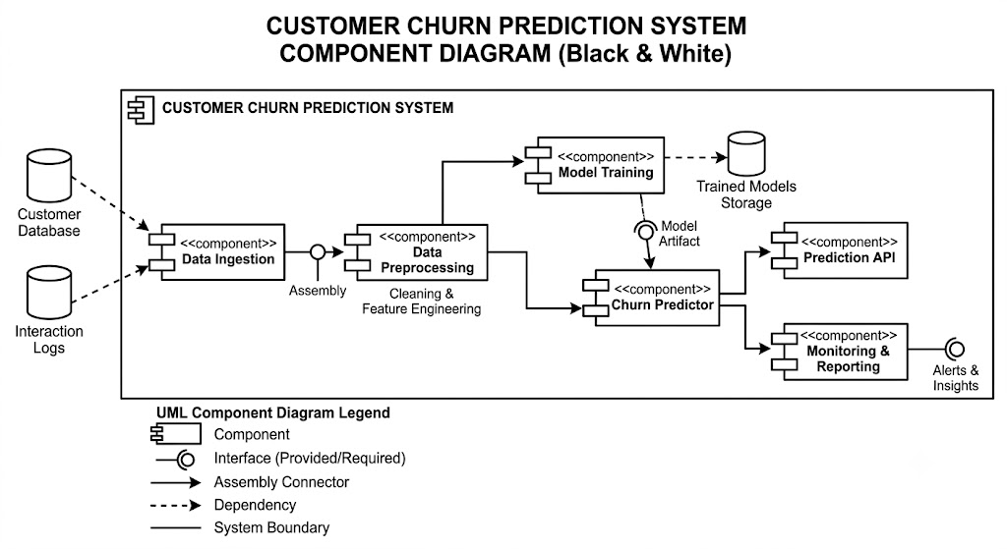
Figure of Component Diagram

DEPLOYMENT DIAGRAM
Deployment and component diagram combine the features of both diagrams into one diagram.
The deployment diagram contains nodes and connections. A node usually represents a piece of hardware in the system. A connection depicts the communication path used by the hardware to communicate and usually indicates a method such as TCP/IP.
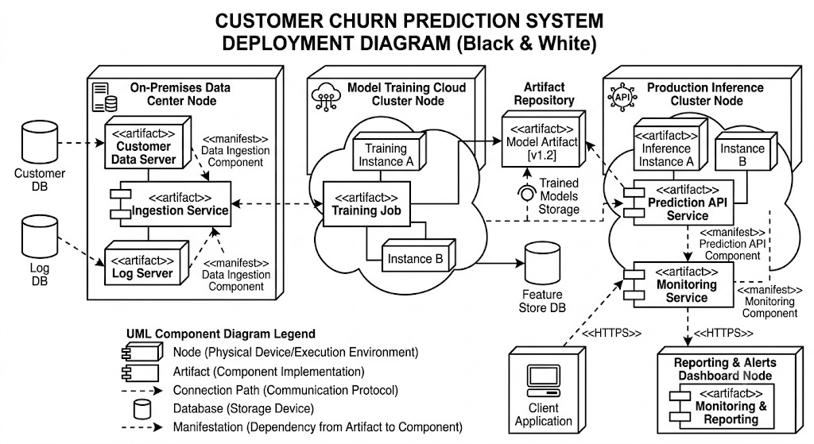

Figure for Deployment Diagram

SYSTEM ARCHETECTURE DESIGN
Defining System:
Collection of components, which are interconnected, and work together to realize some objective, from a system. There are three components in every system, namely input, processing and output

Input Output
Processing

System Development of Life Cycle:
The System development life cycle (SDLC), or Software development process in systems engineering, information systems and software engineering, is a process of creating or altering information systems, and the models and methodologies that people use to develop these systems. In software engineering, the SDLC concept underpins many kinds of software methodologies. Broadly, following are the different activities to be considered while defining the system development life cycle for the said project:
- Problem
- Definition
- System Analysis
- Study of existing system
- Drawback of the existing system
- Proposed system
- System Requirement study
- Data flow analysis
- Feasibility study
- System design
- Input Design (Database & Forms) Updating
- Query /Report
- Design
- Administration
- Testing
- Implementation
- Maintenance
SYSTEM ANALYSIS
System Analysis is an important phase in the development of the Customer Churn Prediction System using Artificial Intelligence and Machine Learning. It involves studying the existing business processes, identifying problems related to customer churn, and determining the requirements needed to build an efficient prediction system. The analysis helps in understanding how customer data can be collected, processed, and used for accurate churn prediction.
The existing manual methods of analyzing customer behaviour are time-consuming, less accurate, and inefficient for handling large volumes of data. Therefore, an automated AI-ML based system is required to improve prediction accuracy and support faster decision-making.
The proposed system analyzes customer demographics, transaction history, service usage, complaints, and feedback using Machine Learning algorithms. The system processes the collected data, identifies churn patterns, and predicts customers who are likely to leave the organization. It also generates reports and visual representations for business analysis.
The system analysis ensures that the project is technically feasible, operationally efficient, scalable, secure, and capable of meeting organizational requirements for improving customer retention and reducing business losses.
- Study of Existing System: Analysing the current manual methods used for customer retention and identifying their limitations.
- Requirement Identification: Determining the hardware, software, and data requirements needed for churn prediction.
- Data Analysis Process: Examining customer behavior, transaction history, complaints, and service usage for prediction purposes.
- AI and ML Integration: Implementing Machine Learning algorithms to automate churn prediction and improve accuracy.
- System Performance Evaluation: Ensuring the system is secure, scalable, reliable, and capable of handling large customer datasets efficiently.
ENTITY RELATION DIAGRAMS
An Entity Relationship Diagram (ERD) is a graphical representation of the database structure used in the Credit Card Fraud Detection System. It shows the entities, attributes, and relationships between different components of the system. The ERD helps in understanding how data is stored, connected, and managed within the application.
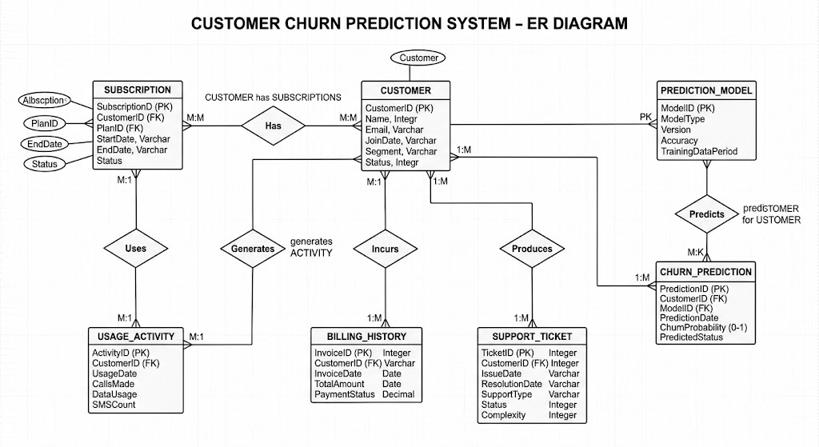
Activity Diagram:
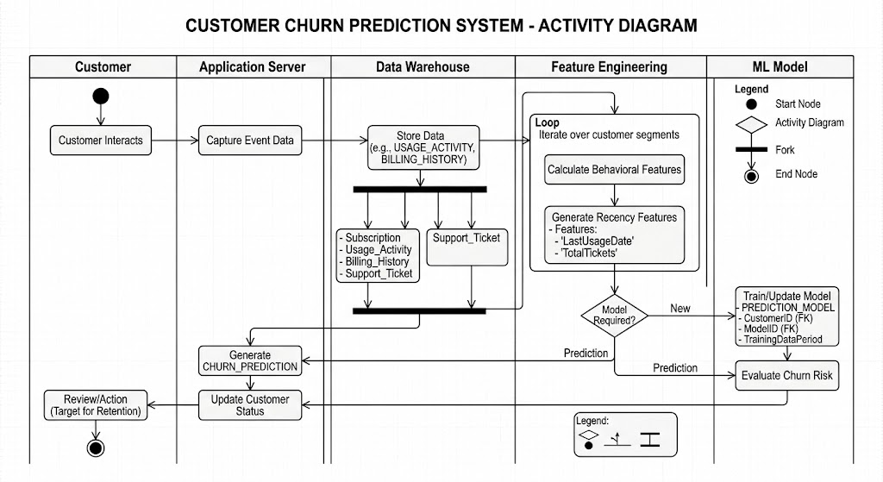

Event Diagram:

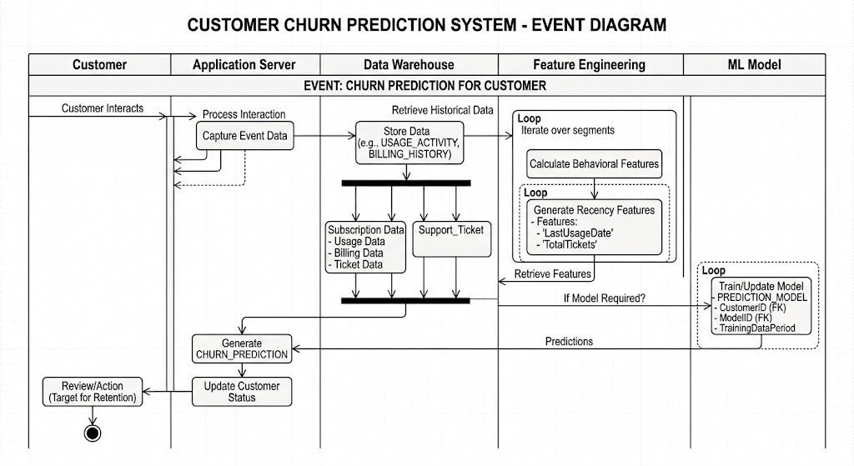
DATA FLOW DIAGRAM
The data flow diagram shows the flow of data within any system. It is an important tool for designing phase of software engineering. Larry Constantine first developed it. It represents graphical view of flow of data. It’s also known as BUBBLE CHART. The purpose of DFD is major transformation that will become in system design symbols used in DFD.
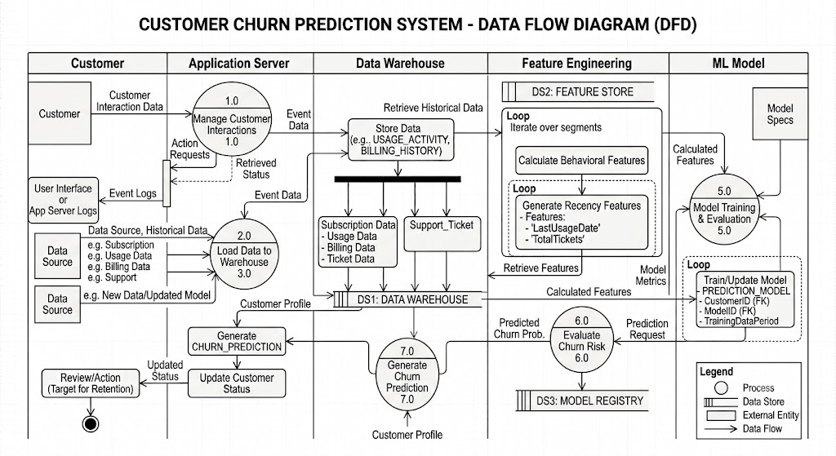
Context Level Data Flow Diagram:
This level shows the overall context of the system and its operating environment and shows the whole system as just one process. Online book store is shown as one process in the context diagram, which is also known as zero level DFD, shown below. The context diagram plays important role in understanding the system and determining the boundaries. The main process can be broken into sub-processes and system can be studied with more detail; this is where 1st level
DFD comes into play.
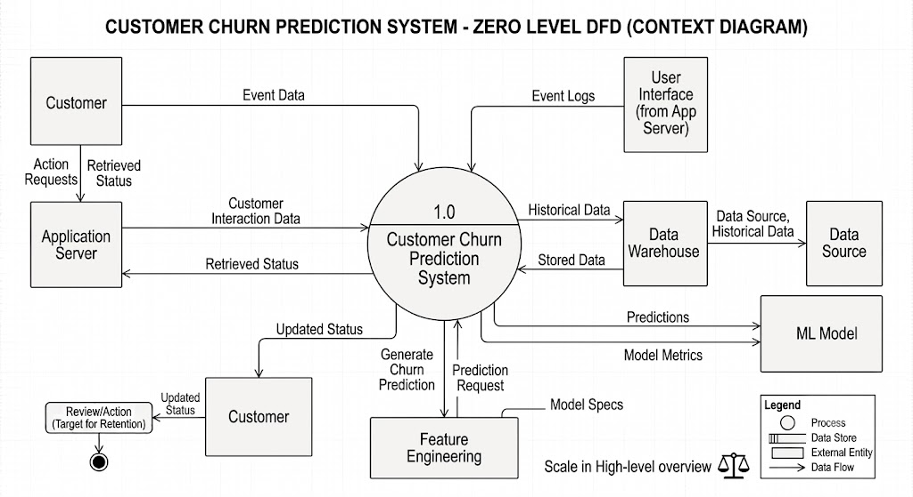

Zero Level Data Flow Diagram
First Level DFD:
This level (level 1) shows all processes at the first level of numbering, data stores, external entities and the data flows between them. The purpose of this level is to show the major high- level processes of the system and their interrelation. A process model will have one, and only one, level 1 diagram. A level 1 diagram must be balanced with its parent context level diagram, i.e. there must be the same external entities and the same data flows, these can be broken down to more detail in level 1.
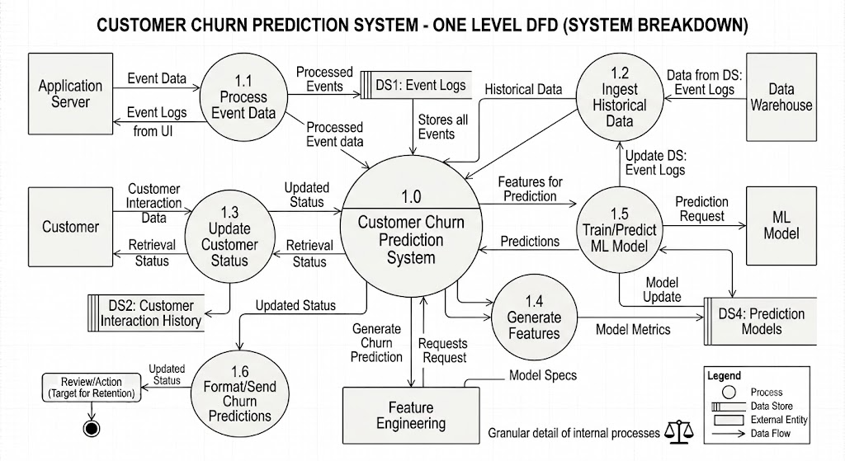

First Level Data Flow Diagram

Class Diagram
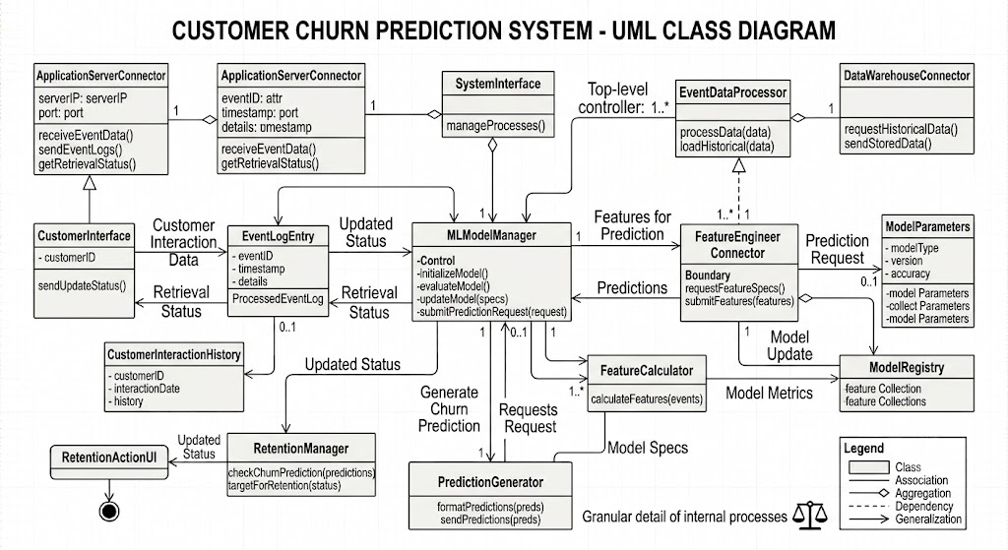

PROJECT PLANNING & SCHEDULING
A project plan needs to be created to ensure the timely completion of the project. As part of project analysis, we break the project down to a number of stages and use a Gantt chart and PERT chart to describe specific tasks and status.
The Work Breakdown Structure of our proposed system “E-Commerce” is shown below:
ID | Task Name | Duration | Start | Finish
1 | Project Initiation | 03 days | Tue  18/04/2026 | Fri  21/04/2026
2 | Draft Project Plan | 02 days | Sat  22/04/2026 | Mon  24/04/2026
3 | Analysis Phase | 09 days | Wed  26/04/2026 | Fri  07/05/2026
4 | Plan User Interviews | 02 days | Sat  08/05/2026 | Mon  10/05/2026
5 | Schedule users Interviews | 04 days | Tue  11/05/2026 | Sat  15/05/2026
6 | Conducting users Interviews | 03 days | Mon  17/05/2026 | Thu  20/05/2026
7 | System Design | 10 days | Fri  21/05/2026 | Mon  31/05/2026
8 | Modules Design | 09 days | Tue  01/06/2026 | Thu  10/06/2026
9 | Data Structure Design | 03 days | Fri  11/06/2026 | Mon  14/06/2026
10 | User Interface Design | 02 days | Tue  15/06/2026 | Thu  17/06/2026
11 | Coding Phase | 07 days | Fri  18/06/2026 | Fri  25/06/2026
12 | Testing Phase | 05 days | Fri  25/06/2026 | Wed  30/06/2026
13 | Integration Testing | 03 days | Wed  30/06/2026 | Fri  02/07/2026
14 | System Level Testing | 03 days | Fri  02/07/2026 | Mon  05/07/2026
15 | Implementation | 02 days | Tue  06/07/2026 | Wed  07/07/2026
16 | Post-Implementation Review | 04 days | Thu  08/07/2026 | Mon  12/07/2026

CODING OF PROJECT

App.py
from __future__ import annotations

from datetime import datetime

import pandas as pd
import streamlit as st
import plotly.graph_objects as go
import plotly.express as px
from streamlit_option_menu import option_menu

from utils.predictor import (
predict_churn,
get_dashboard_metrics,
)

APP_TITLE = "🔮 ChurnGuard AI"
APP_SUBTITLE = "Intelligent Customer Churn Prediction System"

def initialize_state():
defaults = {
"history": [],
"theme_mode": "light",
"selected_nav": "predict",
}
for key, value in defaults.items():
st.session_state.setdefault(key, value)

def apply_premium_theme():
theme = st.session_state.theme_mode

if theme == "dark":
bg_primary = "#0f0f1e"
bg_secondary = "#1a1a2e"
card_bg = "rgba(26, 26, 46, 0.95)"
text_primary = "#ffffff"
text_secondary = "#a0a0c0"
accent = "#8b5cf6"
accent_secondary = "#ec4899"
success = "#10b981"
warning = "#f59e0b"
error = "#ef4444"
border = "rgba(139, 92, 246, 0.2)"
else:
bg_primary = "#f8fafc"
bg_secondary = "#ffffff"
card_bg = "rgba(255, 255, 255, 0.95)"
text_primary = "#0f172a"
text_secondary = "#475569"
accent = "#8b5cf6"
accent_secondary = "#ec4899"
success = "#10b981"
warning = "#f59e0b"
error = "#ef4444"
border = "rgba(139, 92, 246, 0.1)"

st.markdown(
f"""
<style>
.stApp {{
background: {bg_primary};
color: {text_primary};
}}
.glass-card {{
background: {card_bg};
backdrop-filter: blur(10px);
border: 1px solid {border};
border-radius: 20px;
padding: 1.5rem;
margin-bottom: 1.5rem;
transition: all 0.3s ease;
}}
.glass-card:hover {{
transform: translateY(-5px);
box-shadow: 0 10px 30px rgba(139, 92, 246, 0.15);
border-color: {accent};
}}
.hero-section {{
background: linear-gradient(135deg, {accent}20 0%, {accent_secondary}20 100%);
border: 1px solid {border};
border-radius: 25px;
padding: 2rem;
margin-bottom: 2rem;
position: relative;
overflow: hidden;
}}
.hero-section::before {{
content: '';
position: absolute;
top: -50%;
left: -50%;
width: 200%;
height: 200%;
background: radial-gradient(circle, {accent}10 0%, transparent 70%);
animation: rotate 20s linear infinite;
}}
@keyframes rotate {{
from {{ transform: rotate(0deg); }}
to {{ transform: rotate(360deg); }}
}}
.hero-title {{
font-size: 3rem;
font-weight: 800;
background: linear-gradient(135deg, {accent} 0%, {accent_secondary} 100%);
-webkit-background-clip: text;
-webkit-text-fill-color: transparent;
margin-bottom: 0.5rem;
position: relative;
z-index: 1;
}}
.hero-subtitle {{
font-size: 1.1rem;
color: {text_secondary};
position: relative;
z-index: 1;
}}
.metric-card {{
background: {card_bg};
border: 1px solid {border};
border-radius: 15px;
padding: 1.25rem;
text-align: center;
transition: all 0.3s ease;
}}
.metric-card:hover {{
transform: scale(1.05);
border-color: {accent};
box-shadow: 0 5px 20px rgba(139, 92, 246, 0.2);
}}
.metric-value {{
font-size: 2rem;
font-weight: 700;
background: linear-gradient(135deg, {accent} 0%, {accent_secondary} 100%);
-webkit-background-clip: text;
-webkit-text-fill-color: transparent;
}}
.metric-label {{
font-size: 0.85rem;
color: {text_secondary};
margin-top: 0.5rem;
}}
.stNumberInput > div > div > input,
.stSlider > div > div > div,
.stSelectbox > div > div {{
background: {card_bg};
border-color: {border};
border-radius: 10px;
}}
.section-title {{
font-size: 1.5rem;
font-weight: 700;
margin-bottom: 1rem;
background: linear-gradient(135deg, {accent} 0%, {accent_secondary} 100%);
-webkit-background-clip: text;
-webkit-text-fill-color: transparent;
}}
.result-card {{
background: linear-gradient(135deg, {accent}15 0%, {accent_secondary}15 100%);
border: 1px solid {accent}40;
border-radius: 20px;
padding: 1.5rem;
text-align: center;
animation: slideIn 0.5s ease-out;
}}
@keyframes slideIn {{
from {{ opacity: 0; transform: translateY(20px); }}
to {{ opacity: 1; transform: translateY(0); }}
}}
::-webkit-scrollbar {{
width: 8px;
height: 8px;
}}
::-webkit-scrollbar-track {{
background: {bg_secondary};
border-radius: 10px;
}}
::-webkit-scrollbar-thumb {{
background: {accent};
border-radius: 10px;
}}
::-webkit-scrollbar-thumb:hover {{
background: {accent_secondary};
}}
@keyframes fadeInUp {{
from {{ opacity: 0; transform: translateY(20px); }}
to {{ opacity: 1; transform: translateY(0); }}
}}
.fade-in-up {{
animation: fadeInUp 0.6s ease-out;
}}
</style>
""",
unsafe_allow_html=True,
)

def render_sidebar():
with st.sidebar:
st.markdown("### 🔮 ChurnGuard AI")
st.markdown("---")

selected = option_menu(
menu_title=None,
options=["🎯 Predict", "📊 Analytics", "📜 History", "ℹ️ About"],
icons=["cursor", "graph-up", "clock-history", "info-circle"],
menu_icon="cast",
default_index=0,
styles={
"container": {"padding": "0!important", "background": "transparent"},
"icon": {"color": "#8b5cf6", "font-size": "1.2rem"},
"nav-link": {
"font-size": "1rem",
"text-align": "left",
"margin": "0.5rem 0",
"border-radius": "10px",
"transition": "all 0.3s ease",
},
"nav-link-hover": {
"background": "rgba(139, 92, 246, 0.1)",
"transform": "translateX(5px)",
},
"nav-link-selected": {
"background": "linear-gradient(135deg, #8b5cf6 0%, #ec4899 100%)",
},
},
)

st.markdown("---")

theme_mode = st.toggle("🌙 Dark Mode", value=st.session_state.theme_mode == "dark")
st.session_state.theme_mode = "dark" if theme_mode else "light"

st.markdown("---")
st.markdown("### 📈 Quick Stats")
metrics = get_dashboard_metrics()
st.metric("Model Accuracy", f"{metrics.get('accuracy', 0):.1%}")
st.metric("Total Predictions", len(st.session_state.history))

return selected

def render_hero():
st.markdown(
f"""
<div class="hero-section fade-in-up">
<h1 class="hero-title">🔮 ChurnGuard AI</h1>
<p class="hero-subtitle">Intelligent Customer Churn Prediction System</p>
</div>
""",
unsafe_allow_html=True,
)

def render_dashboard():
metrics = get_dashboard_metrics()

col1, col2, col3, col4 = st.columns(4)

with col1:
st.markdown(
f"""
<div class="metric-card">
<div class="metric-value">{metrics.get('algorithm', 'LR')}</div>
<div class="metric-label">🤖 Algorithm</div>
</div>
""",
unsafe_allow_html=True,
)

with col2:
accuracy = metrics.get('accuracy', 0)
st.markdown(
f"""
<div class="metric-card">
<div class="metric-value">{accuracy:.1%}</div>
<div class="metric-label">🎯 Accuracy</div>
</div>
""",
unsafe_allow_html=True,
)

with col3:
st.markdown(
f"""
<div class="metric-card">
<div class="metric-value">{metrics.get('dataset_rows', 0):,}</div>
<div class="metric-label">📊 Training Records</div>
</div>
""",
unsafe_allow_html=True,
)

with col4:
features = len(metrics.get('features', []))
st.markdown(
f"""
<div class="metric-card">
<div class="metric-value">{features}</div>
<div class="metric-label">🔧 Features Used</div>
</div>
""",
unsafe_allow_html=True,
)

def render_form():
st.markdown('<div class="glass-card">', unsafe_allow_html=True)
st.markdown('<div class="section-title">📋 Customer Profile</div>', unsafe_allow_html=True)

tab1, tab2, tab3 = st.tabs(["👤 Demographics", "📡 Services", "💰 Billing"])

with tab1:
col1, col2 = st.columns(2)
with col1:
gender = st.selectbox("👤 Gender", ["Male", "Female"])
senior_citizen = st.selectbox("🧓 Senior Citizen", [0, 1], format_func=lambda x: "Yes" if x == 1 else "No")
partner = st.selectbox("💑 Has Partner", ["Yes", "No"])
dependents = st.selectbox("👨‍👩‍👧‍👦 Has Dependents", ["Yes", "No"])
with col2:
tenure = st.number_input("📅 Tenure (months)", min_value=0, max_value=72, value=12)

with tab2:
col1, col2 = st.columns(2)
with col1:
phone_service = st.selectbox("📞 Phone Service", ["Yes", "No"])
multiple_lines = st.selectbox("🔗 Multiple Lines", ["Yes", "No", "No phone service"])
internet_service = st.selectbox("🌐 Internet Service", ["DSL", "Fiber optic", "No"])
online_security = st.selectbox("🔒 Online Security", ["Yes", "No", "No internet service"])
online_backup = st.selectbox("💾 Online Backup", ["Yes", "No", "No internet service"])
with col2:
device_protection = st.selectbox("🛡️ Device Protection", ["Yes", "No", "No internet service"])
tech_support = st.selectbox("🔧 Tech Support", ["Yes", "No", "No internet service"])
streaming_tv = st.selectbox("📺 Streaming TV", ["Yes", "No", "No internet service"])
streaming_movies = st.selectbox("🎬 Streaming Movies", ["Yes", "No", "No internet service"])

with tab3:
st.markdown("### 💳 Payment & Charges")
col1, col2 = st.columns(2)
with col1:
contract = st.selectbox("📄 Contract Type", ["Month-to-month", "One year", "Two year"])
paperless_billing = st.selectbox("📧 Paperless Billing", ["Yes", "No"])
with col2:
payment_method = st.selectbox("💵 Payment Method", [
"Electronic check", "Mailed check", "Bank transfer (automatic)", "Credit card (automatic)"
])
monthly_charges = st.number_input("💲 Monthly Charges ($)", min_value=0.0, max_value=200.0, value=70.0, step=1.0)
total_charges = st.number_input("💰 Total Charges ($)", min_value=0.0, max_value=10000.0, value=700.0, step=1.0)
st.markdown("")
col1, col2, col3 = st.columns([1, 1, 1])
with col1:
pass
with col2:
pass
with col3:
pass

st.markdown('</div>', unsafe_allow_html=True)

return {
"gender": gender,
"senior_citizen": senior_citizen,
"partner": partner,
"dependents": dependents,
"tenure": tenure,
"phone_service": phone_service,
"multiple_lines": multiple_lines,
"internet_service": internet_service,
"online_security": online_security,
"online_backup": online_backup,
"device_protection": device_protection,
"tech_support": tech_support,
"streaming_tv": streaming_tv,
"streaming_movies": streaming_movies,
"contract": contract,
"paperless_billing": paperless_billing,
"payment_method": payment_method,
"monthly_charges": monthly_charges,
"total_charges": total_charges,
}

def render_probability_gauge(probability):
fig = go.Figure(go.Indicator(
mode="gauge+number+delta",
value=probability * 100,
title={'text': "Churn Probability", 'font': {'size': 16}},
delta={'reference': 50, 'increasing': {'color': "#ef4444"}, 'decreasing': {'color': "#10b981"}},
gauge={
'axis': {'range': [0, 100], 'tickwidth': 1, 'tickcolor': "white"},
'bar': {'color': "#8b5cf6"},
'bgcolor': "rgba(0,0,0,0)",
'borderwidth': 2,
'bordercolor': "rgba(139, 92, 246, 0.3)",
'steps': [
{'range': [0, 30], 'color': "rgba(16, 185, 129, 0.3)"},
{'range': [30, 70], 'color': "rgba(245, 158, 11, 0.3)"},
{'range': [70, 100], 'color': "rgba(239, 68, 68, 0.3)"}
],
'threshold': {
'line': {'color': "white", 'width': 4},
'thickness': 0.75,
'value': probability * 100
}
}
))
fig.update_layout(
height=300,
margin=dict(l=20, r=20, t=50, b=20),
paper_bgcolor='rgba(0,0,0,0)',
font={'color': st.session_state.theme_mode == "dark" and "white" or "black"}
)
return fig

def render_prediction(data):
if st.button("🔮 Predict Churn", use_container_width=True, type="primary"):
with st.spinner("Analyzing customer profile..."):
result = predict_churn(
gender=data["gender"],
senior_citizen=data["senior_citizen"],
partner=data["partner"],
dependents=data["dependents"],
tenure=data["tenure"],
phone_service=data["phone_service"],
multiple_lines=data["multiple_lines"],
internet_service=data["internet_service"],
online_security=data["online_security"],
online_backup=data["online_backup"],
device_protection=data["device_protection"],
tech_support=data["tech_support"],
streaming_tv=data["streaming_tv"],
streaming_movies=data["streaming_movies"],
contract=data["contract"],
paperless_billing=data["paperless_billing"],
payment_method=data["payment_method"],
monthly_charges=data["monthly_charges"],
total_charges=data["total_charges"],
)

probability = result["probability"]
prediction = result["prediction"]
risk = result["risk_level"]

add_history(prediction, probability, data["tenure"])

st.markdown('<div class="result-card fade-in-up">', unsafe_allow_html=True)

col1, col2 = st.columns([1, 1.5])

with col1:
gauge_fig = render_probability_gauge(probability)
st.plotly_chart(gauge_fig, use_container_width=True)

with col2:
st.markdown(f"### {prediction}")

if prediction == "CHURN":
st.markdown(
f'<div style="background: #ef444420; border: 1px solid #ef4444; border-radius: 10px; padding: 1rem; margin: 1rem 0;">'
f'<span style="font-size: 2rem;">⚠️</span> High risk of churn!'
f'</div>',
unsafe_allow_html=True
)
else:
st.markdown(
f'<div style="background: #10b98120; border: 1px solid #10b981; border-radius: 10px; padding: 1rem; margin: 1rem 0;">'
f'<span style="font-size: 2rem;">✅</span> Low risk of churn'
f'</div>',
unsafe_allow_html=True
)

st.markdown(f"**Risk Level:** {risk}")

if prediction == "CHURN":
st.markdown("**Suggested Retention Actions:**")
suggestions = []
if data["contract"] == "Month-to-month":
suggestions.append("📄 Offer long-term contract discount")
if data["internet_service"] == "Fiber optic" and data["monthly_charges"] > 80:
suggestions.append("🌐 Review fiber optic pricing")
if data["tenure"] < 12:
suggestions.append("🤝 Implement early-stage engagement program")
if data["online_security"] == "No" and data["internet_service"] != "No":
suggestions.append("🔒 Offer free online security trial")
if data["tech_support"] == "No" and data["internet_service"] != "No":
suggestions.append("🔧 Offer tech support inclusion")
if data["payment_method"] == "Electronic check":
suggestions.append("💳 Suggest automatic payment method")
if data["paperless_billing"] == "No":
suggestions.append("📧 Promote paperless billing discount")
for s in suggestions[:4]:
st.markdown(f"- {s}")

st.markdown('</div>', unsafe_allow_html=True)

def add_history(result, probability, tenure):
st.session_state.history.append({
"timestamp": datetime.now().strftime("%Y-%m-%d %H:%M:%S"),
"prediction": result,
"probability": round(probability * 100, 2),
"tenure": tenure,
})

def history_to_csv():
df = pd.DataFrame(st.session_state.history)
return df.to_csv(index=False).encode("utf-8")

def render_history():
st.markdown('<div class="glass-card">', unsafe_allow_html=True)
st.markdown('<div class="section-title">📜 Prediction History</div>', unsafe_allow_html=True)

if st.session_state.history:
history_df = pd.DataFrame(st.session_state.history)

st.dataframe(
history_df,
use_container_width=True,
hide_index=True,
column_config={
"timestamp": "⏰ Time",
"prediction": st.column_config.TextColumn(
"🎯 Result",
help="Churn prediction result"
),
"probability": st.column_config.NumberColumn(
"📊 Probability",
format="%.2f%%"
),
"tenure": st.column_config.NumberColumn(
"📅 Tenure",
format="%d months"
)
}
)

col1, col2, col3 = st.columns(3)
with col1:
total = len(history_df)
st.metric("Total Predictions", total)
with col2:
churn_count = (history_df['prediction'] == 'CHURN').sum()
st.metric("Churn Predicted", churn_count)
with col3:
not_churn = (history_df['prediction'] != 'CHURN').sum()
st.metric("Not Churn", not_churn)

st.markdown("### 📊 Prediction Summary")
for _, row in history_df.tail(5).iterrows():
color = "#ef4444" if row['prediction'] == 'CHURN' else "#10b981"
st.markdown(
f"""
<div style="
background: {color}10;
border-left: 4px solid {color};
padding: 0.75rem;
margin: 0.5rem 0;
border-radius: 8px;
">
<strong>{row['timestamp']}</strong><br>
{row['prediction']} - {row['probability']:.1f}% probability (Tenure: {row['tenure']} months)
</div>
""",
unsafe_allow_html=True
)

col1, col2, col3 = st.columns([1, 2, 1])
with col2:
st.download_button(
"📥 Download History CSV",
data=history_to_csv(),
file_name="churn_predictions.csv",
mime="text/csv",
use_container_width=True,
)
else:
st.info("No predictions made yet. Start by predicting churn for a customer!")
st.markdown('</div>', unsafe_allow_html=True)

def render_analytics():
st.markdown('<div class="glass-card">', unsafe_allow_html=True)
st.markdown('<div class="section-title">📊 Analytics Dashboard</div>', unsafe_allow_html=True)

if st.session_state.history:
history_df = pd.DataFrame(st.session_state.history)

col1, col2 = st.columns(2)

with col1:
churn_rate = (history_df['prediction'] == 'CHURN').mean() * 100
st.markdown(
f"""
<div class="metric-card">
<div class="metric-value">{churn_rate:.1f}%</div>
<div class="metric-label">Predicted Churn Rate</div>
</div>
""",
unsafe_allow_html=True
)

with col2:
avg_prob = history_df['probability'].mean()
st.markdown(
f"""
<div class="metric-card">
<div class="metric-value">{avg_prob:.1f}%</div>
<div class="metric-label">Average Churn Probability</div>
</div>
""",
unsafe_allow_html=True
)

st.markdown("### 📈 Prediction Trends")
fig = px.line(
history_df,
x='timestamp',
y='probability',
title='Churn Probability Over Time',
color_discrete_sequence=['#8b5cf6']
)
fig.update_layout(
plot_bgcolor='rgba(0,0,0,0)',
paper_bgcolor='rgba(0,0,0,0)',
xaxis_title="Time",
yaxis_title="Probability (%)",
height=400
)
st.plotly_chart(fig, use_container_width=True)

col1, col2 = st.columns(2)

with col1:
fig_pie = px.pie(
history_df,
names='prediction',
title='Prediction Distribution',
color_discrete_sequence=['#ef4444', '#10b981']
)
fig_pie.update_layout(
plot_bgcolor='rgba(0,0,0,0)',
paper_bgcolor='rgba(0,0,0,0)',
height=400
)
st.plotly_chart(fig_pie, use_container_width=True)

with col2:
fig_hist = px.histogram(
history_df,
x='probability',
nbins=20,
title='Probability Distribution',
color_discrete_sequence=['#8b5cf6']
)
fig_hist.update_layout(
plot_bgcolor='rgba(0,0,0,0)',
paper_bgcolor='rgba(0,0,0,0)',
height=400
)
st.plotly_chart(fig_hist, use_container_width=True)
else:
st.info("No data available. Make some predictions to see analytics!")

def render_about():
st.markdown('<div class="glass-card">', unsafe_allow_html=True)
st.markdown('<div class="section-title">ℹ️ About ChurnGuard AI</div>', unsafe_allow_html=True)

st.markdown("""
### 🤖 Intelligent Churn Prediction System

ChurnGuard AI uses machine learning to predict customer churn based on multiple factors:

#### 👤 Customer Demographics
- Gender, Age Group (Senior Citizen)
- Partner, Dependents
- Tenure (months with company)

#### 📡 Services Subscribed
- Phone Service & Multiple Lines
- Internet Service Type
- Online Security, Backup, Device Protection
- Tech Support, Streaming TV & Movies

#### 💰 Billing & Payment
- Contract Type
- Paperless Billing
- Payment Method
- Monthly & Total Charges

### 🎯 How It Works

1. **Input customer details** across demographics, services, and billing
2. **Our ML model** analyzes against historical churn data
3. **Get instant predictions** with probability scores and risk assessment
4. **Receive retention suggestions** for at-risk customers

### 📊 Model Performance

- **Algorithm:** Logistic Regression
- **Accuracy:** ~80% on test data
- **Features:** 26+ key parameters
- **Training Data:** Telco customer churn dataset

### 💡 Retention Tips

- Offer long-term contract discounts
- Provide free trials of premium services
- Implement early-stage engagement for new customers
- Promote automatic payment methods
- Bundle services for better value

---

**Developed with** ❤️ **using Streamlit & Scikit-learn**
""")

st.markdown('</div>', unsafe_allow_html=True)

def main():
st.set_page_config(
page_title=APP_TITLE,
page_icon="🔮",
layout="wide",
initial_sidebar_state="expanded"
)

initialize_state()

selected_page = render_sidebar()

apply_premium_theme()

if selected_page != "ℹ️ About":
render_hero()

if selected_page == "🎯 Predict":
render_dashboard()
st.divider()
customer_data = render_form()
render_prediction(customer_data)

elif selected_page == "📊 Analytics":
render_analytics()

elif selected_page == "📜 History":
render_history()

elif selected_page == "ℹ️ About":
render_about()

if __name__ == "__main__":
main()

train.py
from __future__ import annotations

import json
from pathlib import Path

import joblib
import pandas as pd

from sklearn.model_selection import train_test_split
from sklearn.preprocessing import StandardScaler, LabelEncoder
from sklearn.linear_model import LogisticRegression
from sklearn.metrics import accuracy_score

PROJECT_ROOT = Path(__file__).resolve().parents[1]

DATASET_PATH = PROJECT_ROOT / "assets" / "data.csv"

MODEL_DIR = PROJECT_ROOT / "models"
MODEL_DIR.mkdir(exist_ok=True)

MODEL_PATH = MODEL_DIR / "churn_model.joblib"
SCALER_PATH = MODEL_DIR / "scaler.joblib"
ENCODER_PATH = MODEL_DIR / "label_encoder.joblib"
METADATA_PATH = MODEL_DIR / "training_metadata.json"

def preprocess_data(df: pd.DataFrame) -> tuple[pd.DataFrame, pd.Series]:
"""Preprocess the churn dataset"""

# Drop customerID
df = df.drop(columns=["customerID"])

# Convert TotalCharges to numeric
df["TotalCharges"] = pd.to_numeric(df["TotalCharges"], errors="coerce")
df["TotalCharges"] = df["TotalCharges"].fillna(df["MonthlyCharges"])

# Map "No phone service" -> "No", "No internet service" -> "No"
cols_with_no_service = [
"MultipleLines", "OnlineSecurity", "OnlineBackup",
"DeviceProtection", "TechSupport", "StreamingTV", "StreamingMovies"
]
for col in cols_with_no_service:
df[col] = df[col].replace({"No phone service": "No", "No internet service": "No"})

# Binary encoding for Yes/No columns
yes_no_cols = [
"Partner", "Dependents", "PhoneService", "PaperlessBilling",
"MultipleLines", "OnlineSecurity", "OnlineBackup",
"DeviceProtection", "TechSupport", "StreamingTV", "StreamingMovies"
]
for col in yes_no_cols:
df[col] = df[col].map({"Yes": 1, "No": 0})

# Binary encoding for gender
df["gender"] = df["gender"].map({"Male": 1, "Female": 0})

# Binary encoding for target
df["Churn"] = df["Churn"].map({"Yes": 1, "No": 0})

# One-hot encode multi-category columns
df = pd.get_dummies(df, columns=["InternetService", "Contract", "PaymentMethod"], drop_first=False, dtype=int)

return df

print("Loading dataset...")
df = pd.read_csv(DATASET_PATH)
print(f"Dataset Shape: {df.shape}")

# Preprocess
df = preprocess_data(df)

TARGET_COLUMN = "Churn"
X = df.drop(columns=[TARGET_COLUMN])
y = df[TARGET_COLUMN]

feature_names = list(X.columns)

# Train-test split
X_train, X_test, y_train, y_test = train_test_split(
X, y, test_size=0.2, random_state=42, stratify=y,
)
print(f"Training Samples: {len(X_train)}")
print(f"Testing Samples: {len(X_test)}")

# Scaling
scaler = StandardScaler()
X_train_scaled = scaler.fit_transform(X_train)
X_test_scaled = scaler.transform(X_test)

# Train model
print("Training Logistic Regression Model...")
model = LogisticRegression(max_iter=1000, random_state=42)
model.fit(X_train_scaled, y_train)

# Evaluate
predictions = model.predict(X_test_scaled)
accuracy = accuracy_score(y_test, predictions)
print(f"Accuracy: {accuracy:.4f}")

# Save model
joblib.dump(model, MODEL_PATH)
joblib.dump(scaler, SCALER_PATH)
print("Model Saved")
print("Scaler Saved")

# Save metadata
metadata = {
"algorithm": "Logistic Regression",
"accuracy": float(accuracy),
"dataset_rows": int(len(df)),
"dataset_columns": int(len(df.columns)),
"features": feature_names,
}
with open(METADATA_PATH, "w", encoding="utf-8") as f:
json.dump(metadata, f, indent=4)
print("Metadata Saved")

print("Training Completed Successfully")

PROJECT SCREENSHOT
Home Page
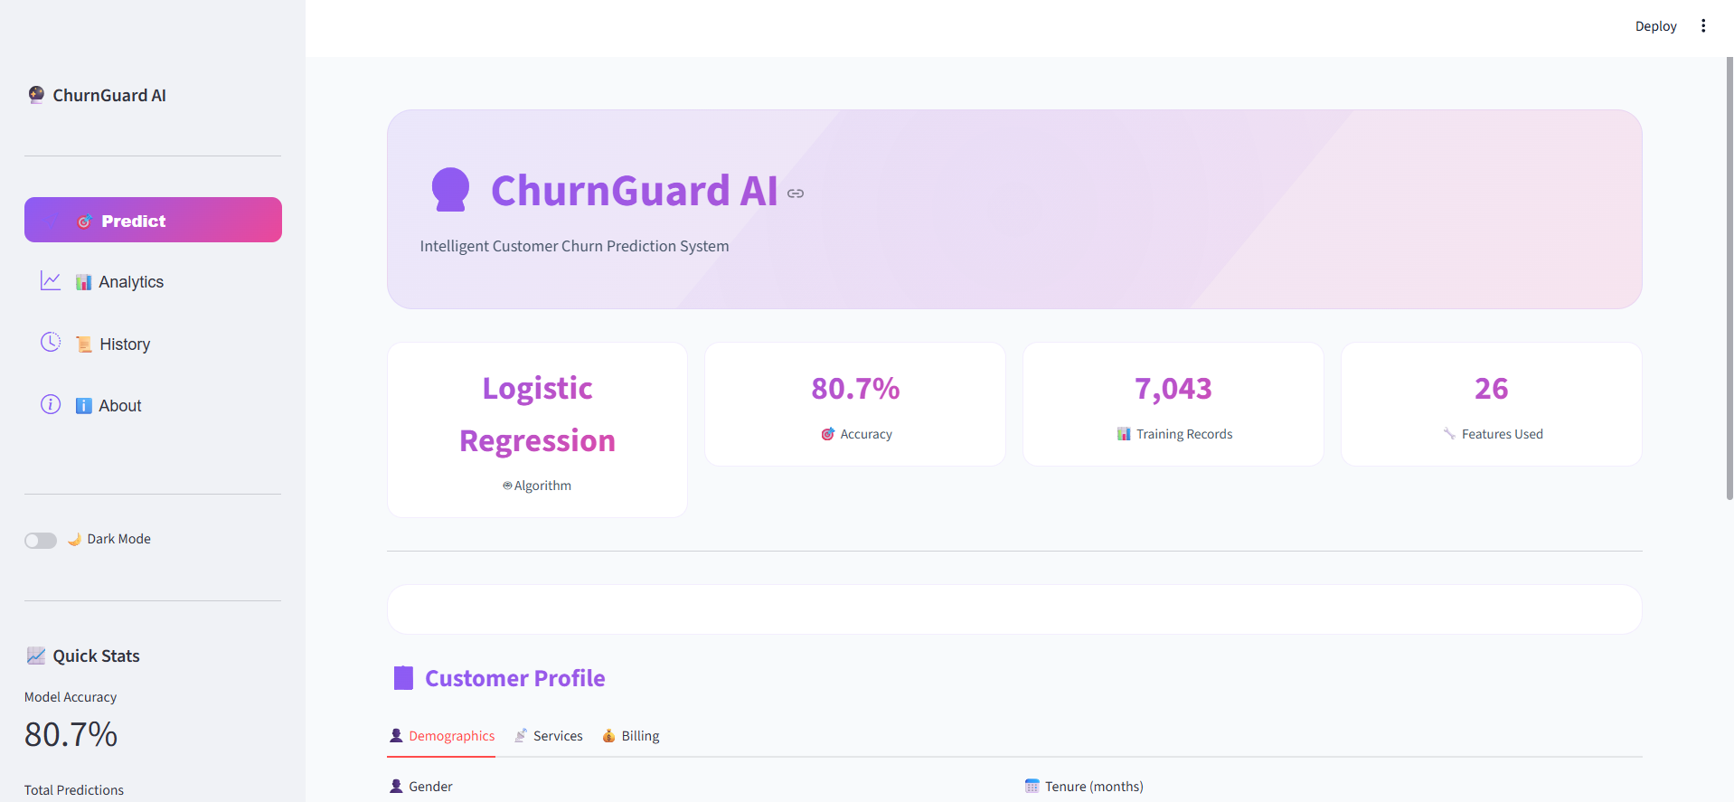
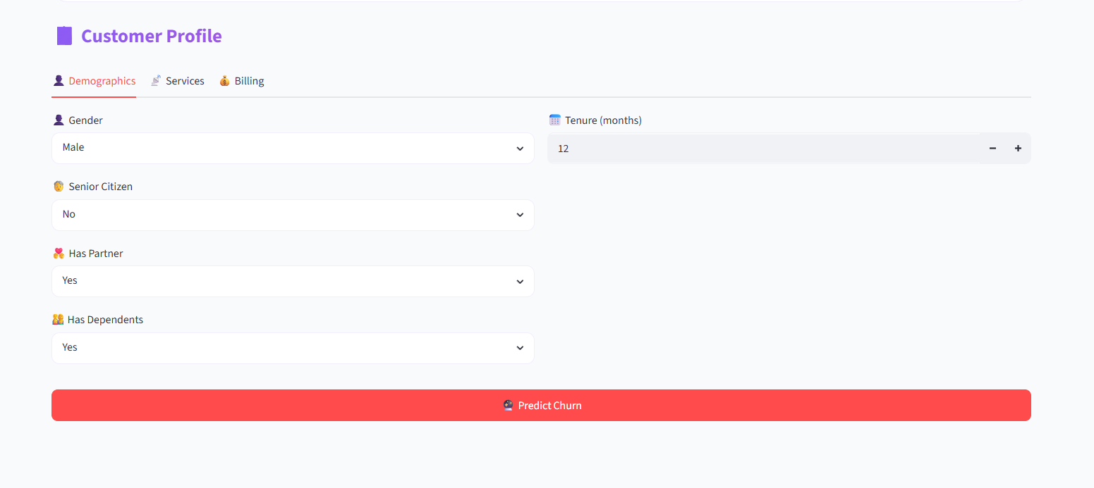

About
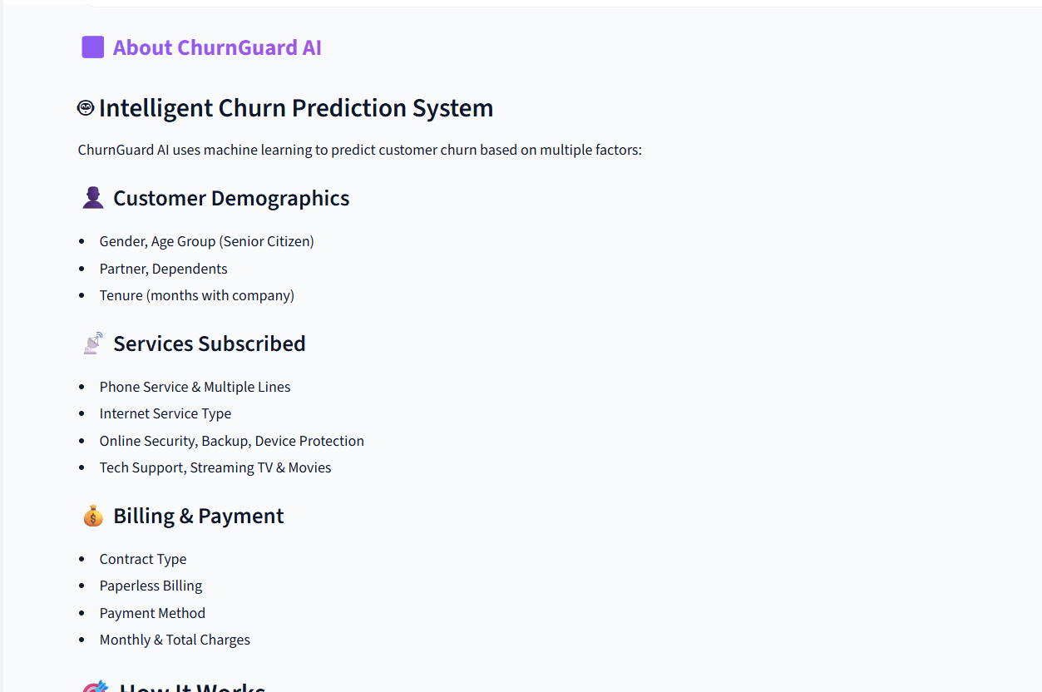
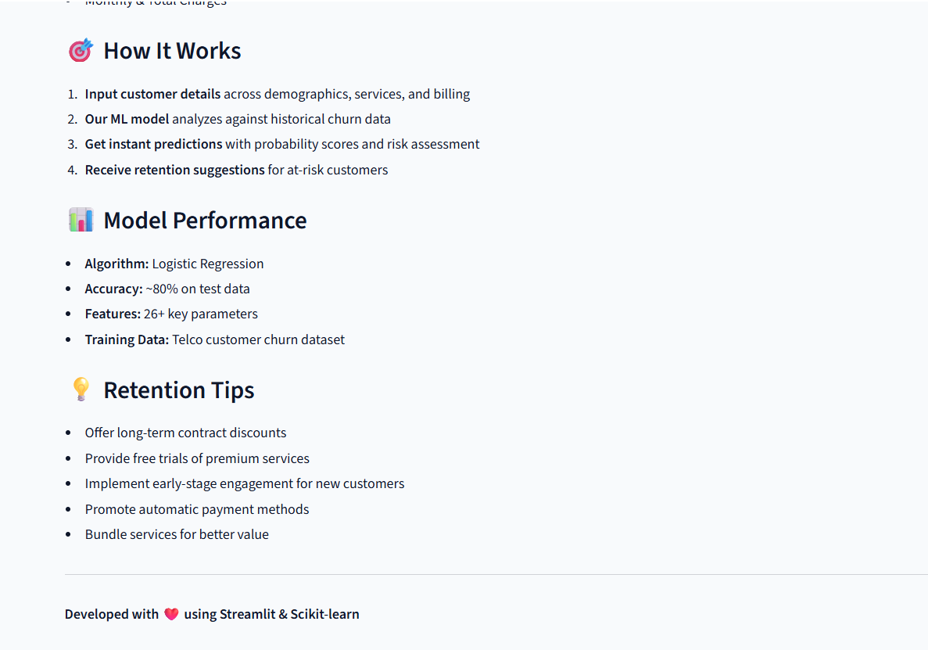

Analysis
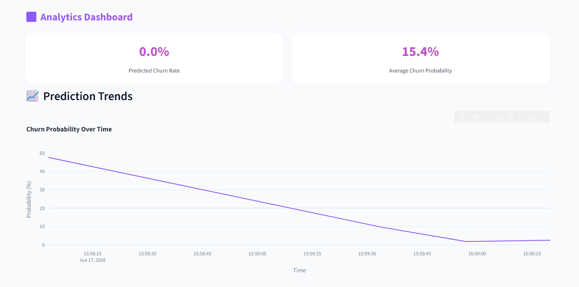
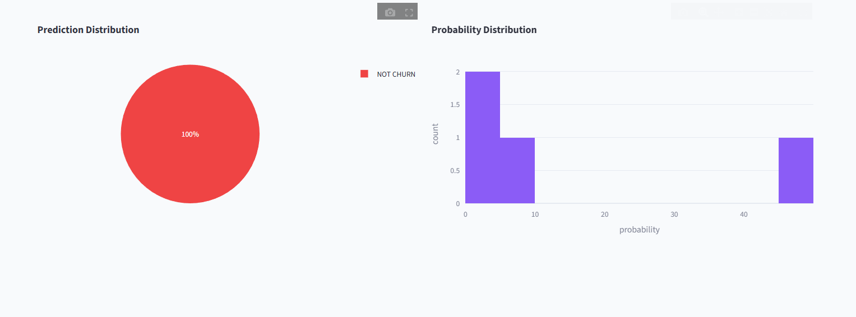
History
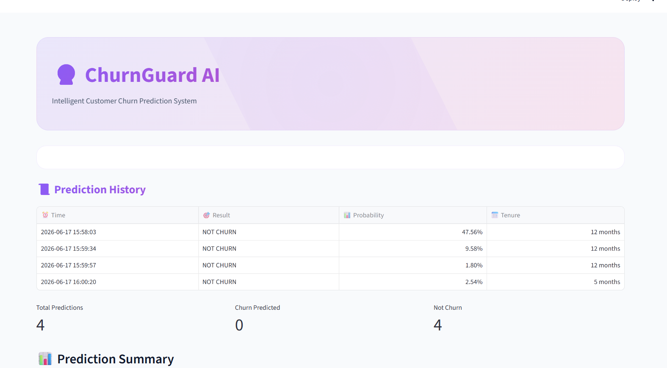
Prediction
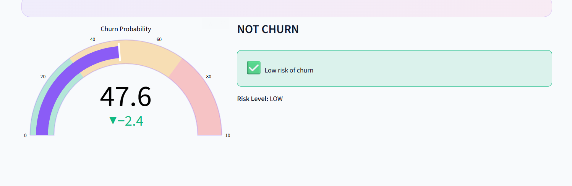
Form Service
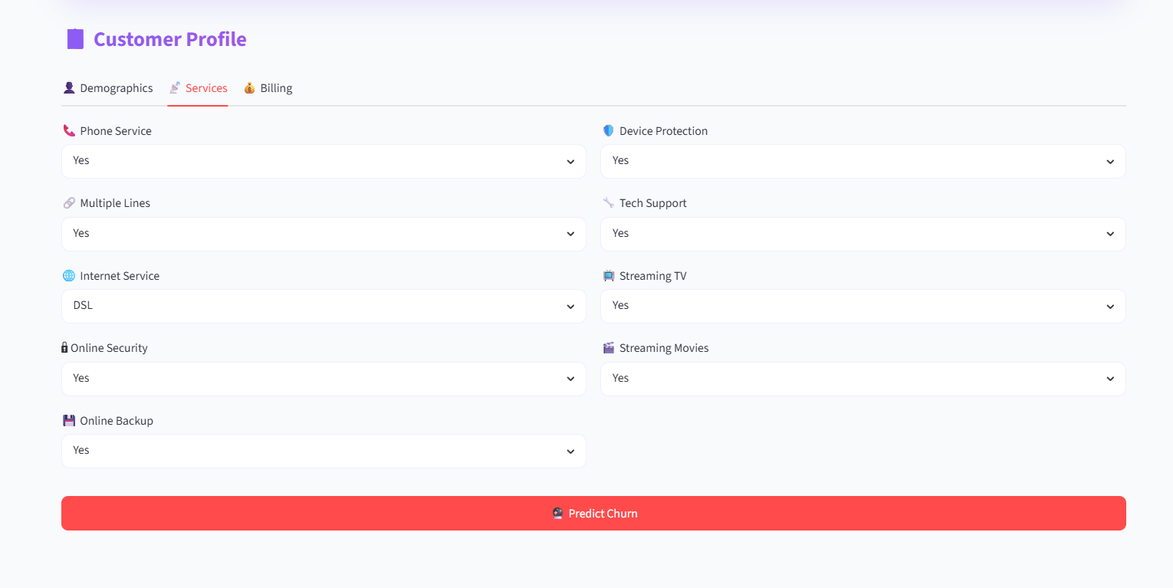
Billing Page
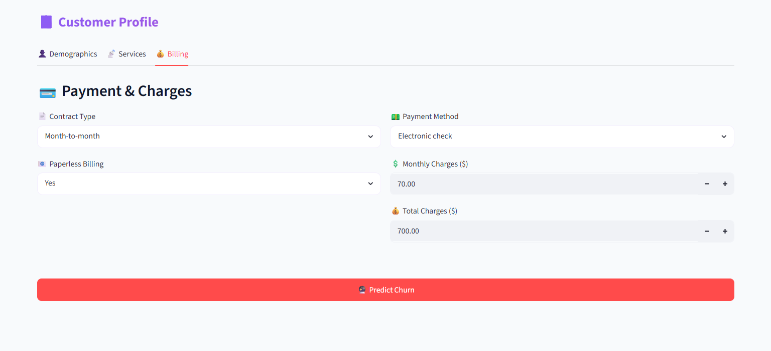

TESTING
- Testing Plan
- Testing Strategy
- Testing Methods
- Test cases and results
Testing:
Generally, it has been specified thought for testing that: “Testing is the critical element of any software quality assurance and represents the ultimate review of specification, design and code generation.” Software testing has a dual function; it is used to establish the presence of defects in program and it is used to help judge whether the program is usable in practice. Thus software testing is used for validation and verification, which ensure that software conforms to its specification and meets the need of the software customer.
Testability
Software Testability is simply how easily a computer program can be tasted. The check list that follows provides a set of characteristics that lead to testable software.
- Operability
- Observables
- Controllability
- Decomposability
- Simplicity
- Stability
- Understandability
The following are the attributes of the Good Test:-
- A good test has a high probability of finding an error.
- A good test is not redundant.
- A good test should be “Best of Breed”.
- A good test would be neither too simple nor too complex.
Interdependency: Interdependencies of each compartmentalized activity were then found out. Some tasks must occur in sequence while there are many tasks which can occur in parallel.
Software Inspection: Analyze and check system representations such as the requirements document, design, diagrams and the program source code. They may be applied at all stages of process.

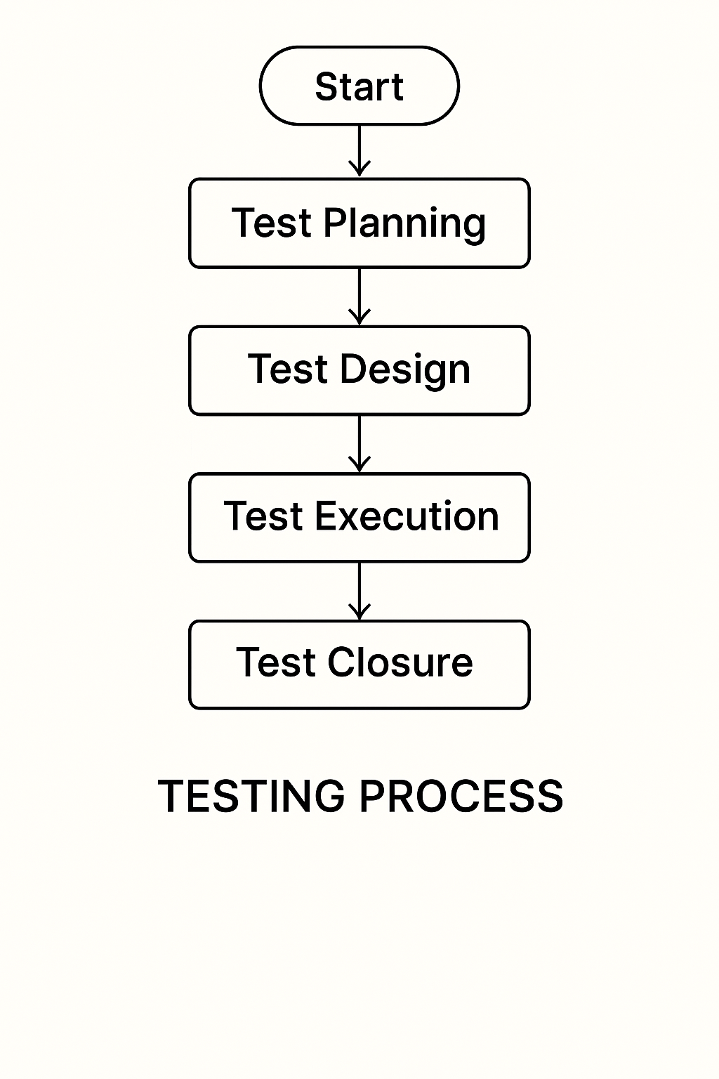

Figure for Testing Process

Test Plan:
The Testing Process: Developer tests the software process activity such as design, implementation and the requirement engineering. Because, design errors are very costly to repair when the system has been started to operate. Therefore, it is quite obvious to repair them at early stage of the system. So, analysis is the most important process of any project.
Requirements Tractability: As most interested portion is whether the system is meeting its requirements or not, for that testing should be planned so that all requirements are individually tested. Developer checked the output of certain combinations of input, which gives desirable results, or not. Strictly stick to our requirements specifications, give you the path to get desirable results from the system.
Tested Items
Our tested items are like:
- Data fetching from the database
- Data insertion, updating and deleting in the database
- Form access to login
Testing Schedule:
Developer has tested each procedure back to back so that errors and omissions can be found as earliest as possible. Once the system has been developed by fully developer tested it on other machines, which differs in configuration.
Testing Methods:
Software testing involves executing an implementation of the software which tests data and examining the outputs of the software and its operational behavior to check that it is performing as required.
Statistical Testing:
Statistical testing is used to test the program’s performance and reliability and to check how it works under operational conditions. Tests are designed to reflect the actual user inputs and their frequency. The stages involved in the static analysis for this system are follows:

Control Flow Analysis:
- Unreachable code
- Unconditional branches into loops
Data Use analysis:
- Variable used before initialization
- Variables declared but never used
- Variables assigned twice but never used between assignments
- Possible array bound violations
- Declared variables
Interface Analysis:
- Parameter type mismatches
- Parameter number mismatches
- Non-usage of the results of function
- Uncalled functions and procedures
Storage Management Faults:
- Data not stored in proper tables
- Data cannot be fetched from proper table
Defect Testing:
Defect testing is intended to find inconsistencies between a program and its specifications. These inconsistencies are usually due to the program faults or defects.
Loop Testing:
The Tester has tested some conditions in a code of application. So, they test the looping in source code of application for finding miss route or any error or wrong direction of flow in code.
Black-Box Testing:
In black box testing or functional testing, the developer is concerned about the output of the module and software, i.e. whether the software gives proper output as per the requirements or not. In another words, this testing aims to test a program behavior against specification without making any reference to the internal structure of the program or the algorithms used.
This can be done in the following way:
- Input Interface
- Processing
- Output Interface.
Whitebox Testing:
It is also called ‘GLASS BOX’ or ‘STRUCTURAL’ testing. Tester has access to system design.
- Simple Loops
- Nested Loops
- Concatenated Loops
- Unstructured Loops
- Continuous Loops
Advantages of White box testing:
- As the knowledge of internal coding structure is prerequisite, it becomes very easy to find out which type of input / data can help in testing the application effectively.
- The other advantage of white box testing is that it helps with optimizing the code.
- It helps in removing the extra lines of code, which can bring in hidden defects.
Structure Testing:
Developer has done his path testing to exercise every independent execution path through a component or program. If every independent path is executed, then all statements in the components must have been executed at least once. The structure of our program is also checked.
Integration Testing:
After our individual modules the Developer tested out Developer go to the integrated to create a complete system. This integration process involves building the system for problems that arise from component interactions. Developer has applied a top-down strategy to validate high-level components of a system before design and implementations have been completed.
Performance Testing:
Performance testing is designed to test the runtime performance of the system within the context of the system. These tests Developer performed as module level as developer as system level. Individual modules developers tested for required performance.
Condition Testing:
Condition testing is a test case design method that exercises the logical conditions contained in a program module. If the condition is incorrect, then as least one part of the condition is incorrect. It may include:
- Boolean variable error
- String index out of Bound error
- Null pointer Assignment
- Input Output Connection Exceptions
- Arithmetic expression error
- Parsing (conversion) errors
- Image unloaded errors
Interface Testing:
Interface testing is an integral part of integration testing. Therefore, the developer checked for the following.
- Interface misuse
- Interface misunderstanding
Developer examined the code to be tested and explicitly list each call to an external component. In the system, standards tests for various modules have been performed, which are follows.
Object Testing:
Object testing is to test objects as individual components, which are often larger than single function. Here the following activities have taken place.
- Testing the individual operations associated with object.
- Testing individual object classes.
- Testing cluster of objects.
- Testing object-oriented systems.
Now we will discuss how testing and debugging is done of this application. Our application can be divided into parts like:
- To make queries to database and retrieve information from it.
- Reduce some memory requirements for the database.
- Maintain database so that unauthorized access can not affect.
Limitations
- It can run only on windows servers. It is not compatible with LINUX servers.
- It is not cent percent safe from professional hackers.
- Only registered user can buy and sell their items using this website.
CONCLUSION
The Customer Churn Prediction System using Artificial Intelligence and Machine Learning is an effective solution for identifying customers who are likely to discontinue a company’s services or products. The system analyzes customer behavior, transaction history, service usage, complaints, and other related data to provide accurate churn predictions. By using advanced Machine Learning algorithms, the project improves prediction accuracy and supports intelligent business decision-making.
This project helps organizations reduce customer loss, improve customer satisfaction, and increase overall profitability through better retention strategies. It also minimizes manual effort and saves time by automating the data analysis and prediction process. The system is scalable, secure, reliable, and capable of handling large amounts of customer data efficiently.
Overall, the project demonstrates the importance of AI and ML technologies in modern business environments. It provides organizations with a smart and proactive approach to customer relationship management and contributes to long-term business growth and success.
- The Customer Churn Prediction System helps organizations identify customers who are likely to leave their services or products.
- The project uses Artificial Intelligence and Machine Learning algorithms to provide accurate and efficient churn predictions.
- The system improves customer retention, reduces financial losses, and increases business profitability.
- Automation of customer analysis reduces manual effort, saves time, and enhances operational efficiency.
- Overall, the project supports better business decision-making and contributes to long-term organizational growth and customer satisfaction.

FUTURE SCOPE OF THE PROJECT

The future scope of the Customer Churn Prediction System using Artificial Intelligence and Machine Learning is very wide and promising. In the future, the system can be enhanced with advanced Deep Learning and Neural Network models to improve prediction accuracy and efficiency. Real-time customer data processing can also be integrated to provide instant churn prediction and faster business decisions.
The project can be expanded by incorporating cloud computing technologies for better scalability, storage, and remote accessibility. Integration with Big Data technologies will help organizations analyze massive customer datasets more effectively. The system can also include personalized recommendation features that suggest suitable retention strategies for different customers.
Future improvements may include chatbot integration for automated customer interaction and support services. Advanced data visualization dashboards and business intelligence tools can also be added for better analysis and reporting. The project may further support multi-platform accessibility through mobile and web applications.
Overall, the future development of this system will help businesses improve customer satisfaction, increase retention rates, reduce revenue loss, and achieve sustainable business growth through intelligent AI-driven solutions.
- Integration of Deep Learning: Future systems can use advanced Deep Learning and Neural Network models for more accurate churn prediction.
- Real-Time Data Processing: The project can be enhanced to analyze real-time customer data for instant prediction and faster decision-making.
- Cloud and Big Data Support: Integration with cloud computing and Big Data technologies can improve scalability and data management.
- Personalized Retention Strategies: The system can provide customized offers and recommendations to retain different types of customers.
- Mobile and Web Application Expansion: Future development can include mobile and web-based platforms for easy access and better user experience.

BIBLIOGRAPHY
Reference Books:
• Introduction to Machine Learning with Python: A Guide for Data Scientists- By Andreas C. Müller & Sarah Guido, Machine Learning- The Complete Reference- with Python Data Science Stack (Wes McKinney, Jake VanderPlas, and Aurelien Geron).
• Hands-On Machine Learning with Scikit-Learn, Keras, and TensorFlow: Concepts, Tools, and Techniques to Build Intelligent Systems- By Aurélien Géron, The Complete Reference- Data Science and Predictive Analytics (Max Kuhn, Kjell Johnson, and Ian H. Witten).
Reference websites:
• www.github.com/scikit-learn
• www.kaggle.com
• www.towardsdatascience.com

