Task3_Vulnerability_Scan/README.md

Task 3: Basic Vulnerability Scan using Nessus

Submitted by:

Name: Srishti Pandey

Tool Used: Nessus Essentials

Scan Date: 26-june-2025

Target: Localhost (127.0.0.1)

Task Objective:

Use Nessus Essentials to scan the local system and identify potential security vulnerabilities. Follow the exact 8 task steps as given.

Task Steps Performed:

Installed Nessus Essentials

- Downloaded and installed from official Tenable website

- Activated with free license

- Opened in browser at `https://localhost:8834`

Set up scan target

- Target was my local machine: `127.0.0.1`

Started a full vulnerability scan

- Chose **Basic Network Scan**

- Named the scan "My PC Scan"

- Launched the scan

Waited for scan to complete

- Total time: approximately **30–60 minutes**

Reviewed the report

- Report showed all vulnerabilities with severity levels

- Exported PDF from Nessus

Researched fixes or mitigations

- Looked up common solutions for top vulnerabilities

- Noted recommendations such as applying system updates and disabling unused services

Documented most critical vulnerabilities

| Vulnerability Title | Severity | Description / Summary |

|--------------------------|----------|------------------------|

| Example Vulnerability 1 | Critic

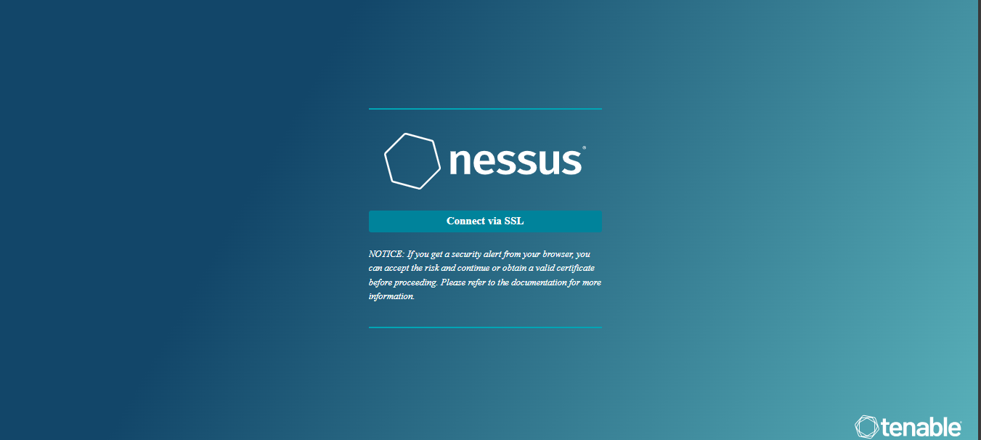

Screenshot_1 – Installation

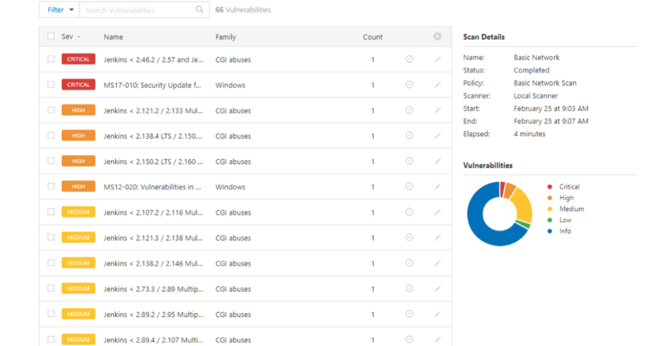

Screenshot_2 – Scan