- Creating directory , renaming director ,creating txt .renaming it .
- 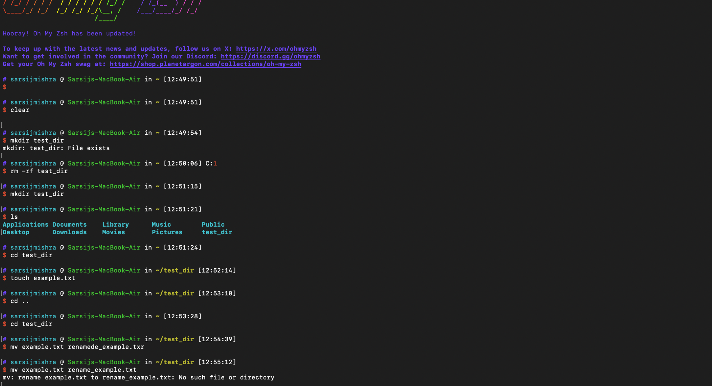

- 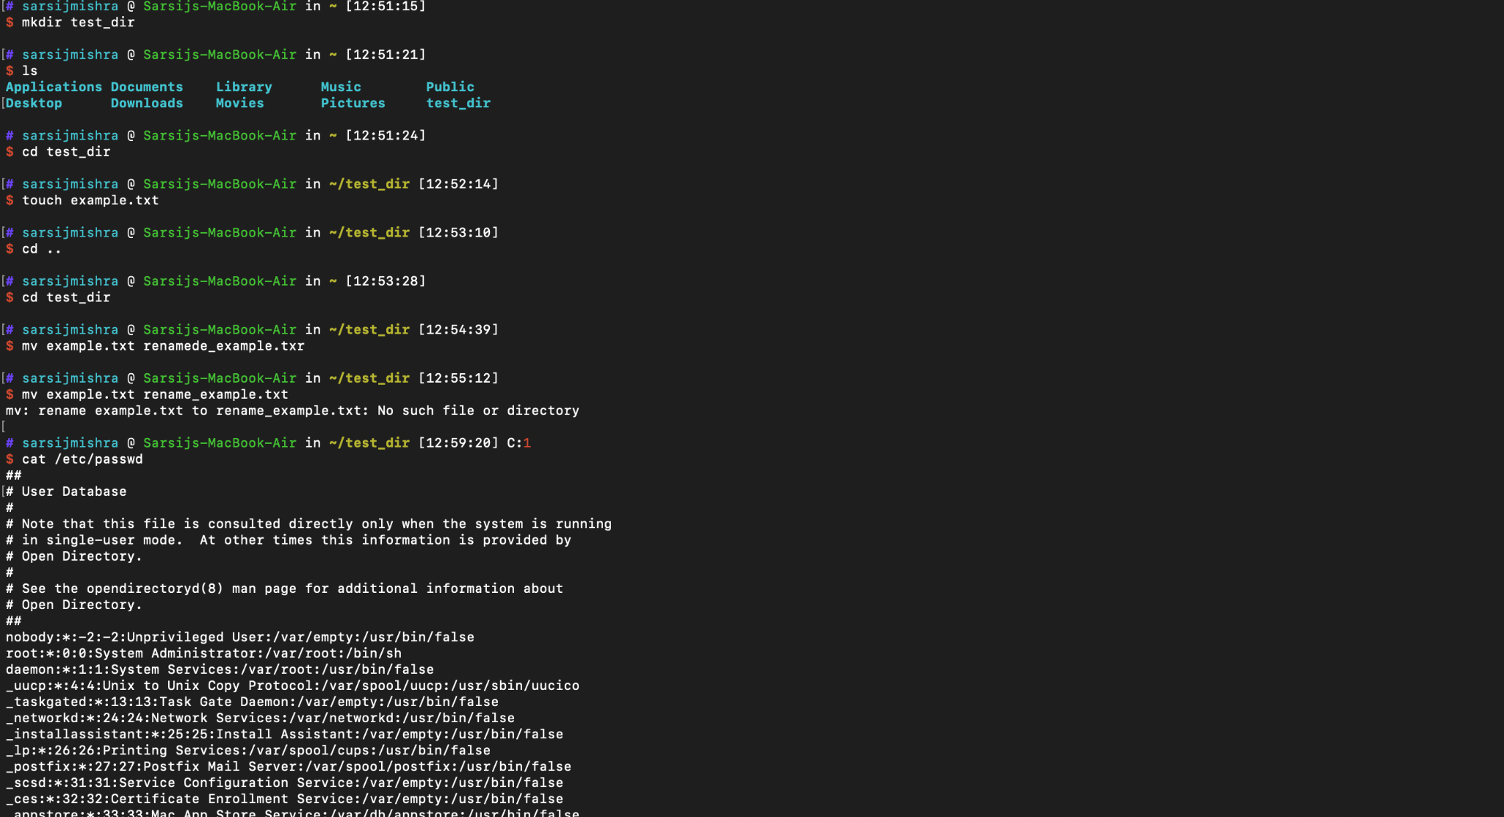
- Displaying all content in /etc/passwd
- 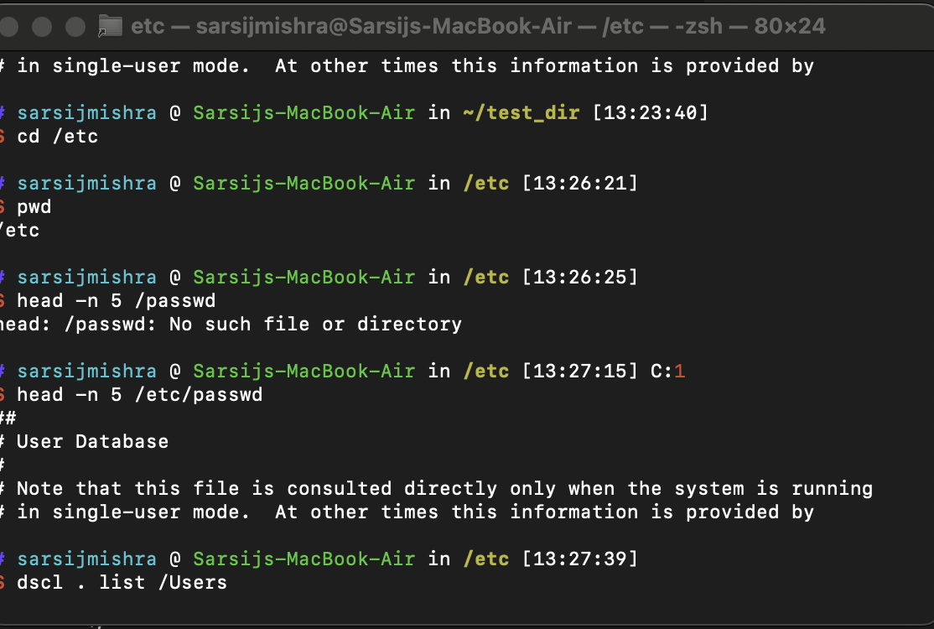
- Using Head commend displaying top 5 lines .in /etc/passwd

- 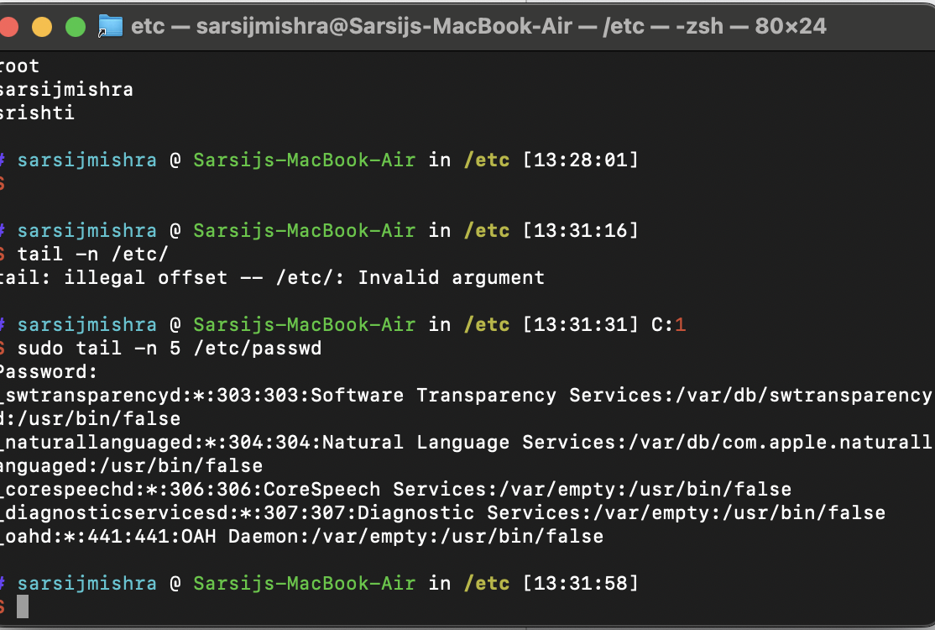
- Grep command filtering root kewyword password
- 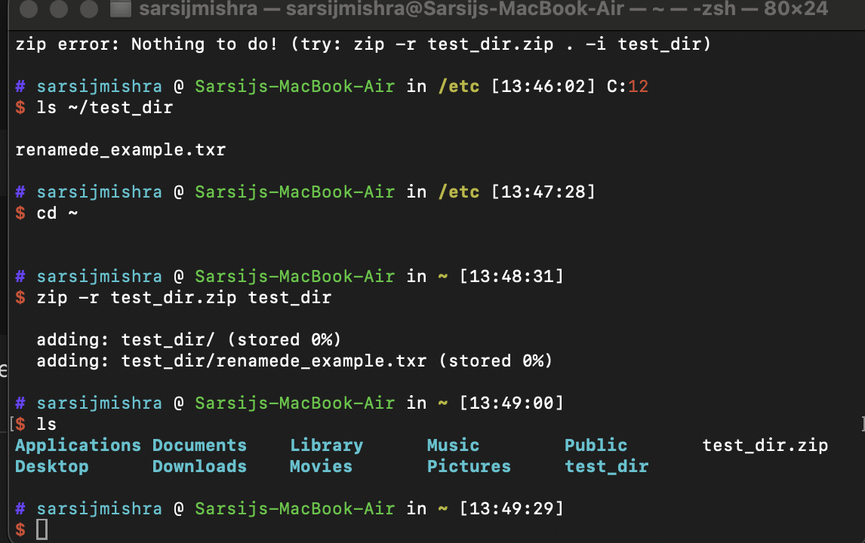
- CREATING ZIP FILE

- unzip ~/test_dir.zip -d ~/unzipped_dir

- 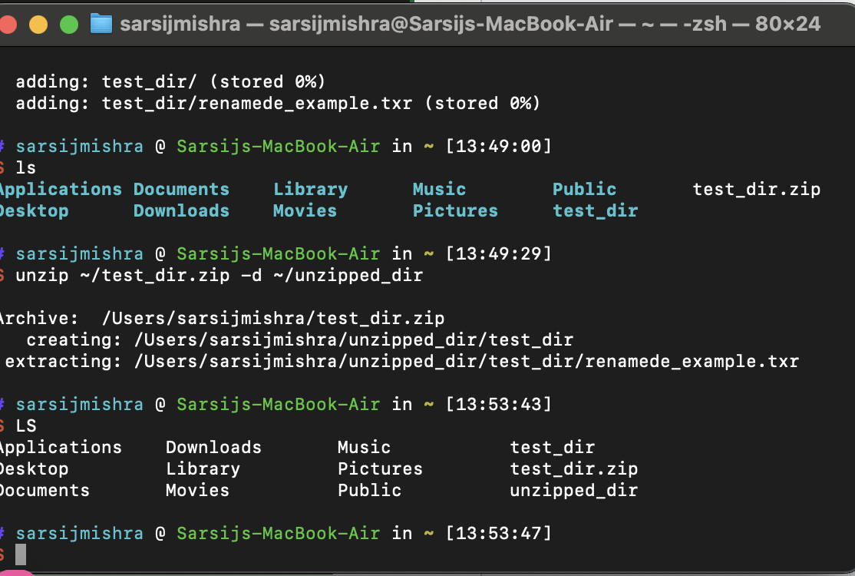
- Unzipped test_dir.zip

- 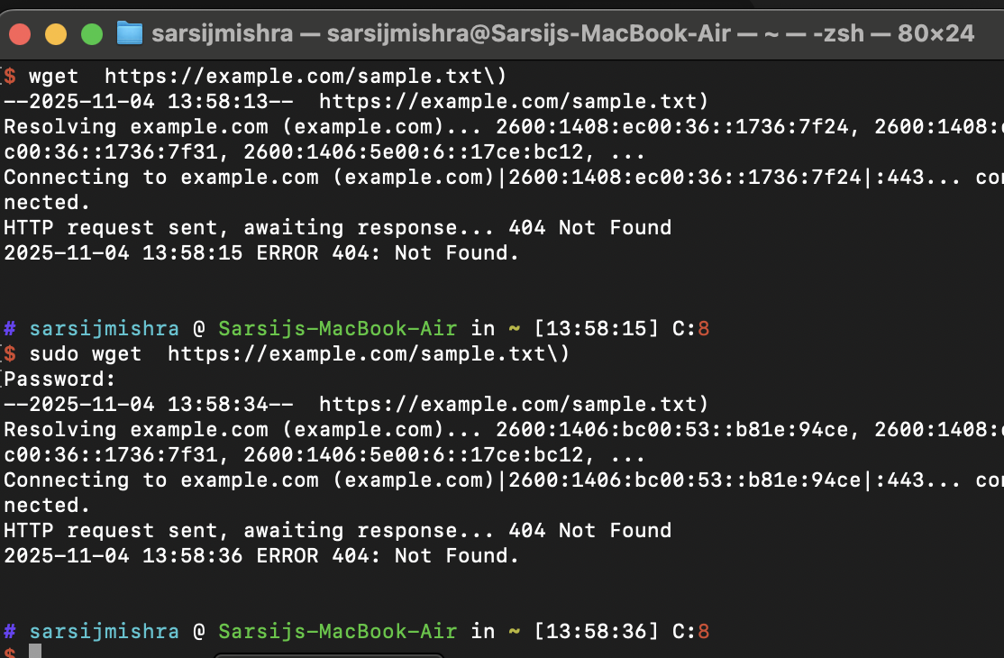
- Wget url( Downloadiing file )
- 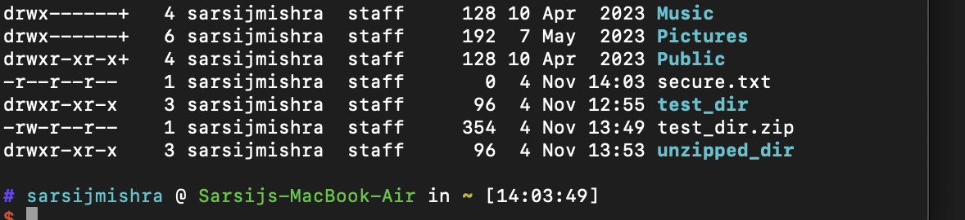

- Permission change secure.txt (read permission )

