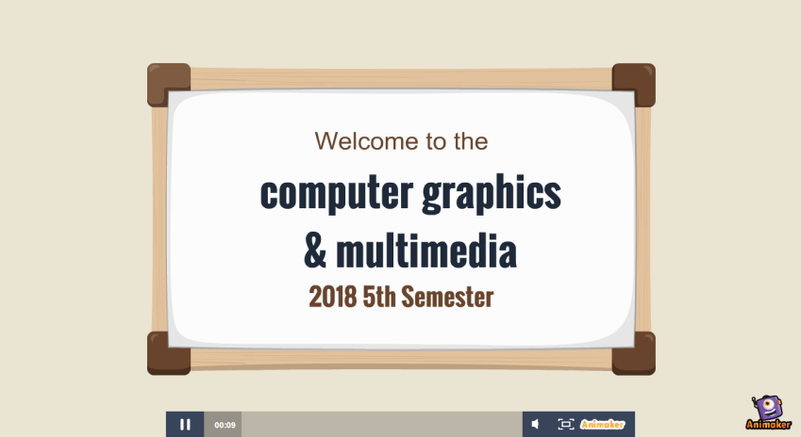









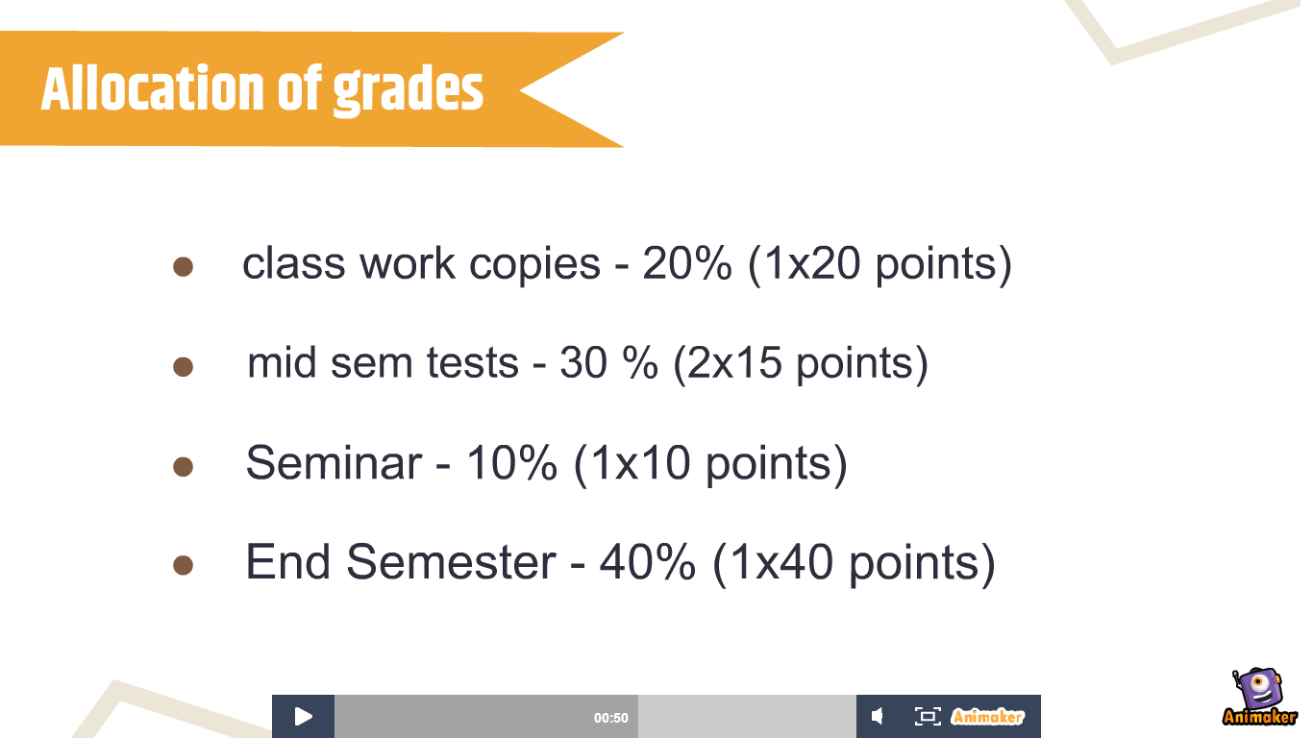









EXPERIMENT-13

ANIMATION

**Animation** is a dynamic medium in which images or objects are manipulated to appear as moving images. In [traditional animation](https://en.wikipedia.org/wiki/Traditional_animation" \o "Traditional animation), images are drawn or painted by hand on transparent [celluloid sheets](https://en.wikipedia.org/wiki/Cel" \o "Cel) to be photographed and exhibited on [film](https://en.wikipedia.org/wiki/Film" \o "Film).

Today most animations are made with [computer-generated imagery](https://en.wikipedia.org/wiki/Computer-generated_imagery" \o "Computer-generated imagery) (CGI). [Computer animation](https://en.wikipedia.org/wiki/Computer_animation" \o "Computer animation) can be very detailed [3D animation](https://en.wikipedia.org/wiki/3D_computer_graphics" \o "3D computer graphics), while [2D computer animation](https://en.wikipedia.org/wiki/2D_computer_graphics" \o "2D computer graphics) can be used for stylistic reasons, low bandwidth or faster real-time renderings. Other common animation methods apply a [stop motion](https://en.wikipedia.org/wiki/Stop_motion" \o "Stop motion) technique to two and three-dimensional objects like [paper cutouts](https://en.wikipedia.org/wiki/Cutout_animation" \o "Cutout animation), [puppets](https://en.wikipedia.org/wiki/Puppet" \o "Puppet) or [clay figures](https://en.wikipedia.org/wiki/Clay_animation" \o "Clay animation). The stop motion technique where live actors are used as a frame-by-frame subject is known as [pixilation](https://en.wikipedia.org/wiki/Pixilation" \o "Pixilation).

Commonly the effect of animation is achieved by a rapid succession of sequential images that minimally differ from each other. The illusion—as in motion pictures in general—is thought to rely on the [phi phenomenon](https://en.wikipedia.org/wiki/Phi_phenomenon" \o "Phi phenomenon) and [beta movement](https://en.wikipedia.org/wiki/Beta_movement" \o "Beta movement), but the exact causes are still uncertain.

[Analog](https://en.wikipedia.org/wiki/Analog_device" \o "Analog device) mechanical animation media that rely on the rapid display of sequential images include the [phénakisticope](https://en.wikipedia.org/wiki/Phenakistiscope" \o "Phenakistiscope), [zoetrope](https://en.wikipedia.org/wiki/Zoetrope" \o "Zoetrope), [flip book](https://en.wikipedia.org/wiki/Flip_book" \o "Flip book), [praxinoscope](https://en.wikipedia.org/wiki/Praxinoscope" \o "Praxinoscope) and film. [Television](https://en.wikipedia.org/wiki/Television" \o "Television) and [video](https://en.wikipedia.org/wiki/Video" \o "Video) are popular electronic animation media that originally were [analog](https://en.wikipedia.org/wiki/Analog_device" \o "Analog device) and now operate [digitally](https://en.wikipedia.org/wiki/Digital_media" \o "Digital media). For display on the computer, techniques like [animated GIF](https://en.wikipedia.org/wiki/Animated_GIF" \o "Animated GIF) and [Flash animation](https://en.wikipedia.org/wiki/Flash_animation" \o "Flash animation) were developed.

Apart from [short films](https://en.wikipedia.org/wiki/Short_films" \o "Short films), [feature films](https://en.wikipedia.org/wiki/Feature_films" \o "Feature films), animated gifs and other media dedicated to the display moving images, animation is also heavily used for [video games](https://en.wikipedia.org/wiki/Video_game" \o "Video game), [motion graphics](https://en.wikipedia.org/wiki/Motion_graphics" \o "Motion graphics) and [special effects](https://en.wikipedia.org/wiki/Special_effect" \o "Special effect).

The physical movement of image parts through simple mechanics in for instance the moving images in [magic lantern](https://en.wikipedia.org/wiki/Magic_lantern" \o "Magic lantern) shows can also be considered animation. Mechanical animation of actual robotic devices is known as [animatronics](https://en.wikipedia.org/wiki/Animatronics" \o "Animatronics).

Techniques

* Traditional animation

#### Full animation

#### Limited animation

#### Live-action/animation

* Stop motion animation