This is docs for client how they can add url/change url on state banner image:

1. First of all go to admin dashboard
2. Click State Banner tab on left (middle) side in dashboard
3. Then go for any post
4. Fill the field (Banner Image url)
5. Click update

Please also see the attachment:

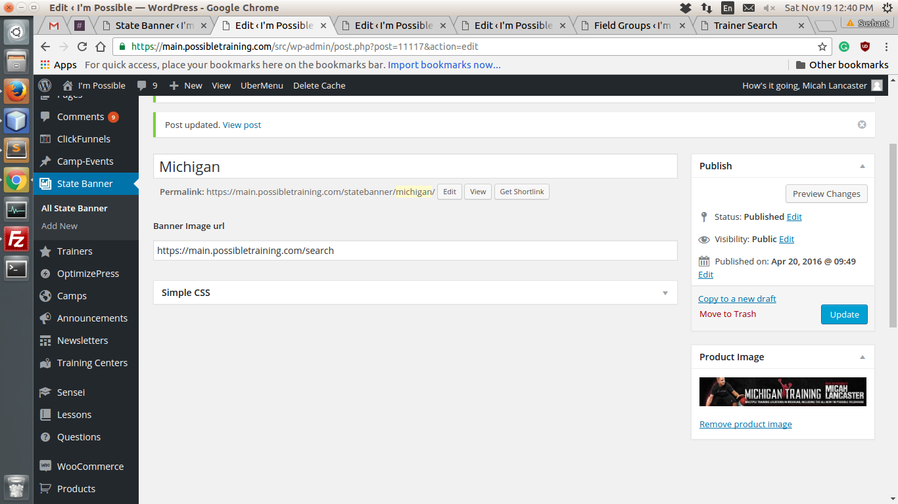

And important thing is for defoult state banner and url we are using state banner and it's url from post Global HQ.

Thanks.....

