FoodLoop
Applied AI portfolio project | Concept note
  - SDG 2 - Zero Hunger | ML benchmark + human-reviewed redistribution workflow

1. Project idea
FoodLoop is a portfolio project with two connected components: an offline machine-learning benchmark that studies EPA modeled food-waste flows by sector, and a browser prototype that helps a donor route a time-sensitive surplus offer to a suitable local recipient. The ML benchmark is an exploratory analysis layer; it does not predict donation acceptance or drive recipient selection. The matching interface applies explicit eligibility constraints and an explainable ranking score, then leaves safety and pickup decisions to a person.

2. Problem and users
Surplus food and unmet local need can exist at the same time, yet coordination often depends on manual calls or messaging. Donors have limited time to find a suitable recipient, while recipient capacity and pickup availability change. The first users are repeat donors at one campus or neighborhood and one trusted food bank, shelter, or community kitchen.

3. Proposed solution and user journey
- Donor enters food category, estimated quantity, preparation/storage details, pickup location, and deadline.
- Hard constraints remove recipients that cannot accept the category, quantity, service area, or pickup window.
- A transparent weighted score ranks the remaining candidates; a donor or coordinator reviews the reasons and contacts the recipient.
- A person confirms food handling and pickup. The prototype does not send messages or claim a donation is complete.

4. AI / ML approach
The offline ML benchmark uses the EPA U.S. Food Waste Flows Between Sectors 2018 method 2 file (8,315 cleaned modeled flow rows). It predicts log1p(FlowAmount in kg) from NAICS producer-sector prefixes and consumed-sector codes using ridge regression. A validation split selects regularization strength; the final test split holds out complete producing-sector codes. The benchmark includes a median-only baseline and reports MAE, RMSE, and R-squared on the log target. The model is trained on EPA modeled sector flows, not measured donations.
Data source: U.S. EPA Office of Research and Development, U.S. Food Waste Flows Between Sectors, 2018 v1.3.2, DOI 10.23719/1529936. The dataset catalog and license details are included in the project repository at data/README.md.
The matching prototype is separate: explicit rules filter candidates and an interpretable weighted score orders those who remain. A future donor-recipient acceptance model would require consented event-level partner data with reliable outcomes, time-aware evaluation, and calibration. No synthetic acceptance labels or probabilities are presented as real evidence.

5. Scope and technology
The demo is a dependency-free HTML/CSS/JavaScript page. The reproducible ML workflow is Python with NumPy and pandas (`analysis/train_model.py`); the checked-in dataset and metrics allow the pipeline to run offline. The dataset files and provenance are under `data/`. The prototype is not a food-safety authority, logistics provider, or automated allocation system.

6. Model benchmark and pilot evaluation
Current grouped-holdout result: 1,642 test rows from producing-sector codes excluded from training. Ridge regression achieved MAE 0.942 and RMSE 1.258 on log1p(kg), compared with 1.980 MAE and 2.425 RMSE for the median baseline; test R-squared was 0.730 versus -0.001. This is one fixed split on modeled 2018 national flows, not evidence of current/local prediction quality. Full run details are in `results/metrics.json`.
Measure | Definition | Pilot target (hypothesis)
Rescued food | Weight or portions in completed handoffs | Track baseline; improve over manual process
Match acceptance | Offers accepted / offers sent | Compare ranking vs coordinator choice
Pickup completion | Completed / accepted offers | Identify operational drop-offs
Time to match | Minutes from offer to confirmed recipient | Reduce median time against manual baseline
Targets are hypotheses, not measured results. Establish a manual baseline with the pilot partner and report counts, dates, and missing data.

7. Risks and safeguards
- Food safety: accept only partner-approved categories and handling conditions; recipient eligibility and safe pickup are confirmed by a human.
- Bad or sparse data: show why a recipient ranked highly, allow manual override, and fall back to coordinator selection.
- Privacy: collect only operational data, restrict access, and set a short retention period for contact details.
- Unequal allocation: monitor which partners receive offers; make ranking criteria visible and allow smaller partners to participate.
- Reliability: offer SMS/phone fallback and never claim a donation is complete until both sides confirm pickup.

8. Pilot plan and next steps
- Week 1: profile EPA data, check sector codes, and document target/source limitations.
- Week 2: reproduce grouped train/validation/test split, tune ridge regularization, and compare with median baseline.
- Week 3: review model errors by sector and build the rule-based offer matching interface.
- Week 4: interview donors/recipients; define a consented event-level data plan before any operational pilot.
Decision gate: continue only if partner interviews confirm the coordination problem, a recipient can accept the proposed categories, and a safe pickup process is agreed.

9. Lean Canvas summary
Problem: edible surplus is hard to route quickly. Solution: apply eligibility rules, rank, review, and confirm. Value: clearer, faster local coordination. Customers: food donors and recipient organizations. Channels: campus kitchens, food banks, NGO networks. Product metrics: rescued quantity, acceptance, completion, and time to match. ML benchmark: grouped generalization across sector codes on EPA modeled flow data. Costs: hosting, partner coordination, safety and privacy review. Revenue hypothesis: grants or institutional sponsorship. Unfair advantage is unproven and depends on trusted local partners and reliable capacity data.
Project team: ____________________ Institution / course: ____________________ Date: ____________________

Prototype screenshot: create an offer
Enter food, quantity, pickup window, and area. Sample records are fictional.
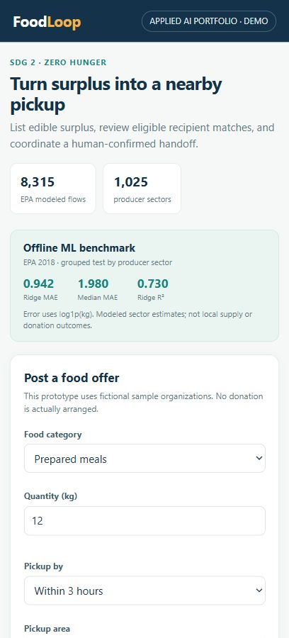

Prototype screenshot: review matches
The demo ranks eligible recipients and explains key factors. A person confirms handling and pickup.
