COMPUTER NETWORKS - PROJECT REPORT
Real-Time Decentralized Collaborative Terminal Canvas over UDP Multicast
A Serverless Peer-to-Peer Group Communication System using IPv4 Multicast and UDP
Submitted by
Srishti Saluja (24BCE2587)
Vidushi Kapoor (24BCE2244)
Item | Detail
Course | Computer Networks
Faculty / guide | [To be completed by the team before submission]
Institution | [To be completed by the team before submission]
Report date | 21 October 2026

Abstract
This report presents the design, implementation and testing of a serverless, peer-to-peer collaborative ASCII drawing application for computers on the same local area network (LAN). Every peer runs identical Python software, keeps its own replica of a 60 x 18 character canvas, and exchanges drawing events as fixed 13-byte binary frames carried in UDP datagrams addressed to the IPv4 multicast group 239.255.0.1 on port 5005. Hosts join the group through the operating system's IGMP membership mechanism, so no central server, broker or authoritative copy of the canvas exists.
The implementation separates five concerns: a binary protocol module, a multicast transport with a background receive thread, a per-sender duplicate-detection and sequence-gap tracker, a canvas state module, and a curses terminal user interface. An automated suite of 155 unit, mocked-socket and local multicast tests passes on the development laptop. In a demonstration with two separate application processes on one laptop, captured with Wireshark on the Wi-Fi interface, the capture shows IGMPv3 membership reports for the group and 79 multicast datagrams whose sizes (UDP length 21 bytes) and payload bytes match the specification exactly.
Communication between two physical laptops has not yet been tested; the report gives the procedure and lists the evidence still required. The limitations of the design (best-effort UDP delivery without loss recovery, possible divergence under concurrent edits, no late-join synchronisation and no authentication) are discussed together with proposed enhancements, which are clearly separated from the implemented system.
Keywords: IPv4 multicast; UDP; IGMP; peer-to-peer; serverless; collaborative editing; binary protocol; socket programming; Python; curses.
Contents
1 Introduction 6
1.1 Background and motivation 6
1.2 Problem statement 6
1.3 Contributions 6
1.4 Organisation of the report 6
2 Objectives and Scope 7
2.1 Objectives 7
2.2 In scope 7
2.3 Out of scope for this version 7
3 Background: UDP, IPv4 Multicast and IGMP 8
3.1 User Datagram Protocol 8
3.2 IPv4 multicast 8
3.3 Internet Group Management Protocol 8
3.4 Unicast, broadcast and multicast 8
3.5 Related systems 9
4 System Architecture 10
4.1 Overview 10
4.2 Why the system is serverless 10
4.3 Sockets used by each peer 11
4.4 Concurrency model 11
4.5 Filtering a peer's own frames 11
5 Packet Format and Message Flow 12
5.1 Frame layout 12
5.2 Message types 12
5.3 Validation 13
5.4 Sizes on the wire 13
5.5 Message flow 13
5.6 Duplicate detection and gap tracking 14
6 Implementation 15
6.1 Modules 15
6.2 protocol.py 15
6.3 network.py 15
6.4 tracker.py 15
6.5 canvas.py 16
6.6 app.py 16
6.7 Configuration 16
6.8 Dependencies 16
7 User Guide 17
7.1 Installation 17
7.2 Choosing the network interface 17
7.3 Running the application 17
7.4 Controls 17
7.5 Screen layout 17
7.6 Troubleshooting 18
8 Testing and Results 19
8.1 Methodology 19
8.2 Automated test results 19
8.3 Selected test cases 19
8.4 Local demonstration: two processes on one laptop 21
8.5 Packet capture on one laptop 22
8.6 Two-laptop test (pending) 23
8.7 Discussion 24
9 Limitations and Future Enhancements 25
9.1 Limitations 25
9.2 Implemented and proposed features 25
9.3 Future enhancements 26
10 Conclusion 27
References 28
Appendix A: Evidence Checklist 29
A.1 Reproducing the automated results 29

List of Figures
Figure 1. System architecture: every peer is both sender and receiver (one laptop tested; two-laptop operation pending) 10
Figure 2. Byte layout of the v1 frame, with a real frame from the capture 12
Figure 3. Implemented message flow for one DRAW event 13
Figure 4. Screenshot of peer A during the local demonstration (one laptop) 21
Figure 5. Screenshot of peer B during the local demonstration (one laptop) 22

List of Tables
Table 1. Comparison of delivery modes for one drawing event sent to N other peers 8
Table 2. Socket configuration of one peer (network.py) 11
Table 3. v1 frame fields (protocol.py) 12
Table 4. Message types 12
Table 5. Size of one frame at each layer 13
Table 6. How the tracker classifies an arriving frame (tracker.py) 14
Table 7. Project modules (non-blank lines counted on 21 October 2026) 15
Table 8. Configuration values (config.py) 16
Table 9. Keyboard controls (app.py) 17
Table 10. Automated tests by module 19
Table 11. Selected test cases 20
Table 12. Results of the local demonstration (21 October 2026) 21
Table 13. Observations from the capture (demo_capture.pcapng) 22
Table 14. Two-laptop test procedure and pass criteria 23
Table 15. Implemented features and proposed enhancements 25
Table 16. Evidence collected and still required 29

1 Introduction

1.1 Background and motivation
Collaborative applications let several users work on a shared workspace in real time. Widely used tools such as Google Docs, Figma and Miro coordinate every edit through central servers: each change travels to a server, which resolves it and relays it to every other client. This architecture is convenient on the Internet, but it introduces a single point of failure, makes the server send one copy of every change per client, and adds connection and encoding overhead that is large compared with a tiny drawing event.
On a single LAN, the network itself can deliver one transmission to many hosts. IPv4 multicast with IGMP group membership lets a sender address a group rather than individual hosts, and UDP carries small, latency-sensitive messages without connection set-up. This project uses these mechanisms to build a collaborative terminal canvas with no application server at all.

1.2 Problem statement
How can multiple users collaboratively draw in real time over a LAN without depending on a central server, while distributing updates efficiently and keeping each user's canvas consistent?

1.3 Contributions
- A compact 13-byte binary application-layer protocol for DRAW and CLEAR events, with strict validation.
- A multicast transport that joins and leaves the group explicitly, pins traffic to a chosen network interface, receives on a background thread, and filters each peer's own looped-back frames.
- Per-sender duplicate detection and sequence-gap tracking that works with the existing frame format.
- A canvas state module and a curses terminal user interface, kept separate so that they can be tested without a terminal.
- An automated test suite (155 tests) and genuine one-laptop evidence: screenshots of two running peers and a Wireshark capture of the traffic.

1.4 Organisation of the report
Section 2 states the objectives and scope. Section 3 summarises UDP, IPv4 multicast and IGMP. Sections 4 and 5 describe the architecture, the packet format and the message flow. Section 6 describes the implementation, and Section 7 is the user guide. Section 8 presents the testing methodology and the actual results, including what remains to be tested. Section 9 covers limitations and future enhancements, and Section 10 concludes.

2 Objectives and Scope

2.1 Objectives
- Build a collaborative ASCII canvas in which every peer is both sender and receiver, with no central application server.
- Use IPv4 multicast (group 239.255.0.1, UDP port 5005) with IGMP group membership as the only communication mechanism.
- Define a compact, custom binary protocol packed with Python's struct module.
- Receive packets on a background thread without blocking the user interface.
- Provide a usable terminal interface with the curses library.
- Verify the behaviour with automated tests and with packet captures in Wireshark.

2.2 In scope
- Drawing single characters in eight colours, erasing, and clearing the whole canvas for all peers.
- Peers on the same subnet (multicast TTL 1), on Windows, Linux or macOS with Python 3.10 or later.
- Detection of duplicate frames and of gaps in each sender's sequence numbers.

2.3 Out of scope for this version
- Recovery of lost events, late-join synchronisation of the existing canvas, and deterministic conflict resolution. These are designed in the project roadmap but not implemented (Section 9).
- Authentication and encryption; the system assumes a trusted LAN.
- Operation across routers (TTL greater than 1).

3 Background: UDP, IPv4 Multicast and IGMP

3.1 User Datagram Protocol
UDP [1] is a connectionless transport protocol. Each datagram carries an 8-byte header with source port, destination port, length and checksum, and is delivered independently: there is no connection set-up, acknowledgement, retransmission or ordering. Datagrams may therefore be lost, duplicated or reordered, and the application must tolerate this. In return, UDP adds very little overhead and has no head-of-line blocking, which suits small, frequent drawing events. UDP is also the transport normally used with IP multicast, because TCP is defined only between two endpoints.

3.2 IPv4 multicast
IPv4 multicast [3] uses the Class D address range 224.0.0.0/4. A datagram sent to a group address is delivered to every host that has joined the group, so one transmission reaches all members. The range 239.0.0.0/8 is administratively scoped [6]; 239.255.0.0/16 is the IPv4 Local Scope, intended for use within a site, which makes 239.255.0.1 an appropriate group for a LAN application. On Ethernet and Wi-Fi, an IPv4 multicast address maps to a MAC address formed from the prefix 01:00:5E and the low 23 bits of the group address [3]; 239.255.0.1 therefore maps to 01:00:5E:7F:00:01, which is exactly the destination MAC observed in the capture in Section 8.5. The project sets the multicast TTL to 1, so datagrams never leave the local subnet.

3.3 Internet Group Management Protocol
IGMP lets hosts tell multicast routers, and IGMP-snooping switches [8], which groups they want to receive. When an application calls setsockopt(IP_ADD_MEMBERSHIP), the operating system sends an IGMP Membership Report for the group; IP_DROP_MEMBERSHIP or closing the socket leads to a report that the host has left. IGMPv2 [4] and IGMPv3 [5] are in use today; IGMPv3 reports are sent to 224.0.0.22 with TTL 1 and the IP Router Alert option, and a host retransmits a state-change report to improve robustness. Membership is maintained per host and interface, not per socket. IGMP carries only membership information; it never carries application data.

3.4 Unicast, broadcast and multicast
Table 1. Comparison of delivery modes for one drawing event sent to N other peers
Mode | Transmissions per event | Who receives it | Suitability
Unicast | N (one per peer) | Only the addressed peer | Sender cost grows with group size
Broadcast | 1 | Every host on the subnet, interested or not | Disturbs uninterested hosts
Multicast | 1 | Only hosts that joined the group (IGMP) | Chosen for this project

3.5 Related systems
Google Docs, Figma, Miro, Etherpad, Excalidraw and tldraw all synchronise collaborators through application-level servers or relays. The aim of this project is not to replace them but to demonstrate a different networking architecture for LAN collaboration, built directly on network-layer group communication.

4 System Architecture

4.1 Overview
Figure 1 shows the architecture. Each laptop runs the same program, organised in four layers: the terminal user interface (app.py), the local canvas replica (canvas.py), the multicast transport (network.py with tracker.py) and the binary protocol (protocol.py). All peers exchange events through the multicast group; there is no other path between them.
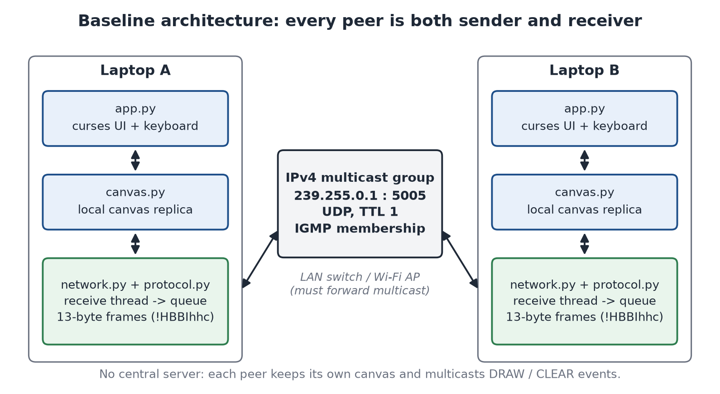
Figure 1. System architecture: every peer is both sender and receiver (one laptop tested; two-laptop operation pending)

4.2 Why the system is serverless
- Every peer runs identical code and holds a complete replica of the canvas; no peer is special.
- A drawing event is multicast once by its author and applied independently by every receiver; nothing is relayed through another peer.
- Group membership is handled by the operating system and the network (IGMP), not by an application server.
- Any peer can start or stop at any time without affecting the others.
The system still depends on network infrastructure: the switch or Wi-Fi access point must forward multicast between hosts. That is network equipment, not an application server, but it is a real deployment risk (Section 7.6).

4.3 Sockets used by each peer
Table 2. Socket configuration of one peer (network.py)
Socket | Configuration | Purpose
Receive socket | SO_REUSEADDR (and SO_REUSEPORT where available)  bind to ('', 5005)  IP_ADD_MEMBERSHIP(239.255.0.1, interface)  IP_MULTICAST_LOOP = 1, receive timeout 0.2 s | Joins the group and receives all frames; several peers can share port 5005 on one host
Send socket | IP_MULTICAST_TTL = 1, IP_MULTICAST_LOOP = 1  IP_MULTICAST_IF and bind to the interface address (when one is configured)  connect() to 239.255.0.1:5005 (ephemeral source port) | Sends frames on the chosen interface; its (ip, port) identifies this peer's frames

On shutdown the receive socket sends IP_DROP_MEMBERSHIP before both sockets are closed.

4.4 Concurrency model
Each peer has two threads. The receive thread blocks in recvfrom() for at most 0.2 s at a time, decodes each datagram, consults the duplicate tracker and puts accepted events on a thread-safe queue.Queue. The main thread owns the canvas and the curses screen: it drains up to 500 queued events per iteration, redraws only when something changed, and waits at most 50 ms for a key. Remote drawing therefore appears promptly even when the local user is idle, and curses is never called from two threads.

4.5 Filtering a peer's own frames
Multicast loopback is enabled so that several peers can run on one machine. The operating system therefore also delivers each peer's own frames back to it. The v1 frame has no sender identifier, so each peer drops received frames whose source address equals the local address of its own connected send socket. Because every peer has its own send socket with a distinct ephemeral port, this identifies its own frames exactly, even when several peers share one IP address.

5 Packet Format and Message Flow

5.1 Frame layout
Every datagram carries exactly one 13-byte frame, packed big-endian with the struct format !HBBIhhc (Table 3, Figure 2). The project presentation described the frame as 12 bytes, but its own field list (2 + 1 + 1 + 4 + 2 + 2 + 1) and struct format both total 13 bytes; all fields were kept, so the frame is 13 bytes.
Table 3. v1 frame fields (protocol.py)
Offset | Size | Field | struct | Meaning and valid range
0 | 2 | Magic | H | 0xCA55; identifies frames of this application (not authentication)
2 | 1 | Type | B | Message type (Table 4)
3 | 1 | Color | B | Terminal colour index 0-255 (the UI uses 0-7)
4 | 4 | Sequence | I | Per-sender counter from 0, wraps after 2^32 - 1
8 | 2 | X | h | Column, 0-32767 (negative values rejected)
10 | 2 | Y | h | Row, 0-32767 (negative values rejected)
12 | 1 | Char | c | Printable ASCII 0x20-0x7E; CLEAR uses 0x00

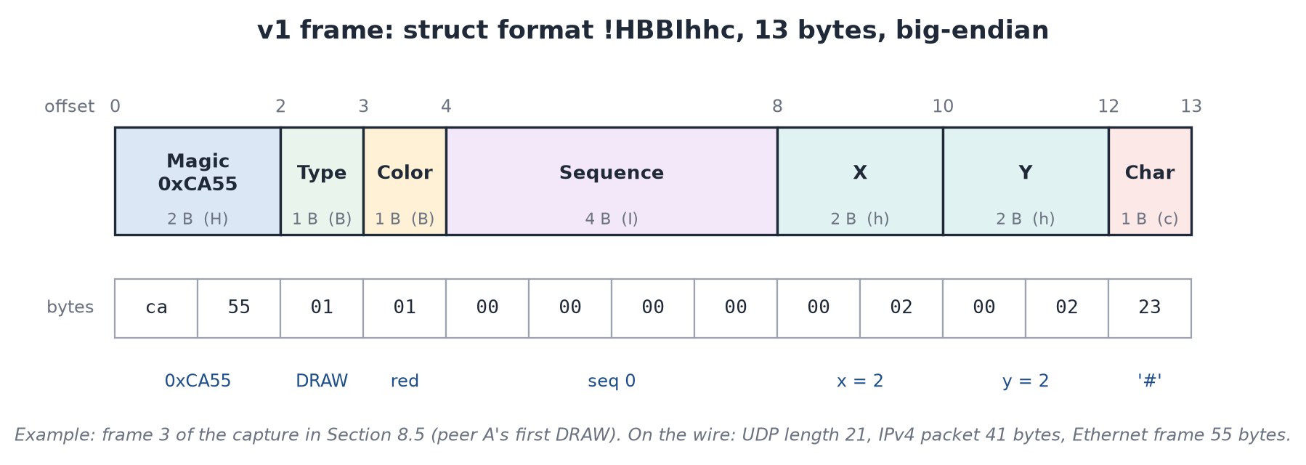
Figure 2. Byte layout of the v1 frame, with a real frame from the capture

5.2 Message types
Table 4. Message types
Code | Type | Status | Fields used
1 | DRAW | Implemented | Color, Sequence, X, Y, Char
2 | CLEAR | Implemented | Sequence; Color, X and Y are 0 and Char is 0x00
3 | STATE_REQ | Proposed - not implemented | Reserved; rejected by encoder and decoder
4 | STATE_RESP | Proposed - not implemented | Reserved; rejected by encoder and decoder

5.3 Validation
decode_event() raises ProtocolError and the receiver drops and counts the datagram if any of the following hold: its size is not exactly 13 bytes; the magic is not 0xCA55; the type is unknown or reserved; X or Y is negative; the character is not printable ASCII; or a CLEAR frame has non-zero fields. The receive buffer is 65,535 bytes, so even an oversized datagram is read whole and rejected rather than raising an error. encode_event() applies the same rules before anything is sent.

5.4 Sizes on the wire
Table 5. Size of one frame at each layer
Layer | Size | Composition
Application frame | 13 bytes | !HBBIhhc
UDP datagram | 21 bytes | 8-byte UDP header + 13-byte frame (UDP length field = 21)
IPv4 packet | 41 bytes | 20-byte IPv4 header + 21
Ethernet frame | 55 bytes | 14-byte Ethernet header + 41 (as captured, without FCS)

All four sizes were confirmed in the Wireshark capture described in Section 8.5.

5.5 Message flow
Figure 3 follows one DRAW event through the implemented system. The author's canvas is updated immediately, exactly once; the event is then encoded and multicast as one datagram. Each receiving peer decodes it on its receive thread, passes it through the duplicate tracker, and hands it to its main thread through a queue, which applies it to the local canvas within one 50 ms input cycle.
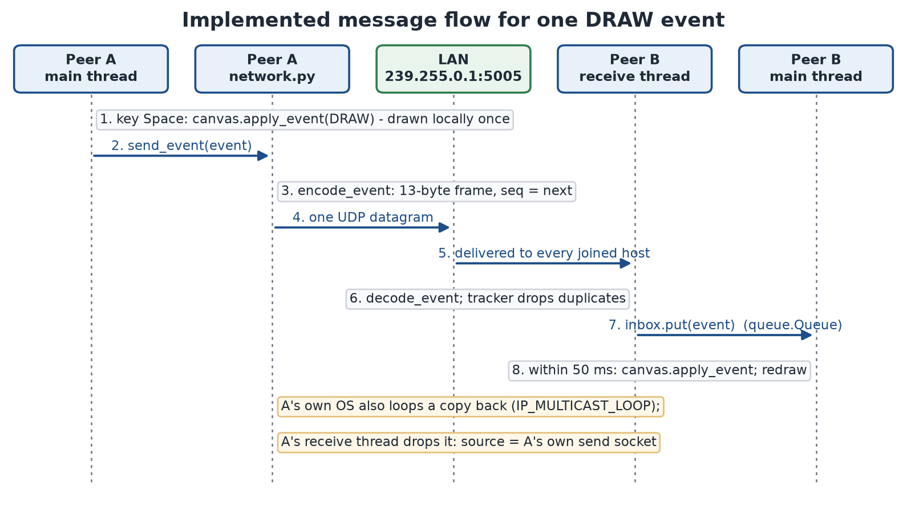
Figure 3. Implemented message flow for one DRAW event

5.6 Duplicate detection and gap tracking
Every peer numbers its own events from 0, so a sequence number is only meaningful per sender. Because the v1 frame has no sender identifier, tracker.py treats each source (ip, port) as one sender; each application session has its own send socket, and on the development laptop Windows allocated successive ephemeral ports (60177, 60178, ...), so a restarted peer appears as a new sender. Sequence numbers are compared with serial-number arithmetic [7], which handles wraparound from 2^32 - 1 to 0. The packet format is unchanged, so this needs nothing new from other peers.
Table 6. How the tracker classifies an arriving frame (tracker.py)
Arriving frame | Verdict | Effect
First frame from a sender, or newer than any seen | NEW | Delivered; skipped numbers are counted as a gap and remembered (up to 1,024 per sender)
A remembered missing number | LATE | Delivered; the gap is partly closed
Any other number that is not newer, while the sender is active (silent for less than 2 s): one already received, or a gap older than the 1,024 remembered | DUPLICATE | Dropped and counted; prevents a duplicated old CLEAR from erasing newer drawing
Not newer and not missing (a repeat or an older number), after 2 s or more of silence from that sender | NEW (restart) | Delivered as a restarted sender that reused its port; that sender's remembered gaps are forgotten

At most 256 senders are tracked; the least recently heard is evicted first. The status line shows Miss (skipped numbers that have not arrived) and Dup (duplicates dropped). The tracker detects loss but does not recover it.

6 Implementation

6.1 Modules
Table 7. Project modules (non-blank lines counted on 21 October 2026)
Module | Lines | Responsibility
config.py | 23 | Group, port, TTL, loopback, interface address, buffer and timeout values, canvas size
protocol.py | 113 | 13-byte frame: encode_event(), decode_event(), validation, ProtocolError
network.py | 266 | Sockets, group join/leave, receive thread, own-frame filtering, start_network() / send_event() / stop_network()
tracker.py | 143 | Per-sender duplicate detection and sequence-gap tracking
canvas.py | 78 | Canvas state: character and colour grid, DRAW/CLEAR application, validation
app.py | 338 | curses user interface, key handling, main loop, start-up and clean shutdown

6.2 protocol.py
Events are plain dictionaries, so the canvas and interface need no protocol classes: {"type": "DRAW", "seq": 7, "x": 20, "y": 10, "char": "#", "color": 2} or {"type": "CLEAR", "seq": 8}. encode_event(event) returns a 13-byte frame and ignores extra keys; decode_event(frame) returns such a dictionary. Both raise ProtocolError, a subclass of ValueError, for invalid input.

6.3 network.py
MulticastPeer creates the two sockets of Table 2, runs the receive thread and assigns sequence numbers. The module-level API used by the application is:
start_network(on_event, **options) -> MulticastPeer # join the group, start receiving
send_event(event) -> int # multicast; returns the sequence number
stop_network() -> None # leave the group, close sockets; idempotent

- send_event() validates the event before using a sequence number, so an invalid event leaves no gap.
- The receive loop ignores timeouts and ConnectionResetError, counts oversized datagrams as dropped, and stops with a logged error only on an unexpected socket failure; the application then shows a warning.
- An exception raised by the on_event callback is logged and does not stop the receive thread.
- If socket set-up fails, nothing is left open, and start_network() raises OSError with the reason.

6.4 tracker.py
SequenceTracker.observe(sender, seq) returns NEW, LATE or DUPLICATE as described in Section 5.6. It is protected by a lock because it is updated on the receive thread and read by the interface; totals() returns the counters shown in the status line.

6.5 canvas.py
Canvas holds a 60 x 18 grid of characters and colour indices. apply_event() applies DRAW and CLEAR; a DRAW outside the canvas is ignored, and a malformed event raises CanvasError. All peers must use the same canvas size, which is set in config.py and is independent of the terminal size.

6.6 app.py
CanvasApp holds the application state and handles keys without any curses dependency, so it can be tested directly. CursesView is the only class that calls curses: it renders the bordered canvas, header and status lines, maps colours 1-7 to curses colour pairs, and translates key codes. main() checks that curses is available, starts the network, runs the loop inside curses.wrapper (which restores the terminal on exit or error), treats Ctrl+C as a normal exit, and always calls stop_network(). Warnings are written to terminal_canvas.log, because console output would corrupt the curses screen.

6.7 Configuration
Table 8. Configuration values (config.py)
Constant | Value | Meaning
MULTICAST_GROUP | 239.255.0.1 | IPv4 Local Scope group
MULTICAST_PORT | 5005 | UDP port
MULTICAST_TTL | 1 | Datagrams stay on the local subnet
MULTICAST_LOOPBACK | True | Allows several peers on one host
INTERFACE_ADDRESS | 172.17.83.158 | Development laptop's Wi-Fi address; each laptop must use its own (or pass --interface)
RECV_BUFFER_SIZE | 65535 | Fits any IPv4 UDP payload
SOCKET_TIMEOUT | 0.2 s | Receive thread checks for shutdown at this interval
CANVAS_WIDTH x CANVAS_HEIGHT | 60 x 18 | Shared canvas size

6.8 Dependencies
The project needs Python 3.10 or later. The protocol, network, tracker and canvas modules and the whole test suite use only the standard library (socket, struct, threading, queue, unittest). The user interface needs curses, which Python on Windows does not include; requirements.txt therefore installs windows-curses on Windows only.

7 User Guide

7.1 Installation
cd terminal-canvas
python -m pip install -r requirements.txt # installs windows-curses on Windows

7.2 Choosing the network interface
Run ipconfig and note the IPv4 address of the adapter connected to the shared network (normally Wi-Fi). The address changes when the laptop reconnects, so check it before every session. If the default 0.0.0.0 is used, the operating system chooses the interface; on the development laptop it chose a VirtualBox host-only adapter, so the address should always be given explicitly.

7.3 Running the application
python app.py # uses INTERFACE_ADDRESS from config.py
python app.py --interface 192.168.1.23 # this laptop's current IPv4 address

The terminal must be at least 62 columns by 23 rows; a smaller terminal shows a message instead of the canvas. To try the system on one computer, run the command in two terminals.

7.4 Controls
Table 9. Keyboard controls (app.py)
Key | Action
Arrow keys | Move the cursor
Space | Draw the brush character at the cursor
p | Toggle pen mode (draws while moving)
e | Erase the cell (draws a space)
b, then a character | Choose the brush character (Esc cancels)
0-7 | Colour: default, red, green, yellow, blue, magenta, cyan, white
X (Shift+x) | Clear the canvas for all peers
q or Ctrl+C | Quit

7.5 Screen layout
- Top line: the group, the interface, and the address this peer sends from.
- The bordered 60 x 18 canvas, with the cursor at the drawing position.
- Status line: brush, colour, pen state, cursor position, Sent and Recv counts, and the tracker's Miss and Dup counts.
- Help line, replaced by messages such as send failures.

7.6 Troubleshooting
- "Could not join ... on interface" at start-up: the address is not this laptop's current address; run ipconfig again.
- "curses is not available": run python -m pip install -r requirements.txt.
- Nothing arrives from the other laptop: the network may isolate clients or filter multicast (common on campus Wi-Fi); try a phone hotspot or home router, or connect both laptops to one Ethernet switch.
- Traffic in one direction only: check Windows Firewall on the receiving laptop. On this laptop the Wi-Fi network was classified as Public; Python must be allowed on that profile, or the network set to Private.
- The app freezes in a classic console window: clicking inside a classic console (title starts with "Select") enters text-selection mode, which pauses program output. Press Esc. This happened once during the local demonstration (Section 8.4). Windows Terminal does not pause programs this way.

8 Testing and Results

8.1 Methodology
Testing was carried out on the development laptop (Windows 11 Home Single Language, build 26200; Python 3.14.3; windows-curses 2.4.2 for interactive runs; Wireshark/TShark 4.6.9). Four kinds of evidence are distinguished, and only the first three have been obtained:
- Automated tests (unittest): pure unit tests, tests with mocked sockets and a fake curses module, and local multicast tests that send real datagrams on this laptop.
- Local demonstration: two separate application processes on one laptop, each in its own console window.
- Packet capture on one laptop: Wireshark capture on the Wi-Fi interface during the local demonstration.
- Two-laptop test: not yet performed (Section 8.6).

8.2 Automated test results
Command: python -m compileall -q . (exit status 0) followed by python -m unittest discover -s tests -v. Result on 21 October 2026: 155 tests run, all passed, none skipped; five further consecutive runs also passed.
Table 10. Automated tests by module
Test module | Tests | Kind of test | Result
tests/test_protocol.py | 25 | Unit: byte layouts, round trips, boundaries, rejection of malformed frames | Pass
tests/test_network.py | 52 | Unit, mocked sockets, and local multicast (real datagrams on this laptop) | Pass
tests/test_tracker.py | 19 | Unit: ordering, duplicates, gaps, wraparound, restarts, bounds, thread safety | Pass
tests/test_canvas.py | 19 | Unit: initial state, bounds, drawing, clearing, invalid events | Pass
tests/test_app.py | 40 | Unit, fake curses, start-up and shutdown, two app instances over local multicast | Pass
Total | 155 | 0 failures, 0 errors, 0 skipped | Pass

8.3 Selected test cases
Table 11 lists representative test cases from the suite; each name is the actual test method, and each passed in the run above.
Table 11. Selected test cases
ID | Test | What it verifies | Result
T1 | test_frame_is_13_bytes | struct format !HBBIhhc is 13 bytes | Pass
T2 | test_draw_exact_bytes | A DRAW encodes to the exact expected bytes | Pass
T3 | test_rejects_bad_magic / test_rejects_wrong_sizes | Foreign or truncated datagrams are rejected | Pass
T4 | test_rejects_reserved_types | STATE_REQ / STATE_RESP are rejected (not implemented) | Pass
T5 | test_receive_socket_binds_and_joins_group | bind to port 5005 and IP_ADD_MEMBERSHIP with the right group and interface | Pass
T6 | test_stop_leaves_group_and_closes_sockets | IP_DROP_MEMBERSHIP is sent and both sockets close | Pass
T7 | test_outgoing_interface_selection | Outgoing traffic is pinned to the configured interface | Pass
T8 | test_events_reach_other_peer | Real multicast delivery between two peers on one laptop | Pass
T9 | test_ignores_own_frames | A peer's own looped-back frames are dropped | Pass
T10 | test_oversized_datagram_does_not_stop_receiver | A 3,000-byte datagram is dropped; receiving continues | Pass
T11 | test_senders_are_independent | Two senders may both use sequence 0 without being duplicates | Pass
T12 | test_duplicate_clear_cannot_replay | A duplicated old CLEAR is dropped | Pass
T13 | test_resent_frame_is_dropped_as_duplicate | A frame re-sent from the same socket over real multicast is dropped | Pass
T14 | test_wrap_from_max_to_zero_is_in_order | 2^32 - 1 followed by 0 is not a gap | Pass
T15 | test_space_applies_locally_once_and_sends_once | Local drawing is applied and sent exactly once | Pass
T16 | test_remote_events_drawn_while_user_is_idle | Remote events appear without key presses | Pass
T17 | test_drawing_appears_on_the_other_canvas_exactly_once | Two app instances over real multicast | Pass
T18 | test_ctrl_c_exits_cleanly_and_stops_network | Ctrl+C exits cleanly and leaves the group | Pass
T19 | test_small_terminal_shows_message_instead_of_canvas | A too-small terminal is handled | Pass

8.4 Local demonstration: two processes on one laptop
Two separate app.py processes (peer A and peer B) were started on the development laptop, each in its own console window, both using the Wi-Fi interface 172.17.83.158. A small test harness injected key presses on a schedule: peer A drew a red line of '#' and a yellow line of '='; peer B drew a green column of '*' and a cyan row of 'o'. The harness only supplied keys; rendering, canvas, network and tracker code were the unmodified application.
Table 12. Results of the local demonstration (21 October 2026)
Observation | Peer A | Peer B
Source address | 172.17.83.158:52705 | 172.17.83.158:52706
Events sent (status line) | 50 | 29
Events received (status line) | 27 at the time of the screenshot (B was still drawing) | 50 (final)
Miss / Dup | 0 / 0 | 0 / 0
Both peers' drawings on the canvas | Yes (Figure 4) | Yes (Figure 5)
Clean exit | Left the group (IGMP Leave captured), then froze while printing its exit message because its console was in text-selection mode (Section 7.6) | Yes, exit code 0

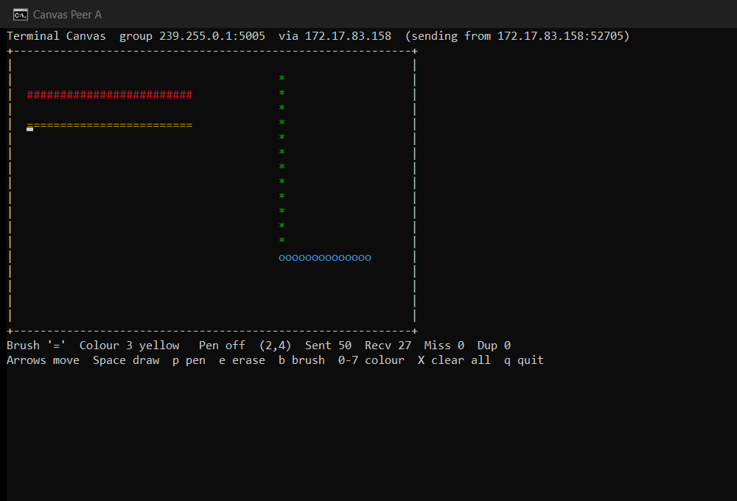
Figure 4. Screenshot of peer A during the local demonstration (one laptop)
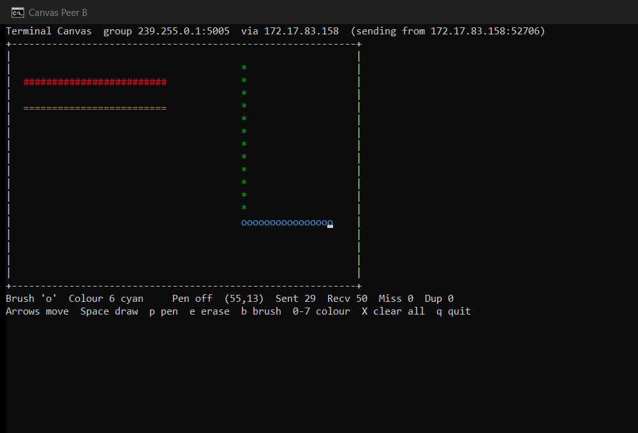
Figure 5. Screenshot of peer B during the local demonstration (one laptop)
Both screenshots were taken from the running console windows. They show the same canvas content on both peers, including each other's drawing, and the expected status lines.

8.5 Packet capture on one laptop
TShark 4.6.9 captured the Wi-Fi interface during the demonstration with the capture filter igmp or udp port 5005. The display filter ip.dst == 239.255.0.1 || igmp matches all 83 captured frames.
Table 13. Observations from the capture (demo_capture.pcapng)
Observation | Value | Status
IGMPv3 Membership Reports joining 239.255.0.1 (to 224.0.0.22, TTL 1, Router Alert) | 2 (at start) | Observed (one laptop)
IGMPv3 Membership Reports leaving 239.255.0.1 | 2 (at exit) | Observed (one laptop)
UDP datagrams to 239.255.0.1:5005 from port 52705 (peer A) | 50 (= peer A Sent) | Observed (one laptop)
UDP datagrams to 239.255.0.1:5005 from port 52706 (peer B) | 29 (= peer B Sent) | Observed (one laptop)
UDP length / IPv4 length / frame length / TTL of every datagram | 21 / 41 / 55 / 1 | Observed (one laptop)
Destination MAC of the datagrams | 01:00:5e:7f:00:01 | Observed (one laptop)

Two reports appear for each join and leave because membership is per host, not per socket, and IGMPv3 retransmits state-change reports (Section 3.3). The packet list and the hex dump of frame 3 (peer A's first DRAW) are reproduced verbatim below; frame 3's payload decodes as magic 0xCA55, DRAW, colour 1, sequence 0, x 2, y 2, '#', matching Figure 2.
1 0.000000000 172.17.83.158 -> 224.0.0.22 IGMPv3 54 Membership Report / Join group 239.255.0.1 for any sources
2 0.030573700 172.17.83.158 -> 224.0.0.22 IGMPv3 54 Membership Report / Join group 239.255.0.1 for any sources
3 2.280557100 172.17.83.158 -> 239.255.0.1 UDP 55 52705 -> 5005 Len=13
4 2.349617900 172.17.83.158 -> 239.255.0.1 UDP 55 52705 -> 5005 Len=13
...
82 14.056209200 172.17.83.158 -> 224.0.0.22 IGMPv3 54 Membership Report / Leave group 239.255.0.1
83 14.534682900 172.17.83.158 -> 224.0.0.22 IGMPv3 54 Membership Report / Leave group 239.255.0.1

Frame 3:
0000 01 00 5e 7f 00 01 60 ff 9e 80 dd cc 08 00 45 00 ..^...`.......E.
0010 00 29 5b 59 00 00 01 11 6e bb ac 11 53 9e ef ff .)[Y....n...S...
0020 00 01 cd e1 13 8d 00 15 40 4a ca 55 01 01 00 00 ........@J.U....
0030 00 00 00 02 00 02 23 ......#

Scope of this evidence. The capture shows this laptop transmitting correctly formed IGMP and multicast frames on its Wi-Fi interface. It does not show that the access point forwards them or that another laptop receives them; that is what the two-laptop test must establish.

8.6 Two-laptop test (pending)
Status: pending. The test between two physical laptops has not been performed. No result is claimed. The procedure and pass criteria below define the test.

Table 14. Two-laptop test procedure and pass criteria
Step | Action | Pass criterion
1 | Copy the project to both laptops; run python -m pip install -r requirements.txt on each | Install succeeds
2 | Connect both laptops to the same network, preferably one that allows client-to-client traffic | Both have IPv4 addresses in the same subnet
3 | Run ipconfig on each; disable VPN clients | Each laptop's Wi-Fi address noted
4 | On laptop B start Wireshark on Wi-Fi with display filter ip.dst == 239.255.0.1 || igmp | Capture running
5 | On each laptop run python app.py --interface <its own address>; allow Python through the firewall | Both apps start; header shows the correct address
6 | Draw on A; draw on B; press X on one | Drawing appears in both directions; both canvases clear
7 | Inspect the capture on B | IGMP reports for 239.255.0.1 and UDP datagrams from laptop A's address, UDP length 21, data starting ca 55
8 | Save the capture and photograph both screens | Evidence files saved

PLACEHOLDER - two-laptop evidence not yet collected Insert here: (a) a photograph or screenshots of both laptops showing the same canvas, each with the other's drawing; (b) a Wireshark screenshot from laptop B showing packets from laptop A's IP address to 239.255.0.1; (c) the IGMP Membership Reports of both laptops.
Record: both laptops' IPv4 addresses, the network used (for example a phone hotspot), the date, and the Sent / Recv / Miss / Dup values from both status lines.

8.7 Discussion
The automated tests and the local demonstration show that the protocol, the transport, the tracker and the interface behave as specified on one machine, and the capture confirms that the frames on the wire match the specification byte for byte. The remaining uncertainty is the network: whether the chosen access point forwards multicast between clients. This cannot be established on one laptop, which is why the two-laptop test is listed as pending rather than assumed.

9 Limitations and Future Enhancements

9.1 Limitations
- Best-effort delivery. UDP does not guarantee delivery. Lost events are detected (Miss) but not recovered, so a peer that misses an event keeps a different canvas. A late frame that fills a gap older than the 1,024 most recent missing numbers of its sender is dropped as a duplicate.
- Concurrent edits can diverge. Each peer applies its own drawing immediately and remote drawing in arrival order. If two users draw on the same cell at the same moment, each may end up showing the other's character.
- No late-join synchronisation. A peer that starts late sees only events sent after it joined.
- No sender identity in the frame. Senders are identified by source (ip, port), so tracking is per peer session. A duplicate arriving 2 s or more after a sender's last frame would be taken as a restart and applied again.
- No authentication or encryption. Any host on the LAN can read frames or send valid ones; the magic number is not a security measure.
- Network dependence. Client isolation, multicast filtering, firewalls and IGMP-snooping switches without a querier can block or interrupt multicast.
- Single subnet. With TTL 1, frames are not routed.

9.2 Implemented and proposed features
Table 15. Implemented features and proposed enhancements
Feature | Status | Notes
Multicast group communication (IGMP join/leave, TTL 1, interface pinning) | Implemented - tested on one laptop | Two-laptop test pending
13-byte binary protocol (DRAW, CLEAR) with validation | Implemented - tested on one laptop | Automated tests; frames verified in the one-laptop capture
Own-frame filtering by source address | Implemented - tested on one laptop | Automated and local tests
Per-sender duplicate detection and gap tracking | Implemented - tested on one laptop | No protocol change
Canvas state and curses user interface | Implemented - tested on one laptop | Local demonstration
Communication between two physical laptops | Pending - not yet performed | Section 8.6
Peer ID and Lamport clock in a versioned (v2) header | Proposed - not implemented | Needed for deterministic conflict resolution
Loss recovery (multicast NACK and retransmission) | Proposed - not implemented | Receiver-initiated, in the style of SRM [10] and NORM [11]
Late-join snapshot (STATE_REQ / STATE_RESP) | Proposed - not implemented | Codes 3 and 4 reserved
Deterministic conflict resolution (Lamport last-writer-wins [9]) | Proposed - not implemented | Fixes divergence under concurrent edits
HMAC integrity and group authentication | Proposed - not implemented | Optional
Encryption; rooms; undo/redo; routing beyond one subnet | Future work | -

9.3 Future enhancements
The project roadmap (PROJECT_ENHANCEMENT_ROADMAP.docx) designs these enhancements in detail. The recommended next step is a versioned 20-byte header carrying a 32-bit Peer ID, the sequence number and a Lamport clock. A Peer ID would make sender identity independent of socket addresses, and a Lamport clock with Peer ID tie-breaking would let every peer resolve concurrent edits of the same cell identically, so that all canvases converge once they have received the same events. Bounded NACK-based recovery and late-join snapshots would follow. None of these is implemented.

10 Conclusion
The project set out to show that a real-time collaborative canvas can work on a LAN without any central server, using only network-layer group communication. The implemented system does this with IPv4 multicast, IGMP membership and UDP: each peer multicasts compact 13-byte frames once, and every member applies them to its own replica. The software is modular, with the protocol, transport, duplicate tracking, canvas state and user interface in separate, separately tested modules. A suite of 155 automated tests passes, two processes on one laptop exchanged drawing correctly with no gaps or duplicates, and a Wireshark capture confirmed the IGMP behaviour and the exact frame format on the wire.
The design accepts UDP's best-effort delivery and states its limits openly: losses are detected but not recovered, concurrent edits can diverge, late joiners start empty, and there is no security. The final validation, communication between two physical laptops, is still pending and depends on a network that forwards multicast between clients. The procedure for that test and the evidence it must produce are defined in Section 8.6.

References
[1] J. Postel, "User Datagram Protocol," RFC 768, IETF, Aug. 1980.
[2] J. Postel, "Internet Protocol," RFC 791, IETF, Sep. 1981.
[3] S. Deering, "Host Extensions for IP Multicasting," RFC 1112, IETF, Aug. 1989.
[4] W. Fenner, "Internet Group Management Protocol, Version 2," RFC 2236, IETF, Nov. 1997.
[5] B. Cain, S. Deering, I. Kouvelas, B. Fenner and A. Thyagarajan, "Internet Group Management Protocol, Version 3," RFC 3376, IETF, Oct. 2002.
[6] D. Meyer, "Administratively Scoped IP Multicast," BCP 23, RFC 2365, IETF, Jul. 1998.
[7] R. Elz and R. Bush, "Serial Number Arithmetic," RFC 1982, IETF, Aug. 1996.
[8] M. Christensen, K. Kimball and F. Solensky, "Considerations for Internet Group Management Protocol (IGMP) and Multicast Listener Discovery (MLD) Snooping Switches," RFC 4541, IETF, May 2006.
[9] L. Lamport, "Time, Clocks, and the Ordering of Events in a Distributed System," Communications of the ACM, vol. 21, no. 7, pp. 558-565, 1978.
[10] S. Floyd, V. Jacobson, C.-G. Liu, S. McCanne and L. Zhang, "A Reliable Multicast Framework for Light-weight Sessions and Application Level Framing," IEEE/ACM Transactions on Networking, vol. 5, no. 6, pp. 784-803, 1997.
[11] B. Adamson, C. Bormann, M. Handley and J. Macker, "NACK-Oriented Reliable Multicast (NORM) Transport Protocol," RFC 5740, IETF, Nov. 2009.
[12] J. F. Kurose and K. W. Ross, Computer Networking: A Top-Down Approach, 8th ed. Pearson, 2021.
[13] A. S. Tanenbaum and D. J. Wetherall, Computer Networks, 5th ed. Pearson, 2011.
[14] Python Software Foundation, "socket - Low-level networking interface," Python 3 documentation.
[15] Python Software Foundation, "struct - Interpret bytes as packed binary data," Python 3 documentation.
[16] Python Software Foundation, "curses - Terminal handling for character-cell displays," Python 3 documentation.
[17] "windows-curses," Python Package Index (PyPI).
[18] Wireshark Foundation, Wireshark User's Guide.

Appendix A: Evidence Checklist
Table 16. Evidence collected and still required
Evidence | Location | Status
Automated test output (155 tests) | Run: python -m unittest discover -s tests -v | Collected
Screenshots of two peers on one laptop | evidence/one_laptop_2026-10-21/screenshot_peer_A.png, screenshot_peer_B.png | Collected
Wireshark capture on one laptop | evidence/one_laptop_2026-10-21/demo_capture.pcapng and capture_analysis.txt | Collected
Photos of two laptops showing the shared canvas | Section 8.6 placeholder | To collect
Wireshark capture on laptop B showing laptop A's packets | Section 8.6 placeholder | To collect
IGMP Membership Reports from both laptops | Section 8.6 placeholder | To collect
Course, faculty and institution details | Title page | To collect

A.1 Reproducing the automated results
python -m compileall -q .
python -m unittest discover -s tests -v

