COMPUTER NETWORKS PROJECT
Real-Time Decentralized Collaborative Terminal Canvas over UDP Multicast
Enhancement Roadmap, Feasibility Assessment and Test Plan
Item | Detail
Subtitle | A Serverless Peer-to-Peer Group Communication System using IPv4 Multicast and UDP
Team | Srishti Saluja (24BCE2587)  Vidushi Kapoor (24BCE2244)
Document date | 21 October 2026
Document type | Technical planning document. Sections marked Proposed describe designs that are NOT implemented.
Code baseline | Phase 1 networking: 72 automated tests passing at audit; current suite: 128 tests, all passing on the development laptop on 21 October 2026.
Two-laptop status | Not verified

Reading guide. Every feature in this document carries a status label: Implemented (backed by code in the repository and its automated tests), Verified with mocked sockets, Pending two-laptop test, Not verified, Proposed - not implemented, Optional - not implemented, or Future work. No experimental results, benchmarks or two-laptop results are reported, because none have been measured yet.
Contents
1. Project overview and current architecture 3
1.1 Modules 3
1.2 Key runtime behaviour of the existing network layer 4
1.3 Application controls (implemented in app.py) 4
2. Verified baseline versus unverified assumptions 5
3. Current protocol format and its limitations 6
3.1 Limitations 6
4. Proposed enhancements and their motivations 7
5. Feasibility assessment 8
5.1 Enhancement A: per-peer identity and sequence tracking 8
5.2 Enhancement B: missing-event detection and recovery 9
5.3 Enhancement C: late-join synchronization 10
5.4 Enhancement D: deterministic conflict handling 10
5.5 Enhancement E: optional integrity and authentication 11
5.6 Feasibility classification 12
6. Proposed revised protocol (v2) 13
6.1 Strategy comparison 13
6.2 Proposed v2 header (20 bytes, big-endian) 13
6.3 Compatibility strategy 13
6.4 Proposed message types 14
7. Serverless architecture and peer-to-peer message flows 15
7.1 Normal drawing (implemented in v1) 15
7.2 Missing-event recovery (proposed) 15
7.3 Late-join synchronization (proposed) 16
8. Reliability limitations and recovery failure scenarios 17
9. Conflict handling and synchronization design 18
9.1 Current behaviour (v1): divergence is possible 18
9.2 Proposed rule (not implemented): Lamport last-writer-wins 18
10. Security considerations and trust assumptions 19
11. Implementation stages and dependencies 20
12. Test plans 21
12.1 Unit tests 21
12.2 Integration tests (one laptop, real sockets) 21
12.3 Simulated loss (proposed) 21
12.4 Two-laptop baseline test (Stage 4, external) 21
13. Demo plan and expected evidence 22
14. Risks, fallback plans and future work 23
14.1 Explicit future work 23
15. Feature status comparison 24

1. Project overview and current architecture
The project is a serverless, peer-to-peer collaborative ASCII drawing application for computers on the same LAN. Every peer runs identical software, keeps its own copy of the canvas, and is both a sender and a receiver. Drawing events travel as compact binary frames in UDP datagrams addressed to the IPv4 multicast group 239.255.0.1, port 5005. Hosts join the group with IP_ADD_MEMBERSHIP, which makes the operating system emit IGMP membership reports; IGMP manages group membership only and never carries drawing data. There is no central application server, broker or authoritative canvas.
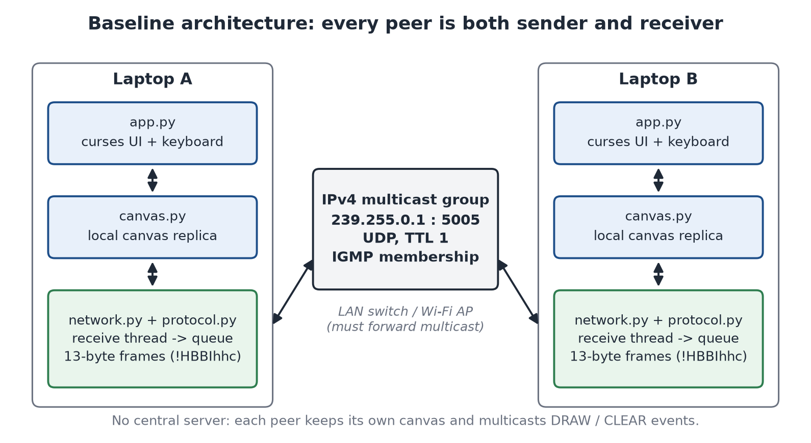
Figure 1. Baseline architecture. One-laptop operation is tested; operation between two physical laptops has not yet been verified.

1.1 Modules
Module | Responsibility | Status
config.py | Shared constants: group 239.255.0.1, port 5005, TTL 1, interface address, buffer and timeout values, and the shared 60x18 canvas size. | Implemented - automated tests
protocol.py | 13-byte frame (!HBBIhhc): encode_event(), decode_event(), strict validation, ProtocolError. | Implemented - automated tests
network.py | Receive socket (group join/leave), connected send socket, background receive thread, own-frame filtering, start_network() / send_event() / stop_network(). | Implemented - tested on one laptop
canvas.py | Canvas state: character and colour grid, DRAW/CLEAR application, validation.  Implemented in Stage 3; covered by tests/test_canvas.py and the real-multicast TwoAppLoopbackTests. | Implemented - tested on one laptop
app.py | curses terminal UI, keyboard handling, queue-based integration with the network layer.  Implemented in Stage 3; requires windows-curses on Windows (requirements.txt). | Implemented - tested on one laptop

1.2 Key runtime behaviour of the existing network layer
- The receive thread decodes each datagram and calls on_event(event) with a dict such as {"type": "DRAW", "seq": 7, "x": 20, "y": 10, "char": "#", "color": 2, "addr": (ip, port)}.
- The network layer assigns sequence numbers on send. An invalid event raises ProtocolError without consuming a sequence number.
- Multicast loopback is enabled so several peers can run on one laptop. Each peer drops its own looped-back frames by comparing the source address with its connected send socket's (ip, port); the frame itself has no peer identifier.
- Malformed, foreign and oversized datagrams are counted and dropped. Unexpected socket errors end the receive thread with a logged error.

1.3 Application controls (implemented in app.py)
Setup on each laptop: python -m pip install -r requirements.txt (installs windows-curses on Windows), then python app.py --interface <this laptop's IPv4 address>. The terminal must be at least 62 x 23 characters.
Key | Action
Arrow keys | Move the cursor
Space | Draw the brush character at the cursor
p | Toggle pen mode (draws while moving)
e | Erase the cell (draws a space)
b, then a character | Choose the brush character (Esc cancels)
0-7 | Colour: default, red, green, yellow, blue, magenta, cyan, white
X (Shift+x) | Clear the canvas for all peers
q or Ctrl+C | Quit

2. Verified baseline versus unverified assumptions
The table separates what the code and tests demonstrate from what is assumed about the deployment network. Automated evidence comes from running python -m unittest discover -s tests -v on the development laptop.
Claim | Evidence | Status
13-byte frames encode, decode and reject malformed input (size, magic, type, coordinates, character). | tests/test_protocol.py | Implemented - automated tests
Sockets bind port 5005, join and leave 239.255.0.1 on the configured interface, use TTL 1 and pin outgoing traffic to that interface. | MockedSocketTests and MockedSpecificInterfaceTests | Verified with mocked sockets
Peers exchange multicast frames, ignore their own frames, survive malformed and oversized datagrams, and stop cleanly. | LoopbackMulticastTests using real sockets on the interface configured on the development laptop (Wi-Fi, 172.17.83.158) | Implemented - tested on one laptop
Frames leave one laptop over Wi-Fi and reach another laptop. | None yet | Not verified
The Wi-Fi access point forwards multicast between clients (no client isolation or multicast filtering). | None yet; depends on the network used | Not verified
IGMP membership reports and 13-byte UDP payloads are visible in Wireshark. | None yet | Not verified
Windows Firewall allows inbound UDP 5005 for Python on both laptops. | None yet | Not verified
Canvas state and terminal application behave correctly. | tests/test_canvas.py and tests/test_app.py, including TwoAppLoopbackTests over real multicast (128 tests in the suite). Additionally, a one-off scripted run of app.py in a real Windows console during development (not stored in the repository). | Implemented - tested on one laptop

Important. Packets delivered between peers on one laptop are looped back inside the operating system. Those tests prove the socket logic, not that the LAN forwards multicast. The baseline is only successful after the two-laptop procedure in Section 12.4 passes.

3. Current protocol format and its limitations
Every datagram is exactly one 13-byte frame, big-endian, packed with struct format !HBBIhhc. The presentation labels the frame as 12 bytes, but its own field list and struct format total 13 bytes; the implementation keeps every field.
Offset | Size | Field | Type | Meaning
0 | 2 | Magic | H | 0xCA55; filters unrelated traffic (not authentication)
2 | 1 | Type | B | 1 = DRAW, 2 = CLEAR; 3 = STATE_REQ and 4 = STATE_RESP reserved and rejected
3 | 1 | Color | B | Terminal colour index 0-255
4 | 4 | Sequence | I | Per-sender counter from 0, wraps after 2^32 - 1
8 | 2 | X | h | Column 0-32767 (negative values rejected)
10 | 2 | Y | h | Row 0-32767 (negative values rejected)
12 | 1 | Char | c | Printable ASCII 0x20-0x7E; CLEAR uses 0x00 with zero colour/x/y

3.1 Limitations
- No sender identity. Every peer numbers its own events from 0, so sequence number 5 from peer A and 5 from peer B are indistinguishable inside the frame. The receiver only knows the source (ip, port) as metadata, which cannot be carried inside retransmissions or snapshots.
- No version field. The only way to recognise the format is magic plus an exact 13-byte length, so the format cannot evolve without an explicit detection strategy (Section 6.3).
- Fixed payload. There is no room for recovery requests (sequence ranges) or snapshot chunks.
- No logical clock. Peers apply events in arrival order, so concurrent edits of the same cell can leave peers with different final canvases (Section 9.1).
- CLEAR is unordered. A delayed CLEAR can erase drawing that happened after it on another peer.
- No integrity protection. Any host on the LAN can send valid frames; UDP checksums only detect accidental corruption.
- Sequence numbers are carried but unused. Receivers do not yet detect duplicates or gaps.

4. Proposed enhancements and their motivations
ID | Enhancement | Motivation | Depends on | Status
A | Per-peer identity, sequence tracking, duplicate and gap detection | Know which events were lost, repeated or stale for each sender | Protocol v2 header | Proposed - not implemented
B | Bounded missing-event recovery (NACK + repair) | Repair isolated losses without TCP or a server | A, heartbeats | Proposed - not implemented
C | Late-join snapshot synchronization (STATE_REQ / STATE_RESP) | A new peer sees drawing made before it joined | A, D | Proposed - not implemented
D | Deterministic conflict handling (Lamport clock + Peer ID tie-break) | All peers converge to the same canvas | A, v2 header clock field | Proposed - not implemented
E | Shared-secret HMAC integrity and authentication | Reject tampered or foreign frames on a shared LAN | v2 header flags | Optional - not implemented

Recommended order. Stage 5 is planned to introduce the v2 header with Peer ID, sequence number and Lamport clock in one step, then implement A and D. Stage 6 would add B and then C. E is optional and independent. Each stage is to be merged only after its own tests pass. None of these stages has started.

5. Feasibility assessment
Status. Enhancements A-E in this section are designs only. None of them is implemented in the repository; each table below begins with its status.
Each enhancement keeps the architecture serverless: no peer is a permanent coordinator, there is no central canvas, and IPv4 multicast over UDP remains the only transport. Complexity is a qualitative estimate for a two-person student team.

5.1 Enhancement A: per-peer identity and sequence tracking
Sequence numbers alone cannot distinguish independent peers. Every sender starts its own counter, so the pair (seq = 12) appears once per peer; a receiver that tracked sequence numbers globally would treat B's event 12 as a duplicate of A's event 12, and would report gaps that are really interleaved streams. Duplicate and gap detection is only meaningful per sender, keyed by a sender identity that travels inside the frame.
The source (ip, port) already identifies a peer for live traffic on one LAN, but it is unsuitable as the protocol identity: it is not inside the frame, so it cannot be named in a recovery request or preserved in a snapshot; it changes on restart; and it depends on socket details rather than on the protocol.
Aspect | Assessment
Status | Proposed - not implemented
Approach | Generate a random 32-bit Peer ID per session with the secrets module. Track, per Peer ID, the highest contiguous sequence number plus a bitmap window (for example 1,024 entries) of out-of-order arrivals. Compare sequence numbers with serial-number arithmetic: a is newer than b when (a - b) mod 2^32 is in 1 .. 2^31 - 1 (RFC 1982 style), which handles wraparound.  The first event from an unknown peer sets its baseline, so a peer seen mid-stream is not reported as missing everything before it.
Protocol changes | v2 header with Peer ID (4 bytes) and a version field. Sequence stays 4 bytes and is consumed only by DRAW and CLEAR.
Benefits | Per-sender duplicate, stale and gap detection; a stable name for recovery requests and conflict tie-breaks; counters for the demo (received, duplicates, gaps).
Complexity | Low to moderate. Pure logic, fully unit-testable.
Risks | ID collision: probability about n^2 / 2^33 for n peers (negligible for a classroom); additionally, a peer that sees its own ID from a different source address regenerates it.  Memory: bounded by a maximum peer count (for example 64, least-recently-seen evicted) and an inactivity timeout (for example 60 s).
Test strategy | Unit tests for in-order, duplicate, reordered, gap, stale, wraparound at 2^32 - 1 -> 0, eviction and ID collision. Local multicast tests with several in-process peers.
Serverless | Yes. Each peer tracks others independently.

5.2 Enhancement B: missing-event detection and recovery
Recovery is NACK-based, in the style of receiver-initiated reliable multicast protocols such as SRM (Floyd et al., 1997) and NORM (RFC 5740): receivers ask only for what they are missing, so a loss-free network carries no extra traffic. It improves the chance of delivery; it does not make UDP reliable.
Aspect | Assessment
Status | Proposed - not implemented
Approach | Each peer keeps a bounded ring buffer of its last N sent events (for example 512).  On a gap, the receiver waits a random 50-150 ms, then multicasts NACK(peer, first_seq, count) unless it already heard an identical NACK (suppression).  The original sender multicasts the original DRAW/CLEAR frames again with the retransmission flag set (there is no separate repair message type), rate-limited per range (for example once per 200 ms).  Receivers retry up to 3 times with exponential back-off, then mark the range unrecoverable and fall back to snapshot synchronization (C) or report it.  A periodic HEARTBEAT (for example every 1-2 s) carries the sender's latest sequence number, which exposes tail loss: the last event of a burst being lost while the sender then stays idle.
Protocol changes | New types HEARTBEAT, NACK and NOT_AVAILABLE; retransmission flag; sender history.
Multicast vs unicast | Multicast NACK: other receivers that missed the same event hear it and suppress their own requests; the sender sees all requests. Costs one small datagram to every member.  Multicast repair: one transmission repairs every receiver with the same loss; duplicates are discarded by A. Costs bandwidth for members that did not need it.  Unicast repair: no wasted bandwidth, but one transmission per requester and no suppression benefit. On this design unicast to port 5005 is also ambiguous when several peers share a host, because SO_REUSEADDR delivers a unicast datagram to only one of the sockets.  Recommendation: multicast NACK and multicast repair, rate-limited. Event sizes are tiny, so the bandwidth cost is small on a LAN.
Complexity | Moderate to high. Timers, retries and suppression interact; needs a loss-injection harness.
Risks | Request storms after burst loss (mitigated by random delay, suppression and per-range rate limits); repairs arriving after newer events (handled by D); history eviction (NOT_AVAILABLE, then snapshot); lost NACKs or repairs (bounded retries); sender crash (history lost; only snapshots from other peers can help).
Test strategy | Deterministic loss injection in the receive path with a seeded random generator: drop chosen sequence numbers, drop NACKs, drop repairs, evict history. Assert recovery, bounded retries, and explicit 'unrecoverable' outcomes.
Serverless | Yes. Only the original sender answers for its own events.

5.3 Enhancement C: late-join synchronization
Aspect | Assessment
Status | Proposed - not implemented
Approach | The new peer joins the group and starts buffering live events before it sends STATE_REQ(nonce).  Every existing peer starts a random 0-200 ms back-off; the first to expire multicasts the snapshot; others hear a STATE_RESP for the same nonce and cancel.  The snapshot is split into STATE_RESP frames. Each starts with a 20-byte chunk header: nonce (4), chunk index (2), chunk count (2), CRC32 of the whole snapshot (4), and the CLEAR watermark as Lamport time (4) plus Peer ID (4). Up to 80 cell records of 14 bytes follow: x (2), y (2), char (1), colour (1), Lamport time (4), Peer ID (4).  Largest frame: 20 (v2 header) + 20 (chunk header) + 80 x 14 (1,120) = 1,160 bytes, or 1,188 bytes as an IP packet with the UDP and IPv4 headers, below the 1,500-byte Ethernet MTU, so no IP fragmentation occurs.  When all chunks arrive and the CRC matches, the joiner merges the snapshot per cell keeping the larger (Lamport time, Peer ID), then replays its buffer with the same rule.
Why nothing is discarded | Per-cell max-merge is commutative and idempotent: applying snapshot and live events in any order produces the same result, so a newer buffered event can never be overwritten by an older snapshot cell.
Protocol changes | STATE_REQ and STATE_RESP payloads defined in v2; requires the Lamport clock and Peer ID from D and A.
Failure handling | Missing or corrupt chunks trigger a bounded re-request; no response after the retries means the peer starts empty and shows a warning (for example when it is the first peer, or multicast is blocked).
Complexity | Moderate to high. Chunking, reassembly, CRC and merge logic.
Test strategy | Unit tests for chunking/reassembly, CRC rejection and merge commutativity (random event orders produce identical canvases). Local multicast test: peer joins after drawing exists and converges, including events drawn during the transfer.
Serverless | Yes. Any existing peer may answer; the responder is chosen by random back-off, not by a fixed leader.

5.4 Enhancement D: deterministic conflict handling
Aspect | Assessment
Status | Proposed - not implemented
Current behaviour | Not deterministic. Each peer applies its own drawing immediately and remote events in arrival order, so two concurrent edits of one cell can leave the peers showing different characters (Section 9.1).
Can the current protocol support it? | No. It has no sender identity for tie-breaking and its sequence number is a per-sender counter, not a logical clock.
Approach | Each peer keeps a Lamport clock: increment before sending; on receive set clock = max(clock, received) + 1.  Each cell stores the (Lamport time, Peer ID) of its last write. An incoming DRAW is applied only if its pair is larger. Peer ID breaks ties, as the presentation proposes.  CLEAR becomes a canvas-wide watermark: cells whose stamp is below the CLEAR stamp are blank.
Why not the per-sender sequence number? | A busy peer accumulates large sequence numbers. If peer A has sent 500 events and peer B, after seeing A's drawing, overwrites a cell with its 3rd event, a sequence-number rule would keep A's older character. A Lamport clock respects that B saw A's event first.
User-visible behaviour | All peers end with the same canvas once they have received the same events. During a true conflict a user may see their own character briefly replaced by a concurrent remote one.
Complexity | Low to moderate; mostly canvas logic.
Test strategy | Property-style unit tests: apply the same event set in many random orders and assert identical final canvases; CLEAR-versus-DRAW races; tie-break by Peer ID.
Serverless | Yes. The rule is applied identically and independently by every peer.

5.5 Enhancement E: optional integrity and authentication
Aspect | Assessment
Status | Optional - not implemented
Approach | Append a truncated HMAC-SHA256 tag (16 bytes) computed with a pre-shared key over header and payload, using Python's standard hmac and hashlib modules. Derive the key from a passphrase with hashlib.pbkdf2_hmac. Frames with a missing or wrong tag are dropped and counted.
What it provides | Integrity (tampering is detected) and group authentication (the sender knows the key).
What it does not provide | Confidentiality: frames remain readable in Wireshark. Per-peer authentication: any key holder can claim any Peer ID. Full replay protection: the duplicate window of A rejects recent replays only.
Encryption | Would need an authenticated cipher such as AES-GCM, which is not in the Python standard library. Out of scope; listed as future work.
Complexity | Low. Tests: tampered byte rejected, wrong key rejected, missing tag rejected, correct tag accepted.
Serverless | Yes, with manual key distribution (the passphrase is typed on each laptop).

5.6 Feasibility classification
Category | Items
Can be built next, before two-laptop testing (fully testable on one laptop) | A: identity, sequence tracking, duplicate and gap detection  D: Lamport clock and LWW rule  E: HMAC (optional)
Needs the two-laptop baseline first | B: recovery (real Wi-Fi loss behaviour matters)  C: late join (must be demonstrated across machines)
Stretch goals / future work | Encryption  Multiple rooms, undo/redo, drawing modes, usernames  Routing beyond one subnet (TTL > 1)  Mixed-version interoperability

6. Proposed revised protocol (v2)
Status. Everything in this section is a proposal. The implemented protocol is the 13-byte v1 frame described in Section 3.

6.1 Strategy comparison
Criterion | Extend the fixed-size frame | Versioned, typed protocol (v2)
New message types with different payloads (NACK ranges, snapshot chunks) | Poor: every type must fit one layout, or the frame grows for all types | Good: payload length and layout depend on type
Explicit format detection | None: relies on total length | Version byte plus payload length
Compatibility with v1 peers | Any added field changes the 13-byte size, so it breaks v1 anyway | Same break, but detected and reported explicitly
DRAW frame size | 21 bytes if Peer ID and clock (4 bytes each) are added | 26 bytes (20-byte header + 6-byte payload)
Wireshark readability | Fair | Good: fixed header, then type-specific payload
Implementation effort | Lower at first, higher later | Moderate once; later types are additive
Recommendation | Not recommended | Recommended

6.2 Proposed v2 header (20 bytes, big-endian)
Offset | Size | Field | Meaning
0 | 2 | Magic | 0xCA55 (unchanged)
2 | 1 | Version | 2
3 | 1 | Type | Message type (Section 6.4)
4 | 1 | Flags | bit 0: HMAC tag present; bit 1: retransmission
5 | 1 | Reserved | 0
6 | 4 | Peer ID | Random 32-bit session identifier
10 | 4 | Sequence | Only DRAW and CLEAR consume a sequence number; all other types carry the sender's latest value without consuming one
14 | 4 | Lamport | Logical clock for ordering (D)
18 | 2 | Payload length | Bytes after the header (excluding an HMAC tag)

6.3 Compatibility strategy
- v1 frames are exactly 13 bytes and have no version field. v2 frames are always at least 20 bytes.
- Existing v1 peers reject every non-13-byte datagram, so v2 traffic is dropped and counted by them and cannot corrupt their canvases.
- A v2 peer that receives a 13-byte frame with magic 0xCA55 classifies it as legacy v1, drops it, and shows a warning naming the sender address.
- Mixed operation would not be supported: all laptops must run the same version. When v2 is implemented, the README must state this and the UI must warn when a legacy frame arrives; neither exists today because v2 does not exist.

6.4 Proposed message types
Code | Type | Payload | Frame size (no HMAC) | Purpose
1 | DRAW | x h, y h, char c, colour B (6 bytes) | 26 | Set one cell
2 | CLEAR | none | 20 | Clear canvas (watermark)
3 | STATE_REQ | nonce I | 24 | Request snapshot (C)
4 | STATE_RESP | 20-byte chunk header + up to 80 cell records of 14 bytes (Section 5.3) | 40 + 14 per cell; at most 1,160 | Snapshot chunk (C)
5 | HEARTBEAT | none (latest sequence in header) | 20 | Presence and tail-loss detection (B)
6 | NACK | target peer I, first seq I, count H | 30 | Request missing events (B)
7 | NOT_AVAILABLE | first seq I, count H, oldest available I | 30 | History evicted (B)

Codes 1-4 keep the values reserved in the current implementation and listed in the presentation. Lost events are repaired by re-sending the original DRAW or CLEAR frame with the retransmission flag, so there is no separate repair type.

7. Serverless architecture and peer-to-peer message flows
All flows below are multicast to the group. No peer is a permanent coordinator: the original sender answers recovery requests for its own events, and snapshot responders are chosen by random back-off.

7.1 Normal drawing (implemented in v1)
- The user presses a key; app.py applies the drawing to its own canvas immediately.
- send_event() encodes the event and multicasts it once to 239.255.0.1:5005.
- Every member's receive thread decodes the frame and places the event on a queue.
- Each application's main loop drains the queue and applies the event to its own canvas.

7.2 Missing-event recovery (proposed)
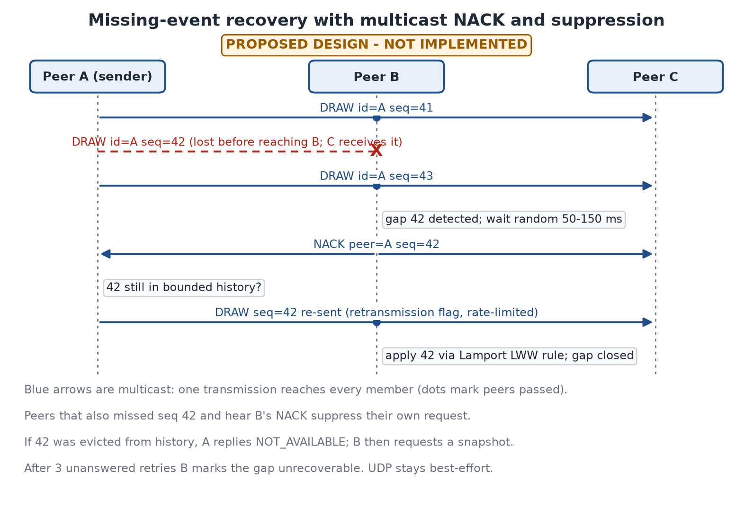
Figure 2. Proposed NACK-based recovery. Not implemented.

7.3 Late-join synchronization (proposed)
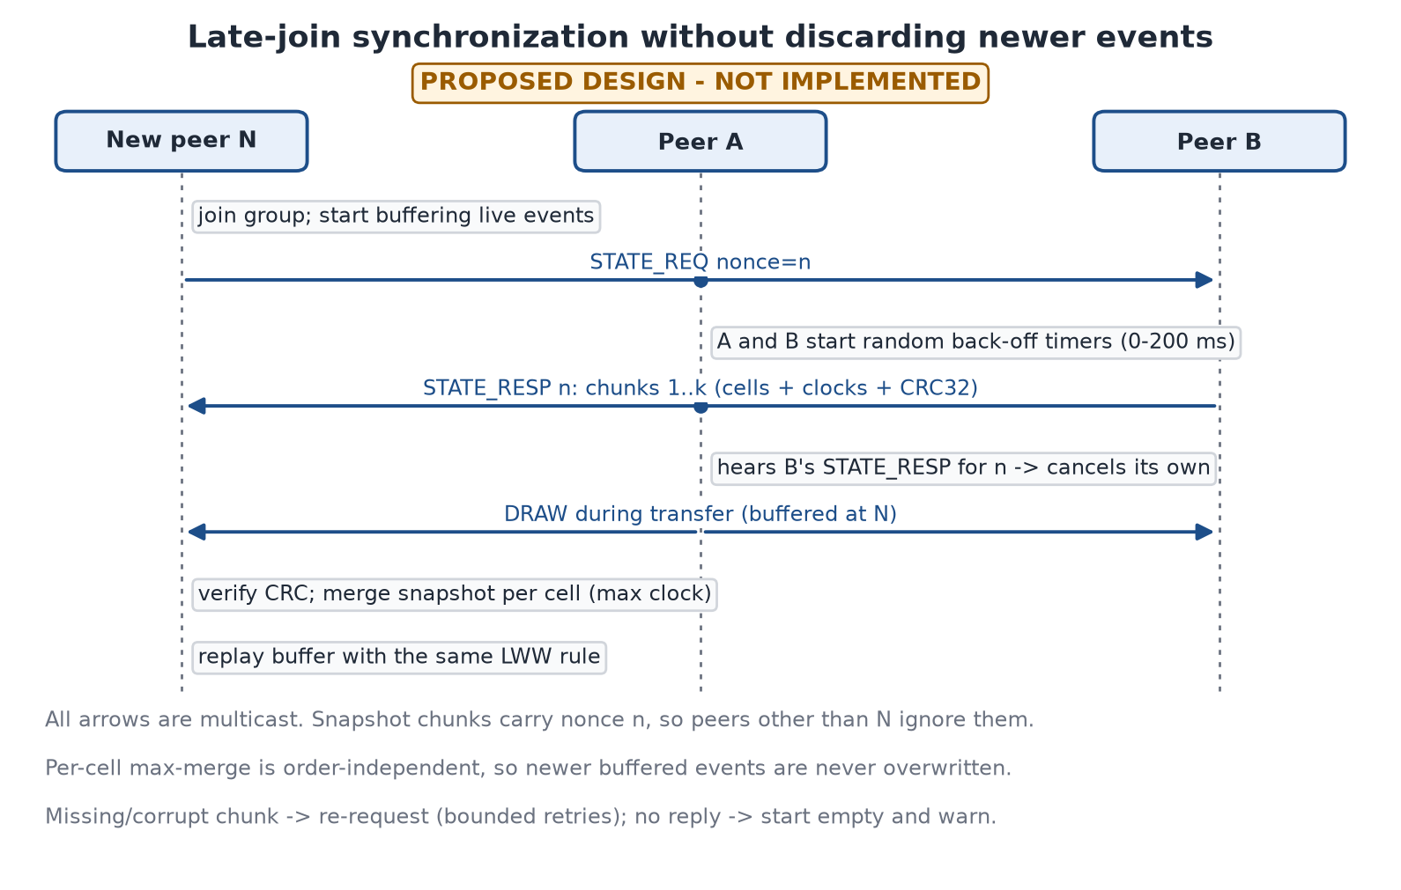
Figure 3. Proposed late-join snapshot transfer. Not implemented.

8. Reliability limitations and recovery failure scenarios
Principle. UDP multicast is best-effort. The proposed recovery improves the probability of delivery but cannot guarantee it: recovery messages travel over the same unreliable network.
Scenario | Baseline (v1) behaviour | With proposed B/C (not implemented) | Residual risk
Single DRAW lost | Silently missing on that peer | Gap detected, NACK, repair | Repair can also be lost (retries)
Last event lost, sender then idle | Silently missing | Heartbeat exposes the gap within one interval | Delay of one heartbeat interval
NACK or repair lost | n/a | Retry up to 3 times with back-off | Range marked unrecoverable
Event evicted from sender history | n/a | NOT_AVAILABLE, then snapshot | Snapshot may also fail
Sender crashed | Its events missing on some peers | Snapshot from another peer that has them | Lost if no peer received them
Burst loss (Wi-Fi interference) | Many cells missing | Range NACKs, rate-limited repairs | Temporary extra traffic
Many receivers miss the same event | n/a | Random delay and NACK suppression | Some duplicate NACKs remain
Network partition (AP stops forwarding) | Canvases diverge | Snapshot merge after healing | Divergence during the partition
Duplicate or reordered delivery | Applied again; order matters | Duplicates dropped; LWW makes order irrelevant | None expected

9. Conflict handling and synchronization design

9.1 Current behaviour (v1): divergence is possible
Time | Peer A canvas cell (5,5) | Peer B canvas cell (5,5)
t0: A draws 'x', B draws 'o' at the same moment | 'x' (own, applied locally) | 'o' (own, applied locally)
t1: each receives the other's event | 'o' (B's event arrived last) | 'x' (A's event arrived last)
Result | Shows 'o' | Shows 'x' - the replicas differ

This is an inherent property of arrival-order application, not a bug in the network code. It is acceptable for the baseline demo but must be explained honestly in the viva.

9.2 Proposed rule (not implemented): Lamport last-writer-wins
- Stamp = (Lamport time, Peer ID). Larger stamp wins; Peer ID only breaks exact ties.
- A cell write is applied only if its stamp is larger than the cell's current stamp, so applying events in any order gives the same canvas.
- CLEAR stores a canvas-wide clear stamp; a cell is visible only if its stamp exceeds the clear stamp, so a delayed CLEAR cannot erase later drawing.
- Snapshots carry stamps, so merging a snapshot is the same per-cell rule (Section 5.3).
- Convergence holds only for events every peer actually received; lost, unrecovered events still leave differences, which is why B and C exist.

10. Security considerations and trust assumptions
The project assumes a trusted classroom LAN. The table states what an attacker on the same network could do.
Threat | Baseline (v1) | With optional HMAC (E, not implemented)
Read drawing traffic | Possible (plaintext) | Still possible (no encryption)
Inject forged DRAW/CLEAR | Possible: magic 0xCA55 is not authentication | Rejected unless the attacker knows the key
Modify frames in transit | Possible | Detected and dropped
Replay captured frames | Possible | Recent replays rejected by the duplicate window; old ones possible
Impersonate a specific peer | Possible | Possible for any key holder (group key, not per-peer)
Flood the group (denial of service) | Possible | Possible; HMAC verification adds CPU cost

- Integrity and authentication answer 'was this frame changed, and did a key holder send it?'
- Encryption answers 'can outsiders read it?' It is not provided and is listed as future work.
- Key distribution is manual (a passphrase typed on each laptop); there is no key server, which keeps the design serverless.

11. Implementation stages and dependencies
Stage | Scope | Depends on | Exit criteria | Status
1 | Audit and verify the Phase 1 baseline | - | 72 tests pass; code matches documentation | Done
2 | This roadmap document | 1 | Reviewed DOCX in the project folder | Done
3 | canvas.py and app.py (curses UI) | 1 | Canvas and app tests pass; app runs on one laptop | Done
4 | Two-laptop baseline test and Wireshark capture | 3 | Procedure in 12.4 passes; capture saved | External - you must perform
5a | Make the network layer codec-pluggable; add protocol v2 header | 4 | v1 tests still pass; v2 codec tests pass | Proposed - not implemented
5b | A: Peer ID, sequence tracking, duplicate/gap detection, heartbeat | 5a | Tracker unit tests incl. wraparound and eviction | Proposed - not implemented
5c | D: Lamport clock and LWW canvas rule | 5a | Random-order convergence tests pass | Proposed - not implemented
6a | B: bounded NACK recovery | 5b, 5c | Loss-injection tests pass; failures reported | Proposed - not implemented
6b | C: late-join snapshot | 5c, 6a | Late-join tests pass; two-laptop demo | Proposed - not implemented
7 | E: optional HMAC | 5a | Tamper and wrong-key tests pass | Optional - not implemented

Stage 3 is complete: canvas.py and app.py are implemented and the suite has 128 passing tests. In addition, app.py was run once in a real Windows console on one laptop with scripted keys while a second in-process peer exchanged multicast with it; that one-off check is not stored in the repository. Stage 4, the two-laptop test, is the next required step and must be performed by the team.

12. Test plans

12.1 Unit tests
- Protocol: exact byte layouts, round trips, boundary values, rejection of malformed frames (existing for v1; to be extended for v2).
- Canvas: initial state, bounds, DRAW, CLEAR, invalid events; later the LWW rule and merge commutativity.
- Application logic: key handling, local events applied exactly once, queue draining, shutdown; tested without a terminal.
- Proposed: sequence tracker, NACK scheduler, snapshot chunking and CRC, HMAC.

12.2 Integration tests (one laptop, real sockets)
- Several peers in one process exchange real multicast datagrams through the operating system (existing LoopbackMulticastTests).
- Two CanvasApp instances in one process draw, clear and exchange events over real multicast (existing TwoAppLoopbackTests).
- A one-off scripted run of app.py in a real Windows console was performed during development; its script and output are not stored in the repository, so it is not a repeatable test.
- Proposed: two app instances in separate processes on one laptop, as a repeatable test.

12.3 Simulated loss (proposed)
- A loss-injection layer between the socket and the decoder drops datagrams with a seeded random generator at configurable rates, or drops specific sequence numbers or message types.
- Scenarios: single loss, burst loss, lost NACK, lost repair, evicted history, lost snapshot chunk. Assertions cover both recovery and the explicit unrecoverable outcome.

12.4 Two-laptop baseline test (Stage 4, external)
- Copy the project folder to both laptops and run python -m pip install -r requirements.txt on each.
- Connect both laptops to the same network. Prefer a network known to allow client-to-client traffic (a phone hotspot or a home router); campus Wi-Fi often isolates clients.
- On each laptop run ipconfig and note the Wi-Fi IPv4 address; start the app with python app.py --interface <that address>.
- Allow Python through Windows Firewall when prompted (Private network), or add an inbound rule for UDP 5005.
- Disable VPN clients (for example Cloudflare WARP or McAfee VPN) during the test.
- Start Wireshark on laptop B on the Wi-Fi interface with display filter: ip.dst == 239.255.0.1 || igmp
- Start the app on both laptops. Draw on A (Space); confirm it appears on B. Draw on B; confirm it appears on A. Press X (Shift+x) on one; confirm both clear.
- Pass criteria: drawings appear in both directions; Wireshark shows IGMP membership reports for 239.255.0.1 and UDP datagrams to port 5005 with a UDP length of 21 bytes (8-byte header + 13-byte payload) whose data starts ca 55.
- Save the capture (.pcapng) and screenshots of both terminals as evidence.

13. Demo plan and expected evidence
Step | What is shown | Evidence to collect
1 | Automated test suite on one laptop | Terminal output of python -m unittest discover -s tests -v
2 | Two laptops drawing on a shared canvas with no server | Photos or screen recordings of both terminals
3 | IGMP membership and multicast UDP traffic | Wireshark capture filtered with ip.dst == 239.255.0.1 || igmp
4 | Frame structure | Wireshark hex view of one DRAW frame, decoded by hand against Section 3
5 | Honest limitations | Explanation of the concurrent-edit divergence (Section 9.1) and UDP loss
6 (after Stage 5+) | Duplicate/gap counters, recovery, late join | Only if implemented and tested by then

Expected evidence is a list of artefacts to capture during the demo, not results; none have been recorded yet.

14. Risks, fallback plans and future work
Risk | Impact | Mitigation / fallback
Wi-Fi client isolation or multicast filtering on campus networks | No packets between laptops | Use a phone hotspot, home router, or an Ethernet switch/cable; verify before the demo
Phone hotspot also blocks multicast or client-to-client traffic | Same as above | Test the specific hotspot in advance; keep a small router or Ethernet cable as backup
Windows Firewall blocks inbound UDP 5005 | One-directional or no traffic | Allow Python on the Private profile or add an inbound UDP 5005 rule
Wrong interface chosen (VirtualBox, VPN adapters) | Traffic sent on the wrong network | Pass --interface or set INTERFACE_ADDRESS to the Wi-Fi address
Wi-Fi address changes on reconnect | Startup failure or silent mis-routing | Check ipconfig before each run; app reports the address it uses
IGMP snooping without a querier on managed switches | Forwarding may stop after a few minutes | Prefer a simple network; restart the app to rejoin; note in the viva
windows-curses not installed | app.py cannot start | pip install -r requirements.txt on both laptops
Concurrent edits diverge in the baseline | Peers show different characters in one cell | Explain honestly; proposed Enhancement D would fix it (not implemented)

14.1 Explicit future work
- Encryption (for example AES-GCM via a third-party library).
- Multiple rooms or channels, undo/redo, drawing modes and usernames (from the presentation).
- Operation beyond one subnet (TTL > 1, multicast routing).
- Mixed-version interoperability between v1 and v2 peers.
- Congestion or rate control for large drawing bursts.

15. Feature status comparison
Feature | Baseline functionality | Planned enhancement | Status
Multicast group communication | 239.255.0.1:5005, TTL 1, IGMP join/leave | - | Implemented - tested on one laptop
Binary protocol | 13-byte DRAW/CLEAR frames | v2 typed header (Section 6) | Implemented - automated tests
Communication between two laptops | Designed for it; not yet tested between two physical laptops | - | Pending two-laptop test
Canvas state | 60x18 grid; DRAW/CLEAR; bounds and input validation | LWW stamps per cell (D) | Implemented - tested on one laptop
Terminal UI | curses app; local draw applied once; remote events via queue; clean shutdown | - | Implemented - tested on one laptop
Own-frame filtering | By send-socket source address | By Peer ID (A) | Implemented - tested on one laptop
Duplicate / gap detection | None | Per-peer tracking (A) | Proposed - not implemented
Loss recovery | None | NACK + repair (B) | Proposed - not implemented
Late-join synchronization | None (STATE_REQ/RESP reserved) | Snapshot transfer (C) | Proposed - not implemented
Deterministic conflicts | Arrival order (may diverge) | Lamport LWW (D) | Proposed - not implemented
Integrity / authentication | None | HMAC-SHA256 (E) | Optional - not implemented
Encryption | None | - | Future work

No feature in this table has been verified between two physical laptops at the time of writing.

