Seventh Semester Project Progress
Arijit Samanta | Team T01 Swifties
Project: Context Rot Detection in LLM Based Exam Preparation
I have implemented the backend prototype that connects tutoring sessions, answer generation, background reliability checks and a single correction attempt. My work focuses on the API, persistent storage and reliable delivery of results to the demonstration interface.

Work completed
• API and access control. Built REST endpoints and OpenAPI documentation with user authentication and revocable API keys.
• Session storage. Saved questions, original answers, source passages, instructions, scores, alerts and linked corrections.
• Background processing. Implemented a persistent job queue and worker with restart recovery and protection against overlapping submissions.
• Correction workflow. Added one retry using retrieved material, bounded conversation history and stored instructions. Unresolved answers remain flagged.
• Live updates and integration. Added streamed answers, WebSocket event replay, an offline model mode, a Gemini adapter and replaceable teammate service interfaces.
• Demonstration and testing. Prepared a browser demo, an automated examiner walkthrough and a concurrent load test.

Recorded validation
17 automated tests passed. The offline load test completed 60 requests across 20 concurrent sessions with no errors. P95 time to first streamed content was 1.92 seconds. Correction history also survived a page reload.

Demo interface
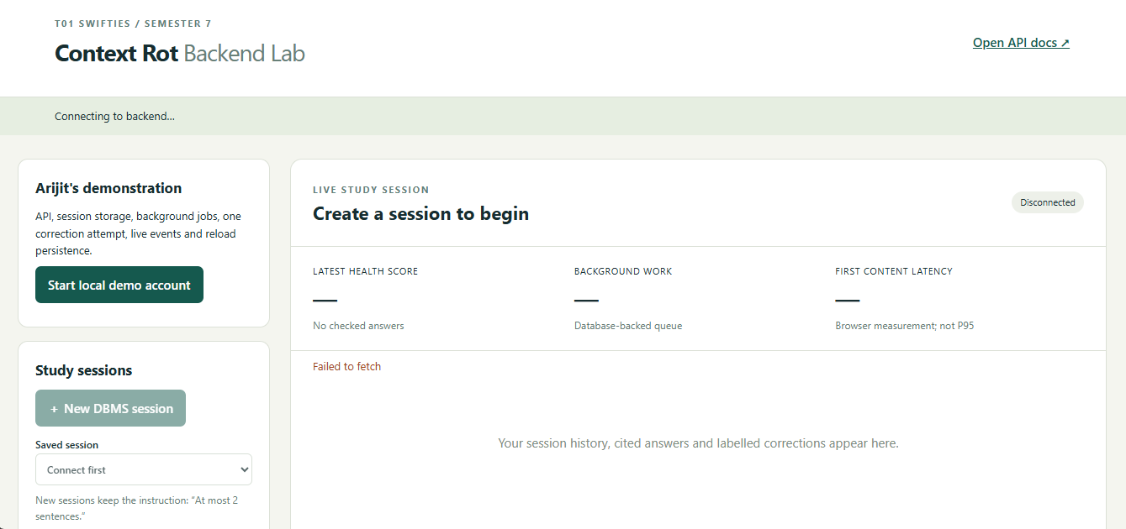
Figure 1. Demo interface in its initial disconnected state. This screenshot shows the interface layout; it does not show a completed live run.

Current scope
The independent demo uses authored DBMS notes, lexical retrieval and a rule based checker. The team's validated retrieval and detection modules, independent dataset labelling and real model evaluation remain to be integrated or completed. The timings above apply only to offline mode.

