Feature Extraction and Price Prediction for Mobile Phones
Project report: data exploration, feature extraction, predictive modelling and pricing recommendations
Dataset: Flip_Data.xlsx (541 listings, 11 attributes) | Prices in Indian rupees (Rs)
Code: mobile_price_project.py | Outputs: figures/, data/, results.json

1. Executive summary
We cleaned the 541 raw listings down to 517 usable phones (174 distinct models), engineered the features that matter, and trained four model families to predict price. The best model, Gradient Boosting, predicts the price of phone models it has never seen to within about Rs 2,165 on average (R² = 0.85, MAPE ≈ 12.7%). A naive "always predict the median" baseline is off by Rs 6,283 on the same phones.
What drives price, in order of importance:
- Performance tier (chipset + RAM + storage): by far the dominant driver. Shuffling this bundle makes predictions worse by about Rs 2,842, more than any other group.
- Brand and 5G: together worth about Rs 1,218 of prediction accuracy. Brand matters (Google's median price is Rs 43,999 versus Rs 8,999 for Infinix) and 5G models carry a clear premium.
- Camera specs: front-camera megapixels are a strong segment signal (Rs 916 for the camera pair); rear-camera megapixels add almost nothing once other specs are known.
- No measurable effect: AI lens (permutation importance ≈ 0) and colour (Kruskal–Wallis p = 0.29 after controlling for specs).
Important honesty note: the brief's plain random train/test split gives flattering results (Gradient Boosting MAE Rs 1,763) because the same phone in different colours or variants lands in both sets. We therefore report a stricter split that holds out entire phone models, which mirrors the real use case of pricing a new launch. Both are shown.

2. Data exploration
The workbook has 541 rows and 12 columns (one is an index column). There are no empty cells, but the data has many quality problems that were only visible on inspection. Columns: Model, Colour, Memory (GB), RAM (GB), Battery (mAh), Rear and Front Camera (strings such as "50MP"), AI Lens (0/1), Mobile Height (cm), Processor (free text, 123 distinct spellings) and Prize (a typo for Price).
Key observations from the raw data:
- Prices span Rs 920 to Rs 80,999 and are right-skewed (Figure 1), so errors on cheap phones and flagships are very different in scale.
- Processor names are inconsistent ("Mediatek Helio G88", "Helio G88", "MediaTek Helio G88", "Octa Core", "ios", "Android").
- Some rows are not smartphones at all: Micromax and "redmi min/max" entries priced under Rs 2,500 with 0–2MP cameras, tiny batteries and impossible storage (e.g. 256 GB for Rs 1,299).
- Mobile Height contains 41.94 cm (Moto G62) and values under 10 cm (feature phones).
- Ten rows are exact duplicates, and the same model appears in many colours with identical specs and price.
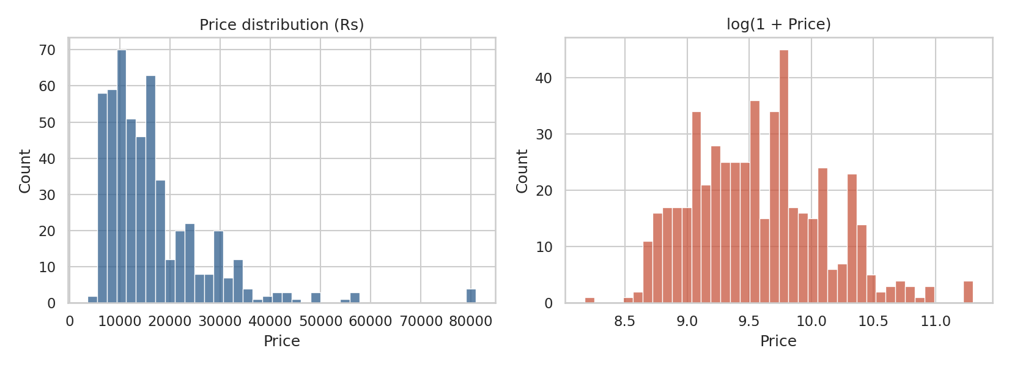
Figure 1. Price is right-skewed; log-transform is closer to symmetric.

3. Data preprocessing
Issue | Action | Rows affected
Exact duplicate listings | Dropped | 10
Feature phones / mis-scraped rows (price < Rs 3,000) | Removed | 14
Impossible handset height (41.94 cm) | Set to missing, median-imputed in the model pipeline | 3
Front camera = 0 MP on a working phone | Treated as missing, median-imputed | 1
"50MP" strings in camera columns | Parsed to numbers | all
Mojibake characters in text (Â®, â_x0084_¢) | Stripped | few
Processor free text (123 variants) | Mapped to chipset family and performance tier (section 4) | all
Chipset tier unknown (e.g. just "Octa Core") | Filled from other rows of the same model, else median | 13

Result: 517 rows. Prices in the cleaned set range from Rs 3,549 to Rs 80,999, median Rs 13,999. Outliers in price itself (flagship iPhones and Pixels above Rs 50,000) were kept because they are genuine, not errors.
Categorical encoding. Brand and chipset family are one-hot encoded (rare brands under 8 rows are grouped as "Other"). Numeric features are median-imputed, and standardised for the linear model. All imputation and encoding happens inside a scikit-learn Pipeline fitted only on training data, so nothing leaks from the test set.

4. Feature extraction
Raw columns were turned into more informative features:
Feature | How it was extracted | Why
Brand | First word(s) of Model; Redmi and POCO merged as Xiaomi; spelling and case unified | Captures brand positioning and trust premium
ChipFamily | Regex on processor text: Snapdragon, Dimensity, Helio, Exynos, Unisoc, Tensor, Apple | Collapses 123 spellings into 8 families
ChipTier (1–4) | Domain mapping: 1 entry (Unisoc, Helio A/P/G3x), 2 lower-mid (G8x/G9x, SD 680–750), 3 upper-mid (SD 778, Dimensity 900–1300), 4 flagship (SD 8-series, Tensor, A-series, Dimensity 8000) | Gives the model an ordered measure of processing power that raw names cannot
Is5G | "5G" and known 5G model names | Connectivity generation is a pricing tier
RearCamera, FrontCamera | Megapixel number from text | Numeric instead of strings
Model, Colour | Not used as predictors (see below) | Would memorise rather than generalise

Terminology. In the machine-learning literature, feature extraction means building new features from the raw data, either by hand-crafted transformations (our brand, chipset tier and megapixel features) or by projection methods such as PCA, which combine the originals into new components. Feature selection means keeping a subset of the original features and discarding the rest (our correlation, mutual information and importance analysis). This project uses both: extraction to create useful inputs, selection to rank them, and PCA as a tested extraction alternative.
Encoding choices. Brand and chipset family have no natural order, so they are one-hot encoded. Chipset tier has a genuine order (entry to flagship), so it is encoded as an ordinal number. Model name and colour have hundreds of levels, which would normally call for frequency or target encoding rather than one-hot; we tested the one-hot version as the brief suggests (next paragraph) and found no gain.
Why Model and Colour were not used as predictors. The brief suggests encoding them, so we tested it. Adding one-hot Model and Colour to a Random Forest did not help on unseen models (MAE Rs 2,750, versus Rs 2,619 without them) and it inflates the random-split score because the model memorises specific phones. There are 275 colours across ~500 rows, and many colour names identify one model only, so they cannot generalise. We also tested colour directly: after removing what specs explain, colour has no significant leftover relationship with price (Kruskal–Wallis H = 8.47, p = 0.29).

5. Feature selection analysis

5.1 Correlation
Spearman rank correlation is used because prices and specs are skewed. Chipset tier (0.81), storage (0.81), front camera (0.79), 5G (0.76) and RAM (0.76) are all strongly associated with price. Battery capacity is negatively correlated (-0.45): budget phones commonly ship 5,000–6,000 mAh batteries while premium phones prioritise slimness. AI Lens is also negative (-0.23) because it appears almost only on entry-level Infinix and Unisoc handsets. These two are associations, not causes.
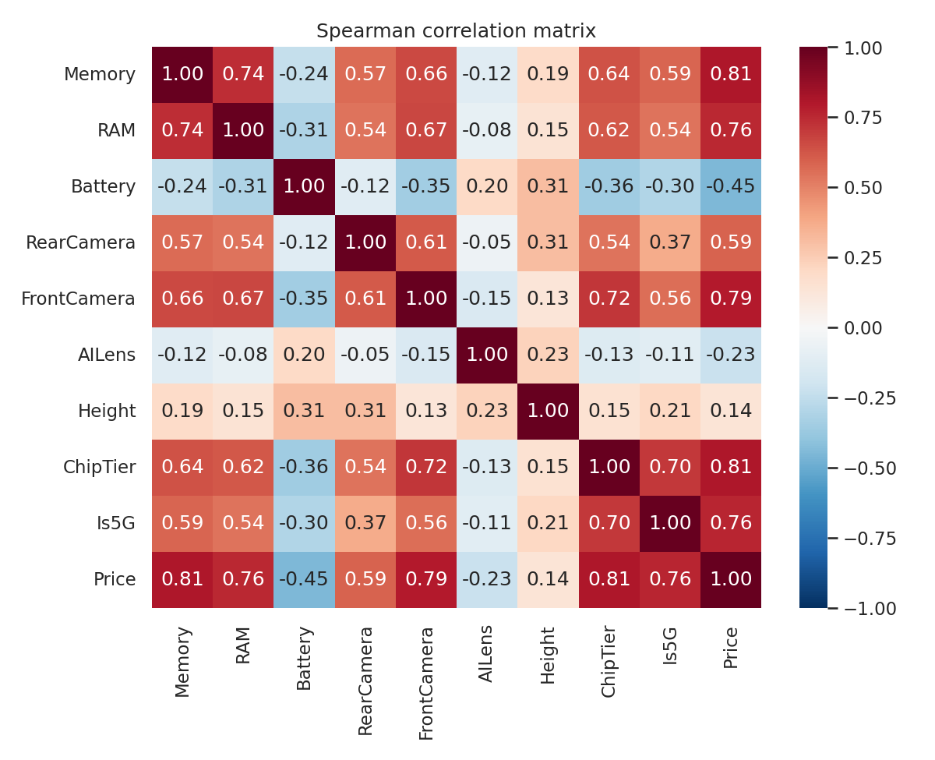
Figure 2. Spearman correlation matrix. Note the strong overlap between RAM, storage, chipset tier and front camera.

5.2 Mutual information and ANOVA
Mutual information captures non-linear relationships. Storage, front camera, RAM and chipset tier rank highest, AI Lens lowest. Height scores high on mutual information but its ANOVA F-test is insignificant (p = 0.40) and its permutation importance is small: it acts as a fingerprint for specific models rather than a real price driver.
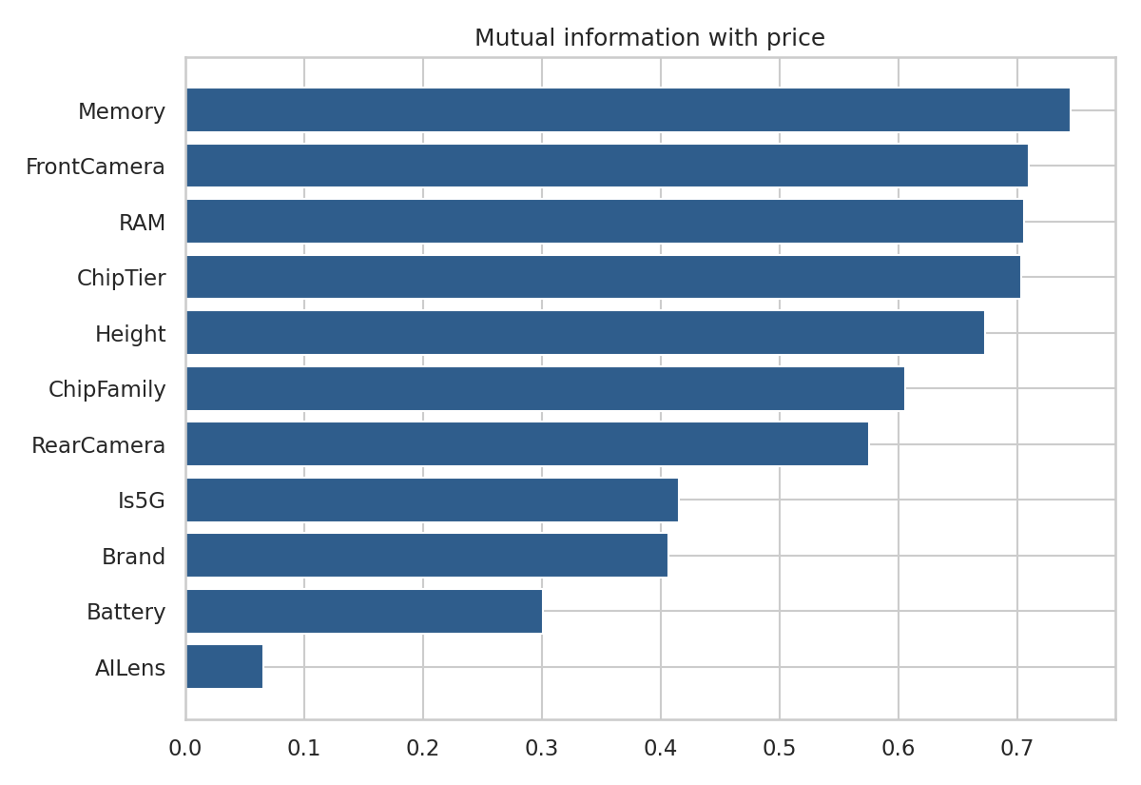
Figure 3. Mutual information between each feature and price.

5.3 Dimensionality reduction (PCA)
The first principal component explains 41.5% of variance and loads almost equally on storage, RAM, chipset tier, 5G and front camera (0.35–0.42 each). In other words, these specs move together as a single "performance level" axis. This is why they need to be analysed as a bundle (section 7). PC2 (18.6%) is mostly battery and screen height, and PC3 is almost entirely AI Lens, which is isolated from everything else.
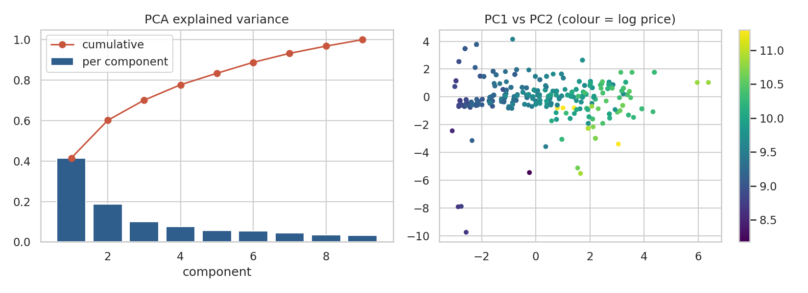
Figure 4. PCA explained variance and the first two components coloured by log price: price rises steadily along PC1.
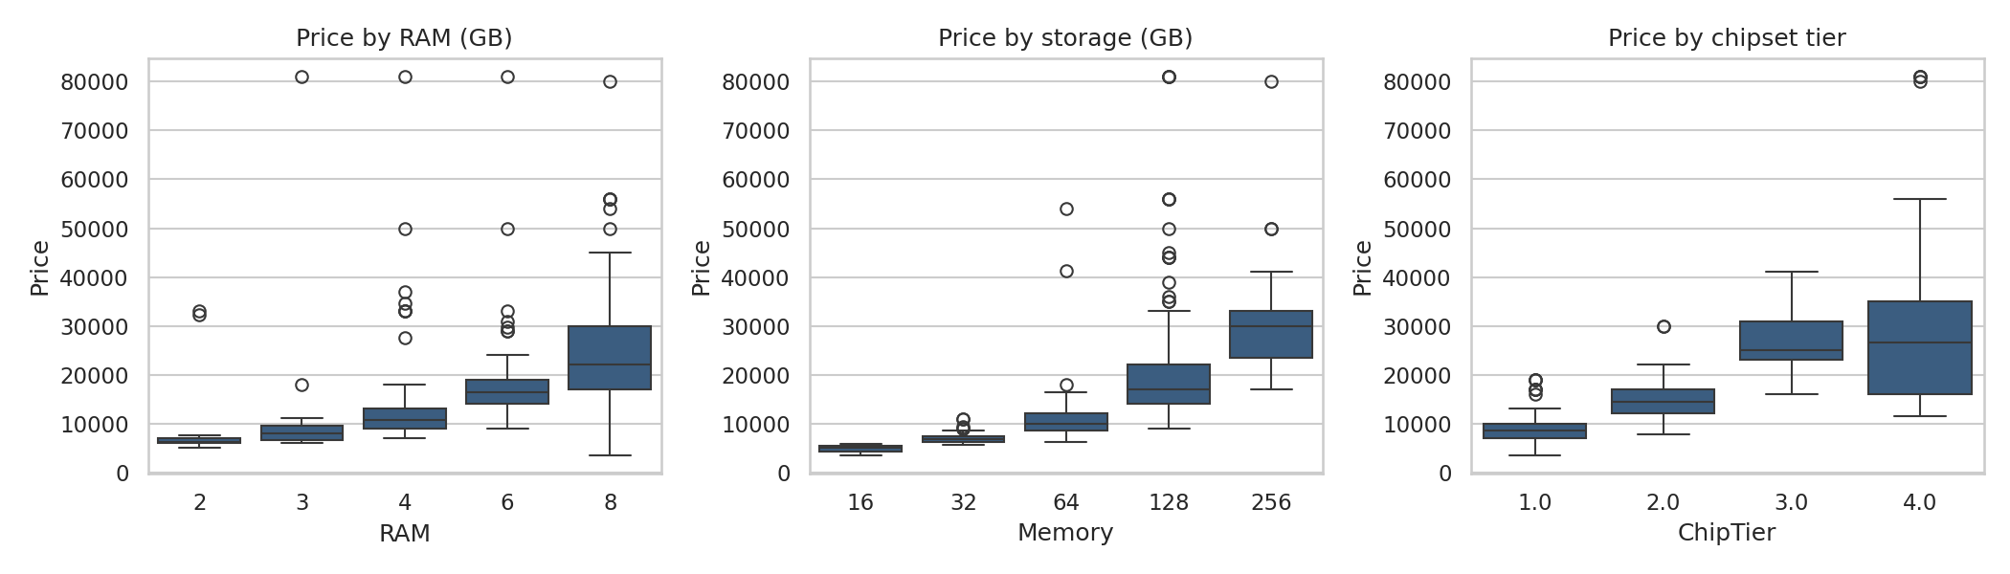
Figure 5. Price rises step by step with RAM, storage and chipset tier.

6. Model building and evaluation
Four models were built: Ridge regression on log-price (linear baseline), a Decision Tree, a Random Forest and Gradient Boosting. Each was evaluated on two splits:
- Random 80/20 split (as in the brief): optimistic, because colour and variant duplicates of one phone appear in both train and test.
- Unseen-model split: whole phone models are held out (35 models, 105 listings in test). This is the honest estimate for pricing a new launch.
Model | Random MAE | Random R² | Unseen MAE | Unseen RMSE | Unseen R² | Unseen MAPE
Ridge (log-price) | 4,003 | 0.50 | 2,752 | 3,484 | 0.81 | 18.1%
Decision Tree | 2,784 | 0.81 | 2,947 | 4,841 | 0.63 | 15.7%
Random Forest | 2,172 | 0.84 | 2,619 | 3,565 | 0.80 | 15.5%
Gradient Boosting | 1,763 | 0.89 | 2,165 | 3,120 | 0.85 | 12.7%
PCA + Ridge (log-price) | 4,340 | 0.47 | 3,117 | 4,057 | 0.74 | 19.6%
PCA + Gradient Boosting | 2,242 | 0.74 | 3,244 | 4,558 | 0.67 | 19.4%
Gradient Boosting (tuned) | - | - | 2,328 | 3,085 | 0.85 | 14.5%
Table 1. Test performance in Rs. MAE = mean absolute error, RMSE = root mean squared error.
Gradient Boosting is the best model on the held-out split (MAE Rs 2,165, RMSE Rs 3,120). Grid-search tuning with grouped cross-validation did not improve the test score (MAE Rs 2,328), which is a normal outcome with only 35 held-out models; we kept the tuned model for the importance analysis because it was selected without touching the test set.

Cross-validation (5 grouped folds)
Model | CV MAE (mean ± sd) | CV R² (mean ± sd)
Ridge (log-price) | 3,009 ± 720 | 0.72 ± 0.13
Decision Tree | 4,239 ± 968 | 0.36 ± 0.30
Random Forest | 3,384 ± 381 | 0.64 ± 0.09
Gradient Boosting | 3,049 ± 493 | 0.69 ± 0.07
PCA + Ridge (log-price) | 3,318 ± 749 | 0.67 ± 0.16
PCA + Gradient Boosting | 3,254 ± 673 | 0.67 ± 0.15

Averaged across folds, Ridge and Gradient Boosting are statistically indistinguishable, both clearly ahead of the Random Forest and far ahead of the single Decision Tree. With this small dataset, the simpler Ridge model is a legitimate alternative and is easier to explain to business users; Gradient Boosting is preferred for its lower variance and better single-split result.

PCA-based models
To test dimensionality reduction inside the modelling pipeline, we standardised all 27 model inputs and kept the 13 principal components that explain 95% of the variance, then fitted Ridge and Gradient Boosting on those components. Both did worse than the same models on the original features (unseen-model MAE Rs 3,117 and Rs 3,244, versus Rs 2,752 and Rs 2,165). With only about 27 inputs there is little to compress, and the components blend features that move price in different directions (for example battery and screen height). PCA remains useful for understanding the data (section 5.3), but feature selection on the original columns is the better choice here, and it keeps the model interpretable.
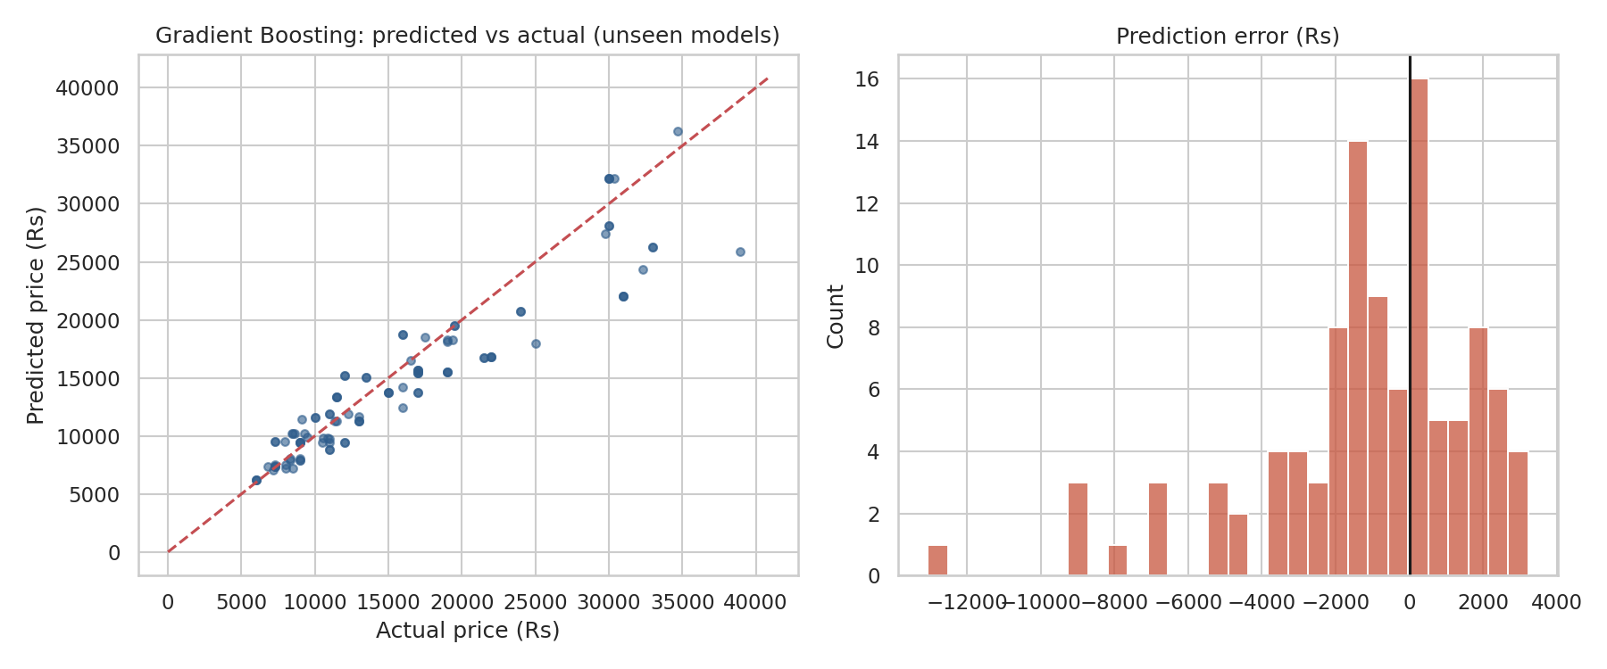
Figure 6. Predicted versus actual price on unseen models, and the distribution of errors.
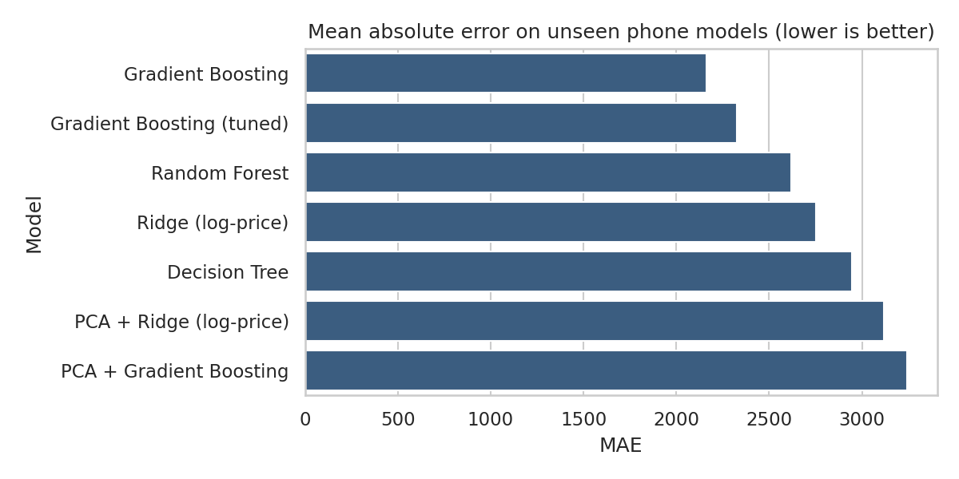
Figure 7. Held-out MAE by model.

7. Feature importance analysis
Importance was measured three ways so that conclusions do not rest on one method: impurity importance (Gradient Boosting and Random Forest), permutation importance on the unseen-model test set, and grouped permutation for correlated features.
Feature | GB impurity | RF impurity | Permutation (Rs MAE lost) | Spearman
ChipTier | 0.417 | 0.505 | 2,042 | 0.81
Brand | 0.058 | 0.057 | 828 | n/a
FrontCamera | 0.157 | 0.128 | 575 | 0.79
Is5G | 0.051 | 0.008 | 531 | 0.76
Battery | 0.179 | 0.116 | 515 | -0.45
Memory | 0.047 | 0.052 | 514 | 0.81
Height | 0.036 | 0.035 | 220 | 0.14
RAM | 0.013 | 0.021 | 154 | 0.76
ChipFamily | 0.021 | 0.052 | 99 | n/a
RearCamera | 0.022 | 0.026 | 28 | 0.59
AILens | 0.000 | 0.000 | 19 | -0.23
Table 2. Feature importance summary, sorted by permutation importance.
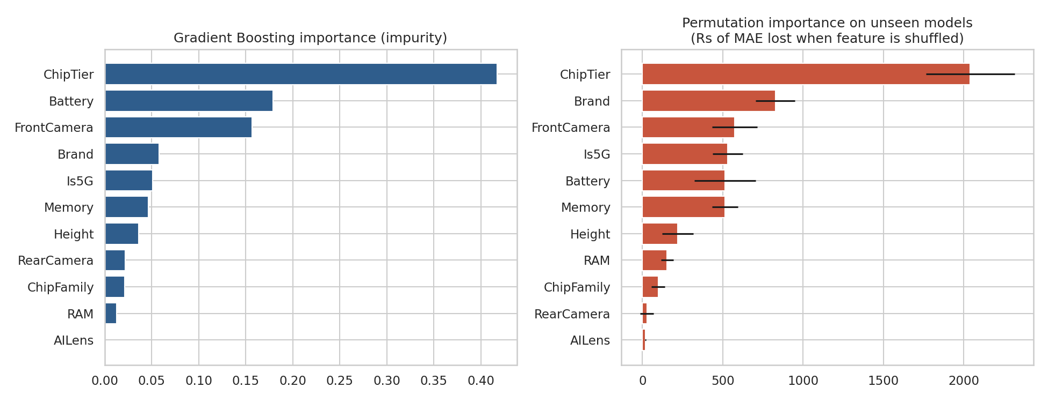
Figure 8. Gradient Boosting impurity importance and permutation importance on unseen models.
Chipset tier is the clear number one in every method. Methods disagree on the middle of the ranking (for example Battery ranks second on impurity but fifth on permutation), which is expected when features are correlated, so the middle ranks should be read as a group rather than a strict order.
RAM and storage look weak individually but are not. They are highly correlated with each other and with chipset tier, so shuffling one of them lets the model recover its information from the others. Shuffling related features together gives a truer picture:
Feature bundle shuffled together | Prediction error added (Rs MAE)
Performance bundle (ChipTier+ChipFamily+RAM+Memory) | 2,842 ± 302
Memory + RAM only | 717 ± 146
Cameras (Front+Rear) | 916 ± 178
Connectivity+Brand (Is5G+Brand) | 1,218 ± 143
Table 3. Grouped permutation importance on unseen models.
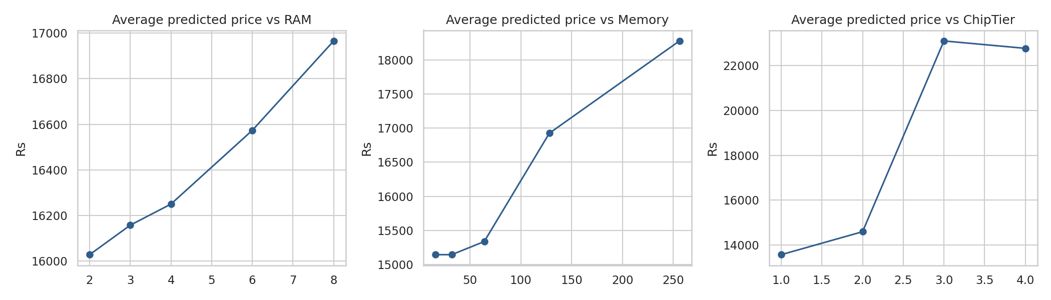
Figure 9. Average predicted price as RAM, storage and chipset tier change, other features unchanged.

8. Recommendations
1. Anchor pricing on the performance tier. Chipset tier is the strongest single lever. Median price rises from Rs 8,574 (entry chips) to Rs 14,490 (lower-mid), Rs 24,999 (upper-mid) and Rs 26,499 (flagship). Use the chipset tier as the first step when positioning any new phone, then adjust for other features.
2. Build a RAM and storage price ladder. Medians step from Rs 6,794 (32 GB) to Rs 9,999, Rs 16,999 and Rs 29,999 (256 GB); and from Rs 6,299 (2 GB RAM) to Rs 10,699, Rs 16,499 and Rs 21,999 (8 GB RAM). Memory configuration is the cheapest way to create distinct price points within one model.
3. Treat 5G and brand as premium add-ons. 5G phones have a median price of Rs 21,749 versus Rs 9,999 for non-5G. Part of this is because 5G arrives together with better chips, but the model still assigns it independent value. Brand median prices range from Rs 8,368 (Tecno) and Rs 8,999 (Infinix) up to Rs 43,999 (Google), and the small premium-brand group (Apple, OnePlus and others, shown as Other) sits at Rs 26,438. Brand still adds accuracy after specs are known, so a brand adjustment belongs in any pricing formula. Apple and OnePlus have too few rows to be modelled separately.
4. Use front camera megapixels as a segment indicator, not a selling point. Front-camera resolution climbs with price tier (5 MP on entry phones, 16 MP and above on mid-range and premium). It is informative for classifying a phone's segment, whereas rear-camera megapixels (50 MP is common even on cheap phones) have almost no pricing power once other specs are known.
5. Do not charge for, or lean on, AI Lens or colour. AI Lens phones have a lower median price (Rs 8,999 versus Rs 14,499) and the feature has essentially zero predictive value. Colour has no significant effect after specs are accounted for. Both are useful for variety, not for price.
6. Battery size is not a price lever. Bigger batteries are associated with cheaper phones. Marketing battery as a value feature suits budget lines; do not expect it to justify a premium.
7. Use the model as a benchmarking tool. For a new or competitor phone, the model gives a reference price to within roughly Rs 2,165 on average. Phones priced far above or below the predicted value are either strong bargains or overpriced relative to the market, which can guide discounting and competitive positioning.

9. Limitations and next steps
- Small dataset: 517 listings and 174 distinct models. The held-out test contained only 35 models, so model rankings (Ridge vs Gradient Boosting) carry real uncertainty; cross-validation is the better guide.
- Premium phones are sparse (a handful of Apple, Google and OnePlus rows), so predictions above about Rs 50,000 are the least reliable. Percentage errors are larger on cheap phones.
- Chipset tier and the 5G flag were built with hand-written rules from domain knowledge; they should be reviewed if exact accuracy matters. 5G detection from model names will miss some 5G handsets.
- Results show associations in one price snapshot, not causal effects. Listing prices may include temporary seller discounts and the data has no date, so price changes over time cannot be modelled.
- Useful additions: launch date, display type and refresh rate, charging speed, build quality and sales volume. Re-train periodically as new models launch.

Appendix: deliverables
File | Contents
mobile_price_project.py | Complete, commented pipeline (cleaning, features, selection, models, evaluation, importance, figures)
data/cleaned_mobile_data.csv | Cleaned dataset with engineered features
data/model_comparison.csv, cross_validation.csv | Model metrics
data/feature_importance_summary.csv | Importance by method
mobile_price_project.ipynb | Step-by-step Jupyter notebook version of the pipeline, with outputs
Mobile_Price_Prediction_Slides.pptx | Short presentation of the findings
figures/*.png | All ten charts used in this report
results.json | All numbers quoted in this report

