**PL/SQL:**

**EXERCISE:1**

CREATE TABLE Customers (

CustomerID NUMBER PRIMARY KEY,

Name VARCHAR2(50),

Age NUMBER,

Balance NUMBER,

IsVIP VARCHAR2(5)

);

CREATE TABLE Loans (

LoanID NUMBER PRIMARY KEY,

CustomerID NUMBER REFERENCES Customers(CustomerID),

InterestRate NUMBER,

DueDate DATE

);

INSERT INTO Customers VALUES (10, 'Ravi Kumar', 63, 11000, 'FALSE');

INSERT INTO Customers VALUES (11, 'Sneha Roy', 59, 4000, 'FALSE');

INSERT INTO Customers VALUES (12, 'Arjun Mehta', 72, 9500, 'FALSE');

INSERT INTO Customers VALUES (13, 'Priya Singh', 35, 15000, 'FALSE');

INSERT INTO Loans VALUES (201, 10, 6.7, SYSDATE + 20);

INSERT INTO Loans VALUES (202, 11, 7.1, SYSDATE + 10);

INSERT INTO Loans VALUES (203, 12, 6.0, SYSDATE + 40);

INSERT INTO Loans VALUES (204, 13, 6.5, SYSDATE + 5);

COMMIT;

SELECT * FROM Customers;

SELECT * FROM Loans;

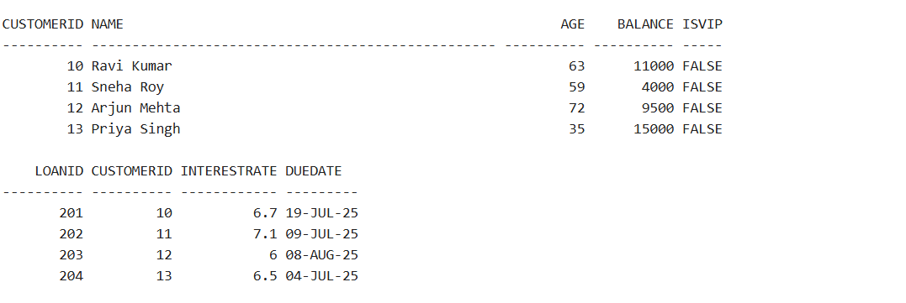

**Scenario 1: Interest discount for age > 60**

BEGIN

FOR cust IN (SELECT CustomerID FROM Customers WHERE Age > 60) LOOP

UPDATE Loans

SET InterestRate = InterestRate - 1

WHERE CustomerID = cust.CustomerID;

END LOOP;

COMMIT;

END;

/

SELECT * FROM Loans;

**OUTPUT:**

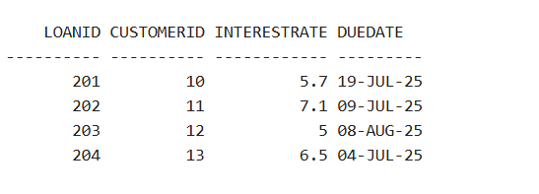

**Scenario 2: Mark VIPs with balance > 10000**

BEGIN

FOR cust IN (SELECT CustomerID FROM Customers WHERE Balance > 10000) LOOP

UPDATE Customers

SET IsVIP = 'TRUE'

WHERE CustomerID = cust.CustomerID;

END LOOP;

COMMIT;

END;

/

SELECT * FROM Customers;

**OUTPUT:**

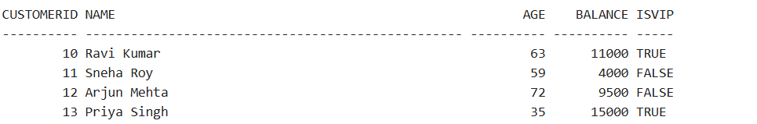

**Scenario 3: Reminders for loans due in next 30 days**

BEGIN

FOR loan_rec IN (

SELECT c.Name, l.DueDate

FROM Loans l

JOIN Customers c ON c.CustomerID = l.CustomerID

WHERE l.DueDate <= SYSDATE + 30

) LOOP

DBMS_OUTPUT.PUT_LINE('Reminder: Loan for ' || loan_rec.Name ||

' is due on ' || TO_CHAR(loan_rec.DueDate, 'DD-MON-YYYY'));

END LOOP;

END;

/

**EXERCISE:3**

CREATE TABLE Accounts (

AccountID NUMBER PRIMARY KEY,

CustomerName VARCHAR2(50),

Balance NUMBER,

AccountType VARCHAR2(20)

);

CREATE TABLE Employees (

EmpID NUMBER PRIMARY KEY,

EmpName VARCHAR2(50),

Department VARCHAR2(50),

Salary NUMBER

);

INSERT INTO Accounts VALUES (201, 'Karan Patel', 5000, 'Savings');

INSERT INTO Accounts VALUES (202, 'Divya Sharma', 2500, 'Current');

INSERT INTO Accounts VALUES (203, 'Manoj Reddy', 8000, 'Savings');

INSERT INTO Accounts VALUES (204, 'Neha Joshi', 7000, 'Savings');

INSERT INTO Employees VALUES (11, 'Kavita Nair', 'Finance', 60000);

INSERT INTO Employees VALUES (12, 'Rohan Jain', 'Marketing', 48000);

INSERT INTO Employees VALUES (13, 'Swati Bhat', 'Finance', 62000);

INSERT INTO Employees VALUES (14, 'Anil Kapoor', 'IT', 52000);

COMMIT;

SELECT * FROM Accounts;

SELECT * FROM Employees;

**OUTPUT:**

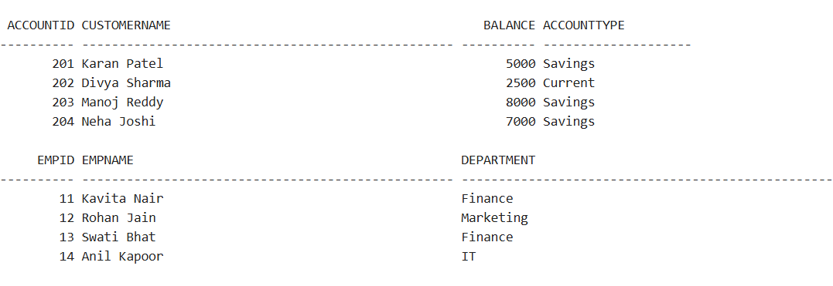

**Scenario 1:**

CREATE OR REPLACE PROCEDURE ProcessMonthlyInterest IS

BEGIN

UPDATE Accounts

SET Balance = Balance * 1.01

WHERE AccountType = 'Savings';

COMMIT;

END;

/

BEGIN

ProcessMonthlyInterest;

END;

/

SELECT * FROM Accounts;

**OUTPUT:**

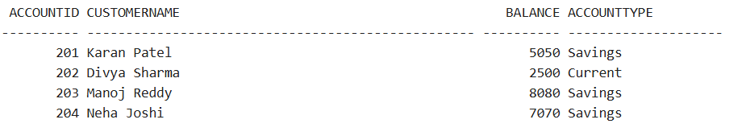

**Scenario 2: UpdateEmployeeBonus**

CREATE OR REPLACE PROCEDURE UpdateEmployeeBonus (

p_dept IN VARCHAR2,

p_bonus_percent IN NUMBER

) IS

BEGIN

UPDATE Employees

SET Salary = Salary + (Salary * p_bonus_percent / 100)

WHERE Department = p_dept;

COMMIT;

END;

/

BEGIN

UpdateEmployeeBonus('Finance', 15);

END;

/

SELECT * FROM Employees;

**OUTPUT:**

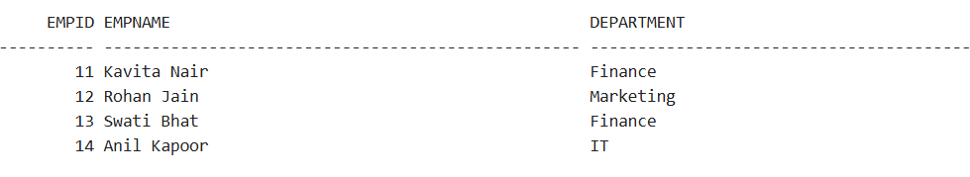

**Scenario 3: TransferFunds**

CREATE OR REPLACE PROCEDURE TransferFunds (

p_from_account IN NUMBER,

p_to_account IN NUMBER,

p_amount IN NUMBER

) IS

v_balance NUMBER;

BEGIN

SELECT Balance INTO v_balance FROM Accounts WHERE AccountID = p_from_account;

IF v_balance < p_amount THEN

RAISE_APPLICATION_ERROR(-20001, 'Insufficient balance for transfer.');

END IF;

UPDATE Accounts

SET Balance = Balance - p_amount

WHERE AccountID = p_from_account;

UPDATE Accounts

SET Balance = Balance + p_amount

WHERE AccountID = p_to_account;

COMMIT;

END;

/

BEGIN

TransferFunds(204, 202, 1000);

END;

/

SELECT * FROM Accounts;

**OUTPUT:**

