Game Design Document

Fill up the following document

1. Write the title of your project.

Riches chase

1. What is the goal of the game?

Goal will be collecting treasure

1. Write a brief story of your game.

A super-intelligent girl detective is ordered by the government to solve the case of the lost treasure. The treasure is kept in the old haunted house. This case has been solved by no one to date. It is a haunted house where the detective needs to enter. After entering the house there will be ___________ number of **NORMAL ROOMS** where the Keys will be kept in a safe and a **MAIN ROOM** where the main treasure is kept... After entering each room if there are any Ghosts /Zombies She needs to shoot them by gun. If she loses to defeat the Ghosts/Zombies, the game will end and again restart. And if she defeats the ghosts/Zombies she needs to Open the safe, rescue the key and go to the next room. She needs to get the keys from each of the rooms by defeating the Ghosts/Zombies and go to the main room. In the main room, there will be double ghosts /Zombies .Defeat all of the

ghosts/Zombies; hand over the treasure to the government, and the game ends.

1. Which are the playing characters of this game?

* Playing characters are the ones who respond to the user based on the input from the user.
* Cars, monkeys, dinos, wizards, etc., are the playing characters in the game.

|  |  |  |
| --- | --- | --- |
| Number | Character Name | What can this character do? |
| 1 | The detective girl | Has to rescue all the treasures from each room and hand over to the government. |

1. Which are the Non-Playing Characters of this game?

* Non-Playing characters are the ones that don't have an action or behavior when the user interacts with the game.
* Hurdles, stones, bananas, coins, etc., are non-playing characters in the game.

|  |  |  |
| --- | --- | --- |
| Number | Character Name | What can this character do? |
| 1 | Ghosts/Zombies | Has to protect the lost treasure from being taken away at any cost. |

Draw your imagination of this game. What does this game look like?

* Draw the game either on your computer or on paper.
* Add images of the game scenes to show each of the playing and non-playing characters at least once.

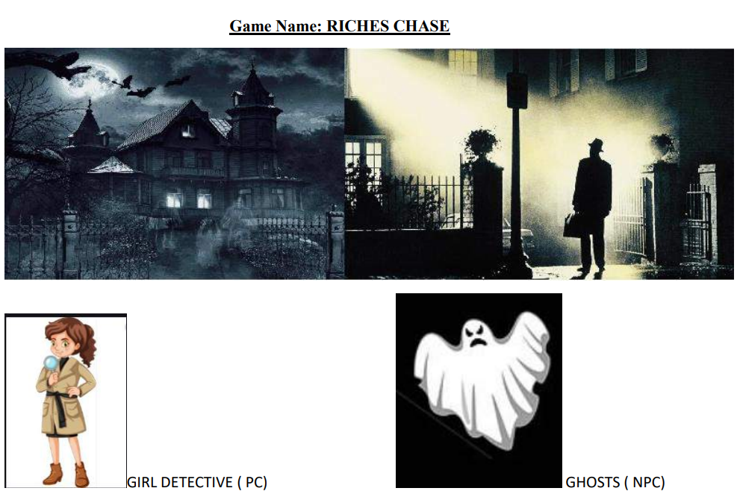

6. How do you plan to make your game engaging?

By giving a loud horror background sound.

By increasing the number of ghosts at each level.

By adding bullet shooting Whenever the girl sees the ghosts.