

PROJECT
1. Complex Filters & Projections:
Q1. List the names and departments of students who have more than 85% attendance and are skilled in both "MongoDB" and "Python".
Solution:
db.students.find(
{
attendance: { $gt: 85 },
skills: { $all: ["MongoDB", "Python"] }
},
{
_id: 0,
name: 1,
department: 1
}
);

Output:

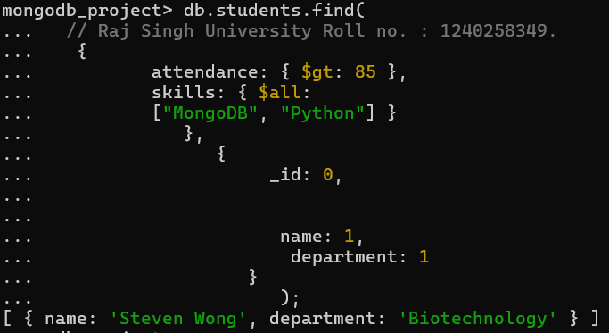

Q2. Show all faculty who are teaching more than 2 courses. Display their names and the total number of courses they teach.
Solution:

db.faculty.aggregate(
[ {
$project: {
name: 1,
totalCourses: { $size: "$courses" }
} },
{
$match: { totalCourses: { $gt: 2 } }
}]);

Output:

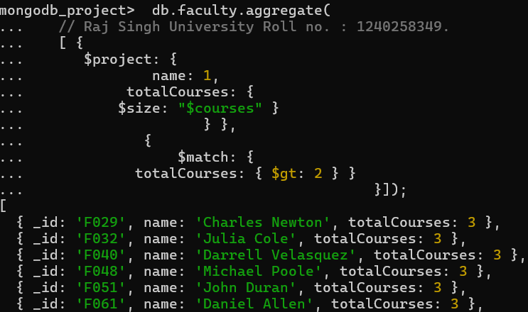

2. Joins ($lookup) and Aggregations:
Q3. Write a query to show each student’s name along with the course titles they are enrolled in (use $lookup between enrollments, students, and courses).
Solution:
db.enrollments.aggregate( [
{
$lookup: {
from: "students",
localField: "student_id",
foreignField: "_id",
as: "studentInfo"
}
},
{
$lookup: {
from: "courses",
localField: "course_id",
foreignField: "_id",
as: "courseInfo"
}
},
{
$project: {
_id: 0,
studentName: { $arrayElemAt: ["$studentInfo.name", 0] },
courseTitles: "$courseInfo.title"
}
}
]
);
Output:

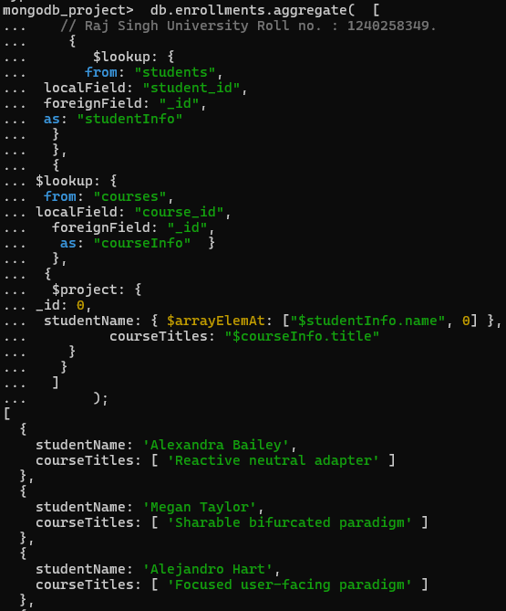

Q4. For each course, display the course title, number of students enrolled, and average marks (use $group).
Solution:
db.enrollments.aggregate( [
{
$group: {
_id: "$course_id",
totalStudents: { $sum: 1 },
averageMarks: { $avg: "$marks" }
}
},
{
$lookup: {
from: "courses",
localField: "_id",
foreignField: "_id",
as: "courseInfo"
}
},
{
$project: {
_id: 0,
courseTitle: { $arrayElemAt: ["$courseInfo.title", 0] },
totalStudents: 1,
averageMarks: 1
}
}
]);

Output:

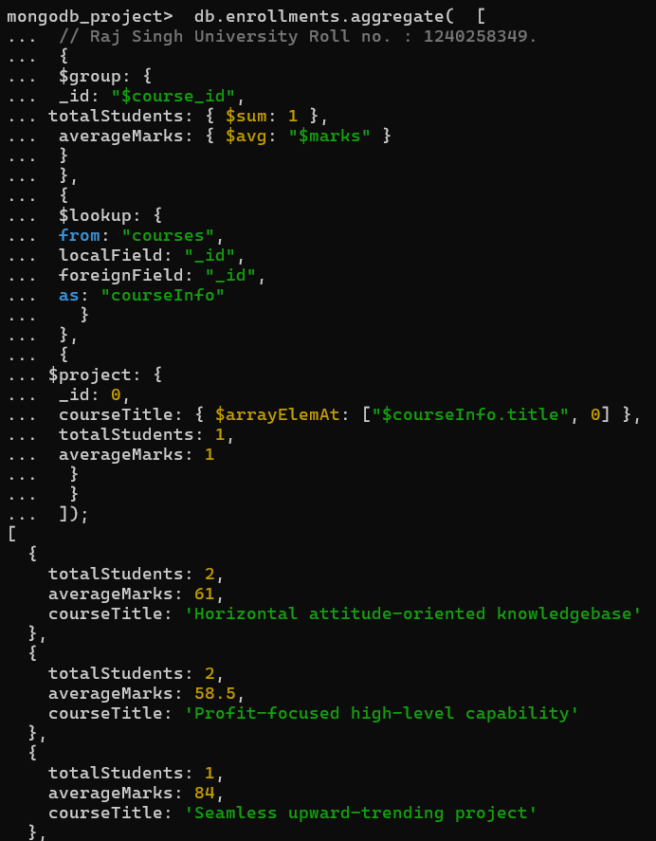

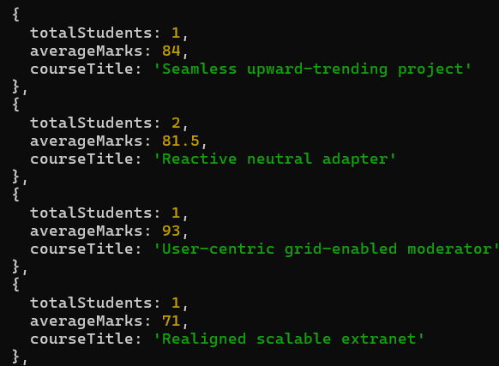
3.Grouping, Sorting, and Limiting
Q.5 Find the top 3 students with the highest average marks across all enrolled courses
Solution:
db.enrollments.aggregate([
{
$group: {
_id: "$student_id",
averageMarks: { $avg: "$marks" }
} },
{
$lookup: {
from: "students",
localField: "_id",
foreignField: "_id",
as: "student_info"
} },
{ $unwind: "$student_info" },
{
$project: {
_id: 0,
student_id: "$_id",
name: "$student_info.name",
department: "$student_info.department",
averageMarks: { $round: ["$averageMarks", 2] }
} },
{ $sort: { averageMarks: -1 } },
{ $limit: 3 }
]) ;

Output:

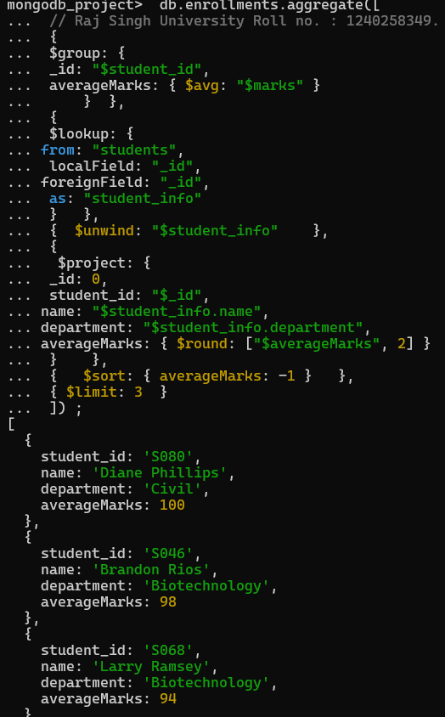

Q6. Count how many students are in each department. Display the department with the highest number of students.
Solution:
db.students.aggregate([
{
$group: {
_id: "$department",
totalStudents: { $sum: 1 }
}
},
{
$sort: { totalStudents: -1 }
},
{ $limit: 1}
] );

Output:

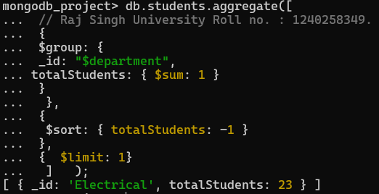

4.Update, Upsert, and Delete

Q7. Update attendance to 100% for all students who won any "Hackathon"
Solution:
db.students.updateMany(
{
_id: {
$in: db.activities.distinct("student_id", { type: "Hackathon", position: "Winner" })
}
},
{ $set: { attendance: 100 } }
)
Output:-

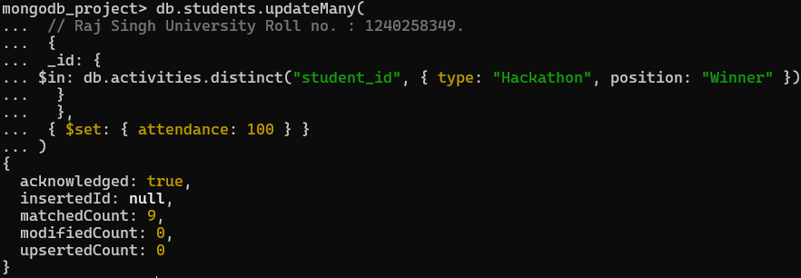

Q8. Delete all student activity records where the activity year is before 2022
Solution:
db.activities_full.deleteMany(
{ year: { $lt: 2022 } });

Output:

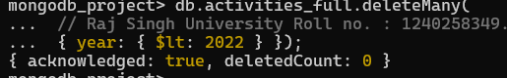

Q9. Upsert a course record for "Data Structures" with ID "C150" and credits 4—if it doesn’t exist, insert it; otherwise update its title to "Advanced Data Structures".
Solution:
db.courses.updateOne(
{ _id: "C150" },
{ $set: { title: "Advanced Data Structures", credits: 4 } },
{ upsert: true }
);
Output:

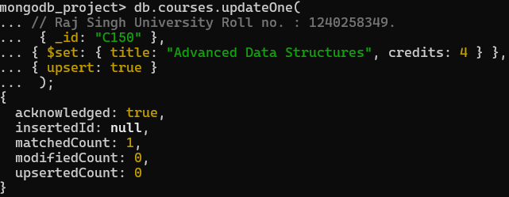
5.Array & Operator Usage
Q10. Find all students who have "Python" as a skill but not "C++"
Solution:
db.students.find({

$and: [
{ skills: "Python" },
{ skills: { $ne: "C++" } }
]
});
Output:

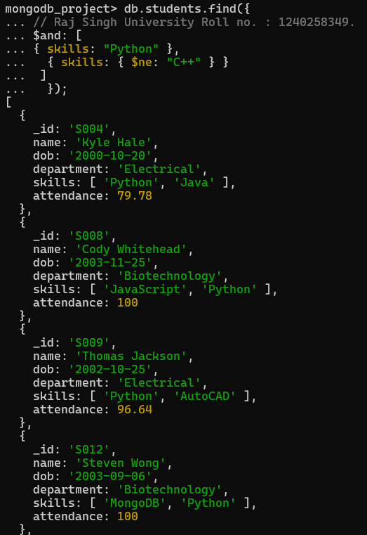

Q11. Return names of students who participated in "Seminar" and "Hackathon" both.

Solution:
db.activities.aggregate([
{
$group: {
_id: "$student_id",
activities: { $addToSet: "$type" }
} },
{
$match: {
activities: { $all: ["Seminar", "Hackathon"] }
} },
{
$lookup: {
from: "students",
localField: "_id",
foreignField: "_id",
as: "student_details"
}
},
{
$project: {
_id: 0,
name: { $arrayElemAt: ["$student_details.name", 0] }
} } ]);

Output:

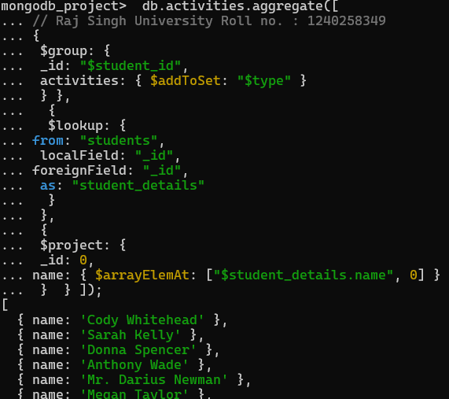

7.Advanced Aggregation (Challenge Level)
Q13. For each faculty member, list the names of all students enrolled in their courses along with average marks per student per faculty.
Solution:
db.faculty.aggregate([
{
$lookup: {
from: "courses",
localField: "_id",
foreignField: "faculty_id",
as: "course_info"
} },
{ $unwind: "$course_info" },
{
$lookup: {
from: "enrollments",
localField: "course_info._id",
foreignField: "course_id",
as: "enroll_info"
} },
{ $unwind: "$enroll_info" },
{
$lookup: {
from: "students",
localField: "enroll_info.student_id",
foreignField: "_id",
as: "student_info"
} },
{ $unwind: "$student_info" },
{
$group: {
_id: {
faculty_id: "$_id",
faculty_name: "$name",
student_name: "$student_info.name"
},
avg_marks: { $avg: "$enroll_info.marks" }
} },
{
$group: {
_id: {
faculty_id: "$_id.faculty_id",
faculty_name: "$_id.faculty_name"
},
students: {
$push: {
student_name: "$_id.student_name",
average_marks: { $round: ["$avg_marks", 2] }
} } } },
{ $project: {
_id: 0,
faculty_name: "$_id.faculty_name",
students: 1 }
} ] );

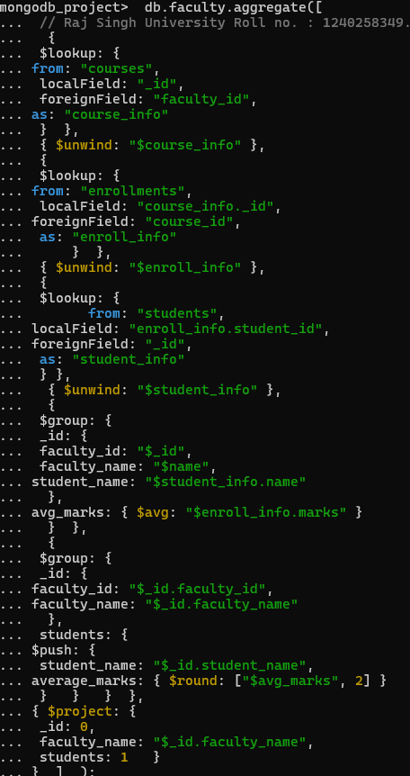

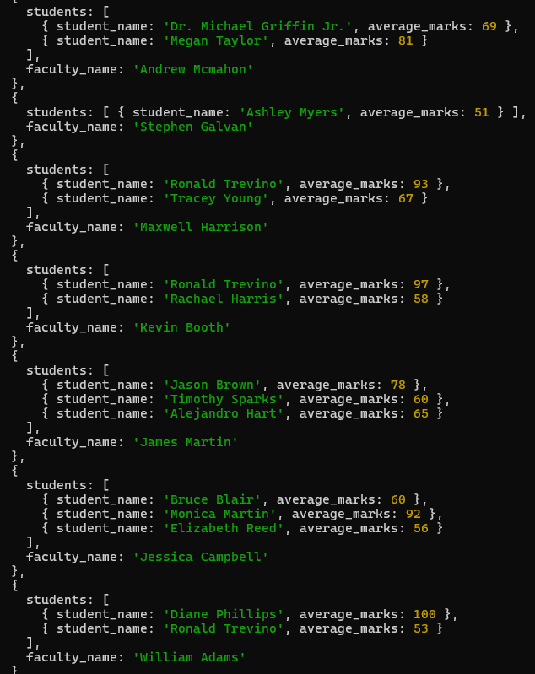

Q14. Show the most popular activity type (e.g., Hackathon, Seminar, etc.) by number of student participants.
Solution:
db.activities.aggregate([
\
{
$group: {
_id: "$type",
totalParticipants: { $addToSet: "$student_id" }
} },
{
$project: {
_id: 1,
participantCount: { $size: "$totalParticipants" }
} },
{
$sort: { participantCount: -1 }
},
{
$limit: 1
} ] );

