

### **Hospital Nursing Intervention Pilot Program**

#### ALY6030-Mod4: Assignment 2

#### Integrated Data Warehousing and SQL

Instructor: [Kayal Chandrasekaran](https://northeastern.instructure.com/courses/140410/users/121784)

16th June 2023

Submitted By: Srishti Singh

**Introduction**

This report presents an analysis of hospital data aimed at providing insights and recommendations to the Leadership team. The dataset includes information from dimension tables such as "business.csv" and "bed_type.csv," as well as a fact table named "bed_fact.csv." By examining the dimensions and facts within the dataset, we can gain a deeper understanding of hospital bed utilization and identify potential candidates for a pilot intervention program.

**Questions:**

1. **Listing each dimension table's dimensions.**

*In the bed_type dimension table, the dimensions are:*

**bed_id (Primary Key), bed_code, bed_desc**

Bed_id: This may be regarded as a dimension and is the primary key (PK) of the dimension table.

bed_code: This variable shows the unique code given to each type of bed. It is an attribute of a dimension.

Bed_desc: This variable offers a summary or more details about each type of bed. It is a dimension property as well.

*In the business dimension table, the identified dimension is:*

**Ims_org_id (Primary Key), Business Name**

Ims_org_id: This can be regarded as a dimension because it is the main key (PK) of the dimension table.

Business_Name: The variable contains the names of several kinds of enterprises. *In the bed_fact fact table, the identified dimension is:*

Ims_org_id + bed_Id is the **composite primary key**

1. **Facts variables present in the single Fact Table**

bed_fact_Table: For this fact table, according to the first preface it looks it has 3 facts:

* census _beds
* staffed_beds
* license_beds

Business_Table : For this fact table, according to the first preface it looks it has 3 facts:

* ttl_census _beds
* ttl_staffed_beds
* ttl_license_beds

Note: After a closer look for each ims_code I was able to see that see bed counts in Bed_fact Table are similar to the total bed counts in Business_table.

1. **Star Schema created using MYSQL Workbench**

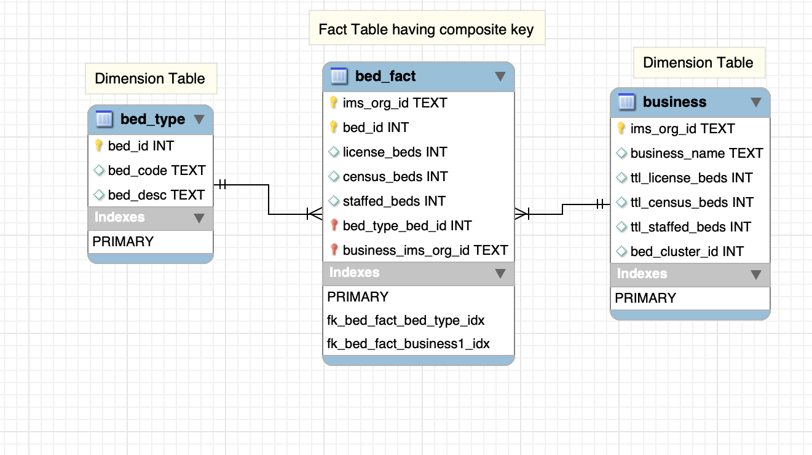

1. **(a) Analysis for Leadership**

Top 10 hospitals by total number of ICU or SICU licensing beds, listed in descending order.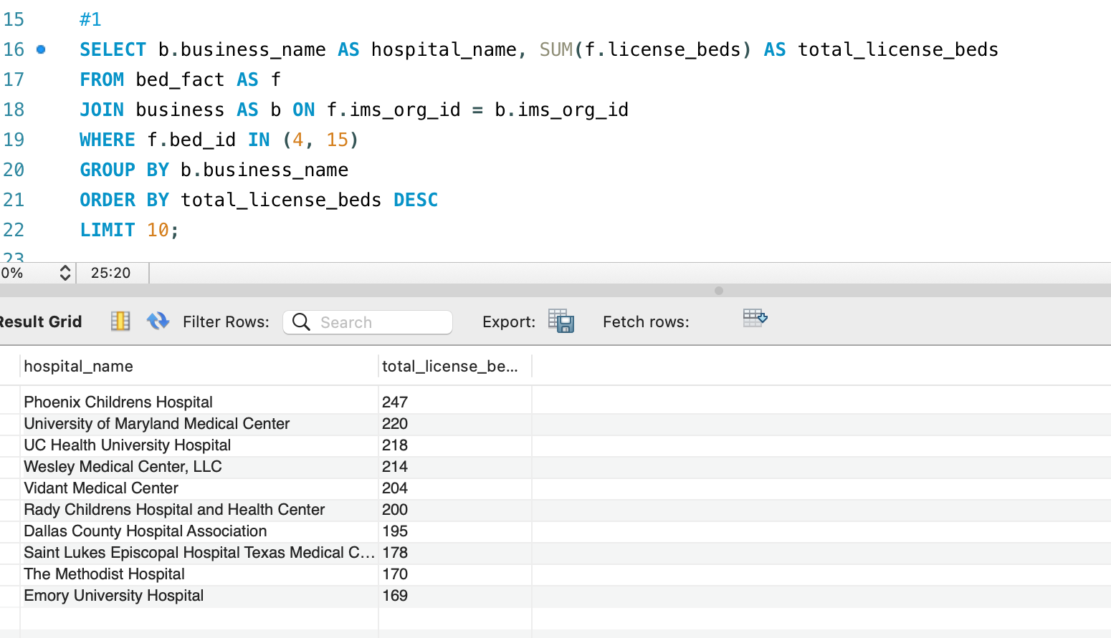

2. List of the top 10 hospitals ranked by the number of ICU or SICU beds.

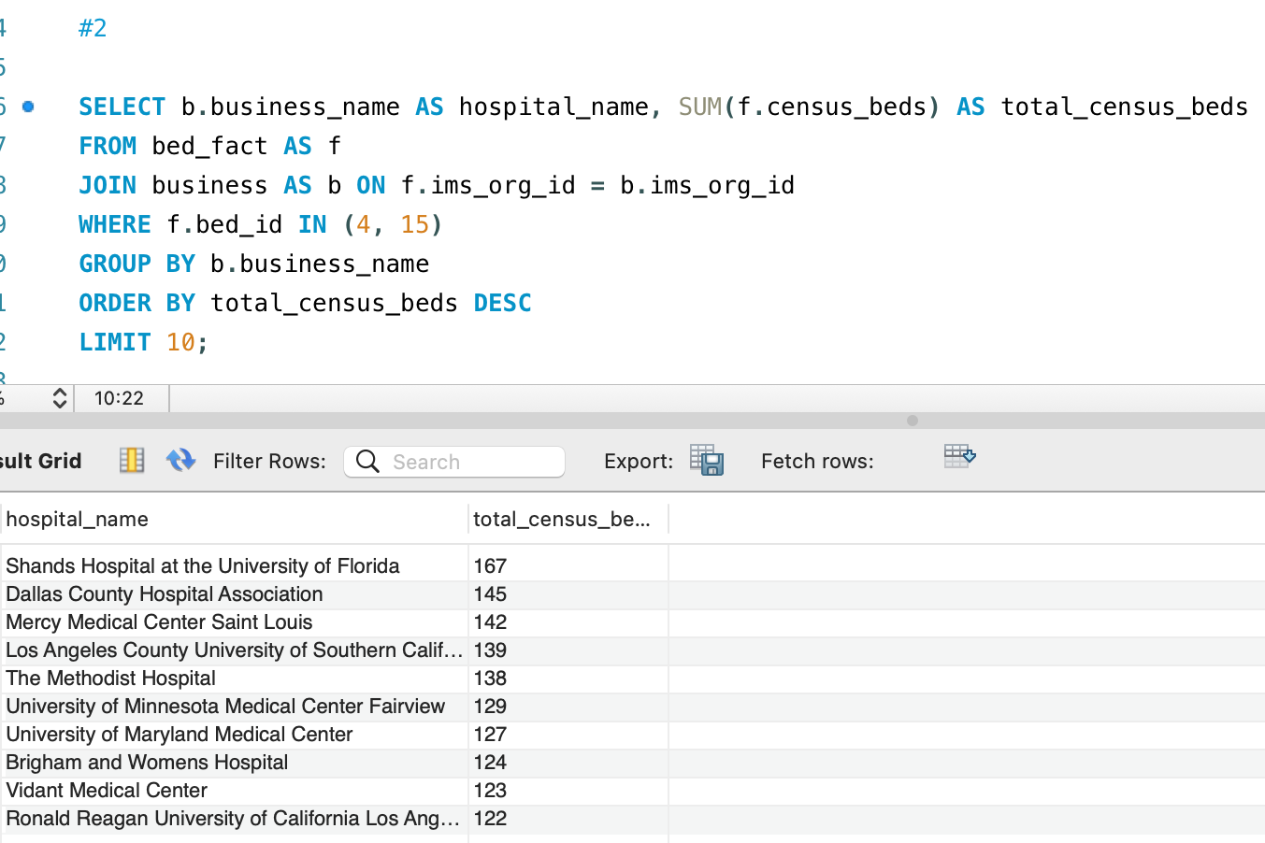

3. List of the top 10 hospitals ranked by the number of beds with ICU or SICU personnel.

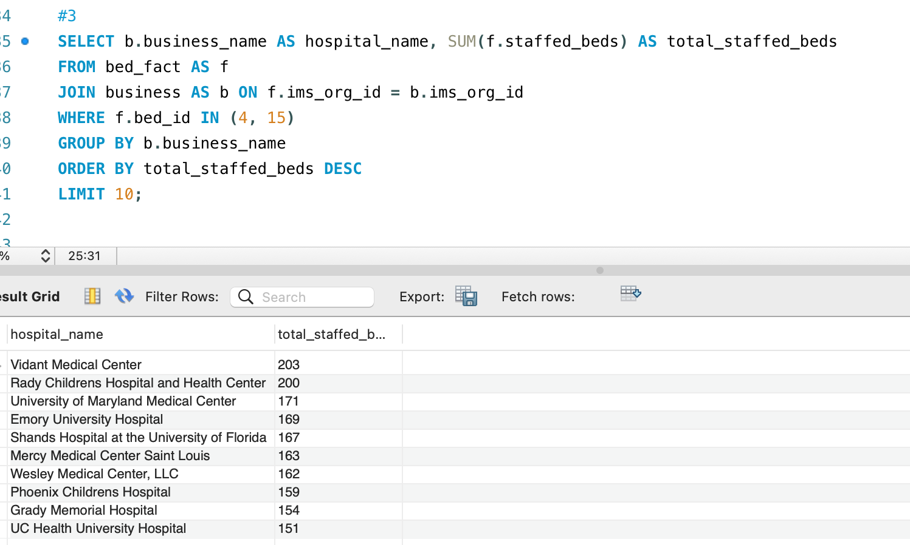

**(b) Findings  from 4a**

1. Top Hospitals by Number of License Beds

The hospitals with the most ICU or SICU licensing beds are **Phoenix Children's Hospital**, **University of Maryland Medical Center**, and **UC Health University Hospital**.

A sizable number of license beds are also available at **Rady Children's Hospital and Health Center, Vidant Medical Center, and Wesley Medical Center LLC.**

1. Top Medical Facilities by Census Beds:

**The University of Florida's Shands Hospital** has the most ICU or SICU census beds.

Among the hospitals having a significant number of census beds are Dallas County Hospital Association, **Mercy Medical Center Saint Louis, and Los Angeles County University of Southern California Healthcare Network**.

1. Best Hospitals by Number of Staffed Beds:

The largest number of beds staffed in an ICU or SICU is at **Vidant Medical Center**. In terms of the number of staff beds, other notable hospitals include The **Methodist Hospital, University of Maryland Medical Center, and University of Minnesota Medical Center Fairview.**

Observations and insights

With respect to licensing beds, census beds, and staffed beds for ICU or SICU, **Vidant Medical Center** routinely places highly in all three categories, demonstrating its considerable presence.

1. **(a) Leadership Analysis having 1 ned of each type i.e., ICU and SICU**

**Top 10 hospitals with both ICU and SICU beds (i.e., only hospitals with at least 1 ICU bed and at least 1 SICU bed) are listed in census_beds.**

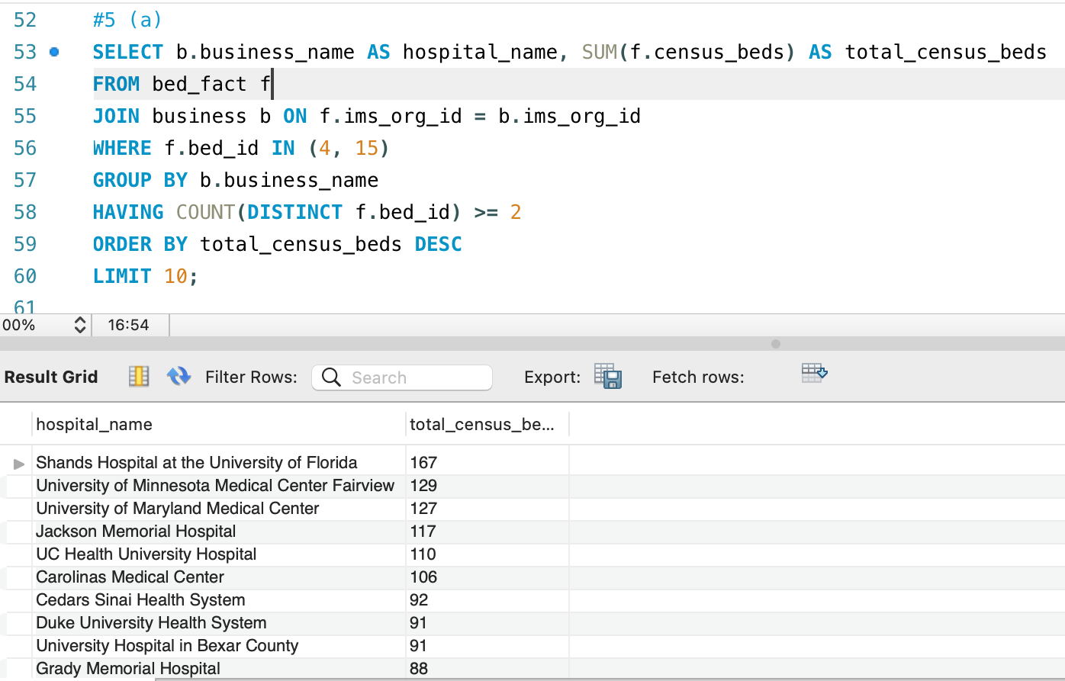

Top 10 hospitals with both ICU and SICU beds, i.e., only hospitals with at least 1 ICU bed and at least 1 SICU bed, according to license beds.

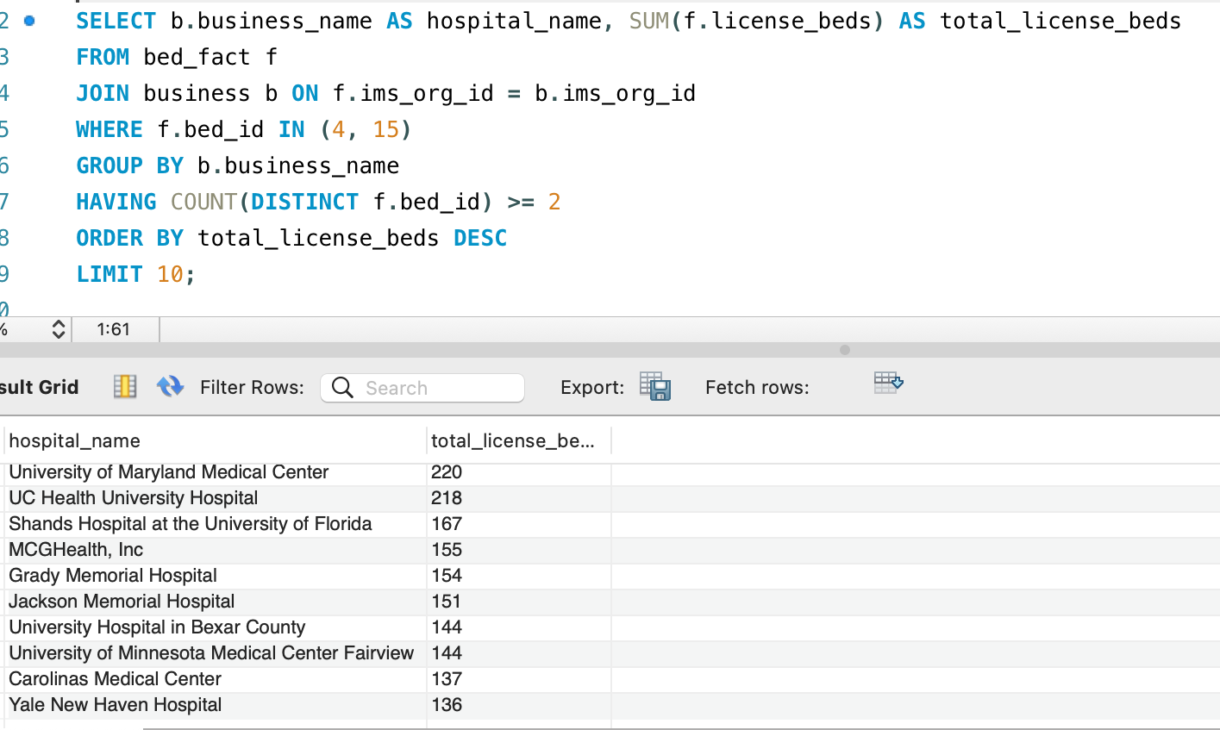

Top 10 hospitals with both ICU and SICU beds, i.e., only facilities with at least 1 ICU bed and at least 1 SICU bed, are considered to have staffed beds.

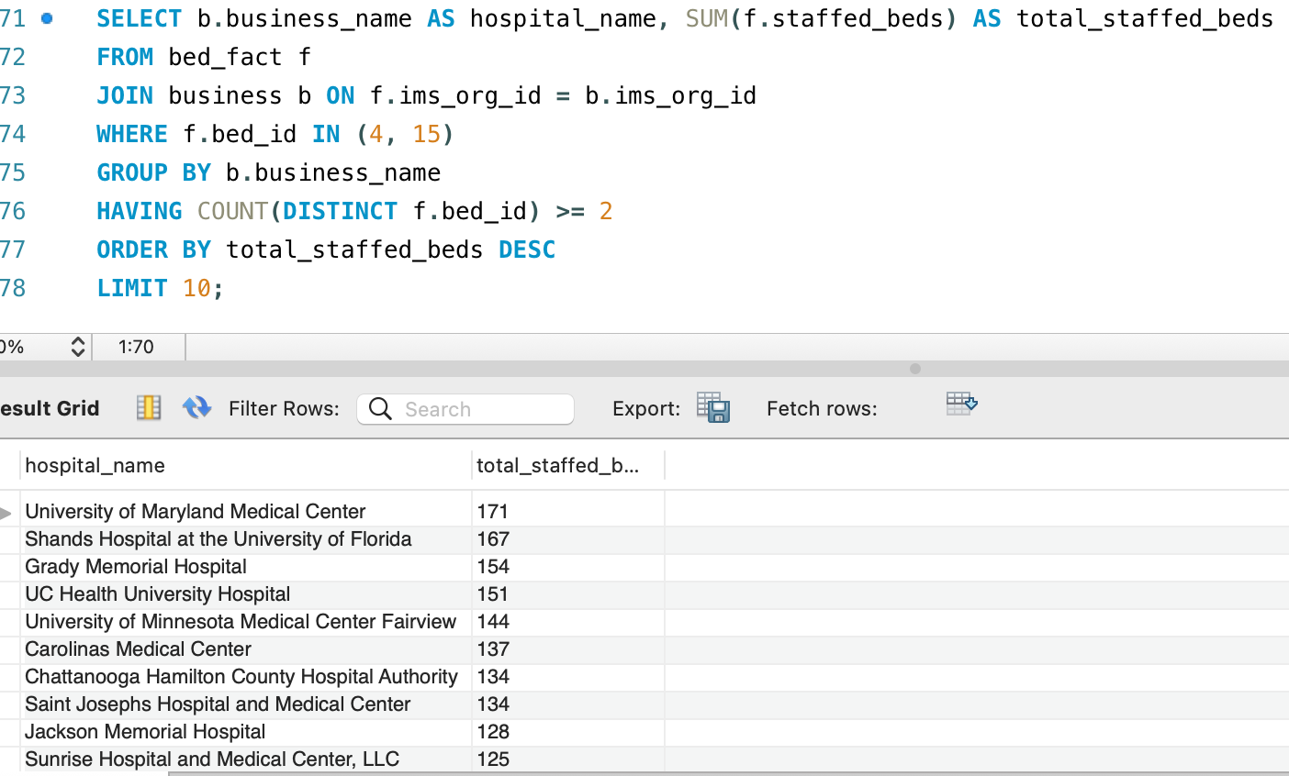

**(b) Final Recommendation to the Leadership based on the Analysis**

The following hospitals are suggested as the best choices for Leadership's pilot intervention program based on the analyses performed in phases 4a and 5a:

1. **Shands Hospital at the University of Florida:**

* High bed volumes in both Census beds and License beds with ICU and SICU.
* Consistently ranked among the top hospitals in terms of bed volume.
* Well-established reputation and expertise in critical care services.

1. **University of Maryland Medical Center:**

* High bed volumes in both License beds and Staffed beds with ICU and SICU.
* Recognized as a leading medical center with a comprehensive range of specialized services.
* Strong track record in critical care and a dedicated team of healthcare professionals.

These hospitals have demonstrated significant bed volumes in multiple categories, indicating their capability to handle critical care patients. Their consistent presence among the top-ranked hospitals in terms of ICU and SICU beds showcases their expertise and capacity to support Leadership's intervention program. By selecting these hospitals as pilot sites, Leadership can leverage their established infrastructure, experienced staff, and track record to test and evaluate the effectiveness of their intervention initiatives.

**Conclusion**

In conclusion, the study of the hospital data yielded important information on the amount and distribution of ICU and SICU beds across various hospitals. We were able to identify prominent hospitals that have a large presence in critical care services by looking at license beds, census beds, and staffed beds.

Top hospitals repeatedly showed they could manage ICU and SICU patients based on license beds, census beds, and staffed beds. Hospitals like ***Vidant Medical Center, University of Maryland Medical Center, and Shands Hospital at the University of Florida*** became well-known institutions in a variety of areas, demonstrating their proficiency and capacity in critical care.Overall, this analysis provides Leadership with valuable insights to make informed decisions regarding resource allocation, intervention programs, and strategic planning to optimize critical care services within their healthcare system.

Additionally, our analysis uncovered a number of institutions that consistently featured on lists, such as ***The Methodist Hospital, University of Minnesota Medical Center Fairview, and Dallas County Hospital Association.*** To increase the number of ICU and SICU beds available as well as resource distribution, these institutions are suitable candidates for focused interventions and improvement initiatives. I advise Leadership to concentrate on **Shands Hospital at the University of Florida and the University of Maryland Medical Center as the top prospects for their pilot intervention program in light of these findings.** These hospitals regularly showed high bed numbers across a range of categories, and they have the resources, know-how, and track record to help the program achieve its goals.

**References :**

1. *MySQL Joins*. (n.d.). <https://www.w3schools.com/mysql/mysql_join.asp>