Backend:  
  
Api checking the post and shorturl

Validating = “Https”

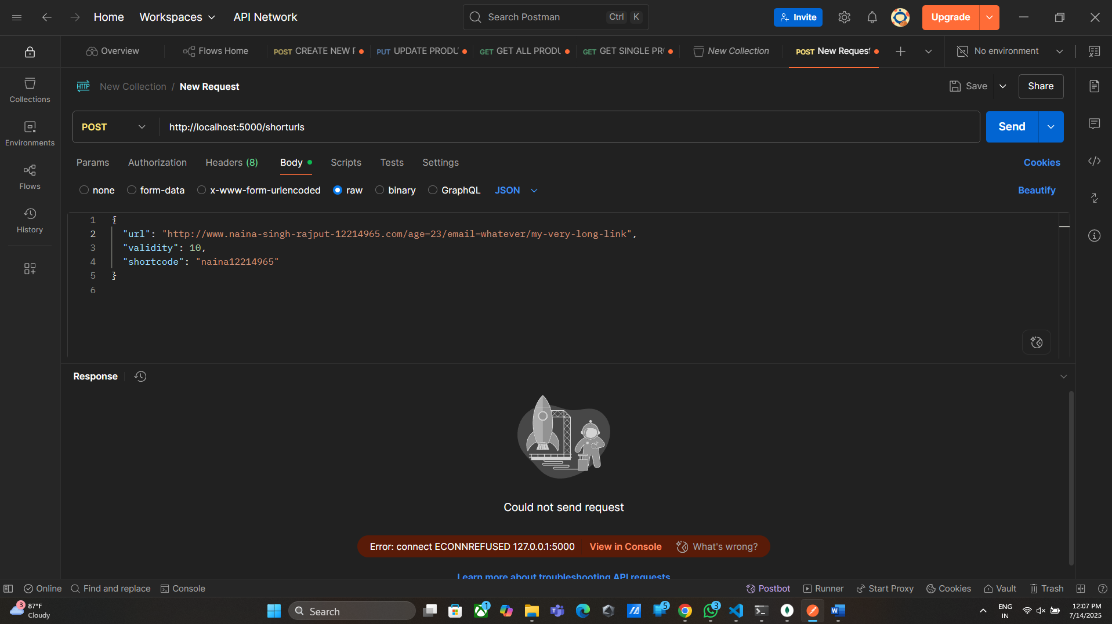

Validate: genrateshortCode();

