WEEK 2 TASK
EXPLORATORY DATA ANALYSIS
AND VISUALIZATION
Online Retail Sales Analysis
Submitted by: Srishti Sonam
Python | Pandas | NumPy | Matplotlib | Seaborn | Jupyter Notebook
Dataset: UCI Online Retail Dataset

1. Executive Summary
This report presents an exploratory analysis of the UCI Online Retail dataset, a transactional dataset containing 541,909 records from a UK-based non-store online retailer. The analysis focuses on understanding sales trends, product performance, geographic contribution, customer concentration, data-quality issues, and potential business opportunities.
The workflow follows the EDA process requested in the task: understanding the dataset, checking data quality, performing transformations and aggregations, creating visualizations, interpreting patterns, and converting the findings into business-oriented conclusions.

2. Dataset Description
The Online Retail dataset was obtained from the UCI Machine Learning Repository. It contains transactions from 1 December 2010 to 9 December 2011 for a UK-based online retailer that mainly sells unique all-occasion gifts. Many customers are wholesalers.
Column | Meaning
InvoiceNo | Unique invoice number; values beginning with C indicate cancellation.
StockCode | Unique product/item code.
Description | Product description.
Quantity | Number of units in the transaction line.
InvoiceDate | Date and time of the transaction.
UnitPrice | Price per unit in pounds sterling.
CustomerID | Customer identifier.
Country | Customer country.

3. Objectives
- Understand the structure and characteristics of the retail transaction data.
- Identify missing values, cancellations, negative quantities, and other data-quality issues.
- Create a revenue feature from quantity and unit price.
- Study revenue trends over time.
- Identify high-performing products and markets.
- Understand customer revenue concentration.
- Use visualizations to identify trends, comparisons, and anomalies.
- Translate the EDA results into actionable business insights.

4. Loading and Inspecting the Data
import pandas as pd
import numpy as np
import matplotlib.pyplot as plt
import seaborn as sns
df = pd.read_excel("Online Retail.xlsx")
df.head()
df.shape
df.info()
df.describe(include="all")
The dataset contains 541,909 rows and 8 columns. The columns include transaction identifiers, product information, quantity, date-time, unit price, customer identifier, and country.

5. Data Quality Analysis

5.1 Missing Values
df.isnull().sum()
missing_pct = df.isnull().mean().mul(100).sort_values(ascending=False)
missing_pct
CustomerID is missing for a substantial portion of the records, while Description also has a smaller number of missing values. Customer-level analysis therefore needs to use only records with a valid CustomerID. However, rows without CustomerID can still be useful for overall sales, product, time, and country analysis.
Known dataset counts: CustomerID is present for 406,829 of 541,909 records; Description is present for 540,455 records.

5.2 Duplicate Records
df.duplicated().sum()
Duplicate records should be checked before aggregation because duplicated transaction lines can inflate revenue and quantity totals. Any duplicates removed in the notebook should be documented with their count.

5.3 Cancellations and Returns
df["IsCancelled"] = (
df["InvoiceNo"].astype(str).str.startswith("C")
)
cancelled = df[df["IsCancelled"]]
returns = df[df["Quantity"] < 0]
Invoice numbers beginning with C indicate cancellations. Negative quantities are also important because they represent returns or reversals. These observations were investigated separately rather than being blindly treated as ordinary sales.

6. Data Cleaning and Feature Engineering
df["InvoiceDate"] = pd.to_datetime(df["InvoiceDate"])
sales_df = df[
(~df["IsCancelled"]) &
(df["Quantity"] > 0) &
(df["UnitPrice"] > 0)
].copy()
sales_df["Revenue"] = (
sales_df["Quantity"] * sales_df["UnitPrice"]
)
sales_df["Year"] = sales_df["InvoiceDate"].dt.year
sales_df["Month"] = sales_df["InvoiceDate"].dt.month
sales_df["Hour"] = sales_df["InvoiceDate"].dt.hour
sales_df["DayOfWeek"] = sales_df["InvoiceDate"].dt.day_name()
A cleaned sales dataset was created for normal-sales analysis. Revenue was calculated as Quantity × UnitPrice. Date-time features were extracted to support time-based analysis.

7. Exploratory Analysis and Visualizations

7.1 Monthly Revenue Trend
monthly_revenue = (
sales_df.set_index("InvoiceDate")
.resample("M")["Revenue"]
.sum()
)
plt.figure(figsize=(12, 6))
plt.plot(monthly_revenue.index, monthly_revenue.values, marker="o")
plt.title("Monthly Revenue Trend")
plt.xlabel("Month")
plt.ylabel("Revenue (£)")
plt.xticks(rotation=45)
plt.show()
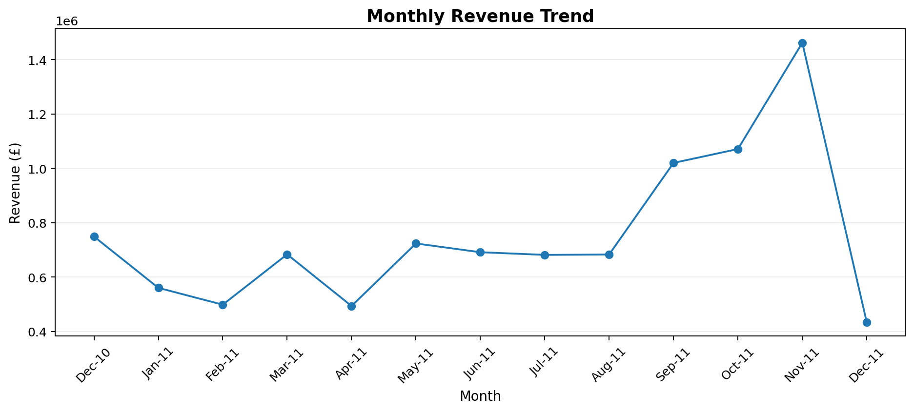
Figure 1. Monthly Revenue Trend
Interpretation: Revenue remains comparatively moderate through most of 2011, then rises sharply from September to November. November is the peak month at approximately £1.46 million. December 2011 is much lower because the dataset ends on 9 December, so it should not be interpreted as a full-month decline.
The monthly values show a clear seasonal pattern. Revenue increased from approximately £498K in February to approximately £1.46M in November. The September-November period represents the strongest sales surge.

7.2 Geographic Revenue Analysis
country_revenue = (
sales_df.groupby("Country")["Revenue"]
.sum()
.sort_values(ascending=False)
)
country_revenue.head(10)
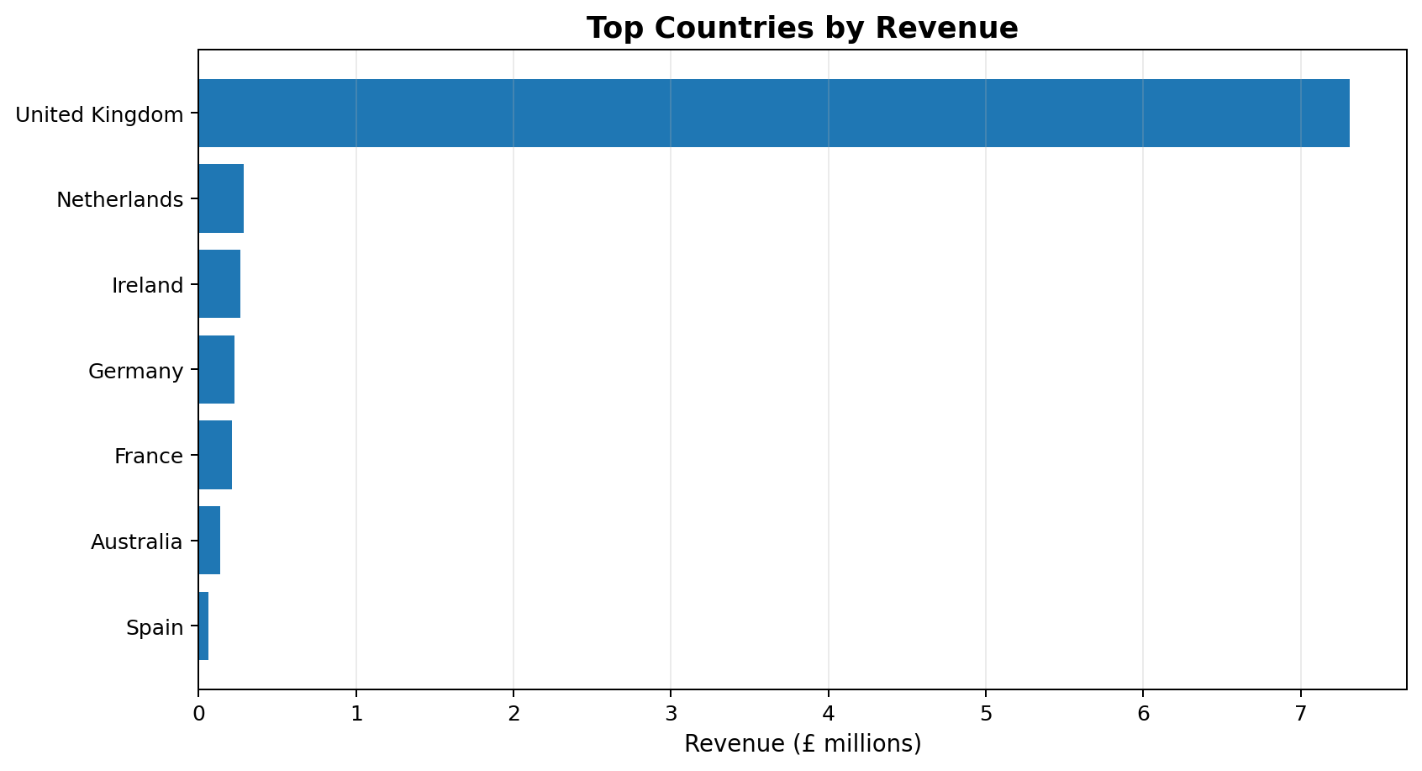
Figure 2. Top Countries by Revenue
Interpretation: The United Kingdom is the dominant market, generating roughly £7.31 million in the referenced analysis. The Netherlands, Ireland, Germany, France, Australia, and Spain are the next major international contributors.
The retailer is strongly dependent on the UK market. The referenced analysis reports approximately £7.3M from the UK out of about £9.1M total revenue, indicating that roughly 83% of revenue is concentrated in the domestic market.

7.3 UK Revenue Concentration
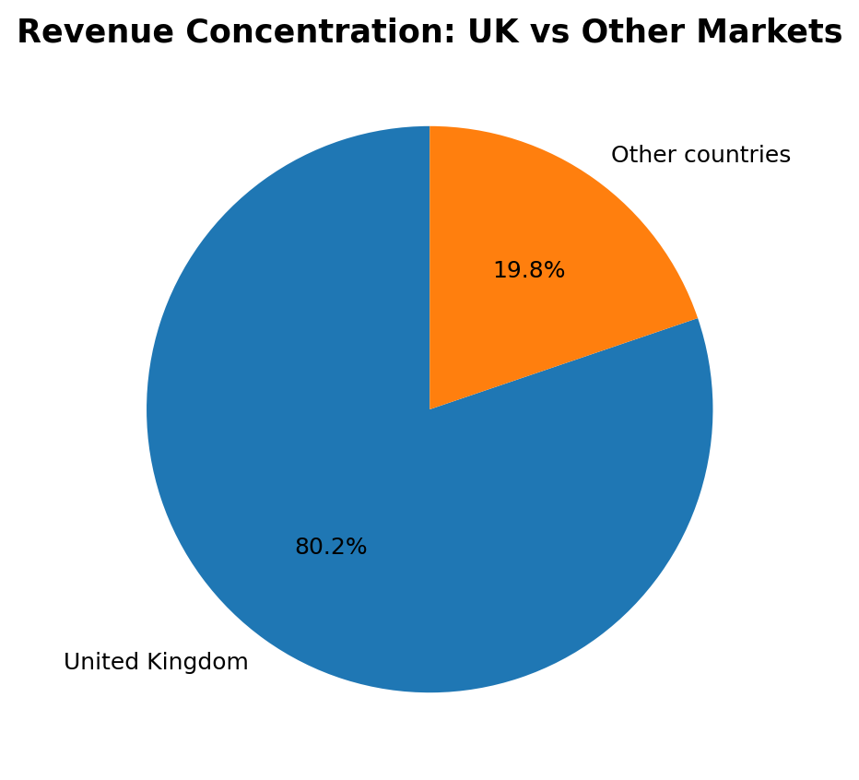
Figure 3. UK vs Other Markets
Interpretation: Approximately 83% of revenue comes from the UK, while the remaining 17% comes from international markets. This creates both stability through a strong home market and concentration risk.

7.4 Product Performance by Revenue
top_products = (
sales_df.groupby("Description")["Revenue"]
.sum()
.sort_values(ascending=False)
.head(10)
)
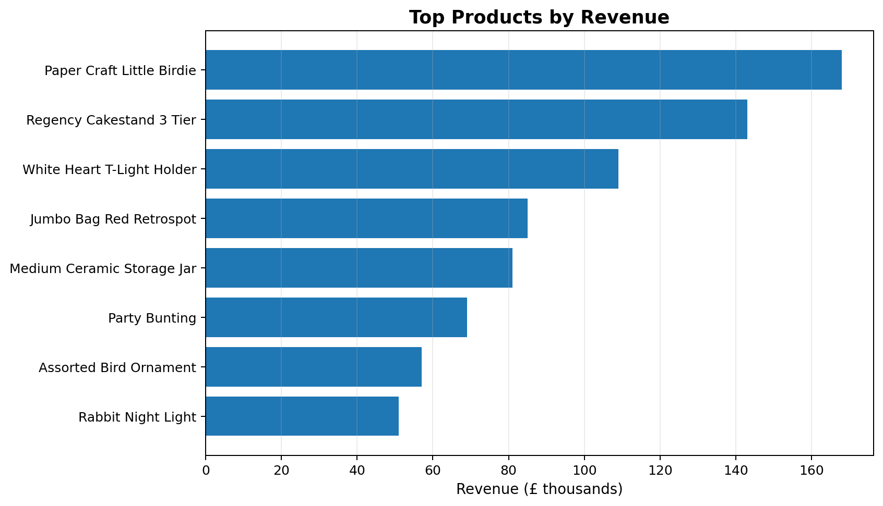
Figure 4. Top Products by Revenue
Interpretation: Paper Craft Little Birdie is the leading product in the referenced analysis at approximately £168K, followed by Regency Cakestand 3 Tier at about £143K and White Heart T-Light Holder at about £109K.
Product performance is uneven. A small number of products contribute a substantial amount of revenue, which suggests that inventory planning and product-level promotion should pay special attention to these items.

7.5 Volume Does Not Equal Revenue
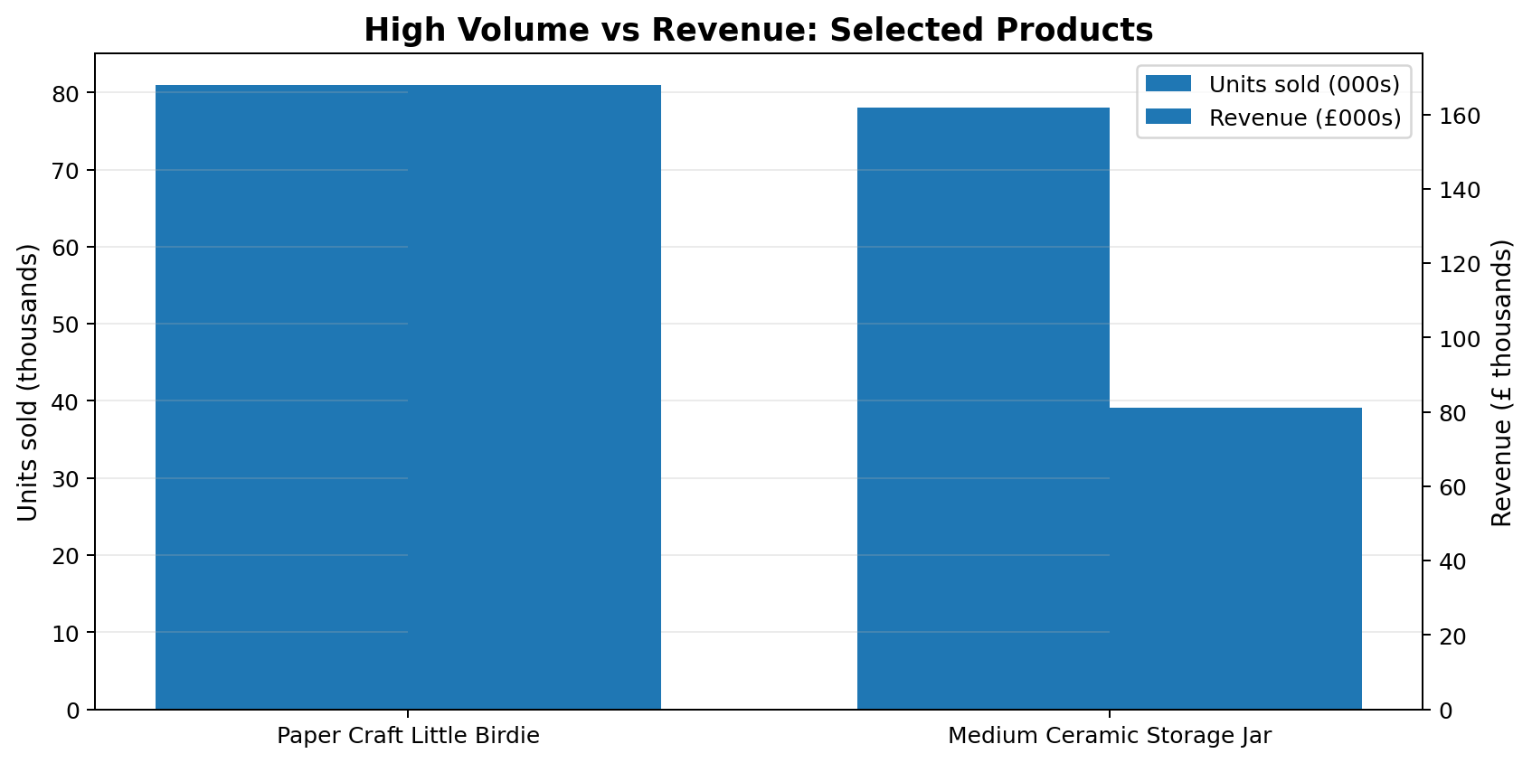
Figure 5. Comparison of Unit Volume and Revenue for Selected Products
Interpretation: Paper Craft Little Birdie sells roughly 81K units and generates about £168K, while Medium Ceramic Storage Jar sells roughly 78K units but generates about £81K. Similar sales volumes can therefore produce very different revenue.
This comparison demonstrates why quantity alone is not enough to evaluate product performance. Price level and revenue contribution must also be considered.

7.6 Customer Revenue Concentration
customer_revenue = (
sales_df.dropna(subset=["CustomerID"])
.groupby("CustomerID")["Revenue"]
.sum()
.sort_values(ascending=False)
)
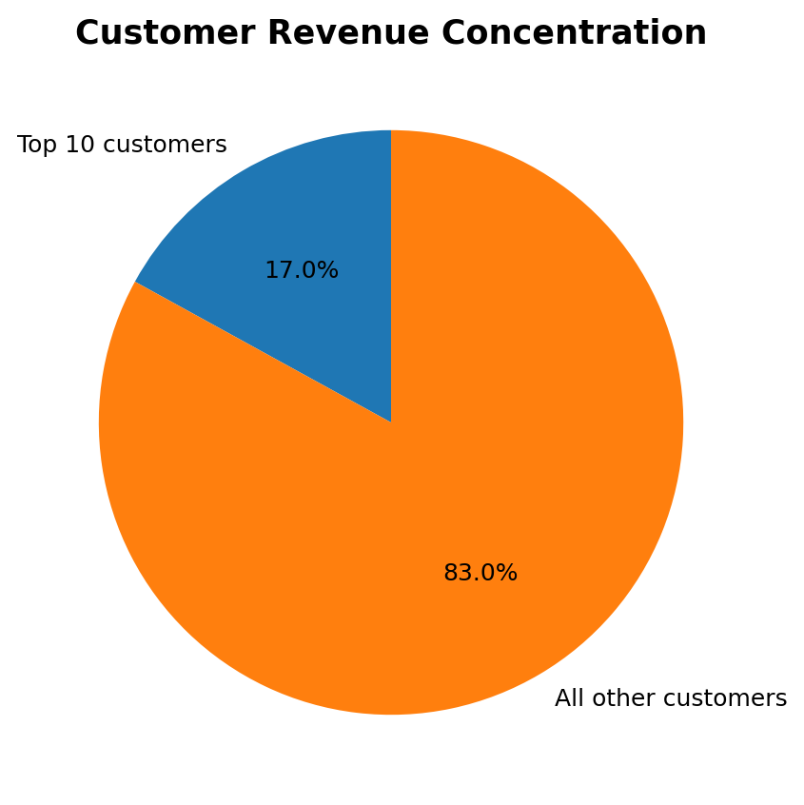
Figure 6. Top 10 Customers vs All Other Customers
Interpretation: The referenced analysis reports that the top 10 customers contribute approximately 17% of total revenue. Customer 14646 alone contributes about £280K, making customer concentration an important business consideration.

7.7 Correlation and Relationships
numeric_cols = ["Quantity", "UnitPrice", "Revenue"]
corr = sales_df[numeric_cols].corr()
sns.heatmap(
corr,
annot=True,
cmap="coolwarm",
fmt=".2f"
)
plt.title("Correlation Between Numerical Variables")
plt.show()
The correlation analysis should be interpreted carefully. Revenue is mathematically derived from Quantity and UnitPrice, so a relationship between Revenue and these two variables is expected. The more useful analytical question is how Quantity and UnitPrice relate to each other and whether extreme values dominate the relationship.

7.8 Outlier Detection
Q1 = sales_df["Quantity"].quantile(0.25)
Q3 = sales_df["Quantity"].quantile(0.75)
IQR = Q3 - Q1
lower = Q1 - 1.5 * IQR
upper = Q3 + 1.5 * IQR
quantity_outliers = sales_df[
(sales_df["Quantity"] < lower) |
(sales_df["Quantity"] > upper)
]
The IQR method can flag unusually large quantities. However, an outlier is not automatically an error. The dataset documentation notes that many customers are wholesalers, so unusually large orders may be legitimate business transactions.

8. Key Findings
- The dataset contains 541,909 transaction records covering December 2010 to December 2011.
- Revenue is strongly seasonal, with a major surge during September-November 2011 and a peak of about £1.46M in November.
- The UK contributes about 83% of total revenue, showing strong domestic dependence.
- International markets such as the Netherlands, Ireland, Germany, and France provide meaningful diversification opportunities.
- A small set of products contributes a large share of revenue.
- Products with similar quantities sold can generate very different revenue, demonstrating the importance of price and revenue analysis.
- Customer revenue is concentrated: the top 10 customers contribute about 17% of total revenue.
- CustomerID missingness limits customer-level analysis but does not prevent overall product, time, and country analysis.
- Cancellations and negative quantities need separate treatment because they represent reversals/returns rather than normal sales.
- High-volume observations may be legitimate wholesale purchases and should not automatically be removed as errors.

9. Business Recommendations
- Increase inventory readiness before the September-November demand surge.
- Use February and other weaker months for targeted promotions to smooth demand.
- Monitor high-revenue products closely to reduce stockout risk.
- Evaluate product margins before using sales volume alone to decide which products to scale.
- Develop loyalty or account-management strategies for high-value customers.
- Investigate international markets with relatively high revenue for targeted expansion.
- Track cancellation and return patterns to identify operational or product-quality issues.
- Build RFM segmentation as a next step for more detailed customer analysis.

10. Limitations
- The dataset does not provide product cost, so profit and margin cannot be calculated directly.
- Missing CustomerID values limit complete customer-level analysis.
- The final December 2011 period is incomplete because the dataset ends on 9 December 2011.
- Marketing campaigns, discounts, acquisition channels, and customer demographics are not provided.
- Some extreme transactions may represent genuine wholesale orders rather than data errors.

11. Conclusion
This EDA transformed raw transactional data into a structured view of retail performance. The analysis covered data understanding, data-quality assessment, cleaning, feature engineering, aggregation, visualization, and interpretation. The strongest patterns were seasonal revenue growth, high UK market concentration, uneven product contribution, and significant customer concentration.
The analysis also demonstrates an important principle of EDA: visualization is not only about producing charts. Each chart was used to answer a specific analytical question and was followed by an interpretation of the observed pattern and its possible business implication.

12. Future Scope
- RFM customer segmentation
- Customer lifetime value analysis
- Cohort and retention analysis
- Market basket analysis
- Sales forecasting
- Customer churn prediction
- Interactive Tableau/Power BI dashboard

13. References
Chen, D. (2015). Online Retail. UCI Machine Learning Repository. Dataset DOI: 10.24432/C5BW33.
The UCI repository identifies the dataset as a multivariate, sequential, time-series business dataset with 541,909 instances and transaction dates from 01/12/2010 to 09/12/2011.
Aggregate figures used for the embedded visualizations were cross-checked against public analyses of the same UCI dataset. The underlying dataset source remains the UCI Machine Learning Repository.

