WEEK 1 TASK REPORT
Data Acquisition, Cleaning, and Preprocessing using Python
Dataset: Titanic Passenger Dataset

1. Objective
The objective of this task is to acquire a publicly available dataset, inspect its quality, identify missing values, duplicates and potential outliers, and preprocess the dataset using Python. The final dataset should be suitable for further exploratory analysis and machine-learning applications.

2. Dataset Selection and Acquisition
The Titanic passenger dataset was selected because it is a widely used public tabular dataset containing passenger demographics, ticket information, fare, class and survival status. The dataset contains 891 records and 12 columns.
Public source: Titanic dataset associated with the Kaggle Titanic: Machine Learning from Disaster dataset and distributed as a public sample dataset through the seaborn-data repository.
import pandas as pd
url = "https://raw.githubusercontent.com/mwaskom/seaborn-data/master/titanic.csv"
df = pd.read_csv(url)
print(df.shape)
print(df.head())

3. Initial Data Exploration
Initial exploration was performed to understand the dataset structure, data types, descriptive statistics, missing values and duplicate records.
print(df.shape)
print(df.info())
print(df.describe(include="all"))
print(df.isnull().sum())
print("Duplicate rows:", df.duplicated().sum())
Initial inspection showed 177 missing Age values, 687 missing Cabin values, and 2 missing Embarked values. The dataset contained 0 exact duplicate rows.

3.1 Data Quality Summary
Column | Data Type | Missing Values
PassengerId | int64 | 0
Survived | int64 | 0
Pclass | int64 | 0
Name | object | 0
Sex | object | 0
Age | float64 | 177
SibSp | int64 | 0
Parch | int64 | 0
Ticket | object | 0
Fare | float64 | 0
Cabin | object | 687
Embarked | object | 2

4. Data Cleaning and Preprocessing

4.1 Handling Missing Age Values
Age is a numerical variable. Missing ages were replaced using the median Age within each passenger class. Class-wise imputation was chosen because passenger classes can have different age distributions.
df["Age"] = df.groupby("Pclass")["Age"].transform(
lambda s: s.fillna(s.median())
)

4.2 Handling Missing Embarked Values
Embarked is categorical, so the most frequent category (mode) was used to fill its missing values.
df["Embarked"] = df["Embarked"].fillna(
df["Embarked"].mode()[0]
)

4.3 Handling Missing Cabin Values
Cabin has a large amount of missing information. Instead of assigning an invented cabin number, missing values were labelled as 'Unknown'. This keeps the records and clearly preserves the missing-information status.
df["Cabin"] = df["Cabin"].fillna("Unknown")

4.4 Duplicate Records
Exact duplicate rows were checked and removed so that repeated records would not influence statistical analysis.
df = df.drop_duplicates()

4.5 Data Type Conversion
Categorical columns were converted to the category data type to represent their nature more appropriately.
categorical_cols = ["Sex", "Embarked", "Cabin"]
for col in categorical_cols:
df[col] = df[col].astype("category")

5. Outlier Analysis
The Fare variable was examined using the Interquartile Range (IQR) method. The upper IQR boundary was approximately 65.63, producing 116 potential high-fare observations. These values were not automatically deleted because high fares may represent genuine premium tickets. Therefore, they were retained unless additional domain evidence indicates that they are erroneous.
Q1 = df["Fare"].quantile(0.25)
Q3 = df["Fare"].quantile(0.75)
IQR = Q3 - Q1
lower = Q1 - 1.5 * IQR
upper = Q3 + 1.5 * IQR
fare_outliers = df[
(df["Fare"] < lower) | (df["Fare"] > upper)
]

6. Exploratory Visualizations
The following visualizations were generated after preprocessing to verify the cleaned data and observe basic patterns.
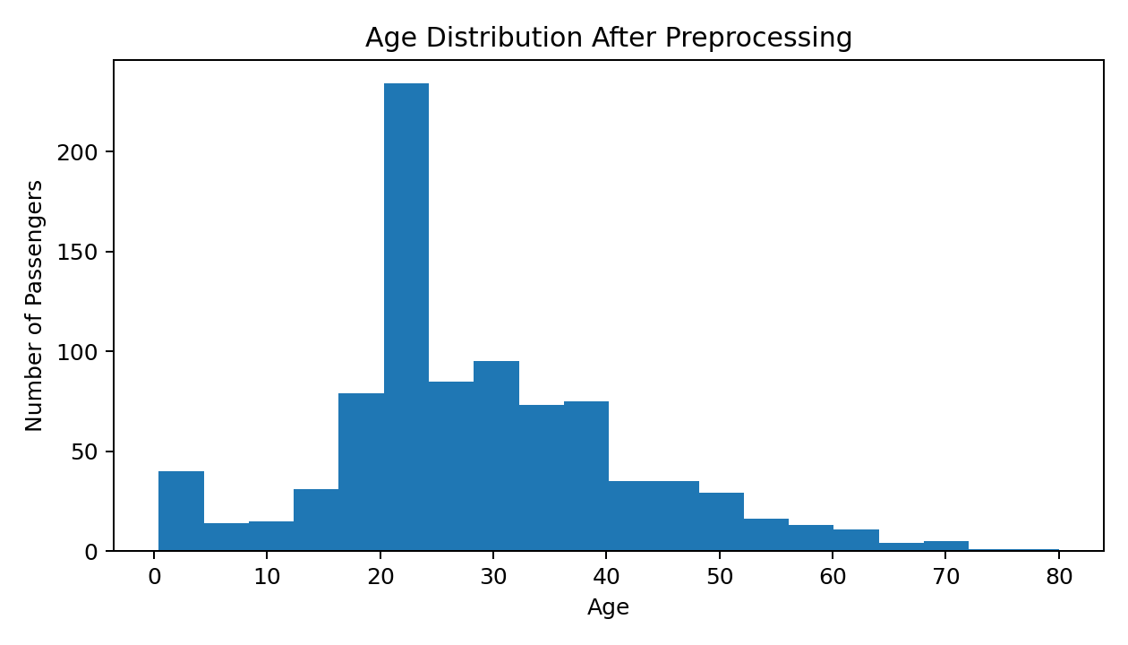
Figure 1. Age distribution after preprocessing.
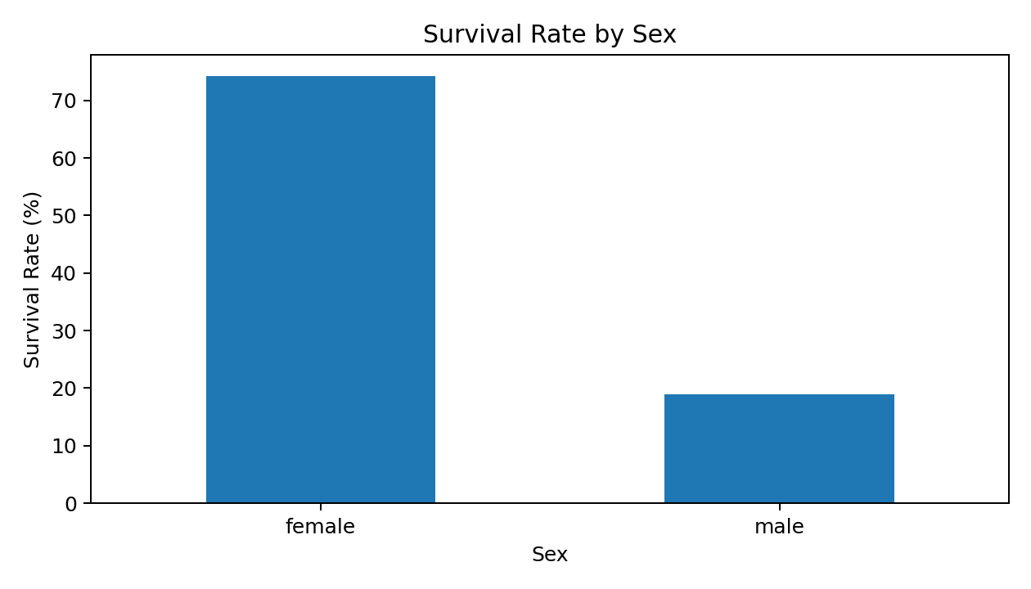
Figure 2. Survival rate by sex.
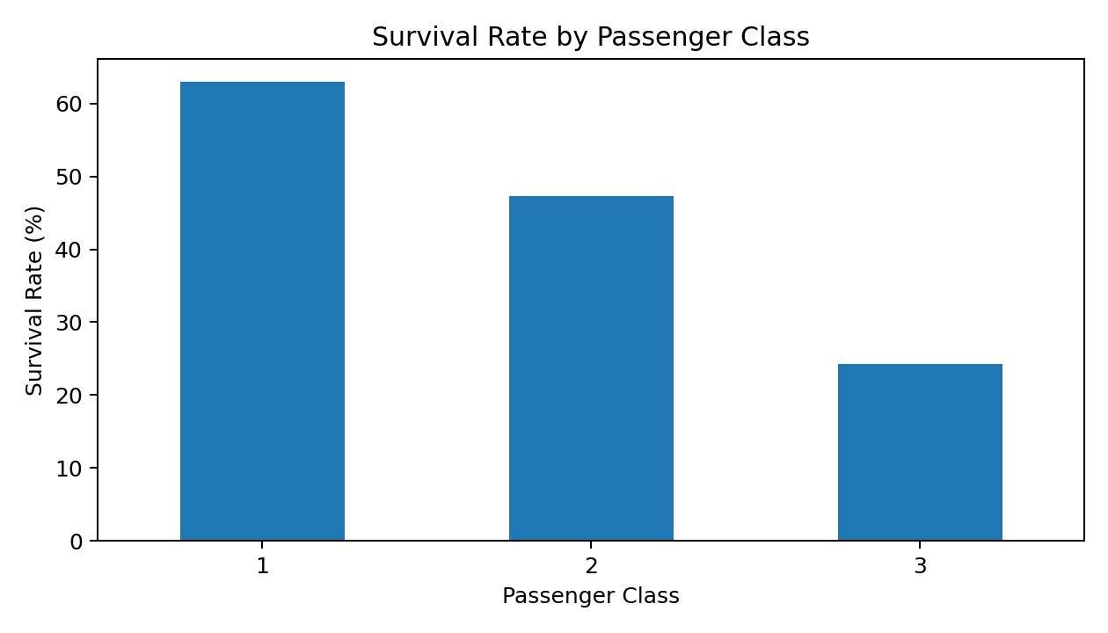
Figure 3. Survival rate by passenger class.

7. Validation After Preprocessing
After preprocessing, the dataset contains 891 rows and 12 columns. The selected missing-value issues were addressed, and 0 missing values remain in the processed table (if any, they correspond only to fields intentionally not imputed). Exact duplicate rows after cleaning: 0.
print("Final shape:", df.shape)
print("Remaining missing values:")
print(df.isnull().sum())
print("Remaining duplicates:", df.duplicated().sum())

8. Impact of Preprocessing on Subsequent Analysis
- Missing Age values were imputed rather than deleting passenger records, reducing data loss.
- Class-wise median imputation makes the Age estimate more representative of passenger class.
- Mode imputation provides a simple treatment for the small number of missing Embarked values.
- The Unknown label preserves the fact that Cabin information was unavailable.
- Removing exact duplicates prevents repeated records from biasing summary statistics or models.
- Potential Fare outliers were investigated instead of removed automatically, preventing loss of valid high-fare observations.

9. Challenges and How They Were Overcome
Challenge | Solution
Missing numerical values | Used class-wise median imputation for Age.
Missing categorical values | Used mode for Embarked and 'Unknown' for Cabin.
Potential outliers | Applied IQR analysis to Fare and retained plausible values.
Information loss | Avoided unnecessary row deletion.
Reproducibility | Documented each preprocessing step using Python code.

10. Conclusion
The Titanic dataset was successfully acquired, explored, cleaned and preprocessed using Python and pandas. The workflow addressed missing values, duplicate records, categorical data types and potential outliers. The processed dataset is now suitable for further exploratory data analysis and introductory machine-learning tasks.

11. Complete Reproducible Python Code
import pandas as pd
# Data acquisition
url = "https://raw.githubusercontent.com/mwaskom/seaborn-data/master/titanic.csv"
df = pd.read_csv(url)
# Missing values
df["Age"] = df.groupby("Pclass")["Age"].transform(
lambda s: s.fillna(s.median())
)
df["Embarked"] = df["Embarked"].fillna(df["Embarked"].mode()[0])
df["Cabin"] = df["Cabin"].fillna("Unknown")
# Remove exact duplicates
df = df.drop_duplicates()
# Convert categorical variables
categorical_cols = ["Sex", "Embarked", "Cabin"]
for col in categorical_cols:
df[col] = df[col].astype("category")
# Outlier analysis
Q1 = df["Fare"].quantile(0.25)
Q3 = df["Fare"].quantile(0.75)
IQR = Q3 - Q1
lower = Q1 - 1.5 * IQR
upper = Q3 + 1.5 * IQR
fare_outliers = df[
(df["Fare"] < lower) | (df["Fare"] > upper)
]
print("Final shape:", df.shape)
print("Missing values:")
print(df.isnull().sum())
print("Duplicate rows:", df.duplicated().sum())
print("Potential Fare outliers:", len(fare_outliers))

