WEEK 4 TASK
Supervised Learning Model Implementation
Wine Cultivar Classification using Logistic Regression
Public Dataset: UCI Wine Recognition Dataset
Python • Pandas • Scikit-learn • Matplotlib

1. Problem Definition
The aim is to build a supervised learning model that predicts the cultivar class of a wine sample from its chemical measurements. Since the target is one of three categorical classes, the problem is formulated as multiclass classification.
Why this problem? The dataset has labelled observations, so a model can learn a relationship between chemical features and the known cultivar labels.
First, we load the public dataset and inspect its structure.
import numpy as np
import pandas as pd
import matplotlib.pyplot as plt
from sklearn.datasets import load_wine
wine = load_wine(as_frame=True)
df = wine.frame.copy()
df.columns = [c.replace(" ", "_").replace("/", "_") for c in df.columns]
feature_cols = list(df.columns[:13])
df["target_name"] = df["target"].map(
dict(enumerate(wine.target_names))
)
print("Dataset shape:", df.shape)
print(df.head())
This code creates the dataframe, identifies the 13 predictors, and converts the numerical target codes into readable class names.

2. Dataset Source and Initial Inspection
The analysis uses the UCI Wine Recognition Dataset. It contains 178 wine samples, 13 numerical features and three cultivar classes. The dataset has no missing values. The official source is:
https://archive.ics.uci.edu/dataset/109/wine
Before modelling, we check the target distribution and missing values. This is important because class imbalance or missing observations can change the preprocessing and evaluation strategy.
print("Dataset shape:", df.shape)
print("\nClass distribution:")
print(df["target_name"].value_counts())
print("\nMissing values:")
print(df[feature_cols].isna().sum())
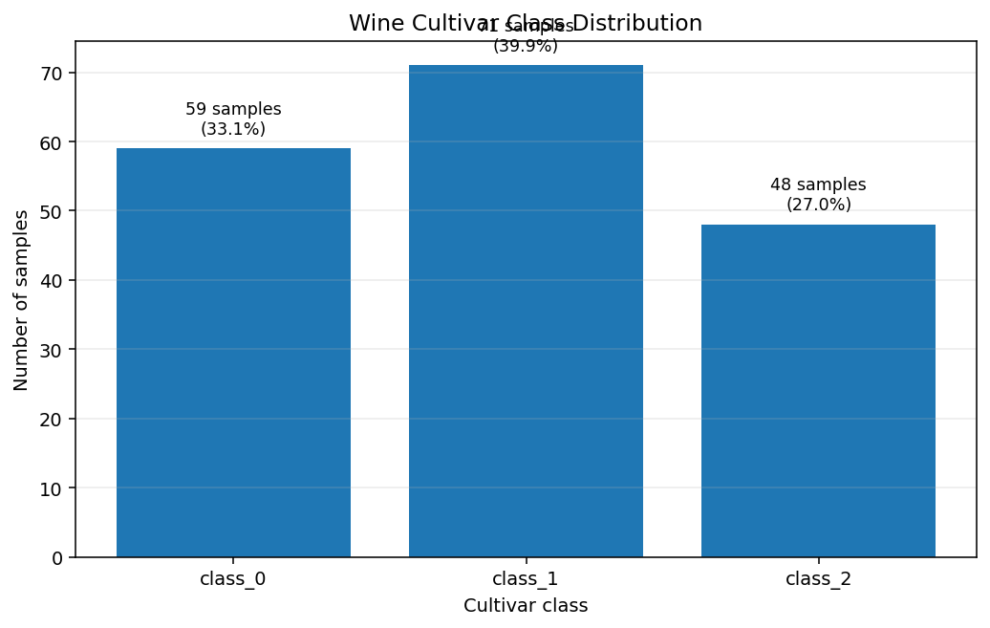
Figure 1. Class distribution. The three classes contain 59, 71 and 48 samples.
The class counts are not identical, so stratification is used later when splitting the data. Macro-averaged metrics are also reported so that each class contributes equally to the summary score.

3. Data Preparation
The target column is separated from the predictors. The raw features are kept as a baseline. A second feature set is then created for the engineered model.
X = df[feature_cols].copy()
y = df["target"].copy()
X_eng = X.copy()
print("Original feature count:", X.shape[1])
print("Target classes:", sorted(y.unique()))
Keeping an untouched baseline allows us to compare the engineered model against the simpler version and determine whether the additional transformations are useful.

4. Feature Engineering — Transformation + Code Together
Feature engineering is included to add modelling depth. Four positive variables—magnesium, malic acid, color intensity and proline—are represented with log1p-transformed versions. The purpose is to compress large values while preserving their ordering. The original columns are retained, so the model can use either representation.
for c in ["magnesium", "malic_acid",
"color_intensity", "proline"]:
X_eng[c + "_log1p"] = np.log1p(X_eng[c])
For example, log1p changes the spacing between large observations more than between small observations. This can reduce the influence of a long right tail without deleting observations.
Next, two interpretable derived features are added. The first is a ratio between flavanoids and total phenols. The second combines total phenols and flavanoids into a simple phenolic index. These are modelling features, not claims about laboratory causation.
X_eng["phenol_flav_ratio"] = (
X_eng["flavanoids"] /
(X_eng["total_phenols"] + 1e-6)
)
X_eng["phenol_index"] = (
X_eng["total_phenols"] +
X_eng["flavanoids"]
)
print("Engineered feature count:", X_eng.shape[1])

5. Aggregation Analysis — With Code
To satisfy the requirement for deeper analysis of transformations and aggregations, we summarize the data at class level. Grouping by cultivar gives mean chemical profiles and helps explain which variables differ across the target classes.
class_summary = (
df.groupby(["target", "target_name"])[feature_cols]
.mean()
.round(3)
)
print("Mean feature values by class:")
print(class_summary)
This aggregation answers a practical question: what does a typical observation in each class look like? For example, comparing mean alcohol, flavanoids, color intensity and proline can show whether these variables have visibly different class-level profiles.
A second aggregation creates alcohol bands and calculates sample counts, mean proline and the share of each class within each band. This demonstrates how a continuous variable can be converted into interpretable groups for descriptive analysis.
df["alcohol_band"] = pd.cut(
df["alcohol"],
bins=[10.9, 12.0, 13.0, 14.0, 15.0],
labels=["11–12", "12–13", "13–14", "14–15"],
include_lowest=True
)
alcohol_summary = (
df.groupby("alcohol_band", observed=False)
.agg(
samples=("target", "size"),
mean_proline=("proline", "mean"),
class_0_share=("target",
lambda s: (s == 0).mean()),
class_1_share=("target",
lambda s: (s == 1).mean()),
class_2_share=("target",
lambda s: (s == 2).mean()),
)
)
print(alcohol_summary.round(3))

6. Visualization — What We Plot and Why
Visualizations are fully annotated so the reader can understand what is being measured without guessing. The class distribution establishes the target structure, the alcohol plot compares a feature across classes, the feature-mean plot summarizes selected variables, and the confusion matrix explains model errors.
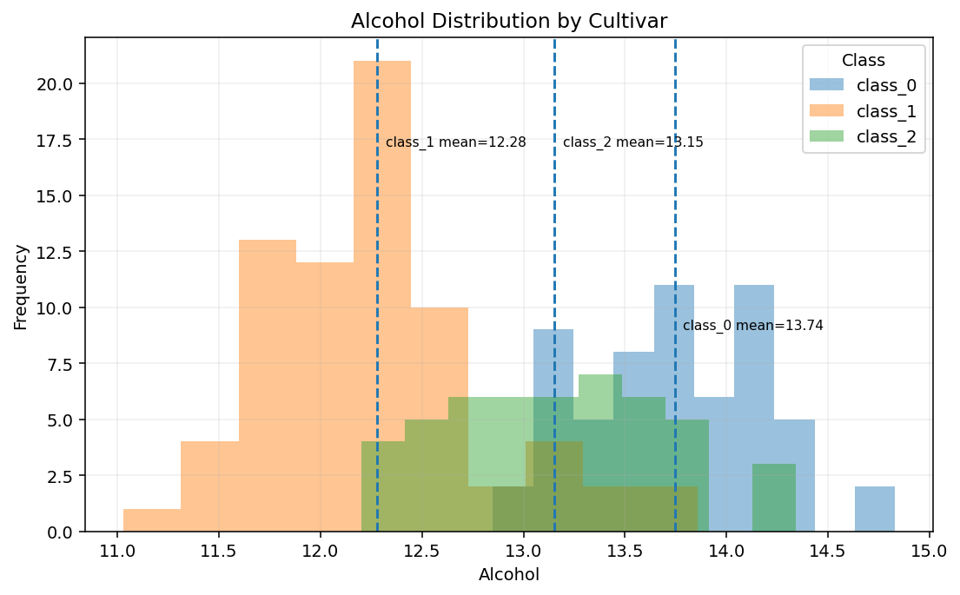
Figure 2. Alcohol distribution by cultivar; dashed markers identify class-specific means.
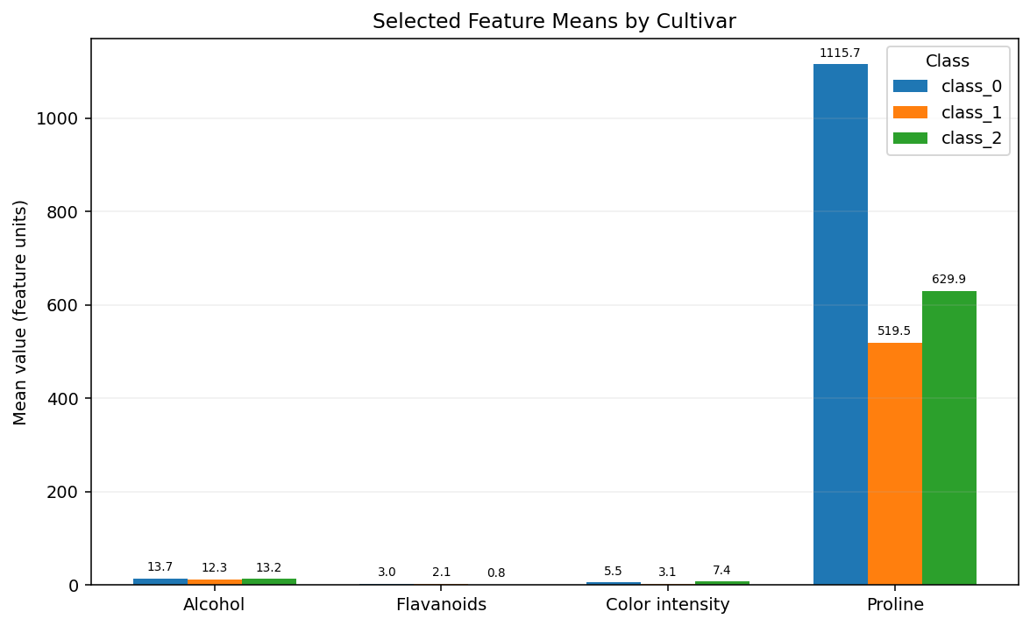
Figure 3. Selected feature means by cultivar; values are labelled directly on the bars.
Example code for the annotated class-distribution plot:
counts = df["target_name"].value_counts().reindex(
wine.target_names
)
fig, ax = plt.subplots(figsize=(7, 4.5))
bars = ax.bar(counts.index, counts.values)
ax.set_title("Wine Cultivar Class Distribution")
ax.set_xlabel("Cultivar class")
ax.set_ylabel("Number of samples")
ax.grid(axis="y", alpha=0.25)
for b, v in zip(bars, counts.values):
ax.annotate(
f"{v} samples ({v/len(df):.1%})",
xy=(b.get_x() + b.get_width()/2, v),
xytext=(0, 6),
textcoords="offset points",
ha="center"
)
plt.tight_layout()
plt.show()

7. Train/Test Split and Preprocessing
The engineered data are split into 80% training and 20% testing sets using stratification. The test set is kept separate so it can provide an unbiased final check after training.
from sklearn.model_selection import train_test_split
X_train, X_test, y_train, y_test = train_test_split(
X_eng,
y,
test_size=0.20,
stratify=y,
random_state=42
)
print("Training samples:", len(X_train))
print("Testing samples:", len(X_test))
Standardization is placed inside the modelling pipeline. StandardScaler learns the mean and standard deviation from the training data and transforms features to comparable scales. Keeping the scaler inside the pipeline prevents test-set information from being used during training.

8. Model Selection and Training
Logistic Regression is selected because it is appropriate for small numerical datasets, is fast to train, supports multiclass classification, and provides interpretable coefficients. It also creates a strong and transparent baseline before trying more complex algorithms.
from sklearn.pipeline import Pipeline
from sklearn.preprocessing import StandardScaler
from sklearn.linear_model import LogisticRegression
model = Pipeline([
("scaler", StandardScaler()),
("classifier", LogisticRegression(
max_iter=2000
))
])
model.fit(X_train, y_train)
y_pred = model.predict(X_test)
y_proba = model.predict_proba(X_test)
The pipeline performs scaling first and classification second. The trained model then produces both predicted class labels and class probabilities, which are required for ROC-AUC.

9. Evaluation Metrics — Explanation + Code
Accuracy measures the proportion of all test observations classified correctly. Precision measures how often predicted members of a class are correct, recall measures how many actual members of a class are recovered, and F1 combines precision and recall. Macro averaging gives all three classes equal importance. For multiclass ROC-AUC, a one-vs-rest calculation is used.
from sklearn.metrics import (
accuracy_score, precision_score, recall_score,
f1_score, roc_auc_score, confusion_matrix,
classification_report
)
accuracy = accuracy_score(y_test, y_pred)
precision = precision_score(
y_test, y_pred, average="macro"
)
recall = recall_score(
y_test, y_pred, average="macro"
)
f1 = f1_score(
y_test, y_pred, average="macro"
)
roc_auc = roc_auc_score(
y_test, y_proba,
multi_class="ovr",
average="macro"
)
print(f"Accuracy: {accuracy:.4f}")
print(f"Macro Precision: {precision:.4f}")
print(f"Macro Recall: {recall:.4f}")
print(f"Macro F1: {f1:.4f}")
print(f"Macro ROC-AUC: {roc_auc:.4f}")
On the fixed 20% test set, the engineered model achieved 0.9722 accuracy, 0.9762 macro precision, 0.9722 macro recall, 0.9722 macro F1 and 0.9977 macro ROC-AUC.

10. Confusion Matrix — Analysis + Code
The confusion matrix shows exactly where predictions are correct or incorrect. This is more informative than accuracy alone because it reveals whether one class is systematically confused with another.
cm = confusion_matrix(y_test, y_pred)
fig, ax = plt.subplots(figsize=(6, 5))
ax.imshow(cm)
ax.set_title("Confusion Matrix — Test Set")
ax.set_xlabel("Predicted class")
ax.set_ylabel("Actual class")
ax.set_xticks(range(3), wine.target_names)
ax.set_yticks(range(3), wine.target_names)
for i in range(cm.shape[0]):
for j in range(cm.shape[1]):
ax.text(
j, i, str(cm[i, j]),
ha="center", va="center"
)
plt.tight_layout()
plt.show()
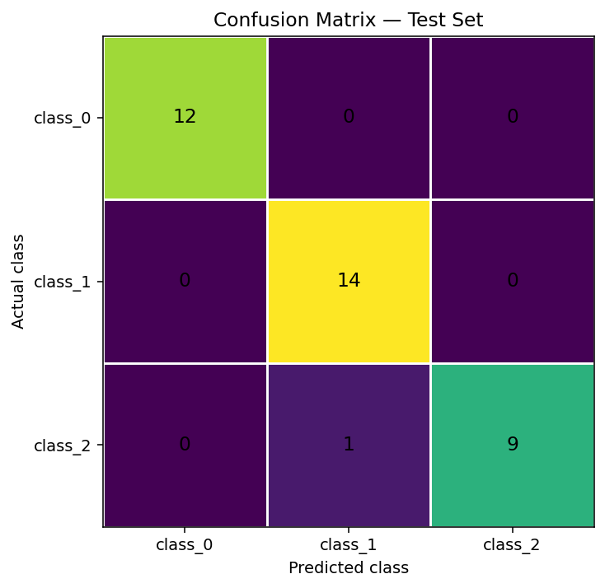
Figure 4. Annotated confusion matrix. The cells show the number of observations for each actual/predicted class combination.
For this run, the test set contained 36 observations. The confusion matrix showed 12/12 correct for class_0, 14/14 correct for class_1 and 9/10 correct for class_2; one class_2 observation was predicted as class_1. This explains the small gap between perfect classification and the observed 97.22% test accuracy.

11. Cross-Validation — Analysis + Code
A single train/test split can be sensitive to which observations happen to fall into the test set. Therefore, 5-fold StratifiedKFold cross-validation is used. Each fold preserves class proportions, and each part of the dataset is used as validation once.
from sklearn.model_selection import (
StratifiedKFold, cross_validate
)
cv = StratifiedKFold(
n_splits=5,
shuffle=True,
random_state=42
)
scoring = {
"accuracy": "accuracy",
"precision": "precision_macro",
"recall": "recall_macro",
"f1": "f1_macro",
"roc_auc": "roc_auc_ovr"
}
cv_results = cross_validate(
model,
X_eng,
y,
cv=cv,
scoring=scoring
)
for metric in scoring:
scores = cv_results["test_" + metric]
print(
metric,
"mean =", scores.mean(),
"std =", scores.std()
)
The executed analysis produced mean 5-fold accuracy of 0.9886 with a standard deviation of 0.0140. The relatively small variation across folds suggests that the result is not driven entirely by one particular split, although the small dataset size still limits how broadly the result should be generalized.
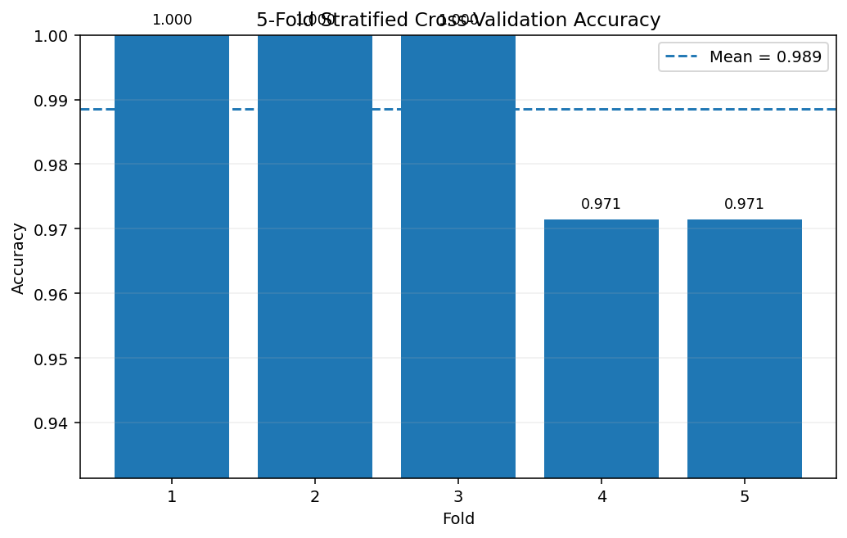
Figure 5. Fully annotated five-fold cross-validation accuracy, with the mean shown as a reference line.

12. Baseline vs Feature-Engineered Model
To test whether feature engineering adds value, a baseline Logistic Regression model is trained using only the original 13 features. The engineered model uses the original features plus the log transforms and two derived phenolic features.
# Baseline feature set
X_train_b, X_test_b, y_train_b, y_test_b = train_test_split(
X, y,
test_size=0.20,
stratify=y,
random_state=42
)
baseline = Pipeline([
("scaler", StandardScaler()),
("classifier", LogisticRegression(max_iter=2000))
])
baseline.fit(X_train_b, y_train_b)
base_pred = baseline.predict(X_test_b)
print("Baseline accuracy:",
accuracy_score(y_test_b, base_pred))
print("Engineered accuracy:",
accuracy_score(y_test, y_pred))
This comparison is important because adding features does not automatically mean improving a model. The correct interpretation is based on the measured difference between the two models on the same evaluation design, not on the assumption that more variables must be better.

13. Model Interpretation — Feature Importance + Code
Logistic Regression coefficients provide a transparent interpretation of the fitted model. Because the classifier is multiclass, the mean absolute coefficient is used to summarize the strength of association across the class-specific decision functions. This is an interpretive aid, not a causal ranking.
coef = model.named_steps["classifier"].coef_
importance = np.mean(
np.abs(coef),
axis=0
)
importance_df = pd.DataFrame({
"feature": X_eng.columns,
"mean_abs_coefficient": importance
}).sort_values(
"mean_abs_coefficient",
ascending=False
)
print(importance_df.head(10))
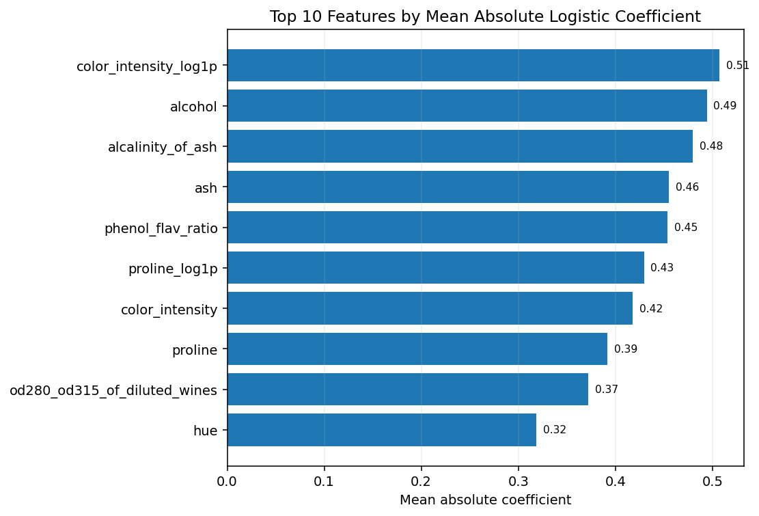
Figure 6. Top features by mean absolute Logistic Regression coefficient. Larger magnitude indicates stronger model contribution after scaling.

14. Strengths, Limitations and Improvements
Strengths
- Public, well-documented dataset with a clear supervised target.
- Stratified splitting and stratified cross-validation.
- Scaling is safely contained inside a Pipeline.
- Feature transformations and aggregations are explicitly justified.
- Multiple evaluation metrics and an annotated confusion matrix are reported.
- A baseline-versus-engineered comparison is included.
- The model remains relatively interpretable.
Limitations
- Only 178 observations are available, so performance estimates can vary with sampling.
- The dataset has no missing values, so imputation is not demonstrated.
- The model predicts cultivar class, not wine quality.
- Logistic Regression mainly represents linear decision boundaries in the transformed feature space.
- High benchmark performance should not be interpreted as guaranteed real-world performance.
Possible improvements
- Compare with Random Forest, Support Vector Machine, K-Nearest Neighbors and gradient boosting.
- Tune hyperparameters inside cross-validation using GridSearchCV or RandomizedSearchCV.
- Evaluate feature selection and dimensionality reduction.
- Use repeated cross-validation to quantify uncertainty more robustly.

15. Complete Reproducible Code
The complete runnable .py file is provided separately. For clarity, the report above places the relevant code immediately after each modelling or analysis step. The full script is reproduced here so the document remains self-contained.
"""
Week 4 Task: Supervised Learning Model Implementation
Dataset: UCI Wine Recognition Dataset
Task: Multiclass classification of wine cultivar from chemical measurements.
Run:
pip install numpy pandas matplotlib scikit-learn
python week4_wine_supervised_learning.py
"""
import numpy as np
import pandas as pd
import matplotlib.pyplot as plt
from sklearn.datasets import load_wine
from sklearn.model_selection import train_test_split, StratifiedKFold, cross_validate
from sklearn.pipeline import Pipeline
from sklearn.preprocessing import StandardScaler
from sklearn.linear_model import LogisticRegression
from sklearn.metrics import (
accuracy_score, precision_score, recall_score, f1_score,
roc_auc_score, confusion_matrix, classification_report
)
# ------------------------------------------------------------
# 1. Load the public dataset
# ------------------------------------------------------------
wine = load_wine(as_frame=True)
df = wine.frame.copy()
df.columns = [c.replace(" ", "_").replace("/", "_") for c in df.columns]
feature_cols = list(df.columns[:13])
df["target_name"] = df["target"].map(dict(enumerate(wine.target_names)))
print("Dataset shape:", df.shape)
print("\nClass distribution:")
print(df["target_name"].value_counts())
print("\nMissing values:")
print(df[feature_cols].isna().sum())
# ------------------------------------------------------------
# 2. Basic transformation / feature engineering
# ------------------------------------------------------------
X = df[feature_cols].copy()
y = df["target"].copy()
# Four positively skewed features receive log1p transforms.
# The original columns are retained so the model can learn from both
# the original scale and the transformed representation.
X_eng = X.copy()
for c in ["magnesium", "malic_acid", "color_intensity", "proline"]:
X_eng[c + "_log1p"] = np.log1p(X_eng[c])
# Interpretable feature engineering:
# ratio = flavonoids relative to total phenols
# index = combined phenolic signal
X_eng["phenol_flav_ratio"] = X_eng["flavanoids"] / (
X_eng["total_phenols"] + 1e-6
)
X_eng["phenol_index"] = (
X_eng["total_phenols"] + X_eng["flavanoids"]
)
# ------------------------------------------------------------
# 3. Train/test split
# ------------------------------------------------------------
X_train, X_test, y_train, y_test = train_test_split(
X_eng,
y,
test_size=0.20,
stratify=y,
random_state=42
)
# ------------------------------------------------------------
# 4. Pipeline: scaling + Logistic Regression
# ------------------------------------------------------------
model = Pipeline([
("scaler", StandardScaler()),
("classifier", LogisticRegression(max_iter=2000))
])
model.fit(X_train, y_train)
y_pred = model.predict(X_test)
y_proba = model.predict_proba(X_test)
# ------------------------------------------------------------
# 5. Test-set evaluation
# ------------------------------------------------------------
accuracy = accuracy_score(y_test, y_pred)
precision = precision_score(y_test, y_pred, average="macro")
recall = recall_score(y_test, y_pred, average="macro")
f1 = f1_score(y_test, y_pred, average="macro")
roc_auc = roc_auc_score(
y_test, y_proba, multi_class="ovr", average="macro"
)
print("\nTest-set metrics")
print(f"Accuracy: {accuracy:.4f}")
print(f"Macro Precision: {precision:.4f}")
print(f"Macro Recall: {recall:.4f}")
print(f"Macro F1: {f1:.4f}")
print(f"Macro ROC-AUC (OvR): {roc_auc:.4f}")
print("\nClassification report:")
print(classification_report(y_test, y_pred, target_names=wine.target_names))
print("\nConfusion matrix:")
print(confusion_matrix(y_test, y_pred))
# ------------------------------------------------------------
# 6. Five-fold stratified cross-validation
# ------------------------------------------------------------
cv = StratifiedKFold(n_splits=5, shuffle=True, random_state=42)
scoring = {
"accuracy": "accuracy",
"precision": "precision_macro",
"recall": "recall_macro",
"f1": "f1_macro",
"roc_auc": "roc_auc_ovr"
}
cv_results = cross_validate(
model,
X_eng,
y,
cv=cv,
scoring=scoring
)
print("\n5-fold cross-validation:")
for metric in scoring:
scores = cv_results["test_" + metric]
print(
f"{metric:10s}: mean={scores.mean():.4f}, "
f"std={scores.std():.4f}"
)
# ------------------------------------------------------------
# 7. Aggregation examples
# ------------------------------------------------------------
class_summary = (
df.groupby(["target", "target_name"])[feature_cols]
.mean()
.round(3)
)
print("\nMean feature values by class:")
print(class_summary)
df["alcohol_band"] = pd.cut(
df["alcohol"],
bins=[10.9, 12.0, 13.0, 14.0, 15.0],
labels=["11–12", "12–13", "13–14", "14–15"],
include_lowest=True
)
alcohol_summary = (
df.groupby("alcohol_band", observed=False)
.agg(
samples=("target", "size"),
mean_proline=("proline", "mean"),
class_0_share=("target", lambda s: (s == 0).mean()),
class_1_share=("target", lambda s: (s == 1).mean()),
class_2_share=("target", lambda s: (s == 2).mean()),
)
)
print("\nAlcohol-band aggregation:")
print(alcohol_summary.round(3))
# ------------------------------------------------------------
# 8. Fully annotated visualizations
# ------------------------------------------------------------
# Class distribution
counts = df["target_name"].value_counts().reindex(wine.target_names)
fig, ax = plt.subplots(figsize=(7, 4.5))
bars = ax.bar(counts.index, counts.values)
ax.set_title("Wine Cultivar Class Distribution")
ax.set_xlabel("Cultivar class")
ax.set_ylabel("Number of samples")
ax.grid(axis="y", alpha=0.25)
for b, v in zip(bars, counts.values):
ax.annotate(
f"{v} samples ({v/len(df):.1%})",
xy=(b.get_x() + b.get_width()/2, v),
xytext=(0, 6),
textcoords="offset points",
ha="center"
)
plt.tight_layout()
plt.show()
# Confusion matrix
cm = confusion_matrix(y_test, y_pred)
fig, ax = plt.subplots(figsize=(6, 5))
ax.imshow(cm)
ax.set_title("Confusion Matrix — Test Set")
ax.set_xlabel("Predicted class")
ax.set_ylabel("Actual class")
ax.set_xticks(range(3), wine.target_names)
ax.set_yticks(range(3), wine.target_names)
for i in range(cm.shape[0]):
for j in range(cm.shape[1]):
ax.text(j, i, str(cm[i, j]), ha="center", va="center")
plt.tight_layout()
plt.show()
# ------------------------------------------------------------
# 9. Model interpretation
# ------------------------------------------------------------
coef = model.named_steps["classifier"].coef_
importance = np.mean(np.abs(coef), axis=0)
importance_df = pd.DataFrame({
"feature": X_eng.columns,
"mean_abs_coefficient": importance
}).sort_values("mean_abs_coefficient", ascending=False)
print("\nTop 10 features by mean absolute coefficient:")
print(importance_df.head(10).to_string(index=False))

16. Dataset and References
- UCI Machine Learning Repository — Wine Dataset: https://archive.ics.uci.edu/dataset/109/wine
- Scikit-learn — load_wine: https://sklearn.org/stable/modules/generated/sklearn.datasets.load_wine.html
- Scikit-learn — LogisticRegression: https://scikit-learn.org/stable/modules/generated/sklearn.linear_model.LogisticRegression.html
- Scikit-learn — Cross-validation: https://scikit-learn.org/stable/modules/cross_validation.html
- Scikit-learn — Classification metrics: https://scikit-learn.org/stable/api/sklearn.metrics.html

