EXP.NO: 6
Session Tracking using HttpSession (Pet Adoption Portal)

AIM
To demonstrate session tracking using HttpSession in a Servlet-based web application by creating a Pet Adoption Portal, where users log in, access a protected adoption dashboard, and maintain session until logout.

ALGORITHM
1. Input:
- User enters username and password in login form.
2. Steps:
- Create Login Form (HTML):
  - Input fields: username & password
  - Submit to servlet
- Create Login Servlet:
  - Retrieve login details
  - Validate user
  - Create session using HttpSession
- Validate Credentials:
  - If valid → create session
  - If invalid → show error
- Session Tracking:
  - Store username using
session.setAttribute("user", username)
- Protected Page (Adoption Dashboard):
  - Check session
  - Display available pets
- Logout:
  - Invalidate session
  - Redirect to login page
- Session Expiry:
  - Automatically ends after timeout

SOURCE CODE

1. index.html (Login Page)
<html>
<head>
<title>Pet Adoption Login</title>
<style>
body{
margin:0;
font-family:Arial;
background:linear-gradient(135deg,#16a34a,#064e3b);
display:flex;
justify-content:center;
align-items:center;
height:100vh;
color:white;
}
.box{
background:#022c22;
padding:30px;
border-radius:12px;
text-align:center;
width:320px;
}
input,button{
width:90%;
padding:10px;
margin:10px;
border:none;
border-radius:5px;
}
button{
background:#16a34a;
color:white;
font-weight:bold;
}
</style>
</head>
<body>
<div class="box">
<h2>PET ADOPTION PORTAL</h2>
<h3>User Login</h3>
<form action="login" method="post">
<input name="username" placeholder="Enter Username" required><br>
<input type="password" name="password" placeholder="Enter Password" required><br>
<button>Login</button>
</form>
</div>
</body>
</html>

2. LoginServlet.java
import java.io.*;
import javax.servlet.http.*;
public class LoginServlet extends HttpServlet {
protected void doPost(HttpServletRequest request,HttpServletResponse response)
throws IOException {
String u = request.getParameter("username");
String p = request.getParameter("password");
if(u.equals("user") && p.equals("123")) {
HttpSession session = request.getSession();
session.setAttribute("user",u);
response.sendRedirect("home");
}
else {
PrintWriter out = response.getWriter();
out.println("<html><body style='text-align:center;font-family:Arial;margin-top:100px;'>");
out.println("<h2>Invalid Login</h2>");
out.println("<a href='index.html'>Try Again</a>");
out.println("</body></html>");
}
}
}

3. HomeServlet.java (Pet Dashboard)
import java.io.*;
import javax.servlet.http.*;
public class HomeServlet extends HttpServlet {
protected void doGet(HttpServletRequest request,HttpServletResponse response)
throws IOException {
HttpSession session = request.getSession(false);
if(session==null || session.getAttribute("user")==null) {
response.sendRedirect("index.html");
return;
}
String user = (String)session.getAttribute("user");
PrintWriter out = response.getWriter();
out.println("<html><body style='text-align:center;font-family:Arial;background:#064e3b;color:white;'>");
out.println("<h1>PET ADOPTION DASHBOARD</h1>");
out.println("<h2>Welcome "+user+"</h2>");
out.println("<h3>Session Created Successfully using HttpSession</h3>");
// PET IMAGES
out.println("<img src='https://cdn.pixabay.com/photo/2017/09/25/13/12/dog-2785074_640.jpg' width='200'>");
out.println("<img src='https://cdn.pixabay.com/photo/2016/02/19/11/53/cat-1207823_640.jpg' width='200'>");
out.println("<p>Available Pets: Dog | Cat</p>");
out.println("<a href='logout'><button>Logout</button></a>");
out.println("</body></html>");
}
}

4. LogoutServlet.java
import java.io.*;
import javax.servlet.http.*;
public class LogoutServlet extends HttpServlet {
protected void doGet(HttpServletRequest request,HttpServletResponse response)
throws IOException {
HttpSession session = request.getSession(false);
if(session!=null)
session.invalidate();
response.sendRedirect("index.html");
}
}

5. web.xml
<web-app>
<welcome-file-list>
<welcome-file>index.html</welcome-file>
</welcome-file-list>
<servlet>
<servlet-name>LoginServlet</servlet-name>
<servlet-class>LoginServlet</servlet-class>
</servlet>
<servlet-mapping>
<servlet-name>LoginServlet</servlet-name>
<url-pattern>/login</url-pattern>
</servlet-mapping>
<servlet>
<servlet-name>HomeServlet</servlet-name>
<servlet-class>HomeServlet</servlet-class>
</servlet>
<servlet-mapping>
<servlet-name>HomeServlet</servlet-name>
<url-pattern>/home</url-pattern>
</servlet-mapping>
<servlet>
<servlet-name>LogoutServlet</servlet-name>
<servlet-class>LogoutServlet</servlet-class>
</servlet>
<servlet-mapping>
<servlet-name>LogoutServlet</servlet-name>
<url-pattern>/logout</url-pattern>
</servlet-mapping>
</web-app>

OUTPUT (Reference)
🟢 Login Page:

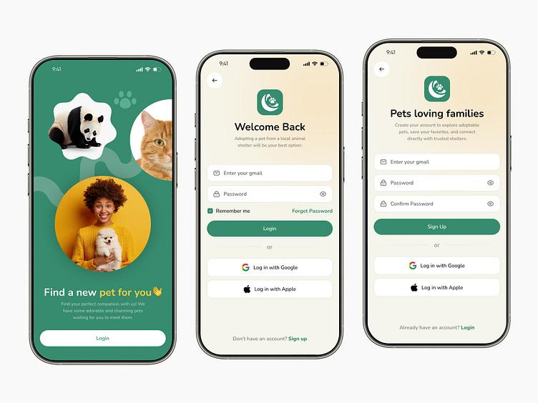

🟢 Dashboard (After Login):

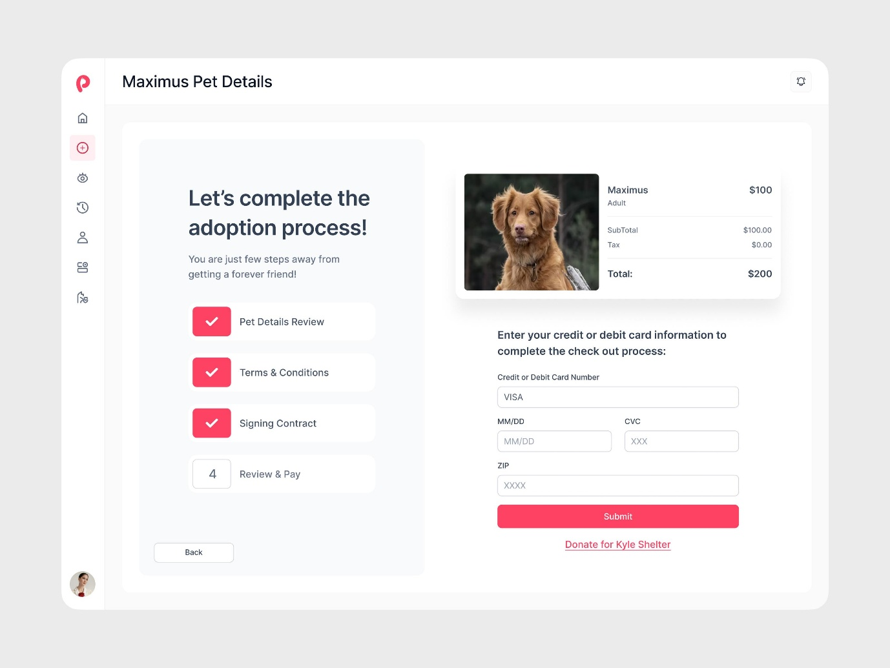

RESULT
Thus, a Servlet-based web application was successfully created to demonstrate session tracking using HttpSession through a Pet Adoption Portal, where user login, session maintenance, and logout were implemented.

